Overall percent passing score is extremely low with as the analysis revealed the top five school type being Charter while the lower being District schools. The larger sized schools fall within the low end of the overall passing.

District Summary

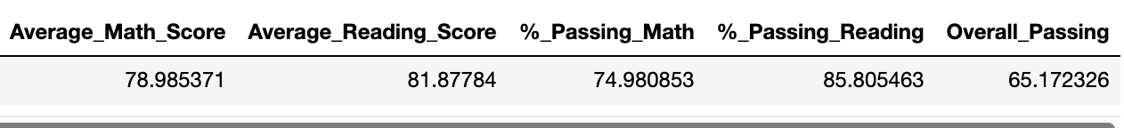

Scores by School Type

Scores by School Size

Top Performing Schools

Bottom Performing Schools

