Background to the DO3SE Model

Describe the aims, development and applications of the DO3SE model, provide details of the different model versions with some simple flow charts, (and respective paper publications); brief overview of planned next steps for model development

Contents

Aims 1

Development 1

Applications 1

Model Flow 1

References 1

# Aims

# Development

# Applications

# Model Flow

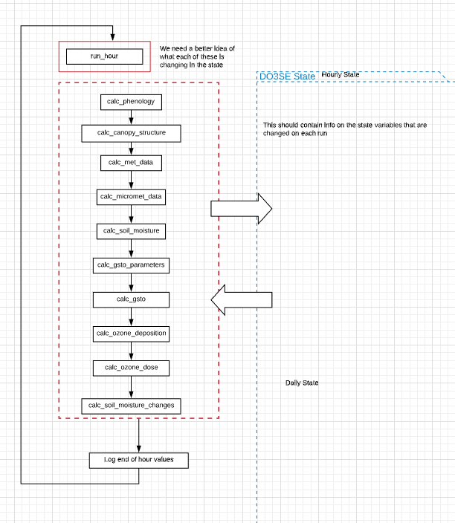

Figure : (WIP) An overview of the data flow in the model.

# References