Meteorological Derivations

The meteorological module provides methods for converting and cleaning meteorological data into a format required by DO3SE.

Contents

Transfer functions for wind speed and ozone concentration 2

10.1 Wind speed 2

10.2 Ozone concentration 4

# Transfer functions for wind speed and ozone concentration

It is common for wind speed and O3 concentrations to be measured above a surface vegetation type that is different from that for which O3 deposition and stomatal O3 flux estimates are being performed (e.g. measurements are often made over a grassland surface where the “target” deposition or flux canopy is a nearby forest). When such a situation occurs, transfer methods need to be applied to allow the derivation of the necessary variables (namely O3 concentration and wind speed) at the “target” canopy height from variables that are measured above the alternative surface vegetation type, here referred to as the “reference” canopy.

To be able to estimate wind speed and O3 concentrations for those situations where either one or both of the variables is measured above a “reference” surface vegetation cover requires derivation of these variables at a height sufficiently removed from the surface vegetation that the atmosphere will be decoupled from the underlying vegetation, and hence the O3 concentration or wind speed can be assumed to be independent of the underlying surface vegetation. In the following calculations, a height of 50 m is assumed appropriate to meet these criteria. The O3 concentration and wind speed variables can then be “bought back down” to the “target” canopy and hence re-coupled with the appropriate land surface type.

The coupling of the vegetation to the atmosphere is described by the friction velocity (u*) which is, in part, determined by the surface vegetation, as such it is necessary to estimate u* for canopies above which the variables wind speed and O3 concentration are measured, as well as for the “target” canopy; these will be referred to as u*Ref,w u*Ref,o and u*,tgt, respectively in the following text.

## 10.1 Wind speed

The wind speed at the “target” canopy height is necessary for the estimation of the boundary layer resistance of representative upper canopy leaves for leaf O3 flux estimates.

If the original wind speed was **NOT** measured over the “target” canopy but over a canopy of a different land-cover type (here referred to as the “reference” canopy), then the friction velocity for the reference canopy (u*ref,w) has to be estimated as follows :-

u*ref,w = 

where uref ,w is the wind speed measured at height href,wabove the reference canopy over which the wind speed measurements are made, *k* is the von Karman constant (0.41), dref,w is the canopy displacement height (where dref,w equals href,w * 0.7) and zoref,wis the canopy roughness length (where zoref,wequals href,w * 0.1), with href,w being the height of the reference canopy above which the wind speed is measured. N.B. Note the wind speed has to be measured ABOVE the “reference” canopy with height hrefCw i.e. href,w > hrefCw.

The u*ref,wcan then be used to estimate wind speed at an upper level height uref,w(hup), here hup is assumed to be 50 m; where the atmosphere would be expected to be largely decoupled from any underlying surface vegetation layer.

uref,w(hup) = 

This 50 m wind speed uref,w(hup) can then be used to estimate u*tgt for the target canopy for which O3 flux is to be estimated as follows :-

u*tgt = 

where dtgt and zotgt are the “target” canopy displacement and roughness length values calculated as 0.7 * htgt and 0.1 * htgt where htgt is the “target” canopy height.

The wind speed at the target canopy height utgt(htgt) can then be estimated according to the following equation assuming a stable atmosphere :-

utgt(htgt) = 

If the original wind speed **WAS** measured over the target canopy uw(hw) at height hw then the wind speed at the top of the canopy, utgt(htgt), can then be calculated as shown below assuming a stable atmosphere :-

utgt(htgt) = 

Figure x describes the variables necessary to estimate wind speed at the target canopy height utgt(htgt) of a forest canopy from measurements of wind speed over a reference canopy (which in this example is represented by a grassland canopy).

**Figure x** Variables necessary to estimate wind speed at a target canopy height utgt(htgt) represented as a forest canopy from measurements of wind speed made over a reference canopy represented by a grassland canopy uref,w(href,w).

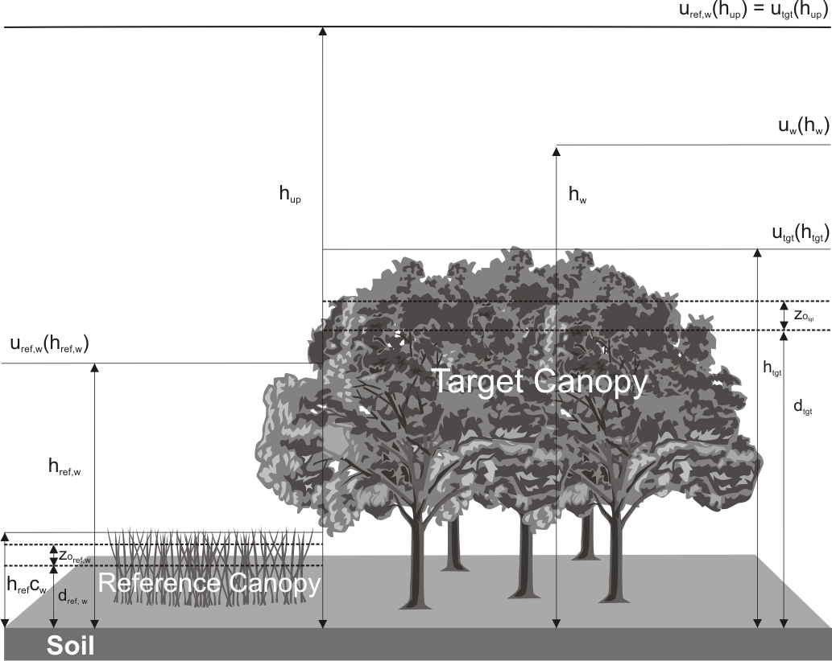

## 10.2 Ozone concentration

To estimate the O3 concentration at the canopy height it is necessary to estimate the atmospheric resistance to O3 transfer from its measurement height to the top of the “target” canopy. As for wind speed, Ra is a function of the coupling between the canopy and the atmosphere (i.e. u*). If the O3 concentration has not been measured above the “target” canopy it is necessary to estimate u* for the “reference” canopy above which the O3 concentration was measured (u*ref,o). This can be achieved using the previous estimates of wind speed at the height (hup) (i.e. a height where the atmosphere is decoupled from the underlying surface vegetation) assuming that at hup wind speed is independent of local surface features so that uref,o(hup) = uref,w(hup) where uref,o is the wind speed for the “ozone reference” canopy. The friction velocity for the “ozone reference” canopy can then be calculated as :-

u*ref,o = 

where dref,o is the canopy displacement height (where dref,o equals href,o * 0.7) and zoref,o is the canopy roughness length (where zoref,o equals href,o * 0.1) where href,o is the canopy height above which the O3 concentration is measured, here referred to as the “reference” canopy.

The O3 concentration at hup can then be estimated from the atmospheric resistance (Raref,o(ho,hup)) to O3 between the measurement height over the reference canopy at which the O3 concentration is measured Cref,o(href,o) and hup:-

Raref,o(ho,hup) =

Where ho is the O3 concentration measurement height.

The deposition velocity Vgref,o at hup for the “ozone reference” canopy is estimated by :-

Vgref,o = 

Where

Raref,o(zoref,o+dref,o,hup) = 

Rbref,o = quasi laminar resistance for „ozone reference” canopy

Rbref,o = 

Rsurref,o = bulk surface resistance for “ozone reference” canopy.

Rsurref,o is estimated by the DO3SE model as described previously in this documentation.

When using the DO3SE interface Ver.1 it is assumed that the Rsurof both the “target” and “reference” canopy are the same to avoid additional computational time. However, the user could perform two model runs to avoid uncertainties in the modelling that might result from differences in the Rsur of the reference and target canopies for both wind speed and ozone conversions. These model runs would be used to estimate the wind speed and/or ozone concentration at hup over the “reference” canopy (i.e. using DO3SE model parameterisation for this reference canopy) which can then be used in the final model run as inputs over the “target” canopy.

The O3 concentration at hup for the O3 “reference” canopy is estimated by :-

Cref,o(hup) = 

Here we assume that at hup the O3 concentration is independent of local surface features so that Ctgt(hup) = Cref,o(hup) where Ctgt is the O3 concentration at the top of the target canopy.

Aerodynamic resistance between hup and htgt for the “target” canopy is calculated by :-

Ratgt (hup, htgt) = 

Deposition velocity at hup for the “target” canopy is estimated as :-

Vgtgt(hup) = 

Where

Ratgt(zotgt+dtgt,hup) = 

Rbtgt = quasi laminar resistance for “target” canopy

Rbtgt = 

Rsurtgt = bulk surface resistance for “target” canopy.

Rsurtgt is estimated by the DO3SE model as described previously in this documentation.

Finally, O3 concentration at the “target” canopy is estimated as:-

Ctgt (htgt) = Cref,o(hup).[1-Ratgt (htgt,hup).Vgtgt (hup)]

If the O3 concentration is measured above the “target” canopy, it is only necessary to estimate the aerodynamic resistance (Ratgt(ho,htgt)) between the O3 measurement height (ho) and the target canopy height (htgt), this can be achieved by substituting the hup for ho as follows :-

Ratgt (ho, htgt) = 

Deposition velocity at hup for the “target” canopy is estimated as :-

Vgtgt(ho) = 

Where

Ratgt(zotgt+dtgt,ho) = 

Rbtgt = quasi laminar resistance for “target” canopy

Rbtgt = 

Rsurtgt = bulk surface resistance for “target” canopy.

Rsurtgt is estimated by the DO3SE model as described previously in this documentation.

Finally, O3 concentration at the “target” canopy is estimated as:-

Ctgt (htgt) = Cref,o(ho).[1-Ratgt (htgt,ho).Vgtgt (ho)]

The O3 concentration at the canopy height is then used in estimates of stomatal O3 flux for assessments of O3 impacts. Figure x describes the variables necessary to estimate O3 concentration at the “target” canopy height Ctgt(htgt) of a forest canopy from measurements of O3 concentration made over a “reference” canopy (which in this example is represented by a grassland canopy).

**Figure x** Variables necessary to estimate O3 concentration at a “target” canopy height Ctgt(htgt) represented as a forest canopy from measurements of O3 concentration made over a “reference” canopy represented by a grassland canopy Cref,o(href,o).

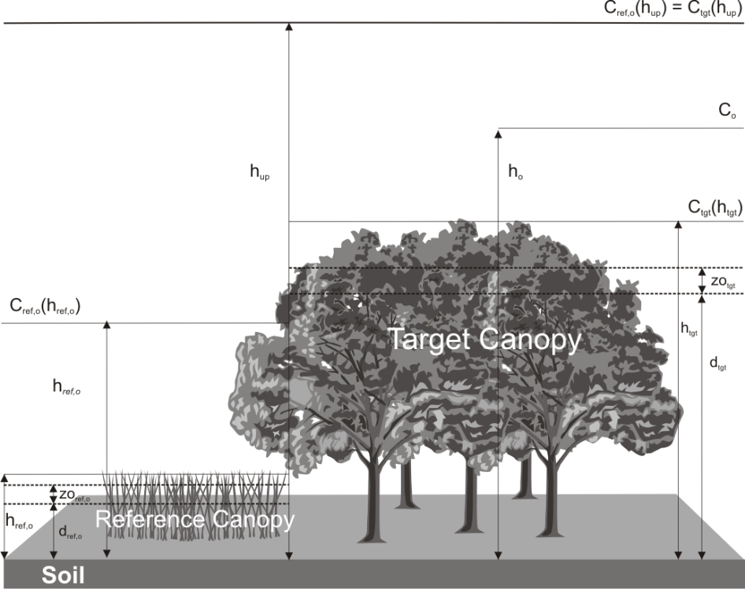

# Above canopy PAR

We calculate above canopy direct and indirect PAR components.

Uses *calc_Idrctt_Idfuse* in code

## Calculate potential PAR:

m = 1.0 / sinB

# Potential direct PAR

pPARdir = 600 * exp(-0.185 * (P / seaP) * m) * sinB

# Potential diffuse PAR

pPARdif = 0.4 * (600 - pPARdir) * sinB

# Potential total PAR

pPARtotal = pPARdir + pPARdif

.

## Sky Transmissivity

Can use either PAR input or cloudFrac to calculate the sky transmissivity.

ST = max(0.21, min(0.9, PAR / pPARtotal))

or

ST = 1.0 - 0.75 * (cloudFrac ** 3.4)

## Direct and Diffuse PAR component

# Direct and diffuse fractions

# A = 0.9

# B = 0.7

if cloudFrac is None or cloudFrac < 0.9:

fPARdir = (pPARdir / pPARtotal) * (1 - ((0.9 - ST) / 0.7)**(2.0 / 3.0))

else:

fPARdir = (pPARdir / pPARtotal)

fPARdif = 1 - fPARdir

# Apply calculated direct and diffuse fractions to PARtotal

Idrctt = fPARdir * PAR

Idfuse = fPARdif * PAR

## Sunlit and Shaded Leaf Calculations

To calculate sunlit and shaded leaves we use the equations from Farquhar 1997. We calculate the sun and shaded values per m2 then multiply this by the leaf area index(LAI) to find the value for the layer/canopy.

[Sunlit shaded equations diagram](media/sunlitshaded_diagram.pdf)

**Constants used**

Sigma = 0.15 # Leaf scattering coefficient of PAR (p_i + T_i)

**Equations**

All equations reference Farquhar 1997

k_b = 0.5 / sinB # Beam radiation extinction coefficient

k_b_alt = 0.46 / sinB # beam and scattered beam PAR extinction coefficient

**Eq A20.**

P_h = (1 - (1 - sigma) ** 0.5) / (1 + (1 - sigma) ** 0.5)

**Eq A19.**

P_cb = 1 - exp(-2 * P_h * k_b / (1 + k_b))

**Eq A21**

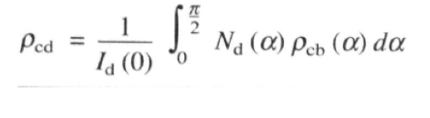

**Eq A5.**

Ir_diffuse = (1 - P_cd) * k_d_alt * Ir_dfuse_0 * exp(-k_d_alt * LAI_c)

**Eq A11.**

Ir_beam_sun = (1 - sigma) * Ir_beam_0 * cosA / sinB

**Eq A8.**

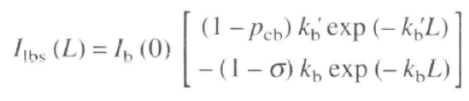

**Eq A12**

PARsun = PARshade + Ir_beam_sun

**E1 A7**

PARshade = Ir_diffuse + Ir_scattered_b

### Multilayer Approach

To calculate the PAR sun and shade at each layer of the canopy we use the cumulative LAI(LAI_c) value at each layer of the canopy where LAI_c = 0 at the top of the canopy. We then calculate the PAR sun at each layer. See surface resistance documentation for how we then combine and upscale this back to the canopy level.

[resistance\surface_resistance\Up-scaling.html](resistance/surface_resistance/Up-scaling.html)

# References

## Sunlit Shaded

* Farqhuar 1997 - DE PURY, D.G.G. and FARQUHAR, G.D. (1997), Simple scaling of photosynthesis from leaves to canopies without the errors of big‐leaf models. Plant, Cell & Environment, 20: 537-557. https://doi.org/10.1111/j.1365-3040.1997.00094.x