Soil Resistance(Rgs)

Soil resistance is calculated based on ground cover.

Contents

Model Flow 2

Soil Resistance(Rgs) 3

References 6

# Model Flow

TODO: Add model flow chart

# Soil Resistance(Rgs)

Soil resistance is calculated from a land cover specific base resistance then modified with snow cover.

This is because snow affects the Rsoil (or Rgs term) i.e. the ozone resistance of the soil term. You can find the equations for this in Eq 58 (and associated eqns) Simpson et al 2012 paper.

Eq 58 describes the general formula for all gases.

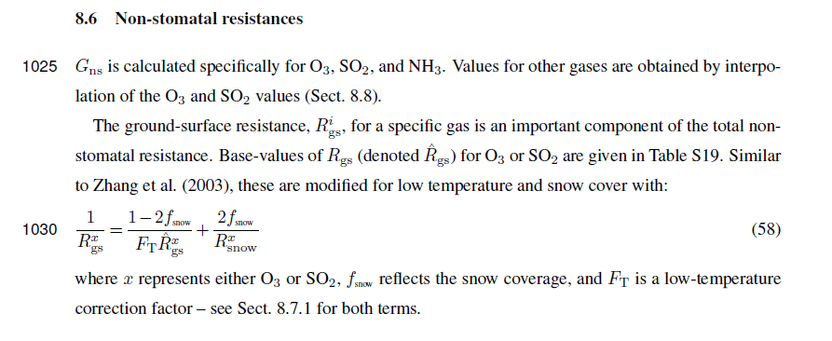

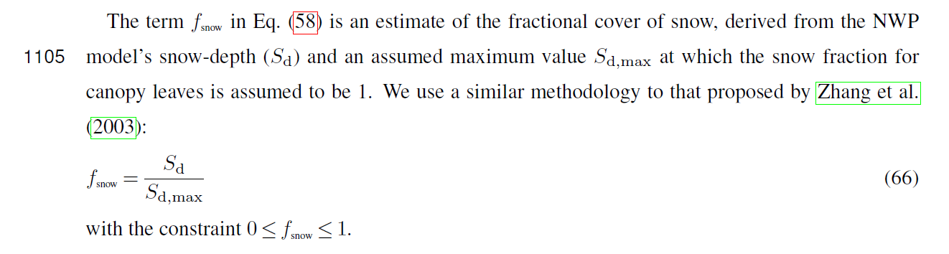

The Ft term is calculated from temperature as described in Eq 64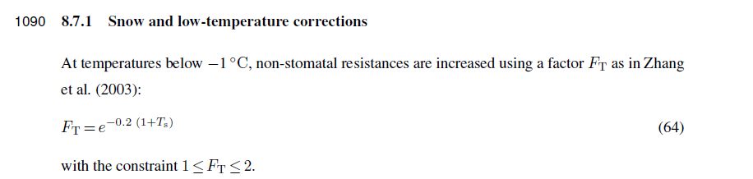

Eq 59 We can now modify our rext term with the Ft term.

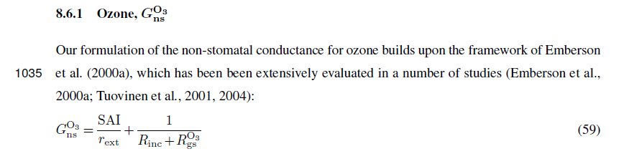

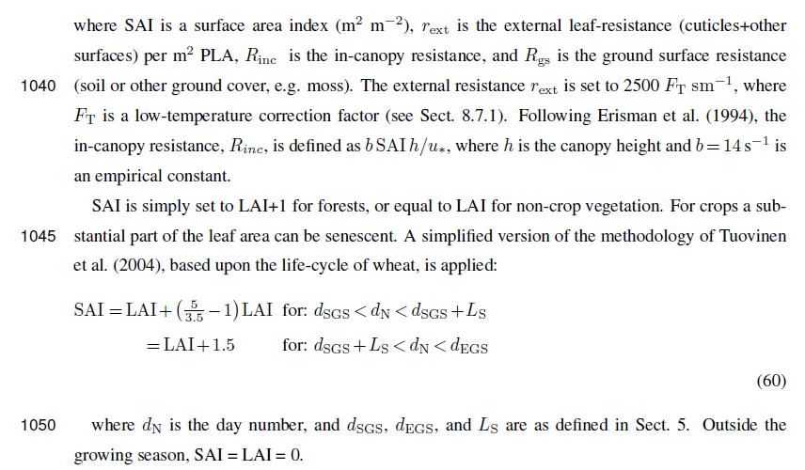

Here are the values for RO3gs for forests - 200s/m and for ice+snow - 2000 (if latter needed?)

This table S19 is also from the supplementary (also attached).

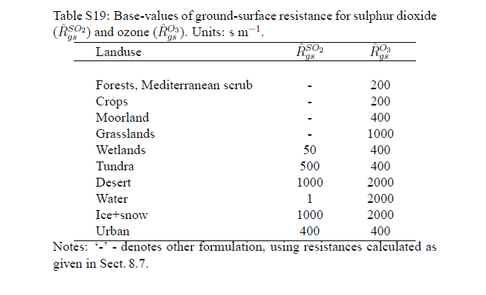

# References

* Simpson, David, et al. "The EMEP MSC-W chemical transport model–technical description." *Atmospheric Chemistry and Physics* 12.16 (2012): 7825-7865.