Page Title

Some introduction text that gives an overview of the module…

Automated table of contents. Must be updated before saving by clicking the contents then Update Table.

Contents

Introduction 1

Model Flow 2

Model Type Options 3

Processes Within This Part of The Model 4

Appendix 5

Glossary of parameters 5

References 6

# Model Flow

An overview of the data flow in this part of the model preferably with a flow chart

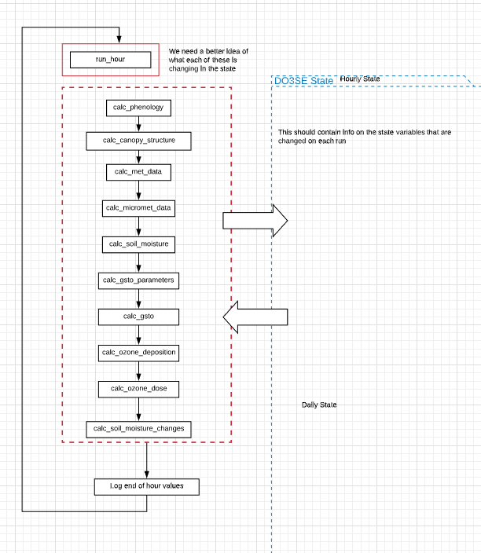

# Model Type Options

Explain key alternate configurations within this part of the model (e.g. fixed vs calculated)

# Processes within This Part of the Model

Main documentation on how this part of the model runs and any background on equations used etc.

## Equation example

$A_{c}=V_{cmax}\left[\frac{C_{i}-Γ*}{C_{i}+K_{c}.\left(1+\frac{O_{i}}{K_{o}}\right)}\right]$ 2

# Appendix

## Glossary of parameters

|  |  |  |  |
| --- | --- | --- | --- |
| **Parameter in Equation** | **Parameter in code** | **Description** | **Units** |
|  |  |  |  |
|  |  |  |  |
|  |  |  |  |
|  |  |  |  |

# References

Mulholland, B.J., Fussell, M., Edmondson, R.N., Burns, I.G., McKee, J.M.T. and Basham, J. (2000) Effect of humidity and nutrient feed K/Ca ratio on physiological responses and the accumulation of dry matter, Ca and K in tomato. Journal of Horticultural Science & Biotechnology 75 (6): 713-722

Olioso, A., Bethenod, O., Rambal, S., Thamitchian, M. (1995) Comparison of empirical leaf photosynthesis and stomatal conductance models. In 10th International Photosynthesis Congress, Montpellier (FRA), 20-25 August 1995, 4pp.