Estimating Ozone Deposition (Total & Stomatal)

Calculate the multi-layer ozone resistance model, deposition velocity and multi-layer ozone concentration. Calculated at leaf level separately.

Contents

[Ozone Deposition 1](#_Toc50029803)

[Total and Stomatal Ozone flux (Ftot and Fst) 1](#_Toc50029804)

[Total O3 flux (Ftot) 1](#_Toc50029805)

[Stomatal O3 flux (Fst[p5] ) 1](#_Toc50029806)

[Accumulated stomatal flux (AFstY) 1](#_Toc50029807)

# Model Flow

TODO: Model Flow

# Ozone Deposition

The DO3SE model’s total dry deposition scheme is shown in Fig 1. The model assumes the key resistances to O3 deposition are the aerodynamic resistance (Ra), the quasi-laminar sub-layer resistance (Rb) above the canopy, and the surface resistance (Rsur). Rsur comprises two resistance paths in series; the stomatal and non-stomatal resistance. The latter represents a) within canopy aerodynamic resistance (Rinc) and subsequent b) soil resistance to decomposition at the soil surface (Rgs) which encompasses features such as leaf litter and ground vegetation under forest canopies, as well as c) resistance to adsorption to the external plant parts (Rext) including cuticle, bark etc… a comment on planned revision of estimation of Rext here?

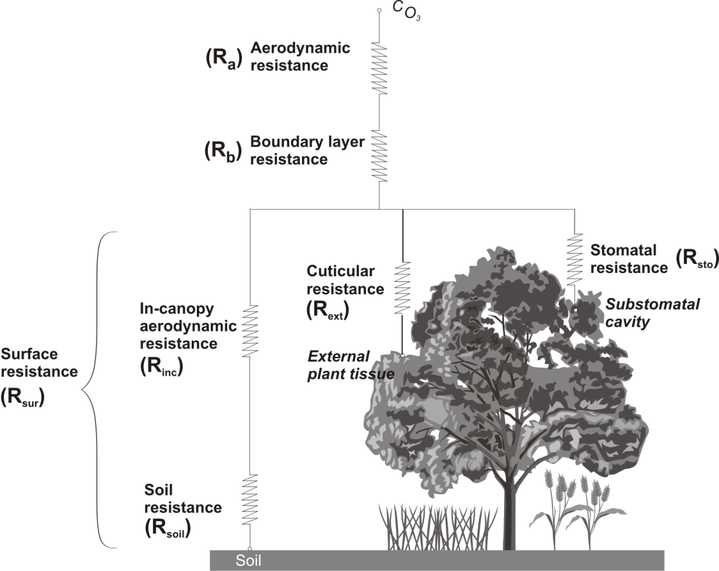

As such, the loss rate of ozone to the ground surface, within a volume unit area and height Δ*z* is given by the product of the deposition velocity (*Vg*) at height *zref* and the concentration (C*i*) at that height as described in eq. 1.

$$\frac{dC_{i(zRef)}}{dt}=\frac{-{Vg}_{\left(zRef\right)}. C_{i(zRef)}}{∆z}$$

1

Where *Vg* is estimated as given in eq. 2

$$Vg=\frac{1}{R_{a}+R_{b}+R_{sur}}$$

2

# Total and Stomatal Ozone flux (Ftot and Fst)

## Total O3 flux (Ftot)

The loss rate of O3 to the land surface (Ftot) is dependent upon the volume, defined by the unit area and height at which the O3 concentration is given and the deposition velocity between that height and the surface.

In the interface O3 concentrations can be provided either above a “reference” canopy or the “target” canopy (see section 3.1). As such, it is theoretically possible to calculate different Ftot values using the following formulations:

The O3 loss rate (Ftot50) from 50m above the canopy (h50) when O3 concentrations are provided above a “reference” canopy :-

            Vg(*50*) =

            Ftot50 = -Vg(*50*) \* O3(*50*)

The O3 loss rate (FtotO3hz) from the height above the “target” canopy (O3hz) that the O3 concentration (O3(z)) was provided :- add schematic here

            Vg(O3hz) =

            FtotO3hz = -Vg(O3hz) \* O3(z)

Finally, it is also possible to estimate the O3 loss rate (Ftoth) from the canopy top (h) when O3 concentrations are calculated for the top of the “target” canopy as is done in the interface code :-

            Vg(h) =

            Ftoth = -Vg(h) \* O3(h)

In the current version of the interface Ftoth is the O3 loss rate provided as output.

## Stomatal O3 flux (Fst[[p5]](" \l "_msocom_5) )

The estimation of stomatal flux of ozone (Fst) is based on the assumption that the concentration of O3 at the top of the canopy (O3(h)) represents a reasonable estimate of the O3 concentration at the upper surface of the laminar layer of the sunlit upper canopy leaves (and the flag leaf in the case of wheat). If O3(h) is the concentration of O3 at canopy top (height h, unit: m), in nmol m-3, then Fst (nmol m-2 PLA s-1), is given by:

Fst = O3(h) \* gsto \*

Where rc is equal to 1/(gsto+gext), here gsto and gext are given in units of m/s. At normal temperatures and air pressure, the conversion is made by dividing the conductance values expressed in mmol m-2 s-1 by 41000 to given conductance in m/s. A value for gext of 1/2500 is used to maintain consistency with the value of 2500 s/m used in the canopy scale estimate of Rsur.

## Accumulated stomatal flux (AFstY)

The accumulated flux above an O3 stomatal flux rate threshold of Y nmol m-2 s-1 (AFstY) is calculated as described below with the accumulation estimated over the respective accumulation period.

AFstY  =   for Fsti  Y nmol m-2 PLA s-1

where *Fsti* is the hourly O3 mean flux in nmol m-2 PLA s-1, and n is the number of hours within the accumulation period.