Phyllochron DVI Method

The Phyllochron DVI phenology method is based on the JULES model and Ewert & Porter 2000 papers.

Contents

Methods 2

Model Flow (Thermal Time Method) 2

Model Notes 4

Phenology 4

Leaf Stage Durations (Approaches to defining leaf duration) 4

Calculating the Phyllochron 5

Calculating Photoperiod 5

Calculating SGS and EGS 5

Calculating development index (DVI) 5

Appendix 7

Glossary of parameters 7

References 8

# Methods

1. Thermal Time DVI JULES method– Phenology calculated using thermal time (Osborne 2015, Porter 1984)
2. Constant – t_l etc provided
3. F_phen – values estimated from f_phen input

# Model Flow (Thermal Time Method)

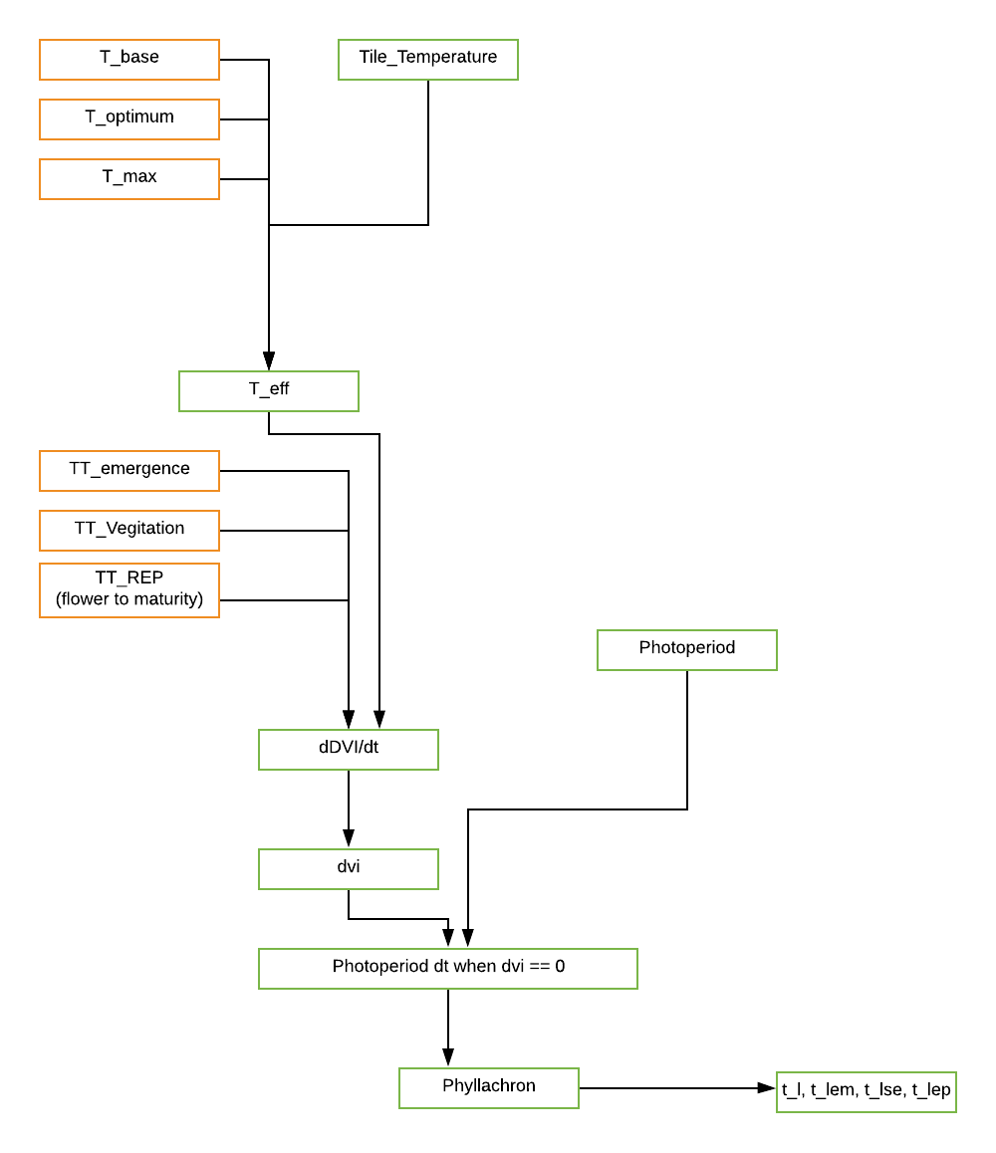

Figure : Calculating life cycle of leaf using Phyllachron

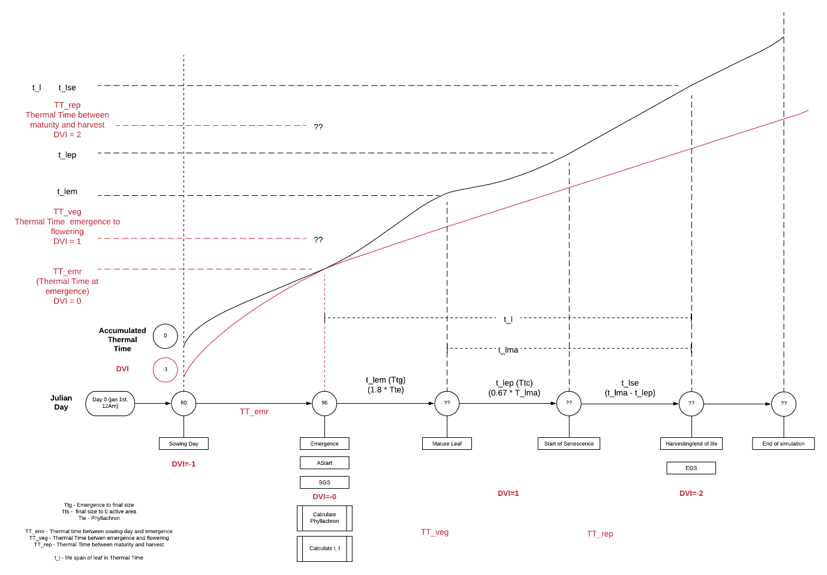

Figure : WIP Model timeline for calculating Phenology

# Model Notes

1. The model is currently only setup for spring wheat.
2. The phyllochron is calculated at emergence day and is then constant for the rest of the growing season

# Phenology

A key driver of O3 deposition to vegetated surfaces and stomatal O3 flux is seasonality (i.e. the timing of the physiologically active growth period); this will primarily depend on geographical location but will also be influenced by land-cover type and species

To calculate the plant leaf stage durations we use the phyllochron which is calculated based on the change in daylight at emergence.

**INSERT COMPARISON OF KEY PHENOLOGY STAGES HERE**

## Leaf Stage Durations (Approaches to defining leaf duration)

There are multiple methods of defining the key stages of leaf duration as outlined below.

#### Ewert & Porter 2000

              tl          - life span of leaf (oC Days)

              tl,ma -    thermal time interval of mature leaf (oC Days)

              tl,se     - thermal time interval of senescence leaf (oC Days)

              tl,ep    - thermal time interval of expanded leaf (oC Days)

              tl,em   - thermal time interval of emerging leaf (oC Days)

#### Jules (Osborne, T et al 2015)

TTemr - thermal time between sowing and emergence (oC Days)

TTveg - thermal time between emergence and flowering (oC Days)

TTrep - thermal time between flowering and maturity/harvest (oC Days)

We calculate the leaf durations using the Jules method then convert these to the values used in the Ewert Paper (Porter 1984).

Ttg = tl,em= 1.8*Tte

Tts = tl,ma = 3.5*Tte

Ttc = tl,ep= 0.67* tl,ma

Tts - Ttc = tl,se = 0.33* tl,ma

tl = Tts + Ttg = tl,em + tl,ma

Where Tte is the Phyllochron

## Calculating the Phyllochron

The phyllochron is 1/y, where y is the rate of leaf emergence and is equal to 0.026 Δ + 0.0104.

*Baker equation from McMaster, G.S. and Wilhelm, W.W., 1995. Accuracy of equations predicting the phyllochron of wheat. Crop Science, 35(1), pp.30-36.*

The change of daylight at emergence (Δ) is calculated using the photoperiod which estimates the daylight hours based on the latitude (Weir 1984)

Δ = Change in day length (in hours) from day n to day n+1, with day n being day of seedling emergence

## Calculating Photoperiod

Calculated from site latitude (Lat) and Julian day number (DOY) using formulae describing the relative movement of the earth and sun

*Weir, A.H., Bragg, P.L., Porter, J.R. and Rayner, J.H., 1984. A winter-wheat crop simulation-model without water or nutrient limitations. The Journal of Agricultural Science, 102(2), pp.371-382.*

dec = ASIN(0.3978*SIN(((2*PI())*(dd-80)/365) + (0.0335*(SIN(2*PI()*dd) - SIN(2*PI()*80))/365)))

PR = 24*(ACOS((((-0.10453)/(COS(RADIANS(lat)))*(COS(dec)))-TAN(RADIANS(lat))*TAN(dec))))/PI()

## Calculating SGS and EGS

DVI starts at -1 upon sowing. When DVI reaches 0 indicates EMERGENCE, therefore, the SGS where leaves begin to appear depending on the phylochron interval. When it reaches 2 indicates MATURITY and thus the EGS.

### Calculating development index (DVI)

The DVI takes the value of -1 upon sowing, increasing to 0 on emergence, 1 at the end of vegetative stage (anthesis) and 2 at crop maturity.

The change in DVI per day is calculated using equation 3 from Osborne, T et al 2015

:func:`calc_dvi`

$$\frac{dDVI}{dt}=\frac{T_{eff}}{{TT}_{emr}} for-1 ≤DVI<0$$

$$\frac{dDVI}{dt}=\left(\frac{T_{eff}}{{TT}_{veg}}\right)RPE for 0 ≤DVI<1$$

$$\frac{dDVI}{dt}=\frac{T_{eff}}{{TT}_{rep}} for 1 ≤DVI<2$$

Where Teff is the effective temperature (oC); TTemr is the thermal time between sowing and emergence; Tveg is the thermal time between emergence and flowering; Trep is the thermal time between flowering and maturity/harvest.

The effective temperature Teff is calculated as follows (Osborne, T et al 2015):

$$T_{eff}=0 for T< T_{b}$$

$$T_{eff}=T-T_{b} for T_{b}≤T ≤T_{o}$$

$$T_{eff}=\left(T_{o}-T_{b}\right)\left(1- \frac{T- T_{o}}{T_{m}- T_{o}}\right) for T_{o}≤T≤ T_{m}$$

$$T_{eff}=0 for T ≥ T_{m}$$

Where T is the mean daily temperature calculated from observed data; Tb is the base temperature; To is theoptimum temperature and Tm is the maximum temperature (oC)

Note: the base temperature used for t_eff can vary. By default DO3SE uses a base temperature of 0.

The relative photoperiod effect(RPE) is calculated as follows:

$$REP=1-(P-P_{crit})P_{sens}$$

Where P is day length; P­crit is the crop specific critical photoperiod and Psens is the degree of sensitivity to the photoperiod (+ve for short day plants and –ve for long day plants

# Appendix

## Glossary of parameters

|  |  |  |  |
| --- | --- | --- | --- |
| **Parameter in Equation** | **Parameter in code** | **Description** | **Units** |
|  |  |  |  |
|  |  |  |  |
|  |  |  |  |
|  |  |  |  |

# References

Osborne, T., Gornall, J., Hooker, J., Williams, K., Wiltshire, A., Betts, R., Wheeler, T., 2015. JULES-crop: a parametrisation of crops in the Joint UK Land Environment Simulator. Geosci. Model Dev. 8, 1139–1155. https://doi.org/10.5194/gmd-8-1139-2015

Ewert, F., Porter, J.R., 2000. Ozone effects on wheat in relation to CO2: modelling short-term and long-term responses of leaf photosynthesis and leaf duration. Global Change Biology 6, 735–750. https://doi.org/10.1046/j.1365-2486.2000.00351.x