Soil Moisture Model

The soil moisture model calculates the …

Contents

Model Flow 2

Calculating change in Soil Water 4

Start of year/simulation 4

Daily Calculations 4

Hourly Calculations 5

# Model Flow

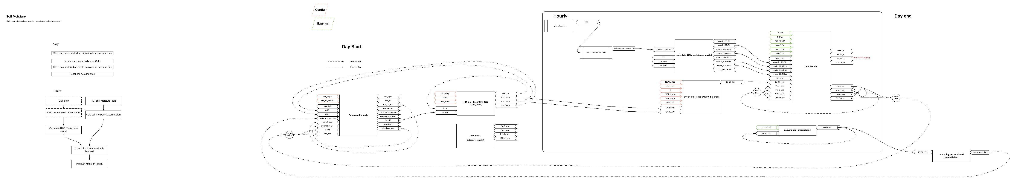

# Calculating change in Soil Water

The DO3SE soil moisture model comprises a soil box model to estimate soil water balance (Figure 1). A simple mass balance calculation is carried out over a finite depth of soil determined by a species-specific maximum root depth (*Rz*).

## Start of year/simulation

At the start of the year, when soil water calculations are initialized, root zone soil water (*Sn\**) is assumed to be equal to field capacity (*FC*) in the absence of data defining actual root zone soil water storage (*Sn*), hence plant available soil water (*ASW*) is assumed to be at a maximum (eq. 2). *FC* defines the relative amount of water held by capillarity against drainage by gravity (m3 m-3) and is dependant on soil texture (Foth, 1984).

## Daily Calculations

At the start of the day we calculate the change in Sn (Figure 1) using accumulated values from the end of the previous day. The new Sn value is then used to calculate SWP and ASW (Figure 2) to be used for the hourly calculations for the current day.

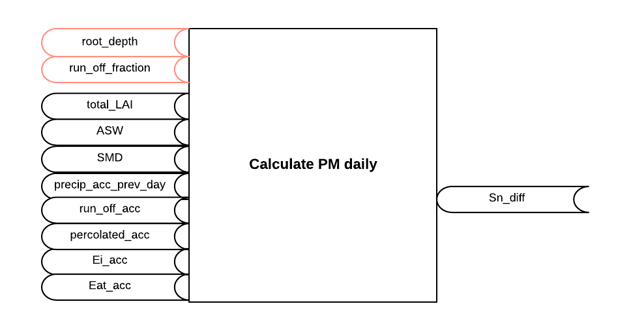

Figure 1 inputs and outputs to calculating Sn_diff. Red inputs are model parameters.

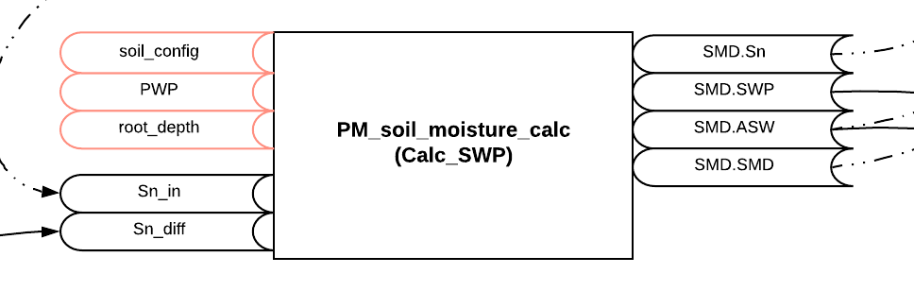

Figure 2 Inputs and outputs to calculate SWP and ASW at the start of the day. Red inputs are model parameters.

## Hourly Calculations

Precipitation is accumulated hourly with the final accumulated value used for the following day.

The H2O resistance model is calculated…

We then check if soil evaporation is blocked (Figure 3).

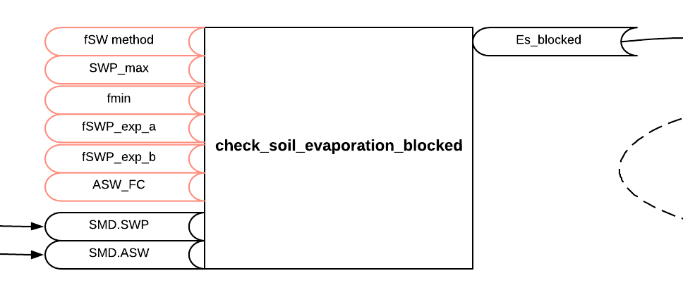

Figure 3. Inputs and outputs to checking if soil evaporation is blocked. Red inputs are model parameters.

Finally we calculate the accumulated Ei, Et, Es and Eat (Figure 4).

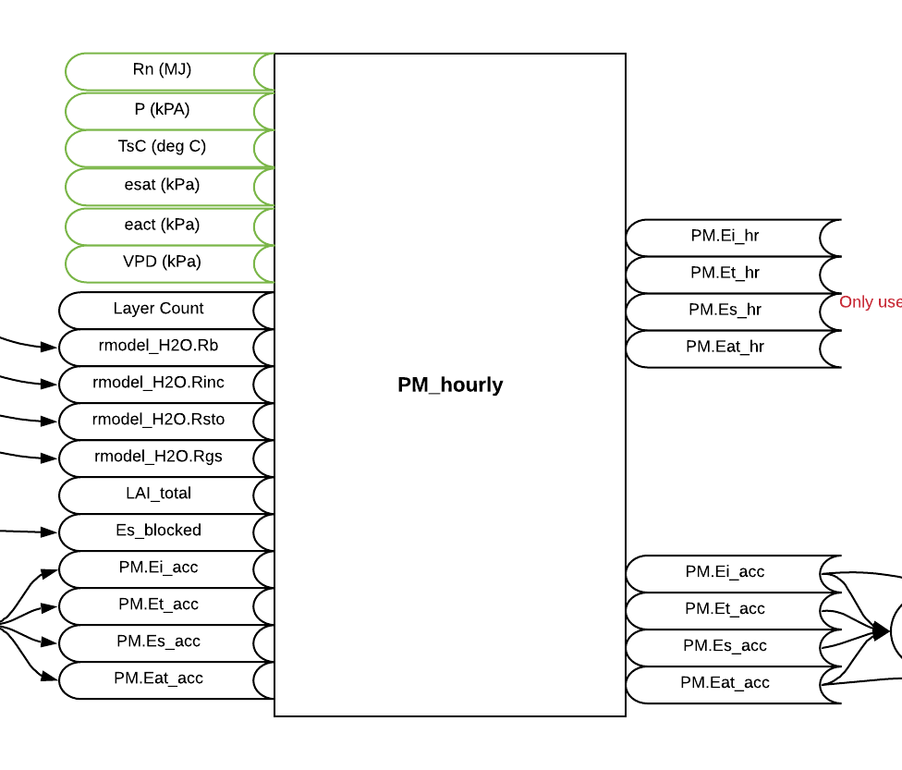

Figure 4. Inputs and outputs to calculated accumulated PM values. Green inputs are environment data.

UNCHECKED

Daily estimations of *Sn* are made according to the mass balance formulation based on the method used by Mintz and Walker (1993) (eq. 3) where *Sn-1* is the *Sn* of the preceding day and the root zone soil water storage difference between the previous day and the current day (*Sn-diff*) is calculated as a function of *Rz*, the incoming daily precipitation (*p*), the daily canopy-intercepted *P* evaporated from the wet vegetation surface (*Ei*) and from the wet soil surface (Es), and the daily actual transpiration (Eat) representing the water transferred from the soil to the atmosphere through the root-stem-leaf system of the vegetation and the .

Sn = Sn-1 + Sn-diff

*Sn-diff*  = (*p* - Sc) + (Sc – min (Ei, Sc)) / Rz, when *p* > 0

*Sn-diff*  = – Eat + Es / Rz, when *p* = 0

*Sn-1* is recharged by *p* events and the amount of *p* intercepted by the canopy is based on its storage capacity (Sc) with remaining *p* assumed to enter directly into the soil. This method is in accordance with the global land surface parameterisation of the Revised Simple Biosphere Model (SiB2; Sellers et al, 1995) which is applied for a range of land covers including broadleaf and needleleaf trees, short vegetation and grassland. In there, Sc (mm) is defined as:

Sc = 0.1*LAI

*Interception and evaporation of P in the canopy*

The fraction of intercepted *p* that might ultimately reach the soil is dependant upon *Ei*, which is estimated using the Penman equation for evaporation from a wet surface (Monteith, 1965).

*Ei* **=**

Where:

 is the slope of the vapour pressure curve (Pa °C-1), *Rn* is the net radiation at crop surface (J m-2 h-1), *G* is the soil heat flux (J m-2 h-1), *a*is the air density (kg cm-3), *Cp* is the specific heat capacity of air (J g-1 °C-1), VPD is the vapour pressure deficit (Pa),  is the psychrometric constant (Pa °C-1),  is the latent heat of vapourisation (J kg-1), *Ra* is the aerodynamic resistance for water (m s-1), *RbH2O* is boundary layer resistance for water (m s-1) and 3600 is a time conversion factor.

To estimate *Ei*, only those resistances (*i.e. Ra and RbH2O*) that occur between the top of the canopy and the measurement height of VPD need to be included in eq. X. The same is the case for the calculation of *Eat* and eq. 5.

Where possible, Rn and G should be directly measured and entered in Wh m-2 which will then be converted by the DO3SE model to J m-2 h-1 for the estimation of Ei.. However, when these data are not available, they will be estimated within the DO3SE model from global radiation (R). For the derivation of Rn see section XX. Furthermore,

*G* = 0.1 *Rn*

Intercepted *p* that is not evaporated will be assumed to add to soil water recharge up to *FC*. In cases where *Ei* exceeds intercepted *p*, no additional water will be available to recharge *Sn-1* and on days with no *p*, *Sn-1* dries at a rate controlled by evapotranspiration.

Hourly actual plant transpiration (*Eat*) is calculated using the Penman-Monteith model allowing for evaporation from a vegetated surface (Monteith, 1965) (eq. X). Again, to estimate *Eat*, only those resistances (*i.e. Ra and RbH2O*) that occur between the top of the canopy and the measurement height of VPD need to be included in eq. 5.

Eat **=** 

Where *RstoH2O* is the canopy resistance to transfer of water vapour. Soil water balance is based on summed daily values of *p*, *Ei* and *Eat*. Any water loss occurring will only affect the *gsto* (and hence *RstoH2O*) of the following day.

DO3SE assumes a single, integrated root-zone similar to the approach taken in several forest growth models (e.g. Randel et al. 2000, Grünhage & Haenel, 1997). Water inputs into the soil-rooting zone are limited to that from *p* until the soil reaches *FC*; all water in excess of *FC* is assumed to run-off or percolate into the substrate. Any capillary movement of water from the soil below the root zone is ignored.

When soil moisture is not limiting (i.e. when *SWC* is equal to *FC*), the soil will lose moisture though evaporation (*Es*) at a rate defined by the Penman-Monteith equation for evaporation modified to include the resistances from the soil surface to the atmosphere (eq. X).

*Es* **= **

Where *Rns* is the net radiation available at the soil surface beneath the canopy, estimated by

*Rns = Rn*

[7]

* = exp(-Ka*LAI)*

Where *Ka* is the coefficient for attenuation of available energy and is set to 0.5 for consistency with the DO3SE module used to estimate canopy radiation penetration.

The amount of water available to the plant is dependent upon the water holding characteristics of the soil and the water extraction capabilities of the plant. Soil water characteristic curves (eq. 8) are used to determine the soil water potential (­*soil*) for a given volumetric water content within a given texture class. In order for the parameterisation of the DO3SE model to be applicable across Europe, soil water characteristic curves were defined for 4 representative soil textures: sandy loam, silt loam, loam and clay loam. The soil water release curve profiles (Fig. X) were defined according to Campbell (1985) and empirical parameters based on Tuzet et al. (2003) as described in Table X.

 [8]

**Table X** Water holding characteristics of four soil texture classes.

|  |  |  |  |  |
| --- | --- | --- | --- | --- |
|  |  | *FC*, m3 m-3 | *Ψe* MPa | *b* |
| Sandy loam | Coarse | 0.16 | -0.00091 | 3.31 |
| Silt loam | Medium coarse | 0.26 | -0.00158 | 4.38 |
| Loam | Medium | 0.29 | -0.00188 | 6.58 |
| Clay loam | Fine | 0.37 | -0.00588 | 7 |



Fig. X. Soil water release curves according to Campbell (1985) and Tuzet et al. (2003)

When expressed as % volumetric content water available to the plant throughout the rooting depth (*ASW*; eq. 10) is estimated assuming the roots are capable of extracting water from the soil from the *FC* to the point where the root zone soil water content has reduced to the permanent wilting point (*PWP*). Commonly a *PWP* of -1.5 MPa is assumed for all plant species, however, results especially from plants growing under dry conditions in the Mediterranean shows that *PWP* for these species can extend down to -4 MPa (i.e. these plants are capable of extracting water held more tightly by the soil) and this is accounted for in DO3SE by allowing stomatal flux to continue at *f*min when soil falls below min. *FC* is assumed to be approximately -0.01 MPa (Foth, 1984) and equivalent volumetric *FC* values are estimated by re-arranging eq. 8 for each soil texture class.

*ASW = Rz(FC – PWP)* [9]

The internal consistency of the O3 deposition and water vapour exchange estimates are largely governed by *f*swp. This determines a daily baseline *gsto* meaning that as the soil dries, the stomates shut thus limiting both the amount of water lost from the soil system as well as the amount of O3 taken up via the stomates. As water lost from the soil system is integrated over the course of a day, the model does not specifically incorporate xylem hydraulic conductivity (Tuzet et al., 2003), however the rapid decrease in *gsto* with a drying soil in effect acts as a surrogate for this phenomenon.

The plant’s ability to access water is determined according to the *f*SWP relationship, described in eq. 10. Primarily, it is assumed that over *Rz*, soil water is readily able to leave the soil system up to a critical value (*ψmax*) past which point soil water is held ever more tightly until a second critical value (*ψmin*) is reached, at this point *g*sto is restricted to *f*min.

Appropriate values for *max*, *min*, *f*min were determined using experimental data collated for beech (*Fagus sylvatica*), temperate oak(*Quercus robur* and *Quercus petraea*), Scots pine (*Pinus sylvestrus*), Norway spruce (*Picea albes*) and holm oak (*Quercus ilex*). Because *f*SWP relationships for boreal/temperate coniferous and deciduous trees are very similar we use a generic *f*SWP relationship for northern and central Europe derived using combined data for both tree types. Both north/central European and Mediterranean relationships are standardised to incorporate 80% of experimental data points as shown in Figure 2.

 [10]

To summarise, all input variables required for the estimation of Ei, Eat and Es are given in Table X.

**Table X**. All input variables required for estimation of evapotranspiration using the Penman-Monteith equation.

|  |  |  |  |
| --- | --- | --- | --- |
| **Input variable** | **unit** | **description** | **source** |
| Rn | J m-2 h-1 | Net radiation at crop surface | measured or calculated by DO3SE |
| G | J m-2 h-1 | Soil heat flux | measured or calculated by DO3SE |
| ra | s m-1 | Aerodynamic resistance | calculated by DO3SE |
| rsto | s m-1 | Bulk surface (canopy) resistance | calculated by DO3SE |
| VPD | Pa | Vapour pressure deficit | measured |
| P | Pa | atmospheric pressure | measured |
| T | °C | temperature | measured |

All other derived variables are:

* = slope of the vapour pressure curve (Pa °C-1)*



Where:



Where esat is the saturated vapour pressure of air (Pa) and T is the air temperature (°C).

*eact:* actual vapour pressure (Pa)



Where esat is the saturated air pressure (Pa) and VPD is the vapour pressure deficit (Pa).

** latent heat of vapourisation (J kg-1)



** the psychrometric constant (Pa °C-1)



*a:* the air density (kg cm-3)



Where *P* is the atmospheric pressure (Pa) and



*Cp: specific heat capacity of air (J g-1 °C-1)*



**Figure 2.** fSWP relationships in comparison with observed data describing relative g with pre-dawn leaf water potential for a) coniferous (Norway spruce and Scots pine) and Deciduous (beech) trees in north and central Europe. *max*=-0.6MPa; *min*=-1.5MPa; *PWP*=-4.0MPa and b) Mediterranean trees (Holm oak). . *max*=-0.9MPa; *min*=-3.6 MPa; *PWP*=-4.0MPa

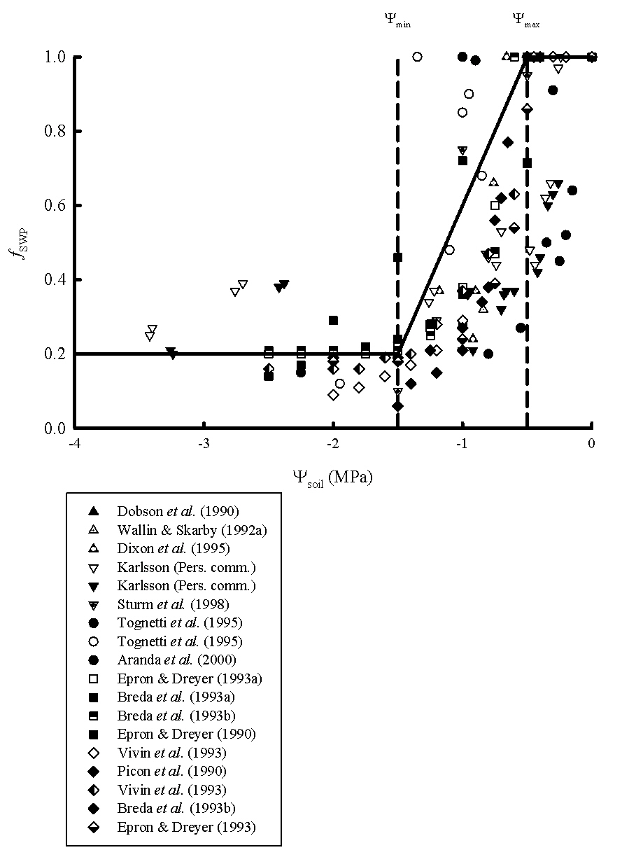

**b)**

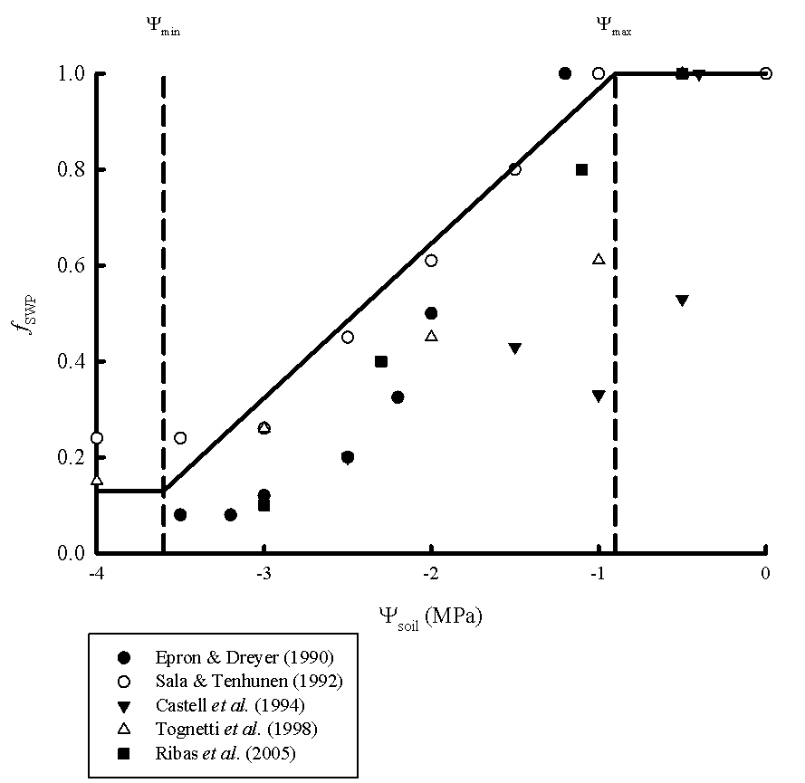

# Water Stress

According to Damour et al 2010 water stress has an impact on the stomatal conductance of leaves. Currently we use the Leuning 1995 model (Eq 12a in Damour et al 2010) to calculate the relationship between Anet and gsto. To include water stress we use the method used in Wang and Leuning 1998 below:



*Leuning 1995*

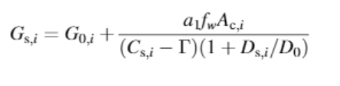

*Wang and Leuning 1998*

Where

$$D_{s,i} (VPD)=e_{sati}-(e_{sati}*h_{s})$$

$D_{0}$ is The VPD at which g_sto is reduced by a factor of 2

$A_{net}$ is the net CO2 assimilation

$C_{s}$ is surface CO2 $C_{s}=C_{a}-(A_{net}*g_{bl}^{co2})$

a is the species specific sensitivity to A­­­net

Γ is CO2 compensation point in the absense of respiration

$f_{w}$ is the fractional influence of water stress on stomatal conductance

And

$$h_{s}= \frac{gsto*e_{sat}+g_{bl}* e_{a}}{e_{sat}*(gsto+g_{bl})}$$

# References

* Damour et al (2010) An overview of models of stomatal conductance at the leaf level
* Leuning R. (1995) A critical appraisal of a combined stomatal photosynthesis model for C3 plants. Plant, Cell & Environment
* Wang, Y.-P., Leuning, R., 1998. A two-leaf model for canopy conductance, photosynthesis and partitioning of available energy I:: Model description and comparison with a multi-layered model. Agricultural and Forest Meteorology 91, 89–111. https://doi.org/10.1016/S0168-1923(98)00061-6