Up-scaling from leaf to canopy

There are two methods of upscaling from leaf to canopy; the Multiplicative method using Flight and the photosynthesis method using C allocation growth model.

Contents

Multiplicative Method 2

Photosynthesis Method 3

Old Documentation 4

Big-leaf model 4

Multi-layer model 4

The hybrid multi-layer multi-component model 4

Within canopy ozone concentration 5

Within canopy irradiance 6

Photosynthesis based modelling 9

Variation with Leaf Nitrogen (N) 10

Carbon allocation 16

8.1 Fixed C allocation coefficients 16

8.2 Dynamic C allocation driven by allometric constraints 16

Dynamic C allocation driven by resource availability 17

# Multiplicative Method

Add Flight docs here

# Photosynthesis Method

Add documentation on C allocation growth model here…

The canopy is split into layers dividing the total LAI. Each layer is then split into sunlit and shaded.

To upscale stomatal conductance and carbon allocation we sum up the sunlit and shaded gsto and A_n components and then integrate(Sum) up the layers.

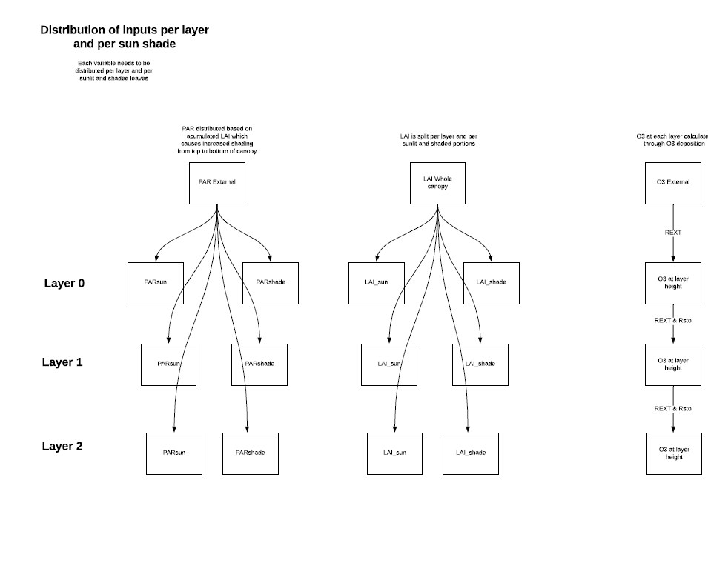

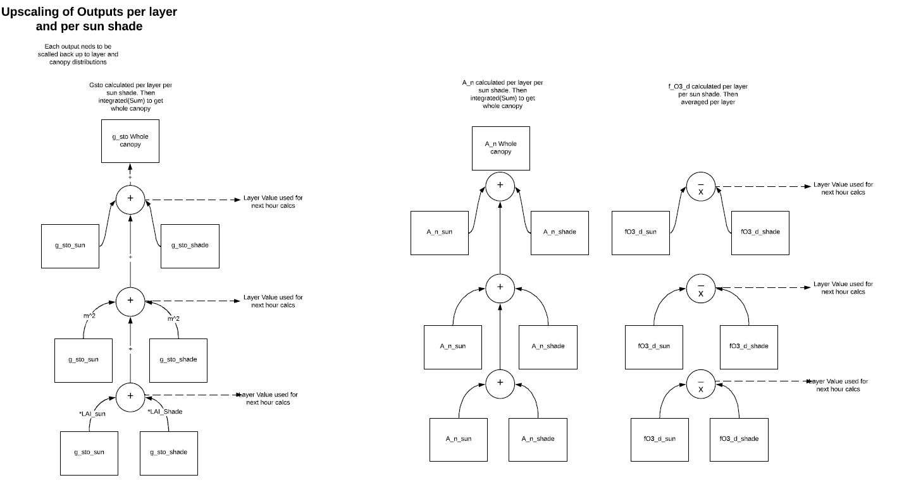

# Old Documentation

# Big-leaf model

# Multi-layer model

## The hybrid multi-layer multi-component model

To accommodate the variable sink strength of different layers within canopies we have developed a hybrid multi-layer model; this model incorporates the variation of irradiance, ozone concentration, wind speed and leaf nitrogen within the canopy, defined according to different layers of LAI within the canopy. This model is also able to accommodate different vegetation characteristics that also vary with canopy height (or cumulative LAI) such as the proportion of sun and shade leaves in forest trees or the combination of different canopy components (forbs, grasses and legumes) in grasslands. This is necessary as studies in for trees (Launiainen et al., 2013), crops (Pleijel, 2008) and grasslands (Jaggi et al., 2006) have found that these variables change with canopy depth affecting canopy layer, and hence whole canopy ozone fluxes. To achieve this the original ‘big leaf’ DO3SE model (Emberson et al., 2001) is split into several layers, the resistance of each layer (*Rx*) is calculated as described in eq. 16 and treated as a parallel sink within the overall ‘big-leaf’ framework as shown in Figure 4.

$$\frac{1}{R_{x}}= \frac{1}{R_{sto, x}}+\frac{1}{R_{ext,x}}+\frac{1}{R_{inc,x}+R_{n+1}}$$

36

Where *Rsto,x* and *Rext,x*, are the ‘stomatal’ and ‘external plant part’ resistances respectively of each layer *x*. *Rinc,x* limits transfer between canopy layers and to the soil based on an estimate of an in-canopy mixing co-efficient. This is estimated from *Rinc* (see eq. 30) with *Rinc,x* (i.e. the in-canopy aerodynamic resistance associated with each layer) being scaled according to the *SAI* of that layer. *Rn+1*represents the soil resistance, since the same resistance is associated with each layer this is written as in eq 17.

$$R_{n+1}= R_{soil}$$

37

### Within canopy ozone concentration

The O3 concentration within a canopy will vary as a function of O3 loss to the canopy (i.e. uptake via the stomates and to the external plant parts) and O3 replacement from ambient air concentrations above the canopy. Limited data have been collected showing how O3 concentrations vary with canopy depth in semi-natural communities (Jaggi et al., 2006). These data suggest that a minimum, bottom canopy, *c(zb)*, O3 concentration is about 0.2 that at the top of the canopy, *c(zh)*; and that the O3 concentration within the canopy is closely related to whole canopy *LAI*.

Since each layer is an independent parallel sink, the flux to a layer depends on the conductance (inverse of resistance) of that layer and the ozone concentration at the top of the layer (*Cx*; with *C1* being the ozone concentration at height *Ch*, the top of the canopy); this is calculated as shown in eqs. 18 and 19

$$C_{x}= C_{1}\frac{R_{x}}{R_{1}}$$

38

$$C_{1}= C_{z}\frac{R_{1}}{R_{total}}$$

39

Where *R1* is the total resistance of layer *x* and the canopy above. The resistance *Rx* refers to the total resistance of layer *x* and below. If the whole canopy is treated as a single layer this resistance scheme is identical to the existing DO3SE resistance scheme, as shown in eq 20.

$$R_{total}= R_{a}+R_{b}+R_{1}$$

40

Figure 4. Resistance scheme for the DO3SE hybrid multi-layer (multi-component grassland) flux model.



The *Rsto, x*term is calculated using the DO3SE stomatal conductance (*gsto*) model (this can use either the multiplicative scheme (see section 4.1) or the coupled photosynthesis-stomatal conductance model (see section 4.2). These models are parameterised for each of the different components (*gsto, comp*) (e.g. sun and shade leaves, grassland types) defined within the canopies depending on whether the multiplicative or coupled photosynthesis-stomatal conductance model is used. Key variables upon which photosynthesis and /or stomatal conductance depend will be affected by canopy height. Irradiance affects gsto both in its derivation by the multiplicative model and the coupled photosynthesis-stomatal conductance model; leaf nitrogen content can only currently be incorporated through its affects on photosynthesis.

### Within canopy irradiance

The model estimates canopy stomatal conductance as a function of irradiance (*Flight*) according to the method of Baldocchi et al. (1987) identifying fractions of sunlit and shaded leaf area and the PAR flux densities on those leaves as in eq. 21.

$$F_{light}=\int_{0}^{f}{df_{sun}\left(f\right)}g\left[PAR_{sun}\left(f\right)\right]+df_{shade} g\left[PAR_{shade}\left(f\right)\right] df$$

41

Where *f* is the leaf area, d*f*sun and d*f*shade are the differences in sunlit (*f*sun) and shaded (*f*shade) leaf areas respectively, between *f* and *f* +d*f,* and PARsun and PARshade are the flux densities of PAR on sunlit and shaded leaves respectively. *f*sun, *f*shade, PARsun and PARshade are calculated according to the model of Weiss & Norman (1985) used in DO3SE to estimate radiative transfer allowing for canopy component variation in the angle of leaf inclination (α) (of which there is some difference for grass (more vertically aligned leaves) and legume of forbs (leaves tend towards a horizontal alignment)). The cumulative sunlit leaf area between the top of the canopy level (*f*) within the canopy is estimated as in eq. 22.

$$f_{sun}\left(f\right)=\left[1-\exp\left(-\frac{α}{sinβ}\right)\right]2sinβ$$

42

where β is the solar elevation angle with the shaded leaf area being the remaining fraction in that particular layer.

The stomatal O3 flux within each canopy layer (*Fst, comp*) is calculated as described in eq 21.

$$F_{st,comp}=C_{x} g_{sto, comp}\frac{r_{c,comp}}{r_{b,comp}+r_{c,comp}}$$

43

Where the leaf resistance term (*rc, comp*) is equal to 1/(*gsto, comp + gext*) with *gext* being the same for all canopy components with a value of 1/2500 in m/s, *gsto, comp*is in units of m/s estimated from mmol m-2 s -1 according to temperature and pressure. Leaf level $r_{b,comp}$ is estimated as described in section 2.3.2). However, this requires that the wind speed within each layer be known This is estimated as described below in section 5.2.1.1.

#### Within canopy wind speed

To estimate in canopy wind speed we use the methods described in Campbell & Norman (1998). These assume wind decreases exponentially with depth with eq. 22 describing the wind speed in the top 90% of the canopy.

$$u\left(z\right)=u\left(h\right)\exp\left\lfloor a_{u}\left(\frac{z}{h}-1\right)\right\rfloor$$

44

Where *u(z)* is the wind speed at height *z* within the canopy, *u(h)* is the wind speed at the top of the canopy, *au* is the attenuation coefficient, *z* is the height within the canopy and *h* is the total canopy height.

Goudriaan, 1977 suggested a simple equation for calculating the attenuation coefficient (*au*) as a function of canopy structure as given in eq. 23.

$$a ≅ {\left(\frac{0.2.SAIh}{l_{m}}\right)}^{\frac{1}{2}}$$

45

Where *SAI* is the Stand Area Index, *h* is the canopy height and *lm* is a mean distance between leaves in the canopy given by eq. 24 for crops

$$l_{m}={\left(\frac{4wh}{πSAI}\right)}^{\frac{1}{2}}$$

46

and eq. 47 for grasses.

$$l_{m}={\left(\frac{6w^{2}h}{πSAI}\right)}^{\frac{1}{3}}$$

47

Where *w* is the leaf width.

For the bottom 10% of the canopy a new logarithmic profile is developed with a zero plane displacement of zero and a roughness length characteristic of the underlying soil surface, eq. 48 can be used for this part of the canopy. Not currently used in current version of DO3SE model.

$$u\left(z\right)=\frac{u^{*}}{0.4}ln\frac{z-d}{z_{m}}$$

48

The wind speed at the top of this layer is equal to the wind speed at the bottom of the exponential layer so that from one wind speed at the top of the canopy all wind speeds can be estimated to the bottom of the canopy. N.B. *u\** is constant for all heights within the canopy.

As such, this hybrid model ensures that the calculation of *Fst, comp*at each layer *x* incorporates the canopy variation in the distribution of plant species (characterised by *LAI* and *gsto* parameterisation), O3 concentration, irradiance and wind speed. It is assumed that *T* and *D* remain constant over the canopy. Given the importance of the two latter variables it is useful to provide more detail of their calculation.

The phytotoxic ozone dose above a threshold (*PODy*) can then be calculated by summing *Fst,, comp* values, over threshold *y*, over the respective accumulation period.

#### Calculating whole canopy stomatal ozone flux

The estimate of whole canopy stomatal conductance (*Gsto*) and stomatal O3 flux (*Fst*)can be estimated by simply summing the individual fluxes to each species component within the different *f* layers. This method also allows derivation of the *Fst* to the canopy component fractions of the total canopy which can be used in derivation of flux-response relationships for these component species.

## Photosynthesis based modelling

14/07/2014 – Propose the following 2 methods for use in DO3SE:

1. Simple method largely following that used in JULES (Clark et al., 2011) but which allows for variation of leaf N within the canopy not only to be driven by irradiance penetration by using methods of (Johnson et al., 2010). This method assumes a direct relationship between leaf N, Vcmax and hence photosynthesis and also allows for a certain amount of Leaf N not to be associated with photosynthesis. Uses Equations [11], [13] with [13] being used for each layer (i) of the canopy. Think this can be condensed to the following…

$$V_{cmax25l}= {N_{e} \left(N_{0}-{\left(N_{0}-N_{b}\right) \left(1-\exp^{-kl}\right)}^{γρ} \right) }_{}$$

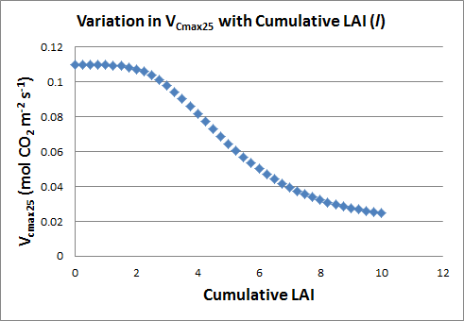

1. Complex method following Mueller et al (2011) which requires modification within the photosynthesis module (see Patrick).

### Variation with Leaf Nitrogen (N)

Photosynthesis over the canopy depends on the biochemical capacity for photosynthesis of individual leaves. An important determinant of this biochemical capacity is the amount of leaf nitrogen (*N*) which will determine the Rubisco and ribulose-1,5-bisphosphate carboxylase/oxygenase contents of leaves. Within-canopy profiles of leaf *N* (or photosynthetic capacity) have been shown to be significantly non-uniform and vary between species (cf. Pury & Farquhar, 1997). These canopy profiles have led to the hypothesis that leaves adapt or acclimate to their radiation environment such that a plant’s *N* resources may be distributed to maximise daily canopy photosynthesis. This leads to the assumption that the optimal distribution of N occurs when *N* is distributed in proportion to the distribution of absorbed irradiance in the canopy, averaged over the previous several days to a week (Pury & Farquhar, 1997).

However, respiration (and in particular maintenance respiration) is also related to protein content through its role in the synthesis and recycling of proteins, and so increasing the photosynthetic enzymes (and protein concentration in general) will not only increase photosynthetic potential, but also maintenance respiration costs. For example, Johnson et al. (1996) developed a model that optimized leaf *N* concentration through the balance between photosynthesis and respiration, so that increases in *N* influenced both photosynthetic potential and maintenance respiration losses. This approach was further extended though description of protein distribution over the canopy (as opposed to setting just a mean value) and reference to protein concentration (mol leaf C)-1, rather than *N* (which is often translated into protein *via* specific leaf area – leaf mass per unit area) (Johnson et al., 2010)).

Johnson et al. (2010) do not use the widely applied assumption that *N* is exponentially distributed through the canopy following the canopy extinction of light since it is recognised that a variety of environmental variables influence *N* distribution (as summarised by Kull, (2002)) with non-exponential profiles also supported by studies published in the literature (Yin et al., 2003). Johnson et al. (2010) use an algorithm that assumes a distribution of N that is fairly linear in the upper canopy and then curves at depth through the canopy allowing for the influence on distribution of both the within canopy light profile (and hence C assimilation) as well as the respiration potential. Here, we use the alogorithm of Johnson et al. (2010) to provide flexibility in the description of *N* distribution, see [11].

$N_{1}= N_{0}-{\left(N_{0}-N_{b}\right) \left(1-\exp^{-kl}\right)}^{γρ}$ [49]

Where *N1* is leaf N concentration per unit leaf area (in mmol/m2), *N0* is leaf N concetration at the top of the canopy (in mmol/m2), *Nb* is leaf N concentration not associated with photosynthesis (in mmol/m2), *k* is the canopy extinction co-efficient (0.5 m2 ground m-2 leaf), *l* is the cumulative leaf area index from the top of the canopy (where *l*=0) (in m2/m2) and *γρ* is dimensionless co-efficient that sets the distribution of N over the canopy. *γρ* ≥ 0 and when *γρ* = 0 [11] simplifies to a constant N distribution over the canopy, when *γρ* = 1 it assumes an exponential distribution (e.g. a distribution determined by within canopy irradiance penetration and as *γρ $→ ∞$* it simplifies to a constant protein distribution defined by *Nb*. In the absence of species-specific parameterisation of this function we use default values of *N0* = 0.3, *Nb* = 0.05 and *γρ* = 8.

Leaf N is converted to photosynthetic Rubisco capacity per unit leaf area, *V1* (in μmol m-2 s-1), assuming a linear relationship between *V1* and *N1* (Field & Mooney, 1986; Evans, 1983) with a residual leaf N content of *Nb* which equates to 0.5% N when *V1* = 0, see [12].

$V_{1}=X_{n}\left(N_{1}-N_{b}\right)$ [50]

Where *Xn* is the ratio of measured Rubisco capacity to leaf N and can be calculated from values of *V1* (from leaf photosynthesis measurements) and from measurements of *N1*.

In JULES Vcmax25 is assumed to be linearly related to leaf N concentration at the top of the canopy (*N0*) by [13]

[51]

where *Ne* is a constant that has values of 0.0008 and 0.0004 mol CO2 m-2 s-1 kgC (kg N)-1 for C3 and C4 plants respectively (Clark et al., 2011). These values were derived from (Schulze et al., 1994) assuming that leaf dry matter is 40% carbon by mass and that maximum rate of photosynthetic uptake is 0.5 Vcmax for C3 plants and equals Vcmax for C4 plants. *N1* is either set equal to *N0*, the leaf N concentration at the top of the canopy, or can be allowed to vary with canopy layer.

Here, photosynthetic capacity at each canopy layer *i* is calculated assuming that the reference value varies according to [14]

$V_{cmax25i}=N_{e}N_{0}e^{-k_{n}(\frac{i}{N})}$ [52]

with *N0* the leaf N concentration at the top of the canopy and *kn* a nitrogen profile coefficient estimated to be 0.78. Vertical profiles of Vcmax remain to be tested further and evaluated for other vegetation types (Clark et al., 2011). All values scale by N0 so that whatever unit is used here should define the units of the calculation (e.g. see Table from (Clark et al., 2011) below).

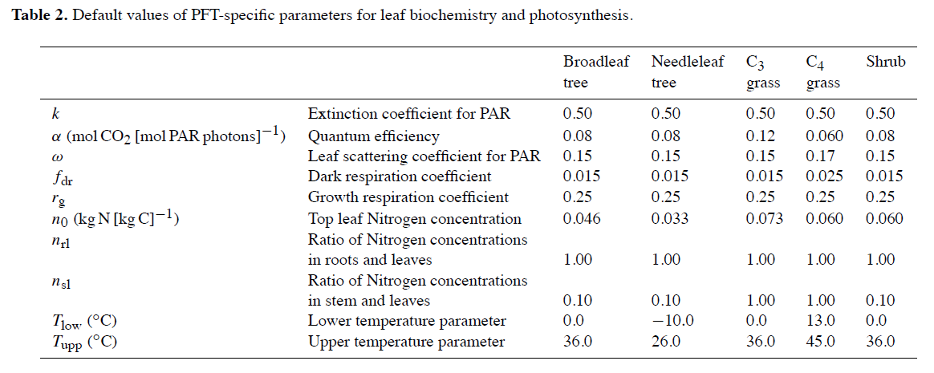

However, a study by (Müller et al., 2005) shows that leaf N interacts with photosynthesis in a number of different ways including:

1. The parameter m of the BWB model may change with leaf age (related to *N1*?).
2. The slope of *VCmax* to*N1* is a measure of the photosynthetic capacity per unit leaf N.
3. The slope of maximum quantum yield on incident Q basis to *N1* can be interpreted in terms of a maximum quantum yield of electron transport per unit leaf N.
4. The increase in *Cdr25* (ratio of dark respiration to *VCmax*, (Cdr at 25oC)) observed in senescing leaves results from a reduction in *Vm25* with decreasing *N1* of about 80% accompanied by a drop in Rd25 of only 60%. Therefore, *Cdr25* may vary during leaf senescence and possibly has to be developed in photosynthesis models rather as a function of leaf development stage than as a constant.
5. Acclimation of leaves to environmental variables across the canopy can affect both N partitioning between photosynthetic pools and leaf structure (e.g. SLA). This may lead to variation in the slope of the relationships between *VCma*x, *Jmax* and *N1* and concentration of nitrogen per unit dry mass.

Therefore, assuming a linear relationship between Vcmax and *N1* is rather simplistic. Müller et al. (2005) developed a method by which different aspects of photosynthesis would in turn be affected by leaf N according to empirical relationships derived from studies involving winter wheat (see Table 1).

Table **2**. Model equations and parameter values describing parameter-N1 relationships in LEAFC3-N (Müller et al., 2005).

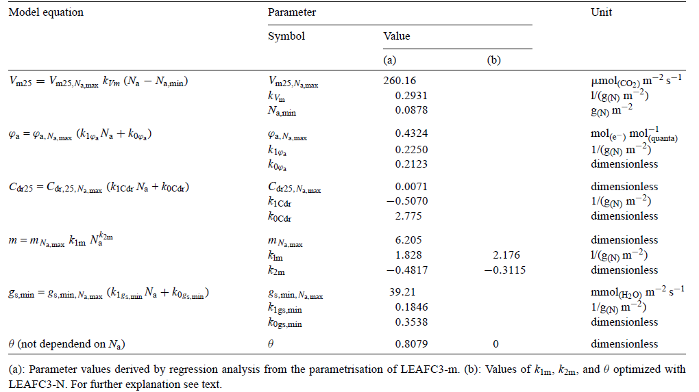

Where *Na* = *N1*, Na, max and Na, min is the maximum and minimum leaf nitrogen concentration respectively.

However, the parameter-*N1* relationships suggested by (Müller et al., 2005) cannot be concluded to be universally valid without independent measurements (the data used to define these are from winter wheat).

Equations [11] and [12] allow leaf N to be calculated for leaves of each layer and converted to photosynthetic capacity. The variable *V1* can then be used to determine a *VCmax* for each leaf layer according to formulas from Müller et al. (2005).

|  |  |  |  |
| --- | --- | --- | --- |
| Variable | Unit | Value | Equation |
| **Canopy nitrogen (N)** |  |  |  |
| Leaf N concentration at the top of the canopy, *N0* | mmol/m2 |  | [11], [12] |
| Leaf N concentration not associated with photosynthesis, *Nb* | mmol/m2 |  | [11], [12] |
| Leaf N concentration per unit leaf area, *N1* | mmol/m2 |  | [11], [12] |
| dimensionless co-efficient that sets the distribution of N over the canopy, *γρ* | - |  | [11] |
| canopy extinction co-efficient, *k* | m2 ground m-2 leaf | 0.7 | [11] |
| Cumulative leaf area index, *l* | m2/m2 |  | [11] |
| Photosynthetic Rubisco capacity per unit leaf area, *V1* | μmol m-2 s-1 |  | [12] |
| ratio of measured Rubisco capacity to leaf N, *Xn* | - |  | [12] |
| Constant relating leaf N to Rubisco carboxylation capacity, *Ne* | mol CO2 m-2 s-1 kg C (kg N)-1 | 0.0008 (C3)  0.0004 (C4) | [13], [14] |
|  |  |  |  |

# Carbon allocation

There are three general approaches to C allocation in (dynamic) vegetation models (also see Malhi et al., 2011):

## Fixed C allocation coefficients

This fairly simplistic approach assumes a fixed C allocation proportion for leaves/canopy : stem/wood : roots, e.g.

0.25 : 0.35 : 0.40 (trees; Running and Coughlan, 1988)

These fixed coefficients are PFT-specific. Models that use this approach include BIOME-BGC, CASA etc.

(Units used here?)

## Dynamic C allocation driven by allometric constraints

Here allocation must satisfy allometric relationships between different C pools. Approach often used for forest ecosystems, where leaf mass is scaled to stem and root mass and stem mass is scaled to root mass (see for example Mccarthy and Enquist, 2007).

This approach is used in JULES/TRIFFID (Cox, 2001), where the stem biomass is taken to scale allometrically with LAI; this involves an allometric constant which is PFT-specific. The biomass of leaves and (fine) roots is assumed to be equivalent:

**1) Leaf C = σl * LAI**

Where σl is the specific leaf C density (kg C M-2 LAI-1), which is PFT-specific:

**2) Root C = Leaf C**

**3) Wood/stem C = awl * LAI5/3**

Where awl is a PFT-dependent parameter relating to LAI and total stem biomass:



### Dynamic C allocation driven by resource availability

Most sophisticated method of C allocation since it follows the widely accepted theory that plants should allocate biomass according to the most limiting resource. More precisely, plants allocate relatively more C to roots when water or nutrients are limiting and more C to shoots when light is limiting. Accordingly, the typical limiting resources accounted for in dynamic vegetation models (e.g. ORCHIDEE) are light, water and N. As such, it would fit very well with the scope of ECLAIRE.

To account for the effect of light on C allocation, Friedlingstein et al. (1999) suggested a light availability factor *L*:

*L* = exp * (-*k* * LAI)

Where *k* is the light extinction coefficient which is usually set to 0.5.

To account for the effect of water availability on C allocation, often a water availability function *W* is used that influences the C allocation to roots:

*W* = max [0, min * (1, *θ* - *θ*wilt/*θ*FC - *θ*wilt)]

Where *θ* is the actual soil moisture content and *θ*FC and *θ*wilt are the soil moisture contents at field capacity and wilting point, respectively. These parameters should be available from DO3SE.

The N limitation effect on C allocation is – if at all – usually accounted for indirectly, i.e. through impacts of soil moisture and temperature on N availability (Friedlingstein et al., 1999), because water and N limitations are often well correlated since soil moisture controls the mineralisation rate (Schimel and Braswell, 1996). Friedlingstein et al. (1999) suggest:

*N* = *T* * *W*

Where T is the temperature abiotic factor, a standard Q10 formulation (Potter et al., 1993).

In addition, Friedlingstein et al. (1999) assumes that light directly control the stem allocation of C and one below-ground resource (either water or N) defines the root allocation of C. Leaves receive the residual; the C allocation to leaves increases when light, water and N are not limiting.

The following equations summarise the Friedlingstein et al. (1999) model:

1. **RootC = 3 * r0 * L/(L + 2 * min (W,N))**
2. **Wood/stemC = 3 * s0 * (min (W, N)/(2 * L + 2 * min (W,N))**
3. **LeafC = 1 – (RootC + Wood/stemC)**

Where r0 and s0 are the fractional C allocation to root and stem for non-limiting conditions, respectively. They are usually set to 0.3 both, leaving a leaf C allocation of 0.4 under totally non-limiting resource conditions. The resources *L*, *W*, *N* (see equations above) are scalars ranging from 0.1 (severely limited) to 1 (non-limited).

**Table (x) Default deposition land-cover and species class methods/values for various aspects of the DO3SE model.**

|  |  |  |  |  |  |  |
| --- | --- | --- | --- | --- | --- | --- |
| **Land-cover type & Species** | **Climate region** | **Canopy height (m)** | **Root depth (m)** | **Albedo (%)** | **Leaf dimension (m)** | **Stomatal flux threshold (Y, nmol O3 m-2 PLA s-1 )** |
|  |  |  |  |  |  |  |
| **Coniferous Forests (CF)** |  | 20 | 1 | 12 | 0.008 | 1.6 |
| Norway spruce  (*Picea abies*) | Northern Europe | 20 | 1 | 12 | 0.008 | 1.6 |
| Scots Pine  (*Pinus sylvestris*) | Atlantic Central Europe | 20 | 1 | 12 | 0.008 | 1.6 |
| Norway Spruce  (*Picea abies*) | Continental Central Europe | 20 | 1 | 12 | 0.008 | 1.6 |
| **Deciduous Forests**  **(DF)** |  | 20 | 1 | 16 | 0.07 | 1.6 |
| ***Generic Deciduous*** | ***All Europe*** | 20 | 1 | 16 | 0.07 | ***1.6*** |
| Silver birch  (*Betula pendula*) | Northern Europe | 20 | 1 | 16 | 0.05 | 1.6 |
| Beech  (*Fagus sylvatica*) | Atlantic Central Europe | 20 | 1 | 16 | 0.07 | 1.6 |
| Oak  (*Quercus petraea & robur*) | Atlantic Central Europe | 20 | 1 | 16 | 0.05 | 1.6 |
| Beech  (*Fagus sylvatica*) | Continental Central European | 20 | 1 | 16 | 0.07 | 1.6 |
| Beech  (*Fagus sylvatica*) | Mediterranean Europe | 20 | 4 | 16 | 0.07 | 1.6 |
| **Mediterranean Needleleaf Forests**  **(NF)** |  | ***10*** | ***4*** | 12 | 0.008 | 1.6 |
| Aleppo Pine  *(Pinus halepensis)* | Mediterranean Europe | 10 | 4 | 12 | 0.008 | 1.6 |
| **Mediterranean Broadleaf Forests**  **(BF)** |  | 15 | 4 | 16 | 0.055 | 1.6 |
| ***Generic Evergreen Mediterranean*** | ***All Europe*** | ***15*** | ***4*** | ***16*** | ***0.055*** | ***1.6*** |
| Holm Oak  (*Quercus ilex*) | Mediterranean Europe | 15 | 4 | 16 | 0.055 | 1.6 |
| **Temperate crops**  **(TC)** |  | 1 | 0.75 | 20 | 0.02 | 6 |
| ***Generic crop*** | ***All Europe*** | ***1*** | ***0.75*** | ***20*** | ***0.02*** | ***3*** |
| Wheat  (*Triticum aestivum*) | All Europe | 1 | 0.75 | 20 | 0.02 | 6 |
| **Mediterranean crops**  **(MC)** |  | 2 | 0.75 | 20 | 0.1 | 0 |
| Maize  *(Zea mays)* | All Europe | 2 | 0.75 | 20 | 0.1 | 0 |
| Sunflower  *(Helianthus annuus)* | All Europe | 2 | 0.75 | 20 | 0.25 | 0 |
| Tomato  *(Solanum lycopersicum)* | All Europe | 1 | 0.75 | 20 | 0.05 | 0 |
| Grape vine  *(Vitis vinifera)* | All Europe | 1.7 | 0.75 | 20 | 0.15 | 0 |
| **Root crops**  **(RC)** |  | 1 | 0.75 | 20 | 0.04 | 6 |
| Potato  (*Solanuum tuberosum*) | All Europe | 1 | 0.75 | 20 | 0.04 | 6 |
| **Semi-Natural / Moorland**  **(SNL)** |  |  | 0.5 | 14 | 0.01 | 0 |
| **Grassland**  **(GR)** |  | 1 | 0.75 | 20 | 0.02 | 0 |
| Perennial rye grass  (*Lolium perenne*) | All Europe | 1 | 0.75 | 20 | 0.02 | 0 |
| Clover  (Trifolium repens) | All Europe | 1 | 0.75 | 20 | 0.03 | 0 |
| **Mediterranean scrub** |  | 1 | 0.5 | 20 |  | 0 |

N.B. The values provided in the table are taken from a number of different references: Simpson et al. (2003); UNECE (2004); ICP Vegetation report (2006); ICP Vegetation report (2009).