Lab Assignment 1

1) Complete the Code below. Trace and understand the Output given by the Printf(“ ”) Function from the Code below: -
……….. float a= 45.6, b=45.6, c= 45.6, d=45.6, e = 45.4;
printf( " %6.3f, %06.3f, %09.3f, %-09.3f, %6.0f", a, b, c, d, e ); …………

Solution

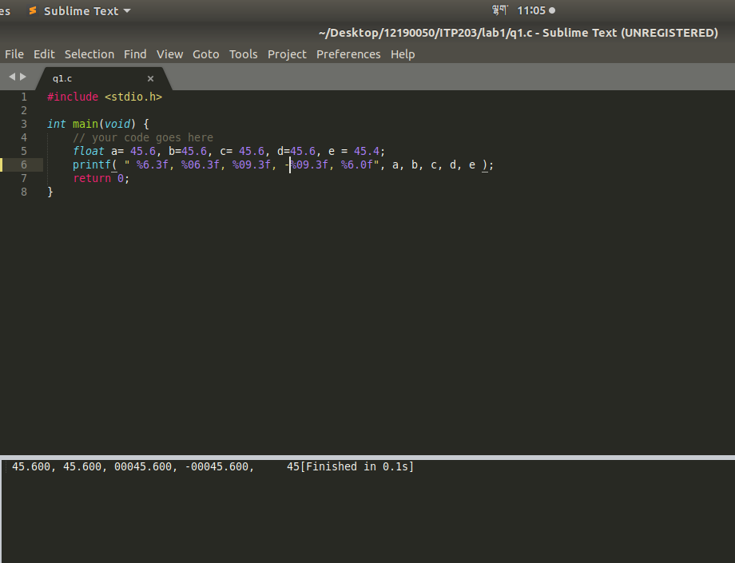

2) WAP to evaluate the Expressions below by using the C operator precedence and associativity rules.
a) 7 * 1 – (5 % 3) * 4 + 9
b) 9 ** (6 % 2) + 1 * 3

solution
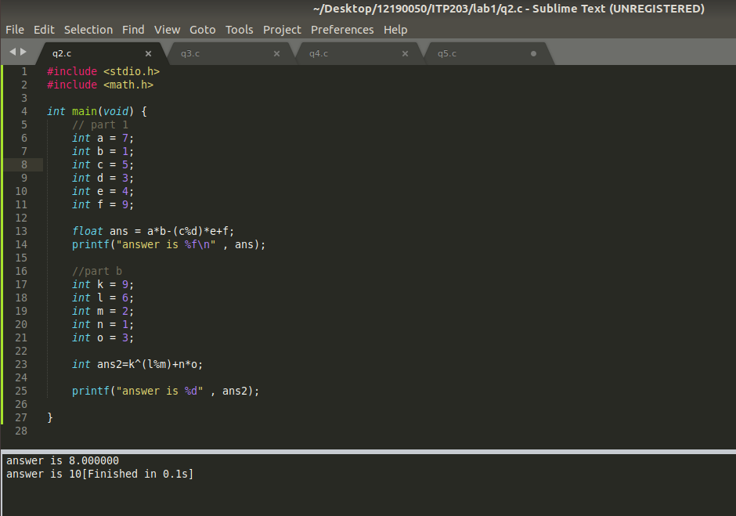

3) WAP to perform following operation on two user input numbers:-
(a) Addition
(b) Subtraction
(c) Multiplication
(d) Division
(e) Modular division

Solution:
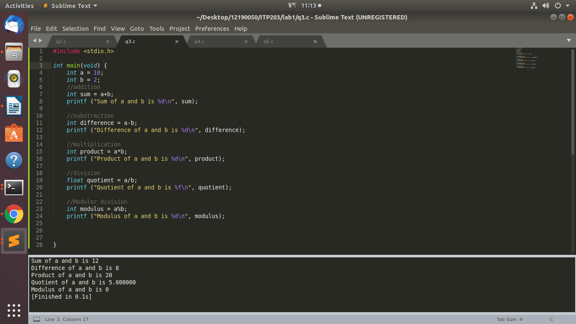

4) WAP in C to find if the student has passed in Mathematics in the Last Semester. The student has to secure 40% each in CA and SE (CA=50% AND SE=50%), meanwhile the total securing 50% at least at the end total.

Solution
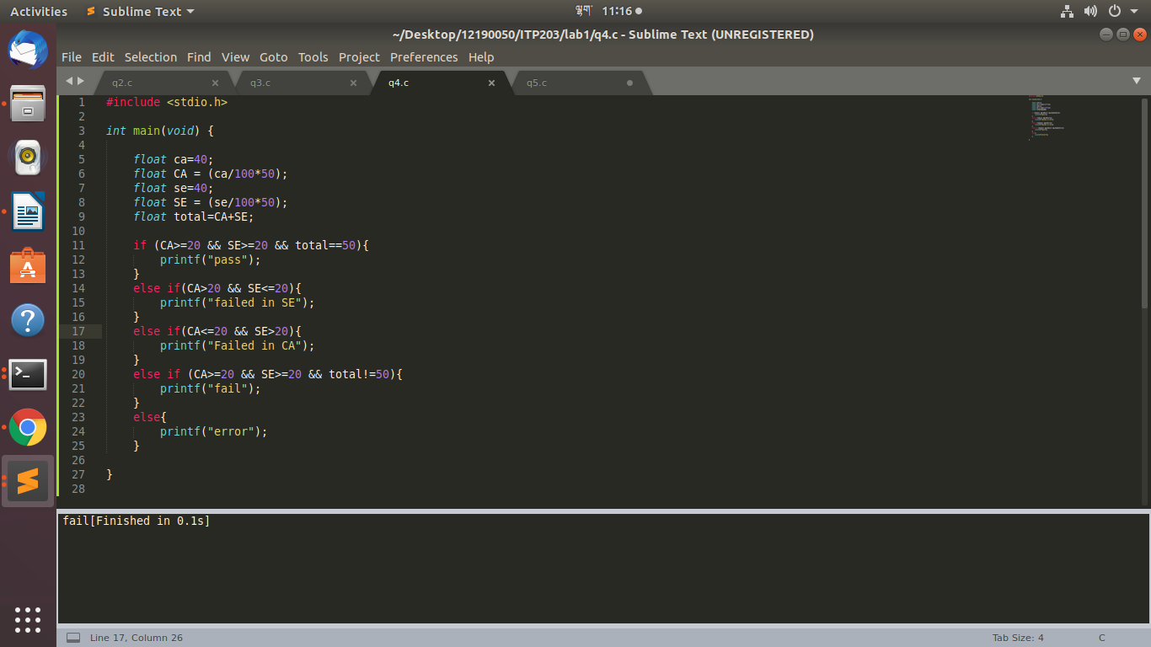

5) WAP to check whether input alphabet is a vowel or not.

