The Event Analysis Configurator

User’s Manual

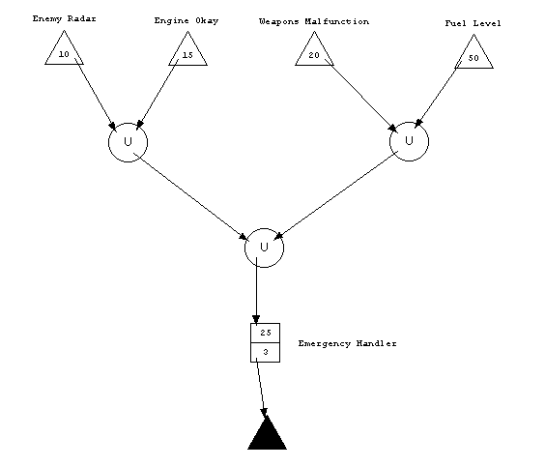

Shawn M Hannan
Washington University-St. Louis
CS 501 (Fall 2000)

Table of Contents

Purpose 3
Program Requirements 3
Installation 3
Starting the Configurator 3
Program Features 3
Loading and Saving Configurations 4
Creating New Configurations 5
Running Configurations 5
Getting Started: Running a Sample Program 5
The EAC Programming Language 6
Sources 7
Sinks 7
Operators 8
Components 8
Labels 8
Connectors 8
Simulation Output 9
Event Flow 9
Report Area 9
Command Window 9
Error Messages and Troubleshooting 10

Purpose

The Event Analysis Configurator (EAC) was designed to assist in the development of real-time systems. It is a visual tool which supports the interactive feasibility analysis of configurations of real-time components, as well as the execution tracing of those configurations.

Program Requirements

The EAC is a Java2 application. It requires the Java Developer’s Kit (JDK)1.2.2 Standard Edition. The JDK must be installed and accessible to run the EAC. To use the supplied batch file to run the program, you must be running Java on a Windows-based PC. The EAC will run on other platforms, but your installation and execution instructions will vary slightly. See your system administrator for assistance.

Installation

To install the EAC, copy the entire EAC directory from the supplied floppy disk into a directory of your choice. Then edit the run100.bat file, located in the class subdirectory of the EAC directory, changing the line which says:

c:\jbuilder\jdk1.2.2\bin\java -cp . EAC.Configurator 100

such that the first part of the line appropriately indicates the location of the java command on your system.

Similarly edit the run1.bat file.

Starting the Configurator

The EAC is run with a command-line argument which affects the speed of simulations when they execute. Lower-valued arguments will yield faster simulations; higher-valued arguments slow simulations down. The supplied batch files execute the EAC with a value of 1 (run1.bat) or 100 (run100.bat).

You can thus execute the EAC by running either of the batch files, or by executing the above-shown command line with an argument you select.

Program Features

The following sections give a high-level overview of the EAC’s features. These features are generally accessed from the Menu Bar located at the top of the main EAC window. Figure 1 shows the main EAC window with the Configuration menu activated.

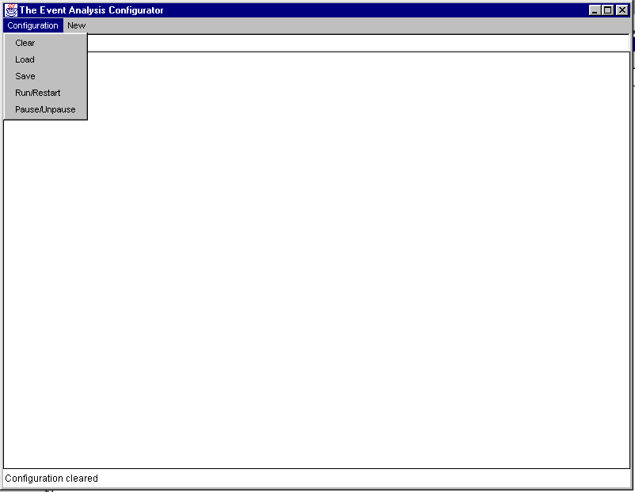

Figure 1. The Event Analysis Configurator (Configuration Menu)

Loading and Saving Configurations

You can save a configuration in its current graphical state by selecting save from the configuration menu. You will be prompted for a filename, which you should type within the confines of the Input Area, which is directly beneath the Menu Bar. (Note that simulation values cannot be captured in this way. Only the component configuration can be saved.)

To load a previously-saved configuration, select Load from the Configuration menu. Again, you will be prompted for a filename, which you should enter in the Input Area. If the filename is valid, the current configuration (if any) will be cleared, and the previously-saved configuration will be displayed. If the filename is invalid, the EAC will take no action.

Creating New Configurations

To create a new real-time component configuration, first select Clear from the Configuration menu to clear away any currently-displayed components. Add new components (also known as primitives) by selecting them from the New menu. Configurations must be constructed according to the rules of the EAC’s programming language. (See The EAC Programming Language for more information.)

Running Configurations

To run a configuration, select Run/Restart from the Configuration menu. While the simulation is running, you can pause it by choosing Pause/Unpause. Choose the same menu option to unpause the simulation. Unpausing resumes the simulation where it left off. To restart the same simulation from the beginning, choose Run/Restart while the simulation is paused.

Getting Started: Running a Sample Program

Let’s look at a sample program to see the EAC in action. Start the program and load the file aircraft.cfg, using the instructions given previously. The EAC should appear as in Figure 2.

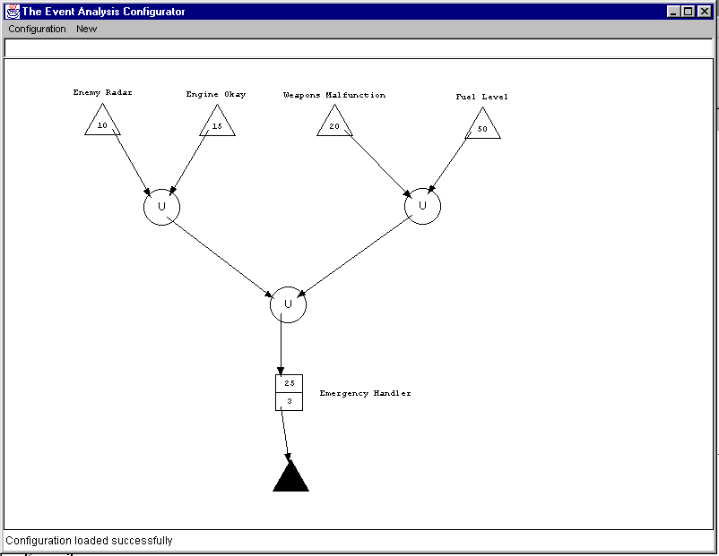

Figure 2. Upon loading the aircraft configuration
This configuration includes four Sources, indicated by white triangles, three Union Operators, indicated by the circles, one Component, indicated by the rectangle, and one Sink, shown as a black triangle. These primitives are connected to each other by arrows, known as Connectors in the EAC. (Connectors are also primitives.)

Select Run/Restart to begin the simulation.

The Sources and Component will show the movement of events through the configuration by reversing color schemes. The Report Area will give an ongoing status report of the simulation. You should see something like what’s shown in Figure 3.

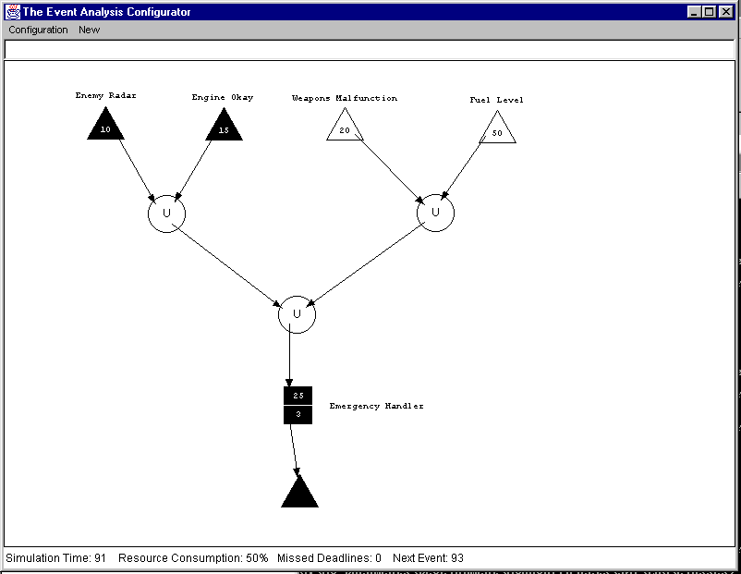

Figure 3. Running the aircraft configuration

The simulation will run indefinitely. To stop it, select Pause/Unpause or simply close the EAC main window.

The EAC Programming Language

To build component configurations which can be simulated by the EAC, you must understand the primitives of the programming language, as well as the syntax and semantics of organizing those primitives. Figure 4 shows the available primitives, and the following subsections explain their usage.

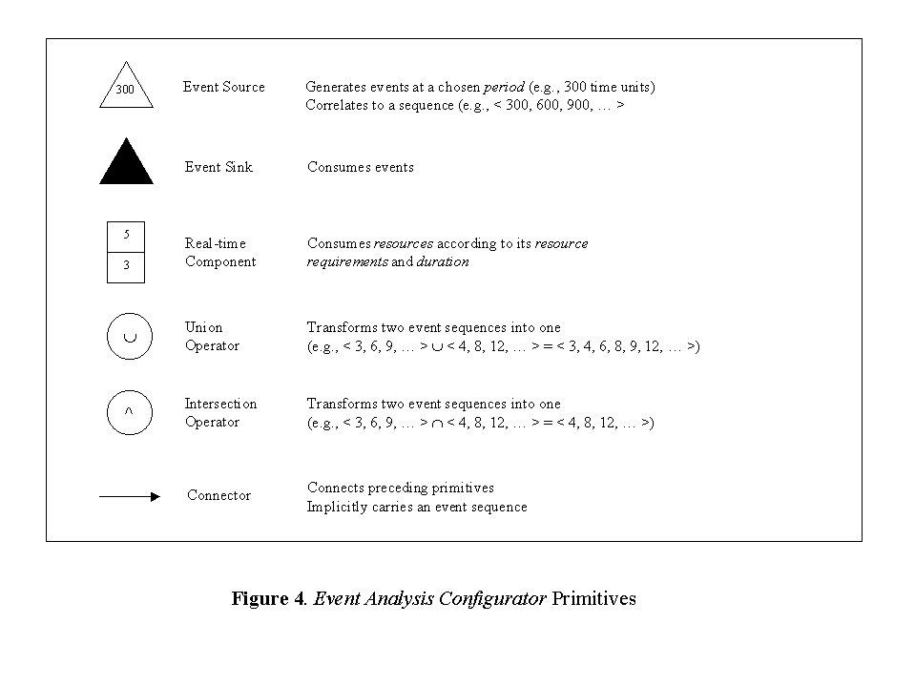

Sources

Sources represent event originating points, such as sensors. A source generates events at a fixed interval, known as its period. Upon generating an event, the source will forward the event to each output Connector (i.e., arrow), which will forward it towards one or more Components.

Sources can have no inputs, so do not try to terminate a connector at a source. Sources can have up to eight outputs.

Sinks

Sinks represent event termination points, such as actuators (e.g., flight surfaces on an aircraft). Currently, sinks do not do anything with events. They merely indicate “the end of the line.” In fact, sinks are not required. Simulations will run the same with or without sinks.

Sinks can have no outputs, so do not try to begin a connector at a sink. Sinks can have up to eight inputs.

Operators

Operators assist with the redirection of events. There are two types of operators: Unions and Intersections. Both kinds of operators are limited to two inputs, and both may have up to eight outputs.

Unions forward all incoming events to all output connectors. Intersections forward a single event to all outputs only upon receipt of an event from both inputs. (In general, operators with only one input are unnecessary; in the case of intersections, two inputs are required for sensible results to be obtained.) Beware that intersections distinguish incoming events by source, so if you configure primitives in such a way that events arrive from a single source at both intersection inputs, results may not be as desired.

Components

Components are at the heart of configurations. They represent software functions which perform work on behalf of the sources. Components consume resources (which are not defined, but could be thought of in terms of CPU, memory, etc.) while running, and must maintain a queue of service requests when the simulated system is heavily-loaded.

Two numbers are displayed within components, and you must enter these values when creating a component. The top number is the resource consumption, meaning what percentage of the system resources will be reserved by the component when it executes. The bottom number is the duration, which is how long the component will run for each event.

Components are limited to a single input, but this input can be from an operator, which can have inputs from operators, and so on. Thus, technically, a component can serve any number of sources. However, the EAC currently limits the capacity of components to eight sources. If you build a configuration with more than that many sources feeding a single component, results will be unreliable.

Components can have up to eight outputs.

Labels

Labels are textual annotations, and may be added anywhere in a configuration. Upon creating a source or component, you will be required to create a label as well. This label will be “owned” by the source or component, and will automatically relocate to maintain a position relative to its associated primitive. Requiring labels for sources and components assists in generating sensible output.

Connectors

Connectors join the other kinds of primitives together. When adding connectors to a configuration, consider the following rules and suggestions:
- A connector must always start and end within the boundaries of two distinct primitives.
- It’s possible, but probably undesirable, to connect two primitives more than once.
- A connector cannot begin at a sink.
- A connector cannot end at a source.
- Only one connector can end at each component.
- Exactly two connectors should end at each operator.
- Sources, operators and components can have up to eight connectors starting within them.
- Sinks can have up to eight connectors ending within them.

Simulation Output

Output from the EAC comes in three forms:
- Sources and Components reverse color schemes at certain times, indicating activity.
- The Report Area at the very bottom of the EAC’s main window shows simulation status.
- The command window from which you run the EAC displays any missed deadlines which occur during a configuration run.

The following sections offer more detail about each of these aspects of system output.

Event Flow

When an event arrives at a component, it notifies the component of its source. The component causes that source to reverse color schemes to signify it is awaiting service. If the component can service the request immediately, it also reverses color schemes. If not, it will maintain its normal colors until it can service the request.

Report Area

The report area provides continuous feedback regarding simulation status. It shows the simulation time, the current percentage of system resources consumed, how many deadlines have been missed so far (see Command Window), and when the next event is scheduled to occur.

Command Window

The window where you start the EAC only shows output when deadlines are missed. A deadline miss occurs when an event arrives from a source and the receiving component has not yet completed service for the previous event from that source. Formally, we define a missed deadline as follows.

Missed Deadline: occurs when an event E_{k} arrives at component C from source S before C has finished servicing event E_{k-1} from S.

The command window will identify the source and component, along with the time at which the event causing the missed deadline arrived.

Error Messages and Troubleshooting

Table 1 shows the list of EAC error messages and their associated causes.

Too many primitives | Attempted to add more than 100 primitives to a configuration
Attempted to place Connector endpoint out of bounds | self-explanatory
Input already established for this component | self-explanatory
Maximum outputs established for this component | self-explanatory
Attempted to place Component partially out of bounds | self-explanatory
Primitives too close together | Primitives have bounding boxes, which can be seen by selecting them. These bounding boxes cannot overlap.
Connector must begin inside a primitive | Attempted to start a connector outside all primitives
Connector cannot start and end at same primitive | Attempted to connect a primitive to itself
Connector must terminate inside a primitive | Attempted to terminate a connector outside all primitives
Attempted to place Operator partially out of bounds | self-explanatory
Operator already has two inputs | self-explanatory
Maximum outputs established for this operator | self-explanatory
Attempted to place Sink partially out of bounds | self-explanatory
Maximum inputs established for sink | self-explanatory
Attempted to add output to sink | self-explanatory
Attempted to place source partially out of bounds | self-explanatory
Maximum outputs established for source | self-explanatory
Attempted to add input to source | self-explanatory

Table 1. EAC error messages and causes

