The Event Analysis Configurator

System Manual

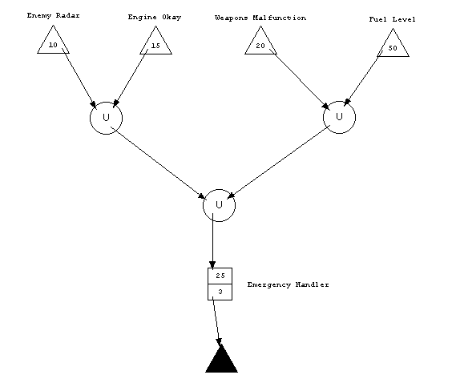

Shawn M Hannan
Washington University-St. Louis
CS 501 (Fall 2000)
Table of Contents

Introduction 3
Part I -- EAC Overview 4
The EAC Source Code 4
Building the EAC 4
The EAC Class Structure 5
EAC Class Relationships 6
Part II -- EAC Primary Modules 8
Primitive 8
EACComponent 8

Introduction
The Event Analysis Configurator (EAC) System Manual is intended to assist in the maintenance of the EAC application. To that end, Part I offers a high-level overview of the application, and Part II discusses the system components in greater detail.

Part I -- EAC Overview

The EAC Source Code

The EAC is comprised of 23 Java2 classes. These classes include roughly 3200 lines of Java source, which breaks down as shown in Table 1.

Class | Source Code Lines
EACComponent | 460
EACPanel | 425
Source | 341
Sink | 231
Configuration | 220
Operator | 206
Connector | 197
EACMenuBar | 196
EACLabel | 187
Primitive | 121
File | 118
Rubberband | 103
Queue | 94
Intersection | 62
Configurator | 58
Union | 56
ResourcePool | 46
RubberbandLine | 28
EACFont | 21
ConnectionException | 14
BoundsException | 13
TooManyPrimitivesException | 13
EmptyQueueException | 13
 | Total: 3223

Table 1. Event Analysis Configurator Source Code

Building the EAC

The Event Analysis Configurator should be easily buildable on any platform running version 1.2.2 of the Java Developer’s Kit. All source code for the EAC is collected in a single package (and therefore, directory). The EAC uses the Abstract Windowing Toolkit. No special libraries are required.

The EAC should be easily convertible to an Applet, but this has not yet been done.

The EAC Class Structure

The EAC Class Hierarchy is shown in Figure 1. (For simplicity, related AWT classes are not shown.) The Configurator class is a subclass of a standard AWT Frame, and builds the frame from four objects: a menu bar, a panel, and two labels (not shown in Figure 1). The menu bar, which appears at the top of the frame, is an instance of the specialized EACMenuBar class. The panel, which comprises the majority of the frame, is an instance of the specialized EACPanel class. The labels are standard AWT labels, and are used for an input area (at the top of the frame) and a reporting area (at the bottom of the frame).

The EACMenuBar manipulates both the Configuration and the EACPanel. The EACPanel also queries and adjusts the Configuration. In contrast, the Configuration is passive, and is oblivious to the existence of the menu bar or panel. (The Primitives which comprise the configuration, however, are individually aware of the panel they will be drawn upon.)

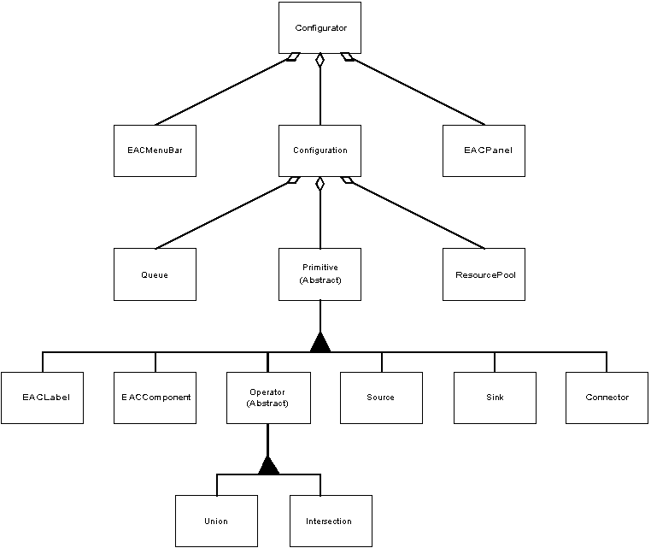

Figure 1. Event Analysis Configurator Class Hierarchy

EAC Class Relationships

The “heart” of the EAC is evenly divided between the EACPanel class, the abstract Primitive class, and the concrete EACComponent class. The latter two classes are discussed in detail in Part II of this manual.

The EACPanel is very tightly coupled to the EACMenuBar, with the menu bar controlling the state of the application, and the panel’s behavior varying according to that state. Table 2 shows the panel states, and when they are used.

Mode | Used when
COMMAND | input to the panel should be ignored
COMPONENT | a Component is being created
CONNECTING | a Connector is being started
CONNECTING_END | a Connector is being finished
COPY | currently unused
CUT | currently unused
DURATION_TYPING | a Component’s duration is being typed
EDIT | a Sink or Operator is being created
LABEL_ADDING | a Label is being added
LABEL_TYPING | a Label’s text is being typed
LOAD | a Configuration is being loaded from a file
PASTE | currently unused
PERIOD_TYPING | a Source’s period is being typed
RC_TYPING | a Component’s resource consumption is being typed
SAVE | a Configuration is being saved to a file
SELECT | input to the panel should be interpreted as selecting an existing primitive
SOURCE | a Source is being created

Table 2. EACPanel States

Figure 1 does not show the exception classes. There are four:

TooManyPrimitivesException
- ConnectionException
- BoundsException

EmptyQueueException

A TooManyPrimitivesException is thrown by the configuration when the user attempts to add more than the maximum number of primitives (currently 100) to the configuration.

A ConnectionException can be thrown by any primitive when it becomes aware of a user attempt to inappropriately adjust the configuration, such as attempting to add an input to a source.

A BoundsException can be thrown by any primitive when the user attempts to position the primitive partially or completely outside the boundaries of the panel.

An EmptyQueueException is thrown by the Queue class when the configuration tries to dequeue an event, but the queue is empty.

The relationships among the primary EAC classes and the exception classes are shown in Figure 2.

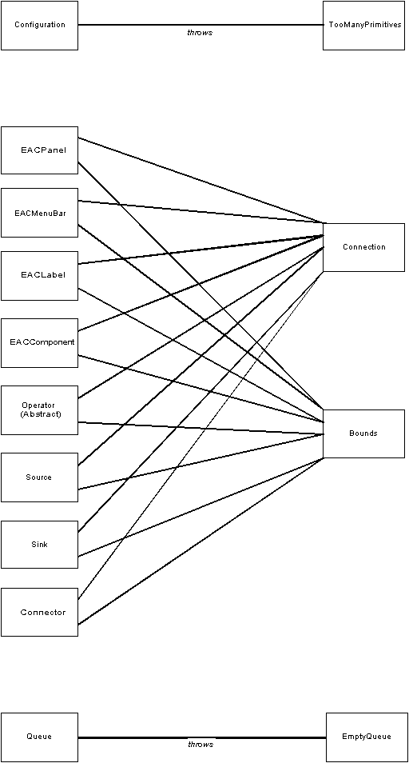

Figure 2. Relationships between primary EAC classes and the exception classes

Part II -- EAC Primary Modules

The critical modules within the Event Analysis Configurator are the abstract Primitive class and one if its concrete subclasses, EACComponent. The next two subsections discuss these two modules.

Primitive

The Primitive class offers a standard interface to all visual primitives of the EAC programming language. When possible, the class defines a concrete method that all subclasses share. In cases where subclass behavior varies, an abstract method is declared. Table 4 summarizes the methods of the Primitive class.

It is also important to note the allowable connections among primitive instances. The limitations shown in Table 3 were chosen in the hopes of balancing flexibility for the user with ease-of-implementation for the developer.

Primitive | Number of Inputs | Number of Outputs
Source | 0 | up to MAX_OUTPUTS
Sink | up to MAX_INPUTS | 0
Operator | 2 | up to MAX_OUTPUTS
Component | 1 | up to MAX_OUTPUTS
Label | 0 | 0
Connector | 1 | 1

Table 3. Connection limitations among primitives

EACComponent

The EACComponent is the most complex, and critical, subclass of Primitive. In addition to implementing the methods declared by the interface exported by Primitive, EACComponent is ultimately responsible for processing events that move through the configuration. This involves keeping an internal service request queue at each component, which must be continually monitored as the simulation progresses. EACComponent is also responsible for reversing the color schemes of components and sources at appropriate times in the simulation.

The methods defined by EACComponent are shown in Table 5.

Method | Purpose
addInput | connects a Connector as an input
addOutput | connects a Connector as an output
contains | checks to see if a point is located within the boundaries of the Primitive’s bounding box
draw | draws the Primitive on the Panel
event | signals an event arrival
getAnchor | returns the anchoring point on the Panel
getInput | returns an input Connector
getInputCount | returns the current number of input connections
getLabel | returns the associated Label
getOutput | returns an output Connector
getOutputCount | returns the current number of output connections
getTop | returns the top, center point of the Primitive’s bounding box
inBounds | returns true if the Primitive’s bounding box is entirely within the Panel, false otherwise
lowerLeft | returns the lower-left corner of the Primitive’s bounding box
lowerRight | returns the lower-right corner of the Primitive’s bounding box
read | reads a Primitive’s data values from a File
reconnect | adjusts input and output connections after moving a Primitive
removeInput | removes an input connection
removeOutput | removes an output connection
restart | “refreshes” the Primitive for a new Configuration run
selectedDraw | draws the Primitive with hotspots
setAnchor | sets the Primitive’s anchoring point on the Panel
setLabel | attaches a Label to the Primitive
setTop | sets the anchoring point, relative to the indicated top, center point of the Primitive’s bounding box
specialDraw | draws in XOR mode for dragging
specialUndraw | erases in XOR mode for dragging
upperLeft | returns the upper-left corner of the Primitive’s bounding box
upperRight | returns the upper-right corner of the Primitive’s bounding box
wakeup | a callback from the Configuration
write | writes a Primitive’s data values to a File

Table 4. Methods of the Primitive class

Method | Purpose
addInput | connects a Connector as an input
addOutput | connects a Connector as an output
contains | checks to see if a point is located within the boundaries of the Component’s bounding box
draw | draws the Component on the Panel
event | signals an event arrival
getDuration | returns the duration
getInput | returns an input Connector
getInputCount | returns the current number of input connections
getOutput | returns an output Connector
getOutputCount | returns the current number of output connections
getResourceConsumption | returns the resource consumption
getTop | returns the top, center point of the Component’s bounding box
inBounds | returns true if the Component’s bounding box is entirely within the Panel, false otherwise
lowerLeft | returns the lower-left corner of the Component’s bounding box
lowerRight | returns the lower-right corner of the Component’s bounding box
normalColor | sets color scheme to black-on-white
read | reads a Component’s data values from a File
reconnect | adjusts input and output connections after the Component has been moved
removeInput | removes an input connection
removeOutput | removes an output connection
restart | “refreshes” the Component for a new Configuration run
reverseColor | sets color scheme to white-on-black
selectedDraw | draws the Component, then calls superclass to draw hotspots
setDuration | sets the duration
setResourceConsumption | sets the resource consumption
setTop | sets the anchoring point, relative to the indicated top, center point of the Component’s bounding box
specialDraw | draws in XOR mode for dragging
specialUndraw | erases in XOR mode for dragging
upperLeft | returns the upper-left corner of the Component’s bounding box
upperRight | returns the upper-right corner of the Component’s bounding box
wakeup | a callback from the Configuration
write | writes a Component’s data values to a File

Table 5. EACComponent Methods

