User Manual for the
Event QoS Aspect Language

Author: George Edwards <g.edwards@vanderbilt.edu>
Project Sponsor: Douglas C. Schmidt <d.schmidt@vanderbilt.edu>

Background

Component middleware generally supports two models for component interaction: (1) a request-response communication model, in which a component invokes a point-to-point operation on another component, and (2) an event-based communication model, in which a component transmits arbitrarily-defined, strongly-typed messages, called events, to other components. Event-based communication models are particularly relevant for large-scale DRE systems (such as avionics mission computing, distributed audio/video processing, and distributed interactive simulations) because they help reduce software dependencies and enhance system composability and evolution. In particular, the publisher/subscriber architecture of event-based communication allows application components to communicate anonymously and asynchronously. The publisher/subscriber communication model defines three software roles:
- Publishers generate events to be transmitted.
- Subscribers receive events via hook operations.
- Event channels accept events from publishers and deliver events to subscribers.
The publisher/subscriber design is an especially powerful architecture for event-based communication because it provides (1) anonymity by decoupling event publishers and subscribers and (2) asynchrony by automatically notifying subscribers when a specified event is generated.

Component-based distributed, real-time and embedded (DRE) software deployments often require custom QoS configurations to target multiple OS, network, and hardware platforms, each of which may have slightly different requirements. In such cases, event QoS requirements (such as latency thresholds and priorities) may only be known when components are deployed, rather than when they are developed. Contemporary component middleware frameworks use XML descriptor files to specify the publisher/subscriber configurations and QoS constraints associated with particular software deployments. The component deployment mechanism is responsible for parsing these files and making the appropriate invocations on the publisher/subscriber configuration interface provided by the middleware run-time infrastructure.

It is tedious and error-prone to manually specify the QoS requirements of large-scale DRE component deployments. Component middleware has become complex to configure due to an increasing number of operating policies (such as transaction and security properties, persistence and lifecycle management, and publisher/subscriber QoS configurations) that exist at multiple middleware layers and employ legacy specification mechanisms not based on XML. To further complicate matters, many combinations of policies are semantically invalid and will result in system failure.

In the context of component applications, modeling tools enable the creation of reusable component deployment models that are easier to build, understand, and maintain than manually written deployments. Moreover, modeling tools can automatically (1) generate XML descriptor files that describe component interactions and configuration files that specify middleware operating policies and (2) validate models to ensure consistency and coherency among component properties.

Overview of the Event QoS Aspect Language

This manual describes the Event QoS Aspect Language (EQAL), which is a modeling tool for graphically specifying publisher/subscriber service configurations. EQAL consists of two complimentary entities:
- A meta-model that defines a modeling language, or paradigm. The meta-model specifies the types of modeling elements, their properties, and relationships.
- Model interpreters that synthesize middleware configuration files from models. The EQAL model interpreters automatically generate publisher/subscriber service configuration files and component property description files.

The EQAL meta-model defines a modeling paradigm for publisher/subscriber service configuration models, which specify QoS configurations, parameters, and constraints. For example, the EQAL meta-model contains a distinct set of modeling constructs for each publisher/subscriber service supported by the Component-Integrated ACE ORB (CIAO), which is the component middleware platform targeted by EQAL. Policies and strategies that can be modeled include (but are not limited to) filtering, correlation, timeouts, locking, disconnect control, and priority.

Publisher/subscriber service policies have differing scope, from a single port to an entire event channel. The EQAL meta-model allows modelers to provision reusable and sharable configurations at each level of granularity. A modeler assigns configurations to individual event connections and then constructs filters for each connection. Two forms of event generation using the push model are supported: a component may be an exclusive supplier of an event type or a component may supply events to a shared channel.

Constructing Models

To use EQAL, you must have GME 3, which can be downloaded from http://www.isis.vanderbilt.edu/education/mic/gme-3.10.13.exe. Download the EQAL distribution from http://www.dre.vanderbilt.edu/~edwardgt/EQAL.zip. One you have opened the EQAL meta-model, run the Meta-GME interpreter, and registered the EQAL paradigm, you are ready to begin building models. The EQAL modeling process can be broken down into the following steps. An example named BasicSP with four components is used to illustrate each step.

Step 1: Create a new assembly model. In the root folder, create a new Component_Assembly model and open it. You will notice that four aspects are available. Give the assembly a name that corresponds with your application.

Step 2: Create components and ports. Begin in the first aspect, named Assembly. For each component that requires a publisher/subscriber QoS configuration, create a Component model. Name the Component exactly as it is named in your application. Now, within each Component, create an eventtype atom for each event type that the component publishes or subscribes to. Name the eventtype exactly as it is named in your application. Return to the Component_Assembly, and create an Event_Source or Event_Sink atom for each component event port. Again, name the Event_Source or Event_Sink exactly as it is named in your application. Finally, connect each Event_Source or Event_Sink to an eventtype. The eventtype appears as a port on the containing Component. An Event_Source or Event_Sink can only be connected to a single event type. These connections should correspond to the port names and event types you specified for the component in IDL.

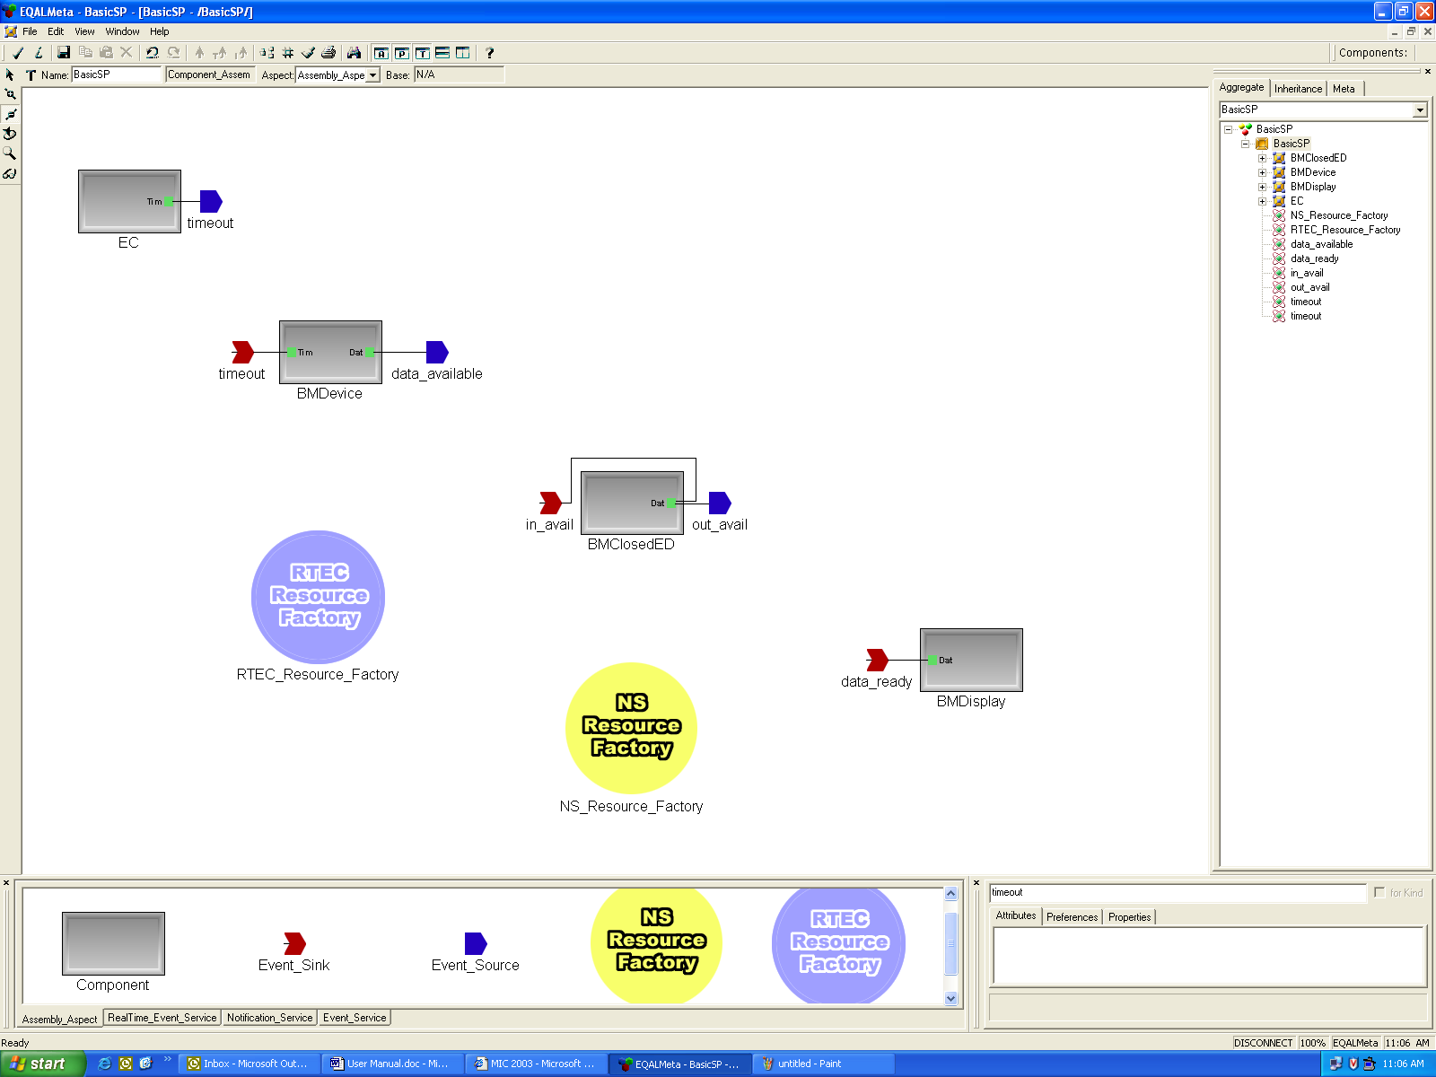
Figure 1: The BasicSP example with components, event types, ports, and channel configurations.

Step 3: Create event channels. Remaining in the Assembly aspect, create an RTEC_Resource_Factory atom for each real-time event channel and an NS_Resource_Factory atom for each notification channel that your application will use. The names given to these atoms will determine the *.conf file name that is generated, so use unique names to avoid conflicts. Now, configure the static properties of each channel by setting the correct attributes. The EQAL constraints will prevent you from specifying inconsistent or invalid combinations of attributes. Figure 1 (above) shows an EQAL model with Step 3 complete.

Step 4: Specify direct connections. While still in the Assembly aspect, specify direct event port connections by connecting the appropriate Event_Source and Event_Sink. Figure 2 shows a direct connection in our example assembly.

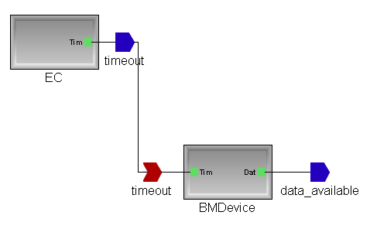
Figure 2: A direct connection in the BasicSP example.

Step 5: Specify Event Service connections. Switch to the Event_Service aspect. Now, for each event source that will use the Event Service, create a EC_Proxy_Consumer atom. Similarly, for each event sink that will use the Event Service, create a EC_Proxy_Supplier atom. Specify the Event Service connections by connecting the appropriate EC_Proxy_Consumer and EC_Proxy_Supplier. The BasicSP example does not use the Event Service.

Step 6: Specify and configure Real-time Event Service connections. Switch to the Realtime_Event_Service aspect. Create an RTEC_Proxy_Consumer for each event source that will use the Real-time Event Service and an RTEC_Proxy_Supplier for each event sink that will use the Real-time Event Service. Within each RTEC_Proxy_Consumer, create an RT_Info atom and configure the RT properties of the associated event source by setting the correct attributes. Also within the RTEC_Proxy_Consumer, create a reference to the event channel configuration that this event source will use. Connect the RT_Info to the RTEC_Resource_Factory_Reference. Now, within each RTEC_Proxy_Supplier, create and connect ConjunctionGroup, DisjunctionGroup, and LogicalANDGroup atoms to indicate the filter for the associated event sink. For each leaf on your filter tree, create and connect an RT_Info atom and configure the RT properties by setting the correct attributes. Finally, return to the Component_Assembly and connect the Event_Source to the correct supplier RT_Info, connect the RTEC_Resource_Factory_Reference to the correct consumer RT_Info, and connect the root of your filter tree to the Event_Sink. Figure 3 shows the Real-time Event Service connections in the BasicSP example.

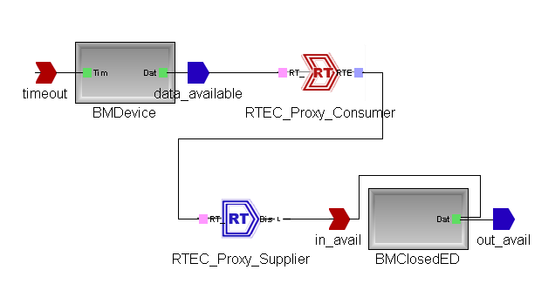
Figure 3: A Real-time Event Service connection in the BasicSP example.

Step 7: Specify and configure Notification Service connections. Switch to the Notification_Service aspect. Create an NS_Proxy_Consumer for each event source that will use the Notification Service and an NS_Proxy_Supplier for each event sink that will use the Notification Service. Within each NS_Proxy_Consumer and NS_Proxy_Supplier, create an NS_QoS atom and configure the RT properties of the associated event source or sink by setting the correct attributes. Within the NS_Proxy_Consumer, create a reference to the notification channel configuration that this event source will use. Connect the NS_QoS to the NS_Resource_Factory_Reference. Now, within each NS_Proxy_Supplier, create and connect NS_Filter atoms to indicate the filter for the associated event sink. Finally, return to the Component_Assembly and connect the Event_Source to the correct supplier NS_QoS, connect the NS_Resource_Factory_Reference to the correct consumer NS_Filter, and connect the consumer NS_QoS to the Event_Sink. Figure 4 shows the Notification Service connections in the BasicSP example.
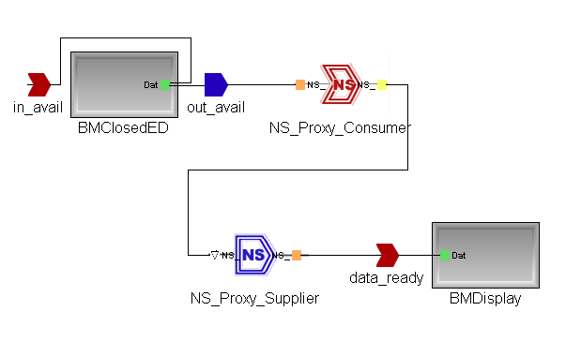
Figure 3: A Notification Service connection in the BasicSP example.

Your EQAL model is now complete and ready for interpretation.

Generating Descriptors

All EQAL constraints are checked during modeling, so you do not need to explicitly check constraints before interpretation. Run the GenerateAllInterpreter to generate the XML descriptors and service configuration files for your component assembly. All files will be created in the same directory as your GME model. A CPF file will be generated for each component event port, a ECD file will be generated for each RTEC filter, and a CONF file will be generated for each event channel configuration. For the BasicSP example, the following files are generated:

BMDevice-data_available.cfp
BMClosedED-in_avail.ecd
BMClosedED-in_avail.cpf
BMClosedED-out_avail.cpf
BMDisplay-data_ready.cpf
BasicSP-rtec.conf
BasicSP-ns.conf

The CPF files contain the port RT and QoS properties. For example, the BMDevice-data_available.cpf file contains the following:

<?xml version="1.0" encoding="UTF-8" ?>
<!DOCTYPE properties SYSTEM "properties.dtd">
<properties>
<struct name="BMDevice-data_available-" type="ACEXML_RT_Info">
<description>TAO Real-time Scheduler info for BMDevice::data_available</description>
<simple name="port" type="string">
<value>data_available</value>
</simple>
<simple name="period" type="string">
<value>0</value>
</simple>
<simple name="entry_point" type="string">
<value></value>
</simple>
<simple name="criticality" type="string">
<value>MEDIUM_CRITICALITY</value>
</simple>
<simple name="enabled" type="string">
<value>DEPENDENCY_NON_VOLATILE</value>
</simple>
<simple name="importance" type="string">
<value>MEDIUM_IMPORTANCE</value>
</simple>
<simple name="quantum" type="string">
<value>0</value>
</simple>
<simple name="threads" type="string">
<value>1</value>
</simple>
<simple name="cached_execution_time" type="string">
<value>0</value>
</simple>
<simple name="worst_case_execution_time" type="string">
<value>0</value>
</simple>
<simple name="info_type" type="string">
<value>OPERATION</value>
</simple>
<simple name="typical_execution_time" type="string">
<value>0</value>
</simple>
</struct>
</properties>

The ECD files contain the RTEC filter specifications. For example, BMClosedED-in_avail.ecd file contains the following:

<?xml version="1.0" encoding="UTF-8" ?>
<!DOCTYPE filter SYSTEM "eventchannel.dtd">
<filter>
<disjunction>
<id>file://BMClosedED-in_avail-.cpf</id>
</disjunction>
</filter>

The CONF files contain the channel configurations. For example, the BasicSP.conf file contains the following:

static EC_Factory " -ECConsumerLock null -ECSupplierFiltering null -ECDispatching priority -ECTimeout priority -ECSupplierLock recursive -ECSupplierControl reactive -ECObserver basic -ECFiltering prefix -ECConsumerControl reactive -ECProxyPushConsumerCollectionSynch st -ECProxyPushConsumerCollectionFlag rb_tree -ECScheduling priority"

