LEESA: Language for Embedded Query and Traversal
Sumant Tambe (sutambe@dre.vanderbilt.edu)
Institute for Software Integrated Systems (ISIS), Vanderbilt University, Nashville, TN
Introduction
LEESA is about a radically new way of writing C++ UDM (Universal Data Model) based GME interpreters. LEESA (Language for Embedded quEry and traverSAl) is a domain-specific embedded language (DSEL) in C++ that provides a succinct and expressive notation for writing object structure traversal. It decouples traversal from visitation actions and improves visitor reusability. By virtue of being declarative (partially), LEESA significantly reduces the development cost of programs operating on complex object structures (e.g., domain-specific modeling language (DSML) interpreters) compared to the traditional techniques. LEESA is embedded in C++ using sophisticated generic programming techniques (Expression Templates)
Motivation and research documents
- A research paper on LEESA titled, “An Embedded Declarative Language for Hierarchical Object Structure Traversal” has been published in the 2nd International Workshop on Domain-Specific Program Development (DSPD), GPCE 2008, Nashville, Tennessee, October 22, 2008.
- Presentation slides for this paper are available here.
Purpose of this document is to provide a through documentation of the features and capabilities of LEESA with examples.
Downloading LEESA

Software needed to use LEESA
LEESA is a header-only C++ library except in one case where it depends on Boost regular expression library.

LEESA Language Documentation
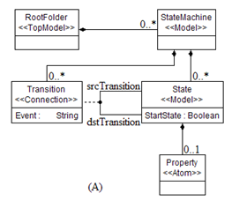
The examples in this document are based on the Statemachine metamodel shown by (A).

