Composable Adaptive Software Systems (COMPASS)

Krishnakumar Balasubramanian <kitty@dre.vanderbilt.edu>

Technical Manual

ABSTRACT

The growing complexity of building and validating software is a challenge for developers of distributed real-time and embedded (DRE) applications. While DRE applications are increasingly based on commercial off-the-shelf (COTS) hardware and software components, substantial time and effort is spent integrating components into applications. Integration challenges are exacerbated by the lack of higher level abstractions for composing complex DRE applications. As a result, considerable application-specific
``glue code'' must be written manually, only to be rewritten again when building and deploying subsequent DRE applications. This rework is due in part to the fact that DRE middleware has traditionally contained considerable amount of meta-data i.e., information that describes systemic characteristics, such as list of files containing the component implementation, versioning information, the resources available for deployment of a component-based application, and the resources required by each component, glued together in a tightly coupled fashion.

This manual explains the implementation details of COMPASS, an MIC tool intended to help ease the task of the system integrator by providing high-level abstractions, such as component assemblies and component packages, that help resolve key challenges associated with composing complex DRE applications built using individual components.

Introduction

Although component-based software development techniques are maturing for business and desktop systems, they are less mature for mission-critical domains, such as distributed real-time and embedded (DRE) applications. In DRE applications, composition of component functionality alone is not sufficient since these types of applications must also ensure end-to-end quality of service (QoS), of which components are the building blocks[1]. Mixing QoS specification and enforcement mechanisms with the application functionality results in complications that tend to grow rapidly as the number of components and hence the complexity of the software increases. COMPASS focuses on the following challenges involved in QoS-enabled software composition in the context of emerging component models:

- The need to reduce tight coupling of component metadata with component functionality. Component meta-data includes information such as the list of files used to implement a component, versioning information, a checksum to ensure component integrity, or information about the required privileges for a component to function.
- The need to specify component QoS requirements in a context-insensitive manner. A component in a DRE application may be functionally correct, yet can malfunction due to failure of assumptions stemming from the lack of context-dependent information, such as thread creation strategies, component lifetime (e.g., persistent vs. transient), type of invocation (e.g., synchronous or asynchronous), and presence or absence of middleware services, such as event channels. The context in which a component executes is generally provided by the external environment. Composition problems can arise when QoS requirements of components are specified with implicit assumptions on properties of external entities (e.g, the threading model required to run the component) that are external to a particular component of a software system. Unstated assumptions related to QoS properties of components make it hard to enforce QoS requirements effectively in open systems.
- The need to validate component properties. A component implementation's properties (e.g., the implementation language, version of the component, level of privileges required, and dependencies on other components) must be validated. Validation should be performed against the component's specification to avoid problems such as (1) errors caused by misconfiguration, (2) unauthorized use of resources by components, and (3) lack of confidence that the QoS assurances provided by the middleware are sufficient from an application's perspective. Validation is required for each individual component, as well as the application and system levels.
- The need to ensure that a complex software system can be deployed seamlessly. To reduce the complexity of installing and maintaining complex DRE applications, it is necessary that all the individual components be deployed using the same framework and follow the same guidelines. If each individual component needs a different mechanism for deployment, the costs of maintenance outweigh the advantages gained by developing applications in a component oriented fashion. It is also hard to track the dependencies of components upon other components and ensure that inter-dependent components are initialized in a particular order. To ease this task, components need to be packaged as a hierarchy that provides information about the related components, and captures dependencies present in component initialization and deployment. This packaging is necessary so that the deployment process can be automated, or at least controlled by an administrator.

Solution Approach

COMPASS defines a modeling paradigm designed to enable a system integrator to

- Create models of the various components that are part of the application
- Model the interconnections between the components
- Specify systemic properties of the components
- Build component assemblies – collection of components connected according to some specification,
- Compose packages, which are a collection of all of the above.

As shown in Figure 1, packaging involves grouping the implementation of component
functionality (which is typically stored in a dynamic link library (DLL) together with other meta-data that describes properties of this particular implementation. Packaged components exist in “passive mode,” i.e., all their functionality is present, but they are inert object code. To perform their functionality at run-time, components must transition to “active mode,” where the interconnections between components are established. Deployment mechanisms are responsible for transitioning components from passive to active mode. COMPASS focuses on generating the information that describes packages using a MIC-based approach.

As shown in Figure 2, COMPASS is designed to be a link in a longer tool chain that enables DRE application developers to model, synthesize, and deploy complete DRE applications.

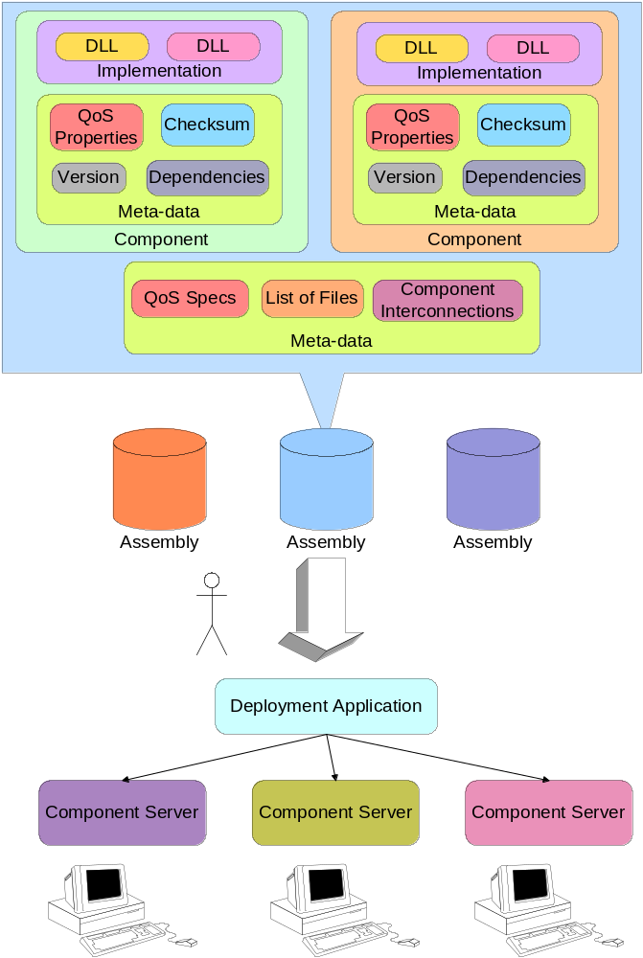
Figure 1 Component Packaging & Deployment

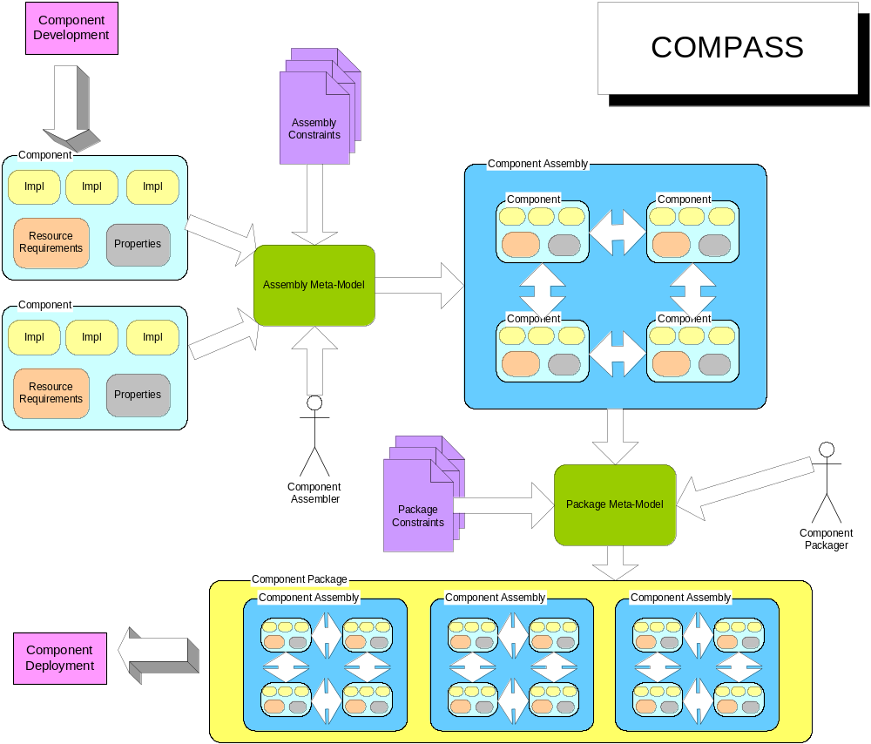
Figure 2 COMPASS

[Kitty, I recommend mentioning which other class projects will be a part of this longer tool chain!]

Modeling Environment

A system integrator should be able to model the various packaging and configuration artifacts of the application using COMPASS. The meta-model therefore contains the various packaging and configuration artifacts, the valid associations between the various artifacts. Since there is a natural hierarchy among the different artifacts of packaging, the modeling paradigm developed reflects it as much as possible. This means that a system integrator will be able to visualize individual packages, the set of assemblies contained within a package, and the individual components contained as part of each assembly. In this section, the different elements of the COMPASS meta-model are explained with help of snapshots from the Generic Modeling Environment (GME) illustrating the structure of the meta-model. Since there are numerous elements that need to be modeled, the meta-model makes use of the multiple paradigm sheets facility available in GME to reduce the complexity associated with modeling this many elements. The different elements associated with each top-level entity in COMPASS are also organized into individual folders. Now we explain the different aspects of component packaging and assembly that can be modeled using COMPASS:

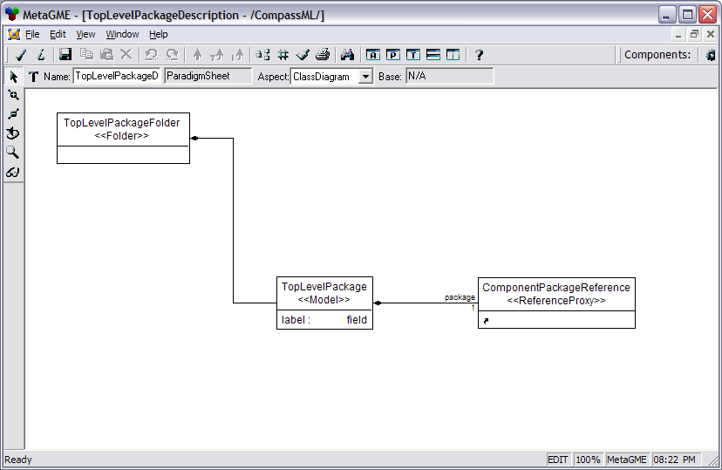
Figure 3 TopLevelPackage

TopLevelPackage

A TopLevelPackage element is present inside the TopLevelPackage folder. A TopLevelPackage element refers to a single ComponentPackage using a ComponentPackageReference. It is used to identify one package among the available packages as the “top-level” package in a ComponentPackage.

Attributes

- label : A label providing descriptive information about this TopLevelPackage.

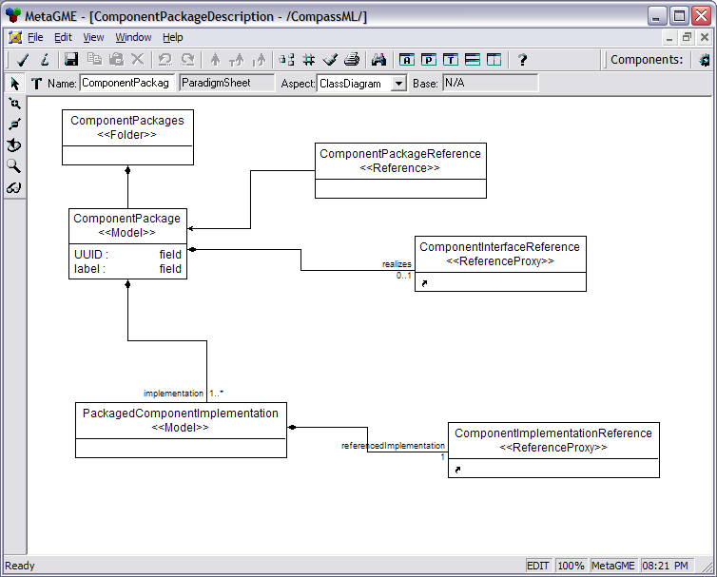
Figure 4 Component Package

ComponentPackage

ComponentPackage element models a component package. It describes multiple alternative implementations of the same component interface, which is contained as a reference using the “realizes” role. The implementations are contained as a PackagedComponentImplemenation.

Attributes

- label : A label providing descriptive information about this ComponentPackage
- UUID: A Universally Unique identifier which uniquely identifies this ComponentPackage among multiple such component packages which might be present in a component repository

PackagedComponentImplementation

A ComponentImplementation is contained within a ComponentPackage as a PackagedComponentImplementation, which allows for mutiple ComponenentImplementations which are similar to be included, based on the name. It contains a ComponentImplementationReference element which refers to a ComponentImplementation
.

ComponentPackageReference

A ComponentPackageReference element refers to a ComponentPackage. It is used in the paradigm whenever a ComponentPackage is referred to using a ReferenceProxy to this element.

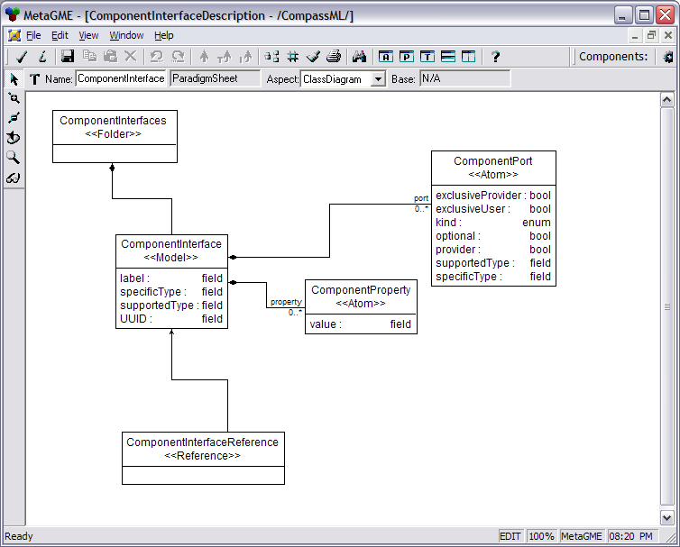
Figure 5 Component Interface

ComponentInterface

A ComponentInterface models the interface that is exposed by a component to the clients. With respect to component packaging and deployment, the key elements of a ComponentInterface are ComponentProperty and ComponentPort.

Attributes
- label : A label providing descriptive information about this ComponentInterface
- UUID: A Universally Unique identifier which uniquely identifies this ComponentInteface among all interfaces that are present in an application composed of multiple components
- supportedType: The list of interfaces that this component supports
- specificType: The most derived interface supported by this component

ComponentInterfaceReference

A ComponentInterfaceReference element refers to a ComponentInterface. It is used in the paradigm whenever a ComponentInterface is referred to using a ReferenceProxy to this element.

ComponentProperty

ComponentProperty element is used to define properties of the component interface. The definition is quite generic and can be used to specify any property of the component interface.

Attributes

- value : Value of the property that is being defined

ComponentPort

ComponentPort models the ports of a component. A component has a collection of ports – Facets, Receptacles, Event Sources & Event sinks, with which it communicates with its clients.

Attributes

- exclusiveUser: Whether the port is a exclusive user of the service provided
- exclusiveProvider: Whether the port is a exclusive provider of a service
- kind: Kind of service provided/consumed. Can be one of Facet, SimplexReceptacle, MultiplexReceptacle, EventEmitter, EventPublisher, or EventConsumer
- optional: Whether this port can be left unconnected
- provider: Whether this port is a provider of a service
- supportedType: The list of interfaces that this port supports
- specificType: The most derived interface supported by this port

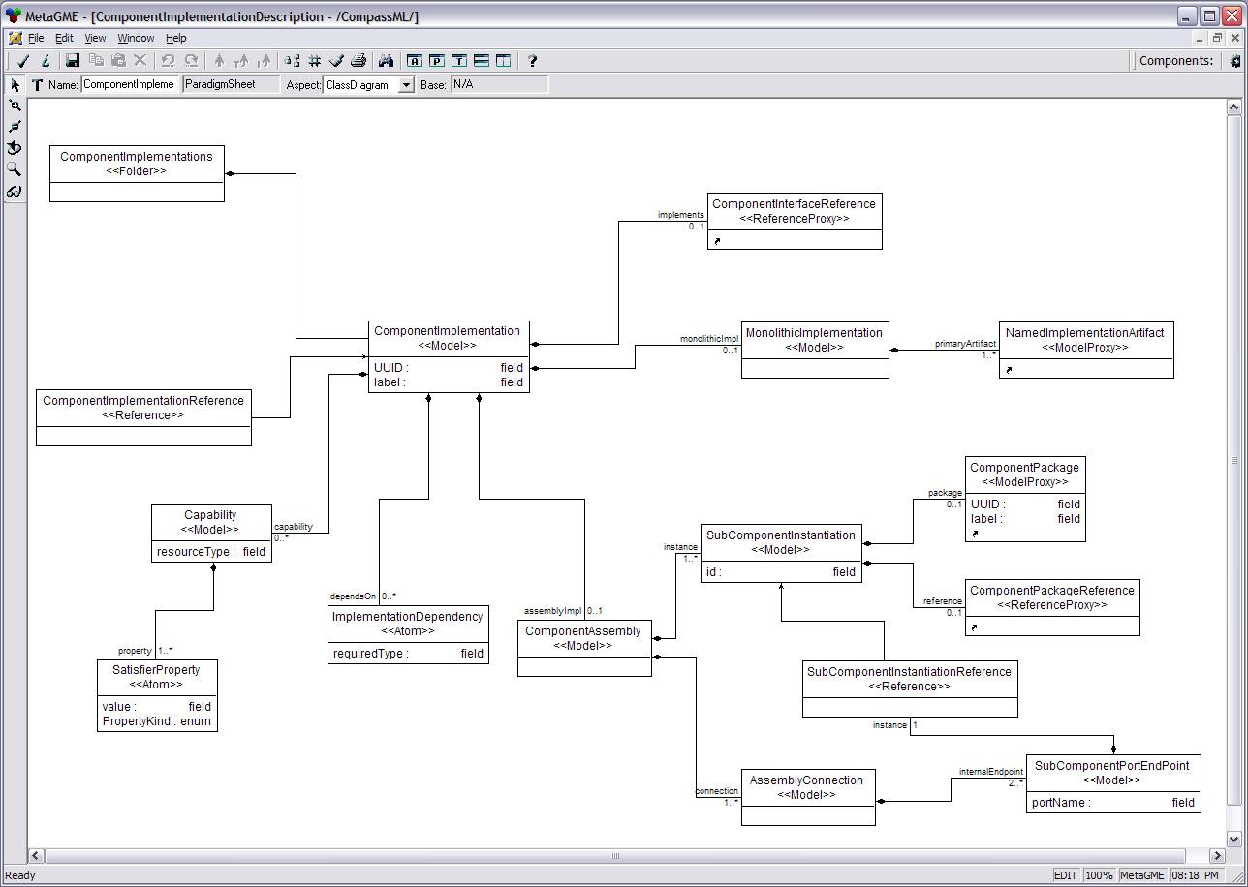
Figure 6 Component Implementation

ComponentImplementation

ComponentImplementation models a specific implementation of a component interface. A ComponentImplementatation can be either be monolithic i.e. consists of a single monolith implementation or can be assembly based, in which there are multiple implementations which are interconnected to perform the functionality.

Attributes

- label : A label providing descriptive information about this ComponentImplemenation
- UUID: A Universally Unique identifier which uniquely identifies this ComponentImplementation among all implementation of a particular component

ComponentImplementationReference

A ComponentImplementationReference element refers to a ComponentImplementation. It is used in the paradigm whenever a ComponentImplementation is referred to using a ReferenceProxy to this element.

ComponentAssembly

A ComponentAssembly models an assembly based component implementation. It contains multiple SubComponentInstantiations, each representing the individual components and a list of AssemblyConnections, representing the connections among the components.

SubComponentInstantiation

A SubComponentInstantiation models a sub-component of an assembly based component implementation.

Attributes

- id: An Identifier used to refer to this sub-component within the context of a single component

AssemblyConnection

An AssemblyConnection models the inter-connection among the different SubComponentInstantiations present within a ComponentAssembly. Each AssemblyConnection elements contains two or more SubComponentPortEndPoint elements which represent the ends of a connection.

SubComponentPortEndPoint

A SubComponentPortEndPoint represents the port of the component that is connected to one or more components within the assembly.

Attributes

- portName: Name of the port that this end point represents

SubComponentInstantiationReference

A SubComponentInstantiationReference element refers to a SubComponentInstantiation. It is used in the paradigm whenever a SubComponentInstantiation is referred to using a ReferenceProxy to this element.

Capability

Capability models the capabilities of the implementations of components being packaged and assembled. It is used in ensuring during planning stage that the requirements can be met by the implementations.

Attributes

- resourceType: Type of resource requirement that can be satisfied by this Capability.

SatisfierProperty

SatisfierProperty is used to represent properties that can be satisfied by a resource or a capability.

Attributes

- value: Value of the property
- PropertyKind: Kind of the property which includes Quantity, Capacity, Minimum, Maximum, Selection, Attribute

ImplementationDependency

ImplementationDependency models the dependencies that implementations have on external environment, and which must be satisfied by the target environment.

Attributes

- requiredType: Type of the required interface that must exist on the target.

MonolithicImplementation

MonolithicImplementation represents a monolith based implementation of a component. It references a NamedImplementationArtifact which contains the implementation for this component.
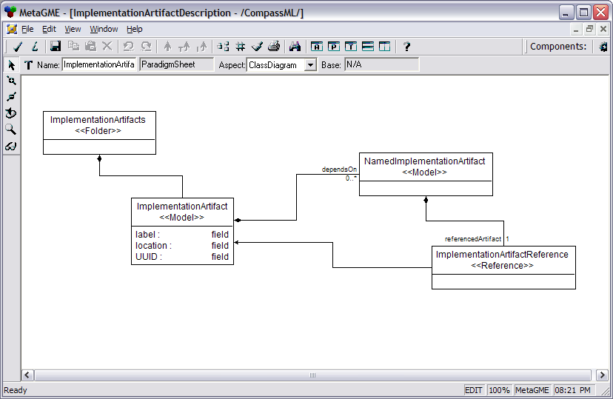
Figure 7 Implementation Artifact

ImplementationArtifact

ImplementationArtifact models the artifacts of a particular implementation of a component like the shared libraries, executables, third-party dependency artifacts etc.

Attributes

- label : A label providing descriptive information about this ImplementationArtifact ComponentImplemenation
- UUID: A Universally Unique identifier which uniquely identifies this ComponentImplementation among all implementation of a particular component
- location: Location, possibly remote, of the ImplementationArtifact

NamedImplementationArtifact

An ImplementationArtifact can express dependencies on other ImplementationArtifacts using a NamedImplementationArtifact element, which in turn contains a reference to an ImplementationArtifact.

ImplementationArtifactReference

An ImplementationArtifactReference element refers to an ImplementationArtifact. It is used in the paradigm whenever an ImplementationArtifact is referred to using a ReferenceProxy to this element.

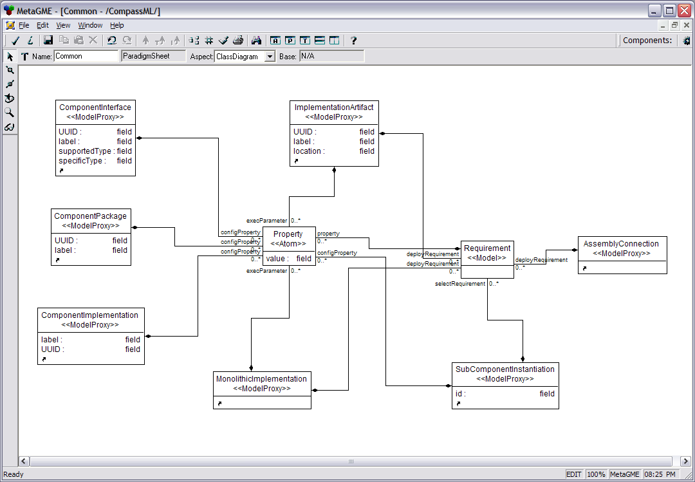
Figure 8 Common Elements

Property

Property represents any general property that can be associated with any of the elements in the meta-model.

Attributes

- value: Value of the property

Requirement

Requirement is used to express the requirements that component implementations have on the resources available in the target environment. Requirements are matched against Capabilities by the run-time environment to make sure that they can be met by the target environment.
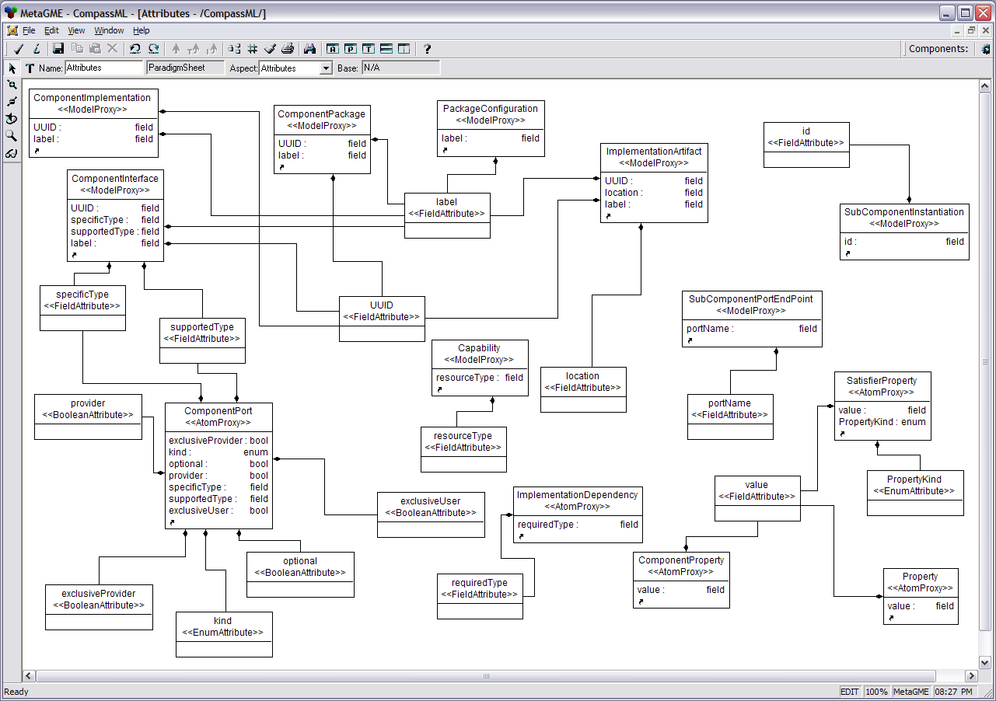
Figure 9 Attributes in the modeling paradigm

Constraints

Constraints are essential to ensuring that the packages created using the modeling environment are valid. The constraints are captured in the meta-model using OCL constraints. Constraints are designed to capture the restrictions that exist in the:
- Creation of component packages
- Inter-connection of component packages
- Composition of packages
- Creation of component assemblies
- Inter-connection of component assemblies
- Composition of assemblies
- Creation of components
- Inter-connection of components

Adding constraints to the meta-model ensures that illegal connections are not made among the various modeling elements. This also allows catching errors early in the component development cycle. As modeling is a static process, this also has the added advantage that sophisticated constraint checking can be done prior to application instantiation, without incurring any run-time cost associated with such constraint checking.

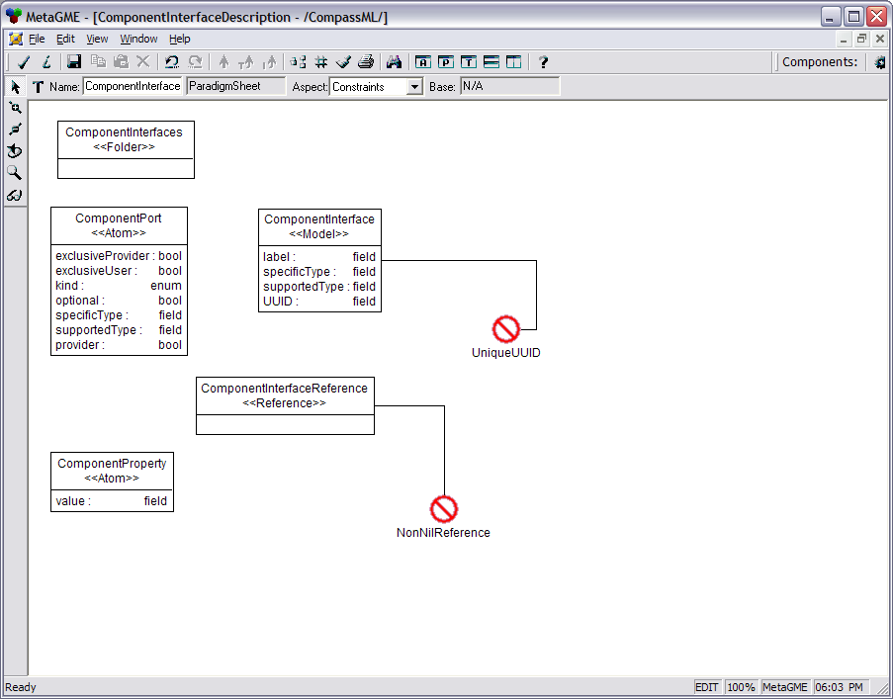Figure 10 Constraints on ComponentInterface

The following constraints are defined in the modeling paradigm:
- UniqueName: This constraint if defined on a <<Model>> ensures that the children of the <<Model>> have unique names.
- UniqueUUID: This constraint if defined on a <<Model>> ensures that the <<Model>> has a universally unique identifier which can be used to identify that element
- NoNilReference: This constraint if defined on a <<Reference>> ensures that the <<Reference>> cannot be a nil reference i.e. cannot point to a null object
- xxxXor: This constraint if defined on a <<Model>> ensures that the <<Model>> contains only one of two possible <<Model>>s as children. For example, ImplementationXor ensures that a ComponentImplementation can contain either a ComponentAssembly or a MonolithicImplementation, but not both.

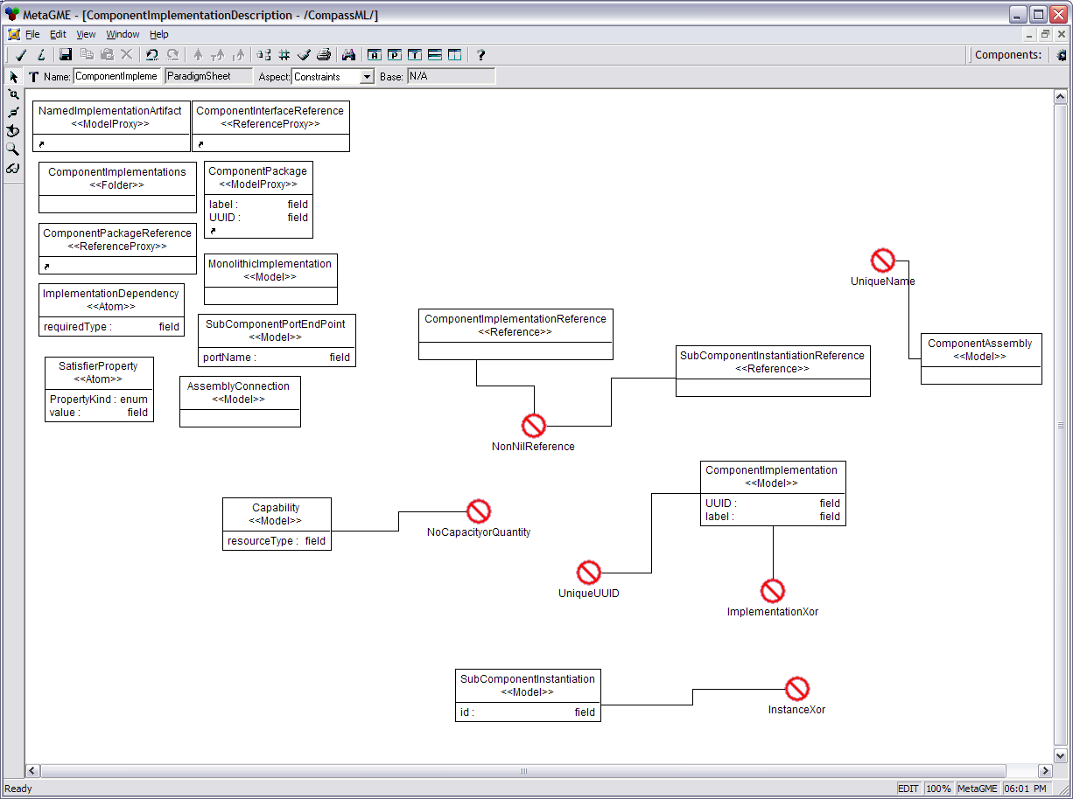Figure 11 Constraints on ComponentImplementation

Interpreting the Model

A model interpreter is provided to translate the various packaging and configuration information into a set of descriptors. A descriptor is a XML file which conforms to a XML schema defined by the “Deployment & Configuration of Component-based Distributed Applications Specification”[8], which is an adopted specification by the Object Management Group (OMG). An XML Schema language is a formalization of the constraints, expressed as rules or a model of a structure, that apply to a class of XML documents. Descriptors contain meta-data that describes the systemic information of component-based DRE applications. Since the meta-model captures the hierarchy inherent in the component packages, COMPASS generates five different top-level descriptors, each describing specific features of the packaged components by traversing this hierarchy. These include:

- Top Level Package Descriptor. Since a package may include component packages for sub-components, a selection mechanism is necessary to distinguish the top-level package. This descriptor points to the ComponentPackage element which corresponds to the root of the tree in a hierarchy of packages. This information is contained in a single file called package.pcd.
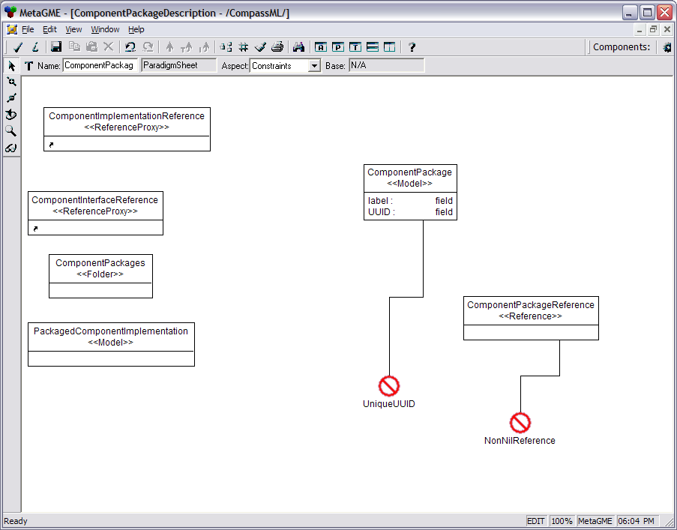Figure 12 Constraints on ComponentPackage
- Component Package Descriptor. Describes the elements in a package. This descriptor contains a ComponentPackage element. This information is generated in a file name <ComponentPackageName>.cpd, where <ComponentPackageName> is the name assigned to the ComponentPackage element. One file per ComponentPackage element is generated by the interpreter.
- Component Implementation Descriptor. Describes elements of a specific implementation of a component interface. This descriptor contains a ComponentImplementation element. This information is generated in a file named <ComponentImplementationName>.cid, where <ComponentImplementationName > is the name assigned to the ComponentImplementation element. One file per ComponentImplementation element is generated by the interpreter.
- Implementation Artifact Descriptor. Describes elements of a monolithic component implementation. This descriptor contains an ImplementationArtifact element. This information is generated in a file named <ImplementationArtifactName>.iad, where <ImplementationArtifactName > is the name assigned to the ImplementationArtifact element. One file per ImplementationArtifact element is generated by the interpreter.
- Component Interface Descriptor. Describes the interface of a single component along with other elements like component ports. This descriptor contains a ComponentInterface element. This information is generated in a file named <ComponentInterfaceName>.cid, where <ComponentInterfaceName > is the name assigned to the ComponentInterface element. One file per ComponentInterface element is generated by the interpreter.

Interpretation is allowed from each of the above elements as they all are self-contained entities and the descriptors should therefore be generated independently. An example descriptor, in this case, a Component Interface Descriptor is shown below:

<?xml version="1.0" encoding="UTF-8" standalone="no" ?>
<Deployment:ComponentInterfaceDescription xmlns:Deployment="http://www.omg.org/Deployment" xmlns:xmi="http://www.omg.org/XMI" xmlns:xsi="http://www.w3.org/2001/XMLSchema-instance" xsi:schemaLocation="http://www.omg.org/Deployment Deployment.xsd">

<label>NavDisplay Component </label>

<UUID>589462ed-e88f-4f96-a7a7-359cdc333d63</UUID>
<specificType>IDL:HUDDisplay/NavDisplay:1.0</specificType>
<supportedType>IDL:HUDDisplay/NavDisplay:1.0</supportedType>

<port>
<name>GPSLocation</name>
<exclusiveProvider>false</exclusiveProvider>
<exclusiveUser>false</exclusiveUser>
<optional>false</optional>
<provider>false</provider>
<supportedType>IDL:HUDDisplay/position:1.0</supportedType>
<specificType>IDL:HUDDisplay/position:1.0</specificType>
</port>

<port>
<name>Refresh</name>
<exclusiveProvider>false</exclusiveProvider>
<exclusiveUser>false</exclusiveUser>
<optional>false</optional>
<provider>false</provider>
<supportedType>IDL:HUDDisplay/tick:1.0</supportedType>
<specificType>IDL:HUDDisplay/tick:1.0</specificType>
</port>

</Deployment:ComponentInterfaceDescription>

Design & Implementation of the Interpreter

There exists a direct mapping between each of the elements used in the different descriptors and the elements of the meta-model. Also as shown above, each descriptor is just a dump of the attributes of each top-level element it is based and any children of the element. So, in order to generate descriptors from these elements, one needs to traverse each top-level <<Model>> element in the meta-model in a depth-first pre-order fashion and print its attributes.

Following the “Open-Closed Principle” i.e., keep the design open for extension but closed for modification, Visitor design pattern is used instead of hard-coding functionality to each node to dump its name and attributes in XML. The Builder Object Network (BON) 2.0 visitor, BON::Visitor, provides the necessary infrastructure by constructing the abstract syntax tree i.e., the BON, which can be traversed to generate the information contained in the models in XML format. This allows the infrastructure to be reused in the future to generate, say IDL interfaces from the same BON.

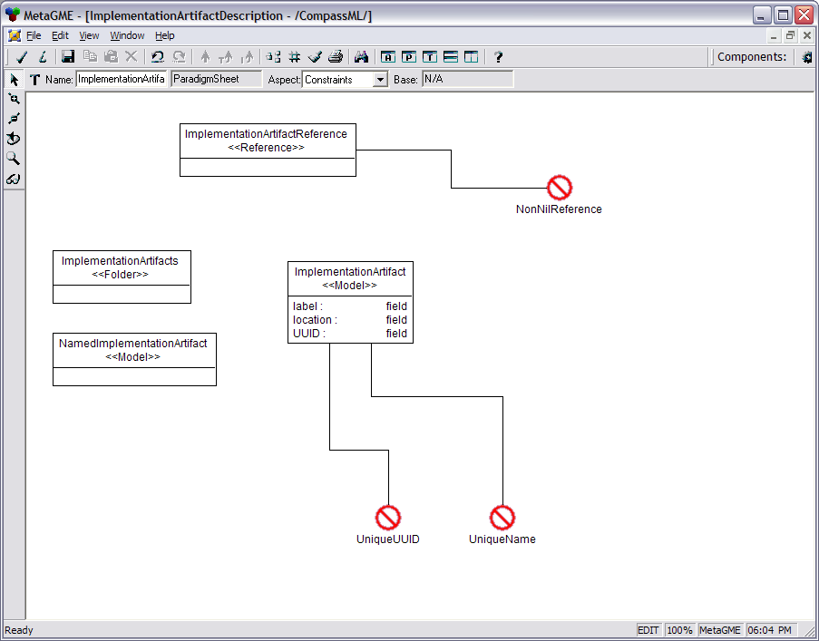
Figure 13 Constraints on ImplementationArtifact
The following are the BON 2.0 Extension classes, used to interpret the models built using COMPASS, to generate the XML Schema[3][4] conformant descriptors:

- TopLevelPackageImpl
- ImplementationArtifactImpl
- NamedImplementationArtifactImpl
- RequirementImpl
- ComponentInterfaceImpl
- ComponentPackageImpl
- PackagedComponentImplementationImpl
- ComponentImplementationImpl
- CapabilityImpl
- ComponentAssemblyImpl
- MonolithicImplementationImpl
- SubComponentInstantiationImpl
- AssemblyConnectionImpl
- SubComponentPortEndPointImpl

All of the extension classes override the virtual function accept() defined in BON::Visitor to implement the depth-first pre-order traversal. In addition to the above extension classes, a visitor called SchemaVisitor, is implemented for traversing the BON. This class is responsible for building a Document Object Model (DOM) [5][6][7] tree, by traversing the BON. SchemaVisitor overrides the implementation of the following BON::Visitor functions:

- visitModelImpl()
- visitAtomImpl()
- visitReferenceImpl()

Once the DOM tree is built, it is traversed to dump out the descriptors. The DOM implementation that comes bundled with Xerces-C++[8], is used for building the DOM tree and the subsequent dump of the DOM tree. Using Xerces-DOM provides useful features like XML pretty-printing, which results in the generated XML being indented in a logical and easy-to-read fashion, instead of resembling a big ball of spaghetti.

Future Work

The scope of this class project is restricted to modeling packaging of CORBA components. It is likely that this project will be extended in future R&D activities at ISIS to package component-based applications that are independent of the underlying middleware technology. For example, the same modeling environment can be extended to capture the packaging of components for component middleware technologies like Enterprise Java Beans (EJB), or for Microsoft .NET infrastructure. Since the artifacts generated as a result of this project are static entities, the different descriptors have to be fed to the run-time infrastructure to be useful. This is another area of co-operation and future work to realize the goal of an end-to-end development of component-based DRE applications using the approach of Model-Integrated Computing.

References
- “Towards Composable Distributed Real-time and Embedded Software”, Krishnakumar Balasubramanian, Douglas C. Schmidt, Nanbor Wang, Christopher D. Gill, Proceedings of the 8th Workshop on Object-oriented Real-time Dependable Systems, Guadalajara, Mexico, Jan 2003
- Object Management Group, Deployment & Configuration of Component-based Distributed Applications Specification”, OMG TC Document ptc/03-07-02
- World Wide Web Consortium (W3C), “XML Schema Part 1: Structures.” W3C Recommendation, May 2, 2001
- World Wide Web Consortium (W3C), “XML Schema Part 2: Datatypes.” W3C Recommendation, May 2, 2001
- Document Object Model Level 2 Core (W3C Recommendation), 13 November 2000, Arnaud Le Hors, Philippe Le Hégaret, Lauren Wood, Gavin Nicol, Jonathan Robie, Mike Champion, Steve Byrne
- Document Object Model Level 2 Traversal and Range (W3C Recommendation),13 November 2000, Joe Kesselman, Jonathan Robie, Mike Champion, Peter Sharpe, Vidur Apparao, Lauren Wood
- Document Object Model Level 3 Core (W3C Candidate Recommendation), 7 November 2003, Arnaud Le Hors, Philippe Le Hégaret
- Apache XML Project, Xerces: XML parsers in Java and C++ (plus Perl and COM), July 2002

- [Kitty, can you briefly describe these descriptors?!]

