Composable Adaptive Software Systems (COMPASS)

Krishnakumar Balasubramanian <kitty@dre.vanderbilt.edu>

User Manual

Introduction

COMPASS defines a modeling paradigm designed to enable a system integrator to

- Create models of the various components that are part of the application
- Model the interconnections between the components
- Specify systemic properties of the components
- Build component assemblies – collection of components connected according to some specification,
- Compose packages, which are a collection of all of the above.

As shown in Figure 1, packaging involves grouping the implementation of component
functionality (which is typically stored in a dynamic link library (DLL) together with other meta-data that describes properties of this particular implementation. Packaged components exist in “passive mode,” i.e., all their functionality is present, but they are inert object code. To perform their functionality at run-time, components must transition to “active mode,” where the interconnections between components are established. Deployment mechanisms are responsible for transitioning components from passive to active mode. COMPASS focuses on generating the information that describes packages using a MIC-based approach.

As shown in Figure 2, COMPASS is designed to be a link in a longer tool chain that enables DRE application developers to model, synthesize, and deploy complete DRE applications.

Modeling using COMPASS

A system integrator should be able to model the various packaging and configuration artifacts of the application using COMPASS. COMPASS allows modeling the various packaging and configuration artifacts, the valid associations between the various artifacts. Since there is a natural hierarchy among the different artifacts of packaging, the modeling paradigm developed reflects it as much as possible. This means that a system integrator will be able to visualize individual packages, the set of assemblies contained within a package, and the individual components contained as part of each assembly. This user manual uses a descriptive example to guide the user through the various facilities available in the COMPASS modeling paradigm. Though it is not necessary, users are strongly encouraged to read the companion technical manual to understand how COMPASS works beneath the hood.

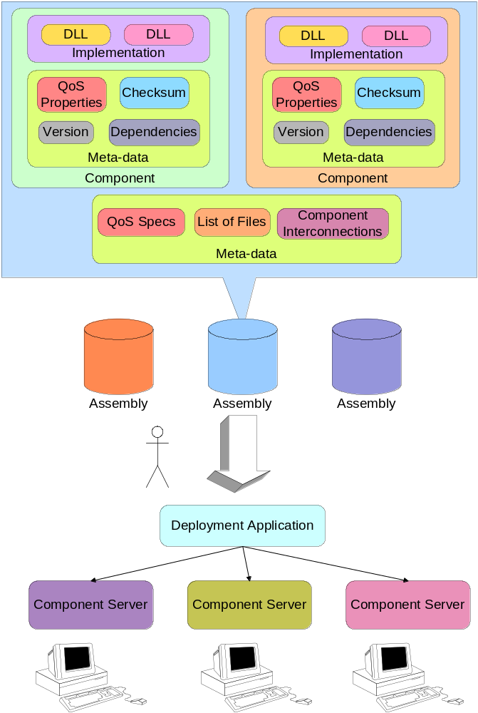
Figure 1 Component Packaging & Deployment
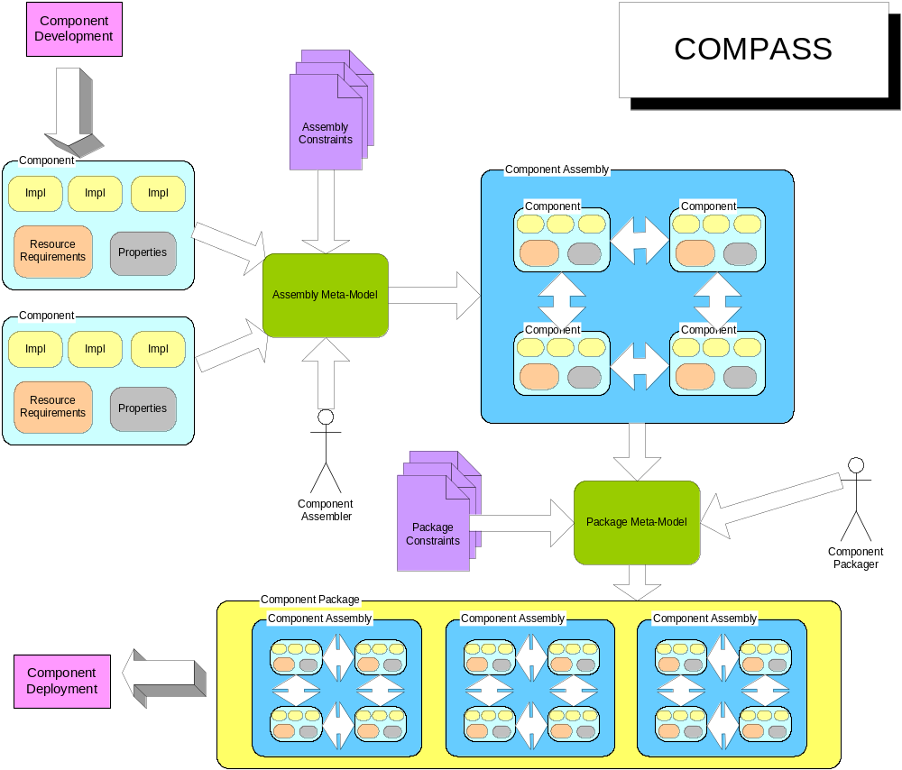
Figure 2 COMPASS

Heads-Up Display Example

The example shown here is a model of a Heads-Up Display, an imaginary car instrument assembly which updates the display of current coordinates of the car periodically. It consists of the following three components as shown in Figure 3:

- RateGen - A rate generator component that allows it's client to start/stop the rate generating event.

- GPS - A Global Positioning System component that interacts with GPS hardware. When this component receives an event from the Refresh port, it queries the GPS hardware and updates its internal cached coordinates. The current location can then be read by accessing the MyLocation interface. It also generates an event on its Ready port to inform the event consumers that a new GPS reading is available.

- NavDisplay - A navigation display component that projects the current location of the vehicle on the windshield. When a NavDisplay receives an event notifying the availability of new data on its Refresh port, it will acquire the current location of the vehicle by querying the interface connected to the GetLocation receptacle.

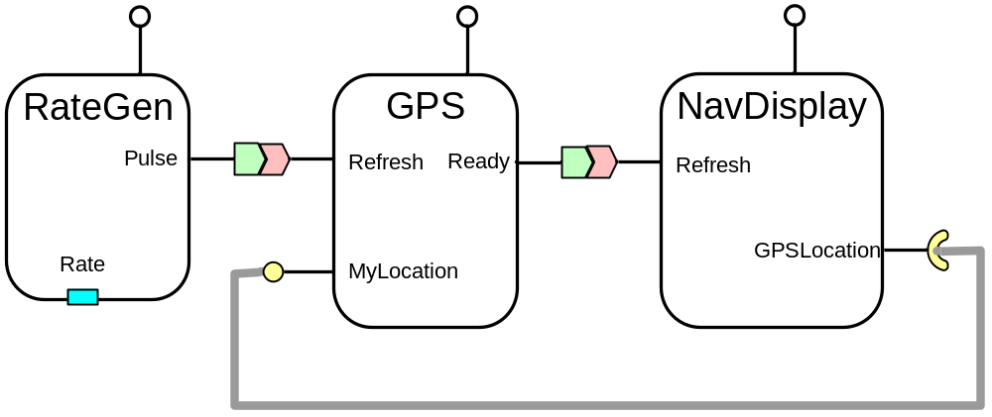
Rate Generator
Positioning
Sensor
Displaying
Device
Figure 3 Heads-Up Display
The goal of this exercise is to model the above example application using COMPASS to create a ComponentAssembly, and generate descriptors for this configuration. As shown in Figure 4, COMPASS presents the different entities that can be modeled using COMPASS in separate folders. Each folder is named according to the top-level element that it contains. In modeling applications using COMPASS, it is always a good idea to start from defining the different ComponentInterfaces. There is no inherent limitation on choosing to start from any other folder, except that one has to keep in mind that COMPASS doesn’t allow nil references. So one has to create the referenced item before creating a reference to the referenced item.

ComponentInterface

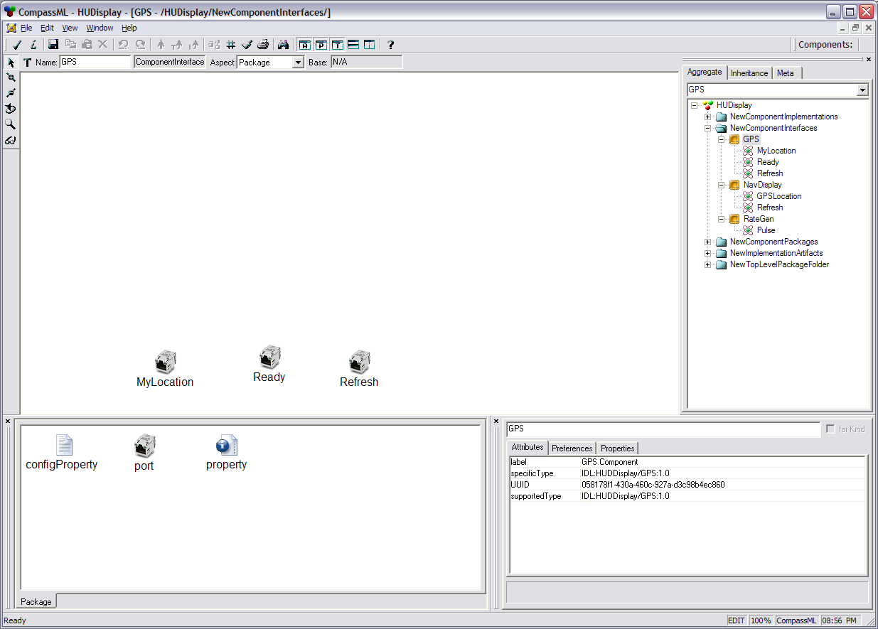
Figure 4 GPS ComponentInterface
Figure 4 shows the modeling of the GPS ComponentInterface. The “Part Browser” window at the bottom shows the different elements that can be contained within a ComponentInterface. In this case, we have modeled the three different ports of GPS, MyLocation, Ready & Refresh. One can also see the values for the attributes of the GPS ComponentInterface like label, UUID etc. Figure 4 also shows the contents of other components in our example viz., NavDisplay and RateGen in the “Browser” window.

ComponentImplementation

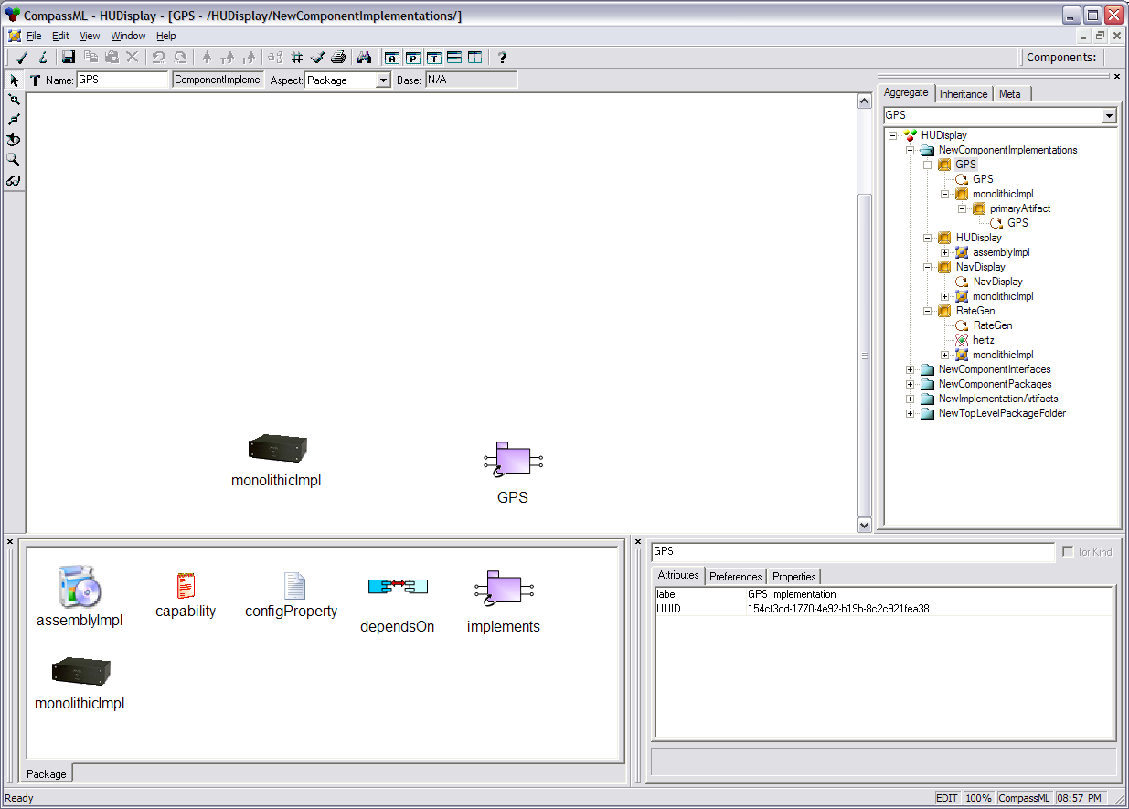
Figure 5 GPS ComponentImplementation

Figure 5 shows the modeling of the GPS ComponentImplementation. The “Part Browser” window at the bottom shows the different elements that can be contained within a ComponentImplementation. In this case, we have modeled the GPS component implementation, which is a MonolithicImplementation. The reference to GPS ComponentInterface is also shown. To create the reference to the GPS ComponentInterface, make sure that the GPS ComponentInterface has been created. Then select the GPS ComponentInterface in the browser window, right-click, select Copy. Change focus to the modeling sheet by clicking in the main window, right-click and select Paste Special-> As reference. Figure 5 also shows the contents of other component implementations in our example viz., HUDisplay, NavDisplay and RateGen in the “Browser” window. Next we have to create the contents of the GPS MonolithicImplementation.

MonolithicImplementation
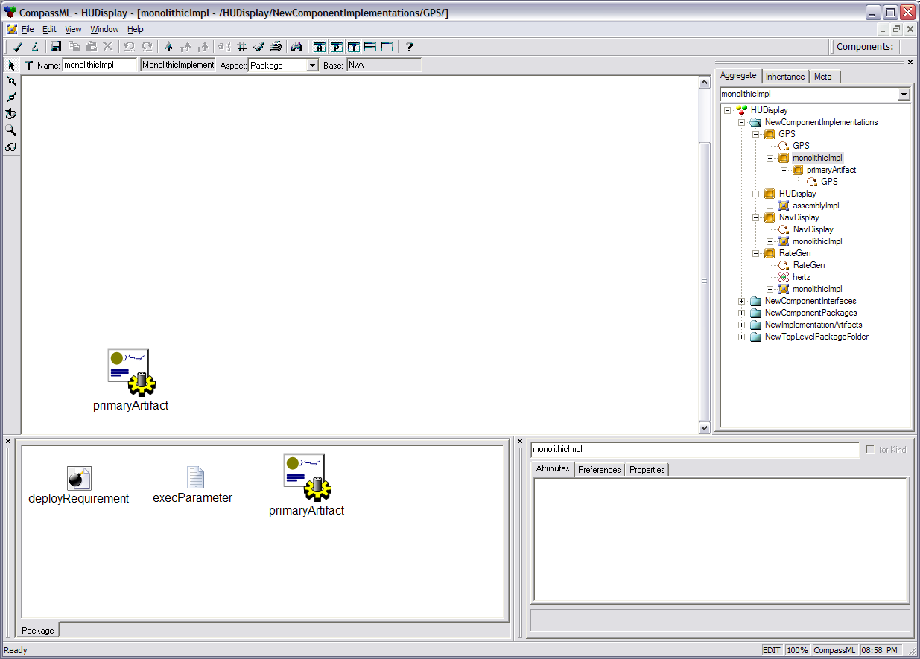
Figure 6 GPS MonolithicImplementation
Figure 6 shows the modeling of the GPS MonolithicImplementation. The “Part Browser” window at the bottom shows the different elements that can be contained within a MonolithicImplementation. In this case, we have modeled the NamedImplementationArtifact i.e primaryArtifact. Though not shown in the Figure 6, double-clicking on primaryArtifact shows that it references the GPS Implementation Artifact (this model has been created apriori) which is described later in the manual.

ComponentAssembly

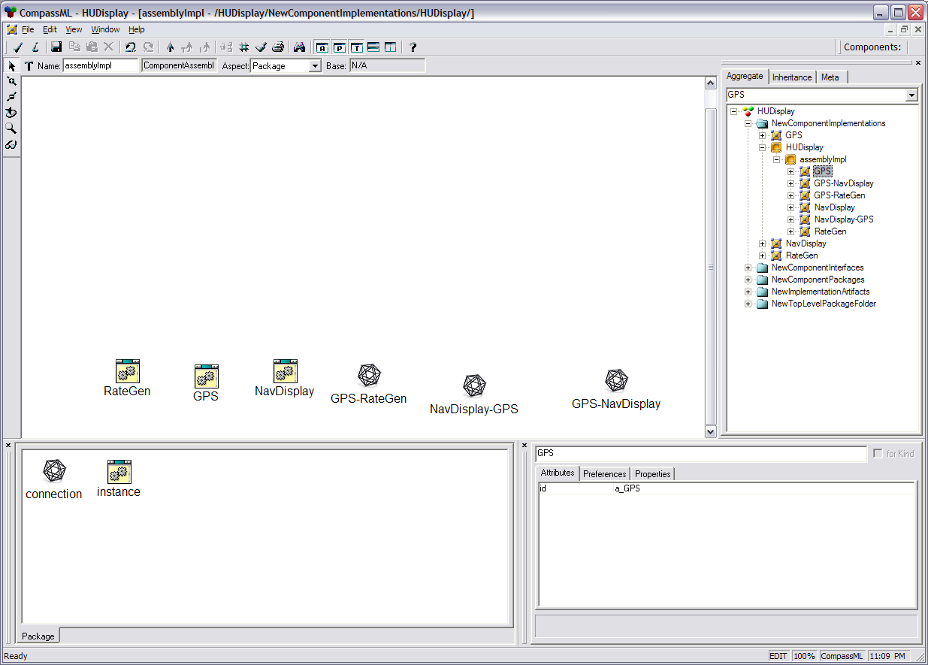
Figure 7 HUDisplay ComponentAssembly
Figure 7 shows the modeling of the HUDisplay ComponentAssembly. The “Part Browser” window at the bottom shows the different type of elements that can be contained within a ComponentAssembly viz., SubComponentInstantiation and AssemblyConnection. In this case, we have modeled the three different sub-components of a HUDisplay viz., RateGen, GPS, NavDisplay. We have also shown different connections within the HUDisplay viz., GPS-RateGen, NavDisplay-GPS, GPS-NavDisplay. Each of the SubComponentInstantiation and AssemblyConnection elements need to be defined, which is done in the next sections.

SubComponentInstantiation

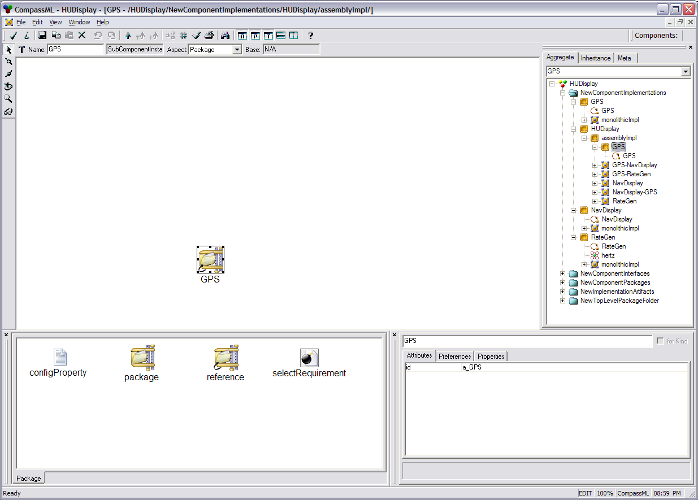
Figure 8 GPS SubComponentInstantiation
Figure 8 shows the modeling of the GPS SubComponentInstantiation. The “Part Browser” window at the bottom shows the different type of elements that can be contained within a SubComponentInstantiation. We have chosen to model the ComponentPackage as a reference and placed a reference to GPS ComponentPackage. The “Browser” window shows the other SubComponentInstantiations in our model viz., NavDisplay and GPS.

AssemblyConnection

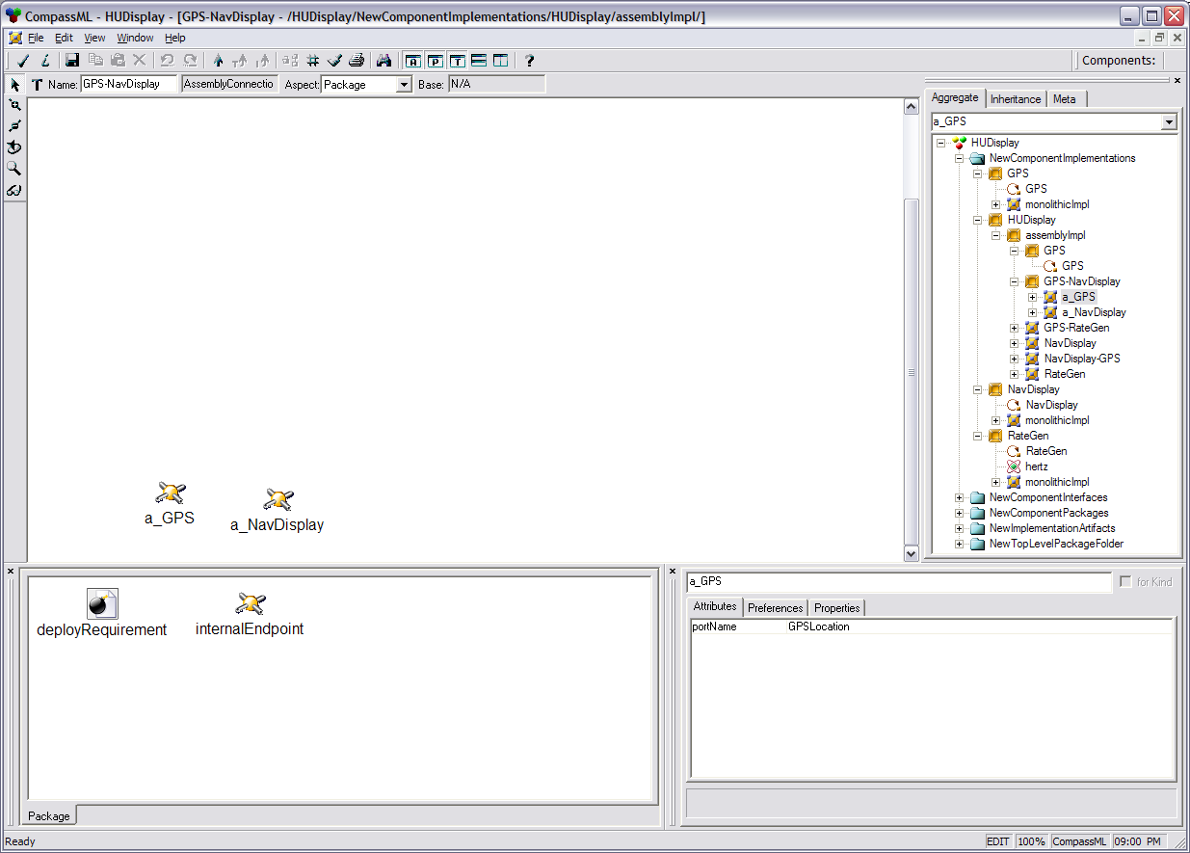
Figure 9 GPS-NavDisplay AssemblyConnection
Figure 9 shows the modeling of the GPS-NavDisplay AssemblyConnection. The “Part Browser” window at the bottom shows the different type of elements that can be contained within an AssemblyConnection. The GPS-NavDisplay AssemblyConnection contains the two SubComponentPortEndPoints of this connection viz., GPS and NavDisplay. For each SubComponentPortEndPoint the portName that participates in the connection is shown in the “attributes” panel, which for the case of GPS is GPSLocation. The “Browser” window shows the other AssemblyConnections in our model viz., GPS-RateGen and NavDisplay-GPS.

ComponentPackage

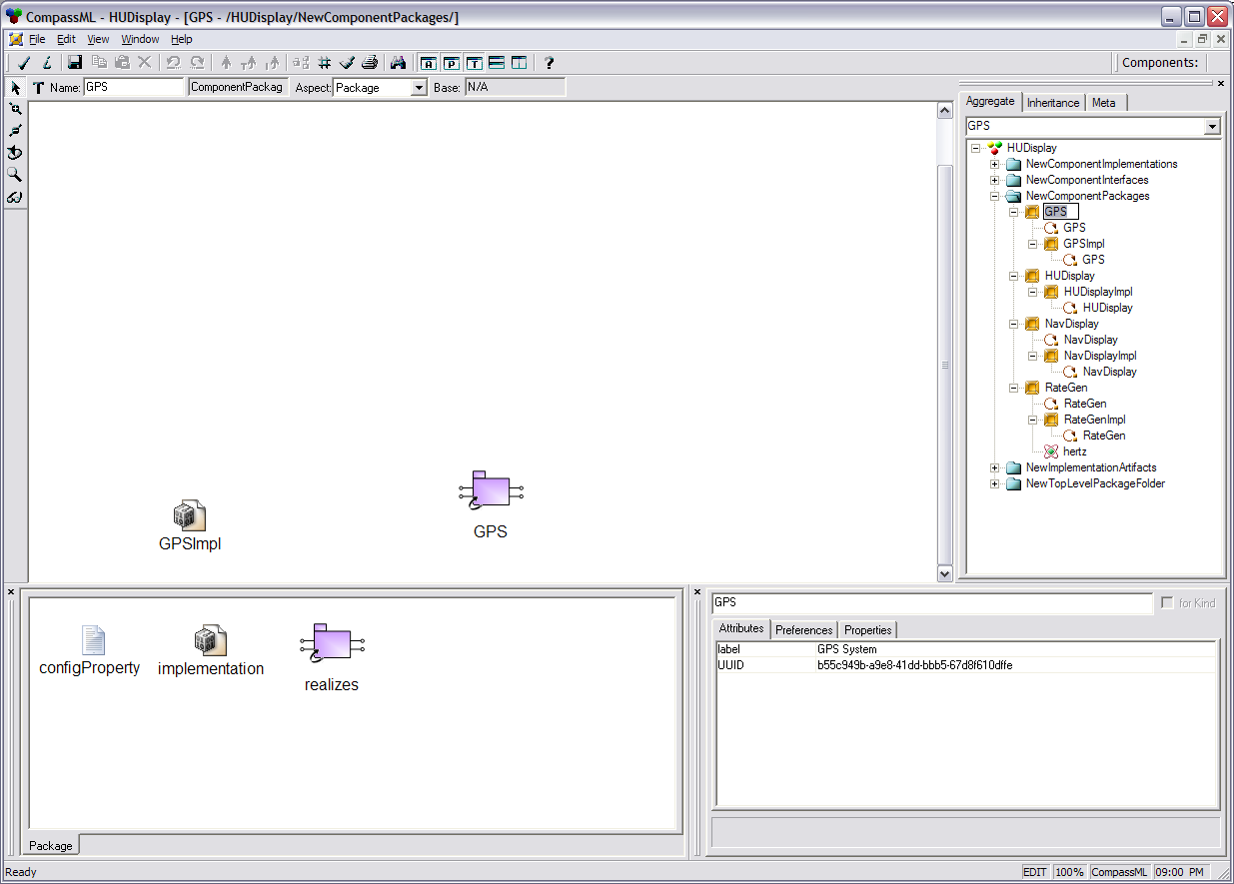
Figure 10 GPS ComponentPackage

Figure 10 shows the modeling of the GPS ComponentPackage. The “Part Browser” window at the bottom shows the different elements that can be contained within a ComponentPackage. The reference to GPS ComponentInterface is also shown. To create the reference to the GPS ComponentInterface, make sure that the GPS ComponentInterface has been created. Then select the GPS ComponentInterface in the browser window, right-click, select Copy. Change focus to the modeling sheet by clicking in the main window, then right-click and select Paste Special-> As reference. Figure 5 also shows the contents of other component packages in our example viz., HUDisplay, NavDisplay and RateGen in the “Browser” window.

ImplementationArtifact

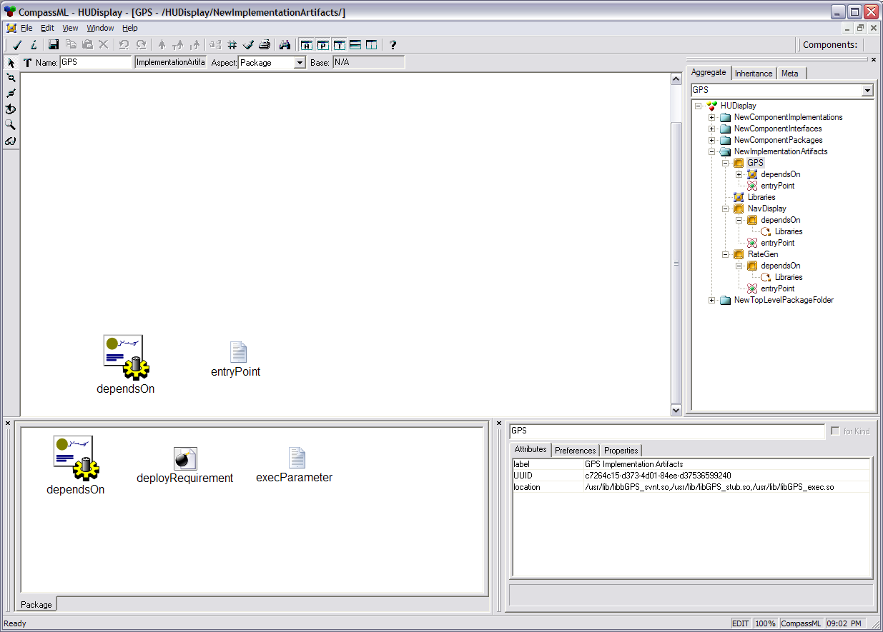
Figure 11 GPS ImplementationArtifact
Figure 11 shows the modeling of the GPS ImplementationArtifact. The “Part Browser” window at the bottom shows the different elements that can be contained within a ImplementationArtifact. The GPS ImplementationArtifact is shown to have a dependency on an external ImplementationArtifact viz., Libraries. The attribute panel shows the other attributes of run-time environment needed to execute this ImplementationArtifact. The other ImplementationArtifacts present in the application are also shown in the “Browser” window.

TopLevelPackage

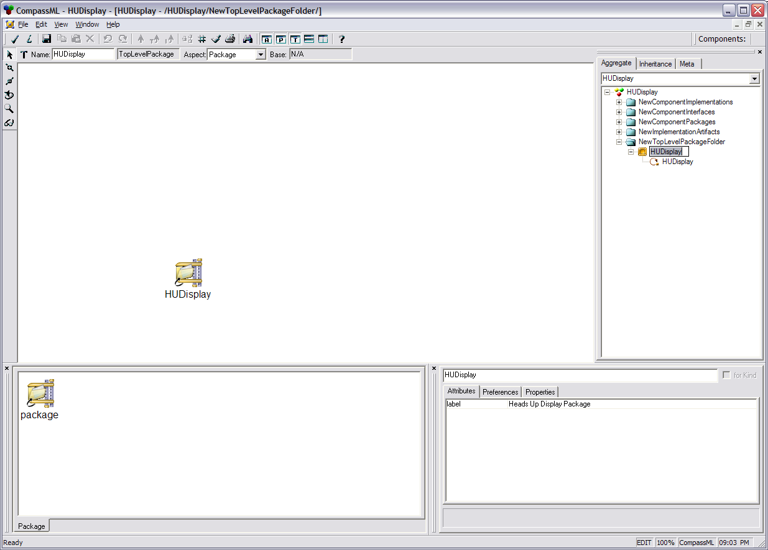
Figure 12 HUDisplay TopLevelPackage

Figure 12 shows the modeling of the HUDisplay TopLevelPackage. The “Part Browser” window at the bottom shows the only element that can be contained within a TopLevelComponentPackage i.e, a reference to the root of the package hierarchy, in this case the HUDisplay ComponentPackage.

Once the above sequence of steps is done for all the individual ComponentInterfaces, ComponentImplementations, ComponentPackages and ImplementationArtifacts, the model should be checked for constraint violations that are not Level 1 constraints, and hence wouldn’t have been triggered till now. This can be done by selecting File->Check->Check All.

[Kitty, I recommend mentioning which other class projects will be a part of this longer tool chain!]

Constraints

Constraints are essential to ensuring that the packages created using the modeling environment are valid.

The following constraints are defined in the modeling paradigm:
- UniqueName: This constraint if defined on a <<Model>> ensures that the children of the <<Model>> have unique names.
- UniqueUUID: This constraint if defined on a <<Model>> ensures that the <<Model>> has a universally unique identifier which can be used to identify that element
- NoNilReference: This constraint if defined on a <<Reference>> ensures that the <<Reference>> cannot be a nil reference i.e. cannot point to a null object
- xxxXor: This constraint if defined on a <<Model>> ensures that the <<Model>> contains only one of two possible <<Model>>s as children. For example, ImplementationXor ensures that a ComponentImplementation can contain either a ComponentAssembly or a MonolithicImplementation, but not both.

All the constraints described above are Level 1 severity constraints. It means that the operation that triggered the constraint violation will be aborted, and the state of the model prior to the violation will be preserved.

Interpreting the Model

A model interpreter is provided to translate the various packaging and configuration information into a set of descriptors. A descriptor is a XML file which conforms to a XML schema defined by the “Deployment & Configuration of Component-based Distributed Applications Specification”[2], which is an adopted specification by the Object Management Group (OMG). Since the meta-model captures the hierarchy inherent in the component packages, COMPASS generates five different top-level descriptors, each describing specific features of the packaged components by traversing this hierarchy. These include:

- Top Level Package Descriptor. Since a package may include component packages for sub-components, a selection mechanism is necessary to distinguish the top-level package. This descriptor points to the ComponentPackage element which corresponds to the root of the tree in a hierarchy of packages. This information is contained in a single file called package.pcd.
- Component Package Descriptor. Describes the elements in a package. This descriptor contains a ComponentPackage element. This information is generated in a file name <ComponentPackageName>.cpd, where <ComponentPackageName> is the name assigned to the ComponentPackage element. One file per ComponentPackage element is generated by the interpreter.
- Component Implementation Descriptor. Describes elements of a specific implementation of a component interface. This descriptor contains a ComponentImplementation element. This information is generated in a file named <ComponentImplementationName>.cid, where <ComponentImplementationName > is the name assigned to the ComponentImplementation element. One file per ComponentImplementation element is generated by the interpreter.
- Implementation Artifact Descriptor. Describes elements of a monolithic component implementation. This descriptor contains an ImplementationArtifact element. This information is generated in a file named <ImplementationArtifactName>.iad, where <ImplementationArtifactName > is the name assigned to the ImplementationArtifact element. One file per ImplementationArtifact element is generated by the interpreter.
- Component Interface Descriptor. Describes the interface of a single component along with other elements like component ports. This descriptor contains a ComponentInterface element. This information is generated in a file named <ComponentInterfaceName>.cid, where <ComponentInterfaceName > is the name assigned to the ComponentInterface element. One file per ComponentInterface element is generated by the interpreter.

Interpretation is allowed from each of the above elements as they all are self-contained entities and the descriptors should therefore be generated independently. Interpretation can be started by selecting the different entities and right-click, then Interpret or by clicking on the Interpret Toolbar icon or by choosing File->Interpret. If successful, the interpreter will produce a bunch of files as described above. An example descriptor, in this case, the GPS Component Interface Descriptor file, GPS.ccd, is shown below:

<?xml version="1.0" encoding="UTF-8" standalone="no" ?>
<Deployment:ComponentInterfaceDescription xmlns:Deployment="http://www.omg.org/Deployment" xmlns:xmi="http://www.omg.org/XMI" xmlns:xsi="http://www.w3.org/2001/XMLSchema-instance" xsi:schemaLocation="http://www.omg.org/Deployment Deployment.xsd">

<label>GPS Component</label>

<UUID>058178f1-430a-460c-927a-d3c98b4ec860</UUID>

<specificType>IDL:HUDDisplay/GPS:1.0</specificType>

<supportedType>IDL:HUDDisplay/GPS:1.0</supportedType>

<port>
<name>Refresh</name>
<exclusiveProvider>false</exclusiveProvider>
<exclusiveUser>false</exclusiveUser>
<optional>false</optional>
<provider>false</provider>
<supportedType>IDL:HUDDisplay/tick:1.0</supportedType>
<specificType>IDL:HUDDisplay/tick:1.0</specificType>
</port>

<port>
<name>Ready</name>
<exclusiveProvider>false</exclusiveProvider>
<exclusiveUser>false</exclusiveUser>
<optional>false</optional>
<provider>true</provider>
<supportedType>IDL:HUDDisplay/tick:1.0</supportedType>
<specificType>IDL:HUDDisplay/tick:1.0</specificType>
</port>

<port>
<name>MyLocation</name>
<exclusiveProvider>false</exclusiveProvider>
<exclusiveUser>false</exclusiveUser>
<optional>false</optional>
<provider>true</provider>
<supportedType>IDL:HUDDisplay/position:1.0</supportedType>
<specificType>IDL:HUDDisplay/position:1.0</specificType>
</port>

</Deployment:ComponentInterfaceDescription>

Concluding Remarks

The descriptors generated by the above process are static description of data. Packaged components exist in “passive mode,” i.e., all their functionality is present, but they are inert object code. To perform their functionality at run-time, components must transition to “active mode,” where the interconnections between components are established. Deployment mechanisms are responsible for using the descriptors generated using COMPASS and transitioning components from passive to active mode.

References

- Object Management Group, Deployment & Configuration of Component-based Distributed Applications Specification”, OMG TC Document ptc/03-07-02

- [Kitty, can you briefly describe these descriptors?!]

