Using RT-DEEP to evaluate DDS

We recently developed an actor-based framework called RT-DEEP (Real-Time DDS Examination & Evaluation Project) for running and testing DDS applications. The goal is to provide a vendor-independent test suite for running any kind of performance test case expected from publish/subscrib middleware. With this framework, communication end points are actors playing certain roles in the pub/sub communication domain. We can switch between different vendors by providing the include path to directory containing vendor-specific code to the compiler. The current framework supports three actors: Source, Sink, Reflector, in which: 1) A Source actor is responsible for periodically publishing data samples to a partition shared with Reflector. It contains a publisher/writer pair. 2) A Reflector actor is responsible for receiving data samples from the publisher and forwarding them to the partition shared with a Sink or another Reflector. It contains a publisher/writer pair as well as a subscriber/reader pair. 3) A Sink actor is responsible for receiving data samples from the partition shared with the Reflector and is the endpoint of the (possibly multi-hop) path. It contains a subscriber/reader pair. These actors are all supplied with timing functionalities and can be configured to conduct performance tests. The RT-DEEP framework contains an application called deepParticipant, which can be started multiple times. With the assigned role, a deepParticipant becomes the actual actor participating in a test. We use XML files to store the configuration settings required by actors in a certain test. The whole set of actors with the configuration settings in a certain test are called a scenario. The design of RT-DEEP framework provides a flexible mechanism for running many kinds of scenarios. Figure 2 shows an example scenario of RT-DEEP actors.

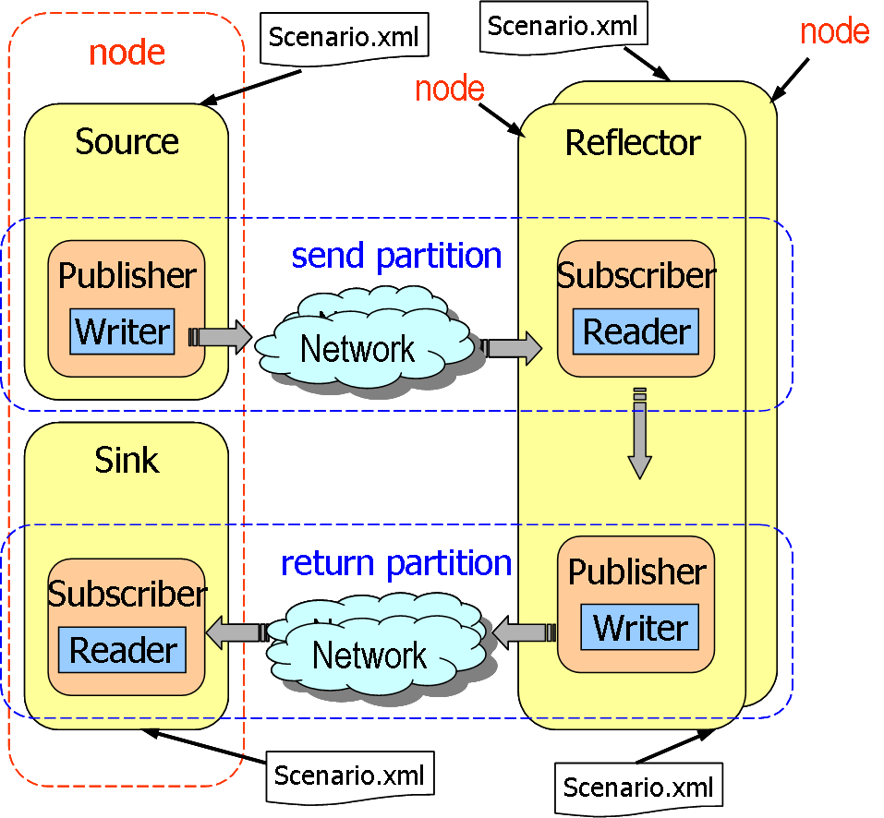
Figure 2. Conceptual of RT-DEEP Framework

We have initially been using RT-DEEP to build our 1-to-many DDS latency tests and our experience has shown that this framework is well-suited to our requirements.
Technical Results
This section describes how various challenges have been encountered while 1) designing RT-DEEP for different vendors and 2) running RT-DEEP applications for specific test scenarios.
Challenge 1: Decoupling standard APIs from vendor specific APIs
Problem: Although DDS defines standard DCPS interfaces, different vendors still make their implementations vendor-specific by 1) having different naming conventions for their DDS interfaces (for example. some vendors have a “DDS_” in front of C++ classes, value types, interface types and constants, or 2) providing extensions to current DCPS interfaces that are not available from other vendors. The design of RT-DEEP makes the assumption that all vendors will use DDS namespaces and no vendor-specific extension codes could be used in any actor implementations. It is generally a challenge to design a framework which perfectly separates standard APIs from vendor-specific APIs because in our previous test implementations without the framework support, we maintained vendor specific code that has specific naming conventions as well as code that uses extension interfaces.
Solution. First, we provide specific directories for storing vendor-specific code. We then use macros to resolve the namespace issue and reference them in vendor-independent code. We then encapsulate vendor code extensions into common interfaces used by actors. These files will be referenced by vendor-independent code and the only thing we need to do is to provide the appropriate include path to the compiler.
Challenge 2: Timer Handling
Problem: Our initial use of RT-DEEP has been focusing on measuring 1-to-n distributed latency where a Source/Sink pair resides in one node and n Reflectors reside on distributed nodes. Our previous tests use a Laptimer mechanism to measure some performance metric such as latency in which a publisher starts a timer, sends out data samples, waits for ack messages, and stops the timer. This all happens in the same process. With RT-DEEP, however, the actor that starts the timer, i.e., the Source, is running on a different process than the actor that stops the timer, i.e., the Sink. Since the latency is measured at the sink side when sink received the data from the reflectors, the start time at the Source side has to be known by the sink somehow. We would like to have a natural way of handling this problem without having to add a timestamp field to the data struct.
Solution: The standard DDS API write() is designed to send data samples along with some metadata, including the timestamp. DDS provides another API write_with_timestamp() to send a data with a timestamp specified by the sender rather than automatically generated. We leveraged these APIs and designed a scenario where the Source publishes data with write() which will deliver the start time in the sample metadata, which can be accessed by Reflector and forwarded by Reflector using write_with_timestamp(). When the Sink receives the data, it gets the timestamp from the Source clock, and a latency can be calculated. This method solves our problem without having to add a timestamp field to the data struct. One drawback of this method is that we are using two different write methods in our tests, but we have estimated the difference of these two write methods to be within 2 to 3 microseconds, and therefore safely ignored.

Challenge 3: Synchronization of the test applications
Problem: The current design of RT-DEEP does not support the s synchronization of executable starup. Thus it is possible that the Source has finished the publishing of the data when a Sink is just about to start receiving them. It is also tedious and error-prone to manually coordinate a 1-to-n distributed latency tests when n is large.
Solution: Currently we solve this problem by carefully choosing a timeout period (e.g., 1500 miliseconds for 1-to-12) for Reflectors and also by starting the Reflectors before Source/Sink pair. The long-term goal is to integrate our DDS Benchmarking Environement (DBE) scripts with RT-DEEP so that the initialization of the testing processes and their synchronizations can automated.
Our experience so far has been positive about using RT-DEEP. RT-DEEP is a very good fit to our current benchmarking suite and will be heavily used in our future work. Ongoing work in this effort will be to 1) improve the current implementation and make it more robust 2) add a logger that can provide more diagnosis/debugging information when running this framework 3) add more performance evaluation functionality in the framework. Current RT-DEEP code can be obtained from http://www.dre.vanderbilt.edu/DDS.

