django_content_type dependencies

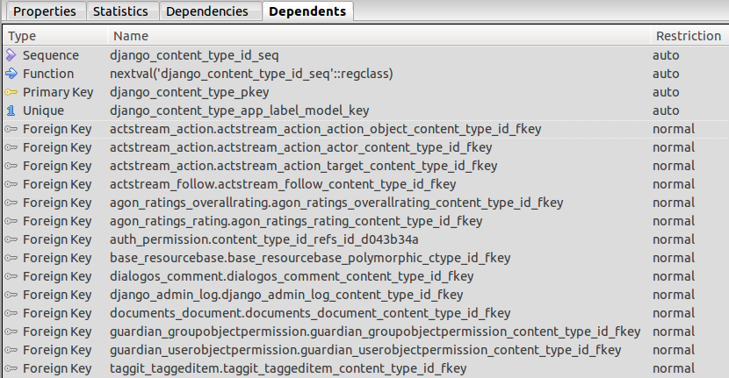

auth_permission dependencies

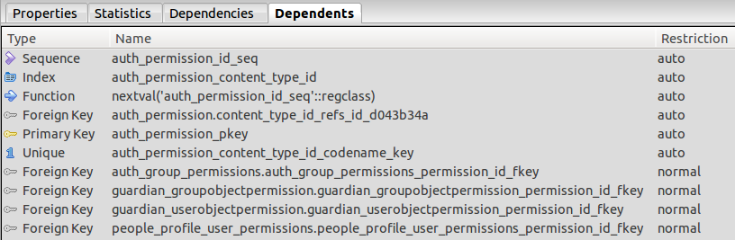

auth_user dependencies

