SARS-CoV-2 Sequencing and Variants in Washington State

Washington State Department of Health

January 31, 2024



##### Page Break

**To request this document in another format, call 1-800-525-0127. Deaf or hard of hearing customers, please call 711 (Washington Relay) or email** [**doh.information@doh.wa.gov**](mailto:doh.information@doh.wa.gov)**.**

**Publication Number:** 420-316

**For more information or additional copies of this report:**

Disease Control and Health Statistics  
Center for Data Science  
1610 NE 150th Street, MS: K17-9  
Shoreline, WA 98155

Phone: 206-418-5700 (24-hour contact for local health jurisdictions only)  
Email: [CommDisEpi@doh.wa.gov](mailto:CommDisEpi@doh.wa.gov)

##### Page break

# SARS-CoV-2 Sequencing and Variants in Washington State

# Washington State Department of Health

# January 31, 2024

Next Generation Sequencing (NGS) is a set of laboratory methods that scientists use to scan a viral genome to determine the genome sequence of a virus. A genome sequence of a virus is referred to as its “genomic fingerprint,” and can reveal mutations in a virus that make it unique. Mutations are changes in a genome sequence and occur naturally over time.

Scientists compare viral genomes to better understand how viruses can spread from person to person. NGS technology allows public health officials to detect clusters of cases and monitor new variant viruses. Groups of same-species viruses that share a set of genome mutations are referred to as a lineage. Some variants belonging to specific lineages may have characteristics such as the ability to spread more quickly, cause more severe disease, or impact clinical therapy such as treatment with monoclonal antibodies. These variants may be classified as variants of interest, variants being monitored, variants of concern or variants of high concern.

Throughout this report, we refer to the scientific name of the virus SARS-CoV-2 that causes COVID-19. Sequencing can only be performed on samples that are processed in laboratories and where swabs are stored in liquid that is compatible with sequencing, which means only samples used for molecular tests (such as PCR) can be included. For this reason, this report is limited to confirmed cases only. The genomes that are sequenced and compared are those of the virus, not of humans.

## At a glance (data through January 30, 2024)

* During the month of December 2023, **%** of all confirmed molecular COVID-19 cases were sequenced. This number is preliminary and will change over time as additional specimens are received from the previous month.
* **144,009 (9.7%)** COVID-19 cases in Washington state have sequencing information available since January 2021.

##### Page break

CDC currently categorizes variants as Variants of High Consequence (VOHC), Variants of Concern (VOC), Variants of Interest (VOI) and Variants Being Monitored (VBM). There are currently no VOHC or VOI so only VOC and VBM are detailed in this report.

## Variants of Concern

| Variant | Area first detected | Background | Cumulative Washington cases detected | First detection in Washington* | Most recent detection in Washington* |
| --- | --- | --- | --- | --- | --- |
| Omicron (B.1.1.529 and descendant lineages) | South Africa | Early research indicates evidence for increased transmissibility, immune evasion, and lower risk of hospitalization and death, relative to Delta. Approved vaccines are effective at preventing severe disease and death against Omicron variants | 77,284 | Nov 29, 21 | Jan 16, 24 |

*Detection dates are based on the date a sample is collected, it can take several weeks before a variant result is completed and added to the report

Note: Omicron lineages in this report are defined as below:

| Omicron grouping | Inclusion |
| --- | --- |
| BA.2 | Includes BA.2.X except BA.2.12.1 and BA.2.75.X |
| CH.1.1 | Includes CH.1.1.X |
| BQ.1 | Includes BQ.1 (Alias of BA.5.3.1.1.1.1.1) except BQ.1.1 |
| XBB | Includes XBB.X except XBB.1.5, XBB.1.9.1, XBB.1.9.2, XBB.1.16, XBB.2.3, FE.1.1 |
| XBB.1.5 | Includes XBB.1.5.X except XBB.1.5.1, XBB.1.5.10, XBB.1.5.59, XBB.1.5.68, XBB.1.5.72, EU.1.1 |
| XBB.1.5.10 | Includes XBB.1.5.11.X |
| XBB.1.5.59 | Includes XBB.1.5.59.X |
| XBB.1.5.68 | Includes XBB.1.5.68.X |
| XBB.1.5.72 | Includes XBB.1.5.72.X |
| EU.1.1 | Includes EU.1.1.X |
| XBB.1.9.1 | Includes XBB.1.9.1.X |
| XBB.1.9.2 | Includes XBB.1.9.2.X |
| EG.5 | Includes EG.5.X |
| XBB.2.3 | Includes XBB.2.3.X except XBB.2.3.8 |
| XBB.1.16 | Includes XBB.1.16.X except XBB.1.16.1, XBB.1.16.6, XBB.1.16.15 |
| XBB.1.16.1 | Includes XBB.1.16.1.X |
| XBB.1.16.6 | Includes XBB.1.16.6.X |
| XBB.1.5.72 | Includes XBB.1.5.72.X |
| XBB.1.5.59 | Includes XBB.1.5.59.X |
| FL.1.5.1 | Includes FL.1.5.1.X |
| XBB.1.5.70 | Includes XBB.1.5.70.X |
| EG.6.1 | Includes EG.6.1.X |
| XBB.1.16.11 | Includes XBB.1.16.11.X |
| GE.1 | Includes GE.1.X |
| XBB.2.3.8 | Includes XBB.2.3.8.X |
| XBB.1.42.2 | Includes XBB.1.42.2.X |
| XBB.1.16.15 | Includes XBB.1.16.15.X |
| HV.1 | Includes HV.1.X |
| GK.2 | Includes GK.2.X |
| GK.1.1 | Includes GK.1.1.X |
| HK.3 | Includes HK.3.X |
| JG.3 | Includes JG.3.X |
| BA.2.86 | Include BA.2.86.X |
| JD.1.1 | Includes JD.1.1.X |
| JF.1 | Includes JF.1.X |
| JN.1 | Includes JN.1.X |
| EG.5.1.8 | Includes EG.5.1.8.X |
| XBB.1.16.17 | Includes XBB.1.16.17.X |

## Variants Being Monitored

| Variant | Area first detected | Cumulative Washington cases detected | First detection in Washington* | Most recent detection in Washington* |
| --- | --- | --- | --- | --- |
| Alpha (B.1.1.7) | United Kingdom | 10,337 | Jan 07, 21 | Sep 08, 21 |
| Beta (B.1.351) | South Africa | 282 | Jan 29, 21 | Jun 29, 21 |
| Delta (B.1.617.2 and AY lineages) | India | 38,826 | Apr 03, 21 | Sep 02, 22 |
| Epsilon (B.1.427 / B.1.429) | California | 4,191 | Dec 11, 20 | Jun 24, 21 |
| Eta (B.1.525) | New York | 92 | Feb 02, 21 | Jun 08, 21 |
| Gamma (P.1) | Brazil | 2,498 | Feb 06, 21 | Dec 02, 21 |
| Iota (B.1.526) | New York | 933 | Jan 21, 21 | Aug 20, 21 |
| Kappa (B.1.617.1) | India | 46 | Mar 22, 21 | Jun 14, 21 |
| Mu (B.1.621) | Colombia | 219 | Apr 09, 21 | Dec 20, 21 |
| Zeta (P.2) | Brazil | 45 | Jan 18, 21 | Apr 20, 21 |

*Detection dates are based on the date a sample is collected, it can take several weeks before a variant result is completed and added to the report

##### Page break

## Epidemiologic curve of variants being monitored and variants of concern by week of specimen collection date from January 01, 2021 to January 19, 2024

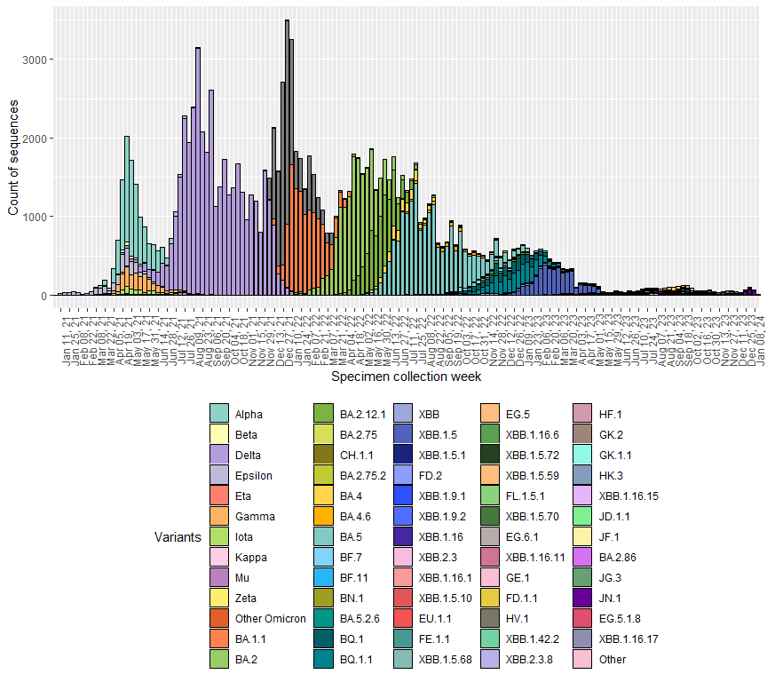

## Epidemiologic curve of variants being monitored and variants of concern by week of specimen collection date from June 01, 2023 to January 19, 2024

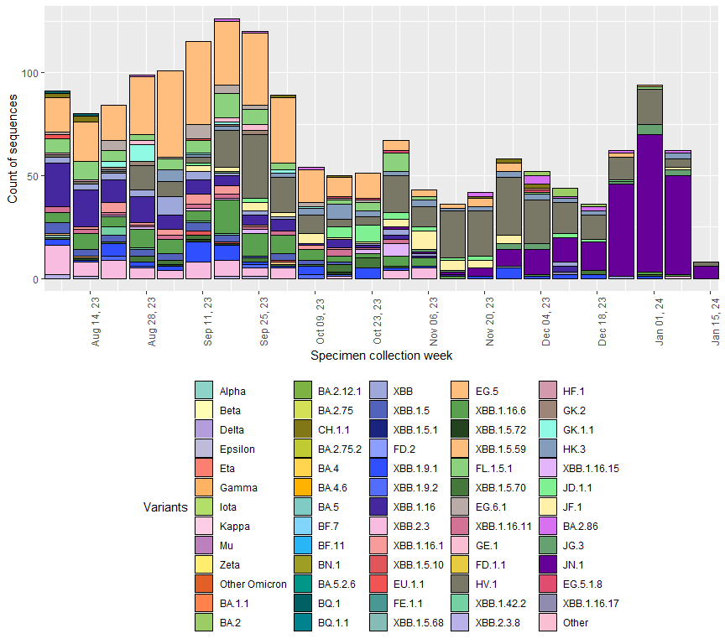

* The above graphs show the total number of variants detected by the week the specimen was collected from a patient.
* Sequencing can be performed on stored patient specimens at any time, so these numbers may change as additional specimens are sequenced.
* This graph shows all specimens sequenced, including specimens sequenced during outbreaks and other targeted sequencing efforts.
* “Other Omicron “ includes B.1.1.529, BA.1.X and BA.3.X sublineages

##### Page break

## Number of specimens sequenced, and percent of Washington State confirmed COVID-19 cases that have been sequenced by specimen collection date from January 2021 through December 2023.

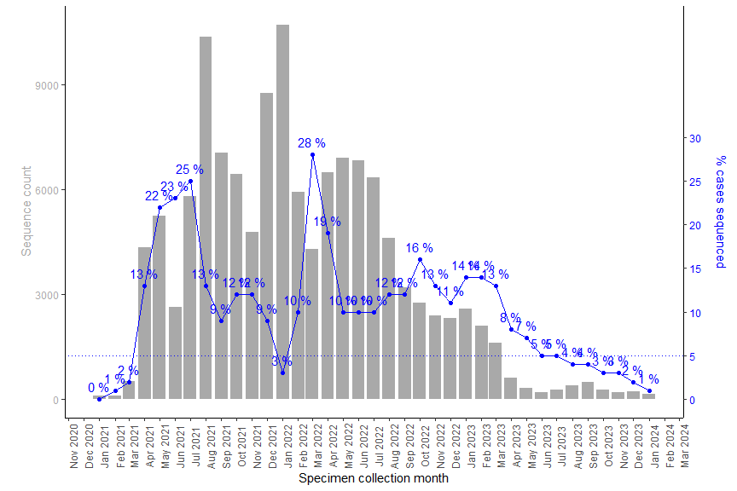

* Samples are not sequenced for every confirmed COVID-19 case. The above graph shows the total number of specimens sequenced (gray bars) and the percent of all confirmed cases (blue line) that have had sequencing performed each month. Data from the previous month may still be incomplete.
* Sequencing can be performed on stored specimens at any time, so numbers from past months may change if stored specimens are sequenced.

##### Page break

## SARS-CoV-2 Lineages Circulating in Washington State

The graph below shows the change in proportion of select SARS-CoV-2 lineages by time period. A viral lineage is a group of viruses that descend from a common ancestor with shared genetic characteristics, allowing them to be grouped together. Since this figure represents the share of all sequences that a particular lineage represents, as the proportion of sequences assigned to one lineage increases, the proportion of sequences assigned to other lineages will decrease.

NOTE: The data on this graph come from cases that marked as “Baseline surveillance” in GISAID. Cases sequenced because they were part of an outbreak or were otherwise manually selected for sequencing are excluded, as this could cause a lineage to appear over represented.

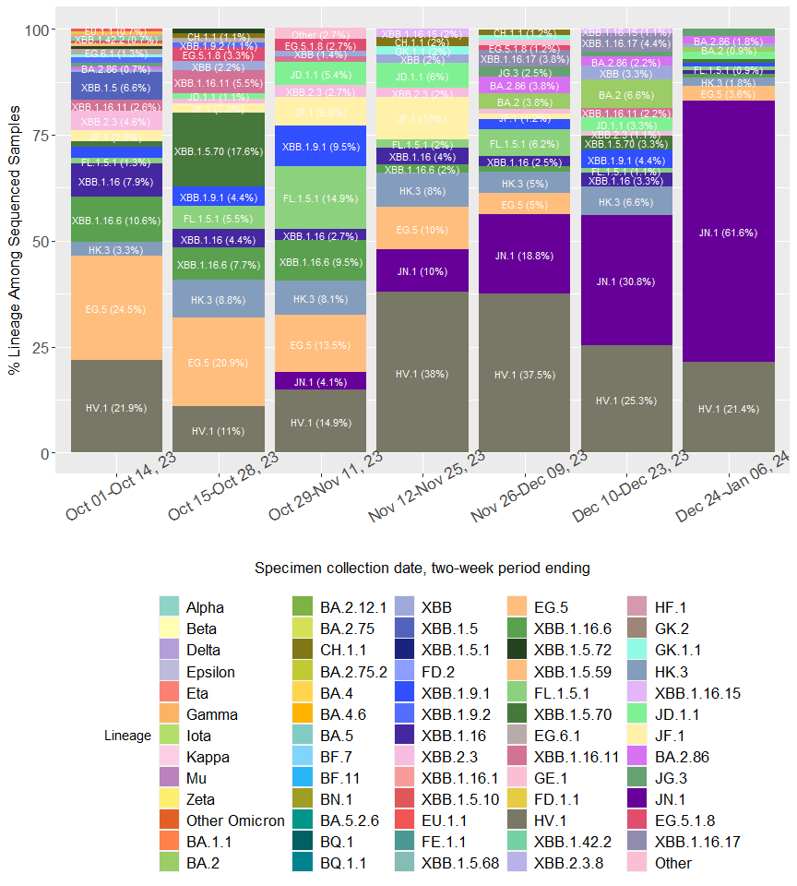

The chart above shows the proportions of the most common SARS-CoV-2 lineages circulating in Washington grouped in two-week intervals. Proportions are calculated using data which are subject to change over time and will be updated as more data becomes available, including data from prior time periods. **Due to the time it takes to complete sequencing, the most recent time period is based on a very small number of sequences and likely to be adjusted over time.**

To see the national trends, visit the CDC’s [variant proportions page](https://covid.cdc.gov/covid-data-tracker/#variant-proportions).

## The figures below show the current number of variants of concern (VOC) detected by county of home address since four months prior; data is from the Washington Disease Reporting System (WDRS).

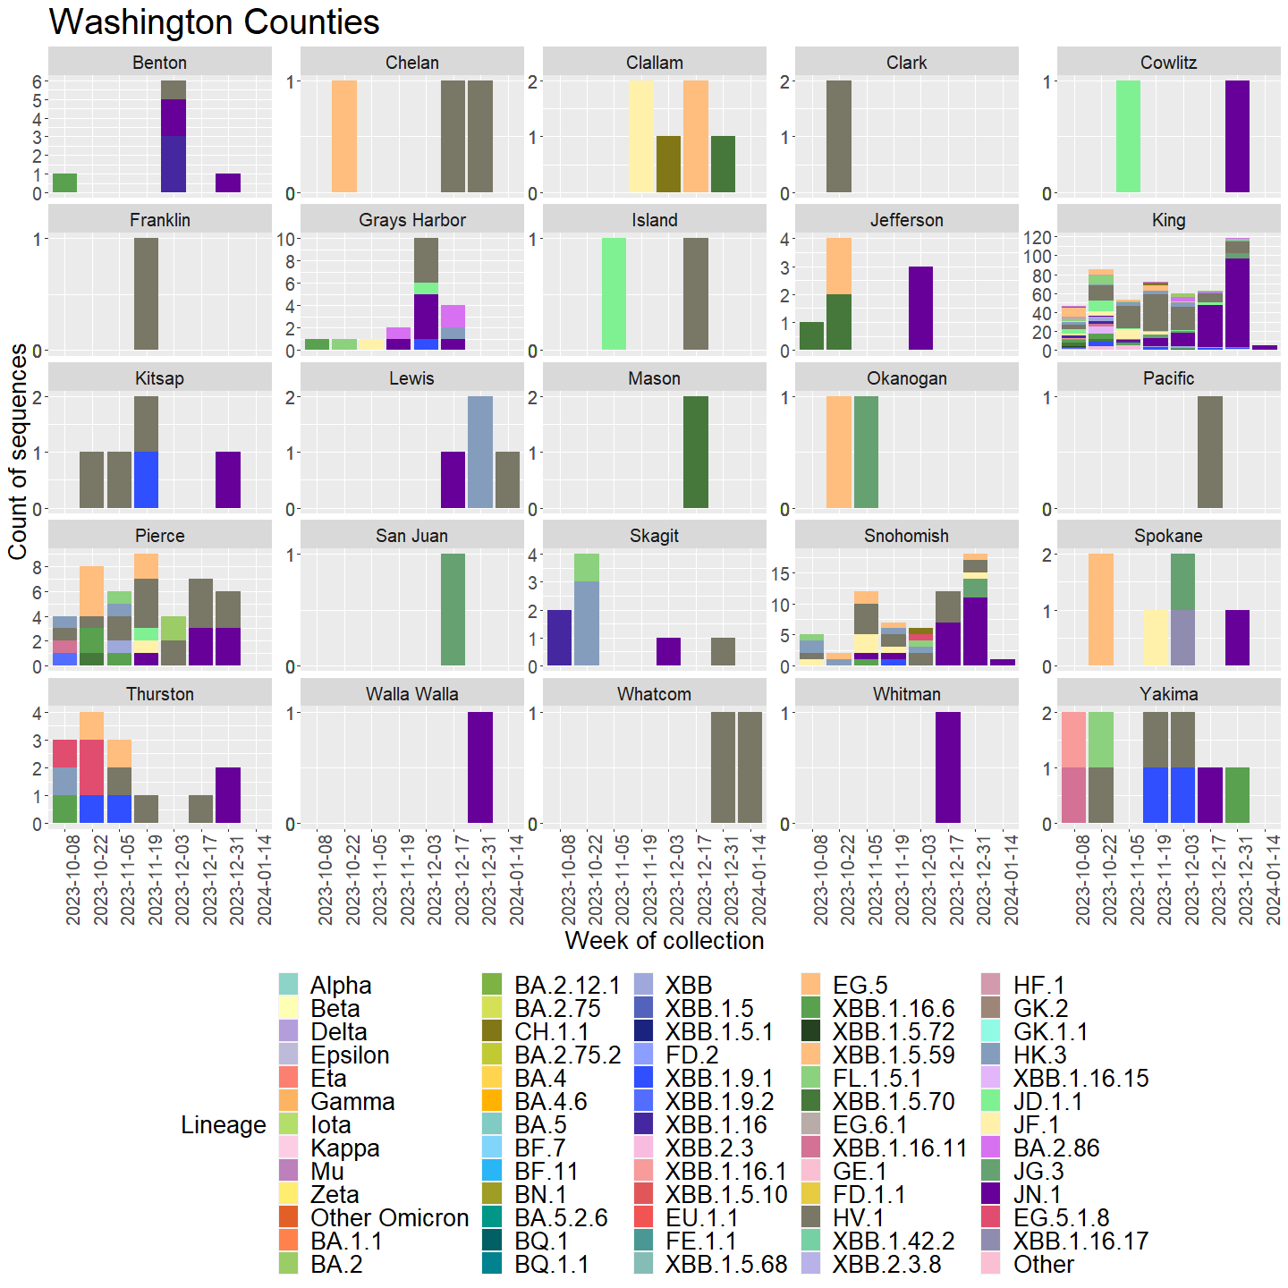

##### Page break

## Geographic Coverage of Sequencing

Efforts are made to sequence specimens from all geographic areas of Washington State. The number of sequences and the percent of cases sequenced vary based on several factors including number of cases in that region and which laboratories conduct the majority of testing in each locality.

## The map below shows the number of specimens sequenced by county of home address since January 1, 2021.

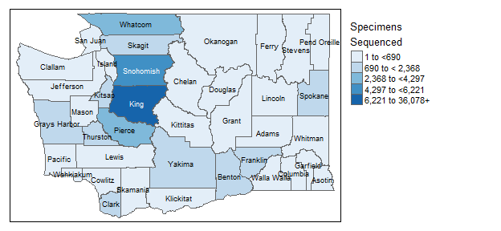

## The map below shows the percent of COVID-19 cases with at least one specimen sequenced by county of home address since January 1, 2021.

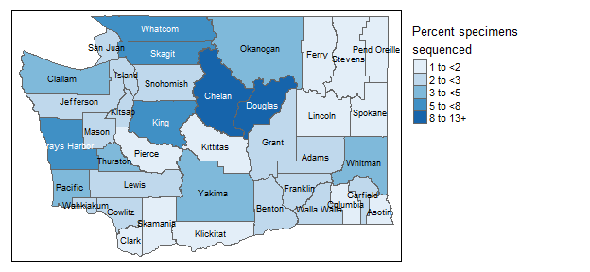

##### Page break

The hospitalization table below includes sequencing data since January 1, 2021 sorted by total number of cases per variant and does not account for factors that can influence hospitalization rates such as age and vaccination status, which may be different across variants. This means that hospitalization rates are not necessarily comparable between variants.

## Hospitalizations and deaths by variant, sorted by total case count

| Variant | Percent cases who were hospitalized | Cases who were hospitalized per 100,000 | Cases who died from COVID-19 | Total cases | Percent of hospitalized cases who died from COVID-19 |
| --- | --- | --- | --- | --- | --- |
| Delta | 4.3% | 4,271 | 1.3% | 38,723 | 17.2% |
| BA.5 | 2.1% | 2,101 | 0.4% | 17,754 | 9.4% |
| BA.2 | 1.2% | 1,167 | 0.2% | 13,801 | 8.1% |
| BA.1 | 1.2% | 1,159 | 0.3% | 12,335 | 14.7% |
| BA.1.1 | 2.3% | 2,349 | 0.8% | 11,323 | 14.7% |
| Alpha | 3.4% | 3,443 | 0.6% | 10,310 | 12.7% |
| BA.2.12.1 | 1.7% | 1,733 | 0.3% | 6,810 | 10.2% |
| Other | 2.6% | 2,586 | 0.8% | 5,298 | 16.8% |
| Epsilon | 2.6% | 2,588 | 0.7% | 4,134 | 16.8% |
| XBB.1.5 | 4% | 4,016 | 0.4% | 3,909 | 3.2% |
| BQ.1.1 | 2.7% | 2,656 | 0.2% | 3,012 | 6.2% |
| Gamma | 6.8% | 6,844 | 1.8% | 2,484 | 17.6% |
| BQ.1 | 2% | 2,015 | 0.2% | 1,836 | 5.4% |
| BA.4 | 1.9% | 1,874 | 0.3% | 1,441 | 3.7% |
| Iota | 3.2% | 3,226 | 1.3% | 930 | 30% |
| BA.4.6 | 2.9% | 2,890 | 0.6% | 692 | 5% |
| BF.7 | 3.2% | 3,195 | 0.8% | 532 | 23.5% |
| XBB | 2.3% | 2,283 | 0% | 438 | 0% |
| EG.5 | 14.4% | 14,441 | 0.8% | 367 | 1.9% |
| BN.1 | 1.4% | 1,351 | 0.3% | 296 | 25% |
| HV.1 | 17.3% | 17,314 | 0% | 283 | 0% |
| Beta | 7.1% | 7,117 | 1.1% | 281 | 15% |
| XBB.1.16 | 8.6% | 8,633 | 0.4% | 278 | 0% |
| JN.1 | 26% | 26,027 | 1.8% | 219 | 5.3% |
| Mu | 2.8% | 2,752 | 1.8% | 218 | 33.3% |
| XBB.1.9.1 | 7.8% | 7,767 | 0% | 206 | 0% |
| BA.2.75 | 1.1% | 1,070 | 0% | 187 | 0% |
| XBB.2.3 | 5.7% | 5,682 | 0% | 176 | 0% |
| BA.5.2.6 | 2.4% | 2,367 | 1.2% | 169 | 50% |
| CH.1.1 | 7.5% | 7,547 | 0% | 159 | 0% |
| XBB.1.16.6 | 12.3% | 12,264 | 0% | 106 | 0% |

##### Page break

## Age distribution by variant, sorted by total case count

| Variant | Age 0-19 | Age 20-34 | Age 35-49 | Age 50-64 | Age 65-79 | Age 80+ | Unknown | Total cases |
| --- | --- | --- | --- | --- | --- | --- | --- | --- |
| Delta | 23% | 29% | 23% | 15% | 8% | 2% | 0% | 38,723 |
| BA.5 | 12% | 28% | 26% | 20% | 12% | 3% | 0% | 17,754 |
| BA.2 | 19% | 32% | 24% | 15% | 8% | 2% | 0% | 13,801 |
| BA.1 | 24% | 33% | 23% | 13% | 5% | 1% | 0% | 12,335 |
| BA.1.1 | 24% | 30% | 22% | 14% | 7% | 2% | 0% | 11,323 |
| Alpha | 27% | 32% | 23% | 13% | 3% | 1% | 0% | 10,310 |
| BA.2.12.1 | 15% | 32% | 24% | 17% | 10% | 3% | 0% | 6,810 |
| Other | 24% | 29% | 24% | 16% | 5% | 2% | 0% | 5,298 |
| Epsilon | 25% | 31% | 24% | 14% | 4% | 1% | 0% | 4,134 |
| XBB.1.5 | 13% | 27% | 26% | 19% | 12% | 3% | 0% | 3,909 |
| BQ.1.1 | 13% | 26% | 27% | 19% | 11% | 3% | 0% | 3,012 |
| Gamma | 22% | 35% | 24% | 12% | 4% | 3% | 0% | 2,484 |
| BQ.1 | 12% | 27% | 26% | 20% | 12% | 3% | 0% | 1,836 |
| BA.4 | 17% | 31% | 26% | 16% | 8% | 2% | 0% | 1,441 |
| Iota | 25% | 33% | 25% | 12% | 4% | 1% | 0% | 930 |
| BA.4.6 | 13% | 31% | 24% | 16% | 13% | 2% | 0% | 692 |
| BF.7 | 10% | 27% | 23% | 23% | 13% | 5% | 0% | 532 |
| XBB | 12% | 31% | 25% | 21% | 8% | 2% | 0% | 438 |
| EG.5 | 14% | 16% | 26% | 16% | 19% | 7% | 0% | 367 |
| BN.1 | 11% | 24% | 30% | 18% | 13% | 3% | 0% | 296 |
| HV.1 | 12% | 15% | 18% | 24% | 23% | 7% | 0% | 283 |
| Beta | 28% | 34% | 21% | 12% | 3% | 0% | 0% | 281 |
| XBB.1.16 | 11% | 21% | 28% | 17% | 18% | 5% | 0% | 278 |
| JN.1 | 1% | 14% | 20% | 26% | 23% | 14% | 0% | 219 |
| Mu | 22% | 37% | 22% | 11% | 6% | 1% | 0% | 218 |
| XBB.1.9.1 | 16% | 17% | 26% | 20% | 15% | 6% | 0% | 206 |
| BA.2.75 | 10% | 25% | 32% | 18% | 14% | 1% | 0% | 187 |
| XBB.2.3 | 16% | 16% | 25% | 19% | 19% | 4% | 0% | 176 |
| BA.5.2.6 | 11% | 30% | 26% | 15% | 15% | 2% | 0% | 169 |
| CH.1.1 | 9% | 30% | 24% | 14% | 17% | 5% | 0% | 159 |
| XBB.1.16.6 | 18% | 14% | 22% | 20% | 21% | 6% | 0% | 106 |

*Other includes all variant viruses that are not categorized as VOC or VBM

##### Page break

**The following clinical laboratories have contributed specimens for sequencing:**

|  |
| --- |
| Aegis Sciences Corporation |
| Allenmore Hospital Laboratory |
| Altius Institute for Biomedical Sciences |
| Atlas Genomics |
| Avero Diagnostics |
| BioReference Laboratories Inc. |
| Cascade Valley Hospital |
| Central Washington Hospital |
| Coumbia Basin Hospital |
| Curative Labs Inc. |
| Dayton General Hospital |
| Deaconess Hospital |
| Diatherix Laboratories |
| Dynacare Northwest Inc. |
| East Adams Rural Hospital |
| Everett Clinic Microbiology |
| Evergreen Healthcare |
| Ferry County Hospital |
| FidaLab |
| Forks Community Hospital |
| Fulgent Genetics |
| Gravity Diagnostics, LLC |
| Harborview Medical Center |
| Healthquest Esoterics |
| Helix/Illumina |
| Incyte Diagnostics Spokane |
| Infinity Biologix |
| Interpath Laboratory |
| Jefferson Healthcare |
| Kaiser Permanente Washington Health Research Institute |
| Labcorp |
| Laboratories Northwest |
| Laboratory Corporation of America |
| Legacy Laboratory |
| Magnolia Diagnostics, LLC |
| Mann-Grandstaff VA Medical Center |
| Mason General Hospital Laboratory |
| Mid Valley Hospital |
| Molecular Testing Labs |
| MultiCare |
| Avero Diagnostics |
| OHSU Lab Services Molecular Microbiology Lab |
| Olympic Medical Center |
| Overlake Hospital |
| PeaceHealth |
| Polyclinic |
| Premier Medical Laboratory |
| Providence Medical Group |
| Public Health Seattle-King County Laboratory |
| Quest Diagnostics Incorporated |
| Samaritan Hospital Lab |
| Seattle & King County Public Health Lab |
| Seattle Children's Hospital |
| Seattle Flu Study |
| Skagit Valley Hospital Laboratory |
| St. Francis Hospital |
| St. Joseph Medical Center Microbiology |
| St. Michael Medical Center Laboratory |
| Swedish Medical Center |
| Tacoma General Hospital |
| The Vancouver Clinic |
| Tomorrow's Health, LLC |
| TridentCare Laboratory |
| TridentCare Laboratory |
| University of Washington Virology Lab |
| Virginia Mason Franciscan Health Microbiology |
| Washington State Department of Health Public Health Laboratories |

**The following labs have reported sequencing data that is included in this report:**

|  |
| --- |
| Aegis Laboratory |
| Altius Institute for Biomedical Research |
| Atlas Genomics |
| Boise VA Medical Center |
| Centers for Disease Control and Prevention |
| Curative |
| Flow Diagnostics |
| Fulgent Genetics |
| Ginkgo Bioworks Clinical Laboratory |
| Gravity Diagnostics, LLC |
| Grittman Medical Center |
| Grubaugh Lab |
| Helix Laboratories |
| Idaho Bureau of Laboratories |
| Infinity Biologix |
| Institute for Systems Biology |
| Kaiser Permanente |
| Laboratory Corporation of America |
| Montana Public Health Laboratory |
| Naval Health Research Center |
| Oregon SARS-CoV-2 Genome Sequencing Center |
| Oregon State Public Health Laboratory |
| Providence St. Joseph Health Molecular Genomics Laboratory |
| Quest Diagnostics |
| Seattle Flu Study |
| The Jackson Laboratory |
| The Lauring Laboratory |
| United States Arm Medical Research Institute of Infectious Diseases |
| University of Washington Virology Lab |
| Washington State Department of Health Public Health Laboratories |