VEGETATION TEST CASE (veg_test.h) :

File Written by: Tarandeep S. Kalra and Alexis Beudin (March, 2016)

The case tests for an idealized vegetation patch along with a marsh face at the southern edge. Tests the effect of vegetation on the inducing momentum changes to hydrodynamics and wave-current interactions through feedback to and from SWAN. The presence of marsh is used to compute the effect of wave thrust on the marsh face.

----------------------------------------------------------------------------------------------------------------------------

Reference:

“Development of a Coupled Wave-Current-Vegetation Interaction Model”, Alexis Beudin, Neil K. Ganju, John C. Warner and Tarandeep S. Kalra

USGS, Woods Hole Coastal and Marine Center, Woods Hole, MA

----------------------------------------------------------------------------------------------------------------------------

This case is designed to test a vegetation patch located in the middle of a (10 x 10) km idealized case with 1 m depth. It has a sloping bathymetry varying from 1 m to 0 m across 10 kms.

Number of points in horizontal directions = 100 x 100 points

Number of points in vertical = 40 points

A square patch of vegetation is located in the middle of the domain of size (1 x 1) km with 10 points spanning the vegetation patch in both horizontal directions.

The marsh is present across the entire Southern edge and extends to 1.5 kms North (15 points) from the Southern edge.

Schematic:

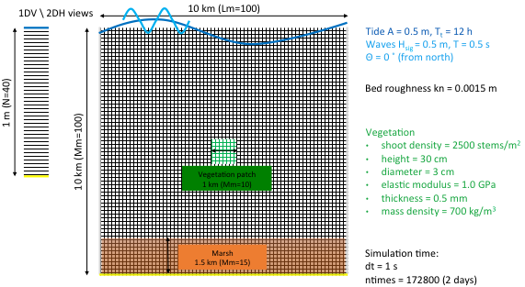

*Figure 1: Schematic showing vegetation and marsh domains*

**The case is currently setup to run with 24 processors.**

Coupling schematic from AB's paper:

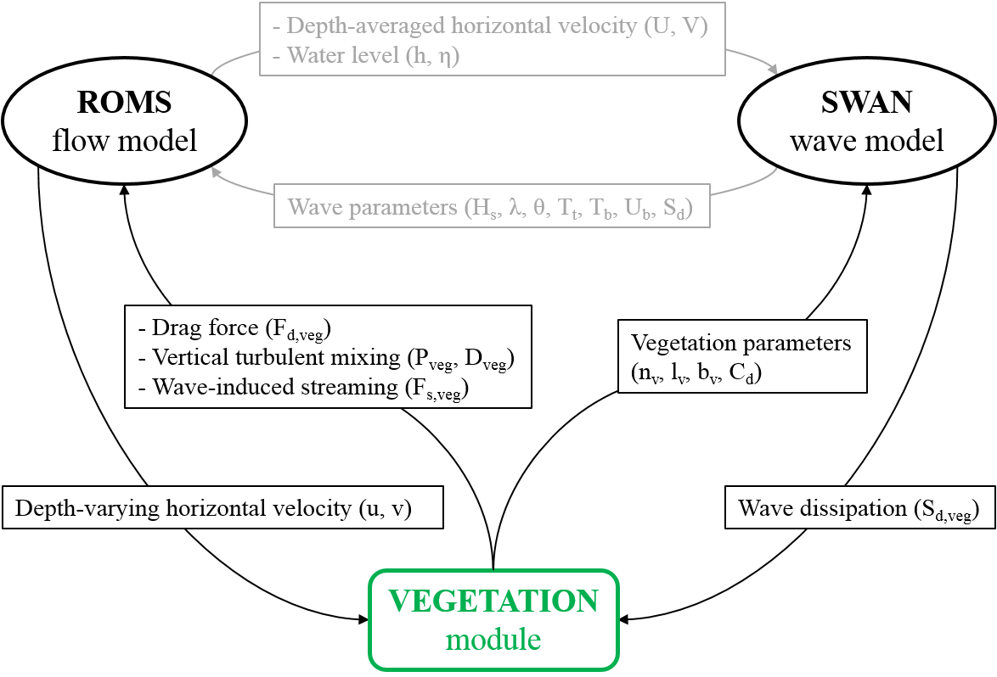

*Figure 2: Diagram showing data exchanges between the flow model, the wave model, and the vegetation module in COAWST. (Beudin et al. 2016)*

**The case requires these ROMS+SWAN input files**

1. coupling_veg_test.in

2. "ocean_veg_test.in" ROMS input

-veg1_init_marsh.nc (ROMS input file)

3. "sediment_veg_test.in" ROMS sediment input (is not altered)

4. "swan_veg_test.in" SWAN input file

- square_xygrid_slope.nc

- swan_bathy_slope.bot

5. "vegetation.in" Vegetation input file

6. "ana_fsobc.in"

**List of flags for the case**

*#define ROMS_MODEL*

*#define SWAN_MODEL*

*#define MCT_LIB*

*#define UV_VIS2*

*#define MIX_S_UV*

*#define MASKING*

*#define WET_DRY*

*#define WET_DRY_LIMIT*

*#define UV_ADV*

*#undef UV_COR*

*#define TS_MPDATA*

*#define DJ_GRADPS*

*#define SOLVE3D*

*#define SPLINES*

*#define WEC_VF*

*#define BOTTOM_STREAMING*

*#define WDISS_WAVEMOD*

*#define UV_KIRBY*

*#undef ANA_INITIAL*

*#define ANA_FSOBC*

*#define ANA_M2OBC*

*/* define only one of the following */*

*#undef UV_LOGDRAG*

*#define SSW_BBL*

*#ifdef SSW_BBL*

*# define SSW_CALC_ZNOT*

*#endif*

*#define VEGETATION*

*# ifdef VEGETATION*

*# undef ANA_VEGETATION*

*# define VEG_DRAG*

*# ifdef VEG_DRAG*

*# undef VEG_FLEX*

*# undef VEG_TURB*

*# endif*

*# define VEG_SWAN_COUPLING*

*# ifdef VEG_SWAN_COUPLING*

*# define VEG_STREAMING ! dependence to WEC_VF/BOTTOM_STREAMING*

*# endif*

*# define WAVE_THRUST_MARSH*

*# endif*

*#ifdef SOLVE3D*

*# define GLS_MIXING*

*# ifdef GLS_MIXING*

*# define KANTHA_CLAYSON*

*# define N2S2_HORAVG*

*# endif*

*# undef SEDIMENT*

*# ifdef SEDIMENT*

*# define SUSPLOAD*

*# undef BEDLOAD_SOULSBY*

*# undef BEDLOAD_MPM*

*# undef SED_MORPH*

*# endif*

*# if defined SEDIMENT || defined SG_BBL || defined MB_BBL || defined SSW_BBL*

*# undef ANA_SEDIMENT*

*# endif*

*# define ANA_SMFLUX*

*# define ANA_STFLUX*

*# define ANA_SSFLUX*

*# define ANA_BPFLUX*

*# define ANA_BTFLUX*

*# define ANA_BSFLUX*

*# define ANA_SPFLUX*

*# define ANA_SRFLUX*

*#endif*

*#define DIAGNOSTICS_UV*