COAWST

User’s Manual

Version 3.9

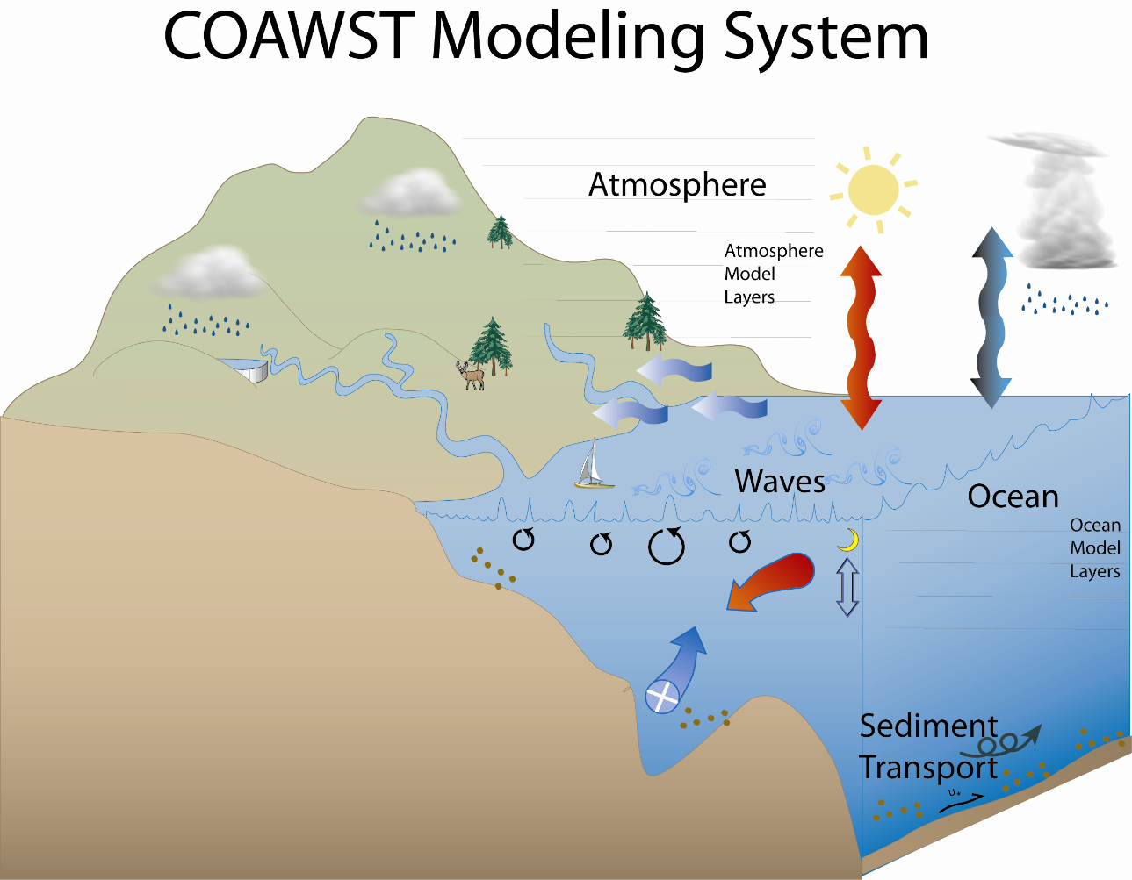

http://woodshole.er.usgs.gov/operations/modeling/COAWST/index.html

September 15, 2026

"Although this program has been used by the USGS, no warranty, expressed or implied, is made by the USGS or the United States Government as to the accuracy and functioning of the program and related program material nor shall the fact of distribution constitute any such warranty, and no responsibility is assumed by the USGS in connection therewith."

Table of Contents.

1. Introduction

2. Accessing COAWST

3. Required libraries for model installation

4. Setting up and running applications

5. Compiling and Running

6. Distributed Projects/examples

7. Visualization Tools

8. Setting up a WRF application

9. Setting up a ROMS application

10. Setting up a SWAN application

11. Setting up a WAVEWATCH III application

12. Setting up a Coupled Application

13. Setting up an InWave application

14. MATLAB (.m) scripts for pre/post processing

15. Tracking model development changes log

16. Previous COAWST training workshops and Data

17. List of References and Acknowledgements

COAWST User’s Manual

1. Introduction
The Coupled-Ocean-Atmosphere-Wave-Sediment Transport (COAWST) Modeling System is an agglomeration of open-source modeling components that has been tailored to investigate coupled processes of the atmosphere, ocean, and waves in the coastal ocean. The modeling system currently contains:

Coupler: - Model Coupling Toolkit (MCT) v 2.11
Ocean: - Regional Ocean Modeling System (ROMS) 4.3
Atmosphere: - Weather Research and Forecasting Model (WRF) v 4.8.0
- WRF Preprocessing System WPS v 4.7
Wave(s): - Simulating Waves Nearshore (SWAN) v 41.51A
- WAVEWATCH III (WW3) v 7.14.2
- Infragravity wave model (InWave) v 2.0
Sediment Transport: - Community Sediment Transport Modeling Systems (CSTMS)

Here are some model specific user forums that can provide useful information:

MCT
http://www.mcs.anl.gov/research/projects/mct/

ROMS
https://www.myroms.org/forum/index.php
https://github.com/myroms/roms

WRF
https://github.com/wrf-model/WRF

SWAN
http://swanmodel.sourceforge.net/

WAVEWATCH III
https://github.com/NOAA-EMC/WW3

The main reference for the COAWST modeling system is:
Warner, J.C., Armstrong, B., He, R., and Zambon, J.B., 2010, Development of a Coupled Ocean-Atmosphere-Wave-Sediment Transport (COAWST) modeling system: Ocean Modeling, v. 35, no. 3, p. 230-244.

The main website is:
https://www.usgs.gov/centers/whcmsc/science/coawst-a-coupled-ocean-atmosphere-wave-sediment-transport-modeling-system

2. Accessing COAWST
The suggested method to get the code is from the github site here:
git clone https://github.com/DOI-USGS/COAWST

You can then get updates using: git pull

For bug reports and Discussion, we are currently using the git issues at:
https://github.com/DOI-USGS/COAWST/issues

The code is also available at https://code.usgs.gov/coawstmodel/COAWST where we put tagged releases and other long term versions. Both sites are now mirrored and should be the same.

3. Required libraries for model installation
The following libraries are required to run the coupled modeling system. These are:
- Fortran Compiler
- NetCDF
- MPI
- MCT
- SCRIP_COAWST
These libraries/programs only need to be installed once, typically by an administrator, and set to be available for all users.

- Fortran Compiler: The system has been tested with several different fortran compilers, including ifort and gfortran. Each compiler is different and the same compiler will have multiple versions. We cannot test them all, but have tried many configurations. You need to use the same fortran compiler to install/compile NetCDF, MPI, MCT, SCRIP_COAWST, and then to compile COAWST itself. Some compilers are free, and some have a cost.

- NetCDF is a common data format that can be freely acquired from
http://www.unidata.ucar.edu/software/netcdf/ The models WRF, ROMS, and SWAN can each individually use NetCDF with the fortran interface. As of COAWST release v3.2, we require NetCDF v4.x for the SCRIP_COAWST interpolation weights package. We therefore require NetCDF v4.x for full model support. You need to set your environment variables so the system knows where to locate the netcdf files. The way to set environment variables is different for each system, so you may need to use “setenv” or “export” or some other command, but an example is listed here:
setenv NETCDF_INCDIR /PATH_TO_YOUR_NETCDF/include
setenv NETCDF_LIBDIR /PATH_TO_YOUR_NETCDF/lib
setenv NETCDF /PATH_TO_YOUR_NETCDF/
setenv NETCDF_CONFIG /PATH_TO_YOUR_NETCDF/nc-config
The settings of NETCDF_INCDIR and NETCDF_LIBDIR are for ROMS. These will be set during the compilation if you set USE_NETCDF4=on in the build_coawst.sh, and if your system has nf-config. The setting of NETCDF is for WRF. The setting of NETCDF_CONFIG is for WAVEWATCH III.

- MPI is a message passing interface software to allow the models to utilize multiple processors. There are many types and versions and we have tested mvapich, openmpi, and MPICH2. MPI is required to run any coupled (more than 1 model) simulation. Some of these are free.

- MCT is the Model Coupling Toolkit, and is freely available from http://www.mcs.anl.gov/research/projects/mct/. We recommend you use the version provided with this distribution in COAWST/Lib/MCT, as it has been slightly modified and tested to be compatible with COAWST.

MCT installation
1) Copy the MCT package from COAWST/Lib/MCT and place into a folder that can be shared to all users. It is recommended to only install this once, and just let all users link to this for all their compilations.
2) ./configure
This will create a file Makfile.conf. You should edit this file and see if the paths are correct. Alos, make sure the compiler flags are the same as needed for your system. For example, if your flags need to use –assume-byterecl (ifort) or -frecord-marker=4 -fconvert=big-endian (gfortran) then add these compiler flags. I included the file Makefile.conf_jcw as an example of how my setup was on a Windows machine.
3) make
This will build the package in both the mct and mpeu directories. I modified the Makefiles in both of those directories so that they can also work in a Windows world. The Windows compilers typically build *.obj files, instead of just *.o files. So I modified the mct/Makefile and mpeu/Makefile for the $(F90RULECPP). You can edit those files and see the changes.
4) make install
This will place the MCT libraries and include files into the locations listed at the bottom of the Makefile.conf file. You can change these locations if you want to, but they typically are something like /usr/lib and /usr/include.
5) Set your environment variables so the system knows where to locate required files. The way to set environment variables is different for each system, so you may need to use “setenv” or “export” or some other command, but an example is listed here:
setenv MCT_INCDIR /usr/include
setenv MCT_LIBDIR /usr/lib [or whatever the actual paths are]

- SCRIP_COAWST (NEW feature for v3.9 – automatically generates files)
The spherical coordinate remapping interpolation package (SCRIP) is freely available from http://oceans11.lanl.gov/trac/SCRIP. This package is required when you have an application using more than one model and the models are using different grids (different spatial extents and/or different number of mesh points), or if you have nesting. This SCRIP code will generate interpolation weights that are used to conservatively remap data fields between the model grids. This original SCRIP package has been modified for COAWST v3.2 and later. As of COAWST v3.9, the SCRIP package will be automatically compiled when you compile the code. Also, as of COAWST v3.9, the SCRIP package will be automatically called at the beginning of the model run. The code will check to see if the scrip weights file exists. If the file does not exist, then it will be generated. If the file does exist, then it will just be used.

Alternatively, you can use SCRIP to make the weights file before the run. You would compile SCRIP and then run the executable to generate a single netcdf file that holds all the interpolation weights for any number of grids. To work with SCRIP_COAWST package, the user needs NetCDF.4.x to have the netcdf group feature available.
SCRIP_COAWST installation (not needed for v3.9 and later)
1) Copy the COAWST/Lib/SCRIP_COAWST package and place into a folder that can be shared to all users. It is recommended to only install this once, and just let all users link to this for all their compilations.
2) Edit the makefile to enter the fortran version that is installed, for example, set
FORT = ifort (or whatever compiler you use)
3) You can build SCRIP using MPI, then it will run with multiple processors. set:
USE_MPI=on # distributed-memory parallelism
USE_MPIF90=on # compile with mpif90 script
4) type “make” at the command prompt.
5) This should compile to create an executable called scrip_coawst[.exe]
If you build scrip using MPI, then scrip can be run using multiple processors.
See Section 5.2 for details on how to use and run this SCRIP program.

Section 4. Setting up and running applications

The COAWST system is designed to allow the user to select any combination of the main models (WRF, ROMS, SWAN, WAVEWATCH III, or InWave). All of these main models compile in a different way, but we need to have one consistent approach to compile the complete coupled system. This procedure is based on the method to build the ROMS code, with additional options for each model and the coupled system. The user needs to list:

- cpp options to select the model(s) (Section 4.1)

- cpp options for each model (Section 4.2)

- cpp options for the coupled system (Section 4.3)
This is accomplished by listing the options in a header control file, let’s call it project.h. This project.h file will list cpp (c pre-processor) choices that determine which options in the code are compiled. These options are listed below and some are described further in the test examples section.

4.1 CPP options to select the model(s)
These are REQUIRED cpp option(s). This allows the user to activate a single model or multiple models. Specify which model(s) you want to use:
#define ROMS_MODEL /* if you want to use the ROMS model */
#define SWAN_MODEL /* if you also want to use the SWAN model */
#define WRF_MODEL /* if you also want to use the WRF model */
#define WW3_MODEL /* if you also want to use the WW3 model */
#define INWAVE_MODEL /* if you also want to use the InWave model */

As of COAWST v3.2, the system can run any set of model choices. As of COAWST v3.9, we have expanded the choices. WW3 can have any number of grids.
Also, you can have multiple grids on the same nested level.
WRF only, ROMS only, SWAN only, WW3 only,
WRF+ROMS, WRF+SWAN, ROMS+SWAN, WRF+ROMS+SWAN
WRF+WW3, ROMS+WW3, WRF+ROMS+WW3,
ROMS+INWAVE
We can also run:
- SWAN only with or without grid refinement,
- ROMS only with or without grid refinement,
- WRF only with or without grid refinement (static + moving nest)
- ROMS+SWAN+WRF with grid refinement in all 3 (WRF with static or moving nest). There can be multiple moving nests for WRF.
- ROMS+WW3+WRF with grid refinement in all 3 (WRF with static or moving nest). There can be multiple moving nests for WRF.

4.2 CPP options for each model
Each model may have individual options that can be set for compilation. These are described below.
- For WRF: there are no additional cpp options that need to be listed in the project.h file at this time. Most options are set in the namelist.input and determined during the build.
- For WAVEWATCH III: there are no additional cpp options that need to be listed in the project.h file at this time. Most options are set in the WW3 switch file for the build.
- For SWAN: there are no additional options needed to be listed in the project.h file at this time. Most options are set in the INPUT file. SWAN is built using Cmake and the following switches are activated: -unix -mpi -netcdf
This activated MPI routines, unix environments, and netcdf functionality. Users do not need to list anything at this time.
- For ROMS: The user need to become familiar with the vast number of ROMS cpp options that are available. Please look at the ROMS/Inlcude/cppdefs.h and the ROMS wiki pages https://www.myroms.org/wiki/Documentation_Portal that has a lot of documentation for ROMS cpp options. The user needs to select the ROMS cpp options and list them in the project.h file.

4.3 CPP options for the coupled system.
Below are cpp options specific to COAWST.

4.3.1) To activate model coupling:
#define MCT_LIB /* if you have more than one model selected and you want to couple them.*/

The following cpp options are activated internally. The user should NOT list these in their project.h file.
ROMS_COUPLING – roms is being used and is coupled to another model.
SWAN_COUPLING – swan is being used and is coupled to another model.
WW3_COUPLING – wavewatch3 is being used and is coupled to another model.
WRF_COUPLING – wrf is being used and is coupled to another model.
AIR_OCEAN – wrf and roms are active (other models could also be active).
WAVES_OCEAN – swan-or-wavewatch3 and roms are active (other models could also be active).
AIR_WAVES – swan-or-wavewatch3 and wrf are active (other models could also be active).

4.3.2) Some wave-current cpp options that are available for the coupling include (works with both WW3 and SWAN):
#define UV_KIRBY /* compute "surface-average" current based on Lwave_mean that will be sent from the ocn to the wav model for coupling
Based on Kirby and Chen (1989)*/
-- or -----
#define UV_BANIHASHEMI /* compute "surface-average" current based on each wave number that will be sent from the ocn to the wav model for coupling based on “Approximation of Wave Action Flux !
Velocity in Strongly Sheared Mean Flows', Banihashemi, Kirby, and Dong. (2017). Ocean Modelling 116, 33-47. */
- To use this option with SWAN, you just need to use #define UV_BANIHASHEMI
- To use this option with WW3, you need to use #define UV_BANIHASHEMI and add CURSP to the switch file.
--- or ----
#define UV_CONST /* send vel = 0 from the ocn to wave model */
If you don’t define either Kirby, Banihashemi, or Const, then the model will send the surface currents (for a 3D) application or depth-avg currents for 2D.

#define ZETA_CONST /* send zeta = 0 from the ocn to wave model */
#define SST_CONST /* do not send sst data from roms to wrf */

Stokes calcluations can be 2 choices (works with both WW3 and SWAN):
#define BULK_STOKES - uses bulk quantities of Hwave, Dwave, and Pwave to
compute stokes velocities
-- or –
#define SPECTRUM_STOKES – uses spectral values from WW3 or SWAN based on
Liu et al (2021). See Wec/wec_stokes.F (default)

4.3.3) Atmosphere and Wave coupling cpp options:

#define ATM2OCN_FLUXES
This option specifies that the heat, moisture, and momentum fluxes as computed by the atmosphere model will be used in the ocean model. This will allow both models to be using the identically same fluxes at the interface. When using this option, you should also use

#undef BULK_FLUXES
because the fluxes will be computed by wrf depending on the surface scheme you select.

# define WAV2OCN_FLUXES (new for COAWST v3.9)
This option computes the ocean surface momentum flux based on the wave source term input as:
$$τ_{oc}=τ_{a}-ρ_{w}g\int_{0}^{2π}{\int_{0}^{∞}{\frac{k}{ω}S_{in} dω dθ}}$$
This option is only available with WW3 (not SWAN) coupling to ROMS. For this option, activate #define BULK_FLUXES so that roms will comute the heat and moisture fluxes, and then the momentum (sustr and svstr) in roms will be replaced with the momentum fluxes from WW3.

At this point in COAWST v3.9, The WAV2OCN_FLUXES can not be combined with ATM2OCN_FLUXES.

If you are just coupling WW3 + ROMS (no WRF), then use
#define WAV2OCN_FLUXES
#undef ATM2OCN_FLUXES
#define BULK_FLUXES

If you are coupling WW3 +ROMS + WRF, then we suggest you use
#undef WAV2OCN_FLUXES
#define ATM2OCN_FLUXES
and also activate #define Z0_WAV_SIN (described below).
This will send a roughness computed in WW3 from the wave source Sin term and send that roughness to WRF. This will be a more consistent approach for momentum, as WRF is using a bottom roughness based on the wave input term, and ROMS will be using a surface stress computed by WRF based on that wave Sin term.

4.3.4) Methods for grid interpolation.
#define MCT_INTERP_WV2AT /* this allows grid interpolation between the wave and atmosphere models */
#define MCT_INTERP_OC2AT /* this allows grid interpolation between the ocean and atmosphere models */
#define MCT_INTERP_OC2WV /* this allows grid interpolation between the ocean and wave models */
- If you use different grids for the ocean, atmosphere, or wave models, then you need to activate the appropriate option above so that the data fields are interpolated between grids.
- If you only have 1 ROMS and 1 SWAN (or 1 WW3) grid, and they are the same grid, then you don’t need these options.
- If you have a coupled application with NESTING in ROMS or SWAN or WW3 or refinement in WRF, then you need to use the appropriate interpolation flag because all the grids talk to all the other grids (for example all WRF grids would communicate to all the ocean grids).
- If you need any of these _INTERP_ cpp options, then you need to create interpolation weights using SCRIP_COAWST. As of COAWST v3.9, this interpolation weights file will be created automatically. This is described in Section 5 below.

4.3.5) Methods for grid refinement.
#define NESTING /* this activates grid refinement in ROMS or SWAN or WW3.*/
- ROMS has one-way, two-way, and composed grids nesting.
- SWAN has one-way grid refinement.
- WW3 has 2-way grid refinement.
- WRF has two way nesting and composed grids.
- As of COAWST v3.2, if you are running a simulation with nesting, the models can all have different number of grids. The test case INLET_TEST_REFINED (explained below) is an example where both roms and swan are coupled, with grid refinement, and coupling on the refined grids. The test case SANDY is an example with 3 grids for roms, 3 for swan or 3 for WW3, and 2 for wrf (2 static – or -- 1 static + 1 moving).
- As of COAWST v3.9, the models can have multiple nests on the same level. For example, in the Sandy test case, we have 1 ROMS parent grid, and 2 nests on the same next level (both nest 1 and nest 2 are children of the same parent grid). This also works for SWAN and WW3 (they can have multiple nests on the same level).
- If the grids for ROMS, SWAN, WW3, and WRF are different sizes, then the code will compute the interpolation weights using SCRIP_COAWST for those grid combinations. The number of grids for ROMS is set in the ocean.in file, the number of grids for SWAN set in the swan.in file, and for WRF set in the namelist.input file.

If your simulations have more than 1 model, and at least one of those models has multiple grids, then the code (as of COAWST v3.9) will automatically create the interpolation weights file using the SCRIP_COAWST library. This creates the netcdf weight files that need to be listed in the coupling.in file.

4.3.6) SWAN –or- WAVEWATCH III wave interactions to ROMS or to WRF:
The following 5 options are available to allow exchange of wave data to ROMS for use in bulk_fluxes for computation of ocean surface stress, and to allow exchange of wave data to WRF for use in MYJSFC and MYNN surface layer schemes to allow increased bottom roughness of the atmosphere over the ocean:

#define COARE_TAYLOR_YELLAND
Taylor, P. K., and M. A. Yelland, 2001: The dependence of sea surface roughness on the height and steepness of the waves. J. Phys. Oceanogr., 31, 572-590.
Works with WW3 or SWAN.
$$\frac{z_{0m}}{H_{s}}=1200{\left(\frac{H_{s}}{L_{p}}\right)}^{4.5}$$

#define COARE_OOST
Oost, W. A., G. J. Komen, C. M. J. Jacobs, and C. van Oort, 2002:New evidence for a relation between wind stress and wave age from measurements during ASGAMAGE. Bound.-Layer Meteor., 103, 409-438.
Works with WW3 or SWAN.
$$\frac{z_{0m}}{L_{p}}=\frac{25.0}{π}{\left(\frac{u_{*}}{C_{p}}\right)}^{4.5}$$

#define DRENNAN
Drennan, W.M., P.K. Taylor and M.J. Yelland, 2005: Parameterizing the sea surface roughness. J. Phys. Oceanogr. 35, 835-848.
Works with WW3 or SWAN.
$$\frac{z_{0m}}{H_{s}}=3.35{\left(\frac{u_{*}}{C_{p}}\right)}^{3.4}$$
where Hs=significant wave height, 𝑧_0𝑚=ocean surface roughness, 𝑢_∗=wind friction velocity, 𝐶_𝑝 = peak wave celerity,
𝐿𝑝 = peak wave length, and 𝑢∗/𝐶𝑝 = wave age.

#define Z0_WAV_SIN (new for COAWST v3.9)
This options uses the wave source term input (Sin) to compute the roughness sent to WRF. Based on Bidlot, Janssen and Abdalla. 2007.“A revised formulation of ocean wave dissipation and its model impact.” ECMWF Technical Memorandum. 509.
$z_{0m}=\frac{α_{c} {\left(u_{*}\right)}^{2}}{g};$ $α_{c}=\frac{\hat{α}}{\sqrt{1-\frac{τ_{in}}{τ_{a}}}}$ ; $τ_{in}=ρ_{w}g\int_{0}^{2π}{\int_{0}^{∞}{\frac{k}{ω}S_{in}dωdϕ}}$
where z0m is the momentum roughness sent to WRF, u* is the stress in the wave model, g is gravity, a^ is 0.0095, $τ_{a}$is the stress from the ATM model (rho_air u*^2), and $τ_{in}$is the integrated source term computed in the wave model. This option works with WW3 for any source term. This options works for SWAN but only for the Janssen wind growth option.

#define Z0_PORCHETTA (new for COAWST v3.9)
$$z_{0m}=20 H_{S}\cos{(0.45 θ)}{\left(\frac{u_{*}}{c_{p}}\right)}^{3.8\cos{(-0.32 θ)}}+0.11 \frac{ν}{u_{*}};$$
This options uses wave height (Hs) and difference in wind and wave direction ($θ$) to compute atm bottom rroughness. Based on Porchetta S, Temel O, Warner JC, et al. Evaluation of a roughness length parametrization accounting for wind–wave alignment in a coupled atmosphere–wave model. Q J R Meteorol Soc. 2021; 147: 825–846. https://doi.org/10.1002/qj.3948.
Works with WW3 or SWAN.

4.3.7) Implementation of wave-current interaction formulation. The method is described in detail Kumar, N., Voulgaris, G., Warner, J.C., and M., Olabarrieta (2012). Implementation of a vortex force formalism in the coupled ocean-atmosphere-wave-sediment transport (COAWST) modeling system for inner-shelf and surf-zone applications. Ocean Modeling 47, pp 65-95. Cpp options for this are:

#define WEC_VF activate wave-current stresses from Kumar et al. Use this for ROMS+WW3, ROMS+SWAN, or ROMS_INWAVE

#define WDISS_WAVEMOD get depth-limited wave breaking dissipation from a wave model, use this to get dissipation when coupling ROMS to either WW3 or SWAN.

Use either of these 2 below when you are not getting depth limited wave breaking dissipation (ie not using WDISS_WAVEMOD) from WW3 or SWAN. This will compute wave dissipation in ROMS:
#define WDISS_THORGUZA wave dissipation from Thorton/Guza
#define WDISS_CHURTHOR wave dissipation from Church/Thorton

This next option is available with ROMS+SWAN, ROMS+WW3, or ROMS+INWAVE:
# define DISSIP_BREAK_DIR use this to compute and use depth-limited wave reaking dissipation in x- and y- directions instead of using the full value and Dwave to determine the directions.

This next option is available with ROMS+SWAN, ROMS+WW3, or ROMS+INWAVE:
Select one of the 3 following options for a roller model.
#define ROLLER_SVENDSEN wave roller based on Svendsen
#define ROLLER_MONO wave roller for monchromatic waves
#define ROLLER_RENIERS wave roller based on Reniers - suggested.

These next options are available with ROMS+SWAN, ROMS+WW3, or ROMS+INWAVE: Select one or both of the bottom and/or surface wave streaming.
#define BOTTOM_STREAMING wave enhanced bottom streaming
If you defined bottom streaming, then you can also select one of these 2 options:
#define BOTTOM_STREAMING_YU
#define BOTTOM_STREAMING_XU_BOWEN

#define SURFACE_STREAMING wave enhanced surface streaming

4.3.8) Drag limiter option.
#define DRAGLIM_DAVIS is a feature added to WRF and SWAN to limit the ocean roughness drag to be a maximum of 2.85E-3, as detailed in:
Davis et al, Prediction of Landfall Hurricanes with the Advanced Hurricane WRF Model, Monthly Weather Review, 136, pp 1990-2005.

In SWAN, this can be activated when using the Komen wind input. For WRF, it can be activated when using myjsfc or mynn surface layer options.

4.3.9) Vegetation options.
Vegetation module was added to get the 3-D effect of vegetation on wave and current fields. Details of the implementation are in this paper:
Beudin, A., Kalra, T. S., Ganju, N. K., and Warner, J.C. (2016). Development of a coupled wave-flow-vegetation interaction module. Computers and Geosciences, http://dx.doi.org/10.1016/j.cageo.2016.12.010.

The following flags can be used to work with the vegetation module.
# define VEGETATION Switch on vegetation module
# define VEG_DRAG Drag terms Luhar M. et.al (2011)
# define VEG_FLEX Flexible vegetation terms
# define VEG_TURB Turbulence terms, Uittenbogaard R. (2003)
# define VEG_SWAN_COUPLING Exchange of VEG data btwn. ROMS and SWAN
# define VEG_STREAMING Wave streaming effects

Within the vegetation module, we can use two processes to account for marsh dynamics: (a) Lateral wave thrust on marsh edge and (b) vertical accretion due to biomass production and change in marsh vegetation properties.
# define MARSH_DYNAMICS Main kernel to call marsh routines
# define MARSH_WAVE_THRUST Lateral wave thrust calculation
# define MARSH_SED_EROSION Calculate sediment release due to wave thrust
# define MARSH_RETREAT Lateral retreat calculation
# define MARSH_VERT_GROWTH Vertical accretion module
# define MARSH_TIDAL_RANGE_CALC Calculates mean high high water and tidal range
There are two choices for vertical growth module
# define MARSH_KIRWAN_FORMULATION Kirwan’s parabolic formulation
# define MARSH_MCKEE_FORMULATION Mckee’s parabolic formulation
# define MARSH_BIOMASS_VEG Updates the stem density from marsh biomass

4.3.10) Estuarine biogeochemistry flags
This routine is a modification of Fennel et al. (2006) ecosystem model to include the Submerged Aquatic Vegetation (SAV) growth model that allows for the fully coupled water column biogeochemistry-sediment-hydrodynamics model.

# define ESTUARYBGC Modification of Fennel module
# define SPECTRAL_LIGHT Spectral light model
# define SAV_BIOMASS SAV biomass growth model
# define SAV_BIOMASS_DAILY_UPDATE Only update SAV properties daily

4.3.11) InWave options.
The following additional cpp options are specific to run the InWave model:
# define INWAVE_MODEL activate InWave model
# define INWAVE_SWAN_COUPLING activate reading of a SWAN 2D spec file
# define DOPPLER use to turn ON or OFF the effect of currents on the dispersion relation
# define ACX_ADVECTION use to turn ON or OFF advection of Ac in the xi direction
# define ACY_ADVECTION use to turn ON or OFF advection of Ac in the etai direction
# define ACT_ADVECTION use to turn ON or OFF advection of Ac in the directional direction

Select one of these 2 depth-limited wave breaking dissipation options:
#define WDISS_GAMMA wave dissipation computed in InWave model based on fractional depth
#define WDISS_ROELVINK wave dissipation from InWave model based on: Roelvink, J. A. (1993). Dissipation in random wave groups incident on a beach. Coastal Engineering, 19(1), 127–150. https://doi.org/10.1016/0378-3839(93)90021-Y

Select either or both of these:
# define WDISS_FRIC use this to activate energy loss due to bottom friction.
# define INWAVE_HSCALE use this to scale the wave heights along the open boundary to match the average input wave conditions.

The InWave model is described more in Section 11. For now you can run InWave forced with a SWAN 2D spec file, or you can impose the wave action density along an open boundary. InWave runs coupled to ROMS for wave-current feedbacks, typically run with the WEC options, wetting drying, sediment, and morphology.

4.3.12) Bottom boundary layer dynamics.
The model has several options for bottom stress computations. The user can choose one of the following 5 options. The first 2 do not need waves, the last 3 do require waves:
#define UV_LOGDRAG use to activate logarithmic bottom stress.
#define UV_QDRAG use to activate quadratic bottom stress.
#define MB_BBL use to activate MB bottom boundary layer
#define SG_BBL use to activate SG bottom boundary layer
#define SSW_BBL use to activate SSW bottom boundary layer

If the SSW BBL is chosen, there are several other options, based on Warner, J.C., Sherwood, C.R., Signell, R.P., Harris, C.K., and Arango, H.G., (2008) “Development of a three-dimensional, regional, coupled wave, current, and sediment-transport model.” Computers and Geosciences, 34, 1284-1306.

#define SSW_CALC_ZNOTactivates the bottom roughness to be computed in SSW, using the sediment roughness.
If you activate SSW_CALC_ZNOT, you can also add to the bottom roughness:
#define SSW_ZOBL add roughness due to bed load transport.
#define SSW_ZORIP add roughness due to ripples.
#define SSW_ZOBIO add roughenss due to biology.
If you do not activate SSW_CALC_ZNOT, the code will use the Z0 from the ocean.in file

#define SSW_LOGINT activates logarithmic interpolation of horizontal velocity components in the water column to get near bottom current velocity used in the bbl computation.
If you activated SSW_LOGINT, then choose one of these 2:
#define SSW_LOGINT_WBL use the wave boundary layer height
#define SSW_LOGINT_DIRECT use a user defined elevation
#define SSW_LOGINT_STOKES This is automatically activated if you have WEC_STOKES on.

Other options include:
#define SSW_CALC_UB if you are not coupled to a wave model, you can use this option to have ROMS compute the bottom orbital velocity and wave amplitude based on Hsig and bottom period.
#define SSW_FORM_DRAG_COR use this to modify the computed bottom stress to include bed form roughness.

4.3.13) Sediment bedload and asymmetric wave driven formulations.
The model has one option for Suspended load
#define SUSPLOAD uses erosion rate suspended load option.

The model has 3 choices for bedload
#define BEDLOAD_MPM uses Meyer Peter Muller method
#define BEDLOAD_SOULSBY uses Sousby bedload method
#define BEDLOAD_VANDERA uses method from vanDerA
van der A, D.A., Ribberink, J.S., van der Werf, J.J.,O'Donoghue, T., Buijsrogge, R.H., Kranenburg, W.M., (2013). Practical sand transport formula for non-breaking waves and currents. Coastal Engineering, 76, pp.26-42.
If you use BEDLOAD_VANDERA, and SSW_BBL, then there are othere options. You can select any or all of these 3:
#define BEDLOAD_VANDERA_ASYM_LIMITS: Original observations consisted a maximum Ursell number of 24 and we have capped to the skewness parameters to that limit.
#define BEDLOAD_VANDERA_SURFACE_WAVE: To include the modification of crest and trough periods in the presence of currents
#define BEDLOAD_VANDERA_WAVE_AVGD_STRESS: Boundary layer streaming term that would enhance crest transport
The Vandera calculation requires current based friction factor at the top of wave boundary layer. You should select one of these 2:
#define BEDLOAD_VANDERA_MADSEN_UDLETA Use Madsen (in conjunction with SSW BBL) formulation to get current friction factor and the near bottom current velocity. This would go along with #define SSW_LOGINT_WBL.
#define BEDLOAD_VANDERA_DIRECT_UDELTA Compute current friction factor with a user defined fixed elevation of wave boundary layer. This would go along with #define SSW_LOGINT_DIRECT.

4.3.14) FLOATS options. We added 2 new options with the floats:

#define FLOATS_WINDS – adds 0.01* wind speed to the u current and v current.

#define FLOATS_STOKES – adds the stokes velocities to the eulerian drift currents.

Section 5. Compiling and Running

This section describes how to:
5.1- How to Compile and Run COAWST
5.2- How to Compile and Run SCRIP_COAWST (for v3.9 this is not needed).
5.3- Some general helpful tips and a few new functionalities.

5.1 To Compile and Run COAWST
First, make sure that you read Section 3 and you have selected a Fortran Compiler and then used that compiler to build and install all the required libraries of: NetCDF, MPI, and MCT.

To compile COAWST, you need to use the build_coawst.sh file. This file is at the COAWST root level. You need to edit the build_coawst.sh to set the options specific to your system and to choose the location of the projects.h file (described in Section 4). Some important parts are:

export COAWST_APPLICATION=INLET_TEST
Use capital letters to list the application name (in this example the application name is INLET_TEST). This needs to be the same name as your project.h file that contains all your cpp options (See Section 4). The project.h file itself can be named in lower case (for example, the COAWST_APPLICATION is INLET_TEST but the file name is inlet_test.h).

export MY_ROOT_DIR=/cygdrive/d/models/COAWST
export MY_PROJECT_DIR=${MY_ROOT_DIR}
The rootdir is the location of the source code. You can have a project dir that you work in. I typically make a new copy of the code each time in case I change something and this means I have multiple rootdirs. Then I can always go back and see exactly the version of code that was used for a particular run. Therefore I set the project dir as the same location as the rootdir.

export MY_ROMS_SRC=${MY_ROOT_DIR}/
Keep this the same as listed here.

For WAVEWATCH III we now have 2 environment variables:

export COAWST_WW3_DIR=${MY_ROOT_DIR}/WW3
The COAWST_WW3_DIR is a pointer to root WW3 code, do not change.

export WW3_SWITCH_FILE=${MY_PROJECT_DIR}/Projects/Sandy/WW3/switch_sandy This switch file is used by WAVEWATCHIII. It is like the roms project.h file. You need to create and enter the name of the file (see Section 11 for more information).

There are several compiler selections:
export USE_MPI=on
export USE_MPIF90=on
The COAWST system was designed to work with MPI for parallel processor applications. If you set the modeling system to build a coupled application, then it will always produce an executable “coawstM”. If you set to build an individual model and also set MPI=on, then you will get a “coawstM.”

export FORT=ifort
You can set this to be ifort, pgi, or gfortran. Other choices may work.

Header and other source directories:
export MY_HEADER_DIR=${MY_PROJECT_DIR}/Projects/Inlet_test/Coupled
export MY_ANALYTICAL_DIR=${MY_PROJECT_DIR}/Projects/Inlet_test/Coupled
Use these to set the locations for you application. Header dir is where your project.h file is located. The analytical dir is where analytical files are located, I usually use the same location for both.

After you edit the build_coawst.sh file you need to run it. To build everything you use:
./build_coawst.sh –j X
(the –j says to use ‘X’ number of processors, for example ./build_coawst.sh -j 20).

Another handy tool is the script command
http://www-users.cs.umn.edu/~skim/cs1901/script.html
You could use:
script coawst.log
./build_coawst.sh -j 10
exit
and then save that coawst.log file to see how the system was built.

The system may take a while to build, especially with WRF. If it was successful, then you will get a coawstM or coawstM.exe file. If you get that file then the build was successful. In some instances you may see an error or warning “undefined wrf.main.” That is the only error that is ok. We can not allow a wrf.exe to be built, nor an ocean.exe, and/or swan.exe to be created. Only one executable is created, and that is called coawstM[.exe].

To Run COAWST, you need to use a shell run script that is dependent on your system. One example of a shell run script used on a PBS system is the file run_nemo:

#!/bin/bash
### Job name
#PBS -N cwstv3
### Number of nodes
#PBS -l nodes=2:ppn=8
### Mail to user
#PBS -m ae
#PBS -M jcwarner@usgs.gov
#PBS -q standard

umask 0002

echo "this job is running on:"
cat $PBS_NODEFILE

NPROCS=`wc -l < $PBS_NODEFILE`

cd /raid1/jcwarner/Models/COAWST_regress/COAWST_v3.3

mpirun -np 16 -machinefile $PBS_NODEFILE ./coawstM Projects/Inlet_test/Couped/coupling_inlet_test.in > cwstv3.out

You need to talk to your system administrator to get a shell run script for your computer system. Not that the mpirun command calls the coawstM and then lists an input file (described below).

To run/submit the the job, you would use the command
qsub run_nemo

To check job status
qstat –an
qstat –f

To kill the job use
qdel ‘pid’ where pid is the job number.

On a SLURM system, the commands are squeue, and sbatch. Please check with your system administrator for specific commands on your system.

Command Run File: coupling.in
To Run COAWST, your shell run script points to an input file.
- If you compiled COAWST for ROMS only, then your run script should point to the ocean.in ROMS input file.
- If you compiled COAWST for SWAN only, then your run script should point to the INPUT file (s) for SWAN.
- If you compiled COAWST for WW3 only, then your run script should point to the ww3_grid.inp for no nesting, or to the ww3_multi.inp for nesting for WW3.
- If you compiled COAWST for WRF only, then your run script should point to the namelist.input file for WRF.
- If you compiled COAWST for more than 1 model (coupled), then your run script must point to a coupling input file. The coupling.in file then lists all the files for ROMS SWAN WW3 and or WRF. The details of this file are:

Step1) Set the nodes to allocate for each model. This will depend on the application, number of processors you have access to, etc.
! Number of parallel nodes assigned to each model in the coupled system.
! Their sum must be equal to the total number of processors.
NnodesATM = 1 ! atmospheric model
NnodesWAV = 1 ! wave model
NnodesOCN = 1 ! ocean model
NnodesHYD = 0 ! hydrology model

Step 2) Set the coupling interval in seconds.
! Time interval (seconds) between coupling of models.
TI_ATM2WAV = 600.0d0 ! atmosphere to wave coupling interval
TI_ATM2OCN = 600.0d0 ! atmosphere to ocean coupling interval
TI_WAV2ATM = 600.0d0 ! wave to atmosphere coupling interval
TI_WAV2OCN = 600.0d0 ! wave to ocean coupling interval
TI_OCN2WAV = 600.0d0 ! ocean to wave coupling interval
TI_OCN2ATM = 600.0d0 ! ocean to atmosphere coupling interval
TI_OCN2HYD = 0.0d0 ! ocean to hydro coupling interval
TI_HYD2OCN = 0.0d0 ! hydro to ocean coupling interval

Step 3) Examples of names of the input files for ROMS, WRF, and SWAN –or- WW3.
! Enter names of Atm, Wav, and Ocn input files.

! For WRF
! The Wav program needs multiple input files, one for each grid.
ATM_name = namelist.input ! atmospheric model

!For SWAN
WAV_name = Projects/Sandy/SWAN/swan_sandy.in ! this is for no nesting.
! ---- or ----
! For SWAN nesting, then use the backslash symbol to make a new line for each grid.
WAV_name = Projects/Sandy/SWAN/swan_sandy.in \
Projects/Sandy/SWAN/swan_sandy_child1.in \
Projects/Sandy/SWAN/swan_sandy_child2.in

!For WW3 uncomment this next line for WW3 no NESTING.
WAV_name = ww3_grid.inp
! ---- or ----
! For WW3 uncomment this next line for WW3 yes NESTING.
WAV_name = ww3_multi.inp

!For ROMS
OCN_name = Projects/JOE_TC/Coupled/ocean_joe_tc.in ! ocean model

! uncomment this next line for Hydrology model.
HYD_name = hydro.namelist

Step 4) We require the use of SCRIP_COAWST Fortran code to create a single weights file. As of COAWST v3.9, this file will be created automatically. But you must list a file name to be created. If the file exists, then the code will just use that file. If the file does not exist, then the code will create that file. This way the file will be available for the next time you run the code with that same setup.

! Sparse matrix interpolation weights files.
! Required if any model has more than 2 grids (ie nesting), or
SCRIP_COAWST_NAME = scrip_weights_joe_tc.nc

5.2- How to Compile and Run SCRIP_COAWST
As of COAWST v3.9, this is library compiled and run automatically. You can still create the scrip file ahead of time if you want. You do not need to fill out this file if you want COAWST v3.9 to run SCRIP_COAWST automatically.
SCRIP_COAWST is required to create a netcdf file that contains interpolation weights. These weights are only needed if you have a coupled application (more than 1 model) and the models are on different grids. To build the SCRIP_COAWST was described in Section 3. To run the program, you need to edit one of the scrip_coawst*.in files. Lets use
COAWST/Lib/SCRIP_COAWST/scrip_coawst_sandy.in as an example.
This Example uses 2 roms grids, 2 swan grids, and 2 wrf grids with the last wrf grid as a moving grid.

Step 1) Enter name of output netcdf4 file
OUTPUT_NCFILE='scrip_sandy_wrf_static_roms_ww3_3grids.nc'

Step 2) Enter total number of ROMS, SWAN, and WRF (max_dom) grids:
NGRIDS_ROMS=3,
NGRIDS_SWAN=0,
NGRIDS_WW3=3,
NGRIDS_WRF=2,
NGRIDS_HYD=0,

Step 3) Enter name of the ROMS grid file(s):
ROMS_GRIDS(1)='../../Projects/Sandy/ROMS/Sandy_roms_grid.nc',
ROMS_GRIDS(2)='../../Projects/Sandy/ROMS/Sandy_roms_grid_child1.nc',
ROMS_GRIDS(3)='../../Projects/Sandy/ROMS/Sandy_roms_grid_child2.nc',
ROMS_PARENT(1)=0,
ROMS_PARENT(2)=1,
ROMS_PARENT(3)=1,

Step 4) Enter SWAN information:
! -the name(s) of the SWAN grid file(s) for coords and bathy.
! -the size of the SWAN grids (full number of grid center points, this is the same as
! size(h) for a roms grid), and
! -if the swan grids are Spherical(set cartesian=0) or
! Cartesian(set cartesian=1).
! -the parent grid number. For the largest grid: the grid id
! number is 1 and my parent is 0.SWAN_COORD(1)='../../Projects/Sandy/SWAN/Sandy_swan_coord.grd',
SWAN_BATH(1)='../../Projects/Sandy/SWAN/Sandy_swan_bathy.bot',
SWAN_NUMX(1)=87,
SWAN_NUMY(1)=65,
SWAN_CARTESIAN(1)=0,
SWAN_PARENT(1)=0,
SWAN_COORD(2)='../../Projects/Sandy/SWAN/Sandy_swan_child1_coord.grd',
SWAN_BATH(2)='../../Projects/Sandy/SWAN/Sandy_swan_child1_bathy.bot',
SWAN_NUMX(2)=110,
SWAN_NUMY(2)=56,
SWAN_CARTESIAN(2)=0,
SWAN_PARENT(2)=1,
SWAN_COORD(3)='../../Projects/Sandy/SWAN/Sandy_swan_child2_coord.grd',
SWAN_BATH(3)='../../Projects/Sandy/SWAN/Sandy_swan_child2_bathy.bot',
SWAN_NUMX(3)=98,
SWAN_NUMY(3)=44,
SWAN_CARTESIAN(3)=0,
SWAN_PARENT(3)=1,

! 5) Enter WW3 information
! -the name(s) of the WW3 grid file(s) for x- y- coords and bathy.
! -the size of the WW3 grids (full number of grid center points).
!
WW3_XCOORD(1)='../../Projects/Sandy/WW3/ww3_xcoord_Sandy_roms_grid.dat',
WW3_YCOORD(1)='../../Projects/Sandy/WW3/ww3_ycoord_Sandy_roms_grid.dat',
WW3_BATH(1)='../../Projects/Sandy/WW3/ww3_bathy_Sandy_roms_grid.dat',
WW3_NUMX(1)=87,
WW3_NUMY(1)=65,
WW3_PARENT(1)=0,
WW3_XCOORD(2)='../../Projects/Sandy/WW3/ww3_xcoord_Sandy_roms_grid_child1.dat',
WW3_YCOORD(2)='../../Projects/Sandy/WW3/ww3_ycoord_Sandy_roms_grid_child1.dat',
WW3_BATH(2)='../../Projects/Sandy/WW3/ww3_bathy_Sandy_roms_grid_child1.dat',
WW3_NUMX(2)=110,
WW3_NUMY(2)=56,
WW3_PARENT(2)=1,
WW3_XCOORD(3)='../../Projects/Sandy/WW3/ww3_xcoord_Sandy_roms_grid_child2.dat',
WW3_YCOORD(3)='../../Projects/Sandy/WW3/ww3_ycoord_Sandy_roms_grid_child2.dat',
WW3_BATH(3)='../../Projects/Sandy/WW3/ww3_bathy_Sandy_roms_grid_child2.dat',
WW3_NUMX(3)=98,
WW3_NUMY(3)=44,
WW3_PARENT(3)=1,

Step 6) Enter the name of the WRF input grid(s). If the grid is a
! moving child nest then enter that grid name as 'moving'.
! Also provide the grid ratio, this is used for a moving nest.
WRF_GRIDS(1)='../../Projects/Sandy/WRF/wrfinput_d01',
WRF_GRIDS(2)='../../Projects/Sandy/WRF/wrfinput_d02',
!WRF_GRIDS(2)='moving',
WRF_PARENT_GRID_RATIO(1)=1,
WRF_PARENT_GRID_RATIO(2)=3,
WRF_PARENT_ID(1)=0,
WRF_PARENT_ID(2)=1,

! 7) Enter the name of the WRF Hydro input grid(s).
!
HYDRO_GRIDS(1)='../../WRF_hydro/forcings/WRF-Hydro/DOMAIN/Fulldom_hires.nc',

Step 8): at the command prompt, run the program as:
./scrip_coawst[.exe] scrip_coawst_sandy.in
This should run and write out information about the weights as it creates the file.
If you compiled with MPI on, then you can run it as
mpirun -np X ./scrip_coawst[.exe] scrip_coawst_sandy.in
where ‘X’ is a number of processors.

5.3 Some general helpful tips and a few new functionalities.
5.3.1) ROMS is sensitive to the vertical coordinate system. The user needs to make sure that the values set in the roms init file are the same as the values set in the ocean.in file. For example the following values are checked for consistency:
Vtransform=2;
Vstretching=4;
theta_s=5.0;
theta_b=0.4;
Tcline=50.0;

N=16;
User should check that these values are the same in their netcdf files as the *.in file. More info is provided at: https://www.myroms.org/wiki/index.php/Vertical_S-coordinate.

5.3.2) ROMS grid files should not have fill values for mask arrays. A command to remove these are:
ncatted -O -a _FillValue,mask_rho,d,, -a _FillValue,mask_u,d,, -a _FillValue,mask_v,d,, -a _FillValue,mask_psi,d,, USeast_grd17.nc

5.3.3) For SWAN, you do not need to specify any OUTPUT commands for the coupling. The coupling and OUTPUT are completely separate. SWAN now offers writing out of files in netcdf. This option is available with the COAWST system.

5.3.4) For WRF, you can have a 2-way nest in WRF, and have this coupled to roms and /or swan. As of COAWST v3.2, we can now couple ROMS and SWAN to a moving WRF nest. As of COAWST v3.8, you can have multiple moving WRF nests.

5.3.5) For WRF-ROMS coupling, you really should set
sst_update = 1
in namelist.input and use the appropriate io_form_auxinput4 settings. This is correct in svn 876. The sst_update computes the correct TSK in WRF and should be activated for ocn-atm coupling.

5.3.6) Some information about heat fluxes for WRF-ROMS.
If WRF_MODEL is defined:
- you still have to define EMINUSP to activate exchange of rain and evap.
- SOLAR_SOURCE is needed, otherwise all the heat goes into the surface layer only.
- longwave outgoing component is estimated in Master/mct_roms_wrf.f so there is no need to define LONGWAVE_OUT in ROMS

If WRF_MODEL is not defined or you are going to use BULK FLUXES:
BULK_FLUXES (in bulk_flux.F) computes turbulent heat fluxes (latent and sensible heat), momentum stress and evaporation (used in the fresh water flux if EMINUPS is also defined -used as salinity surface boundary condition-). Radiative fluxes (i.e., shortwave and longwave radiation flux) are not calculated, nor is the rain component of the EMINUSP calculation. The surface scheme (COARE) implemented in bulk_flux.F requires:
- air temperature (usually at 2m)
- relative humidity (usually at 2m)
- mean sea level pressure
- u-wind component (positive east), usually at 10m v-wind component (positive north), usually at 10m.
With these parameters bulk_flux will estimate latent heat, sensible heat, u-momentum stress, v-momentum stress and evaporation. Note that in the ocean.in, you have to specify:
BLK_ZQ (usually 2m)
BLK_ZT (usually 2m)
BLK_ZW (usually 10m)
these numbers should be consistent with the height of the levels of the surface variables (as said usually wind is at 10m, air temp at 2m, humidity at 2m, but this might be different depending on your surface forcing dataset).

Net shortwave should be provided by you meteo forcing. This is not calculated in bulk_flux.f, but is necessary to compute the full heat flux term.
Net longwave: you have several choices:
- provide net longwave in the forcing file
- provide INCOMING longwave in the forcing file and define LONGWAVE_OUT (ROMS then will estimate the outgoing component based on its SST)
- do not provide the longwave but instead total cloud cover (in the forcing file) and ROMS will estimate the net longwave. You do not need to define CLOUD, as it is defined internally by ROMS if def LONGWAVE

If you want the E-P flux, define EMINUSP and provide in the forcing file the variable rain, while, as said, evaporation is estimated in bulk_flux.F.

So, in the end:

#define BULK_FLUXES
#define LONGWAVE or #define LONGWAVE_OUT or provide the net longwave
in the forcing file
#define EMINUSP is needed, otherwise set to zero the surface salinity fux (#define ANA_SSFLUX and set zero stflx(itrc==isalt) in stflux.h)
#define ATM_PRESS if you want the inverted barometric effect (mean sea level pressure must be in the forcing file)

5.3.7) SWAN restart files.
SWAN has the command 'HOTFILE' that is used to write out the model state of two-dimensional spectra to a file at the end of the simulation. This file can be used as a restart for a future simulation. We have recently added the option to have SWAN create restart files during the simulation. This can be useful for a coupled simulation (for example a roms + swan run). If the modeling system reaches a fault during the run, the ROMS model can be restarted with the ROMS rst or his file. Now you can also restart the SWAN model with a restart file for that same instance in time. You need to add the command "RESTART'. For example, the swan.in file would need:

RESTART 'swan_intest_rst.dat' FREE 1 HR

COMPUTE NONSTATIONARY 20000101.000000 60 SEC 20000101.120000
STOP

With this set of commands, swan is going to run from Jan 1, 2000, at hour 0 to Jan 1, 2000 to hour 12, with a 60 sec time step. The 'RESTART' command will update a file called swan_inlet_rst.dat every 1 hour during that simulation. You can make this be any time you require (1 HR or 30 MIN or 12 HR or whatever). It is recommended that the user set the restart times to be the same for WRF, ROMS, and SWAN so that a consistent set of restart files are available.

5.3.8) SWAN 2D Spec files – only create 1 file per simulation.
When SWAN runs on multiple processors, the output from each processor is written into a sepatate file, and at the end of the simulation those files are merged into 1 file. For example, if you wanted 2D spectra output at a location point1, and SWAN is set to run on 20 processors, then during the simulation there will be 20 files created. At the end of the simulation all the files will be merged into 1 file. To reduce the number of files for 2D spec, we have added the option
#define SWAN_SINGLESPEC
This will only allow swan to create a single file, assigned to the processor that the point is being solved on.

6. Distributed Projects/examples.

Application
6.1 Delilah | ROMS+InWave Coupled; 2D wav-cur interaction, IG comparison at Duck, NC.
6.2 Ducknc -ROMS_InWave | ROMS+InWave Coupled: 1D cross-shore profile (x-z) setup to represent Duck, NC but can be modified to be generic.
6.3 Ducknc – ROMS_SWAN | ROMS + SWAN(forcing file). Wave-current interaction (essentially x-z) for cross-shore flows at Duck, NC.
6.4 Estuary_test2 | ROMS only to test estuarine dynamics, prismatic channel.
6.5 Inlet_test/Coupled | Idealized inlet with wave and tidal driven flows. ROMS+SWAN same grids.
6.6 Inlet_test/DiffGrid | Idealized inlet with wave and tidal driven flows. ROMS+SWAN different grids.
6.7 Inlet_test/InWave | Idealized inlet with wave and tidal driven flows. ROMS+InWave same grids, inlet configuration with infragravity waves.
6.8 Inlet_test/Refined | Idealized inlet with wave and tidal driven flows. ROMS+SWAN have the same parent grids for roms and swan and the same child grids for roms and swan.
6.9 Inlet_test/Swanonly | Idealized inlet with waves only. SWAN only one grid, or with grid refinement.
6.10 Inlet_test/WW3 | Idealized inlet with wave and tidal driven flows. ROMS+WW3 same grids.
6.11 InWave_Shoreface | ROMS+InWave same grid, sloping beach.
6.12 JOE_TC/Coupled | Idealized tropical cyclone that travels west from a deep ocean basin onto a shelf that slopes landward to the west. WRF+ROMS+SWAN all 3 on same grid. Also can be used for WRF-ROMS, WRF-SWAN, or WRF only.
6.13 JOE_TC/DiffGrid | Idealized tropical cyclone that travels west from a deep ocean basin onto a shelf that slopes landward to the west. WRF+ROMS+SWAN with ROMS and SWAN on same grid, WRF on different grid.
6.14 Lip
6.15 Rip_current | ROMS+SWAN same grid, idealized rip current.
6.16 Sandy | WRF + ROMS + SWAN or WW3. WRF with 2 grids and can be static or moving nest, coarse resolution of realistic Hurricane Sandy simulation. ROMS, SWAN -or- WW3 each have 3 grids, with nesting on the same refinement level.
6.17 Sed_bed_toy | ROMS only, tests sediment module.
6.18 Sed_floc_toy | ROMS only, tests sediment module with flocculation.
6.19 Trench | ROMS only, test sediment morphology.
6.20 Wetdry | ROMS only, test wetting/drying algorithms.
6.21 Veg_test | ROMS+SWAN, test vegetation module.
6.22 Veg_growth_test | ROMS+vegetation+sediment+water-column biogeochemistry (including spectral light module),  Test Submerged Aquatic Vegetation (SAV) growth model and fully coupled hydrodynamic-SAV-biological and sediment dynamics
6.23 Marsh_test | ROMS+marsh dynamics (lateral wave erosion+biomass growth)

All of the test cases are described below, some in more detail than others. The cases of JOE_TC, Inlet_test, Rip current and Vegetation are examples of how to set up different idealized configurations. The test case Sandy is provided for a more realistic application. The references for the test cases are provided in Section 15.

6.1 Delilah = ROMS+InWave, 2D plan view at Duck NC for infragravity wave study.
This test case was used and described in more detail in the InWave modeling paper:
Olabarrieta, M., Warner, J. C., Hegermiller, C. A. (2023). Development and application of an infragravity wave (InWave) driver to simulate nearshore processes. Journal of Advances in Modeling Earth Systems, 15, e2022MS003205 https://doi. org/10.1029/2022MS003205
The Duck study site had a cross-shore array of pressure and velocity sensors that were used to compute water levels and waves and currents. This test case was set up to simulate the data collected in October 1990 with a grid that is 450x180 cells, gid resolution of 2m and 5m, out to the 8m depth array and approximately 900 m along the coast. The eastern boundary was forced with 2D spectra from the 8m array and model results compared to the observations.
Results: Observed and modeled cross shore zero-order moment wave height in the gravity band (Hm0_hi) and IG band (Hm0_lo) with Δ𝜃 = 10° bins. Black lines represent the mean Hm0_hi (continuous line) and Hm0_hi averaged every 10 min (discontinuous lines). Thin circles are observed Hm0_hi. Thick circles are observed Hm0_lo. Black dots are modeled Hm0_lo.

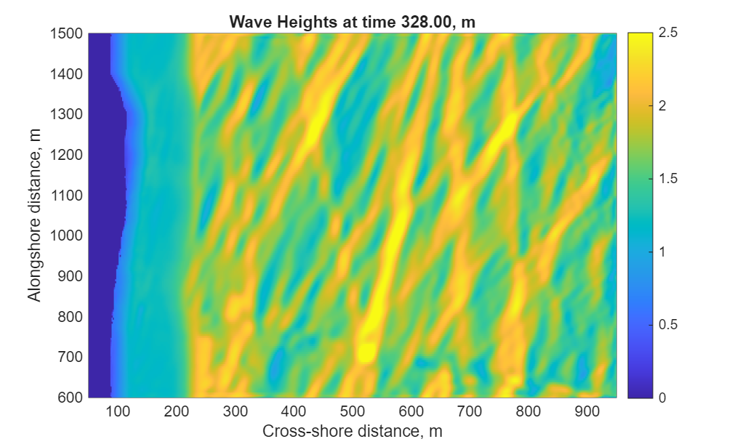
Figure of InWave wave heights at day 328.00 for Delilah.
All the files needed to run this test case are included in the distribution code Projects folder. This application is described in more detail in Section 13.

6.2 DuckNC - ROMS+InWave, Wave-current interaction (x-z) for cross-shore flows at Duck, NC.
This test case is an example of how to set up a cross-shore profile test for ROMS + InWave. This case uses data from Duck, NC but can be adapted to be used anywhere. Some basic steps are outlined below:
1) get data for bathy and wave forcing.
We created the m file “get_duck_data.m” to read data from the https://chldata.erdc.dren.mil thredds server to get xFRF, yFRF, elev, lon and lat for data from 20231109. You can get whatever data you need, and it was saved as bath.mat.

2) the same mfile creates a Jonswap spectra based on Hs=2m and Tp = 12s. Then the m file creates a standard 2D spec ascii file (based on what SWAN would write) to generate a forcing file for InWave (duck_xshore.spc2d).

3) edit the InWave_duck_xshore_param.m file to create the spatial grid (for both ROMS and InWave) and the initial conditions file for InWave. We set
make_InWave_grd=1;
make_InWave_ini=1;
make_InWave_bry=0;
so that the m file will create the grid and ini files.
To create the grid, we are making a very simple grid, so we can use the m file to make a set of coordinates with an initial dx of 2m but then after x=300 the dx increases. All of these are adjustable, we just created this grid as an example.
The bathy from bath.mat is then interpolated to the cross-shore profile.

4) for the InWave grid, we set there to only be one directional bin, from 90 degrees. With an approximate period of 12s (based on the Jonswap spectra). The model will evolve the period, so this is just a first estimate. The m file then creates arrays for AC, cx, cy, and ct.

Run this mfile using InWave_create_files(‘InWave_duck_xshore_param’)
This creates duck_xshore_grd.nc and duck_xshore_InWave_ini.nc.

5) Create ROMS initial conditions: Use create_roms_duck_xshore_init.m to create the initial conditions for ROMS. This is a copy of the generic file Tools/mfiles/create_roms_init, with values set specifical for this test case. Run create_roms_duck_xshore_init.m to create duck_xshore_roms_ini.nc.

6) create a project.h file. We created the file duck_xshore.h that lists all the CPP options for this project. Some of them are

#define ROMS_MODEL
#define INWAVE_MODEL
#ifdef INWAVE_MODEL
# define INWAVE_SWAN_COUPLING <- says to read a swan 2d spec file.
# define ACX_ADVECTION <- activate x-direction advection
# define ACY_ADVECTION <- activate y-direction advection
# define ACT_ADVECTION <- activate theta-direction advection
# define INWAVE_HSCALE <- ensure the boundary wave avg = input
# undef DOPPLER <- could be active as a test for wav-cur
# undef WDISS_GAMMA <- didn’t use this breaking option
# define WDISS_ROELVINK <- chose this breaking option
# define WDISS_FRIC <- additional energy loss due to friction
# define ROLLER_RENIERS <- roller model
# define UV_KIRBY <- how compute current to wave model.
# define DISSIP_BREAK_DIR <- cmopute dissipation in x- and y- directions
#endif
#define WEC_VF <- wave current interactions, stokes, wave breaking to drive flows
#define WET_DRY <- use in shallow water
Many other options in the duck_xshroe.h file for bottom stress, mixing, sediment, and outputs.

7) Create roms+inwave input file: ocean_duck_xshore.in
This is a standard (updated) ROMS input file. All the input files in the Projects folders should have the same options, but with different settings. Some specific settings for this test case are:

Number of grid points. This was set back in the InWave_duck_xshore_param.m file to make the grid.
Lm == 168 ! Number of I-direction INTERIOR RHO-points
Mm == 3 ! Number of J-direction INTERIOR RHO-points

Boundary conditions:

! W S E N
! e o a o
! s u s r
! t t t t
! h h
!
! 1 2 3 4

LBC(isFsur) == Clo Clo Cha Clo ! free-surface
LBC(isUbar) == Clo Clo Fla Clo ! 2D U-momentum
LBC(isVbar) == Clo Clo Fla Clo ! 2D V-momentum
LBC(isUvel) == Clo Clo Gra Clo ! 3D U-momentum
LBC(isVvel) == Clo Clo Gra Clo ! 3D V-momentum
LBC(isMtke) == Clo Clo Gra Clo ! mixing TKE

LBC(isTvar) == Clo Clo Rad Clo

! Wec boundary conditions

LBC(isU2Sd) == Clo Clo Gra Clo ! 2D U-stokes
LBC(isV2Sd) == Clo Clo Gra Clo ! 2D V-stokes
LBC(isU3Sd) == Clo Clo Gra Clo ! 3D U-stokes
LBC(isV3Sd) == Clo Clo Gra Clo ! 3D V-stokes

! InWave boundary conditions

LBC(isAC3d) == Clo Clo Cla Clo ! 3D wave action density
LBC(isCT3d) == Clo Clo Gra Clo ! 3D wave theta celerity
LBC(isCX3d) == Clo Clo Gra Clo ! 3D wave x-dir celerity
LBC(isCY3d) == Clo Clo Gra Clo ! 3D wave y-dir celerity

Notice that all the West South and North are closed. For InWave you need to set ‘Cla’ on the side where the 2D spectra is to be placed, in this case on the East.

Some grid and boundary files:
GRDNAME == Projects/Ducknc/ROMS_InWave/duck_xshore_grd.nc (ROMS grid name)
ININAME == Projects/Ducknc/ROMS_InWave/duck_xshore_roms_ini.nc (ROMS init name)
IWININAME == Projects/Ducknc/ROMS_InWave/duck_xshore_InWave_ini.nc (InWave ini name)
IWSWNNAME == Projects/Ducknc/ROMS_InWave/duck_xshore.spc2d (InWave 2D spec file)

Then compile the model with
./build_coawst.sh -j 8 (or however many procs you can put at it)
Run it with
mpirun -np X ./coawstM Projects/Ducknc/ROMS_InWave/ocean_duck_xshore.in

example outputs are:
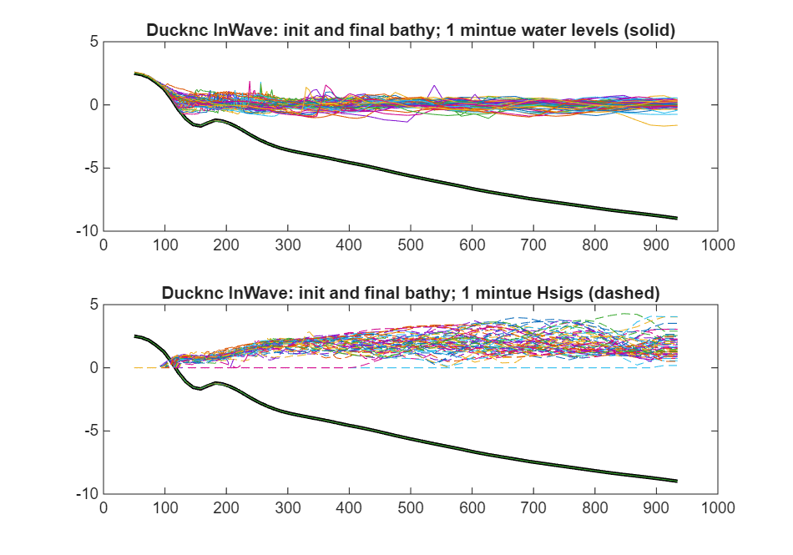
Figure showing cross shore profiles from Ducknc/ROMS_InWave of water levels and Hsig.

6.3 Ducknc – ROMS+SWAN, Wave-current interaction (essentially x-z) for cross-shore flows at Duck, NC. Driven by a SWAN forcing file, not coupled.

This test case validates the implementation of the Wave effect on Currents (WEC) module in the COAWST framework. The case is based upon experriemnts from the Duck (94) experiment. The experiment includes oblique waves that are incident on a synthetic planar beach and a natural barred beach. The simulations show the capability of the WEC module in COAWST to capture nonlinear processes of wave roller generation and wave-induced mixing. The details of the test case are presented in Kumar et al. (2012). To setup the case modify the build_coawst.sh to include this application:
export ROMS_APPLICATION=DUCKNC

Figures 6.1(a) and 6.1(b) show the vertical velocity and vertical stokes velocity respectively varying with cross-shore width (x) at a middle along-shore plane (y=4) at the end of 8400 seconds.

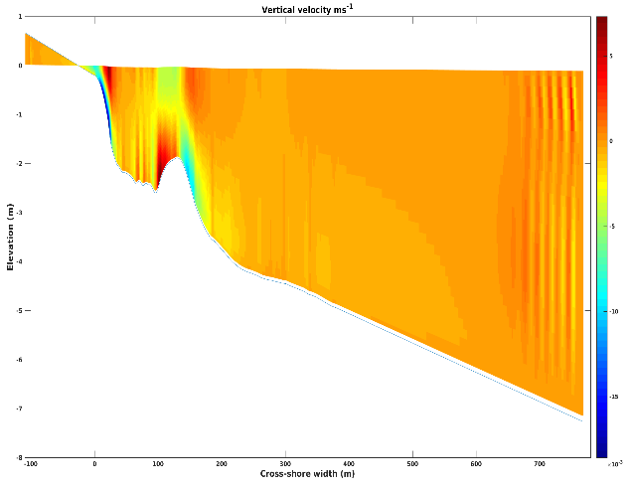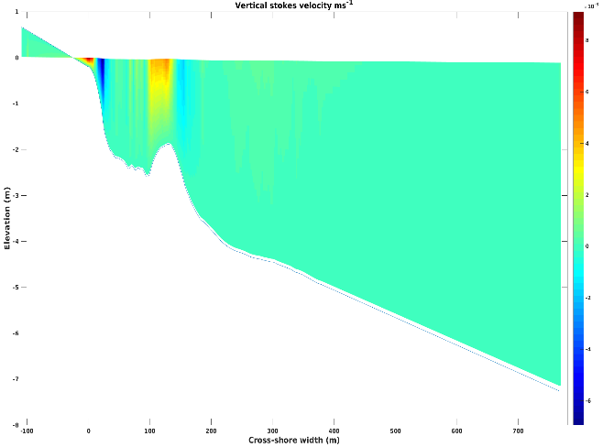

(a) Vertical velocity (b) Vertical stokes velocity

Figure 6.1: Results from Ducknc test case

6.4 Estuary_test2 = ROMS only, to test estuarine dynamics, prismatic channel

This application tests the ROMS for a prismatic shaped estuary that is 110 km long with the ocean end being 60 kms wide. The width of the estuary decreases exponentially from 60 km to 2 kms until 80 kms and stays uniform beyond 80 kms until the river end. The vertical layers follow a gaussian shape and consist of 40 vertical levels. The simulation is run for 5 days.

The application is run by editing the build_coawst.sh file to set
export ROMS_APPLICATION=ESTUARY_TEST2

This case requires mpi and the MCT libraries because it is a coupled application. And the run files are at:
export MY_HEADER_DIR=${MY_PROJECT_DIR}/Projects/Estuary_test2
export MY_ANALYTICAL_DIR=${MY_PROJECT_DIR}/Projects/Estuary_test2

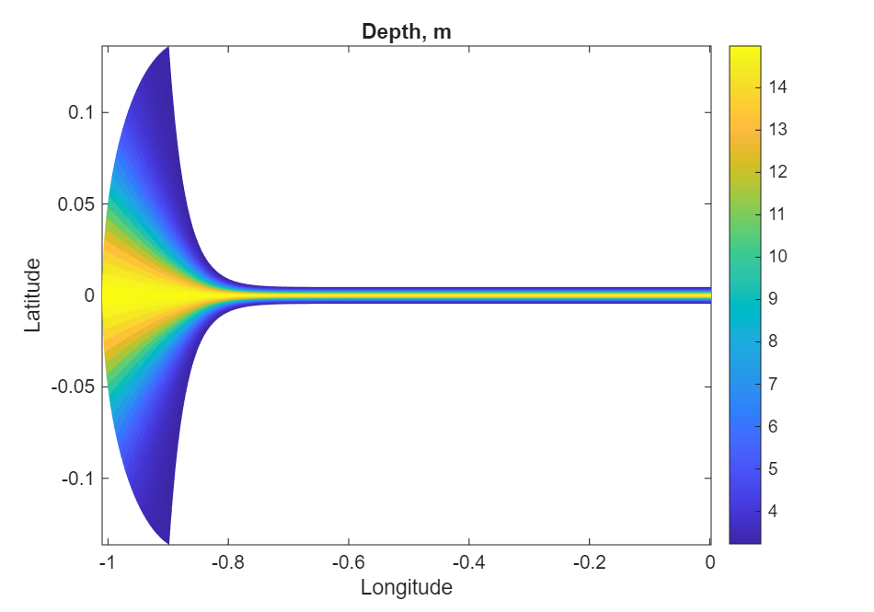
Figure of Estuary grid.

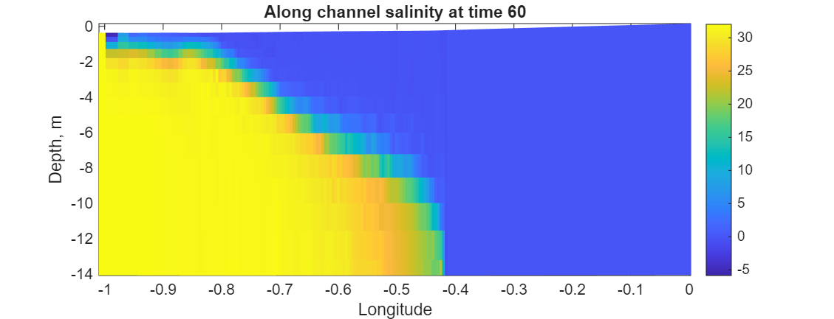
b) Salt intrusion length after 5 days

The above figures show the horizontal grid describing the shape of the estuary along with the salt intrusion at the end of 30 days.

6.5. INLET_TEST/Coupled = ROMS+SWAN same grid
This application tests the MCT coupling between ROMS and SWAN for an idealized inlet. The application has an enclosed basin in the southern part of the domain with a small opening near the center of the grid. The model is driven by a sinusoidal water level on the northern edge and is coupled to SWAN which develops waves from the north with a 1m height propagating towards the south. Flow pattern that developed are shown below:

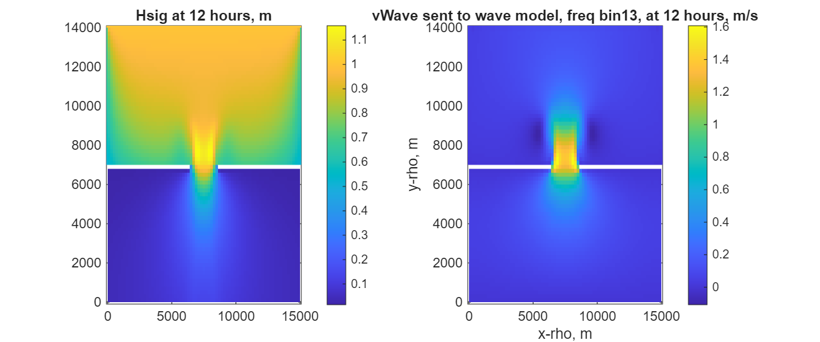
Wave height. depth integrated current to wave model
(Hwave) (vWave)

Figure 6.3. Results for Inlet_test coupled.

All of the grids and input files have already been created for this application and are available in Projects/Inlet_test/Coupled. Here is a basic set of steps required to make these files and run this application.

Step 1: Use create_roms_xygrid.m to create the roms and swan grids. These are simple rectangular grids and can be created easily with these tools. User sets the x/y locations, depth, and masking. This m file calls mat2roms_mw to create the roms grid file called inlet_test_grid.nc and calls roms2swan to create the swan grid files. The swan grid files were renamed to inlet_test_grid_coord.grd and inlet_test_bathy.bot.

Step 2: For this case, we are initializing the roms model from rest, so we are relying on ANA_INITIAL default values. The m file create_roms_init could be used to create a more complicated set of init conditions. We are also using ana_sediment to create a uniform field of 10m thick bed with porosity=0.5 and 1 grain size. This could have been created with the create_roms_init file as well. The file sediment_inlet_test.in lists some sediment properties for this application.

Step 3: For this case we are initializing SWAN from rest so there are no swan init files. we could have run swan for with some wind field, but this case has no winds.

Step 4: create the header file: Edit inlet_test.h to see the options selected for this application. we needed to define
#define ROMS_MODEL
#define SWAN_MODEL
#define MCT_LIB
, as well as several boundary conditions and wave current interaction (WEC) options, the wave-enhanced bottom boundary layer option (SSW_BBL), GLS_MIXING, and some sediment options of suspended load and bed morphology updating.

Step 5: Determine settings for roms and swan in the ocean_inlet_test.in and swan_inlet_test.in. These are some standard options in these files.

Step 6: Create the coupling file called coupling_inlet_test.in to enter the roms and swan input file names and determine the coupling interval.

Step 7: edit the build_coawst.sh file to build this application.

Step 8: compile and run.

6.6. INLET_TEST/DiffGrid = ROMS+SWAN different grids
This test case has a grid for ROMS and a larger grid for SWAN. This is useful for applications where the lateral shadow effects of the wave model can influence the ocean grid. So the wave model can be simulated on a larger grid and the ocean model on a smaller inset grid. This application is very similar to the case above for inlet_test/coupled. All of the files generated for this test case are in Projects/Inlet_test/DiffGrid.

Step 1: ROMS and SWAN are on different grids. You need to create a roms grid and a swan grid. This is achieved using create_roms_xygrid.m.

Step 2: Create the interpolation weights file –
The interpolation weight file for this case will be automatically generated when you run the code and will be “scrip_inlet_test_diffgrid.nc”.
-- Or –
You can follow the steps below to create the interpolation weight file yourself.

Build SCRIP_COAWST
We will use the SCRIP_COAWST package provided in “Lib” folder to create the interpolation weights. The steps for this are described in Section 3 above.

Create the interpolation weights file -
- Edit the flie Lib/SRIP_COAWST/scrip_coawst_inlet_test_diffgrid.in. This is the input file and has already been created for this application. The information has already been set for the output_ncfile name, the number of grids for each model, and the roms and swan grid information.
- Execute the scrip_coawst by going to the path of the SCRIP_COAWST folder and then running the program using
./scrip_coawst scrip_coawst_inlet_test_diffgrid.in
This will create the weights file scrip_inlet_test_diffgrid.nc
You can then copy that weights nc file to the Project folder
cp scrip_inlet_test_diffgrid.nc ../../Projects/Inlet_test/Diffgrid

Step 3: Edit the Projects/Inlet_test/Diffgrid/coupling_inlet_diffgrid.in and use

SCRIP_COAWST_NAME=Projects/Inlet_test/DiffGrid/scrip_inlet_test_diffgrid.nc

Step 4: Edit the ocean model configuration file.
Edit Projects/Inlet_test/DiffGrid/inlet_test.h and add the option
#define MCT_INTERP_OC2WV
This will allow mct interpolation between the ocean and wave models.

Step 5: Change the ocean and wave input file names to be
WAV_name = Projects/Inlet_test/DiffGrid/swan_inlet_test_diff.in ! wave model
OCN_name = Projects/Inlet_test/DiffGrid/ocean_inlet_test.in ! ocean model

Step 6: make, run the program

6.7. INLET_TEST/InWave = ROMS+InWave, Inlet test case.
This case is an example to use the InWave infragravity wave model. The application is an inlet with an enclosed back basin, with offshore open boundaries, similar to the other inlet tests but with a smaller domain size. The offshore northern boundary is driven by a 2Dspec file from SWAN. The model reads that 2d spec file, generates the envelope of the infragravity waves, and propagates them into the domain. (The only other way to drive InWave is to prescribe the wave action density along the open boundary, and that is described with the Projects/InWave_shoreface test case.)

All of the files generated for this test case are placed in Projects/Inlet_test/InWave.
To generate the files for this inlet_test case, you need to first edit Projects/Inlet_test/InWave/InWave_inlet_test_param.m.

Step 1: Edit Projects/Inlet_test/InWave/InWave_inlet_test_param.m.
Follow the instructions in that m file. We need 3 netcdf files: grid, initial, and boundary files. For this test case we need a grid and an initial file. We do not need to create a boundary file because this case reads in a 2dspec file and will internally compute the wave energy. So we selected:
make_InWave_grd=1;
make_InWave_ini=1;
make_InWave_bry=0;

To make the grid, we set up some basic paramters for dx, dy, x, y, depth, angle, masking, f, and spherical. See the m file.
For the initial conditions, we need to set the action density (Ac) and wave celerities (cx, cy, ct). We just start them all at 0. You also need to specify the number of computational bins (Nbins == ND in the ocean.in file), the directions of these bins (direction the wave is coming from), and a representative period (Ta).

Step 2: create the InWave grd and ini by running
InWave_create_files(‘InWave_inlet_test_param’)
This will create InWave_inlet_test_grd.nc and InWave_inlet_test_ini.nc.

Step 3:
Edit the Projects/Inlet_test/InWave/inlet_test.h file, to add InWave cpp options:
#ifdef INWAVE_MODEL
# define INWAVE_SWAN_COUPLING
# define ACX_ADVECTION
# define ACY_ADVECTION
# define ACT_ADVECTION
# undef INWAVE_HSCALE
# define DOPPLER
# undef WDISS_GAMMA
# define WDISS_ROELVINK
# define WDISS_FRIC
# define ROLLER_RENIERS
# define UV_KIRBY
# define DISSIP_BREAK_DIR
#endif
The “INWAVE_SWAN_COUPLING” says that it will read a 2d spec file from swan. The AC*_ADVECTION activate the advective terms (like UV_ADV for ROMS). The DOPPLER could be activated, and adds the effects of currents to the celerities. Then there are two choics for wave dissipation – a gamma approach and that of Roelvink.
The UV_KIRBY computes currents sent to the wave model, and the dissip_break_dir computes the dissipation in x- and y- directions.

Step 4:
Edit the Projects/Inlet_test/InWave/ocean_inlet_test.in
The key new options here would be to set

-1) The number of wave directional bins for the computation. This needs to be the same as in the init file
ND == 20 ! Number of wave directional bins

- 2) Inwave boundary conditions:
! InWave boundary conditions
! west south east north
LBC(isAC3d) == Gra Clo Gra Cla ! 3D wave action density
LBC(isCT3d) == Gra Clo Gra Gra ! 3D wave theta celerity
LBC(isCX3d) == Gra Clo Gra Gra ! 3D wave x-dir celerity
LBC(isCY3d) == Gra Clo Gra Gra ! 3D wave y-dir celerity
For this case, we want the 2dspec to be applied on the north (isAC3d is Clamped).
The others can be gradient, or closed (on the south as that is a wall).

- 3) Set output or parameters
Hout(idACen) == T ! AC 3D wave action
Hout(idACcx) == T ! Cx 2D Group velocity in xi dimension
Hout(idACcy) == T ! Cy 2D Group velocity in etai dimension
Hout(idACct) == T ! Ct 2D Group velocity in the directional dimension
Hout(idACtp) == T ! Tp 2D Group peak period

- 4) enter the grid and ini files:
GRDNAME == Projects/Inlet_test/InWave/InWave_inlet_test_grd.nc
(this is the same as the roms grid)

IWININAME == Projects/Inlet_test/InWave/InWave_inlet_test_ini.nc
( this is the ini file created with AC, ct, cx, cy, Ta).

Step 5: edit build_coawst.sh and build this as any other application. Run as any other application. An example of the output is shown here for the wave height.

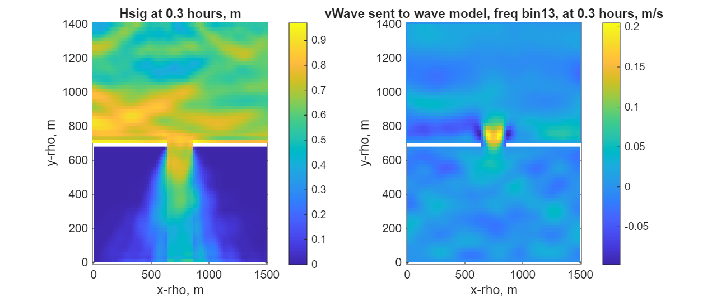
Figure Significant wave height and vWave at 0.3 hrs for the InWave inlet test.

6.8. INLET_TEST/Refined = ROMS+SWAN same grid + grid refinement in each model.
This test case has a coarse and fine grid for ROMS, and a coarse and fine grid for SWAN, run coupled on both grids. All of the files generated for this test case are in Projects/Inlet_test/Refined.

Step1: You need to create a roms grid for the coarse model, roms grid for fine model, swan grid for coarse model, and swan grid for fine model. Suggest you do this:
- First create a roms grid for the coarse model. This was done using Tools/mfiles/create_roms_grid and selecting the inlet_test case.
- Then create the refined grid, use the following procedure:

F=coarse2fine('inlet_test_grid.nc','inlet_test_grid_ref5.nc',3,24,54,40,56);
Gnames={'inlet_test_grid.nc','inlet_test_grid_ref3.nc'}
[S,G]=contact(Gnames,'inlet_test_contact_ref3.nc');

This uses m files from Rutgers and they are in the Tools directory. These calls set a refinement ratio of 3 and set the starting and ending indices of the child grid to range from Istr=24 to Iend =54, and Jstr = 40 to Jend =56. When you run those 3 commands above a series of figures are created that allow you to see the parent and child grids. The inlet test grids and the contact files need to be listed in the ocean.in file ocean_inlet_test_ref3.in.

- To create the two swan grids, you can use Tools/mfiles/roms2swan.m. Use this twice to create swan grids from the 2 roms grids.

Step 2: Create input files for the ocean and the swan grids. You need one ocean.in file, with the parameter values repeated for the 2 grids. See Projects/Inlet_test/Refined/ocean_inlet_test_ref3.in. Edit this ocean*.in and set values for all Numgrids (ie dt, file names, etc.)
- For Lm and Mm the values are -2 of the total number of rho points.

Step 3: You need to create to separate SWAN INPUT files. See that same folder for the 2 swan files (swan_inlet_test.in and swan_inlet_test_ref3.in).

Step 4: Need to create init and bndry files for the largest scale ocean and wave grids.

Step 5: Need to create init file for each ocean and wave refined child grids. The child grids do not need boundary files.

Step 6: Edit the Projects/Inlet_test/Refined/coupling_inlet_test_refined3.in file and list the input files: swan has two, just one for roms.

Step 7: Create the interpolation weights file:
The interpolation weight file for this case will be automatically created as “scrip_inlet_test_refined.nc”.
-- or –
Follow the steps below to create the interpolation weight file yourself.
Build SCRIP_COAWST
We will use the SCRIP_COAWST package provided in “Lib” folder to create the interpolation weights. The steps for this are described in Section 3 above.

Create the interpolation weights file -
- Edit the flie Lib/SRIP_COAWST/scrip_coawst_inlet_test_refined.in. This is the input file and has already been created for this application. The information has already been set for the output_ncfile name, the number of grids for each model, and the roms and swan grid information.
- Execute the scrip_coawst by going to the path of the SCRIP_COAWST folder and then running the program using
./scrip_coawst scrip_coawst_inlet_test_refined.in
This will create the weights file scrip_inlet_test_refined.nc
You can then copy that weights nc file to the Project folder
cp scrip_inlet_test_refined.nc ../../Projects/Inlet_test/Diffgrid

Step 8: Edit the Projects/Inlet_test/Refined/coupling_inlet_test_ref3.in and use

SCRIP_COAWST_NAME=Projects/Inlet_test/Refined/scrip_inlet_test_refined.nc

Step 9: Build the model
./ build_coawst.sh –j
and run it using
mpiexec –np 2 ./coawstM.exe Projects/Inlet_test/Refined/coupling_inlet_test_refined3.in

6.9. INLET_TEST/Swanonly = SWAN by itself, also with grid refinement.
This test case is basically the swan files from case 7 (mentioned above), but allows you to run swan by itself, and with a child grid.

To run SWAN by itself, with only 1 grid, the header file should have
#define SWAN_MODEL
#undef NESTING

./ build_coawst.sh to compile.
One note is that this needs to be run with the command pointing to the swan input file(s). So to run the swan only with just one grid, run the model with (X can be any number of processors)
mpiexec –np X ./coawstM.exe Projects/Inlet_test/Swanonly/swan_inlet_test.in

To run SWAN by itself and with a child grid, the header file should have
#define SWAN_MODEL
#define NESTING

./ build_coawst.sh to compile.
The command line needs to point to the swan input files. So to run the swan only with a parent and a child use (X can be any number of processors)
mpiexec –np 1 ./coawstM.exe Projects/Inlet_test/Swanonly/swan_inlet_test.in
Projects/Inlet_test/Swanonly/swan_inlet_test_refined5.in
(all that is on one line, the text is just word wrapping here).

6.10. INLET_TEST/WW3 = Inlet test case with ROMS + WW3 coupled.

This test case is basically the same as Inlet_test/Coupled but this time we use WW3 instead of SWAN. The application has an enclosed basin in the southern part of the domain with a small opening near the center of the grid. The model is driven by a sinusoidal water level on the northern edge and is coupled to WW3 which develops waves from the north with a 1m height propagating towards the south. Flow pattern that developed are shown below:

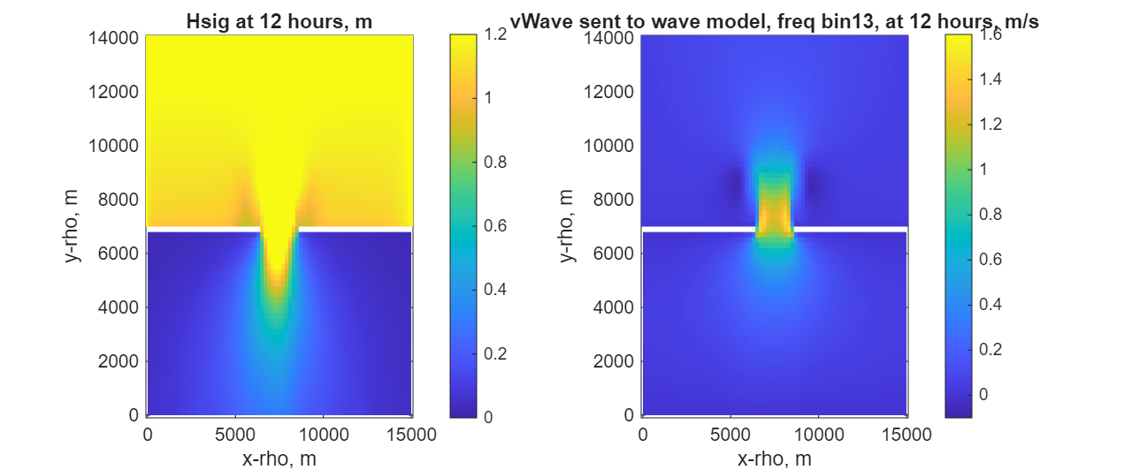

Wave height. depth integrated current to wave model
(Hwave) (vWave)

Figure 6.7. Results for Inlet_test coupled ROMS + WW3.

All of the grids and input files have already been created for this application and are available in Projects/Inlet_test/WW3. Here is a basic set of steps required to make these files and run this application.

Step 1: Use create_roms_xygrid.m to create the roms grids. These are simple rectangular grids and can be created easily with these tools. User sets the x/y locations, depth, and masking. This m file calls mat2roms_mw to create the roms grid file called inlet_test_grid.nc.

Step 2: create WW3 grids from the ROMS grids. Use COAWST\Projects\Inlet_test\WW3\create_ww3_grid_files.m to read the roms grid and create the WW3 curvilinear grid files: ww3_inlet_test_xcoord.dat, ww3_inlet_test_ycoord.dat, ww3_inlet_test_bathyh.bot, and ww3_inlet_test_mapsta.inp. The mapsta is basically the mask file.

Step3: create the WW3 boudnary file:
Use COAWST\Projects\Inlet_test\WW3\create_boundnc_file.m to create a netcdf forcing file, and then fill that file with a sample 2D spectra. The spectra is in that m file, and can be adjusted for other applications.

Step4: create the WW3 switch file: switch_inlet_test
This file tells WW3 what components to compile. For this case we have set:
F90 NC4 NOGRB TRKNC DIST MPI PR3 UQ FLX4 LN1 ST6 STAB0 NL1 BT1 DB1 MLIM TR0 BS0 IC2 IS2 REF0 IG1 XX0 WNT1 WNX2 RWND CRT1 CRX1 TIDE O0 O1 O2 O2a O2b O2c O3 O4 O5 O6 O7 SCRIP SCRIPNC SCRIPMPI

You can look in the WW3 user manual for all these options. Some important ones for this case are:
F90, DIST- use fortran and MPI
NC4 – use netcdf4
NOGRB – no read grib files
SCRIP, SCRIPNC, and SCRIPMPI – are all for WW3 only. They would be used by WW3 if WW3 had a child grid.

Step 5: Create the inlet_test.h header file
The COAWST\Projects\Inlet_test\WW3\inlet_test.h file is already setup to have all the settings for this application. Such as
#define ROMS_MODEL
#define WW3_MODEL
#define MCT_LIB

#ifdef WW3_MODEL
# define DISSIP_BREAK_DIR
# define WAV2OCN_FLUXES
#endif
and other options similar to the inlet_test/coupled.

Step6: compile the code
Edit the build_coawst.sh file and set
export COAWST_APPLICATION=INLET_TEST
set your:
export MY_ROOT_DIR=/cygdrive/d/models/COAWST
For WW3 we set 2 flags:
#1) do not change this:
export COAWST_WW3_DIR=${MY_ROOT_DIR}/WW3

and
# 2) WW3_SWITCH_FILE is like cpp options for WW3. You need to create it and
# provide the full path and file name here.
export WW3_SWITCH_FILE=${MY_PROJECT_DIR}/Projects/Inlet_test/WW3/switch_inlet_test
Notice that the name of the swith file needs to match the switch file created in step 4.

Set
export MY_HEADER_DIR=${MY_PROJECT_DIR}/Projects/Inlet_test/WW3
export MY_ANALYTICAL_DIR=${MY_PROJECT_DIR}/Projects/Inlet_test/WW3

compile the code
./build_coawst.sh -j 10

Step6: Run the WW3 utilities- Now we need to create intermediate files for WW3 to read.

Utility ww3_grid
- edit Projects/Inlet_test/WW3/ww3_grid.inp. Here is where you enter number of bins,
1.1 0.038 30 30 6.
time steps
20. 20. 20. 20.
and the grid settings
'RECT' F 'NONE'
77 72
200 200 1.
0 0 1.
10. 0.1 40 -1. 1 1 '(....)' 'NAME' 'ww3_inlet_test_bathy.bot'
and the mapsta:
40 1 1 '(....)' 'NAME' 'ww3_inlet_test_mapsta.inp'
cd to Projects/Inlet_test/WW3 and run
../../../WW3/build/bin/ww3_grid [.exe]
This will create mask.ww3, mapsta.ww3, mod_def.ww3.
If you change the time steps in ww3_grid.inp, then you need to rerun ww3_grid.exe and create new mod_def file.

Utility ww3_strt
- edit Projects/Inlet_test/WW3/ww3_strt.inp. Here is where you enter init information.
cd to Projects/ Inlet_test/WW3 and run
../../../WW3/build/bin/ww3_strt to create restart.ww3.

Utility ww3_bounc
- edit Projects/Inlet_test/WW3/ww3_bounc.inp. This inp file will read the ww3_bound_spec.nc file created above, and create a nest.ww3 file that is used as a boundary file. Then run
../../../WW3/build/bin/ww3_bounc to create nest.ww3.

Utility ww3_prep
We do not have any wind forcing data, so this is not needed.

Utility ww3_shel
- edit Projects/Inlet_test/WW3/ww3_shel.inp. Here is where you enter run information for grid coupling. The first letter is to set if the field is to be not used (F), used as read in from a file (T), or used and read in from a coupled model ( C). So those settings are to read winds from a file. To couple WW3 to ROMS, then we use:
C F Water levels
C F Currents
F F Winds

You need to set the run times here:
20000101 000000
20000101 120000

$ Type 1 : Fields of mean wave parameters
20000101 000000 3600 20000101 120000
and set to have the fields of Hwave, Dwave, and Lwave written out:
$ HS LM T02 T0M1 T01 FP DIR SPR DP
T T T T T T T T T

We do NOT need to run ww3_shel because that would run the wave model. We will run the wave model as coawstM.

11) Edit the coupling_inlet_test.in file.
Edit Projects/Inlet_test/WW3/coupling_inlet_test.in and set the following information:

number of procs for each model:
NnodesWAV = X ! wave model
NnodesOCN = Y ! ocean model. This needs to = NtileI * NtileJ in the ocean.in

! Time interval (seconds) between coupling of models.
TI_WAV2OCN = 600.0d0 ! wave to ocean coupling interval
TI_OCN2WAV = 600.0d0 ! ocean to wave coupling interval
The ocean (dt =60 ) and wave (dt = 20) models must time step evenly into the coupling interval.

!input files
WAV_name = ww3_grid.inp ! WW3 no NESTING
OCN_name = Projects/Inlet_test/WW3/ocean_inlet_test.in ! ocean model

!SCRIP name - not needed for this example

12) cd back to the root dir, where coawstM is. Now we need to copy (or soft link) those ww3 files to the root location.
Copy: ww3_shel.inp, ww3_grid.inp, mod_def.ww3, restart.ww3, ww3_ounf.inp
from Projects/Inlet_test/WW3/ to the root dir.

13) run the code using a run script on your system. We have run_coawst as an example of a run script, but you need to get a script that works on your system. You do not need to set the number of processors in any of the ww3 files.
mpirun –np X ./coawstM Projects/Inlet_test/WW3/coupling_sandy.in

13) When the model is done you can visualize the output by using
./WW3/build.bin/ww3_ounf
This will create a ww3.*.nc file called ww3.201210.nc.
Or you can ncview the roms his file.

6.11 Inwave_shoreface = ROMS+InWave (Sloping beach).
This case is an example to use the InWave infragravity wave model. The application is an inlet with a simple sloping beach in the north-south direction, eastern wall, open western coast. The south, north, and western boundaries are driven by wave action density from a netcdf file. This test case is advanced in that the user needs to understand the physics to create the wave actions time series. The other way to drive InWave is to provide a SWAN 2d spec file and that is described with the Projects/Inlet_test/InWave test case.)

All of the files generated for this test case are placed in Projects/Inlet_test/InWave.

Step 1: Edit Projects/InWave_shoreface/InWave_shoreface_param.m.
Follow the instructions in that m file. We need 3 netcdf files: grid, initial, and boundary files. For this test case we need all 3 – grid, initial, and boundary files so we selected:
make_InWave_grd=1;
make_InWave_ini=1;
make_InWave_bry=1;

To make the grid, we set up some basic paramters for dx, dy, x, y, depth, angle, masking, f, and spherical. See the m file.

For the initial conditions, we need to set the action density (Ac) and wave celerities (cx, cy, ct). We just start them all at 0. You also need to specify the number of computational bins (Nbins), the directions of these bins (direction the wave is coming from), and a representative period (Ta).

To create the boundary forincg file, the user needs to create the time series of wave action density. This is a user defined option.

Step 2: run the mfile by using:
Run this mfile using InWave_create_files(‘InWave_shoreface_param’)
This creates InWave_shoreface_grd.nc, InWave_shoreface_ini.nc, and InWave_shoreface_bry.nc.

Step 3:
Edit the Projects/inwave_shoreface.h file, to add InWave cpp options:
#ifdef INWAVE_MODEL
# undef INWAVE_SWAN_COUPLING
# define ACX_ADVECTION
# define ACY_ADVECTION
# define ACT_ADVECTION
# undef INWAVE_HSCALE
# define DOPPLER
# define WDISS_GAMMA
# undef WDISS_ROELVINK
#endif
The “INWAVE_SWAN_COUPLING” is to read s 2d spec file from swan, and we are not doing that for this application. The AC*_ADVECTION activate the advective terms (like UV_ADV for ROMS). The DOPPLER adds the effects of currents to the celerities. Then there are two choics for wave dissipation – a gamma approach and that of Roelvink.

Step 4:
Edit the Projects/InWave_shoreface/ocean_inwave_shoreface.in
The key new options here would be to set

-1) The number of wave directional bins for the computation. This needs to be the same as in the init file
ND == 11 ! Number of wave directional bins

- 2) Inwave boundary conditions:
! InWave boundary conditions
! west south east north
LBC(isAC3d) == Cla Gra Clo Gra ! 3D wave action density
LBC(isCT3d) == Gra Gra Clo Gra ! 3D wave theta celerity
LBC(isCX3d) == Gra Gra Clo Gra ! 3D wave x-dir celerity
LBC(isCY3d) == Gra Gra Clo Gra ! 3D wave y-dir celerity
For this case, we want the wave action to be applied on the west (isAC3d is Clamped).
The others can be gradient, or closed (on the east as that is a wall).

- 3) Set output or parameters
Hout(idACen) == T ! AC 3D wave action
Hout(idACcx) == T ! Cx 2D Group velocity in xi dimension
Hout(idACcy) == T ! Cy 2D Group velocity in etai dimension
Hout(idACct) == T ! Ct 2D Group velocity in the directional dimension
Hout(idACtp) == T ! Tp 2D Group peak period

- 4) enter the grid and ini files:
GRDNAME == Projects/InWave_shoreface/InWave_shoreface_grd.nc
(this is the same as the roms grid)

IWININAME == Projects/InWave_shoreface/InWave_shoreface_ini.nc
(this is the ini file created with AC, ct, cx, cy, Ta).

Step 5: edit build_coawst.sh and build this as any other application. Run as any other application. An example of the output is shown here for the wave height.

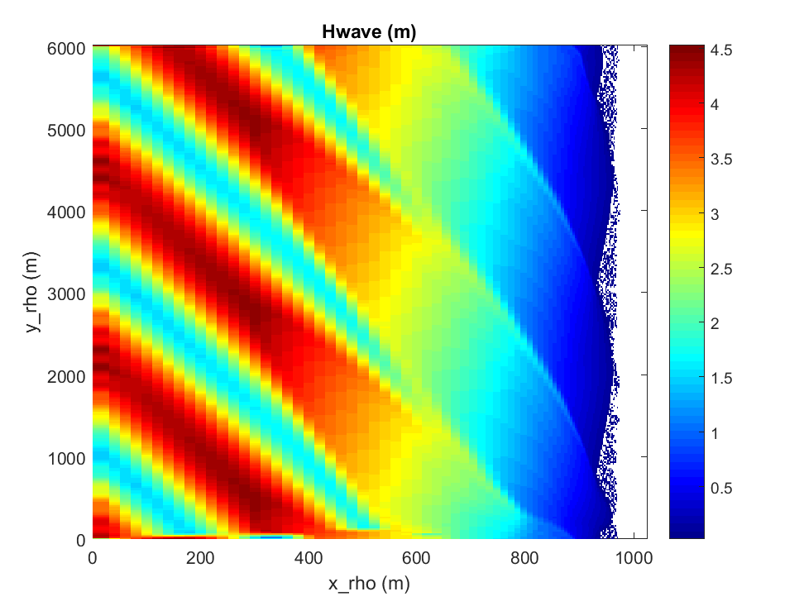
Figure 6.8. Significant wave hegith at 200s for the InWave_shoreface test.

6.12 JOE_TC/Coupled = WRF-ROMS-SWAN all 3 on same grid.
Step 1: Create a folder to hold all the project files. For this application a folder is already made and is called COAWST/Projects/JOE_TC/Coupled. This will be referred to as the ‘project folder.’

Step 2: Create WRF grid, init file, and input files:
wrfbdy_d01
wrfinput_d01
namelist.input
These files need to be placed in the root_dir.
Copies of these files have already been created and are located in the Projects/JOE_TC folder. Copy these 3 files from that folder to the root dir.
Edit namelist.input and set in the &domains section the number of processors for WRF to use for the simulation (total WRF = nproc_x*nproc_y).
nproc_x = M
nproc_y = N

step 3: Create a project ‘header’ file.
The application control file has already been created for this setup. For this case, we can use the file in the project directory
COAWST/Projects/JOE_TC/Coupled/joe_tc.h
We have preselected to use a certain case G, which has the 3 way coupling.
Some key parameters in here are ….
# define ROMS_MODEL
# define SWAN_MODEL
# define WRF_MODEL
If you want to create your own, the best choice is to start out by copying an ‘application.h’ file from some other project folder which is similar to your configuration, and then tailor it to the new application.

Step 4: Build the system.
Edit build_coawst.sh and provide appropriate file locations and run the build command:
./ build_coawst.sh
During the build if wrf asks for the location of the netcdf files, you can provide them. If you set NETCDF=___ to the correct location in your environment, then WRF will know where the files are.
During the buld wrf will ask for the system you are using such as:

Select option for PC Linux x86_64, PGI compiler 5.2 and higher (RSL_LITE)
And select 1 for normal. Compiling wrf can take up to 20 minutes or longer.

Step 5: Create the ocean grid. The project folder already contains the roms grid. This grid was made from a version of :
COAWST/Tools/mfiles/create_roms_grid.m.
Alternatively, we now distribute wrf2roms_mw.m that can be used to create a roms grid from a wrf grid. After creating the grid, copy the grid file (in this case joe_tc_grd.nc) to the project directory.

Step 6: Create the initial file for the ocean model. The project folder already contains the roms init file but if you want to see how it was made you can use: COAWST/Tools/mfiles/create_roms_init.m.
After creating the init file copy the file (in this case joe_tc_ocean_init.nc) to the project directory.

Step 7: Create an ocean input file.
The application ocean input file has already been created and we can use the file in the project directory
COAWST/Projects/JOE_TC/Coupled/ocean_joe_tc.in
Set the total number of processors to be allocated to roms as:
NtileI == 4 ! I-direction partition
NtileJ == 3 ! J-direction partition

Step 8: Make the swan bathy + grid files.
When you use create_roms_grid, there were other files created:
roms_bathy.bot
grid_coord.grd
These were created by roms2swan.m and these are the swan files needed. Rename these (such as joe_tc_roms_bathy.bot and joe_tc_grid_coord.grd) and copy these 2 files to the project directory. (This has already been done.)

Step 9: create swan input file
The best step here is to copy an existing file and tailor it to your application. For now we can use:
COAWST/Projects/JOE_TC/Coupled/INPUT_JOE_TC

Step 10: modify the coupling.in file COAWST/Projects/JOE_TC/Coupled /coupling_joe_tc.in to:
- allocate processors for all 3 models
- set coupling time interval
- list input file names

NnodesATM = 4 ! atmospheric model
NnodesWAV = 4 ! wave model
NnodesOCN = 4 ! ocean model

! Time interval (seconds) between coupling of models.

TI_ATM_WAV = 600.0d0 ! atmosphere-wave coupling interval
TI_ATM_OCN = 600.0d0 ! atmosphere-ocean coupling interval
TI_WAV_OCN = 600.0d0 ! wave-ocean coupling interval

! Coupled model standard input file name.

ATM_name = namelist.input ! atmospheric model
WAV_name = Projects/JOE_TCs/INPUT_JOE_TC ! wave model
OCN_name = Projects/JOE_TCs/ocean_joe_tc.in ! ocean model

Step 11: run the system using a PBS run script or whatever is for your system
/usr/local/mpi/bin/mpirun -np 12 -machinefile $PBS_NODEFILE ./coawstM Projects/JOE_TC/coupling_joe_tc.in > joe_tc.out

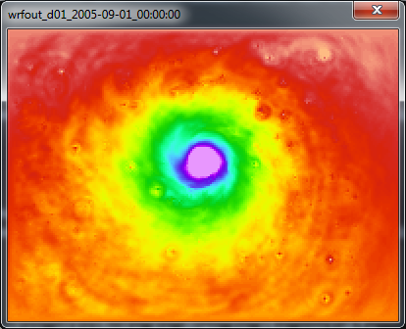
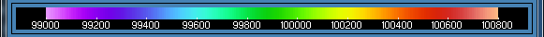

A) PSFC from WRF at hour 40.

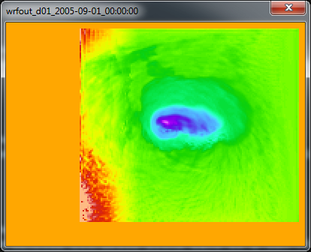
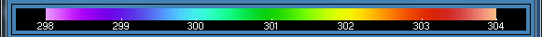

B) SST from ROMS in the WRF output at hour 40.

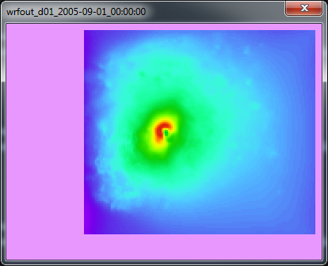
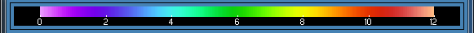

C) Hwave from SWAN in the WRF output at hour 40.

Figure 6.9. Results at hour 40 for JOE_TCs simulation for: A) PSFC from WRF; B) SST from ROMS; and C) HWAVE from SWAN.

Additional notes for JOE_TCS:
This test case is distributed with "ExpG" defined. That case has ROMS+WRF+SWAN all coupled. You can select to activate a different case in the Projects/JOE_TC/Coupled /joe_tc.h file, such as "ExpA1" which is just WRF+SWAN, or "ExpA" which is just WRF+ROMS.

6.13 JOE_TC/DiffGrid simulation using ROMS + SWAN same grid, WRF different grid.
This application provides information on how to run the models on different grids. Each model could be on a separate grid, but for this example roms and swan are on the same grid, and wrf is on a different grid. This will be very close to the setup in 1 but now we will just create new grids for roms and swan. The roms and swan grids will be decreased resolution to have 100 cells in the x-direction and 75 cells in the y-direction (instead of 200x150).

Step 1: Create a new projects folder
Projects/JOE_TC/DiffGrid. (this has already been created).

Step 2: Create roms + swan grids. This can be accomplished using
COAWST/Tools/mfiles/create_roms_xygrid.m or wrf2roms_mw.
We renamed grid_coord.grd and roms_bathy.bot to
joe_tc_coarse_grid_coord.grd and joe_tc_coarse_roms_bathy.bot. Copy these 2 files and the joe_tc_coarse_grd.nc file to the project folder.

Step 3: create roms init files using
COAWST/Tools/mfiles/mtools/create_roms_init.m

Step 4: Create wrf files: we will use the same wrf files from before of:
wrfbdy_d01
wrfinput_d01
namelist.input
These files need to be placed in the root_dir (I also make a copy and put into the project folder).

Step 5: Create the interpolation weights file:
The interpolation weight file for this case will be automatically created as “scrip_joe_tc_diffgrid.nc”
-- or --
Follow the steps below to create the interpolation weight file yourself.

Build SCRIP_COAWST
We will use the SCRIP_COAWST package provided in “Lib” folder to create the interpolation weights. The steps for this are described in Section 3 above.

Create the interpolation weights file -
- Edit the “scrip_coawst_joetc_diffgrid.in”. This is the input file and needs to be edited. (The input file for this case is provided). The name of the output interpolation weight file can be added at the beginning of this file. Let us call it “scrip_joe_tc_diffgrid.nc”
- Execute the scrip_coawst by going to the path of the SCRIP_COAWST folder and then running the program using
./scrip_coawst scrip_coawst_joe_tc_diffgrid.in
This will create the weights file scrip_joe_tc_diffgrid.nc
You can then copy that weights nc file to the Project folder
cp scrip_ scrip_joe_tc_diffgrid.nc ../../Projects/JOE_TC/Diffgrid

Step 6: Edit the Projects/JOE_TCd/coupling_joe_tc.in and use

SCRIP_COAWST_NAME=Projects/JOE_TC/DiffGrid/scrip_ joetc_diffgrid.nc

Step 7: change the ocean and wave input file names to be
WAV_name = Projects/JOE_TC/DiffGrid/INPUT_JOE_TC_COARSE ! wave model
OCN_name = Projects/JOE_TC/DiffGrid /ocean_joe_tc_coarse.in ! ocean model

Step 8: Edit the ocean model configuration file.
Edit Projects/JOE_TC/DiffGrid /joe_tc.h and add the option
#define MCT_INTERP_WV2AT
#define MCT_INTERP_OC2AT
This will allow mct interpolation between the wave – atm models, and between the ocean – atm models.
This is set already to define case H which has those cpp options set.

Step 9: make, run the program

6.14. Lip test case.

6.15. Rip_current test case.
This test case is provided as an example of how to setup a coupled simulation to study a rip current. The current test case is coupling of ROMS+SWAN, and the application is described in detail in Kumar et al. (2012) in section 4.3 of that paper. Users can adapt the test case for other types of similar investigations.

The application is run by editing the build_coawst.sh file to set
export ROMS_APPLICATION=RIP_CURRENT

This case requires mpi and the MCT libraries because it is a coupled application. And the run files are at:
export MY_HEADER_DIR=${MY_PROJECT_DIR}/Projects/Rip_current
export MY_ANALYTICAL_DIR=${MY_PROJECT_DIR}/Projects/Rip_current

This is built like the other tests cases, using ./ build_coawst.sh. The user needs to set the total number of processors for each of roms and swan in the coupling_rip_current.in file. Then you need to set the processor allocation in the ocean_rip_current.in. The model is set up to run for 1 hour of simulation time, with swan on a 5s time step and roms on a 1s time step. Coupling is every 5s. The model is run using:

mpiexec -np 4 ./coawstM.exe Projects/Rip_current/coupling_rip_current.in

You can certainly change the number of processors for your own system. Upon completion of the test case, you can use the included plot_rip_current.m matlab file to create the plot below.
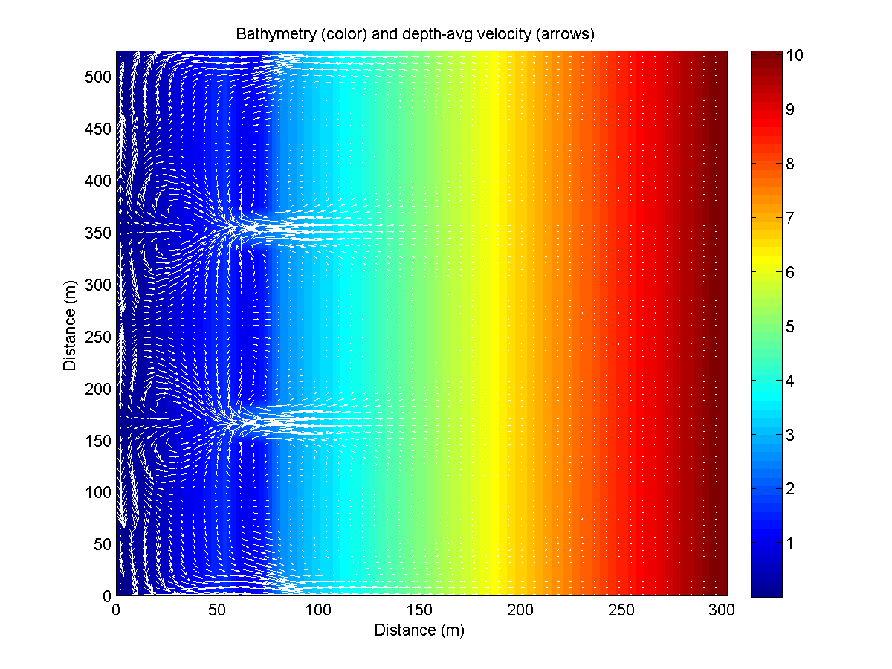

Figure 6.15. Rip current test case bathy and currents.

6.16 Hurricane Sandy = 2 grids for WRF, 3 grids for ROMS, 3 grids for SWAN or 3 grids for WW3 – Nesting on the same level.
This test case is used as the basis for the methodology in Sections 8 How to setup a WRF application, Section 9 How to set up a ROMS application, Section 10 how to set up a SWAN application, Section 11 how to set up a WW3 application, and Section 12 how to setup a coupled application. These are step by step instructions that provide a general guideline to set up these system components.

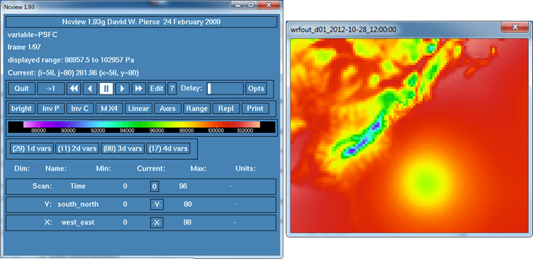
Figure 2: fPSFC of Hurricane Sandy along the US east coast.
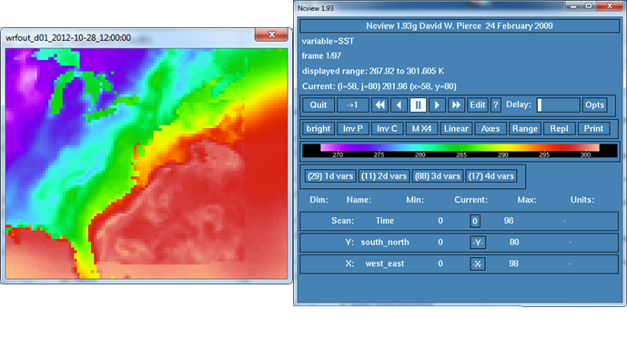

Figure 3: SST combined GFS and ROMS in WRF output.

6.17 Sedbed_toy test case - ROMS only, tests sediment module.

This test case is formed to highlight the capabilities of the sediment module in COAWST framework to simulate various sediment transport processes (for instance sediment erosion, deposition) etc. This is setup to essentially be a 1D vertical profile test case. It can incorporate both cohesive and non-cohesive sediment types. The details of the sediment module and related processes that can be handled are described in Warner et al., 2008. The application is run by editing the build_coawst.sh file to set:
export ROMS_APPLICATION=SEDBED_TOY

Figures 6.14 (a) and (b) illustrate the results at the end of simulation (). The results show the concentration for two non-cohesive sediment classes varying with the number of vertical levels.
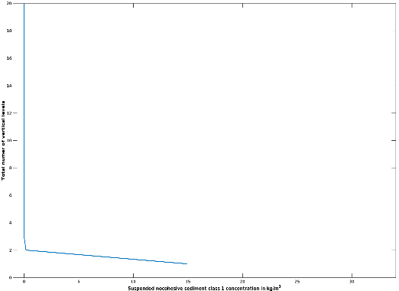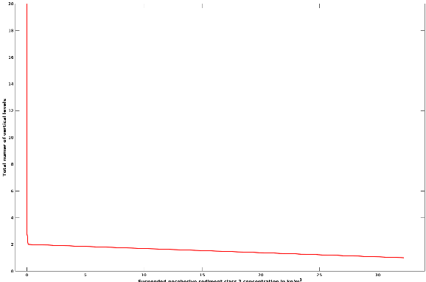
(a) Non-cohesive sediment class 1 (b) Non-cohesive sediment class 2
Figure 6.17 Results from Sed_bed_toy test case

6.18. Sed_floc_toy test case - ROMS only, tests sediment module with flocculation.
The test case is added to test the additional sediment module routines in COAWST that account for the aggregation, disaggregation of the cohesive sediment class in the water column. These processes are desribed as flocculation dynamics. This test case is set up to be a 1D vertical profile test of the flocculation algorithms.
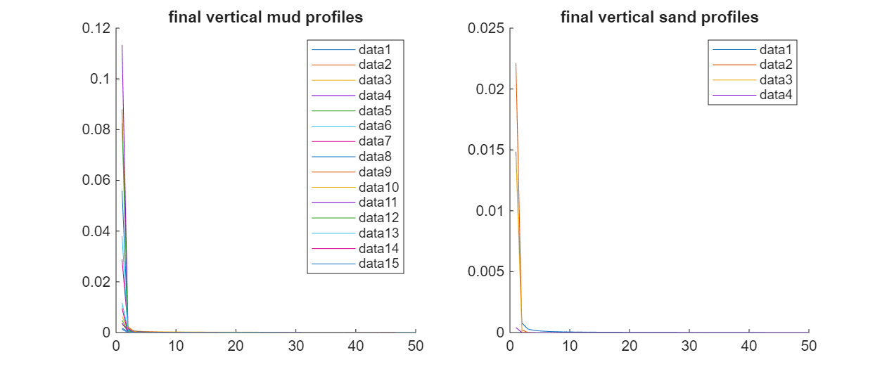
(a) cohesive sediment classes (b) Non-cohesive sediment classes
Figure 6.18 Results from Sed_floc_toy test case

6.19 Trench test case - ROMS only, test sediment morphology.12

The test case is based on the morphological evolution of bedload by simulating the experiemental work of Van Rijn (1993). The setup consists of a 30-m straight channel with a vertical trench in a mobile sand bed. More details are present in Warner et al. (2008). The application is run by editing the build_coawst.sh file:
export ROMS_APPLICATION=TRENCH
Figure 6.19 shows the bed thickness varying with along channel distance at the start and end of the simulation at 500 secs. The results are extracted from a cross channel plane of y=4.
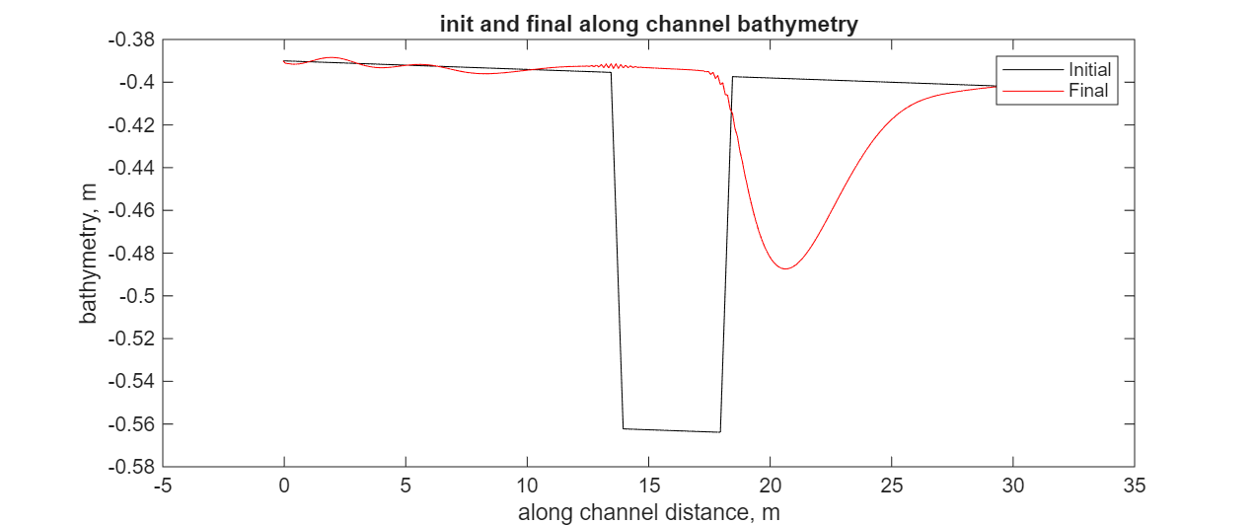
Figure 6.19 Results from Trench test case

6.20 Wetdry test case - ROMS only, test wetting/drying algorithms.

This case is provided to test the ability of COAWST framework to let the computational cells to get indundated/wet or dewatered/dry when total depth in a cell is less than a user defined critical value. This test case is consisting of a basin of rectangular water basin. The test case allows for water to spill through an opening to flood in an initially dry flood plain. More details of the methodology and test case is provided in

Warner, J.C., Haas, K.H ., Defne, Z., and Arango, H.G.(2013). A wetting and drying scheme for ROMS, Computers and Geosciences, 58, 54-61.

Figures 6.20 shows the free surface level at different time increments.

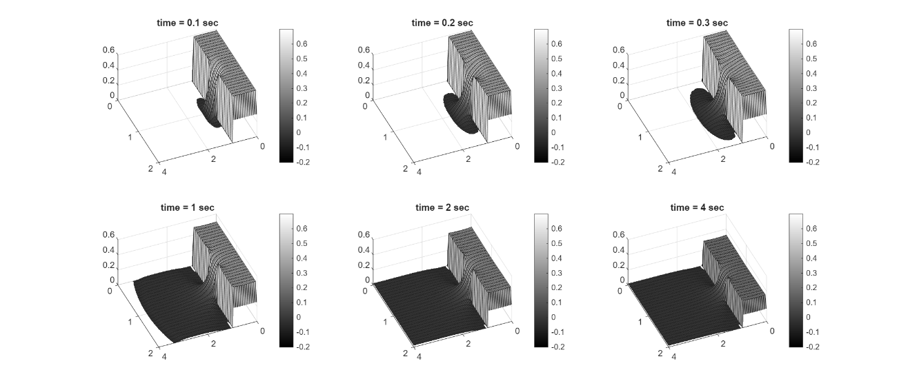

Water level at 6 different time steps

Figure 6.20 Wetdry test case

6.21. Vegetation test case - ROMS+SWAN, test vegetation module.
This test case presents an idealized tidal and wave basin inhabited by a square patch of submerged aquatic vegetation (SAV). It accounts for the following hydrodynamic effects of vegetation in ROMS: sink of momentum, flexible plant reconfiguration, production and dissipation of turbulent kinetic energy. It also addresses wave damping by vegetation in SWAN and wave-current interactions around a vegetation patch (ROMS-SWAN). The details of this implementation are presented in
Beudin, A., Kalra, T. S., Ganju, N. K., and Warner, J.C. (2016). Development of a coupled wave-flow-vegetation interaction module. Computers and Geosciences, http://dx.doi.org/10.1016/j.cageo.2016.12.010,

Users can adapt the test case for other types of similar investigations. All the steps described below have already been undertaken to setup a vegetation test case in the Veg_test folder distributed with COAWST. The description of this test case is provided in the veg_test_case.docx file.
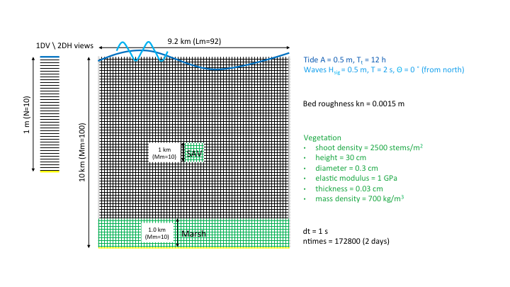
Figure 6.16 (a): Schematic showing vegetation and marsh domains

Step 1: Create roms grid and init files using

COAWST/Tools/mfiles/mtools/create_roms_netcdf_grid_file.m
COAWST/Tools/mfiles/mtools/create_roms_init.m - To setup vegetation properties in the intial file, enter NVEG. Currently plant density, height and diameter and the marsh_mask arrays are set to zero. The user can provide these values depending on the presence of the vegetation. Copy the grid and init file to the vegetation test folder.

Step 2: Create the SWAN grid file and bathymetry file and copy them to the vegetation folder.

Step 3: Edit coupling_veg_test.in.
NnodesWAV and NnodesOCN provide the number of processors for Swan and Roms codes respectively. Provide the path of Swan and Roms input file in WAV_NAME and OCN_name inputs

Step 4: Edit the ocean_veg_test.in for providing number of interior points in I and J directions (Lm, Mm), number of vertical layers. Enter the tiling inputs NtileI and NtileJ accordingly. Provide the name of roms grid and input file as generated in Step 1 above in GRDNAME and ININAME options.

Step 5: Edit the swan input file to enter the swan grid file and bathymetry file. Make sure to have the Keyword “NPLANTS” and “VEGETATION” properties correctly. The Vegetation properties should be consistent with the ROMS input file.

Step 6: Edit the “vegetation.in” to specify sptatially fixed vegetation properties along with the specifying logical options such as Hout(pdens)==T to output vegetation density in the output “.nc” file.

Step 7: Edit ana_fsobc.in for tidal inputs.

Step 8. Compile the code using ./ build_coawst.sh (Check that the application is set to veg_test). Run the code by using the input file “coupling_veg_test.in”).

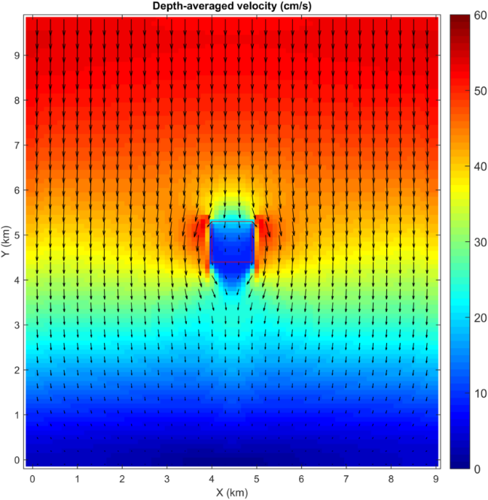

Figure 5: Figure generated from Veg_test case simulation showing depth averaged velocity (cm/s). Vegetation patch is in the outlined red box

6.22 Veg_growth test case - ROMS+vegetation+sediment+water-column biogeochemistry (including spectral light module)

This test case is implementated in an idealized domain where the introduction of sediment in the water column (SSC) at one end of the domain provides sub-optimal light conditions that causes SAV dieback in that region. The model is based upon previous SAV models published by Madden and Kemp (1996) and Cerco and Moore (2001). The module is built to interact dynamically with the water-column biogeochemistry module bio_fennel, a bio-optical model, and the sediment transport model and this coupled package is called estuarybgc. Based on the change in SAV biomass (above ground, below ground) and epiphyte biomass, SAV density and height evolve in time and space and directly couple to three-dimensional water-column biogeochemical, hydrodynamic, and sediment transport models. SAV biomass is computed from temperature, nutrient loading and light predictions obtained from coupled hydrodynamics (temperature), bio-geochemistry (nutrients) and bio-optical (light) models. In exchange, the growth of SAV sequesters or contributes nutrients from the water column and sediment layers. The presence of SAV modulates current and wave attenuation and consequently affects modelled sediment transport and fate. The resulting modelling framework provides a two-way coupled SAV-biogeochemistry-hydrodynamic and morphodynamic model. This allows for the simulation of the dynamic growth and mortality of SAV in coastal environments in response to changes in light and nutrient availability, including SAV impacts on sediment transport and nutrient, carbon, and oxygen cycling. More details of the modeling methodology are presented in: Kalra,T.S., Ganju, N.K., and Testa, J.M. (2020). Development of a submerged aquatic vegetation growth model in the Coupled Ocean–Atmosphere–Wave–Sediment Transport (COAWSTv3.4) model, Geosci. Model Dev., 13, 5211–5228, 2020. https://doi.org/10.5194/gmd-13-5211-2020.
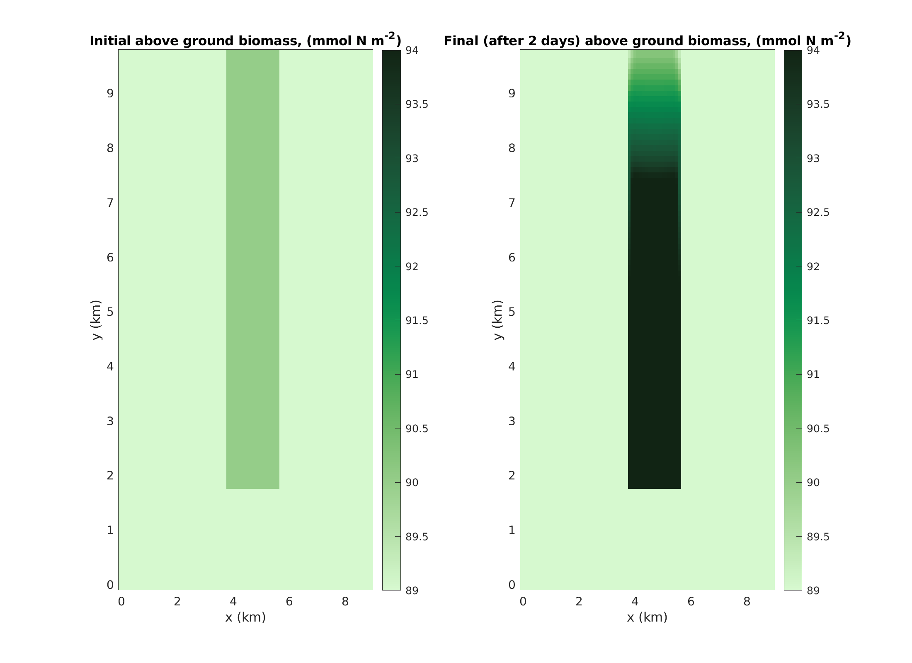

Figure 6.22. Above ground biomass (initial) and final at the end of 2 days.

6.23 Marsh_test – ROMS+ marsh dynamics

This test case is used to verify two marsh dynamics processes: horizontal retreat due to lateral wave thrust on marsh edge and vertical accretion due to biomass production and sediment trapping. The former requires an input of wave forcing and latter is based on a parabolic formulation to get biomass. The lateral wave thrust action on the marsh edge leads to an export of sediment from marsh cells to non-marsh cells. It is done through an exchange of bed mass. This leads to a change in vertical bed thickness and an evolution of bathymetry (allocothonous changes). Note that, there can be an import of sediment on marsh cells through the suspended sediment in water column. The model also accounts vertical accretion of marsh platform through below ground biomass production (autochthonous supply). The dynamic biomass production can modify the emergent marsh vegetation properties (density, height, diameter) and that in return, can affect the hydrodynamics and sediment dynamics (Kalra TS, Ganju NK, Aretxabaleta AL, Carr JA, Defne Z and Moriarty JM (2021) Modeling Marsh Dynamics Using a 3-D Coupled Wave-Flow-Sediment Model. Front. Mar. Sci. 8:740921. doi: 10.3389/fmars.2021.740921).
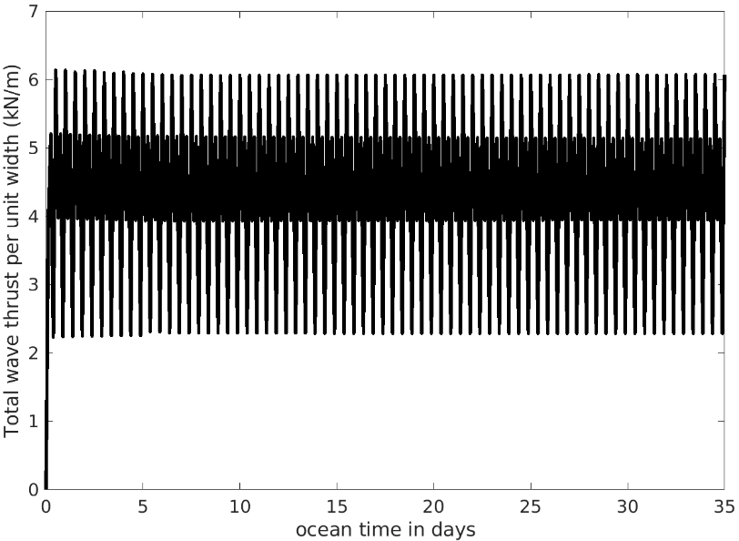
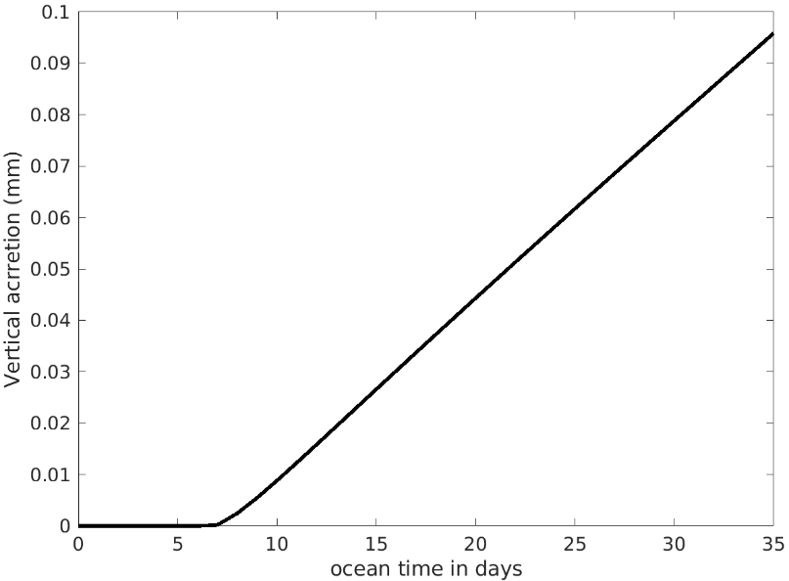

Figure 6.23. Time series of total wave thrust and vertical accretion from the marsh dynamics test case.

Section 7. Visualization Tools.

NCVIEW
Source code at:
http://meteora.ucsd.edu/~pierce/ncview_home_page.html

Some new colormaps at:
https://www.myroms.org/forum/viewtopic.php?f=31&t=1930&p=6926#p6926

Section 8. Setting up a WRF application.

This section describes how to set up a WRF (only) application. Some of this was taken from the WRF ARW User’s manual. It is recommended for you to do the online wrf tutorial (http://www2.mmm.ucar.edu/wrf/OnLineTutorial/). These instructions are directed towards the Sandy test case. Specific steps for your own application may differ.

1. Building the WRF Code
You can use our distributed WRF and WPS programs to create the WRF forcings and/or to run WRF by itself.
• Make a new directory and copy the COAWST code into that dir, and cd into that dir.
• You will always need a Projects header file. I recommend that you create a directory called "My_Project" (create your own name, dont actually use 'My_Project'). The directory could be: COAWST/Projects/My_Project. In that directory, create a header file (basic text file) such as: my_project.h. Set the project to only use the WRF model (for now) by using:

#define WRF_MODEL
• edit build_coawst.sh and set the Project name, header file location, and build location.
• build the model with
./ build_coawst.sh
choose one of the WRF build options depending on your system (we use 15 for Linux dmpar). There are two choices for parallel applications: dmapr = distributed memory parallel or smpar = shared memory parallel. If WRF is to be coupled, then you have to use a dmpar option, do not use shared memory for a coupled application. For WRF by itself you can choose serial or parallel (dmpar or smpar).
• Then choose then 1 for basic nesting ( For the Sandy example we start with basic 1).
• When it is done, at the root dir you should see a link of coawstM to WRF/main/wrf.exe

>ls –ltr
...
drwxrwxr-x 2 jwarner domain users 4096 Jan 31 10:40 Build
drwxrwxr-x 21 jwarner domain users 4096 Jan 31 10:41 WRF
lrwxrwxrwx 1 jwarner domain users 16 Jan 31 11:16 coawstM -> WRF/main/wrf.exe
Also list the contents of WRF/main: ls WRF/main/*.exe and you should see ndown.exe, real.exe, and wrf.exe

2. Building the WPS Code
Building WPS requires that WRF is already built. WPS is distributed with the code.
• cd COAWST/WPS
./configure
If you want to use the grib2 and if your jasper is greater than ver 3, then do:
• ./configure --build-grib2-libs
• choose one of the options, usually a serial build is ok for a first test with a smaller grid.
• ./compile &> foo
• ls -ltr *.exe and you should see geogrid.exe, ungrib.exe, and metgrid.exe
• ls -ltr util/*.exe and you should see a number of utility executables also such as:
g1print.exe, g2print.exe, rd_intermediate.exe, mod_levs.exe, avg_tsfc.exe, calc_ecmwf_p.exe, height_ukmo.exe, int2nc.exe, netCDF2intermediate_GHRSST.exe

3. geogrid: Creating a Grid

3a) edit WPS/namelist.wps. We distribute a copy for Sandy as: COAWST/Projects/Sandy/WRF/namelist.wps. You can copy that file to COAWST/WPS. For this step we focus on the &share and the &geogrid parts, modified the H Sandy test case to be:

namelist.wps

&share
wrf_core = 'ARW',
max_dom = 2,
start_date = '2012-10-28_12:00:00','2012-10-28_12:00:00',
end_date = '2012-10-30_12:00:00','2012-10-30_12:00:00',
interval_seconds = 21600
io_form_geogrid = 2,
/

&geogrid
parent_id = 1, 1,
parent_grid_ratio = 1, 3,
i_parent_start = 1, 33,
j_parent_start = 1, 8,
e_we = 85, 100,
e_sn = 82, 100,
!
!!!!!!!!!!!!!!!!!!!!!!!!!!!! IMPORTANT NOTE !!!!!!!!!!!!!!!!!!!!!!!!!!!!
! The default datasets used to produce the MAXSNOALB and ALBEDO12M
! fields have changed in WPS v4.0. These fields are now interpolated
! from MODIS-based datasets.
!
! To match the output given by the default namelist.wps in WPS v3.9.1,
! the following setting for geog_data_res may be used:
!
! geog_data_res = 'maxsnowalb_ncep+albedo_ncep+default', 'maxsnowalb_ncep+albedo_ncep+default',
!
!!!!!!!!!!!!!!!!!!!!!!!!!!!! IMPORTANT NOTE !!!!!!!!!!!!!!!!!!!!!!!!!!!!
!
geog_data_res = 'default','default',
dx = 30000,
dy = 30000,
map_proj = 'lambert',
ref_lat = 37.50,
ref_lon = -75.00,
truelat1 = 30.0,
truelat2 = 60.0,
stand_lon = -75.0,
geog_data_path = '/vortexfs1/scratch/jwarner/WPS/geog_data'
/

&ungrib
out_format = 'WPS',
prefix = 'NAM',
/

&metgrid
fg_name = 'NAM', ‘RTG’
io_form_metgrid = 2,
/

3b) get the geogrid data from this page:
http://www2.mmm.ucar.edu/wrf/users/download/get_sources_wps_geog.html
I chose the geog_high_res_mandatory.tar.gz. Then untar this file in a directory
tar -xvf geog_high_res_mandatory.tar.gz
Set the geog_data_path in the namelist.wps file to this directory.

3c) make sure there is a link to the correct geogrid table.
> ls –ltr WPS/geogrid/*.TBL
should return
> geogrid/GEOGRID.TBL -> GEOGRID.TBL.ARW
If not then cd to WPS/geogrid and type
ln -sf GEOGRID.TBL.ARW GEOGRID.TBL

3d) run geogrid
>WPS ./geogrid.exe
and get back a complete successful information.

3e) ls –ltr should show geo_em.d01.nc and geo_em.d02.nc files. Use ncview or some other viewer to check it out. Also look in geogrid.log.

4. ungrib: Getting IC and BC data

4a) Get grib data for initial and boundary conditions. You can start here:

http://www2.mmm.ucar.edu/wrf/users/download/free_data.html

I chose to use NCEP 12km data here: https://gdex.ucar.edu/datasets/d609000/dataaccess/
Use direct download or one of the other options for full data files from 2012-10-27 to 2012-11-01. Copy the files to a new directory. The files were:
20121027.nam.t00z.awphys00.grb2.tm00
…..
20121101.nam.t18z.awphys00.grb2.tm00

4b) This data is in grib2 format. We want to convert that format to something that WRF can read so we use the ungrib.exe program. cd to COAWST/WPS
link a Vtable to the NAM data with:
>ln –sf ungrib/Variable_Tables/Vtable.NAM Vtable

4c) link the NAM files (from step 1) to common names that WPS will recognize. For example:
> ./link_grid.csh /WPS/path_the _files_are_in/2012*.tm00
Do an ls -ltr and see all the GRIBFILE.AAA etc ….linking to all the gfs data files.

4d) Run ungrib
> ./ungrib.exe >& ungrib.out &
Edit the .out file and see if there were any problems. do an ls and see files:
NAM:2012-10-29_00 up to NAM:2012-10-30_06
You can then unlink all the GRIB files using: rm GRIBFILE.A*

4e) Get SST data

Go here for SST data:

https://podaac.jpl.nasa.gov/dataset/MUR-JPL-L4-GLOB-v4.1

Data Access Tab, then HTTPS access.

-- Or here ---

GHRSST - GHRSST catalogue

( https://ghrsst.org/ghrsst-data-services/for-sst-data-producers/ghrsst-catalogue/#/metadata/d7f4e737-86b4-4542-94fb-fbe46518079d )

then click on

https://search.earthdata.nasa.gov/search/granules?p=C1996881146-POCLOUD

and select the start and end dates and download the files.

These files need to be converted to WPS intermediate files. I obtained code from:

https://www2.mmm.ucar.edu/wrf/users/special_code.html as netcdf-to-intermediate.f

and copied that to be netCDF2intermediate_GHRSST.F

and modified to read data from the GHRSST files. This utility is compiled automatically in WPS/util/. For each SST file you need to run:

netCDF2intermeidate_GHRSST.exe 20121029….

netCDF2intermeidate_GHRSST.exe 20121030….

This will create 2 new files

SST:2012-10-29_00

SST:2012-10-30_00

Do an ls and see files:
SST:2012-10-28_00 up to NAM:2012-10-31_00

5. metgrid: Interpolate ungribbed met data to the grid.
5a) Check the the metgrid table is pointing to the right place.
> > ls –ltr WPS/metgrid
should show METGRID.TBL -> METGRID.TBL.ARW_GHRSST
I added some fields into the ARW table and called it _GHRSST.

5b) because we acquired sst data, then edit
WPS/namelist.wps and change the fg_name to
fg_name = ‘NAM’, ‘SST’

5c) run metgrid
in WPS/ run ./metgrid.exe
As it runs you see …. processing NAM, SST, …
When done check that the met files were made. Do an ls –ltr and see the met_em.d01** files.
met_em.d01.2012-10-28_12:00:00.nc … met_em.d01.2012-10-30_12:00:00.nc
met_em.d02.2012-10-28_12:00:00.nc … met_em.d02.2012-10-30_12:00:00.nc

6. real.exe to create the init and BC files.
Now we need to run the real program.

6a) >cd WRF/test/em_real
edit the namelist file. I have:

&time_control
run_days = 0,
run_hours = 48,
run_minutes = 0,
run_seconds = 0,
start_year = 2012, 2012, 2012,
start_month = 10, 10, 10,
start_day = 28, 28, 28,
start_hour = 12, 12, 12,
start_minute = 00, 00, 00,
start_second = 00, 00, 00,
end_year = 2012, 2012, 2012,
end_month = 10, 10, 10,
end_day = 30, 30, 30,
end_hour = 12, 12, 12,
end_minute = 00, 00, 00,
end_second = 00, 00, 00,
interval_seconds = 21600
input_from_file = .true.,.true.,.false.,
history_interval = 30, 30, 60,
frames_per_outfile = 1000, 1000, 1000,
restart = .false.,
restart_interval = 5000,
io_form_history = 2
io_form_restart = 2
io_form_input = 2
io_form_boundary = 2
debug_level = 0
auxinput4_inname = "wrflowinp_d<domain>"
auxinput4_interval = 360, 360, 360,
io_form_auxinput4 = 2
/

&domains
time_step = 180,
time_step_fract_num = 0,
time_step_fract_den = 1,
max_dom = 2,
e_we = 85, 100, 94,
e_sn = 82, 100, 91,
e_vert = 48, 48, 48,
p_top_requested = 5000,
num_metgrid_levels = 40,
num_metgrid_soil_levels = 4,
dx = 30000, 10000, 3333.33,
dy = 30000, 10000, 3333.33,
grid_id = 1, 2, 3,
parent_id = 0, 1, 2,
i_parent_start = 1, 33, 30,
j_parent_start = 1, 8, 30,
parent_grid_ratio = 1, 3, 3,
parent_time_step_ratio = 1, 3, 3,
feedback = 1,
smooth_option = 0
nproc_x = 1
nproc_y = 1
/

&physics
mp_physics = 6, 6, 6,
cu_physics = 1, 1, 0,
ra_lw_physics = 1, 1, 1,
ra_sw_physics = 1, 1, 1,
bl_pbl_physics = 1, 1, 1,
sf_sfclay_physics = 1, 1, 1,
sf_surface_physics = 2, 2, 2,
radt = 30, 30, 30,
bldt = 0, 0, 0,
cudt = 5, 5, 5,
icloud = 1,
surface_input_source = 1,
num_soil_layers = 4,
num_land_cat = 21,
sf_urban_physics = 0, 0, 0,
sst_update = 1,
/

&fdda
/

&dynamics
hybrid_opt = 2,
w_damping = 0,
diff_opt = 1, 1, 1,
km_opt = 4, 4, 4,
diff_6th_opt = 0, 0, 0,
diff_6th_factor = 0.12, 0.12, 0.12,
base_temp = 290.
damp_opt = 0,
zdamp = 5000., 5000., 5000.,
dampcoef = 0.2, 0.2, 0.2
khdif = 0, 0, 0,
kvdif = 0, 0, 0,
non_hydrostatic = .true., .true., .true.,
moist_adv_opt = 1, 1, 1,
scalar_adv_opt = 1, 1, 1,
gwd_opt = 1,
/

&bdy_control
spec_bdy_width = 5,
spec_zone = 1,
relax_zone = 4,
specified = .true., .false.,.false.,
nested = .false., .true., .true.,
/

&grib2
/

&namelist_quilt
nio_tasks_per_group = 0,
nio_groups = 1,
/

Pay attention to time and e_* settings.

6b) cd to WRF/test/em_real and link the met files to here.
> ln –sf /raid1/jcwarner/Models/WRF/WPS/met_em.d01.2003-09* .

6c) run the real program
edit namelist.input and set nproc_x=1, nproc_y=1
add:
auxinput4_inname = "wrflowinp_d<domain>"
auxinput4_interval = 360, 360, 360,
io_form_auxinput4 = 2

add: sst_update =1,

run ./real.exe
When done, check to see that it made:
wrfinput_d01, wrfbdy_d01, and wrflowinp_d01 netcdf files. And the same for d02 if needed. Edit the rsl.error* and rsl.out* files to see that all went well.
I then removed the met* files.

7. run WRF.
Now we need to run the wrf program. This was already compiled at the start of this procedure. So you should have a coawsM. Make sure you copy several files to the COAWST root directory:
(these files need to be at the same place as the executable)
cp WRF/test/em_real/namelist.input COAWST (this is the root location)
cp all the wrfbdy*, wrfinput*, and wrflow* files to the root location
edit the namelist.input and set nproc_x=NX, nproc_y=NY (your choice here for NX NY)

> ./sbatch run_poseidon with something like:

#!/bin/bash
#PBS -N wrf1
#PBS -l nodes=1:ppn=36,walltime=120:00:00
#PBS -q standard

NPROCS=`wc -l < $PBS_NODEFILE`
cd /raid1/jcwarner/Models/COAWST
mpirun -np 16 -machinefile $PBS_NODEFILE ./coawstM > wrf_run1.out

So for this example it used np 40 cores, and this number should = NX*NY in your namelist.input

8. look at the output.
ncview wrfout_d01_***

9. For a WRF moving nest.
To run WRF with a moving nest, you need to:
- compile COAWST (WRF) with a moving nest option 3
- change the namelist.input lines from:
input_from_file = .true.,.true.,.false.,
auxinput4_inname = "wrflowinp_d<domain>"
auxinput4_interval = 360, 360, 360,
to:
input_from_file = .true.,.false.,.false.,
auxinput4_inname = "wrflowinp_d01"
auxinput4_interval = 360, 0, 0,
- and then run as before.
- look at the output and the wrfout_d02* should be different with a moving location.

Section 9. Setting up a ROMS application.
There are many ways to set up a ROMS application, dependent on what physcis you are looking at, the domain size, nesting, etc. This is just one example. We will continue the Sandy example here to set up the ROMS grids (one parent and 2 child nests, with the nests at the same level).

1. ROMS grid
There are many ways to make a roms grid, such as
- Gridgen: http://code.google.com/p/gridgen-c
- Easygrid: https://www.myroms.org/wiki/easygrid
- Gridbuilder: http://austides.com/downloads
- COAWST Tools: wrf2roms_mw.m, create_roms_xygrid.,
- many othere tools out there.

We will use the wrf grid to get the outline, but with a different resolution. These steps use Matlab. Load the wrf grid to get coastline data, cd to Projects/Sandy and use:
netcdf_load('wrfinput_d01')
figure
pcolorjw(XLONG,XLAT,double(1-LANDMASK))
hold on
title('WRF LANDMASK grid, Lambert conformal proj')
xlabel('longitude'); ylabel('latitiude')

Pick 4 corners for roms parent grid
xl=-82; xr=-65;
yb= 28; yt= 43;

Pick number of points in the grid
numx=86; numy=64;

Make a matrix of the lons and lats.
dx=(xr-xl)/numx; dy=(yt-yb)/numy;
[lon, lat]=meshgrid(xl:dx:xr, yb:dy:yt);
lon=lon.';lat=lat.';
plot(lon,lat,'k-')
plot(lon',lat','k-')
text(-75,27,'- - - roms grid')

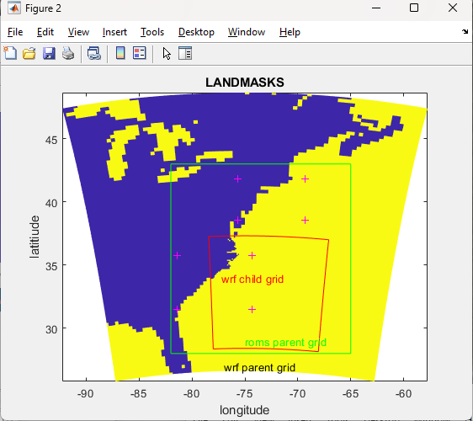
Figure. First steps to show how WRF and ROMS grids will overlay.

Call generic grid creation.
roms_grid='Sandy_roms_grid.nc';
rho.lat=lat; rho.lon=lon;
rho.depth=zeros(size(rho.lon))+100; % for now just make zeros
rho.mask=zeros(size(rho.lon)); % for now just make zeros
spherical='T';
%projection='lambert conformal conic';
projection='mercator';
save temp_jcw33.mat rho spherical projection
eval(['mat2roms_mw(''temp_jcw33.mat'',''',roms_grid,''');'])
!del temp_jcw33.mat
%User needs to edit roms variables
disp([' '])
disp(['Created roms grid --> ',roms_grid])
disp([' '])
disp(['You need to edit depth in ',roms_grid])
disp([' '])

2. ROMS grid masking
Start out with the WRF mask.
F = scatteredInterpolant(double(XLONG(:)),double(XLAT(:)), double(1-LANDMASK(:)),'nearest');
roms_mask=F(lon,lat);
figure
pcolorjw(lon,lat,roms_mask)
title('ROMS 1-LANDMASK grid, Mercator proj')
xlabel('longitude'); ylabel('latitiude')

Compute mask on rho, u, v, and psi points.
water = double(roms_mask);
u_mask = water(1:end-1,:) & water(2:end,:);
v_mask= water(:,1:end-1) & water(:,2:end);
psi_mask= water(1:end-1,1:end-1) & water(1:end-1,2:end) & water(2:end,1:end-1) & water(2:end,2:end);
ncwrite('Sandy_roms_grid.nc','mask_rho',roms_mask);
ncwrite('Sandy_roms_grid.nc','mask_u',double(u_mask));
ncwrite('Sandy_roms_grid.nc','mask_v',double(v_mask));
ncwrite('Sandy_roms_grid.nc','mask_psi',double(psi_mask));

Now we want to make it nicer by using editmask. We need a coastline first.
You can use GEODAS software http://www.ngdc.noaa.gov/mgg/geodas/geodas.html
I selected lat bounds of 45 / 25 lon of -84 / -60 and saved this as coastline.mat
editmask('Sandy_roms_grid.nc','coastline.mat');
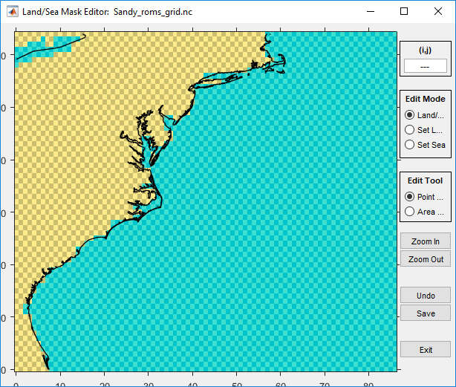
Use “editmask.m” to clean up the land sea masking for Sandy_roms_grid.

3. Bathymetry
Bathymetry can come from many different places. You can use a source like this:
http://www.ngdc.noaa.gov/mgg/global/global.html
For this application, we use data from a local file
load USeast_bathy.mat
netcdf_load('Sandy_roms_grid.nc')
h=griddata(h_lon,h_lat,h_USeast,lon_rho,lat_rho);
h(isnan(h))=5;
%smooth h a little
h(2:end-1,2:end-1)=0.2*(h(1:end-2,2:end-1)+h(2:end-1,2:end-1)+h(3:end,2:end-1)+h(2:end-1,1:end-2)+h(2:end-1,3:end));

figure
pcolorjw(lon_rho,lat_rho,h)
hold on
load coastline.mat
plot(lon,lat,'k')
caxis([5 2500]); colorbar
title('ROMS bathy')
xlabel('longitude'); ylabel('latitiude')
ncwrite('Sandy_roms_grid.nc','h',h);

4. Roms child grids
To create a nested child grid, we want to see how the 2WRF and the 3 ROMS/SWAN-or-WW3 grids will overlay.
cd Projects/Sandy
figure
netcdf_load('WRF/wrfinput_d01')
pcolorjw(XLONG,XLAT,double(1-LANDMASK))
hold on
netcdf_load('WRF/wrfinput_d02')
pcolorjw(XLONG,XLAT,double(1-LANDMASK))
plot(XLONG(1,:),XLAT(1,:),'r'); plot(XLONG(end,:),XLAT(end,:),'r')
plot(XLONG(:,1),XLAT(:,1),'r'); plot(XLONG(:,end),XLAT(:,end),'r')
% plot roms parent grid
netcdf_load('ROMS/Sandy_roms_grid.nc');
plot(lon_rho(1,:),lat_rho(1,:),'g'); plot(lon_rho(end,:),lat_rho(end,:),'g')
plot(lon_rho(:,1),lat_rho(:,1),'g'); plot(lon_rho(:,end),lat_rho(:,end),'g')
text(-75,29,'roms parent grid' ,'color','g')
text(-77,27,'wrf parent grid')
text(-77.2,34,'wrf child grid' ,'color','r')
title('LANDMASKS')
xlabel('longitude'); ylabel('latitiude')

cd ROMS
Select child indices and plot location of roms child grid 1.
Istr=4; Iend=40; Jstr=16; Jend=34;
plot(lon_rho(Istr,Jstr),lat_rho(Istr,Jstr),'m+')
plot(lon_rho(Istr,Jend),lat_rho(Istr,Jend),'m+')
plot(lon_rho(Iend,Jstr),lat_rho(Iend,Jstr),'m+')
plot(lon_rho(Iend,Jend),lat_rho(Iend,Jend),'m+')
ref_ratio=3;
roms_child_grid='Sandy_roms_grid_child1.nc';
F=coarse2fine('Sandy_roms_grid.nc','Sandy_roms_grid_child1.nc', ref_ratio,Istr,Iend,Jstr,Jend);

Select child indices and plot location of roms child grid 2.
Istr=33; Iend=65; Jstr=46; Jend=60;
plot(lon_rho(Istr,Jstr),lat_rho(Istr,Jstr),'c+')
plot(lon_rho(Istr,Jend),lat_rho(Istr,Jend),'c+')
plot(lon_rho(Iend,Jstr),lat_rho(Iend,Jstr),'c+')
plot(lon_rho(Iend,Jend),lat_rho(Iend,Jend),'c+')
ref_ratio=3;
roms_child_grid='Sandy_roms_grid_child2.nc';
F=coarse2fine('Sandy_roms_grid.nc','Sandy_roms_grid_child2.nc', ref_ratio,Istr,Iend,Jstr,Jend);

Create the contact file for ROMS.
Gnames={'Sandy_roms_grid.nc','Sandy_roms_grid_child1.nc','Sandy_roms_grid_child2.nc'};
[S,G]=contact(Gnames,'Sandy_roms_contact_2child.nc');

Compute bathy for the child 1.
netcdf_load('Sandy_roms_grid_child1.nc')
load USeast_bathy.mat
h=griddata(h_lon,h_lat,h_USeast,lon_rho,lat_rho);
h(isnan(h))=5;
h(2:end-1,2:end-1)=0.2*(h(1:end-2,2:end-1)+h(2:end-1,2:end-1)+h(3:end,2:end-1)+ ...
h(2:end-1,1:end-2)+h(2:end-1,3:end));
figure
pcolorjw(lon_rho,lat_rho,h)
hold on
load coastline.mat
plot(lon,lat,'r')
caxis([5 2500]); colorbar
title('ROMS bathy')
xlabel('longitude'); ylabel('latitiude')
ncwrite('Sandy_roms_grid_child1.nc','h',h);

Compute bathy for the child 2.
netcdf_load('Sandy_roms_grid_child2.nc')
load USeast_bathy.mat
h=griddata(h_lon,h_lat,h_USeast,lon_rho,lat_rho);
h(isnan(h))=5;
h(2:end-1,2:end-1)=0.2*(h(1:end-2,2:end-1)+h(2:end-1,2:end-1)+h(3:end,2:end-1)+ ...
h(2:end-1,1:end-2)+h(2:end-1,3:end));
figure
pcolorjw(lon_rho,lat_rho,h)
hold on
load coastline.mat
plot(lon,lat,'r')
caxis([5 2500]); colorbar
title('ROMS bathy')
xlabel('longitude'); ylabel('latitiude')
ncwrite('Sandy_roms_grid_child2.nc','h',h);

At this point, you should check that the bathy in the parent grid represents an average of the child bathy.

Recompute child1 mask based on WRF mask
netcdf_load('../WRF/wrfinput_d01');
netcdf_load('Sandy_roms_grid_child1.nc')
F = TriScatteredInterp(double(XLONG(:)),double(XLAT(:)), ...
double(1-LANDMASK(:)),'nearest');
roms_mask=F(lon_rho,lat_rho);
figure
pcolorjw(lon_rho,lat_rho,roms_mask)
title('ROMS child1 mask')
xlabel('longitude'); ylabel('latitiude')
hold on
plot(lon,lat,'r')
water = double(roms_mask);
u_mask = water(1:end-1,:) & water(2:end,:);
v_mask= water(:,1:end-1) & water(:,2:end);
psi_mask= water(1:end-1,1:end-1) & water(1:end-1,2:end) & water(2:end,1:end-1) & water(2:end,2:end);
ncwrite('Sandy_roms_grid_child1.nc','mask_rho',roms_mask);
ncwrite('Sandy_roms_grid_child1.nc','mask_u',double(u_mask));
ncwrite('Sandy_roms_grid_child1.nc','mask_v',double(v_mask));
ncwrite('Sandy_roms_grid_child1.nc','mask_psi',double(psi_mask));

Recompute child2 mask based on WRF mask
netcdf_load('../WRF/wrfinput_d01');
netcdf_load('Sandy_roms_grid_child2.nc')
F = TriScatteredInterp(double(XLONG(:)),double(XLAT(:)), ...
double(1-LANDMASK(:)),'nearest');
roms_mask=F(lon_rho,lat_rho);
figure
pcolorjw(lon_rho,lat_rho,roms_mask)
title('ROMS child2 mask')
xlabel('longitude'); ylabel('latitiude')
hold on
plot(lon,lat,'r')
water = double(roms_mask);
u_mask = water(1:end-1,:) & water(2:end,:);
v_mask= water(:,1:end-1) & water(:,2:end);
psi_mask= water(1:end-1,1:end-1) & water(1:end-1,2:end) & water(2:end,1:end-1) & water(2:end,2:end);
ncwrite('Sandy_roms_grid_child2.nc','mask_rho',roms_mask);
ncwrite('Sandy_roms_grid_child2.nc','mask_u',double(u_mask));
ncwrite('Sandy_roms_grid_child2.nc','mask_v',double(v_mask));
ncwrite('Sandy_roms_grid_child2.nc','mask_psi',double(psi_mask));

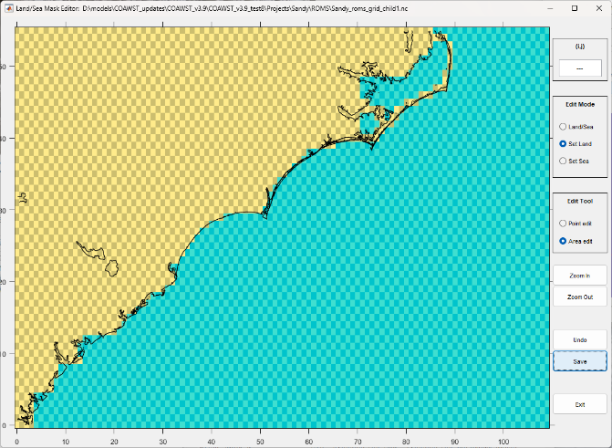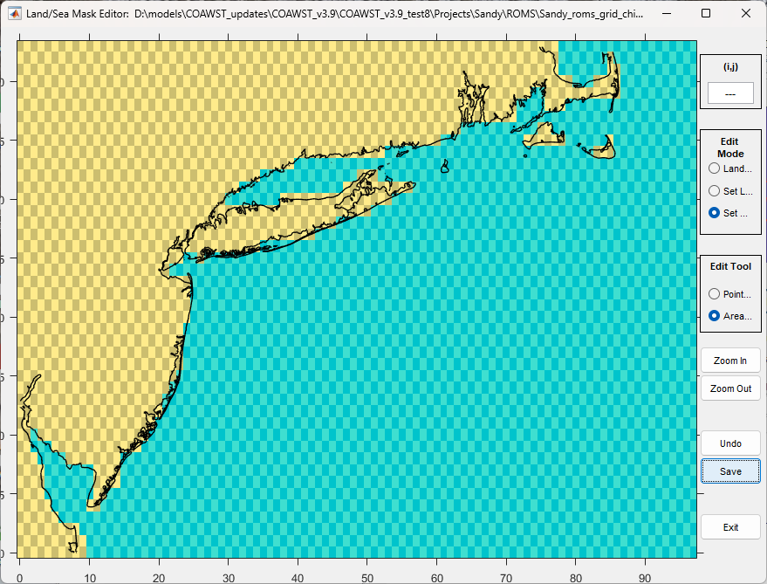
ROMS child grid1 and grid1 masks. I used editmask again to make this nicer.

5. 3D BC's, IC’s, and Climatology fields.
This step creates roms init conditions, bc's, and nudging files. There are several tools out there. Here we will use the Tools folder and use
Tools/mfiles/mtools/roms_master_climatology_coawst_mw
This m file will create BC, IC, and Climatology for the parent grid. Here is the header information that you can edit:

%%% START OF USER INPUT %%%%%%
% (1) Enter start date (T1) and number of days to get climatology data
T1 = datenum(2012,10,28,12,0,0); %start date
%number of days and frequency to create climatology files for
numdays = 5;
dayFrequency = 1;

% (2) Enter URL of the HYCOM catalog for the requested time, T1
% see http://tds.hycom.org/thredds/catalog.html
url = 'http://tds.hycom.org/thredds/dodsC/GLBa0.08/expt_90.9'; % 2011-01 to 2013-08

% (3) Enter working directory (wdr)
wdr = 'F:\data\models\COAWST_tests\coawstv3.4_update\coawst_v3.4_tests\sandy\Projects\Sandy';

% (4) Enter path and name of the ROMS grid
modelgrid = 'Sandy_roms_grid.nc'

% (5) Enter grid vertical coordinate parameters --These need to be consistent with the ROMS setup.
theta_s = 5;
theta_b = 0.4;
Tcline = 50;
N = 16;
Vtransform = 2;
Vstretching = 4;
%%%%%%%%% END OF USER INPUT %%%%%%%%%%%%%%%

When you run this m file, it will create multiple files:
- Inititial conditions: coawst_ini.nc
- Boundary conditions: coawst_bdy_20121028.nc, 29, 30, 31, 01 (5 files) and a
merged_coawst_bdy.nc (all 5 of those merged into 1 file).
- Climatology: coawst_clm_20121028.nc, 29, 30, 31, 01 (5 files) and a
merged_coawst_clm.nc (all 5 of those merged into 1 file). I renamed:
coawst_ini.nc to Sandy_ini.nc
merged_coawst_bdy.nc to Sandy_bdy.nc
merged_coawst_clm.nc to Sandy_clm.nc

For child grids, you need to create init and clm file. You can use the same procedure as above using the master_climatology file, or you can interpolate the data from the parent using:

create_roms_child_init( 'Sandy_roms_grid.nc', 'Sandy_roms_grid_child1.nc', 'Sandy_ini.nc', 'Sandy_ini_child1.nc')

create_roms_child_init( 'Sandy_roms_grid.nc', 'Sandy_roms_grid_child2.nc', 'Sandy_ini.nc', 'Sandy_ini_child2.nc')
and
create_roms_child_clm( 'Sandy_roms_grid.nc', 'Sandy_roms_grid_child1.nc', 'Sandy_clm.nc', 'Sandy_clm_child1.nc')

create_roms_child_clm( 'Sandy_roms_grid.nc', 'Sandy_roms_grid_child2.nc', 'Sandy_clm.nc', 'Sandy_clm_child2.nc')

6. 2D BC's
To add tidal forcing, you can use several methods We distribute a method that uses an older ADCIRC data base adcirc_ec2001v2e_fix_uv.mat and adcirc_ec2001v2e_fix_z.mat.

You can choose to use a newer ADCIRC data base or the OSU data base. For them see instructions at https://www.myroms.org/wiki/Tidal_Forcing.
Then you need to edit Tools/mfiles/tides/create_roms_tides to select the tidal database and the tide start time. Also enter that tide start time into the ocean.in file. We chose the OSU tidal data base and ran that file as:
create_roms_tides
to create tide_forc_Sandy.nc

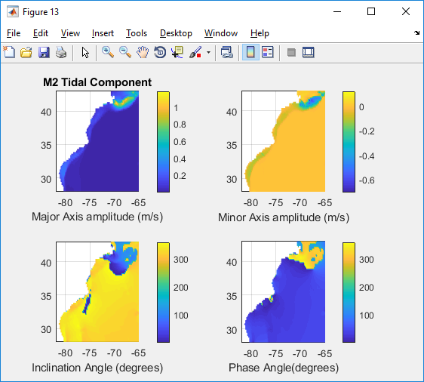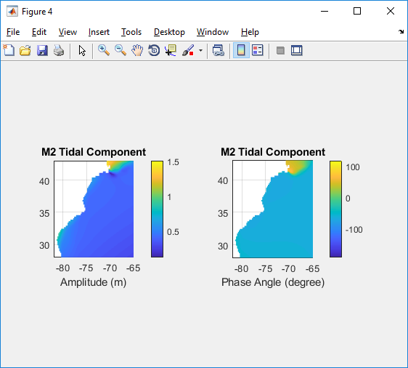
M2 tides to force Sandy example (1 of 9 tidal constituents).

7. Surface forcings.
To create ROMS surface forcing files, there are several options such as:
- create_roms_forcings.m: converts data from matlab workspce to a netcdf forcing file.
- narrnc2roms.m : converts nc files from
ftp.cdc.noaa.gov/Datasets/NARR/monolevel to netcdf.
- ncei_2roms.m : uses THREDDS to get data and create a forcing file.
We used ncei_2roms to create the romsforc_NARR_Sandy2012.nc for Sandy.

8. ROMS input files.
There are several input files to edit.

- Projects/Sandy/sandy.h
Here is where you set model compile options. For this current setup, we will just run ROMS with a child grid so set:
#define ROMS_MODEL
#define NESTING
#undef WRF_MODEL
#undef SWAN_MODEL
#undef MCT_LIB
#undef MCT_INTERP_OC2AT
#undef MCT_INTERP_WV2AT
#undef MCT_INTERP_OC2WV
There are many other ocean model options in that file.

- Projects/Sandy/ocean_sandy.in
There are many settings in here. Some of them are:
! Number of nested grids.
Ngrids = 3

! Number of grid nesting layers. This parameter is used to allow refinement and composite grid combinations.
NestLayers = 2

! Number of grids in each nesting layer [1:NestLayers].
GridsInLayer = 1 2
! These lines above establish that there is 1 parent grid, with 2 child nests on the same parent grid.

! Grid dimension parameters. See notes below in the Glossary for how to set these parameters correctly. These Lm and Mm numbers are 2 less then the total number of rho points.
Lm == 85 108 96 ! Number of I-direction INTERIOR RHO-points
Mm == 63 54 42 ! Number of J-direction INTERIOR RHO-points
N == 16 16 16 ! Number of vertical levels
ND == 0 ! Number of wave directional bins
Nbed = 0 ! Number of sediment bed layers
NAT = 2 2 2 ! Number of active tracers (usually, 2)
NPT = 0 ! Number of inactive passive tracers
NCS = 0 ! Number of cohesive (mud) sediment tracers
NNS = 0 ! Number of non-cohesive (sand) sediment

…
! Input NetCDF file names, [1:Ngrids].
GRDNAME == Projects/Sandy/ROMS/Sandy_roms_grid.nc \
Projects/Sandy/ROMS/Sandy_roms_grid_child1.nc \
Projects/Sandy/ROMS/Sandy_roms_grid_child2.nc
ININAME == Projects/Sandy/ROMS/Sandy_ini.nc \
Projects/Sandy/ROMS/Sandy_ini_child1.nc \
Projects/Sandy/ROMS/Sandy_ini_child2.nc
…
! Nesting grids connectivity data: contact points information.
NGCNAME = Projects/Sandy/ROMS/Sandy_roms_contact_2child.nc

! Input lateral boundary conditions and climatology file names.
NCLMFILES == 1 ! number of climate files
CLMNAME == Projects/Sandy/ROMS/Sandy_clm.nc \
Projects/Sandy/ROMS/Sandy_clm_child1.nc \
Projects/Sandy/ROMS/Sandy_clm_child2.nc

NBCFILES == 1 ! number of boundary files
BRYNAME == Projects/Sandy/Sandy_bdy.nc
For COAWST, you can also use multiple Boundary and/or Climatology files. For example you could use:
NBCFILES == 1 ! number of boundary files
! BRYNAME == Projects/Sandy/Sandy_bdy.nc
BRYNAME == Projects/Sandy/coawst_bdy_20121028.nc |
Projects/Sandy/coawst_bdy_20121029.nc |
Projects/Sandy/coawst_bdy_20121030.nc |
Projects/Sandy/coawst_bdy_20121031.nc |
Projects/Sandy/coawst_bdy_20121101.nc

NFFILES == 1
FRCNAME == Projects/Sandy/ROMS/romsforc_NARR_Sandy2012.nc \
Projects/Sandy/ROMS/romsforc_NARR_Sandy2012.nc \
Projects/Sandy/ROMS/romsforc_NARR_Sandy2012.nc

9. Build and run code
- edit and run build_coawst.sh and set the Project name, header file location, and build location.
- to run the code, edit your run file like run_poseidon with something like:

#!/bin/bash
#PBS -N roms_sandy
#PBS -l nodes=1:ppn=36,walltime=120:00:00
#PBS -q standard

NPROCS=`wc -l < $PBS_NODEFILE`
cd /raid1/jcwarner/Models/COAWST
mpirun -np 16 -machinefile $PBS_NODEFILE ./coawstM > wrf_run1.out

So for this example it used np 16 cores, and this number should = NtileI*NtileJ in your ocean.in

10. look at the output.
ncview Sandy_ocean_his.nc, ncview Sandy_ocean_child1_his.nc, and Sandy_ocean_child2_his.nc

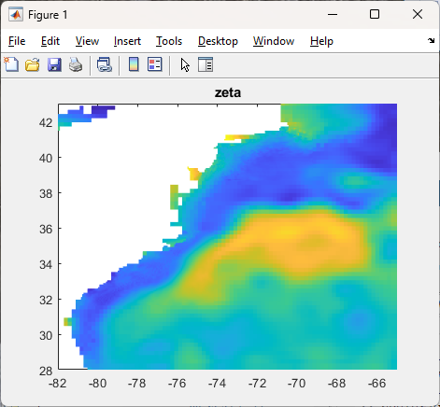
Water levels from all 3 grids.

Section 10. Setting up a SWAN application.
There are many ways to set up a SWAN application, dependent on what physcis you are looking at, the domain size, nesting, etc. This is just one example. We will continue the Sandy example here to set up the SWAN grids (2 grids nested).

1. SWAN grid
There are many ways to make a swan grid. We will use the roms grids and use them to create SWAN on the same grid. You can use differnet size grids (see for example the inlet_test/diffgrid), but for this Sandy application we will use the same grids for both roms and swan. Here we will use a parent SWAN grid, and 2 child nests at the same level, this is the same as was created for the Sandy case with ROMS.

cd to Projects/Sandy/SWAN
roms2swan('../ROMS/Sandy_roms_grid.nc')
This created swan_coord.grd and swan_bathy.bot and I renamed them to be
Sandy_swan_bathy.bot and Sandy_swan_coord.grd

roms2swan('../ROMS/Sandy_roms_grid_child1.nc')
This created swan_coord.grd and swan_bathy.bot and I renamed them to be
Sandy_swan_child1_bathy.bot and Sandy_swan_child1_coord.grd

roms2swan('../ROMS/Sandy_roms_grid_child2.nc')
This created swan_coord.grd and swan_bathy.bot and I renamed them to be
Sandy_swan_child2_bathy.bot and Sandy_swan_child2_coord.grd

The grid size information needs to be entered to the SWAN input. To get the size I usually do this:
netcdf_load('../ROMS/Sandy_roms_grid.nc')
size(h) (ans = 87 65)
So we enter swan.in with values that are 1 less:
CGRID CURVILINEAR 86 64 EXC 9.999000e+003 9.999000e+003 CIRCLE 36 0.04 1.0 24
READGRID COORDINATES 1 'Projects/Sandy/Sandy_swan_coord.grd' 4 0 0 FREE
Similarly for the 2 child grids. You need to create a total of 3 SWAN INPUT files:
swan_sandy.in, swan_sandy_child1.in, swan_sandy_child2.in

In each SWAN INPUT file, you need to list the grid configurations and connectivity. The line for NSGRIDS has been updated for v3.9. For the parent grid we have:
&& KEYWORD NSGRIDS: Number of nested SWAN grids, grid id number, and my parent. For the largest grid: the grid id number is 1 and my parent is 0.
NSGRIDS 3 1 0
You need to list the word “NSGRIDS”
The first number says we will have 3 grids.
The second number says this is grid # 1.
The third number says the parent is grid 0.

For the first child INPUT file, we have
NSGRIDS 3 2 1
And for the second child we have
NSGRIDS 3 3 1
So both of these children have parent grid #1.
It is recommended to list these grids in the same order as you listed them for ROMS, but not necessary.

2. Wind Forcing
If not coupled to wrf, you need to download wind data from somewhere and create an ascii wind forcing file. See the SWAN manual as to the format. We typically use format number 4. You can obtain winds from many places. We have some files to do this.

To create a surface wind forcing file for SWAN, you can use ncei_2swan. This m-file uses THREDDS to access data via internet to create the forcing file. Here is a shortened part of the header for that file:

%(1) Select which variables to include in this ascii forcing file.
% put a '1' if you want to include it, '0' otherwise.
get_Wind=1; % surface u- and v- winds (m/s)

%(2) Enter name of output SWAN forcing file
SWAN_forc_name='swan_narr_Oct2012.dat';

%(3) Enter start and end dates - needed if using get_NARR or get_NAM
namnarr_start = datenum('28-Oct-2012');
namnarr_end = datenum('01-Nov-2012');

%(4) Select which data to obtain: NAM, NARR, or GFS.
get_NARR=0; %NARR-A grid 221 32km data, dt = 3 hr
get_NAM=0; %NAM grid 218 12km data, dt = 3 hr
get_GFS=1; %GFS 0.5 degree, dt = 6 hr
%

%(5) Select to interpolate to a swan grid or a user defined grid.
% Set one of these to a 1, the other to a 0.
interpto_swan_grid = 0;
interpto_user_grid = 1;
. . .
% !!! I made this 0.25 for the Sandy test case, you need finer resolution like 0.1 !!!
lon_rho=[255:0.25:310]+offset;
lat_rho=[ 10:0.25:50 ]; % Create a 0.1 degree lon-lat grid
. . .
Run this file as
ncei_2swan
and this will create swan_GFS_Oct2012.dat. Make a copy of this for the child swan grid.
cp swan_GFS_Oct2012.dat swan_GFS_Oct2012_ref3.dat

In the swan INPUT file, you need to set the WIND Inpgrid commnand line to be consistent with the data file created. The INPGRID line for this example would look like

&& KEYWORD TO CREATE WIND GRID &&
INPGRID WIND REGULAR -105 10 0 220 160 0.25 0.25 &
NONSTATIONARY 20121028.000000 6 HR 20121031.000000
READINP WIND 1 'Projects/Sandy/swan_GFS_Oct2012.dat' 4 0 FREE

These values are from the grid size and time stamps:
The -105 is because the roms grid uses longitudes -180:180.
The 10 is coincident with latitude start of 10.
The 0 is angle.
The 220 is number of ‘x-direction’ points: (310-255)/0.25 = 220.
The 160 is number of ‘y-direction’ points: (50-10)/0.25 = 160.
The 0.25 and 0.25 are the delta space.
Then list the time start, dt, time end.

If you have more than one SWAN grid, you can use the same wind file but you will need to make a copy of it. For example
cp swan_GFS_Oct2012.dat swan_GFS_child1_Oct2012.dat
and then put in the child swan.in:
&& KEYWORD TO CREATE WIND GRID &&
INPGRID WIND REGULAR -105 10 0 220 160 0.25 0.25 &
NONSTATIONARY 20121028.000000 6 HR 20121031.000000
READINP WIND 1 'Projects/Sandy/swan_GFS_child1_Oct2012.dat' 4 0 FREE
Same for child2.

3. Boundary data
There are several sources and methods to obtain boundary data for SWAN. Only the SWAN parent grid needs BC data, the child grids get 2D spec interpolated to them from the parent at each time step. You can create 1D or 2D Spec files from a buoy or ADCP, or create TPAR files that have parametric values of wave height, period, and direction. In this example we will obtain data from Wave Watch 3 and use this to create boundary files. You will need to download historical ww3 from NOAA's ftp server. First, decide what grid and data format you want to use. Read this:
ftp://polar.ncep.noaa.gov/pub/history/waves/README You have several choices.

To create TPAR (parametric foring files)
1. Get the data. Go here to get ftp data from the grid and time period you need. For example, this is the global data set:
ftp://polar.ncep.noaa.gov/pub/history/waves/nww3/
scroll down to multi_1.glo_30m.xx.YYYYMM.grb2
get the three files for each month: xx = hs, tp, dp files (Hsig, Period, and Direction).
multi_1.at_10m.tp.201210.grb2
multi_1.at_10m.hs.201210.grb2
multi_1.at_10m.dp.201210.grb2
Do not change the file names.

2. The file Tools/mfiles/swan_forc/ww3_swan_input.m is the main driver. This can be set to create SWAN TPAR boundary forcing files. For hindcast mode, the TPAR files will be converted from the grib2 data using nctoolbox. This matlab toolbox is not included in the COAWST distribution, so go here and get it: http://code.google.com/p/nctoolbox/

Edit Tools/mfiles/swan_forc/ww3_swan_input.m
and enter the user required info in the USER section of that m file. This includes:
% 1) Enter WORKING DIRECTORY.
working_dir='coawst_v3.4_tests\Projects\Sandy\ww3'

% 2) Enter start dates of data requested.
yearww3='2012'; %input year of data yyyy
mmww3='10'; %input month of data mm
ddww3='00'; %keep this as '00'
long_run=0;

% 3) Enter path\name of SWAN grid. This is set up to use the roms grid as the same for swan.
modelgrid='coawst_v3.4_tests\Projects\Sandy\Sandy_roms_grid.nc';

% 4) Enter the spacings of the forcing file locations around the perimeter
specres=20; % spec point resolution

% 5)
% Here you decide to use gridded field output (to make TPAR) or spectral partition data (to make 2Dspec).
% Pick one of these:
use_field_output=1; % will create TPAR files.
use_partition_data=0; % will create 2D spec files.
% Enter the ww3 grid area
ww3_area='multi_1.at_10m'; %western north atlantic

Run the m file. This will create multiple TPAR* files and a file called Bound_spec_command.

3. Edit the SWAN INPUT file (for the parent only) and add the information from the Bound_spec_command file. Place the TPAR files in the Projects folder and make sure path names are correct.

To create 2D Spec files (spectral foring files)
1. Get the data. Go here to get ftp data from the grid and time period you need. For example, this is the global data set:
ftp://polar.ncep.noaa.gov/pub/history/waves/multi_1/
scroll down to 201210/partitions/ and get
multi_1.partition.glo_30m.201210
This is a big file. Do not change the file names.

2. The file Tools/mfiles/swan_forc/ww3_swan_input.m is the main driver. This can be set to create SWAN 2D spec forcing files. For hindcast mode, the 2Dspec files will be converted from the ASCII partition file.
Edit Tools/mfiles/swan_forc/ww3_swan_input.m
and enter the user required info in the USER section of that m file. This includes:

% 1) Enter WORKING DIRECTORY.
working_dir='coawst_v3.4_tests\sandy\Projects\Sandy\ww3'

% 2) Enter start dates of data requested.
yearww3='2012'; %input year of data yyyy
mmww3='10'; %input month of data mm
ddww3='00'; %keep this as '00'
long_run=0;

% 3) Enter path\name of SWAN grid. This is set up to use the roms grid as the same for swan.
modelgrid='coawst_v3.4_tests\Projects\Sandy\Sandy_roms_grid.nc';

% 4) Enter the spacings of the forcing file locations around the perimeter
specres=20; % spec point resolution

% 5)
% Here you decide to use gridded field output (to make TPAR) or spectral partition data (to make 2Dspec).
% Pick one of these:
use_field_output=0; % will create TPAR files.
use_partition_data=1; % will create 2D spec files.
partfile='multi_1.partition.glo_30m.201210';

Run the m file. This will create multiple 2DSpec files and a file called Bound_spec_command.

3. Edit the SWAN INPUT file (for the parent only) and add the information from the Bound_spec_command file. Place the 2DSpec files in the Projects folder and make sure path names are correct.

4. Initial Conditions Files
Method 1: (try this first). In the swan input file, use the command
INITIAL DEFAULT

Method 2:
To create an init file for swan, you can run SWAN in stationary mode and create ‘hot start’ files. To do this, edit your project.h file and activate SWAN model (with nesting if needed).
#undef ROMS_MODEL
#define NESTING
#undef WRF_MODEL
#define SWAN_MODEL
#undef MCT_LIB
#undef MCT_INTERP_OC2AT
#undef MCT_INTERP_WV2AT
#undef MCT_INTERP_OC2WV

Run build_coawst.sh to build a new executable.
Edit the bottom of swan_sandy.in to be:
COMPUTE STAT 20121028.120000
&COMPUTE NONSTAT 20121028.120000 180 SEC 20121030.120000
HOTFILE 'Sandy_init.hot'

And the bottom of swan_sandy_child1.in to be:
COMPUTE STAT 20121028.120000
&COMPUTE NONSTAT 20121028.120000 90 SEC 20121030.120000
HOTFILE 'Sandy_child1_init.hot'
Same for child2

And in all swan.in files use
& Restart name **********************************
INIT

Run SWAN and create the init files use:
mpirun -np 1 ./coawstM Projects/Sandy/SWAN/swan_sandy.in Projects/Sandy/SWAN/swan_sandy_child1.in Projects/Sandy/SWAN/swan_sandy_child1.in > cwstv3.out
(all that on one line)

Notice we have to call all the swan input files. Also, the ‘1’ means one processor and we will get one init *.hot file for each grid. We can use that to run multiple processor simulations next. You can look at the output. ncview Sandy_hsig.nc

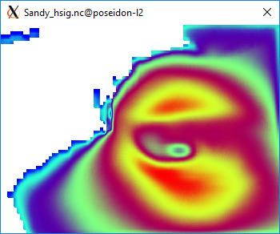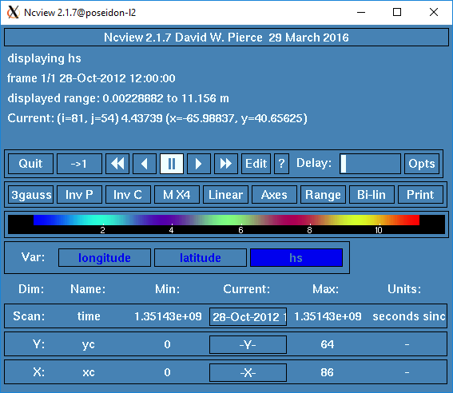
Figure. Initial conditions for Swan.

5. Run SWAN for a longer simulation
To run SWAN for the multi day simulation, edit the swan.in files and list the init files:
For swan_sandy.in use:
& Restart name **********************************
INITIAL HOTSTART SINGLE 'Projects/Sandy/Sandy_init.hot'
&INIT
. . .
RESTART 'swan_rst.dat' FREE 1 HR
% and change the run to be nonstationary
&COMPUTE STAT 20121028.120000
COMPUTE NONSTAT 20121028.120000 180 SEC 20121030.120000
HOTFILE 'Sandy_init.hot'

Notice the command to create hourly restart files ‘RESTART’ is before the COMPUTE command. So every hour, swan will create a restart file (like for roms) that you can use to restart a simulation that dies at some undesired point. You can change the ‘1 HR’ to be other times.

Similarly, for swan_sandy_child1.in use:
& Restart name **********************************
INITIAL HOTSTART SINGLE 'Projects/Sandy/Sandy_child1_init.hot'
&INIT
. . .
RESTART 'swan_child1_rst.dat' FREE 1 HR
% and change the run to be nonstationary
&COMPUTE STAT 20121028.120000
COMPUTE NONSTAT 20121028.120000 180 SEC 20121030.120000
HOTFILE 'Sandy_child1_init.hot'
Same for child 2.

Then run the program
mpirun -np X./coawstM Projects/Sandy/SWAN/swan_sandy.in Projects/Sandy/SWAN/swan_sandy_child1.in Projects/Sandy/SWAN/swan_sandy_child2.in > cwstv3.out
(all on one line)

Section 11. Setting up a WAVEWATCH III application.
As of July, 2019 we have added WaveWatch III from their github site to the COAWST coupled system. WaveWatch can be run alone or coupled to ROMS, to WRF, or to both. As of August 2024, we can run one WW3 grid (ww3_shel) by itself, multiple WW3 grids concurrently nested (ww3_multi), WW3 single or multiple grids coupled to WRF, WW3 single or multiple grids to ROMS.

When you run WW3 and ROMS, we recommend that you use the same grids for both models. So if you are using 2 ROMS grids, then use those same 2 grids with WW3. As with every other model, we recommend that the user become familiar with that model first. The WW3 user manual is provided in COAWST/WW3 directory.

Section 11.1 is for 1 ROMS grid and 1 WW3 structured grid.
Section 11.2 is for 3 ROMS grids and 3 WW3 structured grids.
Section 11.3 is for 3 ROMS grids structured and 3 WW3 unstructured grids.

Section 11.1 Sandy with 1 ROMS grid and 1 WW3 grid.
For this example we will use the Sandy test as an example to run WW3 not nested (1 grid) and coupled to ROMS (1 grid). We will use all the files and setup for ROMS that was created in Section 9: Setting up a ROMS application. The next few sections are for WW3 and the coupled ROMS+WW3 application.

1) edit build_coawst.sh and set:
export COAWST_APPLICATION=SANDY
and set the root location of your code, such as:
export MY_ROOT_DIR=/sand/usgs/users/jcwarner/tests/coawst_v3.8

2) We then need to set 2 WW3 environement settings.
#1) COAWST_WW3_DIR is a pointer to root WW3 code, do not change.
export COAWST_WW3_DIR=${MY_ROOT_DIR}/WW3/model

#2) WW3_SWITCH_FILE is like cpp options for WW3. You need to create it and
# list the full name here.
export WW3_SWITCH_FILE=${MY_PROJECT_DIR}/Projects/Sandy/WW3/switch_sandy

3) As with all applications, set the MPI and compiler information (this will depend on your system):
export USE_MPI=on # distributed-memory parallelism
export USE_MPIF90=on # compile with mpif90 script
export which_MPI=openmpi # compile with OpenMPI library
export FORT=ifort

4) Set the location of the header and analytical files:
export MY_HEADER_DIR=${MY_PROJECT_DIR}/Projects/Sandy/
export MY_ANALYTICAL_DIR=${MY_PROJECT_DIR}/Projects/Sandy/

5) For this description, we are saying to run WW3 coupled to ROMS so edit Projects/Sandy/WW3/sandy.h as:
#define ROMS_MODEL
#undef NESTING
#define WW3_MODEL
#define MCT_LIB
#undef MCT_INTERP_OC2AT
#undef MCT_INTERP_WV2AT
#undef MCT_INTERP_OC2WV

6) Create a switch file.
The switch file is like the cppdefs file for roms. It tells WW3 what features to compile. We have a file Projects/Sandy/WW3/switch_sandy. The file should start with ‘switch_’ Here is the switch_sandy:

F90 NOGRB NC4 DIST MPI PR2 UQ FLX4 LN1 ST6 STAB0 NL1 BT1 DB1 MLIM TR0 BS0 IC2 IS2 REF0 XX0 WNT1 WNX2 CRT1 CRX1 TIDE RWND IG1 TRKNC O0 O1 O2 O2a O2b O2c O3 O4 O5 O6 O7 SCRIP SCRIPNC SCRIPMPI

Please read the WW3 manual in the WW3 directory. Some important options are:
NOPA DO NOT USE THIS.
DIST, MPI These are needed, to use mpi.
SCRIP this is needed for WW3to internally compute nesting weights between the
WW3grids.

7) compile the code by running ./build_coawst.sh at the command prompt.
This calls to use WW3 cmake to build that code. If it compiles correctly, you will get a coawstM. Also, several WW3 utilities will be created in WW3/build/

8) Now we need to create some WW3 grids files. Here is a way to do that. There are probably many other ways to do this.
You can use Tools/mfiles/mtools/create_ww3_grid_files to create an x, y, bath, and mask files for WW3. This m file uses the roms grid to create the WW3 files placed in Projects/Sandy/WW3:
ww3_xcoord_Sandy_roms_grid.dat, ww3_ycoord_Sandy_roms_grid.dat, ww3_bathy_Sandy_roms_grid.dat, and ww3_mapsta_Sandy_roms_grid.dat.

9) Forcing files for WW3: again, there are probably many ways to do this, but here is one way. You can use Tools/mfiles/mtools/create_ww3_wind_forcing to create a wind forcing file ww3_sandy_wind_forc.dat.

10) We then need to create some WW3 run files using 4 of their utilities:

Utility ww3_grid
- edit Projects/Sandy/WW3/ww3_grid.inp. Here is where you enter number of bins, advection choices, time steps (we chose 180), and the grid settings
'CURV' T 'NONE'
87 65
40 1. 0. 1 1 'FREE' 'NAME' 'ww3_sandy_xcoord.dat'
40 1. 0. 1 1 'FREE' 'NAME' 'ww3_sandy_ycoord.dat'
-1.0 -1.0 40 -1. 1 1 '(....)' 'NAME' 'ww3_sandy_bathy.bot'
and the mapsta:
40 1 1 '(....)' 'NAME' 'ww3_sandy_mapsta.inp'

cd to Projects/Sandy/WW3 and run
../../../WW3/build/bin/ww3_grid [.exe]
This will create mask.ww3, mapsta.ww3, mod_def.ww3.
If you change the time steps in ww3_grid.inp, then you need to rerun ww3_grid.exe and create new mod_def file.

Utility ww3_strt
- edit Projects/Sandy/WW3/ww3_strt.inp. Here is where you enter init information.
cd to Projects/Sandy/WW3 and run
../../../WW3/build/bin/ww3_strt to create restart.ww3.

Utility ww3_prep
- edit Projects/Sandy/WW3/ww3_prep.inp. Here is where you enter forcing data. We have:
$
'WND' 'LL' T T
$ Additional input format type 'LL' ---------------------------------- $
$ Grid range (degr. or m) and number of points for axes, respectively.
$ Example for longitude-latitude grid.
-105. -50. 276 10. 50. 201
This tells WW3 that the wind is on a grid with these lon/lat values.

$ Define data files -------------------------------------------------- $
$ The first input line identifies the file format with FROM, IDLA and
$ IDFM, the second (third) lines give the file unit number and name.
'NAME' 1 1 '(....)' '(....)'
40 'ww3_sandy_wind_forc.dat'
This tells WW3 the name of the wind forcing file.
cd to Projects/Sandy/WW3 and run
../../../WW3/build/bin/ww3_prep to create wind.ww3.

Utility ww3_shel
- edit Projects/Sandy/WW3/ww3_shel.inp. Here is where you enter run information.

If you wanted to just run WW3 alone use:
F F Water levels
F F Currents
T F Winds
The first letter is to set if the field is to be not used (F), used as read in from a file (T), or used and read in from a coupled model ( C). So those settings are to read winds from a file.

If we had coupled WW3 to WRF we could use
F F Water levels
F F Currents
C F Winds
And that would get coupled winds from WRF.

If we had coupled WW3 to ROMS, then we use (USE this one )
C F Water levels
C F Currents
T F Winds
To get coupled fields from roms to ww3 and read a wind file.

If we had coupled WW3 to ROMS and to WRF, then we could use
C F Water levels
C F Currents
C F Winds

You need to set the run times here:
$ Type 1 : Fields of mean wave parameters
20121028 120000 1800 20121030 120000
and set to have the fields of Hwave, Dwave, and Lwave written out:
$ HS LM T02 T0M1 T01 FP DIR SPR DP
T T T T T T T T T

We do NOT need to run ww3_shel because that would run the wave model. We will run the wave model as coawstM.

11) Edit the coupling_sandy.in file.
Edit Projects/Sandy/WW3/coupling_sandy.in and set the following information:

number of procs for each model:
NnodesWAV = X ! wave model
NnodesOCN = Y ! ocean model. This needs to = NtileI * NtileJ in the ocean.in

! Time interval (seconds) between coupling of models.
TI_WAV2OCN = 900.0d0 ! wave to ocean coupling interval
TI_OCN2WAV = 900.0d0 ! ocean to wave coupling interval
The ocean (dt =30 ) and wave (dt = 180) models must time step evenly into the coupling interval.

!input files
WAV_name = ww3_grid.inp ! WW3 no NESTING
! WAV_name = Projects/Sandy/WW3/ww3_multi.inp ! WW3 with NESTING
OCN_name = Projects/Sandy/WW3/ocean_sandy.in ! ocean model

!SCRIP name - not needed for this example

12) Now we are ready to run WW3. Cd to the root dir. Now we need to copy (or soft link) those ww3 files to the root location.
cp Projects/Sandy/WW3/* .
and use a run script to run the code on your system. We have run_coawst as an example of a run script, but you need to get a script that works on your system. You do not need to set the number of processors in any of the ww3 files.
mpirun –np X ./coawstM Projects/Sandy/WW3/coupling_sandy.in

If you were running WW3 by itself with this setup, then you need to use
mpirun –np X ./coawstM ww3_grid.inp
You need to have the ww3_grid.inp and the ww3_shel.inp at the root level for WW3 to read them.

13) When the model is done you can visualize the output by using
./WW3/build.bin/ww3_ounf
This will create a ww3.*.nc file called ww3.201210.nc.

Section 11.2 Sandy with 3 ROMS grids and 3 WW3 grids.
For this example we will use the Sandy test as an example to run WW3 with a parent grid and 2 nested grids (on the same refinement level) and coupled to ROMS with a parent grid and 2 nested grids (on the same refinement level). We will use all the files and setup for ROMS that was created in Section 9: Setting up a ROMS application. The next few sections are for WW3 and the coupled ROMS+WW3 application.

1) edit build_coawst.sh and set:
export COAWST_APPLICATION=SANDY
and set the root location of your code, such as:
export MY_ROOT_DIR=/sand/usgs/users/jcwarner/tests/coawst_v3.8

2) We then need to set 2 WW3 environement settings.
#1) COAWST_WW3_DIR is a pointer to root WW3 code, do not change.
export COAWST_WW3_DIR=${MY_ROOT_DIR}/WW3/model

#2) WW3_SWITCH_FILE is like cpp options for WW3. You need to create it and
# list the full name here.
export WW3_SWITCH_FILE=${MY_PROJECT_DIR}/Projects/Sandy/WW3/switch_sandy

3) As with all applications, set the MPI and compiler information (this will depend on your system):
export USE_MPI=on # distributed-memory parallelism
export USE_MPIF90=on # compile with mpif90 script
export which_MPI=openmpi # compile with OpenMPI library
export FORT=ifort

4) Set the location of the header and analytical files (note the WW3 dir):
export MY_HEADER_DIR=${MY_PROJECT_DIR}/Projects/Sandy
export MY_ANALYTICAL_DIR=${MY_PROJECT_DIR}/Projects/Sandy

5) For this description, we are saying to run WW3 and ROMS. We have these files in the Projects/Sandy/WW3/ directory, and sandy.h has
#define ROMS_MODEL
#define NESTING
#define WW3_MODEL
#define MCT_LIB
#define MCT_INTERP_OC2WV

6) Create a switch file.
The switch file is like the cppdefs file for roms. It tells WW3 what features to compile. We have a file Projects/Sandy/WW3/switch_sandy. The file should start with ‘switch_’ Here is the switch_sandy:

F90 NOGRB NC4 DIST MPI PR2 UQ FLX4 LN1 ST6 STAB0 NL1 BT1 DB1 MLIM TR0 BS0 IC2 IS2 REF0 XX0 WNT1 WNX2 CRT1 CRX1 TIDE RWND IG1 TRKNC O0 O1 O2 O2a O2b O2c O3 O4 O5 O6 O7 SCRIP SCRIPNC SCRIPMPI

Please read the WW3 manual in the WW3 directory. Some important options are:
NOPA DO NOT USE THIS.
DIST, MPI These are needed, to use mpi.
SCRIP* this is needed for WW3to internally compute nesting weights between the
WW3grids.

7) compile the code by running ./build_coawst.sh at the command prompt.
This calls cmake to build WW3 and regular make for ROMS. If it compiles correctly, you will get a coawstM. Also, several WW3 utilities will be created in WW3/build/.

8) Now we need to create WW3 grids files for both the parent and the child. There are probalbly many other ways to do this, but we have some m files that work.
You can use Tools/mfiles/mtools/create_ww3_grid_files to create an x, y, bath, and mask files for WW3. This m file uses the roms grid to create the WW3 grids, and the files placed in Projects/Sandy/WW3. Enter the names of the ROMS grids that will be used to create the WW3 grids:
%1) cd to a working directory
cd D:\models\COAWST\Projects\Sandy\ROMS

%2) how many WW3 grids do you have for this configuration?
numgrids=3;

%3) Enter name of ROMS grid file(s)
roms_grid{1}='Sandy_roms_grid.nc';
roms_grid{2}='Sandy_roms_grid_child1.nc';
roms_grid{3}='Sandy_roms_grid_child2.nc';

Run the mfile and it will create the ww3_xcoord*, ww3_ycoord*, ww3_bathy*,ww3_mapsta* and ww3_*.msh files. You can move all these files to the ../WW3 directory.

9) Forcing files for WW3: again, there are probably many ways to do this, but here is one way. You can use Tools/mfiles/mtools/create_ww3_wind_forcing, it will read the roms winds forcing file and create a ww3 wind forcings file called ww3_sandy_wind_forc.dat.

10) We then need to create some WW3 run files using 4 of their utilities:

Utility ww3_grid
- edit Projects/Sandy/WW3/ww3_grid.inp. Here is where you enter number of bins, advection choices, etc. We will run this file 3 times.
For all the grids we chose 1.1 increment freq factor, 0.038 first freq, 32 freqs, 36 dir bins.
1.1 0.038 32 36 0.

For time steps for the parent grid:
100. 100. 100. 100.

, and the grid settings
'CURV' T 'NONE'
87 65
40 1. 0. 1 1 'FREE' 'NAME' 'ww3_xcoord_Sandy_roms_grid.dat'
40 1. 0. 1 1 'FREE' 'NAME' 'ww3_ycoord_Sandy_roms_grid.dat'
10.0 0.1 40 -1. 1 1 '(....)' 'NAME' 'ww3_bathy_Sandy_roms_grid.dat'

and the mapsta:
40 1 1 '(....)' 'NAME' 'ww3_mapsta_Sandy_roms_grid.dat'

Then cd to Projects/Sandy/WW3 and run
../../../WW3/build/bin/ww3_grid [.exe]
This will create mask.ww3, mapsta.ww3, mod_def.ww3, and the ST4 table.
Because we are running 3 grids, we need to move (rename) these files:
mv mask.ww3 mask.grd1
mv mapsta.ww3 mapsta.grd1
mv mod_def.ww3 mod_def.grd1

Then edit ww3_grid.inp and change the settings to be for child grid 1:
time stepping
50. 50. 50. 50.
and grid
$ Uncomment these next 5 lines for the child1 Sandy grid - structured
'CURV' T 'NONE'
110 56
40 1. 0. 1 1 'FREE' 'NAME' 'ww3_xcoord_Sandy_roms_grid_child1.dat'
40 1. 0. 1 1 'FREE' 'NAME' 'ww3_ycoord_Sandy_roms_grid_child1.dat'
10.0 0.1 40 -1. 1 1 '(....)' 'NAME' 'ww3_bathy_Sandy_roms_grid_child1.dat'
and
$ Uncomment these next 1 line for the child1 Sandy grid - structured
40 1 1 '(....)' 'NAME' 'ww3_mapsta_Sandy_roms_grid_child1.dat'

Then cd to Projects/Sandy/WW3 and run
../../../WW3/build/bin/ww3_grid [.exe]
This will create mask.ww3, mapsta.ww3, mod_def.ww3.
Because we are running 3 grids, we need to move (rename) these files:
mv mask.ww3 mask.grd2
mv mapsta.ww3 mapsta.grd2
mv mod_def.ww3 mod_def.grd2

Then do the same for the 3rd grid (child grid 2).
$time steps
25. 25. 25. 25.

$ Uncomment these next 5 lines for the child2 Sandy grid - structured
'CURV' T 'NONE'
98 44
40 1. 0. 1 1 'FREE' 'NAME' 'ww3_xcoord_Sandy_roms_grid_child2.dat'
40 1. 0. 1 1 'FREE' 'NAME' 'ww3_ycoord_Sandy_roms_grid_child2.dat'
10.0 0.1 40 -1. 1 1 '(....)' 'NAME' 'ww3_bathy_Sandy_roms_grid_child2.dat'

$ Uncomment these next 1 line for the child2 Sandy grid - structured
40 1 1 '(....)' 'NAME' 'ww3_mapsta_Sandy_roms_grid_child2.dat'

Then cd to Projects/Sandy/WW3 and run
../../../WW3/build/bin/ww3_grid [.exe]
This will create mask.ww3, mapsta.ww3, mod_def.ww3.
Because we are running 3 grids, we need to move (rename) these files:
mv mask.ww3 mask.grd3
mv mapsta.ww3 mapsta.grd3
mv mod_def.ww3 mod_def.grd3

It is recommended to perform those ww_grid steps with the 3 WW3 grids in the same order as the 3 ROMS grids.

Utility ww3_strt
- edit Projects/Sandy/WW3/ww3_strt.inp. Here is where you enter init information.
cd to Projects/Sandy/WW3 and run this twice:

cp mod_def.grd1 mod_def.ww3
../../../WW3/build/bin/ww3_strt
mv restart.ww3 restart.grd1
$
cp mod_def.grd2 mod_def.ww3
../../../WW3/build/bin/ww3_strt
mv restart.ww3 restart.grd2
$
cp mod_def.grd3 mod_def.ww3
../../../WW3/build/bin/ww3_strt
mv restart.ww3 restart.grd3

Utility ww3_prep
- edit Projects/Sandy/WW3/ww3_prep.inp. Here is where you enter forcing data. We used the ROMS winds to make the ww3_sandy_wind_forc.dat file. We have:

$
'WND' 'LL' T T
$ Additional input format type 'LL' ---------------------------------- $
$ Grid range (degr. or m) and number of points for axes, respectively.
$ Example for longitude-latitude grid.
-105. -50. 276 10. 50. 201
This tells WW3 that the wind is on a grid with these lon/lat values and sizes.

$ Define data files -------------------------------------------------- $
$ The first input line identifies the file format with FROM, IDLA and
$ IDFM, the second (third) lines give the file unit number and name.
'NAME' 1 1 '(....)' '(....)'
40 'ww3_sandy_wind_forc.dat'
This tells WW3 the name of the wind forcing file.

cd to Projects/Sandy/WW3 and run the prep command. We will need to do this three times:

cp mod_def.grd1 mod_def.ww3
../../../WW3/build/bin/ww3_prep
mv wind.ww3 wind.grd1
$
cp mod_def.grd2 mod_def.ww3
../../../WW3/build/bin/ww3_prep
mv wind.ww3 wind.grd2
$
cp mod_def.grd3 mod_def.ww3
../../../WW3/build/bin/ww3_prep
mv wind.ww3 wind.grd3

Utility ww3_multi
For a single grid (undef NESTING) we use ww3_shel.inp.
For multiple grids (define NESTING) we use ww3_multi.inp.
Edit Projects/Sandy/WW3/ww3_multi.inp. Here is where you enter run information.
Some important parts are:

$ The first input line sets up the general multi-grid model definition
$ by defining the following six parameters :
$ 2 grids 2 input fields etc
3 3 F 1 F F
$ There should be 9 entries after the '' name.
$ These next 3 lines are for WW3 coupled to roms and using a wind
$ forcing file, or coupled to roms and wrf.
'grd1' T T T F F F F F F
'grd2' T T T F F F F F F
'grd3' T T T F F F F F F
Here we list the 3 grids. The first T is saying get water levels, the scond T is to get currents, the third T is to get winds.

If you did not want water levels and currents from roms, then use
'grd1' F F T F F F F F F
'grd2' F F T F F F F F F
and
'grd1' 'no' 'no' 'native' 'no' 'no' 'no' 'no' 'no' 'no' 1 1 0.00 1.00 F
'grd2' 'no' 'no' 'native' 'no' 'no' 'no' 'no' 'no' 'no' 2 1 0.00 1.00 F

To determine where to get the data, we use:
$ The next 3 lines are for Sandy case with just WW3. Winds read from a file.
$ 'grd1' 'no' 'no' 'native' 'no' 'no' 'no' 'no' 'no' 'no' 1 1 0.00 1.00 F
$ 'grd2' 'no' 'no' 'native' 'no' 'no' 'no' 'no' 'no' 'no' 2 1 0.00 1.00 F
$ 'grd3' 'no' 'no' 'native' 'no' 'no' 'no' 'no' 'no' 'no' 3 1 0.00 1.00 F
$
$ The next 3 lines are for Sandy case with ROMS+WW3. Winds read from a file.
$This will use the coupler to get water levels and currents from ROMS, and winds from a native file.
'grd1' 'CPL:native' 'CPL:native' 'native' 'no' 'no' 'no' 'no' 'no' 'no' 1 1 0.00 1.00 F
'grd2' 'CPL:native' 'CPL:native' 'native' 'no' 'no' 'no' 'no' 'no' 'no' 2 1 0.00 1.00 F
'grd3' 'CPL:native' 'CPL:native' 'native' 'no' 'no' 'no' 'no' 'no' 'no' 3 1 0.00 1.00 F
$
$ The next 3 lines are for Sandy case with ROMS+WW3+WRF coupled.
$ 'grd1' 'CPL:native' 'CPL:native' 'CPL:native' 'no' 'no' 'no' 'no' 'no' 'no' 1 1 0.00 1.00 F
$ 'grd2' 'CPL:native' 'CPL:native' 'CPL:native' 'no' 'no' 'no' 'no' 'no' 'no' 2 1 0.00 1.00 F
$ 'grd3' 'CPL:native' 'CPL:native' 'CPL:native' 'no' 'no' 'no' 'no' 'no' 'no' 3 1 0.00 1.00 F

Enter the run times and output info
$ Starting and ending times for the entire model run,
20121028 120000 20121030 120000
….

We do NOT need to run ww3_multi because that would run the wave model. We will run the wave model as coawstM.

11) Create the SCRIP interpolation weights file.
As of COAWST v3.9, this will happen automatically.
-- or --
As described in Section 5.2, you need to build SCRIP_COAWST, edit the input file, and run scrip_coawst.

-cd to Lib/SCRIP_COAWST, edit the makefile and set FORT to the compiler.
#FORT = ifort
FORT = gfortran

-at the command prompt, type make That should build the code.

-edit scrip_coawst_sandy.in and set information for the output nc file name, number of grids for ROMS WRF WW3 and SWAN. Here we are just using
NGRIDS_ROMS=3,
NGRIDS_WW3=3,

-enter the ROMS and WW3 grid info. This info is already in the scrip_coawst_sandy.in file. The size of the WW3 grids are listed as full size, ie size(h).

-run scrip as mpirun -np X ./scrip_coawst[.exe] scrip_coawst_sandy.in
This will create the output file that you specified, here it is
OUTPUT_NCFILE='scrip_sandy_roms_ww3_3grids.nc'
cp that output file to Projects/Sandy/WW3

12) Edit the coupling_sandy.in file.
Edit Projects/Sandy/coupling_sandy.in and set the following information:

number of procs for each model:
NnodesWAV = X ! wave model
NnodesOCN = Y ! ocean model. This needs to = NtileI * NtileJ in the ocean.in

! Time interval (seconds) between coupling of models.
TI_WAV2OCN = 900.0d0 ! wave to ocean coupling interval
TI_OCN2WAV = 900.0d0 ! ocean to wave coupling interval
The ocean (dt =30 ) and wave (dt = 180) models must time step evenly into the coupling interval.

!input files
! WAV_name = ww3_grid.inp ! WW3 no NESTING
WAV_name = Projects/Sandy/WW3/ww3_multi.inp ! WW3 with NESTING
OCN_name = Projects/Sandy/WW3/ocean_sandy.in ! ocean model

!SCRIP name
SCRIP_COAWST_NAME = Projects/Sandy/WW3/scrip_sandy_roms_ww3_3grids.nc ! roms(3) ww3(3)
This file will be created.

12) Now we are ready to run the coupled system.
cd to the root dir. Now we need to copy (or soft link) those ww3 files to the root location.
cp Projects/Sandy/WW3/*grd1 .
cp Projects/Sandy/WW3/*grd2 .
cp Projects/Sandy/WW3/ww3_multi.inp .

and use a run script to run the code on your system. We have run_coawst as an example of a run script, but you need to get a script that works on your system. You do not need to set the number of processors in any of the ww3 files.
mpirun –np X ./coawstM Projects/Sandy/coupling_sandy.in

13) When the model is done you can visualize the output by using
./WW3/build.bin/ww3_ounf
This will create a ww3.*.nc file called ww3.201210.nc.

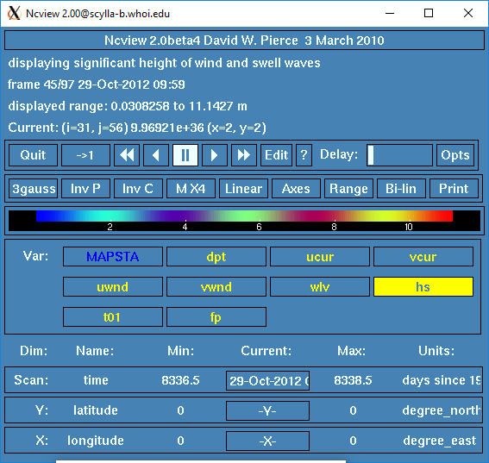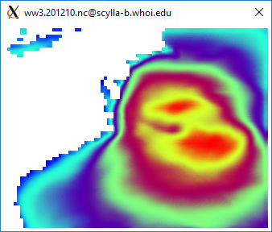

Figure 11.2 Ncview of WW3 wave heigth for Sandy simulation.
Or you can visualize the ROMS nc file.

Section 11.3 Sandy with 3 ROMS structured grids and 3 WW3 unstructured grids.
For this example we will use the Sandy test as an example to run WW3 nested (3 grids unstrucutred) and coupled to ROMS (3 grids). You need to have the same number of WW3 unstructured grids as we do ROMS grids. Please list the WW3 grids in the ww3_multi.inp file in the same order as the ROMS grids were listed in the ocean.in. We will use all the files and setup for ROMS that was created in Section 9: Setting up a ROMS application. We also use the procedure in Section 11.2 for 3 roms + 3 ww3 strucuted grids, with some slight modification for the unstructured WW3 grids. Suggest the user perform section 11.2 first, then make these changes to use the unstructured WW3 grids. The steps below are the modifications to Section 11.2, not the full procedure.

The ‘unstructured’ WW3 is just the structured grid, with a line that connects the lower left corner to the upper right corner of each structured grid cell. This creates a mesh that is triangular and can be run with the unstructed version of the code. This allows for an implicit time stepping option that can run faster, especially at coastal shallow water scales.

- Section 11.2 Step8: The ‘unstructed’ WW3 grids are created in the step to make the WW3 grids, using create_ww3_grid_files.m. In that routine the structured and unstructured WW3 grids are created.

- Section 11.2 Step 9: Utility ww3_grid
In the file ww3_grid.inp, change the line
$ & UNST, UGOBCAUTO = T, IMPFSN = T /
to
& UNST, UGOBCAUTO = T, IMPFSN = T /
The $ is a comment, the & is a line continuation.

For the parent, use the same time steps
100. 100. 100. 100.

$ Uncomment these next 2 lines for the parent Sandy grid - unstructured
'UNST' T 'NONE'
10.0 0.1 40 -1. 4 1 '(20f10.2)' 'NAME' 'ww3_Sandy_roms_grid.msh'

And for the mapsta lines.
$ Uncomment these next 1 line for the parent Sandy grid - unstructured
10 1 1 '(....)' 'PART' 'ww3_mapsta_Sandy_roms_grid.dat'

And use
$ Close list by defining point (0,0) (mandatory)
0 0 F
$
$ Excluded grid points from segment data ( FROM != PART )
0 0 F
$ Second, define a point in a closed body of sea points to remove
$ the entire body of sea points. Also close by point (0,0)
0 0

cd to Projects/Sandy/WW3 and run
../../../WW3/build/bin/ww3_grid
../../../WW3/build/bin/ww3_strt
../../../WW3/build/bin/ww3_prep
cp mod_def.ww3 to mod_def.grd1.
cp the restart.ww3 to restart.grd1
cp wind.ww3 to wind.grd1

and then do the same for grid 2 using
the correct time steps and
$ Uncomment these next 2 lines for the child1 Sandy grid - unstructured
'UNST' T 'NONE'
10.0 0.1 40 -1. 4 1 '(20f10.2)' 'NAME' 'ww3_Sandy_roms_grid_child1.msh'

$ Uncomment these next 1 line for the child1 Sandy grid - unstructured
10 1 1 '(....)' 'PART' 'ww3_mapsta_Sandy_roms_grid_child1.dat'

run the grid strt and prep and cp the files but use .grd2.
Do the same for grid 3.

The ww3_multi can stay unchanged.

Section 11.2 Step12:
You do not need to make a new SCRIP weights file.
Run it as mpirun –np X ./coawstM Projects/Sandy/WW3/coupling_sandy.in

Section 12. Setting up a Coupled Application.
A coupled application is when you are using more than one model. To set up a coupled application, we highly recommend that you try to run each individual model first. This will allow you to focus on the grids and input files for each model separately before you run the system coupled. We have been going thru the Sandy example for WRF, ROMS, SWAN, and WW3 in Sections 8, 9, 10, and 11. We will now go through the steps to set up a coupled application following the Sandy Project. To run a coupled setup you need to:
- the SCRIP file will be automatically generated
- use the coupling.in input file
- set some cpp options,

1. SCRIP
As of COAWST v3.9, this file is automatically generated. But you can still make it ahed of time as needed.
We use the Spherical Coordinate Remapping Interpolatin Package (SCRIP) from Los Alamos National Laboratory to create interpolation weights. The weights are needed if the grids are different sizes or if you have nested grids. The weights are used by MCT to conservatively remap the scalars and fluxes between the grids. We have modified SCRIP to read in the model grids, compute the weights and then to provide one netcdf output file with all weights. This output file uses structures so it needs Netcdf_4.

- cd to Lib/SCRIP_COAWST and edit the makefile. Select the compiler:
FORT = ifort
#FORT = gfortran
#FORT = pgi
The location of the directory is important, as it uses the ../../Compilers directory (just like ROMS and SWAN will) to get the Fortran flags. Build the code using:
make
this should create a scrip_coawst[.exe]

- Edit the SCRIP input file. We provide several, for this case lets use scrip_coawst_sandy. Here are some of the important parts:

! 1) Enter name of output netcdf4 file
OUTPUT_NCFILE='scrip_sandy_static.nc'

! 2) Enter total number of ROMS, SWAN, WW3, and WRF grids:
!
NGRIDS_ROMS=2,
NGRIDS_SWAN=2,
NGRIDS_WW3=0,
NGRIDS_WRF=2,

! 3) Enter name of the ROMS grid file(s):
!
ROMS_GRIDS(1)='../../Projects/Sandy/ROMS/Sandy_roms_grid.nc',
ROMS_GRIDS(2)='../../Projects/Sandy/ROMS/Sandy_roms_grid_child1.nc',
ROMS_GRIDS(3)='../../Projects/Sandy/ROMS/Sandy_roms_grid_child2.nc',
ROMS_PARENT(1)=0,
ROMS_PARENT(2)=1,
ROMS_PARENT(3)=1,

! 4) Enter SWAN information:
! the name(s) of the SWAN grid file(s) for coords and bathy.
! the size of the SWAN grids (full number of center points), and
! if the swan grids are Spherical(set cartesian=0) or
! Cartesian(set cartesian=1).
!
SWAN_COORD(1)='../../Projects/Sandy/SWAN/Sandy_swan_coord.grd',
SWAN_BATH(1)='../../Projects/Sandy/SWAN/Sandy_swan_bathy.bot',
SWAN_NUMX(1)=87,
SWAN_NUMY(1)=65,
SWAN_CARTESIAN(1)=0,
SWAN_PARENT(1)=0,
SWAN_COORD(2)='../../Projects/Sandy/SWAN/Sandy_swan_child1_coord.grd',
SWAN_BATH(2)='../../Projects/Sandy/SWAN/Sandy_swan_child1_bathy.bot',
SWAN_NUMX(2)=110,
SWAN_NUMY(2)=56,
SWAN_CARTESIAN(2)=0,
SWAN_PARENT(2)=1,
SWAN_COORD(3)='../../Projects/Sandy/SWAN/Sandy_swan_child2_coord.grd',
SWAN_BATH(3)='../../Projects/Sandy/SWAN/Sandy_swan_child2_bathy.bot',
SWAN_NUMX(3)=98,
SWAN_NUMY(3)=44,
SWAN_CARTESIAN(3)=0,
SWAN_PARENT(3)=1,

! 6) Enter the name of the WRF input grid(s). If the grid is a
! moving child nest then enter that grid name as 'moving'.
! Also provide the grid ratio, this is used for a moving nest.
!
WRF_GRIDS(1)='../../Projects/Sandy/WRF/wrfinput_d01',
WRF_GRIDS(2)='../../Projects/Sandy/WRF/wrfinput_d02',
!WRF_GRIDS(2)='moving',
WRF_PARENT_GRID_RATIO(1)=1,
WRF_PARENT_GRID_RATIO(2)=3,
WRF_PARENT_ID(1)=0,
WRF_PARENT_ID(2)=1,

Run the SCRIP as:
./scrip_coawst scrip_coawst_sandy.in
Then I copied the output netcdf file scrip_sandy_static.nc to Projects/Sandy.

2. Coupling.in file
edit Projects/Sandy/coupling_sandy.in Here are some of the important parts:

Set the number of cores for each model.
NnodesATM = 1 ! atmospheric model
NnodesWAV = 1 ! wave model
NnodesOCN = 1 ! ocean model

! Time interval (seconds) between coupling of models.
TI_ATM2WAV = 1800.0d0 ! atmosphere to wave coupling interval
TI_ATM2OCN = 1800.0d0 ! atmosphere to ocean coupling interval
TI_WAV2ATM = 1800.0d0 ! wave to atmosphere coupling interval
TI_WAV2OCN = 1800.0d0 ! wave to ocean coupling interval
TI_OCN2WAV = 1800.0d0 ! ocean to wave coupling interval
TI_OCN2ATM = 1800.0d0 ! ocean to atmosphere coupling interval

! Enter names of Atm, Wav, and Ocn input files.
! The Wav program needs multiple input files, one for each grid.

ATM_name = namelist.input ! atmospheric model
WAV_name = Projects/Sandy/swan_sandy.in \
Projects/Sandy/swan_sandy_ref3.in ! wave model
! WAV_name = WW3/work/ww3_grid.inp
OCN_name = Projects/Sandy/ocean_sandy.in ! ocean model

! Sparse matrix interpolation weights file that is generated.
SCRIP_COAWST_NAME = Projects/Sandy/scrip_sandy_static.nc

- 3. Cpp options. Edit your project.h file (sandy.h) and activate:
#define ROMS_MODEL
#define NESTING
#define WRF_MODEL
#define SWAN_MODEL
#define MCT_LIB
#define MCT_INTERP_OC2AT
#define MCT_INTERP_WV2AT
#define MCT_INTERP_OC2WV

- 4. Build the executable
edit and run build_coawst.sh to build the code

- 5. Run the model
edit your run script and set np = NnodesATM+NnodesWAV+NnodesOCN = NP
edit namelist.input to set NnodesATM = nproc_x*nproc_y
edit ocean.in and set NtileI*NtileJ = NnodesOCN
swan does not set the number of procs in its input file.

Run it as mpirun –np NP ./coawstM Projects/Sandy/coupling_sandy.in

6. For a Moving WRF Nest:
You can have a moving WRF nest coupled to the system. For SCRIP set
!WRF_GRIDS(2)='../../Projects/Sandy/wrfinput_d02',
WRF_GRIDS(2)='moving',
This will create a different scrip weights file. Select this file in coupling.in
You will need to recompile and select vortex following for WRF.
Then run it as before.

Section 13. Setting up an InWave application.

InWave solves the wave action balance conservation equation, which is given by:
$$\frac{∂\left(A\right)}{∂t}+\frac{∂\left(C_{g,x}A\right)}{∂x}+\frac{∂\left(C_{g,y}A\right)}{∂y}+\frac{∂\left(C_{g,θ}A\right)}{∂θ}=-\frac{D_{w}}{σ}$$where A stands for the time varying energy action or density for each directional bin ($A=E(x,y,θ,t)/σ(x,y,θ,t)$); $C_{g,x}$, $C_{g,y}$, and $C_{g,θ}$ represent the wave group celerity in the x, y, and θ directions respectively (Olabarrieta, et al., in prep). $D_{w}$ is the energy dissipation due to the wave breaking and is the intrinsic wave frequency. Details are provided in:

Olabarrieta, M., Warner, J.C., & Hegermiller, C. A. (2023). Development and application of an infragravity wave (InWave) driver to simulate nearshore processes. Journal of Advances in Modeling Earth Systems, 15, e2022MS003205. https://doi.org/10.1029/2022MS003205.

There are two ways to run InWave: 1) forcing the model using a 2D spec file from SWAN and 2) imposing time series of wave action density along the open boundaries. Option 1 has examples for Ducknc-ROMS_InWave (Example 6.2) that is a 1D cross-shore profile test case with wave current interaction and bed morphology, and for the Inlet_test/InWave (Example 6.7). Option 2 example is InWave_Shoreface (Example 6.11). The cpp options for InWave are described in 4.3.11.

Other examples of the InWave applications are

Hegermiller, C.A.*, Warner, J.C., Olabarrieta, M., Sherwood, C.R., and Kalra, T. (2022). Barrier island breach dynamics during Hurricanes Sandy and Matthew Journal of Geophysical Research - Earth Surface, https://doi.org/10.1029/2021JF006307.

Warner, J.C., Sherwood, C.R., Carson, M., Olabarrieta, M., Subgranon, A., Klepac, S., Gonzalez, J.M., Zambon, J., He, R., Xue, G., Bao, D., Ou, Y., Hunter, E., Moskaitis, J., Doyle, J. Danielson, J., Amante, C., and Enwright, N. (2025). Inundation processes and barrier island breaching during Hurricane Michael (2018)., Earth and Space Science, 12, e2025EA004446. https://doi.org/10.1029/2025EA004446.

Section 14. MATLAB (.m) scripts for pre/post processing.
- As of release 567, February 8, 2012, we have rewritten the m files to use native matlab netcdf interface. This will allow a more uniform practice amongst users. The caveat of this is that the matlab interface uses the Fortran convention, ie the variables are read and writen as Var(x,y,z,t). Many of the previous toolboxes used the C convention of Var(t,z,y,x). Please be careful when using the native matlab. You can use Tools/mfiles/mtools/netcdf_load to use native matlab to load a netcdf file into the workspace.

- Another optional toolbox that may be needed is nctoolbox found at: http://code.google.com/p/nctoolbox/
Follow instructions on that website to install that toolbox. These nctools are optionally used in the roms_clm routines to read HYCOM data via opendap, and they are optionally used in the swan_forc m files to read the grib2 WW3 data. This nctoolbox is not required to run the COAWST system but provides additional functionality.

mfile listing:
- inwave_tools: under development.

- m_map: set of utilities used in the grid generation routines, used to convert lat/lon to meters, and to support different projections.

- mtools: set of utilites mostly for ROMS to create grids, load a netcdf file, converting grids for scrip, creating wrf grid from roms grid, etc.

- roms_clm: main driver is roms_master_climatology_coawst_mw.m, used to create boundary, init, and climatology files for roms grids using opendap to read HYCOM data.

- rutgers: contains m files from Rutgers for bathymetry, boundary, coastlines, forcing, grid, landmask, netcdf, seawater, and utility folders.

- swan_forc: main driver is ww3_swan_input.m to read WW3 grib2 data and create SWAN TPAR forcing files

- tides: Use this set of m files to create tidal forcings for roms.

Section 15. Tracking model development changes log.

"svn log" gives the whole listing. Here are some key updates:

Rev # Date Description
-------------------------- COAWST V1.0 ------------------------------------
0 01Jan2009 First upload.
17 23Feb2009 Merge grid refinement with atm coupling methods.
83 16Apr2009 Update time stepping for refined grids.
99 24Apr2009 Add SWAN forcing package.
107 28Apr2009 Add InWave.
147 06Jul2009 Add Inlet tests (3).
185 07Aug2009 Update to WRFV3.1.1
196 03Sep2009 Add BLOCK_JONSSON.
203 14Sep2009 Add UV_KIRBY vel avg for wave coupling.
207 16Sept2009 Added hwave/lwave from SWAN to WRF.
-------------------------- COAWST V2.0 ------------------------------------

250-262 01May2010 Update to ROMS svn 455, Update SWAN 4072ABCDE
This was a major update. Complete build is now handled thru coawst.bash script.

-------------------------- COAWST V3.0 ------------------------------------

300-315
330 15Jun2010 Removed old Project files.
331-338 07Jul2010 Add ATM2OCN_FLUXES to allow consistent wrf-roms fluxes and to update scrip interpolation to use conservative fluxes.
351 19Jul2010 Update Inlet tests to work with consv fluxes, and be more consistent. Update manual to include Inlet Tests descriptions, added m files to create the refined grids.
393 07Dec2010 SWAN uses urms instead of ubot to compute Madsen bottom stress. Also pass urms to roms for bbl models instead of ubot. Rename Ub_swan to Uwave_rms. If user does not activate a bbl, then swan fric will be based on user supplied value in swan.in. If user does activate bbl, then swan fric is based on ZoNik.
426 27Feb2011 Update to WRF 3.2.1
430 05Mar2011 Incorporate wec-vortex force method.
433 09Mar2011 Update to SWAN 40.81
469 02Jun2011 Add WPS and WRF to run separately
476-477 12Jul2011 Add WRF_CPL_GRID to choose which wrf grid to couple to. Modifications to work for ifort on cx2. Create mct_couple_params file to hold coupled vars. Modify WRF to write to stdout, not to rsl files. modify coupling.in files.
500-516 27Oct2011 Update to conservative 2-way grid refinement for ROMS.
528-531 30Nov2011 Incorporate Seaice module.
561 08Feb2012 Update m files to use native matlab netcdf interface. Go thru the distributed swan_forc, roms_clm, and mtools to ensure functionality. Update /cleanup manual.
599 11Jul2012 last distribution on hosted-projects.com Moved to Source repo.
602 11Jul2012 Allow SWAN only simulations.
603 11Jul2012 Allow WRF only simulations.
607-635 24Jul2012 Update to WRF 3.4.
669 02Oct2012 Add #define ROMS_MODEL to all roms apps.
672 11Oct2012 Change mct_couper_params to mct_wrf_coupler_params in wrf side, update wrf time step counter.
673 11Oct2012 Update ROMS grid refinement to allow refined region to vary spatially in the parent grid (interp2 w/ spline).
680 22Oct2012 Edit Compilers to not use LIBS=netcdf calls for swan only compilations.
681 22Oct2012 Allow SWAN to create its own hot file.
682 24Oct2012 Allow SWAN to run in STAT mode.
686 01Nov2012 Update mask_io to not overwrite point sources in his files.
701-708 04Feb2013 Update SWAN to 4091A.
725 26Apr2013 Update JOE_TC to use sf_surface_physics = 2.
751-752 06Sept2013 Update Rip_current test case to Kumar et al 2012.
758 16Sept2013 Update some roms input files so they all have Ltracer src
762-767 26Sept2013 Allow WRF-SWAN coupling, add DRAGLIM_DAVIS
771 23Oct2013 Add headland test case
789 19Dec2013 Update wrf-swan cpling for diff grids.
801 07Mar2014 Update Compilers and mct_coupler for gfortran with wrf.
813 17Apr2014 Update Compiles and wrf makefile, -I more wrf paths, gfortran flags for recl=4
866 07Aug2014 COAWST v3.1 released.
914 17Sept2014 Add new src weights for atm land points to ocn wet pts.
919 25Sept2014 Reorganize JOE TC and other test cases.
933 20Oct2014 Update wec stokes computations.
936 01Nov2014 Correct tile MPDATA ranges.
943 17Nov2014 Add spectral light and sea grass.
951 10Dec2014 Correct Longwave flux bug for roms from multiple wrf grids. Correct restart for coupled wrf runs, and modify wrf determination of grid number for cpling.
953 17Dec2014 Add some SCRIP as matlab routines
956 19Dec2014 Update to Rutgers nesting and wet/dry masking.
959 06Jan2015 Update way to call SCRIP in weights computation mfiles.
964 05Feb2015 Rutgers bug 658 to use LallocateClima in mod_arrays.F and correct gasdev.F for randum number; Rutgers bug # 659 for set_contact.F for wet_dry weights and mod_mixing.F for FORWARD_MIXING spelling.
965 10Feb2015 Correct swan compute bound locations for child, enforce no-removal of grid rows for tiling during all swan apps
973 04Mar2015 Update SCRIP routines to check for coincident grids.
974 04Mar2015 Add NPLANTS to SWAN read.
982 19Mar2015 Allow SWAN to create RESTART files during time stepping. Add gridnum to write out during SWAN STATIONARY runs.
985 24Mar2015 Add wetdry_psi to wrt_his, add swan restart file to Inlet_test, update inlet test sediment input files to include bcs, update init m files to read a his file and to add bedload.
986 02Apr2015 Updates for ROMS src bug #s 662, 663, ad 664 for t3dmix, lmd mixing, and 3dfldr routines.
990 14Apr2015 update ww3_swan_input to use nctoolbox v1.1.1
994 27Apr2015 update def his for pmask_wet
996 12May2015 correct east west sums in nesting.F
1000 26May2015 add disclaimer
1001 29May2015 change waves in WRF/Registry from i0124rhd to i012rhd,
only have one namelist.input file for JOE_TC examples.
1008 14Jul2015 updates to ROMS to include src#665: fennel.h; src#666: nesting.F checksums; src#667 was wetdry mask write for his but we already had this; src#668: check_multifile EXIT removed; src#669: add limit_stflux_coolig to set_vbc; src#670: ad_v2dbc typo; src#671: mod_boundary tl typo
1010 04Aug2015 updates to ROMS to include src#674 MEAN_AGE plus inp_par changes to load_s1d and _s2d; src#675 for ANA_SSFLUX and ANA_PASSIVE; and src#676 nesting.F deallocation. Update Adjoint, Representer, and Tangent folders, User, and Functionals.
1014 20Aug2015 updates to Rutgers: src#677 npzd powell; src#673 dogbone ngc files; src#678 ntimestep.F for >3 telescoped nested grids; src#679 inimetricval in mod_grid.F; src#680 masking in refined and read_stapar.F; update Projects Sedbed_toy and Sed_floc_toy
1015 31Aug2015 make sstupdate read i1, update joetc scrip master
1023 15Sep2015 update maplev to use nearest not average.
1032 08Oct2015 update to Rutgers: src#682 for timers.F; src#684 for nesting.F check of massflux for debugging only; src#685 for nesting call from main2d and main3d.
1033 08Oct2015 correct fac2 computation in wec_wave_mix.F.
1072-1077 20May2016 Release of COAWST v3.2
1084 24June2016 correct point source indices.
1086 07July2016 correct WRF moving nest GLW to ROMS.
1087 12July2016 update to Rutgers: src#697 output z_* to his files; src#698; src#699 gmake version; src#700 Output switches for sediment wrt to his and station files; src#701 SGRID conventions; src#702 4DV update
1111 22Sep2016 ROMS src updates 705, 706, 707, 709, 710, WRF Registry.EM_COMMON update, Correct WRF rotations to ROMS for U10, V10, USTRESS, and VSTRESS for non-mercator grids, add nomads_2roms.m, add offset in SCRIP-COAWST for coincident grids.
1122 06Dec2016 InWave read of 2d spec files
1130 01Jan2017 Update SCRIP for WRF – ROMS land sea masking mismatches.
1132-1136 15Feb2017 ROMS src updates including 704 and 708 Quick Files, 711-720 for bug in nesting tracer flux, adjoint updates, write water points, nc_config replace nf_config, Copyright to 2017, and reading Qbar.
1142 02Mar2017 set surface dissip props from swan to 0 for initial exchange to roms because they are not computed yet
1143 06Mar2017 update SCRIP for swan-roms coindent points.

1151 13Apr2017 add line contunations to SCRIP
1165 09Jun2017 update InWave Lwave and zeta_filter
1179 31July2017 add sedslump
1197-1200 12Jan2018 COAWST v3.3: Update ROMS to svn 885, WRF to v3.9.1.1, SWAN to v41.20, add WW3 v 5.16
1237-1256 04Jun2018 Update to COAWST v3.3.1 to include ROMS tickets 757-769
1350-1397 13Feb2019 Update to COAWST v3.4 to include ROMS tickets 770-794, 796,799, 800. WRF v 4.0.3.

1396 20Feb2019 Update srflux and ssflux for Sandy
1410 25Jul2019 Add WaveWatchIII from github site
1419 04Aug2019 Update WRF to 4.1.2
1423 11Aug2019 Update to ROMS 3.8
1439-1444 18Oct2019 Update InWave
1445-1452 04Nov2019 Update van der A sediment formula
1458 29Dec2019 Update SCRIP to use MPI and ultiple moving wrf grids
1470-1478 23Apr2020 Update to CAOWST v3.6 to include ROMS tickets 825-849, update WRF to 4.1.2, SCRIP in MPI, multiple moving nests for SCRIP, ROMS Tracer advection now listed *.in.

As of March 2022, we are exclusively distributing the code via Github.

COAWST v3.9 Release: August 4, 2026

The Coupled-Ocean-Atmosphere-Wave-Sediment Transport (COAWST) Modeling System v3.9 is now available at: https://github.com/DOI-USGS/COAWST

with major updates including:

- Component updates to MCT v2.11, ROMS v4.3, WRF v4.8.0, WPS v4.7, SWAN v41.51A, WW3 v 7.14.2, InWave v 2.0;

- Wave number dependent wav-current interaction based on Banihashemi 2017.

- Coupling of multiple nests on the same refined level (WRF, ROMS, WW3, and SWAN).

- SCRIP automatic generation of weights file.

- Wave dissipation computed in component x- and y- directions instead of bulk quantity and mean wave direction.

- Z0_WAV computes roughness from wav model to atm based on the integral of the wave Source input (Sin) term.

- Z0_PORCHETTA computes roughness from wave model to atm based on wave directions.

- WAV2OCN fluxes computes surface stress sent to ocn model based on wave Source input (Sin) term. Provides complete separation of wave stresses into surface stress, depth-limited breaking, whitecapping, and bottom friction.

- InWave transform metrics for curvgrids.

- FLOATS WINDS and FLOATS_STOKES add wind slippage and stokes velocities to Eulerian drifter currents.

- Updated information in User manual. Please use updated inputs files, build scripts, and Compilers files.

Section 16. Previous COAWST training workshops and Data.

We have held several COAWST Modeling System Trainings.
https://github.com/DOI-USGS/COAWST/wiki/COAWST-Trainings

- The first was at the USGS Woods Hole Science Center from July 23-27, 2012. It was attended by 46 scientists from over 8 countries onsite.
- The second Training was held on the Woods Hole Oceanographic Institution (WHOI) campus from August 25-28, 2014. It was attended by 78 scientists from over 15 countries.
- The third was also on the WHOI campus from August 15-19, 2016 and was attended by over 85 scientists onsite and via webex worldwide.
- The fourth was at North Carolina State University Campus from February 25-28, 2019, and was attended by 70 scientists on site and ~ 30 online.
- The fifth was online from May 24-27, 2021 and was attended by ~ 90 people.
The recordings for this meeting are available online here:
https://drive.google.com/drive/folders/1OIV4r5lym-kRiBvuOMpojjySXgxWDsZy
- The sixth one was at the USGS St. Petersburg, FL office in January 2024 and was attended by 14 people and 6 online.

17. List of References and Acknowledgements.
Available online:
https://github.com/DOI-USGS/COAWST/wiki/Publications

Acknowledgements
We thank all the modeling and tool systems for open access to their codes, and to the Integration and Application Network (ian.umces.edu/symbols), University of Maryland Center for Environmental Science, for the courtesy use of their symbols and diagrams.

