CREATE TABLE logistics (
order_id VARCHAR(20) PRIMARY KEY,
order_date DATE,
ship_date DATE,
delivery_date DATE,
actual_delivery_days INT,
region VARCHAR(20),
shipping_mode VARCHAR(20),
sales DECIMAL(10,2),
shipping_cost DECIMAL(10,2)
);

TOTAL SALE:
SELECT sum (sales) AS total_sales FROM logistics;

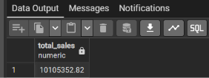

TOTAL ORDERS:
SELECT COUNT (order_id) as total_order FROM logistics;

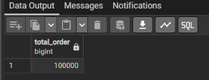

TOTAL SHIPPING COST:
SELECT SUM (shipping_cost) as total_shipping_cost FROM logistics;

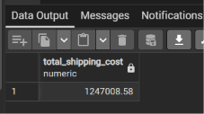

AVERAGE DELIVERY TIME IN DAYS:
SELECT ROUND (AVG (delivery_date - Order_date), 2) AS
average_delivery_time_in_days
FROM logistics;

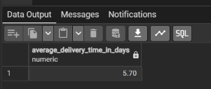

(OTD) ON-TIME DELIVERY : (delivered within 7 days)
SELECT
COUNT (order_ID) AS total_orders,
ROUND (COUNT (*) FILTER (WHERE actual_delivery_days <=7) *100.0 /
COUNT (*), 2) AS on_time_orders FROM logistics;

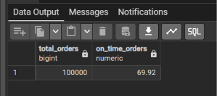

TOTAL ORDERS BY REGION:
SELECT region, COUNT (order_ID) as total_order
FROM logistics
GROUP BY region
ORDER BY total_order DESC;

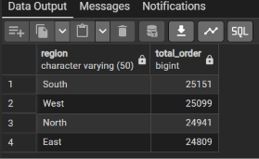

TOTAL SALE BY REGION:
SELECT region, SUM (sales) AS total_sales
FROM logistics
GROUP BY region
ORDER BY total_sales ASC;

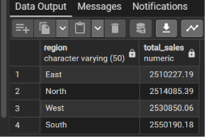

SHIPPING COST BY REGION:
SELECT region, SUM (shipping_cost) AS total_shipping_cost
FROM logistics
GROUP BY region
ORDER BY total_shipping_cost DESC;

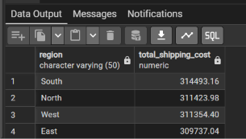

WORST DELIVERY DELAYS BY REGION
SELECT
region,
COUNT(order_id) AS total_orders,
ROUND(AVG(actual_delivery_days), 2) AS avg_delivery_days,
ROUND(COUNT(*) FILTER (WHERE actual_delivery_days > 7) * 100.0 / COUNT(*), 2) AS late_delivery_pct
FROM logistics
GROUP BY region
ORDER BY late_delivery_pct DESC;

