SQL QUERIES
create table public_aa_logistics (
container_id varchar (50),
carrier varchar(100),
cargo_type varchar(100),
arrival_date date,
pickup_date date,
free_days_allowed int,
daily_demurrage_fee int
);
TOTAL CONTAINERS
select count (container_id) as Total_containers from public_aa_logistics;
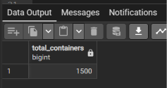
AVERAGE PORT DWELL TIME
select
round (avg (pickup_date::date-arrival_date::date),2) as average_days_at_port from public_aa_logistics;
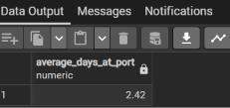
AVERAGE DAYS AT PORT BY CARRIER
select carrier,
count (container_id) as Total_containers,
round(avg(pickup_date::date-arrival_date::date),1) as average_days_at_port from public_aa_logistics
group by carrier
order by average_days_at_port desc;
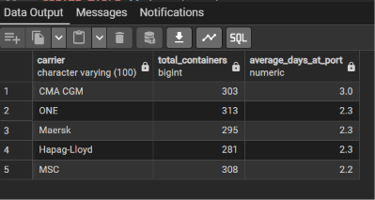

CALCULATE THE TOTAL FINANCIAL PENALTY (DEMURRAGE)
select cargo_type,
sum (case
when (pickup_date::date - arrival_date::date)>3
then ((pickup_date::date - arrival_date::date)-3)*75 else 0 end )
as Total_penalty_fees_in_euros
from public_aa_logistics
group by cargo_type
order by Total_penalty_fees_in_euros desc;
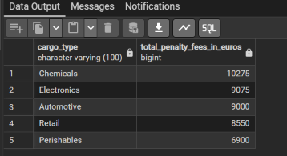
PEAK TRAFFIC ANALYSIS (BUSIEST MONTHS)
select
date_trunc('month', arrival_date::date) as arrival_month,
count(container_id) as total_arrivals
from public_aa_logistics
group by date_trunc('month', arrival_date::date)
order by arrival_month asc;
