

**FPT UNIVERSITY**

Assignment

**Bike Rescue Application**

|  |  |
| --- | --- |
| **Group 1** | |
| **Group members** | Phan Si Nguyen – SE130582  Ngo Vu Kha Minh – SE130516  Dong Huu Long – SE130623  Do Duc Nam – SE130186 |
| **Supervisor** | **Mr. Lai Duc Hung** |

-Ho Chi Minh City, 15/07/2020-

1. **USE CASE DIAGRAM**

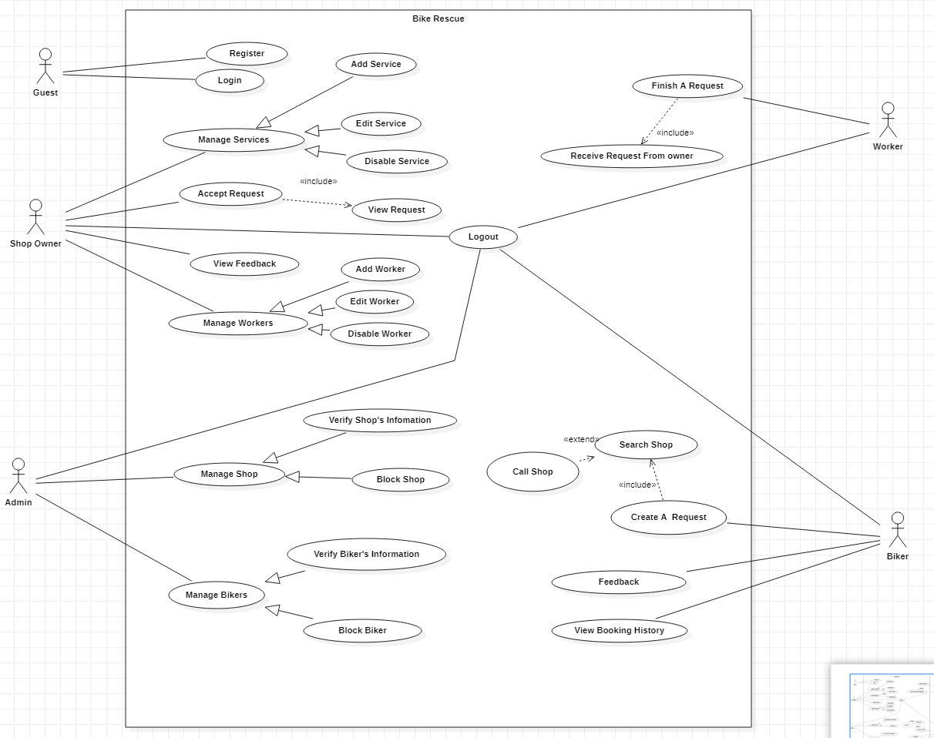

1. **USE CASE DETAIL**

**<Shop Owner> Add Service**

# Use case diagram

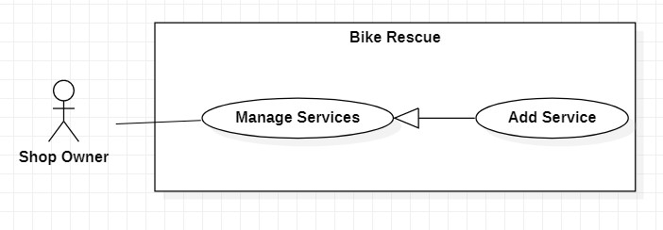

# Figure 1 <Shop owner>Add Service Use Case Specification

|  |  |  |  |
| --- | --- | --- | --- |
| **USE CASE – BRU001** | | | |
| **Use Case No.** | **BRU001** | **Use Case Version** | 1.0 |
| **Use Case Name** | **Add Service** | | |
| **Author** | **Dong Huu Long** | | |
| **Date** | 06/06/2020 | **Priority** | High |
| **Actor:**   * Shop owner **Summary:** * This use case allows shop owner to add new service of shop.   **Goal:**   * Add service of shop successfully.   **Triggers:**   * In manage service page, shop owner clicks “Add Service” button.   **Preconditions:**   * User is logged as role shop owner.   **Post condition:**   * New service information is stored in the database. * System shows a successful message with add new service. | | | |

|  |  |  |  |  |  |  |  |  |  |  |  |  |  |  |  |  |  |  |
| --- | --- | --- | --- | --- | --- | --- | --- | --- | --- | --- | --- | --- | --- | --- | --- | --- | --- | --- |
| **Main Success Scenario:**   |  |  |  | | --- | --- | --- | | Step | Actor Action | System Response | | 1 | Shop owner click “Add New Service” button. | System displays a form for the shop owner to fill in the following information:   * Name Service: free text input, required, length 2 – 50. * Price Service: number text input, value minimum 1000 VND. * Describe Service: free text input, required, length 2 – 50.   [Exception 1]  [Exception 2] | | 2 | Shop owner click “Save Service” button. | Information of new service save in database.  System show message: “Add Service Successful”.  System navigates to manage page of shop owner. |     **Alternative Scenario: N/A**      **Exception:**     |  |  |  | | --- | --- | --- | | Step | Actor Action | System Response | | 1 | Shop owner enter wrong identity information. | System shows message on the corresponding field “This field is required” | | 2 | The service is existed. | Wrong the service is existed in shop service.  System shows message “This service is existed”. |         **Relationships:** Specializes for “Manage Services”.    **Business Rules:**  - The price of services must be check by admin:  + For small services: the price can’t bigger than 100.000 VND (tire patch…) And if the distance less than 5km the biker must pay 20.000 VND for service money.  + If the distance more than 5km the biker must pay 10.000 VND * distance.  + For bigger services: free money if the distance less than 5km. |

# <Shop Owner> Disable Service

**Use case diagram**

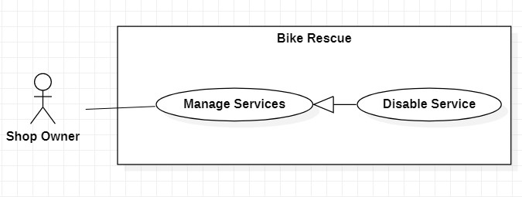

**Figure2<Shop Owner> Disable Service**

## Use Case Specification

|  |  |  |  |
| --- | --- | --- | --- |
| **USE CASE** **– BRU002** | | |  |
| **Use Case No.** | **BRU002** | **Use Case Version** | 1.0 |
| **Use Case Name** | **Disable service** | |  |
| **Author** | **Do Duc Nam** | |  |
| **Date** | 06/06/2020 | **Priority** | High |
| **Actor:**   * Shop owner **Summary:** * This use case allows shop owner to disable service.   **Goal:**   * Disable service of shop successfully.   **Triggers:**   * Shop owner click “Disable Service” switch button.   **Preconditions:**   * User is logged in as role shop owner.   **Post condition:**   * Disable status of service is update in the database. * System shows a successful message with disable service. | | |  |

|  |  |  |  |  |  |  |
| --- | --- | --- | --- | --- | --- | --- |
| **Main Success Scenario:**   |  |  |  | | --- | --- | --- | | Step | Actor Action | System Response | | 1 | Shop owner click “Disable Service” switch button. | System update status of service in database.  System show message: “Disable Service Successfully”. |       **Alternative: N/A**    **Exception: N/A**    **Relationships:** Specializes for “Manage Services”    **Business Rules: N/A** |

# < Shop Owner > Edit Service Use case diagram

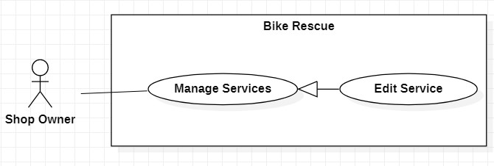

**Figure 3<Show Owner> Edit Service**

## Use Case Specification

|  |  |  |  |
| --- | --- | --- | --- |
| **USE CASE – BRU003** | | | |
| **Use Case No.** | **BRU003** | **Use Case Version** | 1.0 |
| **Use Case Name** | **Edit Service** | | |
| **Author** | **Dong Huu Long** | | |
| **Date** | 06/06/2020 | **Priority** | High |
| **Actor:**   * Shop owner.   **Summary:**   * This use case allows shop owner to update name, price and describe of service.   **Goal:**   * Edit information of service successfully.   **Triggers:**   * Shop owner click “Edit Service” button.   **Preconditions:**   * User is logged in as role shop owner.   **Post condition:**   * Name, price and describe of service are update in database. - System shows a successful message with update service. | | | |

|  |  |  |  |  |
| --- | --- | --- | --- | --- |
| **Main Success Scenario:** | | | | |
|  | Step | Actor Action | | System Response |
| 1 | In manage service page, shop owner click “Edit Service” button. | | System displays a form for the shop owner to fill in the following information:   * Name Service: free text input, required, length 2 – 50. * Price Service: number text input, value minimum 1000 VND. * Describe Service : free text input, required, length 2 – 50. [Exception 1] |
| 2 | In edit service page, shop owner click “Update Service” button. | | New information of services is save in database.  System show message: “Edit Service Successful”.  System navigates to manage page of shop owner. |
| **Alternative Scenario: N/A Exception:** | | | |
| Step | | Actor Action | System Response |
| 1 | | Shop owner enter wrong identity information. | System shows message on the corresponding field “This field is required” |
| **Relationships:** Specializes for “Manage Services”**.**  **Business Rules:**  - The price of services must be check by admin:  + For small services: the price can’t bigger than 100.000 VND (tire patch…) And if the distance less than 5km the biker must pay 20.000 VND for service money.  + If the distance more than 5km the biker must pay 10.000 VND * distance.  + For bigger services: free money if the distance less than 5km. | | | |

# <Biker> Create A Request

## Use case diagram

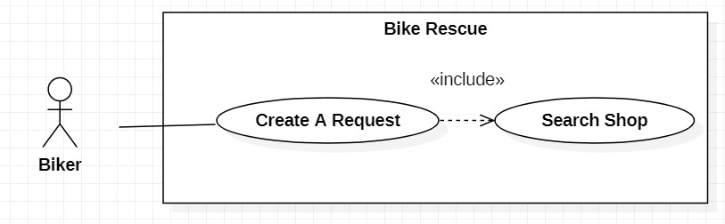

**Figure 4<Biker> Create A Request**

## Use Case Specification

|  |  |  |  |
| --- | --- | --- | --- |
| **USE CASE – BRU004** | | |  |
| **Use Case No.** | **BRU004** | **Use Case Version** | 1.0 |
| **Use Case Name** | **Create A Request** | |  |
| **Author** | **Phan Si Nguyen** | |  |
| **Date** | 06/06/2020 | **Priority** | High |
| **Actor:**   * Biker **Summary:** * This use case allow biker to create a request. **Goal:** * Create a request successfully.   **Triggers:**   * In home page, biker click “Booking Service” **Preconditions:** * User is logged in as role biker. **Post condition:** * Dispatcher to search shop page. | | |  |

|  |  |  |  |  |  |  |  |  |  |  |  |  |  |  |  |  |  |  |  |  |  |  |  |  |
| --- | --- | --- | --- | --- | --- | --- | --- | --- | --- | --- | --- | --- | --- | --- | --- | --- | --- | --- | --- | --- | --- | --- | --- | --- |
| **Main Success Scenario:**       |  |  |  | | --- | --- | --- | | Step | Actor Action | System Response | | 1 | In home page, biker click “ Booking Service” button. | System navigates to search service page. | | 2 | In search shop page, biker click on drop box button to choose bike want to booking service. | System check information of bike. | | 3 | Biker enter bike problem of bike in text box. | Problems Information:  - Problem descriptions: free text input, required, length 2 – 50. | | 4 | Biker click “Search Shop” button. | [Exception 1]  [Exception 2]  System show list of shops that are near the biker.  Shop information:   * Shop name: String * Shop address: String * Shop phone: Integer |     **Alternative Scenario:** N/A    **Exception:**     |  |  |  | | --- | --- | --- | | No | Actor Action | System Response | | 1 | Description of bike required form fields is not filled in. | System show message: Please enter your bike problem ”. | | 2 | No shop is found | System show message: Can’t found any shops ”. |     **Relationships: -** Include “Search Shop”.    **Business Rules:**   * Non-member rescue fee:   + Tire patch: in the morning: 20.000 VND, after that 30.000 VND  + Broken machine: in the morning: 100.000 VND, after that 150.000 VND + Transportation fee: less than 5km: 20.000 VND. more than 5km: 20.000 VND + 10.000 VND each km.     * Member rescue fee:   + Tire patch: in the morning: 15.000 VND, after that 25.000 VND  + Broken machine: in the morning: 70.000 VND, after that 100.000 VND + Transportation fee: less than 5km: 10.000 VND. more than 5km: 10.000 VND + 5.000 VND each km. |

# <Biker> Search Shop

## Use case diagram

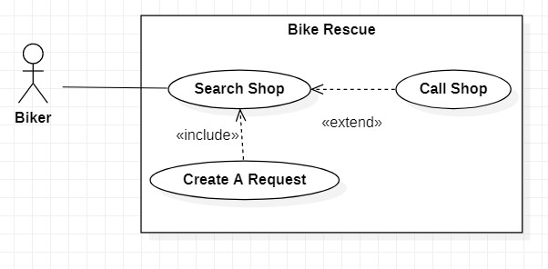

**Figure5<Biker> Search Shop**

## Use Case Specification

|  |  |  |  |
| --- | --- | --- | --- |
| **USE CASE – BRU005** | | | |
| **Use Case No.** | **BRU005** | **Use Case Version** | 1.0 |
| **Use Case Name** | Search service | | |
| **Author** | Phan Si Nguyen | | |
| **Date** | 06/06/2020 | **Priority** | High |
| **Actor:**   * Biker **Summary:** * This use case allows the biker to search shops by nearest location.   **Goal:**   * List of shops are shown successfully.   **Triggers:**   * Biker click “Search Shop” button.   **Preconditions:**   * User is logged in as Biker.   **Post condition:**   * Lists of shops are shown successfully. | | | |

|  |  |  |  |  |  |  |  |  |  |  |  |  |  |  |  |  |  |  |  |  |  |
| --- | --- | --- | --- | --- | --- | --- | --- | --- | --- | --- | --- | --- | --- | --- | --- | --- | --- | --- | --- | --- | --- |
| **Main Success Scenario:**   |  |  |  | | --- | --- | --- | | Step | Actor Action | System Response | | 1 | In search shop page, biker click on drop box button to choose bike want to booking service. | System check information of bike. | | 2 | Biker enter bike problem of bike in text box. | Problems Information:  - Problem descriptions: free text input, required, length 2 – 50. | | 3 | Biker click “Search Shop” button. | [Exception 1]  [Exception 2]  System show list of shops that are near the biker.  Shop information:   * Shop name: String * Shop address: String * Shop phone: Integer |     **Exception:**     |  |  |  | | --- | --- | --- | | No | Actor Action | System Response | | 1 | Description of bike required form fields is not filled in. | System show message: Please enter your bike problem ”. | | 2 | No shop is found | System show message: Can’t found any shops ”. |   **Alternative Scenario: N/A**    **Relationships:**   * Included by “Create a Request”. * Extends to “Call shop”.       **Business Rules: N/A** |

## <Biker> View booking history

**Use case diagram**

### Bike Recuse

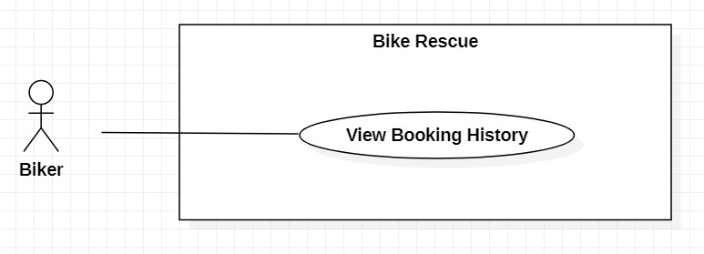

**Figure 6<Biker> View booking history**

### Use Case Specification

|  |  |  |  |
| --- | --- | --- | --- |
| **USE CASE – BRU006** | | |  |
| **Use Case No.** | **BRU006** | **Use Case Version** | 1.0 |
| **Use Case Name** | View booking history | |  |
| **Author** | Ngo Vu Kha Minh | |  |
| **Date** | 06/06/2020 | **Priority** | Normal |
| **Actor:**   * Biker **Summary:** * This use case allows biker to view booking history.   **Goal:**   * Booking history of biker is shown successfully.   **Triggers:**   * Biker click “View Booking History” button.   **Preconditions:**   * User is logged in as biker.   **Post condition:**   * Information of bookings history are view successfully. | | |  |

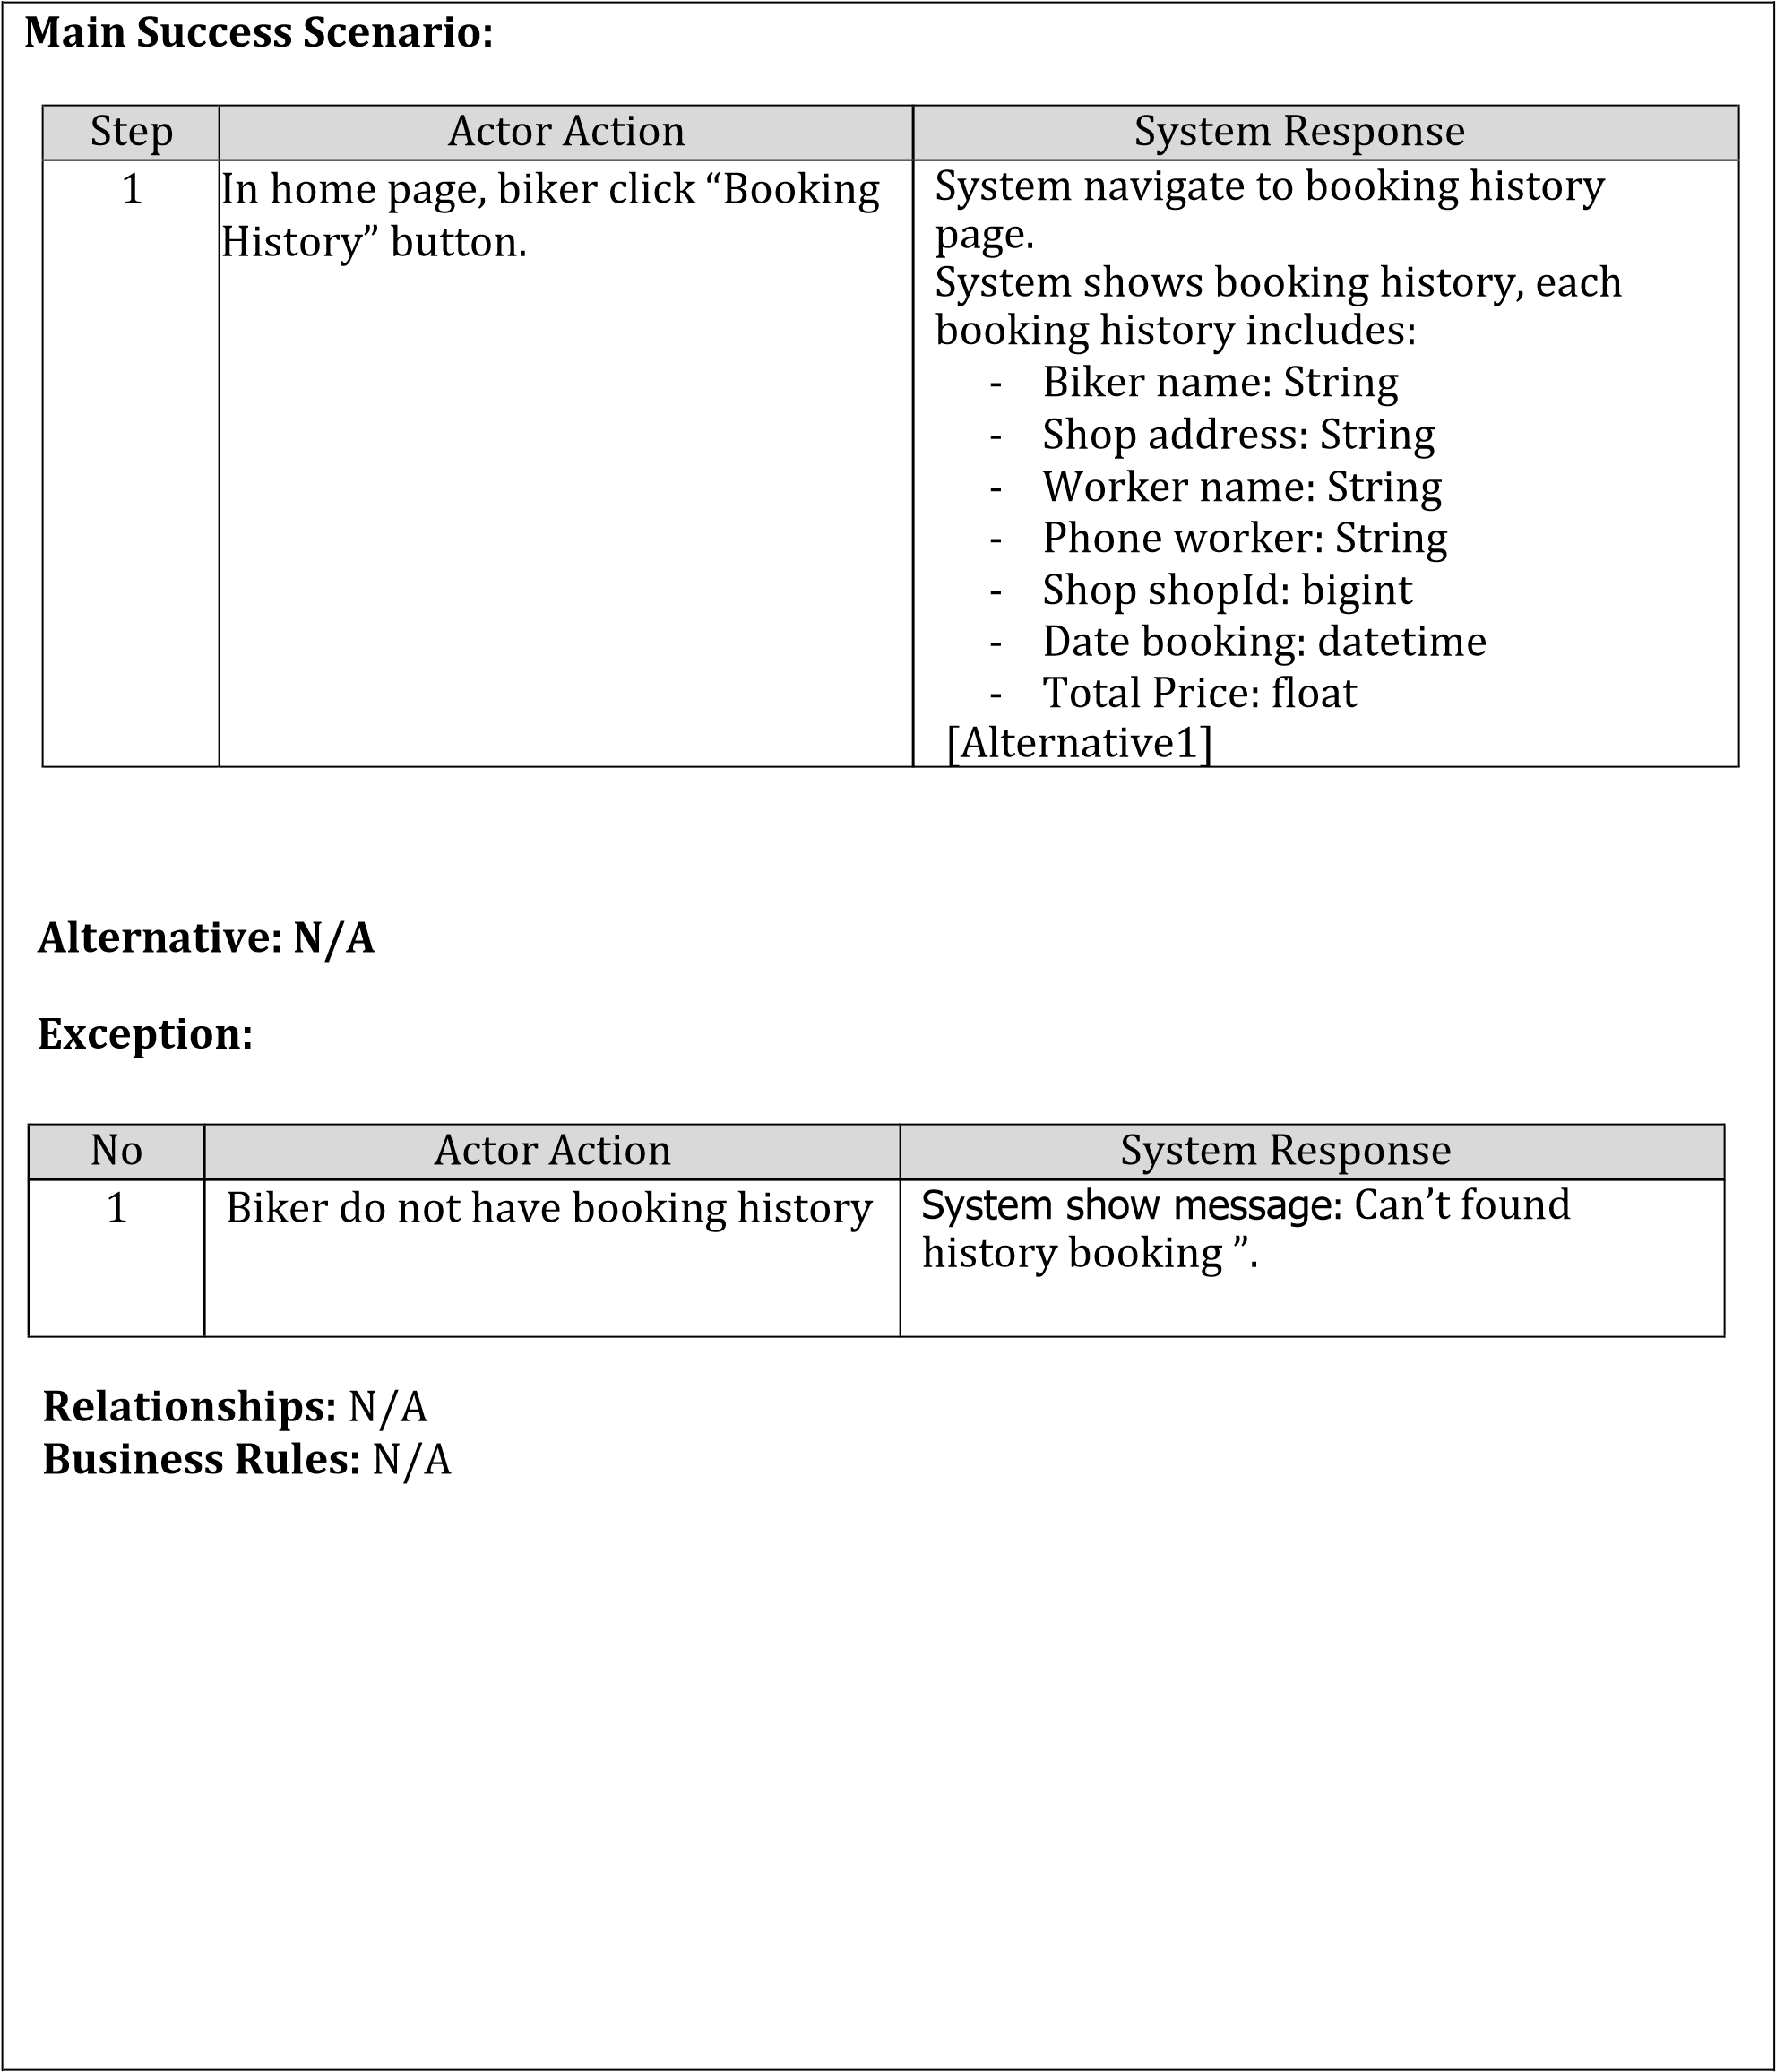

## <Biker> Feedback

### Use case diagram

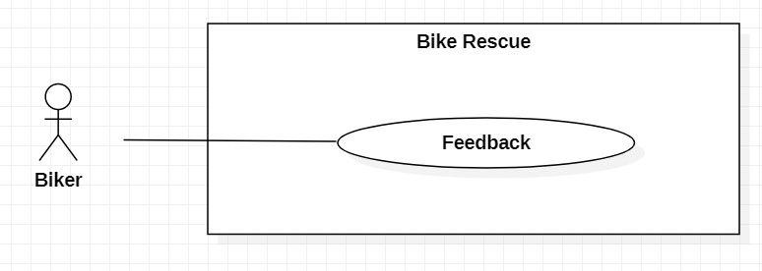

### Figure 7 <Biker> Feedback

|  |  |  |  |
| --- | --- | --- | --- |
| **USE CASE – BRU007** | | |  |
| **Use Case No.** | **BRU007** | **Use Case Version** | 1.0 |
| **Use Case Name** | **Feedback** | |  |
| **Author** | **Ngo Vu Kha Minh** | |  |
| **Date** | 06/06/2020 | **Priority** | High |
| **Actor:**   * Biker **Summary:** * This use case allows biker to feedback.   **Goal:**   * Feedback save to database successfully.   **Triggers:**   * Biker click “Feedback” button.   **Preconditions:**   * User is logged in as role biker.   **Post condition:**   * Feedback save to database successfully. * System show message “Feedback Successfully”. | | |  |

|  |  |  |  |  |  |  |
| --- | --- | --- | --- | --- | --- | --- |
| **Main Success Scenario:** | | | | | | |
| Step | Actor Action | | System Response | | |  |
| 1 | After finished booking, biker click “Feedback” button. | | System navigate to feedback page. | | |
| 2 | In feedback page, biker enter feedback to text box and rate the rank. | | Feedback description: String, length 2 to 50 Default rank is 5. | | |
| 3 | Biker click “Send Feedback” button. | | System show message: “Send feedback successfully”.  The application go back home page. [Exception1] | | |
| **Exception:** | | | | | |
| No | | Actor Action | | System Response |  |
| 1 | | Description of bike required form fields is not filled in. | | System show message: Please enter your feedback”. |
| **Alternative: N/A**    **Relationships: N/A**    **Business Rules: N/A** | | | | |

## <Biker> Call Shop

### Use case diagram

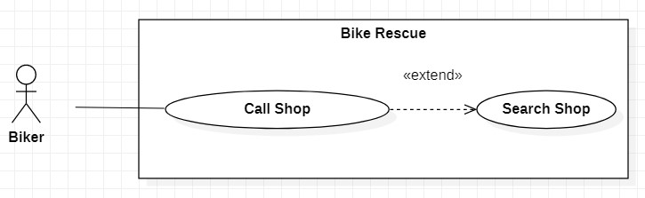

### Figure 8 <Biker> Call Shop

|  |  |  |  |
| --- | --- | --- | --- |
| **USE CASE – BRU008** | | |  |
| **Use Case No.** | **BRU008** | **Use Case Version** | 1.0 |
| **Use Case Name** | **Call Shop** | |  |
| **Author** | **Do Duc Nam** | |  |
| **Date** | 06/06/2020 | **Priority** | High |
| **Actor:**   * Biker **Summary:** * This use case allows biker to call shop.   **Goal:**   * Send request to shop owner successfully.   **Triggers:**   * Biker click “Call Shop” button.   **Preconditions:**   * User is logged in as role biker.   **Post condition:**   * Send request to shop owner successfully. * System show message “Call shop Successfully”. | | |  |

|  |  |  |  |
| --- | --- | --- | --- |
| **Main Success Scenario:** | | | |
| Step | Actor Action | System Response |  |
| 1 | After search shop, biker click “Call Shop” button. | System send a request to shop owner and wait for shop owner accept. System go to booking page and view message. |
| **Exception: N/A**    **Alternative: N/A**    **Relationships:** “Call Shop” extend to “Search Shop”.    **Business Rules: N/A** | | |