Audio and Signal Processing
2026311323 Howon Chung

1. Problem Statement
Given X(ω) = |X(ω)| e^(j∠X(ω)), so that log X(ω) = log|X(ω)| + j∠X(ω): prove that for a minimum-phase system, the phase ∠X(ω) is fully determined by the log-magnitude log|X(ω)|.
A minimum-phase sequence x[n] is real, causal, and stable, with a causal and stable inverse 1/X(z) -- equivalently, every zero AND every pole of X(z) lies strictly inside the unit circle.
2. Setup: the Complex Cepstrum
Define the complex cepstrum as the inverse transform of log X: x̂[n] = IDFT{log X(k)}, where log X(k) = log|X(k)| + j∠X(k). The proof proceeds in two steps: (1) show that the minimum-phase condition forces x̂[n] to be causal (x̂[n] = 0 for n < 0); (2) show that for ANY real, causal sequence, the real and imaginary parts of its transform are a Hilbert-transform pair. Combining the two: log|X(ω)| and ∠X(ω) are a Hilbert-transform pair whenever x[n] is minimum phase, which is exactly the sense in which one determines the other.
3. Step 1 — Minimum Phase ⟹ Causal Cepstrum
Write X(z) in factored (zero/pole) form. For a minimum-phase system, every zero a_k and every pole c_k satisfies |a_k| < 1, |c_k| < 1 (strictly inside the unit circle):
X(z) = A · Π_k (1 − a_k z⁻¹) / Π_k (1 − c_k z⁻¹), |a_k| < 1, |c_k| < 1 for all k
Taking the log turns the product into a sum: log X(z) = log A + Σ_k log(1 − a_k z⁻¹) − Σ_k log(1 − c_k z⁻¹). Each term expands as a power series using log(1−x) = −Σ_{ℓ=1}^∞ xℓ/ℓ, valid for |x|<1, i.e. for |z| > |a_k| — a region that includes the unit circle since |a_k| < 1:
log(1 − a_k z⁻¹) = −Σ_{ℓ=1}^∞ (a_kℓ/ℓ) z⁻ℓ
Every term on the right is a NEGATIVE power of z (z⁻ℓ, ℓ ≥ 1) — there is no z⁺ℓ term at all. (Had a_k instead been OUTSIDE the unit circle, the same expansion, now valid for |z| < |a_k|, would have produced only POSITIVE powers of z, i.e. an anticausal contribution — this is the exact mechanism that breaks down outside the minimum-phase case, used again in Section 6.) Summing every zero and pole term:
log X(z) = log A + Σ_{n=1}^∞ x̂[n] z⁻ⁿ, x̂[n] = (Σ_k a_kⁿ − Σ_k c_kⁿ) / n for n ≥ 1
No negative-n term appears anywhere in this sum. Therefore x̂[n] = 0 for n < 0: the complex cepstrum of a minimum-phase sequence is causal. This is the same expansion Chapter 6 (p.12) derives for a single zero factor, generalized here to the full minimum-phase product (every factor, not just one).
4. Step 2 — A Causal Real Sequence's Transform Has Hilbert-Paired Real/Imaginary Parts
This step uses no properties of X specifically — it holds for any real, causal sequence h[n] (h[n]=0 for n<0). Split h[n] into even and odd parts: h_e[n] = (h[n]+h[−n])/2, h_o[n] = (h[n]−h[−n])/2. Because h is causal:
n > 0: h[−n] = 0 ⟹ h_e[n] = h_o[n] = h[n]/2
n < 0: h[n] = 0 ⟹ h_e[n] = h[−n]/2 = −h_o[n]
Both cases combine into a single relation valid for every n ≠ 0: h_o[n] = sgn(n) · h_e[n]. Taking the DTFT: h_e[n] is even and real, so its transform H_e(ω) is real (and even); h_o[n] is odd and real, so its transform H_o(ω) is purely imaginary (and odd). Hence Re{H(ω)} comes entirely from h_e, and Im{H(ω)} entirely from h_o. The time-domain relation h_o[n] = sgn(n)·h_e[n] is precisely the operation that defines the discrete Hilbert transform in the frequency domain: multiplying a sequence by sgn(n) is the time-domain counterpart of taking its Hilbert transform. So for ANY real causal h[n]: Im{H(ω)} = Hilbert{Re{H(ω)}} (up to the fixed sign convention of the transform).
5. Combining the Two Steps
Apply Step 2 with h[n] = x̂[n]. By Step 1, x̂[n] is causal whenever x[n] is minimum phase, so Step 2's conclusion applies directly:
Re{log X(ω)} = log|X(ω)|, Im{log X(ω)} = ∠X(ω)
⟹ ∠X(ω) = Hilbert{ log|X(ω)| }
This is the statement to prove: for a minimum-phase system, the phase is the (discrete) Hilbert transform of the log-magnitude — a fixed, invertible linear operation, not merely a loose correlation. Knowing log|X(ω)| at every ω therefore determines ∠X(ω) completely (up to the n=0 cepstrum term x̂[0] = log A, an overall real gain that carries no phase information).
6. Why Minimum Phase Specifically — and the Reconstruction It Enables
Step 1 used BOTH directions of the zero/pole argument: a factor inside the unit circle contributes only to n ≥ 0, and (by the same expansion, now centered outside the unit circle) a factor outside contributes only to n < 0. A general (mixed-phase) system has some zeros/poles outside, so its cepstrum has a genuine non-causal part, and Step 2 no longer applies — the log-magnitude and phase are then independent: many different phase responses are consistent with the same |X(ω)| (the differences are exactly the all-pass factors obtained by reflecting a zero from inside to outside the unit circle, which leave |X(ω)| unchanged but change ∠X(ω)). Minimum phase is what removes this ambiguity.
The proof is also constructive, matching the liftering procedure in Chapter 6 (p.31, "Zero- and Minimum-phase Synthesis"): from log|X(ω)| alone, (i) inverse-transform to get the real cepstrum (automatically even, since log|X(ω)| is real and even); (ii) keep the n=0 term, double every n>0 term, discard every n<0 term — this constructs a fully causal x̂[n] satisfying x̂_o[n]=sgn(n)x̂_e[n] exactly; (iii) forward-transform and exponentiate. The result's phase is not merely similar to the original -- it recovers the exact minimum-phase ∠X(ω), as verified numerically below.
7. Numerical Verification
Example: X(z) = (1 − a₁z⁻¹)(1 − a₂z⁻¹) with a₁=0.6, a₂=-0.4 (both zeros strictly inside the unit circle — minimum phase). For contrast, a second system reflects a₁'s zero to 1/a₁ (outside the unit circle) while keeping a₂ unchanged; by construction this has the IDENTICAL magnitude response (max |log-magnitude difference| = 7.8e-16) but is NOT minimum phase.
Quantity | Minimum-phase system | Non-minimum-phase system (same |X(ω)|)
max |x̂[n]| for n < 0 (should be 0 iff causal) | 7.70e-18 | 0.400
max |x̂[n]| for n ≥ 0 | 0.260 | 0.600

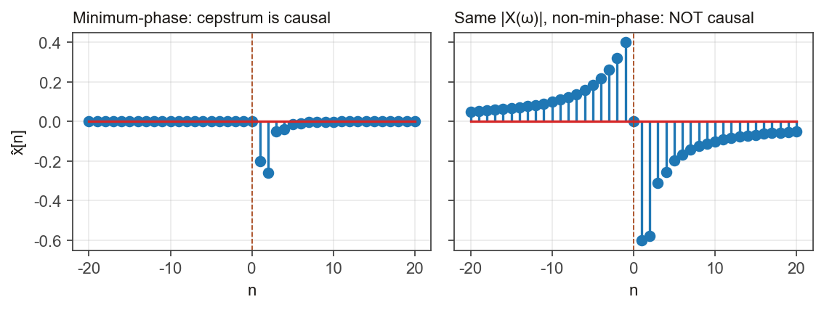
The minimum-phase cepstrum's n<0 part is at machine-precision noise level (7.7e-18) against an n≥0 part of order 0.3 -- causal, as Section 3 predicts. The non-minimum-phase cepstrum's n<0 part (0.400) is the same ORDER OF MAGNITUDE as its n≥0 part -- genuinely non-causal, confirming the minimum-phase condition is what makes causality (and therefore the Hilbert-transform / determinacy result) hold.
Despite having identical magnitude, the two systems' phases differ by up to 3.142 rad (= π, exactly a half-cycle at ω=π in this example) -- concrete confirmation that log-magnitude alone does NOT determine phase once the minimum-phase restriction is dropped.
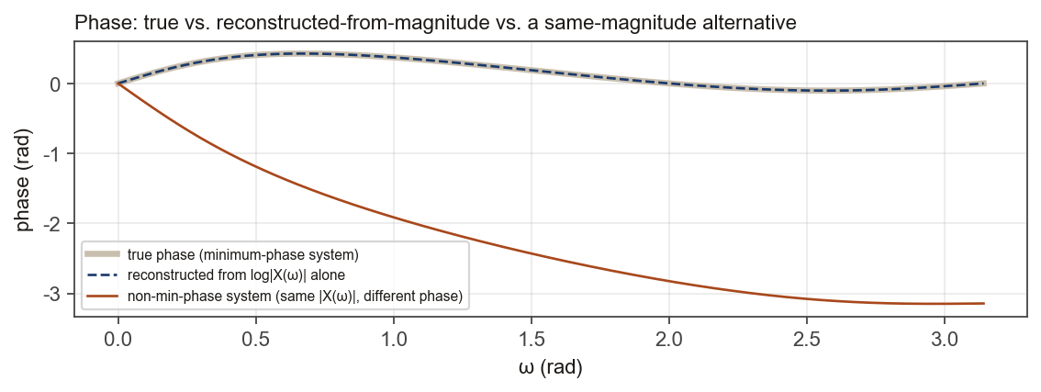
Reconstructing phase from the minimum-phase system's log-magnitude alone (Section 6's liftering procedure) matches the true phase to within 4.2e-16 rad, and the reconstructed log-magnitude matches to within 4.4e-16 -- both at floating-point noise level, i.e. an exact reconstruction up to numerical precision.
8. Conclusion
For a minimum-phase system, every zero and pole lies inside the unit circle, which forces the complex cepstrum to be causal (Section 3). Any real, causal sequence has real and imaginary transform parts related by the discrete Hilbert transform (Section 4) -- a general fact independent of this problem. Applying this to log X(ω) = log|X(ω)| + j∠X(ω) gives ∠X(ω) = Hilbert{log|X(ω)|}: the phase is the Hilbert transform of the log-magnitude, hence fully (and constructively) determined by it. The result fails outside the minimum-phase case because zeros/poles outside the unit circle contribute an anticausal part to the cepstrum, breaking the causality Step 1 depends on -- confirmed numerically above by a same-magnitude, different-phase counterexample.

