Audio and Signal Processing
2026311323 Howon Chung

1. Introduction
This report records a spoken sentence, compares it after downsampling to 16 kHz, 8 kHz and 2 kHz, and analyzes it by classifying each frame as background, unvoiced, or voiced speech with timing information. It closes with ideas for automating that segmentation.
2. Recording
The sentence below was recorded through the browser microphone, which captured audio natively at 16,000 Hz, mono. To meet this assignment's SF = 48,000 Hz requirement, the recording was resampled to 48,000 Hz mono for submission. Note that resampling upward does not add back any frequency content above the original capture's 8,000 Hz Nyquist limit — it only conforms the file to the required sample rate.
“Speech has evolved as a primary form of communication between humans. The topic of this class, ‘discrete-time speech signal processing’ can be defined as the manipulation of sampled speech signals by a digital processor to obtain a new signal with some desired properties.”
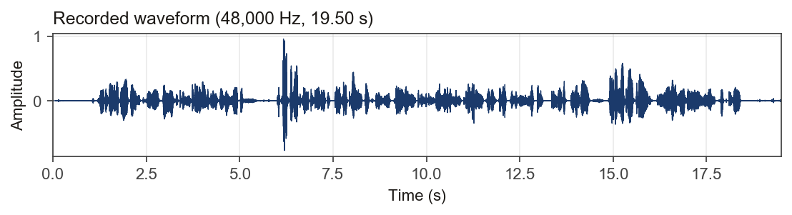
3. Down-sampling Comparison (16 / 8 / 2 kHz)
Down-sampling by an integer factor lowers the sampling rate, and with it the Nyquist frequency fs/2 — the highest frequency the signal can represent. Any content above the new Nyquist frequency is removed (after anti-alias filtering) rather than folded back, so a lower sampling rate simply means a narrower retained bandwidth. The recording was down-sampled to 16 kHz, 8 kHz, and 2 kHz to observe this directly.
The overlaid spectrum below shows each version's content being cut off at its own Nyquist frequency; the spectrograms alongside share an identical frequency axis and color scale (0 Hz to the original Nyquist) so the shrinking retained bandwidth is directly comparable across the three versions.
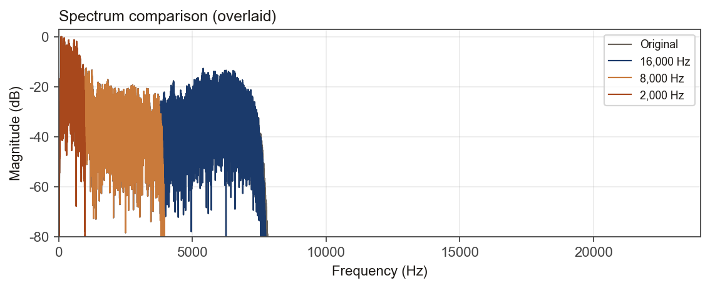
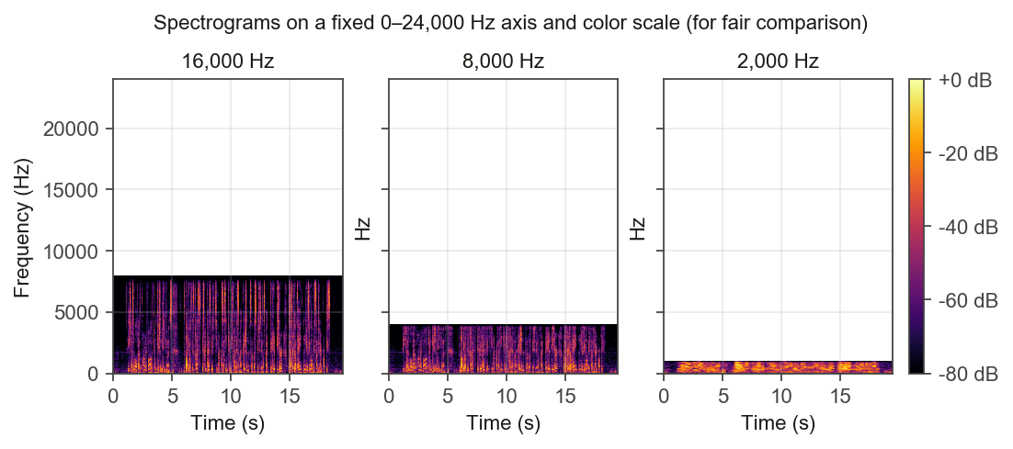
- 16,000 Hz: Retains content up to 8 kHz. Most consonant/fricative cues survive; hard to tell apart from the original by ear.
- 8,000 Hz: Retains content only up to 4 kHz — telephone-quality audio; sibilants (s, sh) sound noticeably duller.
- 2,000 Hz: Retains content only up to 1 kHz — most fricative/stop cues are lost. Vowels remain audible but consonants become hard to distinguish.
4. Signal Analysis: Voiced / Unvoiced / Background Classification
Each frame's short-time energy (RMS, in dB) and zero-crossing rate (ZCR) were computed using 25 ms frames with a 10 ms hop (60% overlap). A frame is classified as background(0) if its energy is near the estimated noise floor; otherwise it is voiced(2) if a reliable pitch (YIN) is detected or ZCR is low, and unvoiced(1) otherwise.
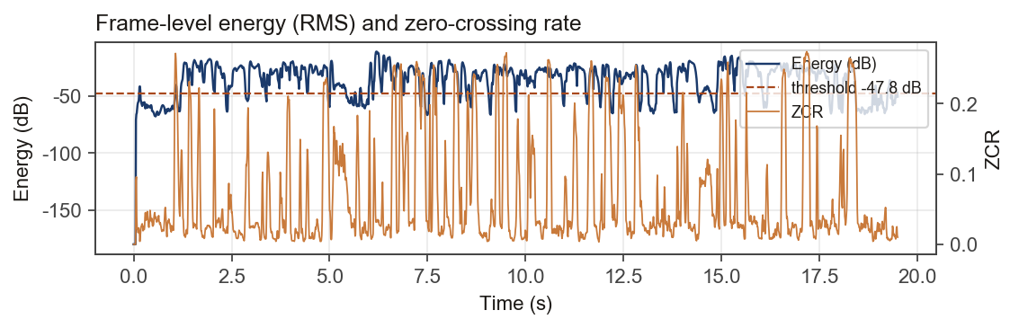
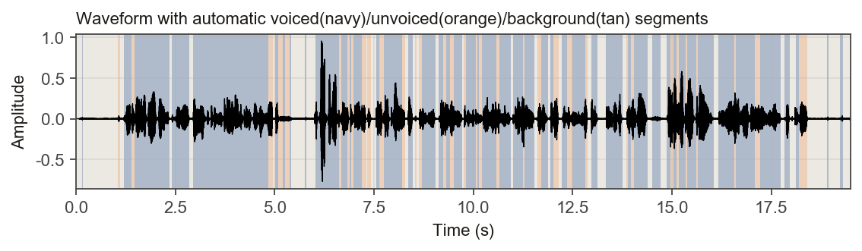
Classified regions and timing:
Time range | Class
0.00 ~ 0.15 sec | background
0.14 ~ 0.18 sec | voiced
0.17 ~ 1.05 sec | background
1.06 ~ 1.10 sec | unvoiced
1.11 ~ 1.19 sec | background
1.20 ~ 1.40 sec | voiced
1.41 ~ 1.46 sec | unvoiced
1.47 ~ 2.34 sec | voiced
2.35 ~ 2.40 sec | background
2.41 ~ 2.85 sec | voiced
2.85 ~ 2.94 sec | background
2.95 ~ 4.83 sec | voiced
4.83 ~ 4.96 sec | unvoiced
4.96 ~ 5.01 sec | background
5.01 ~ 5.09 sec | voiced
5.09 ~ 5.20 sec | unvoiced
5.20 ~ 5.25 sec | voiced
5.25 ~ 5.38 sec | unvoiced
5.38 ~ 5.42 sec | voiced
5.42 ~ 5.76 sec | background
5.76 ~ 5.80 sec | voiced
5.80 ~ 6.02 sec | background
6.03 ~ 6.62 sec | voiced
6.62 ~ 6.67 sec | unvoiced
6.67 ~ 6.83 sec | voiced
6.83 ~ 6.88 sec | unvoiced
6.88 ~ 6.93 sec | voiced
6.94 ~ 6.99 sec | unvoiced
6.99 ~ 7.18 sec | voiced
7.19 ~ 7.30 sec | unvoiced
7.30 ~ 7.33 sec | background
7.33 ~ 7.42 sec | unvoiced
7.42 ~ 7.56 sec | background
7.57 ~ 7.62 sec | voiced
7.62 ~ 7.75 sec | unvoiced
7.75 ~ 8.21 sec | voiced
8.21 ~ 8.29 sec | unvoiced
8.28 ~ 8.36 sec | background
8.35 ~ 8.49 sec | voiced
8.48 ~ 8.53 sec | background
8.52 ~ 8.57 sec | unvoiced
8.56 ~ 8.64 sec | background
8.63 ~ 8.72 sec | unvoiced
8.71 ~ 9.06 sec | voiced
9.05 ~ 9.12 sec | background
9.12 ~ 9.24 sec | voiced
9.23 ~ 9.33 sec | unvoiced
9.32 ~ 9.42 sec | voiced
9.41 ~ 9.52 sec | unvoiced
9.51 ~ 9.73 sec | voiced
9.72 ~ 9.77 sec | background
9.76 ~ 9.82 sec | unvoiced
9.81 ~ 10.07 sec | voiced
10.06 ~ 10.11 sec | unvoiced
10.10 ~ 10.15 sec | voiced
10.14 ~ 10.23 sec | unvoiced
10.22 ~ 10.59 sec | voiced
10.58 ~ 10.66 sec | unvoiced
10.65 ~ 10.95 sec | voiced
10.94 ~ 11.00 sec | background
10.99 ~ 11.26 sec | voiced
11.25 ~ 11.29 sec | unvoiced
11.28 ~ 11.54 sec | voiced
11.53 ~ 11.61 sec | background
11.60 ~ 11.72 sec | unvoiced
11.71 ~ 11.89 sec | voiced
11.88 ~ 11.94 sec | background
11.93 ~ 12.03 sec | voiced
12.02 ~ 12.15 sec | unvoiced
12.14 ~ 12.24 sec | background
12.23 ~ 12.37 sec | voiced
12.36 ~ 12.50 sec | unvoiced
12.49 ~ 12.82 sec | voiced
12.81 ~ 12.88 sec | unvoiced
12.88 ~ 12.97 sec | background
12.96 ~ 13.14 sec | voiced
13.13 ~ 13.34 sec | background
13.33 ~ 13.76 sec | voiced
13.75 ~ 13.86 sec | background
13.85 ~ 13.89 sec | unvoiced
13.88 ~ 13.98 sec | voiced
13.97 ~ 14.04 sec | unvoiced
14.04 ~ 14.39 sec | voiced
14.38 ~ 14.50 sec | background
14.49 ~ 14.72 sec | voiced
14.71 ~ 14.88 sec | background
14.88 ~ 14.96 sec | voiced
14.96 ~ 15.04 sec | unvoiced
15.03 ~ 15.12 sec | voiced
15.11 ~ 15.18 sec | unvoiced
15.17 ~ 15.35 sec | voiced
15.34 ~ 15.39 sec | unvoiced
15.38 ~ 15.61 sec | voiced
15.60 ~ 15.65 sec | unvoiced
15.64 ~ 16.04 sec | voiced
16.05 ~ 16.16 sec | background
16.17 ~ 16.56 sec | voiced
16.57 ~ 16.61 sec | unvoiced
16.61 ~ 17.09 sec | voiced
17.10 ~ 17.21 sec | unvoiced
17.21 ~ 17.74 sec | voiced
17.75 ~ 17.83 sec | background
17.84 ~ 17.97 sec | voiced
17.98 ~ 18.11 sec | background
18.12 ~ 18.20 sec | voiced
18.21 ~ 18.41 sec | unvoiced
18.42 ~ 18.90 sec | background
18.91 ~ 18.95 sec | voiced
18.95 ~ 19.23 sec | background
19.23 ~ 19.31 sec | voiced
19.32 ~ 19.49 sec | background

5. Automatic Segmentation
Ideas for automating the region classification performed manually above:
- Short-time energy + ZCR thresholding: The method used above: split background/speech by per-frame RMS energy, then split voiced/unvoiced by ZCR. Simple to implement, but thresholds must be re-tuned for every noise condition.
- Adaptive thresholding: Estimate the noise floor from the recording's own quiet frames (as done here) so the energy threshold sets itself automatically. Re-estimating it in a sliding window handles noise levels that drift over the course of a recording.
- Periodicity-based voiced/unvoiced decision: Use autocorrelation or the cepstrum: a clear peak indicates vocal-fold vibration (voiced), no peak indicates unvoiced. More robust to noise than ZCR alone.
- Spectral features: Spectral flux (frame-to-frame spectral change) can detect segment boundaries (onsets); spectral entropy or the low/high-frequency energy ratio can reinforce fricative detection.
- Statistical / model-based methods: Train a GMM classifier on features such as (energy, ZCR, pitch strength, spectral tilt), or decode a 3-state (silence/unvoiced/voiced) HMM à la Rabiner–Sambur for a temporally smooth label sequence with less frame-to-frame flicker than a rule-based decision.
- Deep-learning VAD/segmentation: Use a pretrained voice-activity detector (WebRTC VAD, Silero VAD) or train a frame-level CNN/RNN classifier on labeled data. More robust to noise and channel variation than hand-tuned rules.

