Audio and Signal Processing
2026311323 Howon Chung

1. Introduction
This report implements and analyzes three short-time speech processing techniques: framing with overlap-and-add (OLA) analysis/synthesis, pitch (F0) estimation via autocorrelation and AMDF, and a rule-based voice activity detector (VAD). The recording from Homework 1 is used throughout.
The recording's microphone captured audio natively at 16,000 Hz; as in the Homework 2 submission, it is resampled to 48,000 Hz here for consistency (upsampling does not restore frequency content above the original 8,000 Hz Nyquist limit, so this affects only the sample counts reported below, not any Hz- or second-based result).
2. Short-Time Framing and Overlap-and-Add (OLA)
The signal was split into 20 ms frames (960 samples at 48,000 Hz) with 50% overlap (hop = 480 samples), each multiplied by a Hamming window, then reconstructed by overlap-and-add. Frame length and overlap are implemented as free parameters (not hard-coded to 20 ms/50%), so other configurations can be produced directly.
2.1 Hanning vs. Hamming
A window satisfies the constant-overlap-add (COLA) property when shifted, overlapping copies of it sum to a constant — only then does plain OLA reconstruct the original signal without amplitude modulation. The window-sum profiles below were measured directly (not assumed) at 25%, 50%, and 75% overlap:
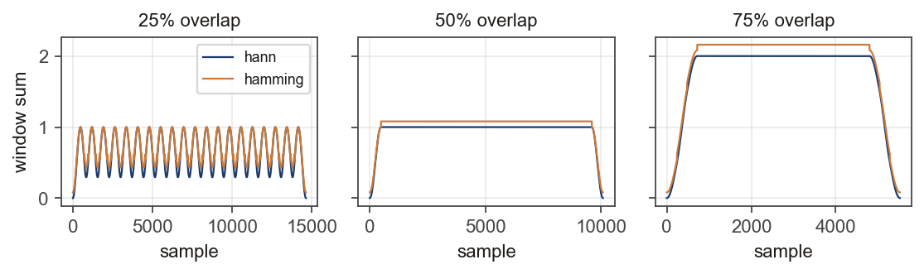
Overlap | Window | Steady-state sum | Ripple (%)
25% | hann | 0.665 | 106.4%
25% | hamming | 0.719 | 79.4%
50% | hann | 1.000 | 0.0%
50% | hamming | 1.080 | 0.0%
75% | hann | 2.000 | 0.0%
75% | hamming | 2.160 | 0.0%

At 50% and 75% overlap, both Hanning and Hamming sum to an exactly flat constant (ripple ≈ 0%) — this is a general property of any single-cosine ("raised-cosine") window at hop = frame_length / 2^k for integer k, not something specific to Hanning. At 25% overlap (hop = 3/4 of the frame, not a power-of-two fraction), neither window satisfies COLA exactly, and both show real ripple. In this measurement, Hanning actually ripples somewhat more than Hamming at 25% overlap — the intuition that "Hamming always ripples more" is a common oversimplification; the real distinguishing factor is whether hop/frame_length is a power-of-two fraction, independent of the specific window's cosine coefficients.
2.2 Weighted OLA as error compensation
At 50% overlap (flat window sum, constant = 1.08 for Hamming), plain OLA already reconstructs the signal almost perfectly once that constant is factored in: RMSE = 0.003993 (unweighted) vs. 0.000000 (weighted), both negligible relative to the input's RMS amplitude of 0.0499. At the non-ideal 25% overlap, the gap widens: unweighted RMSE = 0.01711 vs. weighted RMSE = 0.00000 — dividing by the (non-constant) window-sum profile measurably reduces the amplitude-modulation artifact that an unnormalized sum leaves behind.
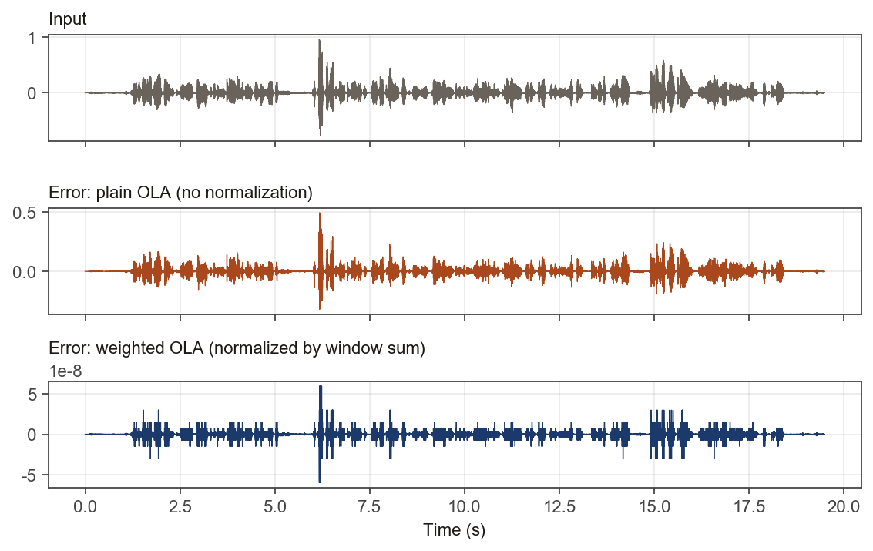
2.3 Non-50% overlap and the Griffin–Lim connection
The framing/OLA implementation takes overlap as a continuous percentage rather than assuming 50%, so 25%/75%/etc. overlap ratios are handled by the same code path (see Table above, computed at all three).
Griffin and Lim (1984), Section II ("Signal Estimation from Modified Short-Time Fourier Transform"), derive the estimate that minimizes the mean-squared error between a candidate signal's STFT and a given (possibly modified) target STFT: their Eq. (6), x(n) = Σ_m w(mS−n)y_w(mS,n) / Σ_m w²(mS−n) — normalized by the SUM OF THE SQUARED analysis window, not the plain sum. This is a stronger, theoretically-derived result and is not the same formula as this report's weighted OLA (Section 2.2): that normalizes by the unsquared window sum, Σ_m w(mS−n), which is the paper's Eq. (7), "the [standard] overlap-add procedure" — a simpler, pre-existing method the paper itself calls an ad hoc special case, valid when reconstructing an exact/unmodified STFT (our case, since we resynthesize from our own consistent, unmodified frames) but not the least-squares-optimal choice once the STFT has actually been modified. The paper's Eq. (8), a generic "weighted overlap-add" with an arbitrary synthesis filter (which subsumes an analysis/synthesis window product), is likewise not something Griffin and Lim generalize to themselves in Section II — they attribute it to Portnoff (1980) and Crochiere (1980), citing it as prior work. Griffin and Lim's own further contribution, the iterative LSEE-MSTFTM algorithm that alternates between time-domain reconstruction (via Eq. 6) and re-imposing a target magnitude, appears separately in Section III ("Signal Estimation from Modified STFT Magnitude") — needed there because a magnitude-only target is in general not realizable by any single signal, so no closed form suffices and iteration is required; that complication does not arise here, since our frames are never modified between analysis and synthesis.
3. Pitch Estimation: Autocorrelation vs. AMDF
Both estimators operate on unwindowed (rectangular) 20 ms/50%-overlap frames — pitch detectors are sensitive to the near-zero taper a Hamming/Hanning window puts at frame edges, which otherwise biases the search toward spuriously long lags. Autocorrelation searches the lag range corresponding to 65–400 Hz for the highest normalized peak; AMDF searches the same range for the deepest dip in the average magnitude difference.
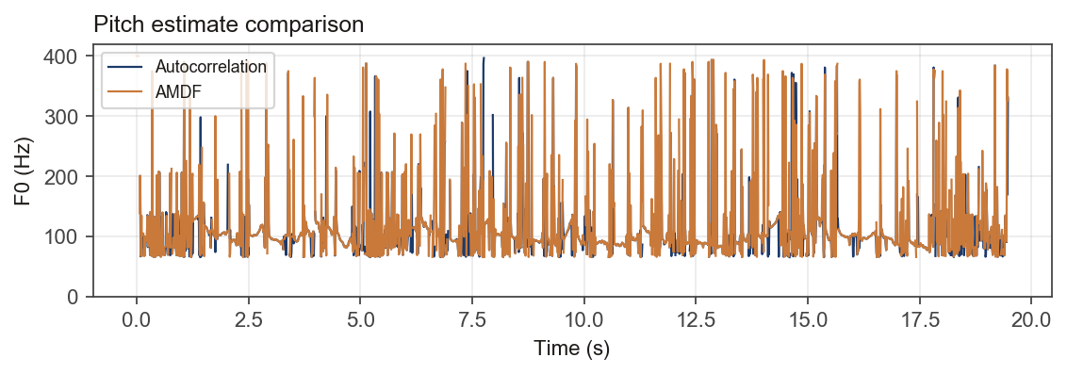
Autocorrelation: 1821/1948 frames reached confidence ≥ 0.3 (median F0 95 Hz among those). AMDF: 1834/1948 frames (median F0 99 Hz). AMDF marks more frames as "reliable" but its track is visibly noisier frame-to-frame, consistent with AMDF being more sensitive to local amplitude variation than the normalized autocorrelation peak.
3.1 Setting and evaluating thresholds
The confidence threshold (normalized autocorrelation peak height, or normalized AMDF dip depth) is not a single universal constant — it trades off missed voiced frames (threshold too high) against spurious pitch on unvoiced/silent frames (threshold too low). It was evaluated qualitatively here by comparing the separate F0, waveform, and VAD-active-region plots side by side and checking that gaps in the F0 track (no reliable pitch reported) line up with unvoiced/silent regions rather than cutting through clearly voiced vowels; a more rigorous evaluation would compare against a reference pitch track (e.g. from a laryngograph/EGG signal, or a well-validated algorithm such as YIN) and report voicing-decision error rate and F0 deviation on frames both mark voiced.
3.2 Preventing octave errors (doubling/halving)
Two distinct octave-error mechanisms were addressed. First, a naive peak/dip search can default to the edge of the search range (lag_min or lag_max) when no genuine periodicity is present in an unvoiced or silent frame — this is not really a doubling/halving of a real pitch so much as the search finding nothing and reporting the boundary anyway; both _autocorr_pitch_frame and _amdf_pitch_frame now detect this (peak/dip sitting exactly at either edge) and heavily down-weight that frame's confidence so it is excluded from "reliable" pitch, rather than being reported as a confident but spurious frequency. Second, AMDF specifically can lock onto an exact integer multiple of the true period, since a multiple can align to a whole-sample lag more exactly than a non-integer-sample fundamental does; _amdf_pitch_frame now checks whether a shorter sub-multiple (period/2, /3, /4, /5) has a comparably deep dip and prefers it when so.
On top of these frame-level fixes, a simple clip-level correction was implemented: frames with reliable confidence are compared to the GLOBAL median F0 of every reliable frame in the whole clip (a single scalar, 95.4 Hz here — not a local/neighboring-frame statistic), and any frame whose value is close to 2× or 0.5× that global median is snapped back onto the correct octave (median F0 for autocorrelation shifted from 95.4 Hz to 95.0 Hz after correction on this recording). Because this reference is global rather than local, it can misfire on a genuine sustained pitch excursion (e.g. question intonation lasting many consecutive frames) that happens to sit near 2× the whole-clip median, since nothing here distinguishes an isolated single-frame artifact from a real, sustained contour change — it is best suited to cleaning up occasional one-off slips, not to tracking genuine pitch movement. More robust standard approaches include constraining the search range to the expected speaker's F0 range, enforcing temporal continuity with dynamic programming/Viterbi smoothing across the whole utterance (which would naturally distinguish a brief artifact from a sustained excursion), and cross-checking the two methods against each other (autocorrelation and AMDF tend to make different octave-error mistakes, so frames where they disagree by close to an integer ratio are good candidates for correction).
4. Voice Activity Detection (VAD)
The VAD combines three per-frame features: relative energy (RMS in dB above an automatically estimated noise floor), pitch reliability (the autocorrelation confidence from Section 3), and zero-crossing rate (ZCR). A frame is marked active if its relative energy clears a margin above the noise floor, and it looks either voiced (pitch reliably detected, i.e. low, periodic ZCR) or like an unvoiced consonant (broadband and noise-like, i.e. a HIGH zero-crossing rate rather than a low one — unvoiced fricatives and stops lack vocal-fold vibration entirely, which is the opposite acoustic signature from voiced speech, so the two branches use ZCR in opposite directions rather than both requiring it to be low).
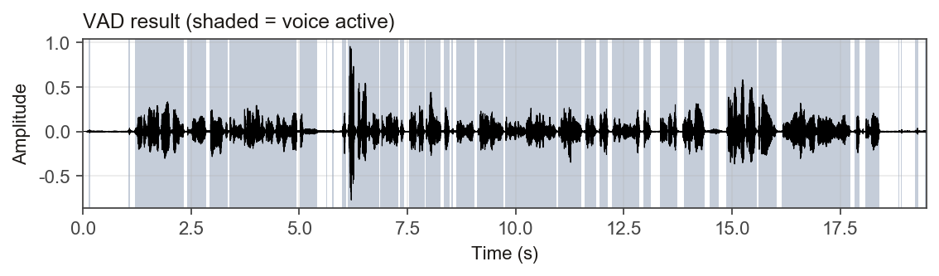
On this recording, 75% of frames were marked active, noise floor -59.9 dB, threshold -47.9 dB.
4.1 Setting and evaluating thresholds
As in Homework 2's classifier, the energy threshold is set relative to a noise floor estimated from the recording itself (10th percentile of frame energy) plus a fixed margin, rather than a single absolute dB value, since absolute levels vary with microphone gain and recording environment. It was evaluated by visually checking that active regions line up with the waveform's audibly speech-containing parts and that pauses between words are correctly marked inactive; a quantitative evaluation would need ground-truth voice-activity labels to compute precision/recall or a false-alarm/miss-rate curve while sweeping the margin and ZCR threshold.
4.2 Detecting voice activity in noisy environments
- Track a moving noise floor: instead of one global percentile over the whole recording, re-estimate the floor over a sliding window so it adapts if background noise changes partway through (e.g., an air conditioner turning on).
- Use spectral, not just time-domain, features: spectral flatness or the ratio of energy in speech-relevant bands (300–3400 Hz) to total energy is more robust to broadband noise than raw time-domain energy, since noise and speech can have similar RMS but different spectral shape.
- Pre-process with noise/spectral subtraction: estimate the noise spectrum during non-speech intervals and subtract it before computing VAD features, reducing the energy/ZCR distortion noise introduces.
- Fall back to a learned model: a pretrained VAD (WebRTC VAD, Silero VAD) trained on noisy speech generalizes better than hand-tuned thresholds once the rule-based approach's assumptions (clear energy gap between speech and noise) break down.

