Audio and Signal Processing
2026311323 Howon Chung

1. Introduction
This report implements Homework #5 (Linear Prediction Analysis): the Levinson-Durbin recursion is implemented directly from its defining equations (E(0)=φ[0]; k_i = {φ[i] − Σ_{j=1}^{i-1} a_j^{(i-1)} φ[i-j]} / E(i-1); a_i^{(i)}=k_i; a_j^{(i)}=a_j^{(i-1)} − k_i a_{i-j}^{(i-1)}; E(i)=(1−k_i²)E(i-1)) rather than via scipy.linalg.solve_toeplitz(), and is run inside the overlap-and-add (OLA) framing implemented for Homework #3, so that linear prediction coefficients (LPC) are computed independently in each frame of the recorded input speech signal. As specified, the signal is analyzed at 8,000 Hz with a 25 ms frame length and a 10 ms frame shift (200 samples / 80 samples at 8,000 Hz).
The recording's microphone captured audio natively at 16,000 Hz; it is resampled to 8,000 Hz here because the assignment specifies an 8 kHz sampling frequency for this analysis.
2. Levinson-Durbin Inside the OLA Program
Each frame is windowed (Hamming), its autocorrelation φ[0..p] is computed, and the Levinson-Durbin recursion solves for the LPC coefficients a_1..a_p of that frame alone (no information is shared across frames). The residual e(n) = x(n) − Σ_k a_k x(n−k) is obtained by passing the frame through the analysis filter A(z) = 1 − Σ a_k z⁻ᵏ; the reconstructed frame is obtained by passing that SAME frame's residual back through the synthesis filter 1/A(z), i.e. V(z) = G/A(z) with unit gain excitation e(n). Per-frame residuals and per-frame reconstructions are then each reassembled into continuous signals via weighted overlap-and-add, exactly as in Homework #3.
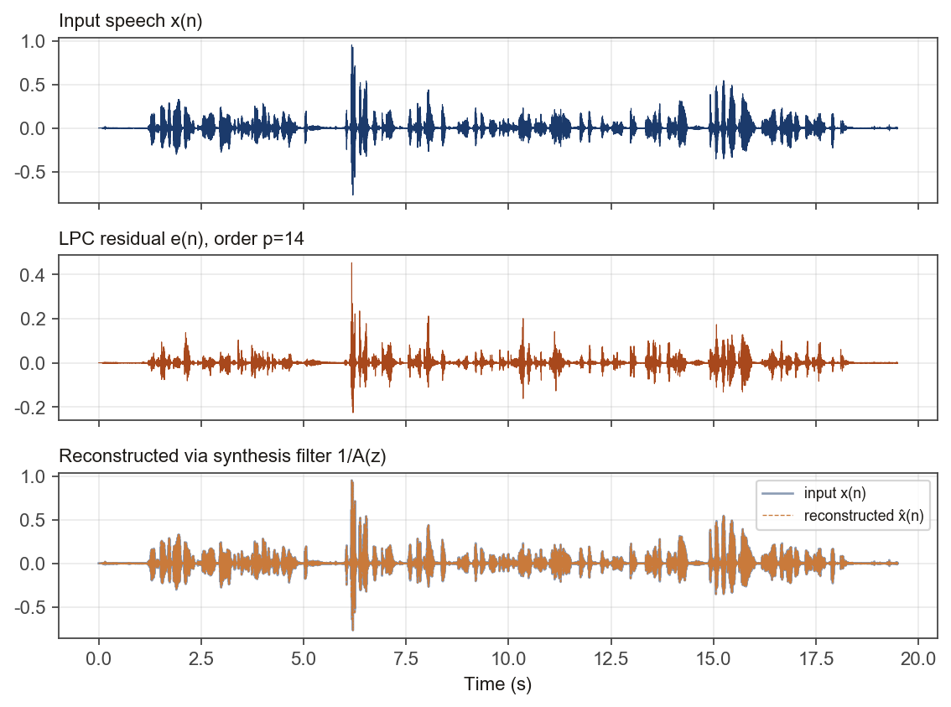
At p=14 (matching the lecture's own worked example on p.61, "M = 14"), the reconstructed signal overlays the input essentially exactly (RMSE = 6.74e-29, against an input RMS of 0.047). This is expected and holds at every order tested below, not just p=14: since the synthesis filter 1/A(z) uses the identical coefficients the analysis filter A(z) used to produce that frame's own residual, applying one after the other is mathematically an identity (up to floating-point precision and the stability clamp on the reflection coefficients), independent of how good a model A(z) actually is. A near-zero reconstruction RMSE is therefore a check that the analysis/synthesis pipeline is wired correctly, not evidence that any particular order models the vocal tract well.
2.1 What actually varies with order: residual whitening
The quantity that genuinely depends on model order is the prediction-error (residual) energy itself: E(i) = (1−k_i²) E(i-1) is non-increasing by construction, so adding more poles can only reduce or leave unchanged the energy left in the residual, never increase it. The table and plot below show the mean residual energy, averaged over every frame in the recording, at each of the orders the assignment specifies. (This is φ[0]'s own scale -- a biased autocorrelation, i.e. a raw sum of squares over one 200-sample Hamming-windowed frame, not a per-sample power -- so it is only meaningful compared across orders/frames on this same scale, not directly against a whole-clip RMS figure quoted elsewhere in this report.)
Order p | Mean residual energy | Reconstruction RMSE (sanity check)
4 | 0.010183 | 5.78e-29
8 | 0.006904 | 7.49e-29
12 | 0.005776 | 6.22e-29
16 | 0.005293 | 3.06e-29
20 | 0.005032 | 1.49e-28

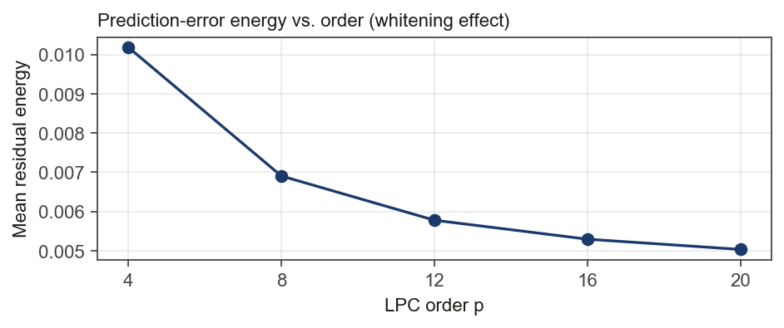
Residual energy drops by 43% from p=4 to p=12, but only a further 13% from p=12 to p=20 -- diminishing returns set in well before p=20. This matches the lecture's own model-order budget (p.59: ≈10 poles for the vocal tract's resonance density over a 4–5 kHz bandwidth, plus a few more for the radiation/glottal terms, ≈14–16 total): once enough poles exist to cover the formant structure, additional poles mostly re-fit residual noise rather than removing more structure.
3. AR Spectrum for Frames of Different Characteristics
Representative frames were selected automatically from the Homework #2 background/unvoiced/voiced classifier (longest segment of each class in this recording), rather than picked by eye, so the choice is reproducible from the recording alone.
3.1 Voiced (vowel-like)
Longest voiced segment: 1.92 s, frame extracted at t=3.91 s.
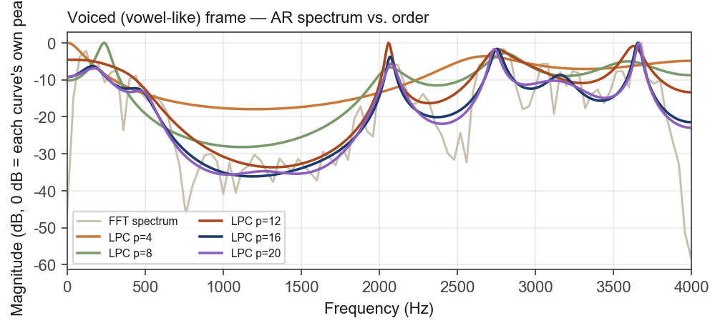
3.2 Unvoiced (fricative/stop-like)
Longest unvoiced segment: 0.34 s, frame extracted at t=5.25 s.
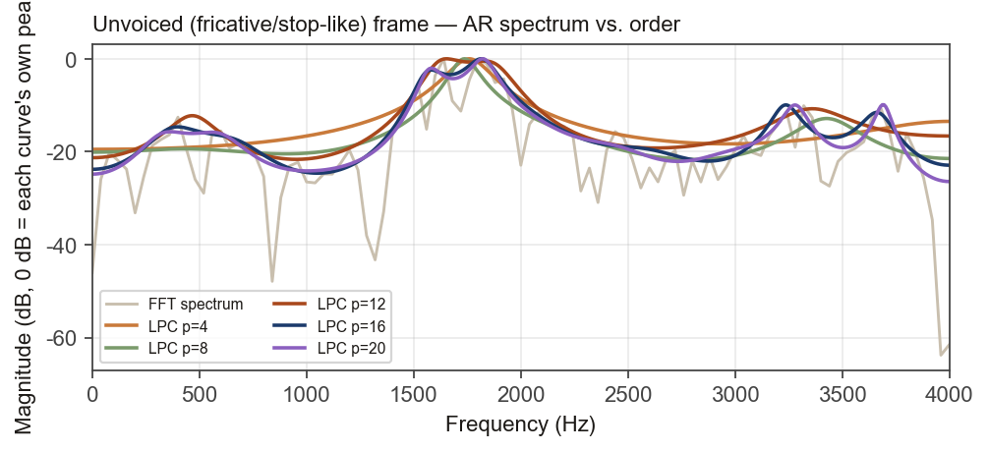
3.3 Background / silence
Longest background segment: 1.05 s, frame extracted at t=0.70 s.
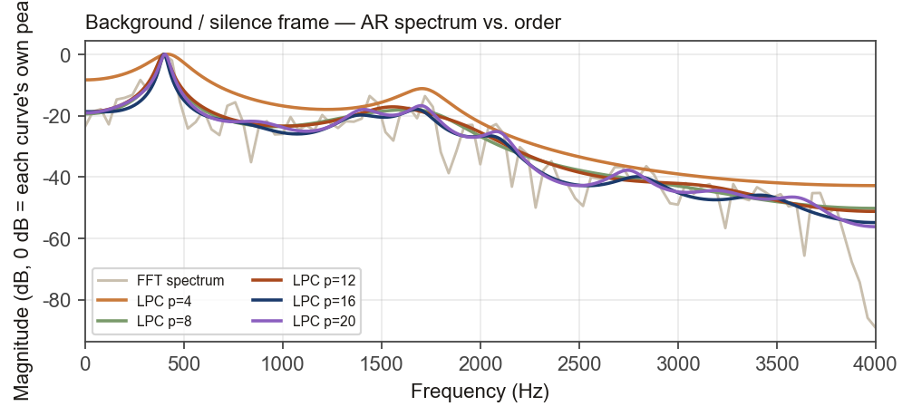
3.4 Findings
Frame | Signal energy (sum sq.) | Residual/signal, p=4 | Residual/signal, p=20
Voiced (vowel-like) | 0.28844 | 17.9% | 5.8%
Unvoiced (fricative/stop-like) | 0.01523 | 16.2% | 10.7%
Background / silence | 0.00015 | 1.9% | 1.5%

On the voiced frame, raising the order progressively resolves separate formant peaks that low orders blur together into one broad bump; at p=20 the strongest AR peak sits at 3664 Hz, and the residual/signal energy ratio falls from 17.9% at p=4 to 5.8% at p=20 -- the largest order-dependent improvement of the three frame types, because there is real formant structure for the extra poles to remove. Because voiced excitation is quasi-periodic, the raw FFT spectrum is a dense comb of harmonic lines; the AR curve instead traces only the smooth formant envelope those harmonics sit under, which is exactly the separation of "what the vocal tract did" from "what the glottis did" that motivates LPC-based (vocoder) coding. This also matches the lecture's own "Criterion of Goodness" property (p.55): the LP error criterion favors a good fit near spectral peaks over spectral valleys, which is visible directly in the plot above -- each AR curve tracks its FFT spectrum's peaks far more tightly than its valleys, at every order.
On the unvoiced frame, the FFT spectrum is comparatively flat and noise-like (no harmonic comb, consistent with turbulent/frication excitation rather than periodic glottal pulses), and the residual/signal ratio only falls from 16.2% to 10.7% (p=4 to p=20) -- a visibly smaller improvement than the voiced frame's -- because there is less underlying spectral structure for extra poles to uncover, so the gap between low- and high-order AR curves is correspondingly smaller here than for the voiced frame.
On the background/silence frame, both the FFT spectrum and the AR envelope are comparatively flat at every order, and the residual/signal ratio is already low at p=4 (1.9%) and barely changes by p=20 (1.5%) -- additional poles add essentially no interpretable detail. In absolute terms this frame's signal energy is about 1985× smaller than the voiced frame's, consistent with it containing near-silence rather than real formant structure for the all-pole model to recover.
4. Consideration: Implementing LPC with Deep Learning
The clearest existing example is LPCNet (Valin & Skoglund, 2019): rather than replacing LPC, it keeps the classical per-frame linear predictor exactly as implemented here, and uses a small recurrent network (a WaveRNN-style architecture) only to model the excitation/residual that remains after linear prediction, conditioned on the LPC coefficients and acoustic features. This division of labor is deliberate: the linear predictor already removes most of the short-term spectral redundancy very cheaply (as Section 2.1 shows, with a closed-form, non-iterative solution), so the network only has to learn the harder, more nonlinear part -- modeling the fine-grained excitation -- which lets a lightweight model run in real time on a CPU at high speech quality and low bitrate, which a from-scratch neural vocoder (predicting waveform samples directly) normally cannot do without much more compute.
A second, complementary idea is to replace the closed-form Levinson-Durbin step itself with a learned predictor: a small network (e.g. over a frame's autocorrelation, or directly over mel-spectral features) predicts the reflection coefficients k_i, trained end-to-end against a perceptual or waveform loss rather than pure prediction-error energy. Because the standard recursion is purely linear and closed-form, it cannot represent the mild nonlinearities (e.g. glottal-source/vocal-tract interaction, breathiness) real speech exhibits; a learned estimator could in principle fit those, at the cost of losing the closed-form recursion's guaranteed filter stability (|k_i|<1), which would need to be re-imposed some other way -- for instance a bounded output activation such as tanh, which enforces |k_i|<1 by construction, rather than the hard min/max clamp this report's own Levinson-Durbin implementation uses to keep the recursion numerically stable.
5. Summary
The Levinson-Durbin recursion was implemented from its defining equations and embedded in the Homework #3 OLA framework, run per-frame at 8,000 Hz / 25 ms frames / 10 ms shift on a recorded speech signal. Residuals and reconstructions were obtained and plotted against the input, confirming the analysis/synthesis pipeline is self-consistent; the AR spectrum was compared across orders 4/8/12/16/20 for voiced, unvoiced, and background frames, showing that higher order resolves sharper formant structure mainly where real periodic structure exists (voiced speech), with diminishing returns elsewhere, consistent with the lecture's own vocal-tract pole budget.

