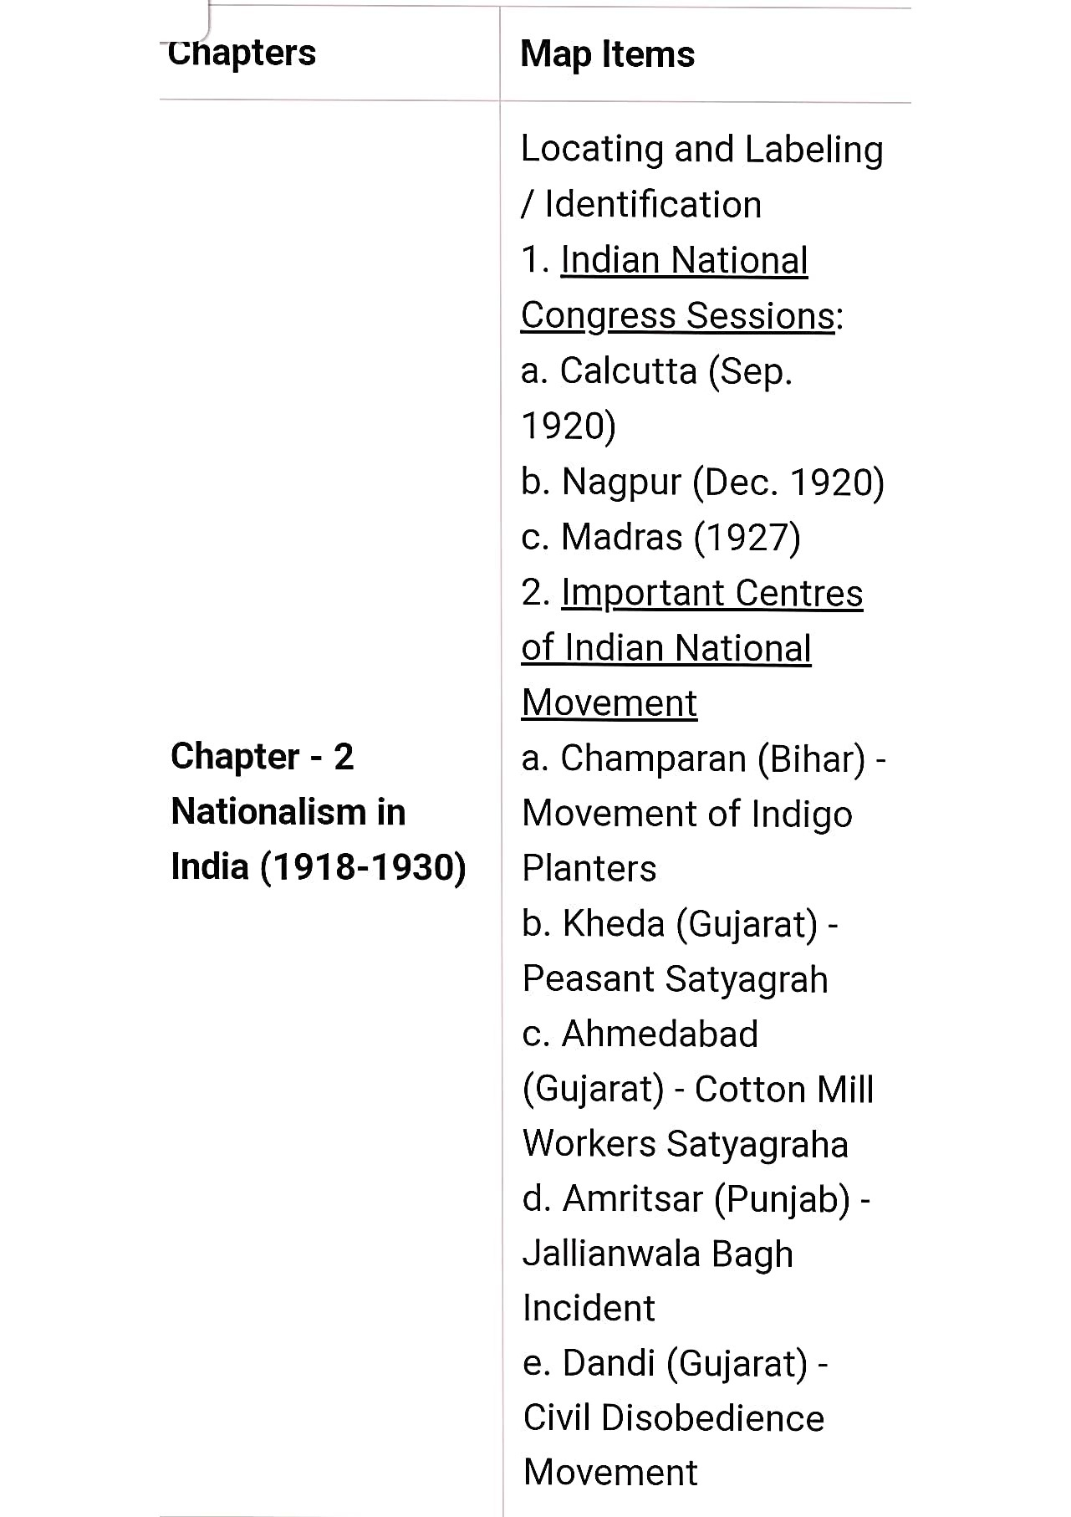

|  |  |
| --- | --- |
| Chapter 1:  Resources and Development | (Identification only)  a. Major soil Types |
| Chapter 3:  Water  Resources | (Locating and Labelling) Dams:   1. Salal 2. Bhakra Nangal 3. Tehri 4. Rana Pratap Sagar 5. Sardar Sarovar 6. Hirakud 7. Nagarjuna Sagar 8. Tungabhadra |
| Chapter 4: Agriculture | (Identification only)   1. Major areas of Rice and Wheat 2. Largest/Major producer states of   Sugarcane, Tea, Coffee,  Rubber, Cotton, and Jute |
|  |  |

Geography

Minerals (Identification only).

1. Iron Ore mines

1. Mayurbhanj
2. Durg
3. Bailadila
4. Bellary
5. Kudremukh 2. Coal Mines
6. Raniganj
7. Bokaro
8. Talcher
9. Neyveli

3. Oil Fields: Chapter 5:

1. Digboi

Minerals and

1. Naharkatia

Energy

1. Mumbai High

Resources

1. Bassien
2. Kalol
3. Ankleshwar Power Plants (Locating and Labeling 1. Thermal
4. Namrup
5. Singrauli
6. Ramagundam 2. Nuclear
7. Narora
8. Kakrapara
9. Tarapur

|  |  |
| --- | --- |
|  | 1. Kakrapara 2. Tarapur 3. Kalpakkam |
| Chapter 6:  Manufacturing  Industries | (Locating and Labelling  Only)  1. Cotton Textile Industries: a. Mumbai   1. Indore 2. Surat 3. Kanpur 4. Coimbatore   2. Iron and Steel Plants:   1. Durgapur 2. Bokaro 3. Jamshedpur 4. Bhilai 5. Vijayanagar 6. Salem   3. Software Technology Parks:   1. Noida 2. Gandhinagar 3. Mumbai 4. Pune 5. Hyderabad 6. Bengaluru 7. Chennai 8. Thiruvananthapuram |
|  |  |

1 . Major Sea Ports (Locating and Labelling)

* 1. Kandla
  2. Mumbai
  3. Marmagao
  4. New Mangalore
  5. Kochi
  6. Tuticorin
  7. Chennai
  8. Vishakhapatnam

Chapter 7:. Paradip Lifelines ofj. Haldia

National2. International Airports

# Economya. Amritsar (Raja Sansi Sri Guru Ram Dass Jee) b. Delhi (Indira Gandhi)

1. Mumbai (Chhatrapati Shivaji)
2. Chennai (Meenam Bakkam)

# e. Kolkata (Netaji Subhash Chandra Bose)

f. Hyderabad (Rajiv Gandhi)

# History

Chapter - 2 Nationalism in India (1 918-1930)

1. Indian National Congress Sessions:

1 . Calcutta (Sep. 1920)

* 1. Nagpur (Dec. 1920)
  2. Madras (1927)
     1. 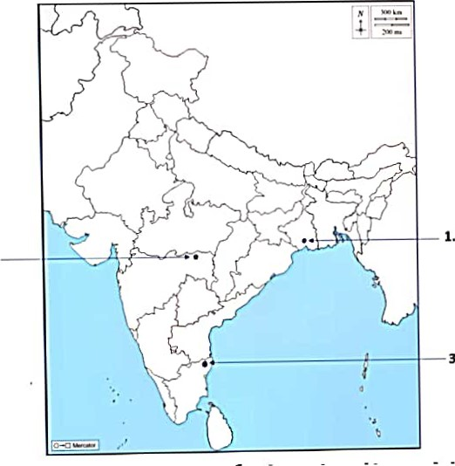Calcutta (Sep. 1920)
     2. Nagpur (Dec. 1920)
     3. Madras (1927)

1. Important Centres of the Indian National Movement

1 . Champaran (Bihar) - Movement of

Indigo Planters

* 1. Kheda (Gujarat) - Peasant Satyagraha
  2. Ahmedabad (Gujarat) - Cotton Mill

Workers Satyagraha

* 1. Amritsar (Punjab) - Jallianwala Bagh

Incident

* 1. Dandi (Gujarat) - Civil Disobedience

Movement

4. Amrltsar (Punjab)_ Jallianwala Bagh Incident

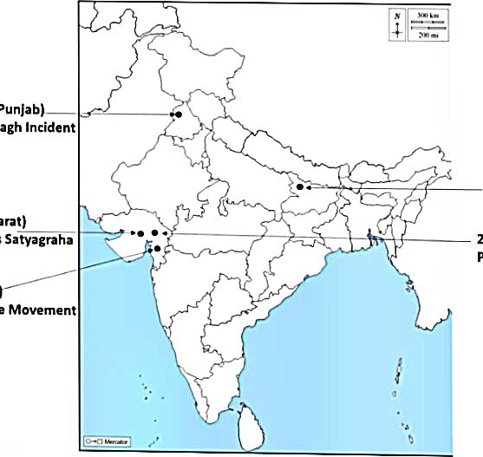

Workers

1. Champaran (Bihar)

Movement of Indigo Planters 3. Ahmedabad (Gujarat)

Cotton Mill 2. Kheda (Gujarat)

Peasant Satyagrah

5. Dandi (Gujarat

Civil Disobedience

## Geography

|  |
| --- |
| 880 920 960E |

Chapter 1: Resources and Development (Identification only)

### a. Major soil Types

C apter 3: Water Resources (Locating ana

Labelling)

Dams:

Salal

1. Bhakra Nangal
2. Tehri
3. Rana Pratap Sagar
4. 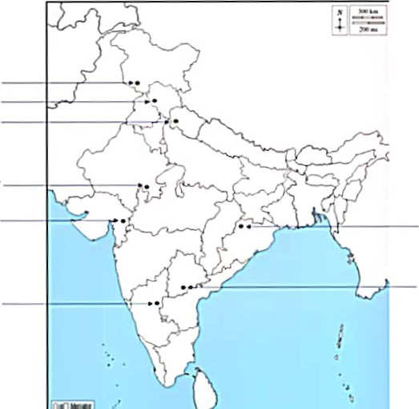Sardar Sarovar
5. Hirakud
6. Nagarjuna Sagar
7. Tungabhadra

Dams

1. salal
2. Bhakra Nangal
3. Tehrl
4. Rana Pratap Sagar
5. Sardar Sarovar6. Hirakud
   1. Nagarjuna Sagar
   2. Tungabhadra

pter 4: Agriculture (Identification only)

1. Major areas of Rice and Wheat
2. Largest / Major producer states of

Sugarcane, Tea, Coffee, Rubber, Cotton, and

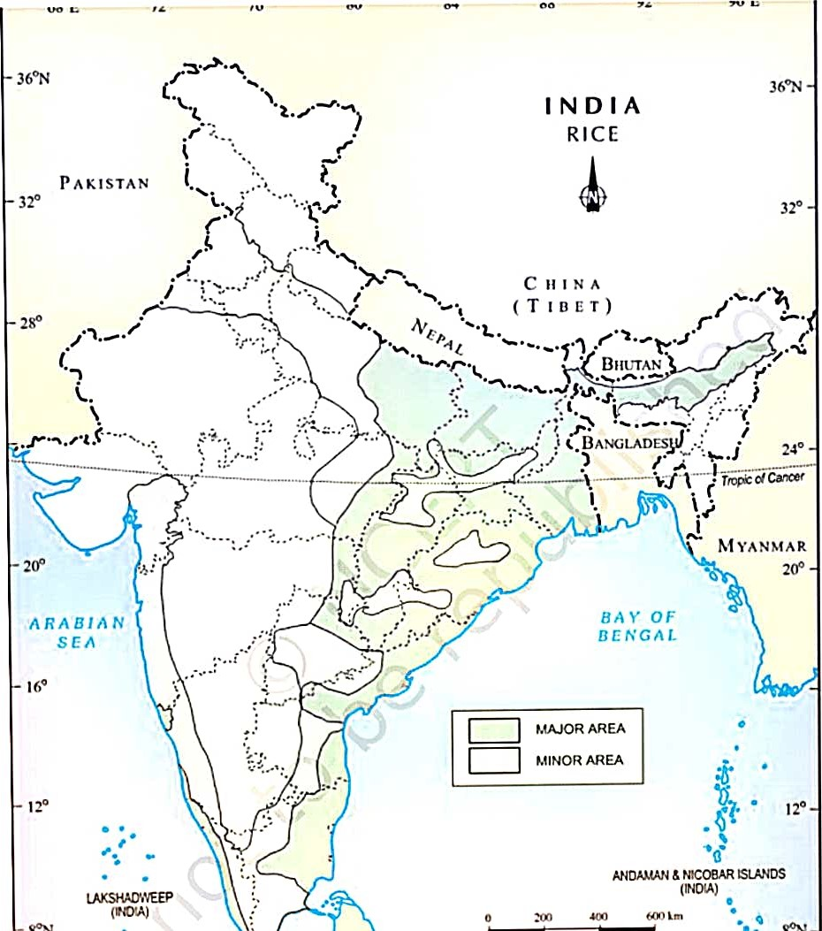Jute

Rice

The main rice-producing states are Tamil Nadu, West Bengal, Andhra Pradesh, Bihar, Odisha, Uttar Pradesh, etc.

Wheat

The major wheat-producing states are Punjab, Haryana, Uttar Pradesh, Madhya Pradesh, and Rajasthan.

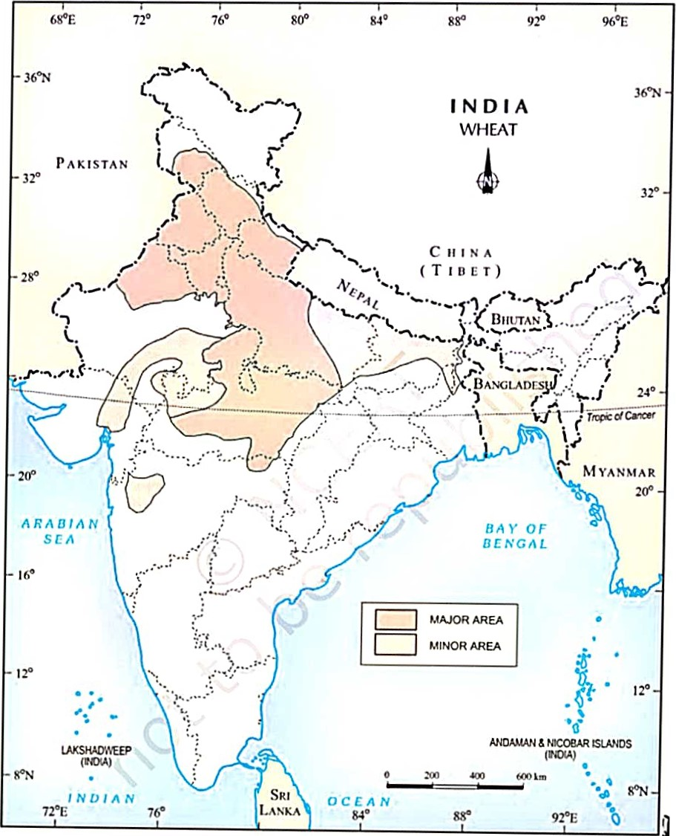

India:

listrilmdion

IVIteat

### Sugarcane

The major sugarcane-producing states are Uttar Pradesh, Maharashtra, Karnataka, Tamil Nadu, Bihar, etc.

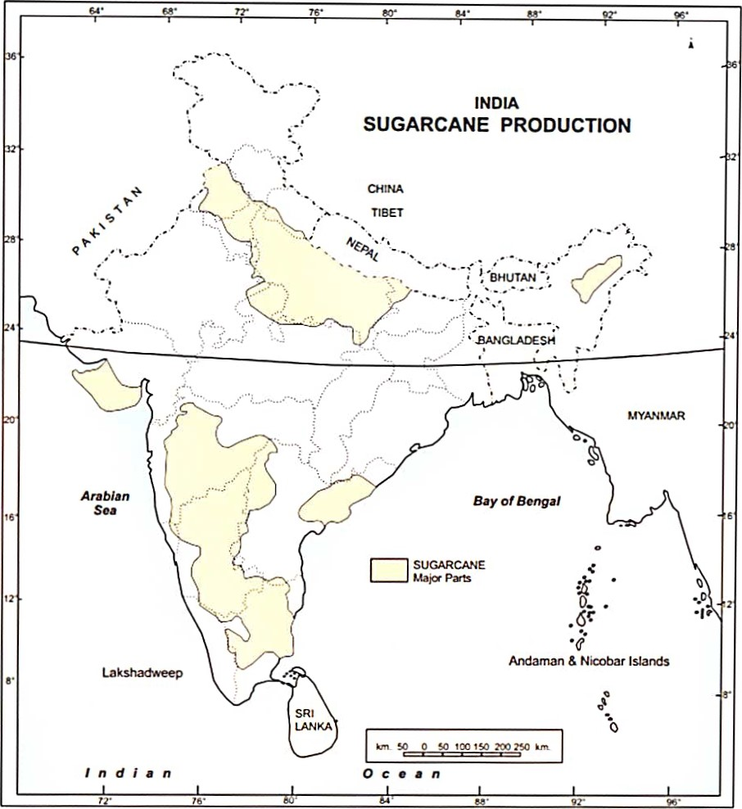

### ea

|  |  |  |  |
| --- | --- | --- | --- |
|  | Arabian |  |  |
|  | | |

Major tea-producing states are Assam, the hills of Darjeeling and Jalpaiguri districts, Wesl Bengal, Tamil Nadu, and Kerala.

#### Coffee

Karnataka, Kerala, and Tamil Nadu are the main states of coffee production in India.

##### Rubber

Rubber is mainly grown in Kerala, Tamil Nadu, Karnataka, and the Garo hills of Meghalaya.

##### Cotton

Major cotton-producing states are Maharashtra, Gujarat, Madhya Pradesh,

Karnataka, etc.

|  |  |
| --- | --- |
| 16 |  |
|

### Jute

|  |  |
| --- | --- |
|  | 300 km |
| 200 mi |
| i |

West Bengal, Bihar, Assam, Odisha, and Meghalaya are the major jute-producing states.

Chapter 5: Minerals and Energy Resources

Minerals (Identification only)

#### A Iron Ore mines

1 . Mayurbhanj

1. Durg
2. Bailadila
3. 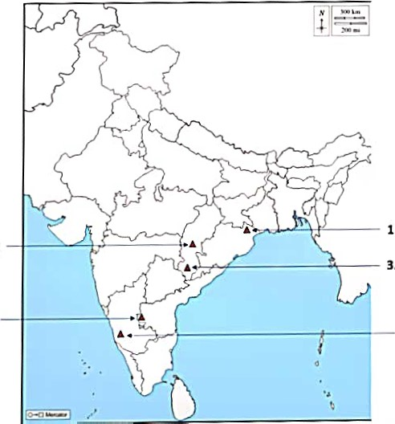Bellary
4. Kudremukh

Iron Ore

Mines

* 1. Mayurbhanj
  2. Durg
  3. Bailadila
  4. Bellary
  5. Kudremukh

B. Coal Mines

1. . Raniganj
2. Bokaro
3. Talcher
4. 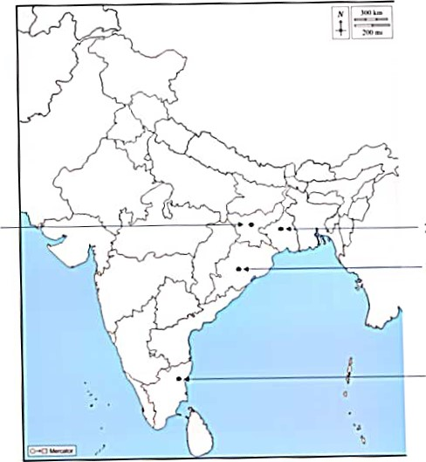N eyveli

Coal Mines

2. Bokaro

1. Ran1ganJ

1. Talcher
2. Neyveli

C. Oil Fields:

1. . Digboi
2. Naharkatia
3. Mumbai High

#### 4. Bassien

1. Kalol
2. Ankleshwar

Oil Fields

* + 1. Digboi
    2. 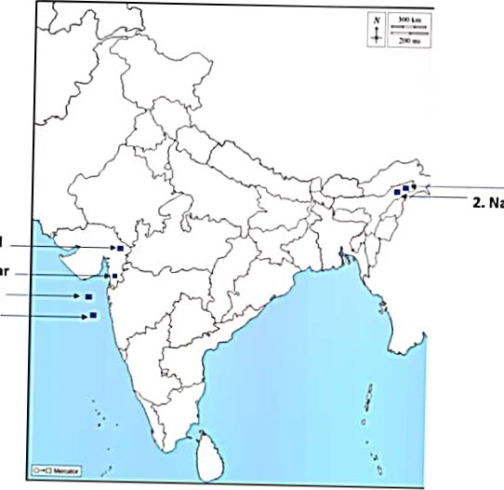Naharkatla
  1. Kalol
  2. Ankleshwar

4. Bassien

3. Mumbai High

Power Plants (Locating and Labelling only)

1. Thermal
   1. . Namrup
   2. Singrauli
   3. Ramagundam

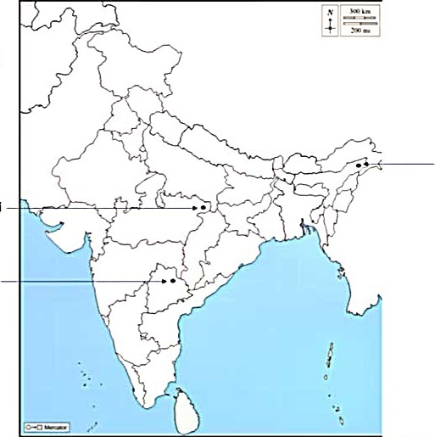Thermal

Power Plants

* + 1. Namrup
    2. Singrauli
    3. Ramagundam

1. Nuclear
   1. Narora
   2. Kakrapara
   3. Tarapur
   4. Kalpakkam

Nuclear

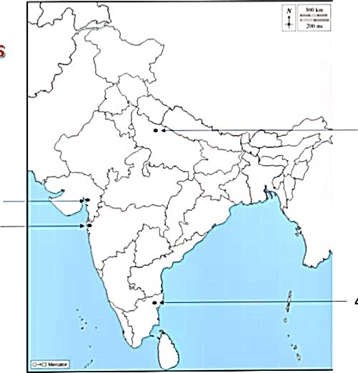Power Plants

* + - 1. Narora
      2. Kakrapara
      3. Tarapura
      4. Kalpakkam

Chapter 6: Manufacturing Industries (Locating and Labelling Only)

1. Cotton Textile Industries:
   1. Mumbai
   2. Indore
   3. Surat
   4. Kanpur
   5. Coimbatore

Cotton Textile

Industries

4. Kanpur

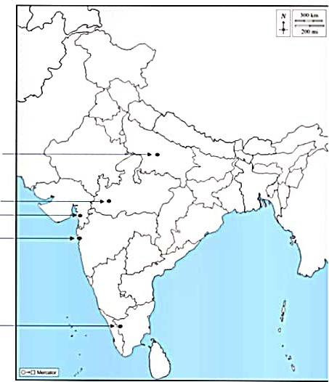

—

—

* + 1. Indore
    2. Surat —

i. Mumbai

5. Coimbatore

1. Iron and Steel Plants:
   1. . Durgapur
   2. Bokaro
   3. Jamshedpur
   4. Bhilai
   5. Vijayanagar
   6. Salem

Iron and

Steel Plants

* + - 1. Bokaro —1. Durgapur
      2. 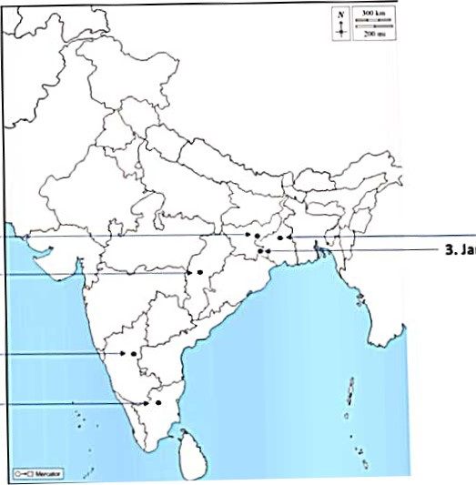Jamshedpur
      3. Bhilai -

S. Vijayanagar — 6. Salem—

1. Software Technology Parks:
   1. . Noida
   2. Gandhinagar
   3. Mumbai
   4. Pune
   5. Hyderabad
   6. Bengaluru
   7. Chennai
   8. Thiruvananthapuram

|  |  |
| --- | --- |
| 1. Noida  Gandhinagar  3. Mumbai |  |
|
|
| 6. Bengaluru  Thiruvananthapuram |
|  |
|  |
|

Software

Technology

Parks

2.

* + - * 1. Pune
        2. Hyderabad

7. Chennai

8.

Chapter 7: Lifelines of National Economy

1. Major Sea Ports (Locating and Labeling)
   1. . Kandla
   2. Mumbai
   3. Marmagao
   4. New Mangalore
   5. Kochi
   6. Tuticorin
   7. Chennai
   8. Vishakhapatnam
   9. Paradip



* 1. Haldia

Major Sea

Ports

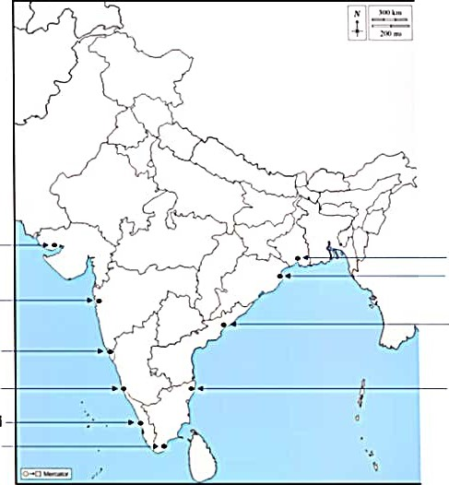1. Kandla —10. Haldia

9. Paradip

2. Mumbai —

8. Vishakhapatnam

* + 1. Marmagao
    2. New Mangalore7. Chennai

S. Kochi

6. Tuticorin—

1. International Airports
   1. Amritsar (Raja Sansi - Sri Guru Ram

#### Dass Jee)

1. Delhi (Indira Gandhi)
2. Mumbai (Chhatrapati Shivaji)
3. Chennai (Meenam Bakkam)
4. Kolkata (Netaji Subhash Chandra Bose)
5. Hyderabad (Rajiv Gandhi)

|  |  |
| --- | --- |
| • Amrltsar  Airport • Delhi  Airport  Airport |  |
|
|
|
|
|  |
|

International Airports

1. Raja Sans! Airport
2. Indira Gandhi

5. Netaji Subhash Chandra Bose

Airport - Kolkata

1. Chhatrapati Shivaji

* Mumbai

6. Rajiv Gandhi Airport

* Hyderabad

4. Meenam Bakkam

- Chennai