Game Design Document

Fill up the following document

1. Write the title of your project.

**FRUIT AND VEGITABLE CATCHER**

1. What is the goal of the game?

To catch all the fruits and vegitables that fall from the sky

1. Write a brief story of your game.

There are random fruits and vegitables and boms falling from the sky

We need to catch the fruits and vegetables

And ignore the boms

And if any boms are caught by the player it is gameover

1. Which are the playing characters of this game?

* Playing characters are the ones who respond to the user based on the input from the user.
* Cars, monkeys, dinos, wizards, etc., are the playing characters in the game.

|  |  |  |
| --- | --- | --- |
| Number | Character Name | What can this character do? |
| 1 | The basket | Catch the fruits |
| 2 |  |  |
| 3 |  |  |
| 4 |  |  |
| 5 |  |  |
| 6 |  |  |
| 7 |  |  |
| 8 |  |  |

1. Which are the Non-Playing Characters of this game?

* Non-Playing characters are the ones that don't have an action or behavior when the user interacts with the game.
* Hurdles, stones, bananas, coins, etc., are non-playing characters in the game.

|  |  |  |
| --- | --- | --- |
| Number | Character Name | What can this character do? |
| 1 | Fruits | Add points to player |
| 2 | Vegitables | Add points to player |
| 3 | Boms | Make player to lose the game |
| 4 |  |  |
| 5 |  |  |
| 6 |  |  |
| 7 |  |  |
| 8 |  |  |

Draw your imagination of this game. What does this game look like?

* Draw the game either on your computer or on paper.
* Add images of the game scenes to show each of the playing and non-playing characters at least once.

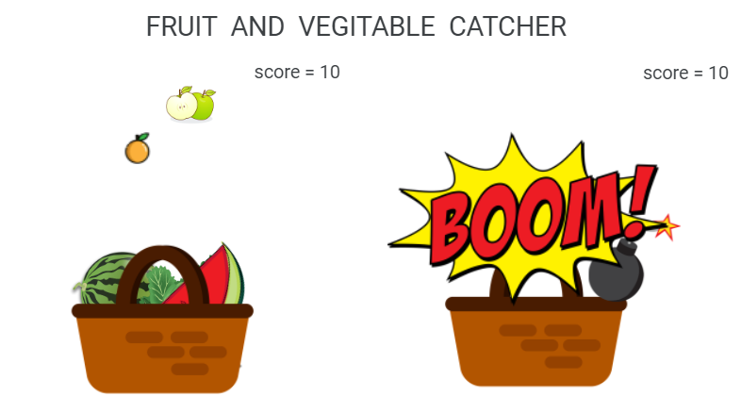

How do you plan to make your game engaging?