MEMORANDUM

Investigating cells and batteries
Grade 5 Term 3 Practical Experiment

QUESTIONS:
- What do you observe?

There’s light coming from the bulb
- What happens when you disconnect one end of one of the wires?

The light goes off
- The one end of the cell is labelled positive and the other end is negative. Draw a diagram of the cell and label the ends as positive or negative.
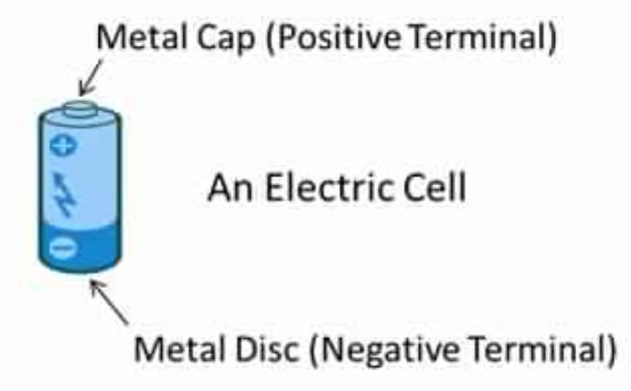

Part 2
Set up a new circuit with 2 cells and 1 bulb.
- Explain how you connected the cells so the bulb still lights up.

Series connected (connection where the electric current has one path way).

- Did the globe glow brighter or dimmer than in part 1, or did it glow the same?

Brighter than in part one.

- Explain your answer to question 2.

There is more chemical energy that has been converted to electrical energy, giving the bulb

more brightness

- Describe an electric circuit

An electrical circuit is a network consisting of a closed loop, giving a return path for the current.
OR
Closed path that consists of circuit components in which electrons from a voltage or current source can flow.

Conclusion:
The more cells (chemical energy converted to electrical energy) that are connected to the circuit, the more brighter the light bulb will be. OR There more batteries that a connected to the circuit, the more brighter the light bulb will be.

