Investigating cells and batteries
Grade 5 Term 3 Practical Experiment
Subject:
Learner:
School:
Date:

Aim: investigating the effect of input energy in an electrical circuit

APPARATUS:
- 1,5v cells (3)
- 1 light bulb
- connecting wires

METHOD:

Part 1
- Set up the circuit as shown in the following diagram.
- Make sure all the wires are connected to form a closed loop.
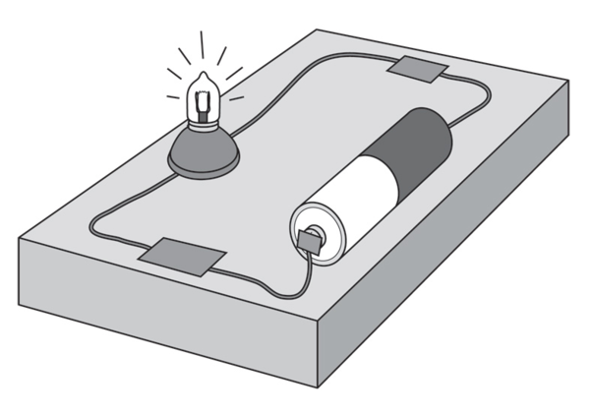

QUESTIONS:
- What do you observe?

- What happens when you disconnect one end of one of the wires?

- The one end of the battery is labelled positive and the other end is negative. Draw a diagram of the battery and label the ends as positive or negative.

Part 2
Set up a new circuit with 2 batteries and 1 globe.
- Explain how you connected the batteries so the globe still light up.

- Did the globe glow brighter or dimmer than in experiment 1, or did it glow the same?

- Explain your answer to question 2.

- Describe an electric circuit.

Conclusion:

