|  |  |  |  |  |  |
| --- | --- | --- | --- | --- | --- |
| **SCHOOL OF COMPUTER SCIENCE AND ARTIFICIAL INTELLIGENCE** | | | **Name:DONTHI MEGHANA**  **ID NO.:2403A510D9** | | |
| **AssignmentNumber:3.2**(Present assignment number)/**24**(Total number of assignments) | | | | | |
|  | | | | | |
|  | 1 | **Task Description#1**   * Ask AI to write a function to calculate compound interest, starting with only the function name. Then add a docstring, then input-output example   **Expected Output#1**   * Comparison of AI-generated code styles   **Code And Output:**    **Explanation:** | |  |  |

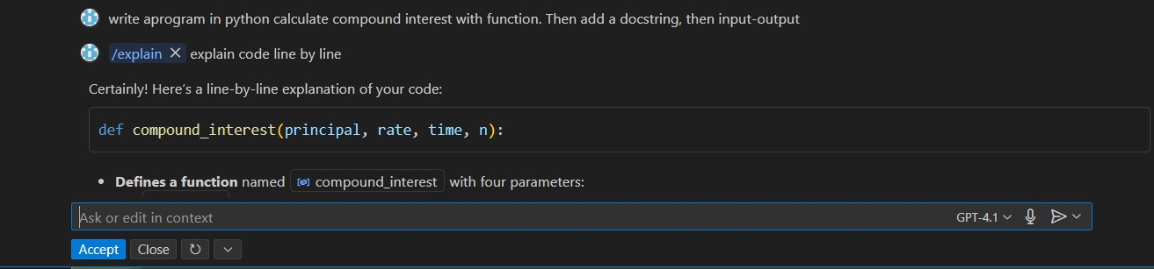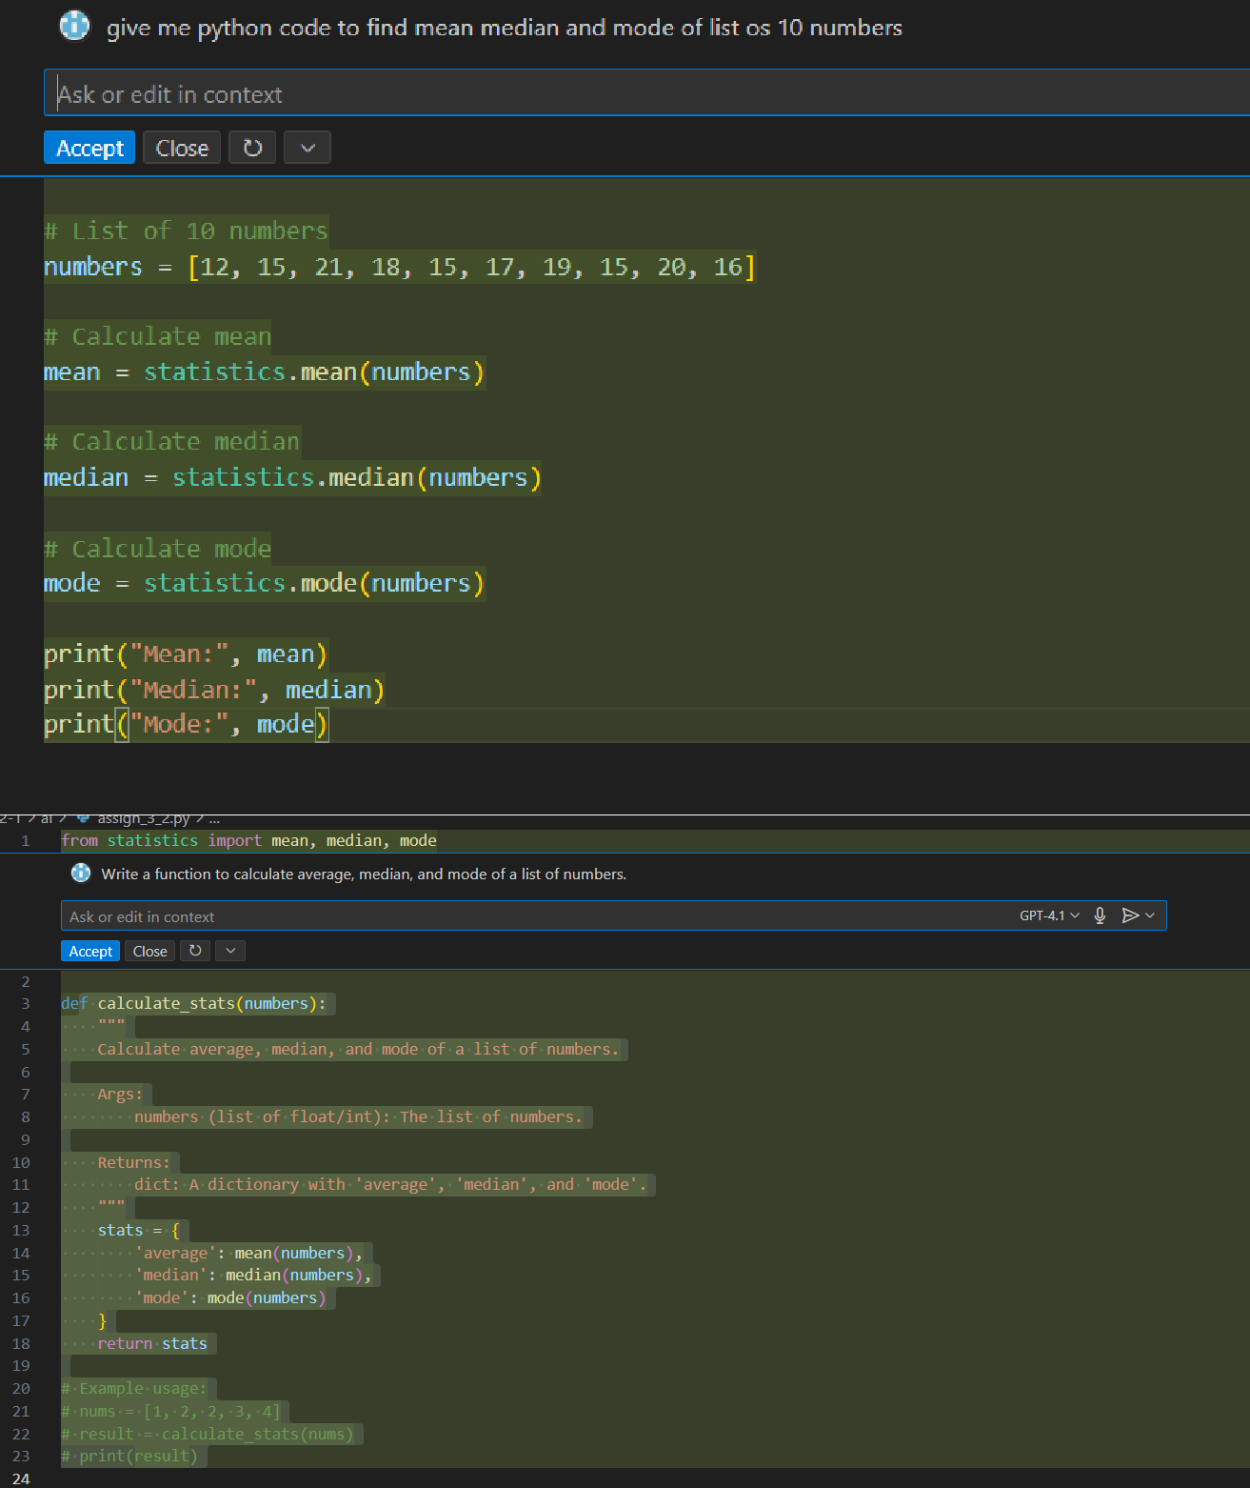

# Task Description#2

* Do math stuff, then refine it to: # Write a function to calculate average, median, and mode of a list of numbers.

# Expected Output#2

* AI-generated function evolves from unclear to accurate multi-statistical operat

# Explanation:



Only two pages were converted.

Please **Sign Up** to convert the full document.

[**www.freepdfconvert.com/membership**](https://www.freepdfconvert.com/membership)