Select the header file (.hdr) for the dataset to be displayed. Then a dialog box like the following will be displayed, containing pertinent File information from the header, describing the chosen dataset. Channels may be selected to be displayed, using the standard channel selection syntax. By checking the Include ANA channels…, any channels which are used as the external marker of extrinsic Events will also be included. The Channels box may be left blank, indicating display of no data channels, but the ANA channels should be selected. Click on the OK button (or press the Enter key) to continue on to the display.

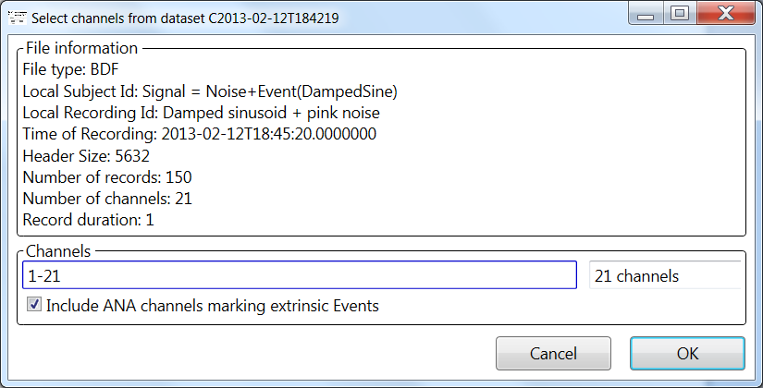

Below is the initial display of the dataset selected. The panel at the top shows a graphic representation of the channels selected. At the bottom this list of channels is a row labeled “Events”. This shows an encoded representation of the Events marked in the Status channel of the BDF file. In the center is a dotted red line which is labeled below to indicate the time in seconds since the beginning of the dataset. On either side of this line are light blue vertical lines labeled with the offset in seconds since the central time. Channels are labeled with their names from the BDF file header at left.

The initial width of the displayed data is 10 seconds. This “window” of data may be scrolled through the dataset using the scrollbar at the bottom or by left-clicking with the mouse and dragging to the left or right while holding the mouse button down. The window may also be moved from Event to Event. This will be described later.

The bottom panel contains items for controlling the display panel. Note that the current width in seconds of the display panel is indicated near the center of this panel.

