university of virginia
Volume
1
Division of Perceptual Studies – Wesphal Neuroimaging Lab
Experimenter User’s Guide
Division of Perceptual Studies – Westphal neuroimaging lab

Experimenter User’s Guide

© UVA – Divison of Percptual Studies
P.O. Box 800152 Charlotesville VA 22908
Phone 434.924.2281

Table of Contents
Table of Contents

Before the Experiment Protocol Starts | Pg 4
Running an Experiment Protocol | Pg 7
After the Experiment Protocol has run | Pg 26
Useful Utilities | Pg 27

Appendix
Catalog of Experiments | Pg 28
Check lists | Pg 31
Location of Experiment Files | Pg 35

Before the Experiment Protocol Starts
Chapter
1
There are several steps that should be done before running the actual experiment. These steps have been made into a check list which appears in the Appendix and can be printed and used as before the experiment.
Before the Subject Arrives

- Set shielded room fan [lower right wall] to 2. This will help ventilation.

- Check all EEG supplies, soak active electrodes 5 minutes in saline. Pre-load gel.

- Make sure lights and monitor are turned on in the shield room (and volume is set appropriately on the monitor).

- Check and install Biosemi batteries. Make sure both Biosemi boxes are turned on in the shielded room.

- Power up Biosemi and Experiment computers and monitors (if necessary).

- Make sure that Macro Express Pro is running on the Biosemi PC (should automatically start when the PC is booted). Note: Look at the small icons in the System Tray (right-hand side of Taskbar at the bottoms of Windows screen). See Figure A and B below.

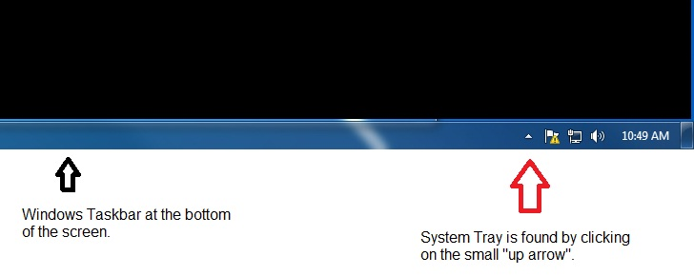
Figure A.

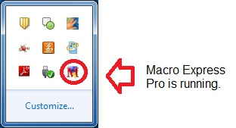

Figure B.

Electrode Preparation

- Greet subject. Preview the procedures to be followed.

- Provide individualized hairbrush and brush entire head to reduce impedances.

- Measure head circumference and select appropriate electrode cap size.

- Carefully measure subject's head to locate Cz and mark that location.

- Apply selected cap and locate position A1 at Cz.

- Keeping A1 at Cz – align the cap so central electrodes follow nasion/inion line.

- Check whether the subject needs to use the bathroom before applying the electrodes.

- Apply the non-EEG electrodes.

- Carefully apply gel to all scalp sites – taking care to fill gel columns less than ¾ full.

- Plug active electrodes into corresponding sites – back to front.

- Plug in CMS/DRL and wrap its lead around the scalp leads approximately 5 times.

- Make sure the subject is still comfortable.

- Enter the shielded room with the subject.

In the Shielded Room

- Seat the subject as appropriate with head preferably not contacting the chair back.

- Connect ribbon cables and other electrodes to the Biosemi system in correct order.

- Power up Biosemi system (if not already powered). Check CMS/DRL lights.

- In dialogue with the experimenter – adjust any malfunctioning contacts.

- Make sure the subject is still comfortable and ready to go. Leave the shielded room and close the door.

Running an Experiment Protocol
Chapter
2

All of the shortcuts to running a particular experiment protocol are stored in various folders inside NEW EXPERIMENTS AND UTILITIES folder on the Experiment PC. At the experiment PC's main screen, double-click on the EXPERIMENTS AND UTILITIES folder.

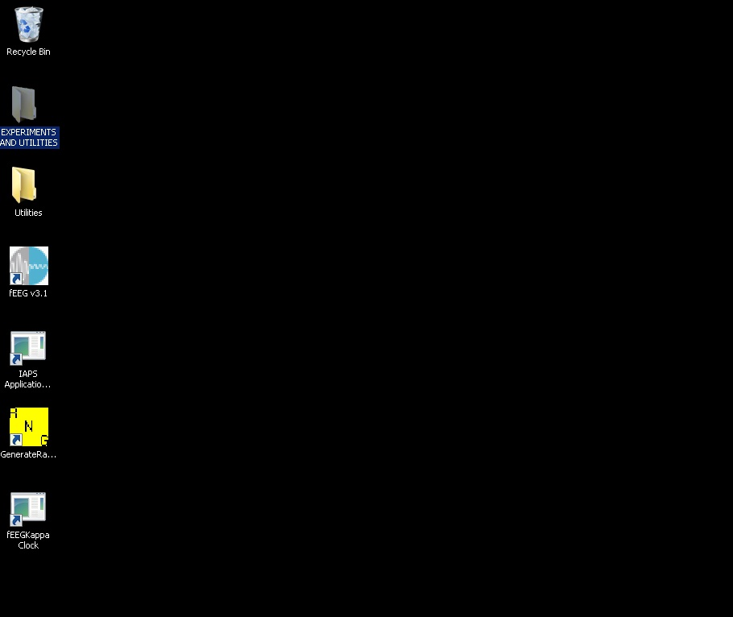
Figure 1

Now, choose the type of experiment protocol to run. In this case, the experimenter is running a special protocol developed for Ross. So, double-click on the Ross folder.

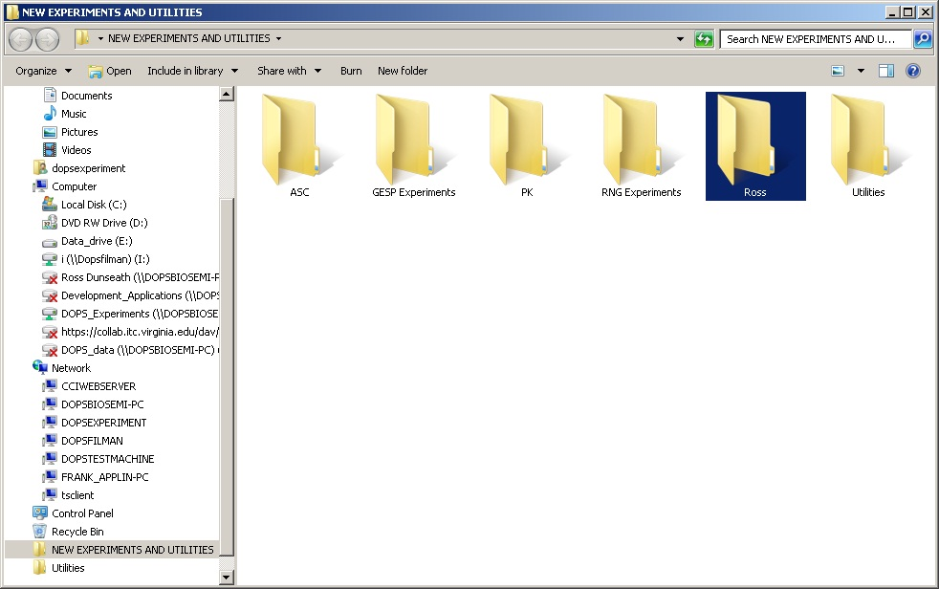
Figure 2

The experimenter must now choose the specific experiment protocol that he/she would like to run. In this case, the experimenter will double-click on the Audio Paced Trials executable.

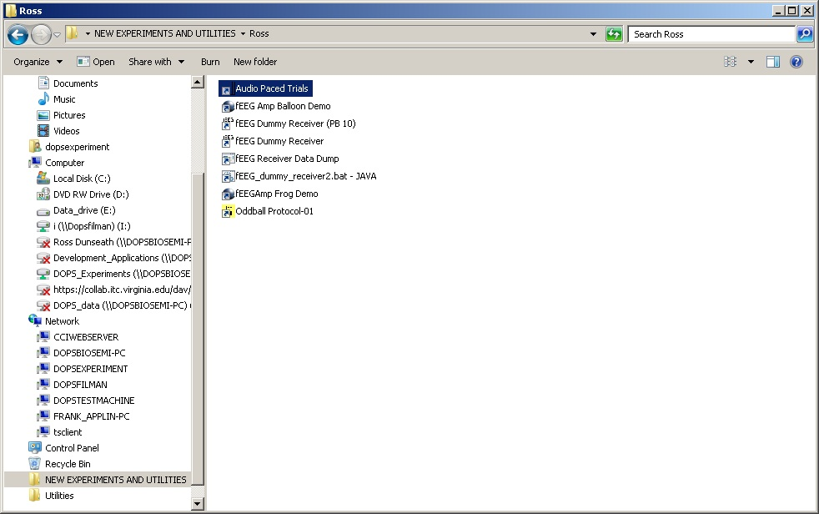
Figure 3

This is the screen that first appears when the Audio Pace Trials is run.

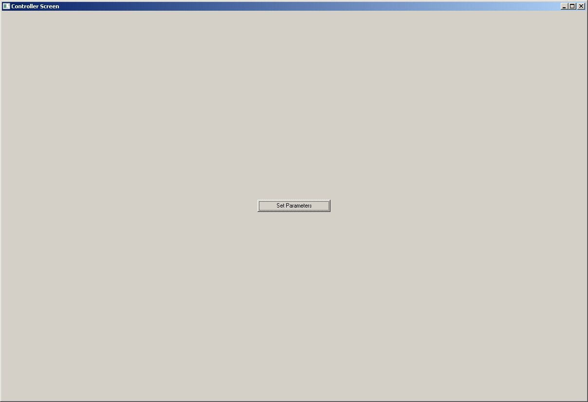
Figure 4

The experimenter now has several parameters that he/she can set for the experiment protocol. These will vary from protocol to protocol. There are several parameters that are common to almost protocols: Number of Trials, Subject ID, Trial Duration, Long Description, and EEG Settings. An explanation of the individual parameters can be obtained by clicking on the “?” button.

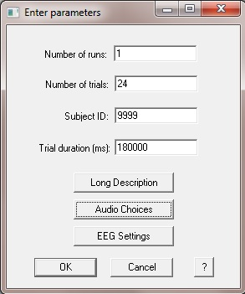
Figure 5

The experimenter can also select many values that will be automatically set on the Biosemi computer for Actiview Biosemi to use during the experiment run.

The Edit EEG button allows the experimenter to edit the definition files for 32, 64, and 128 channels. This allows him/her to create their own labels for each channel, which in turn are visible in the Biosemi program. He/she can also Edit the label defintions for the AIB and Bipolar Leads.

The Load AIB and Load BL buttons allow the experimenter to use different definition files for labels for the AIB channels and the Bipolar Leads.

The Load defaults buttons allow the experimenter to choose a file where he/she has previously saved all of the settings of this screen including if particular AIB and/or BL default files have been used. The Save defaults button allow the experimenter to save to a file all of the settings of this screen including if particular AIB and/or BL default files have been used.
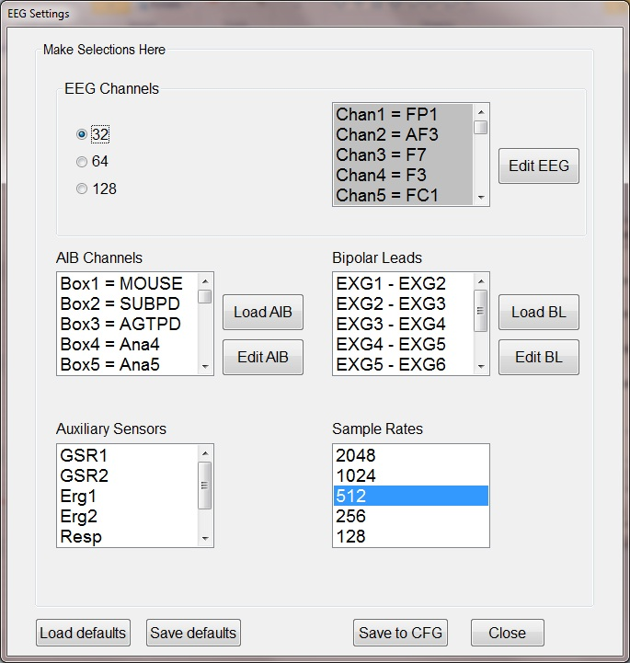
Figure 6

Editing the labels for the EEG Channels. To edit the label of a particular channel, simple click on the line and then modify the label in the box to the right. When you are through modifying the label, Click the Update button. The experimenter now can choose the Save/Save As button to save these settings. They will be saved in either a Default.EEG, Default, Default64.EEG, or Default128.EEG – depending upon whether 32, 64, or 128 channels were selected on the previous screen.

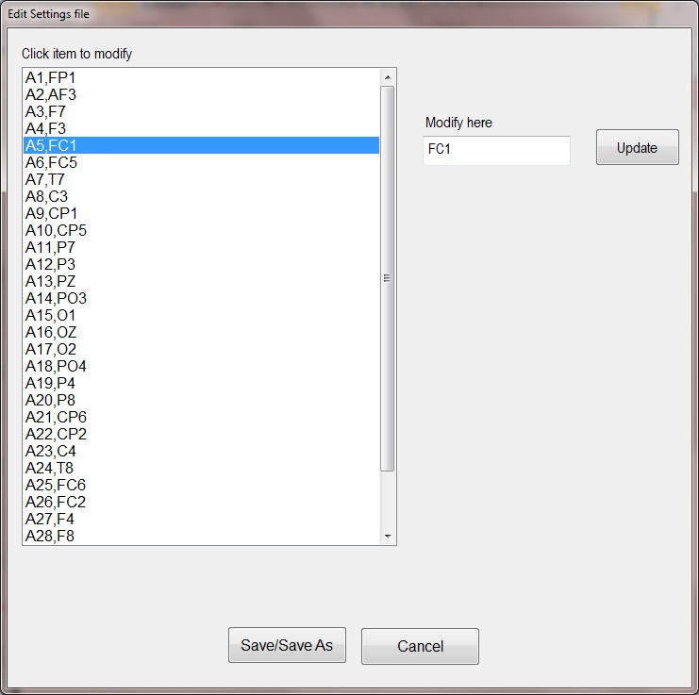
Figure 7

Editing the labels for the AIB Channels. To edit the label of a particular channel, simple click on the line and then modify the label in the box to the right. When you are through modifying the label, Click the Update button. The experimenter now can choose the Save/Save As button to save these settings. The experimenter can name the file anything he/she chooses. The extension of the file will always be .AIB.

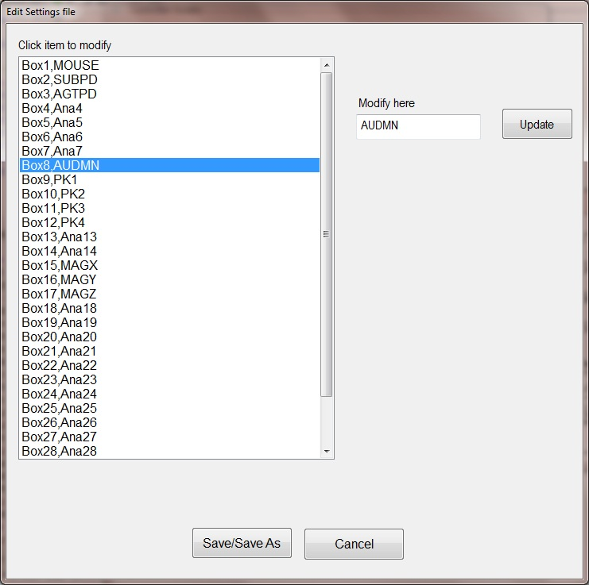
Figure 8

Editing the labels of the BL (Bipolar Leads) Channels. To edit the label of a particular channel, simple click on the line and then modify the label in the box to the right. When you are through modifying the label, Click the Update button. The experimenter now can choose the Save/Save As button to save these settings. The experimenter can name the file anything he/she chooses. The extension of the file will always be .BL.

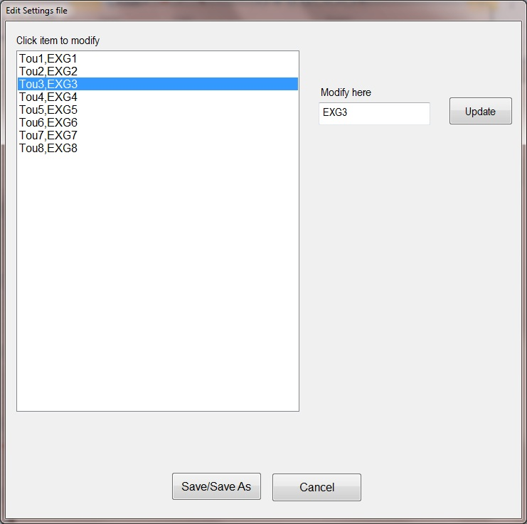
Figure 9

At this time the experimenter will be asked to enter the name(s) of the experimenter(s) and/or technicians that are running this protocol.

If there is a technician helping with the experiment, type in his/her name in the text box under the label Technician and click the Add button. Type in the experimenter’s name in the text box under the label Experimenter and click the Add button.

To remover a technician or experimenter, click on the name of the technician or experimenter in the list and click the Remove button.

Click the Save button to continue.

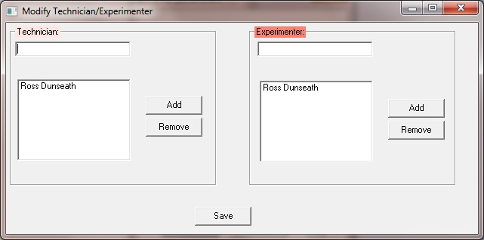
Figure 10

A reminder prompt should appear reminding the experimenter to turn on the Biosemi batteries and to make sure that Macro Express Pro is running on the Biosemi PC.
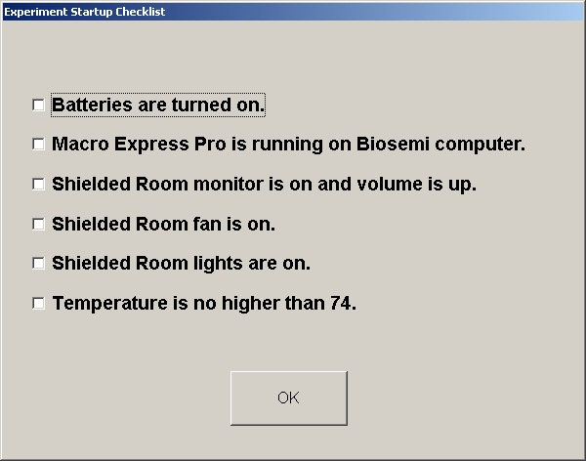
Figure 11

At this time the Active Webcam application automatically starts up and starts recording the subject area inside the shielded room. Note: If there is no image showing up from the monitor camera in the shielded room then a) Check to see if monitor in the shielded room is on [try turning the monitor on and off] and/or b) Go to the Active WebCam application and click File/Open a Session and choose the file named Active WebCam.AWSes. If this doesn’t fix it – call Frank or Ross.

The experimenter is now asked to wait while Biosemi is starting up. The Biosemi machine will give a verbal indication of when you can move on to the next step on the Experimenter PC.

Biosemi will now be running using the parameters selected on the EEG Settings screen. The experimenter should use this time to check impedance levels of the EEG electrodes and check any other settings that may need changing.

Once the experimenter is confident the impedance levels look good and any other Biosemi settings have been adjusted, he/she may click OK to start Biosemi recording.

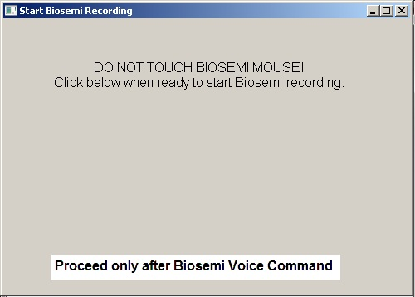
Figure 12

When the experimenter knows that Biosemi is recording, he/she can now click OK to start the trials. The Biosemi machine will give another verbal indication that it is OK to start the experiment.

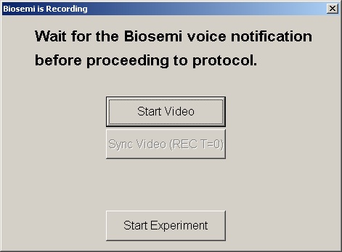
Figure 13

Now, depending on the protocol chosen the subject in the shielded room may or may not see a screen indicating for them to click OK to initiate the start of the trials.

The experimenter should see the trial number in the title of the Experiment screen.

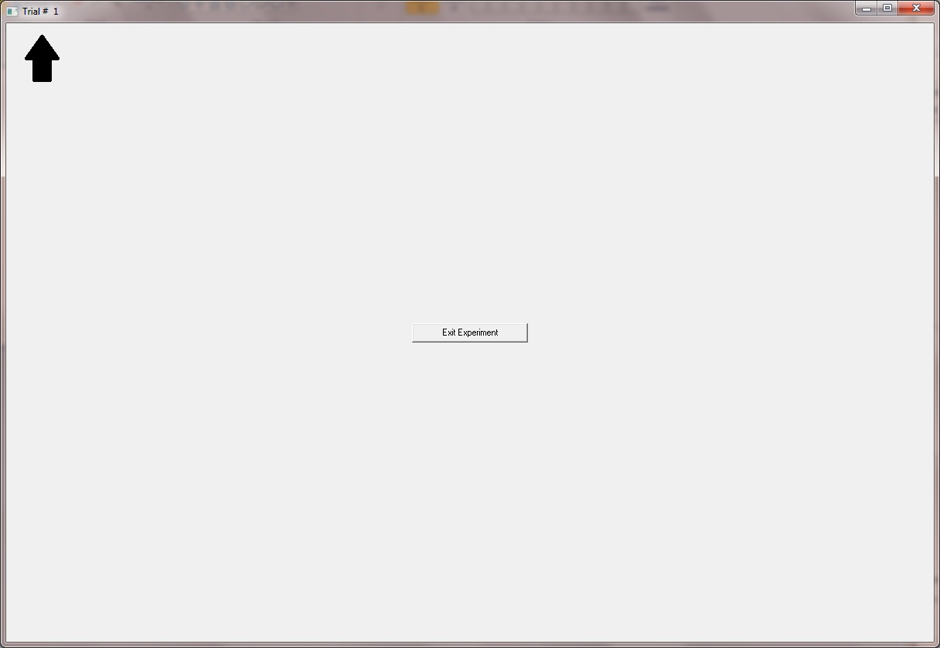
Figure 14

At the conclusion of the experiment, the experimenter will click the Exit Experiment button. The following screen will appear. This screen allows the experimenter to gather all of the files generated by the experiment program (or used by the experiment program) and put them in a place of his/her choice for later use.

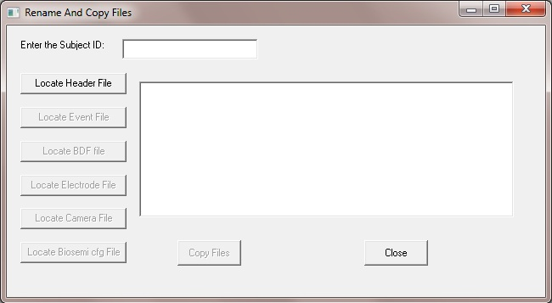
Figure 15

The experimenter should type in the Subject ID in the text box labeled “Enter the Subject ID:”

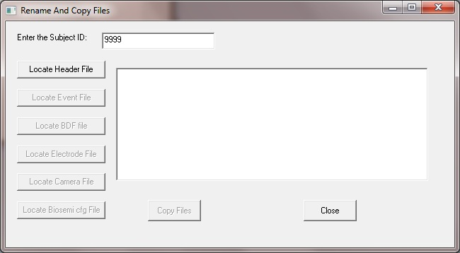
Figure 16

Then the experimenter should click the Locate Header file button and choose the header file associated with this particular experiment.

This screen opens to the default of where the header for this particular Subject ID was stored on the Experiment PC. The experimenter must now choose the correct header file and click the Open button.

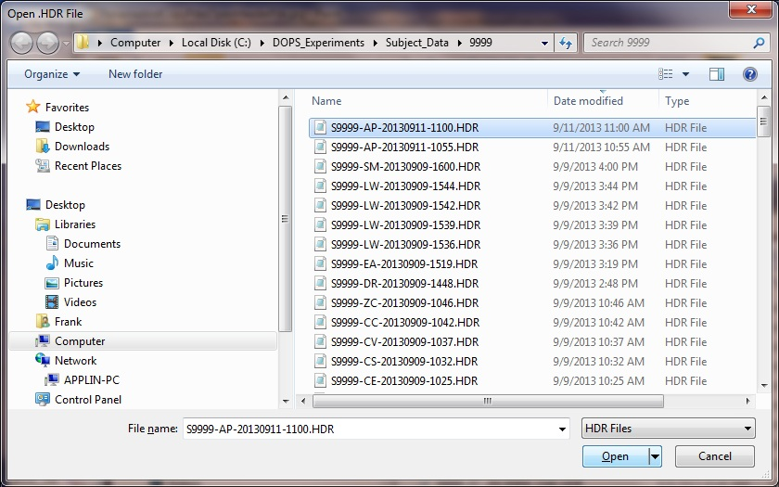
Figure 17

All of the other files associated with this experiment will be filled in by default. A warning window appears letting the experimenter know that he/she should check the files that were chosen by default before copying the files.

If a particular file is not the file the experimenter expects for this particular experiment then he/she can click one of the buttons on the left and choose another file to replace the default.

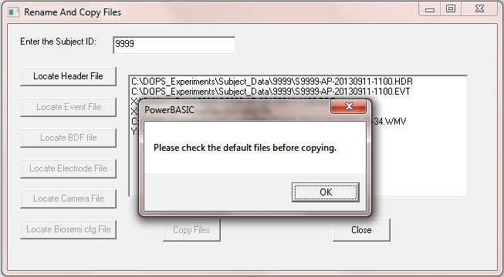
Figure 18

When the experimenter is satisfied with the files, he/she should click on the Copy Files button. A window will appear asking the experimenter where he/she would like to copy all of the files to. There is a drive mapped to the Filman PC that the experimenter can choose, but the experimenter can copy them to anywhere, including local drives, DVDs, flash drives, and network drives.

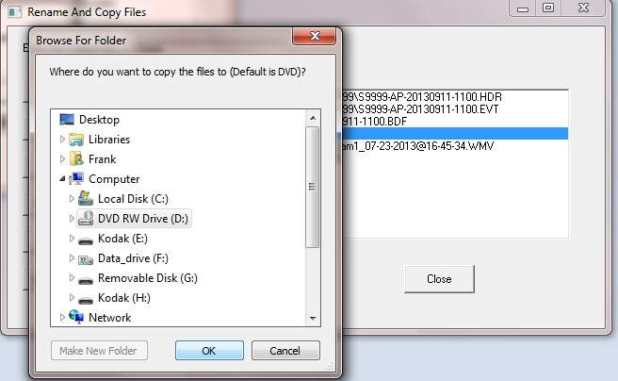
Figure 19

Once the files have been copied, the experimenter should move on to his/her list of “After Experiment” duties.
After the Experiment Protocol has run
Chapter
3
After the Experiment

- Remove the electrode cap and any auxiliary electrodes.

- Escort the subject to the bathroom for cleanup.

- Debrief the subject.

- After the subject departs, power down the Biosemi boxes.

- Carefully clean all the electrodes using only warm/hot water.

- Dry electrodes with paper/cloth towels and hang them in their storage positions.

- Wash electrode cap in warm soapy water. Rinse in H₂O₂. Dry and store.

- Recharge or replace the Biosemi batteries as needed.

- Make additional entries in the Session log notes – as appropriate.
Useful Utilities
Chapter
4
Modify Experimnter And Technician | This utility allows the experimenter to modify the Experimenter(s) and/or technician(s) in either the experiment header file [located in the Subject_Data directory] or the .INI file that is associated with a particular experiment. This could be useful if a technician had to leave during an experiment and someone else took over the role. This utility would allow the change after the experiment.
Modify Header Comment | This utility allows the experimenter to modify the header comment for a particular experiment. This could be useful if a comments were needed to be added after the experiment.
Experiment File Manager | This utility allows the experimenter control and ease of access to all of the files associated with a particular experiment. These files include: header (.HDR), event (.EVT), config file (.CFG), electrode position file (.ETR), EEG file (.BDF), and the camera file (.WMV). The files are all located in the C:\DOPS_Experiments\Subject_Data directory structure. The sub-directory that houses the files are based on the Subject ID (4 digits). Files can be copied, deleted, zipped, and viewed. There are also filter that allow narrowing the search for particular files.

Catalog of Experiments
Appendix

The experiments below form a family of "General ESP" (GESP) experiments prepared for the Westphal Lab using classical forced-choice testing techniques. See Guidebook to Preliminary Psi-Testing Methods. For each experiment, targets are selected trial-by-trial, either before or after you respond, by a sophisticated pseudo-random algorithm (Mersenne-Twister), and your task is to identify which of the possible targets has been picked, or will be picked, for each trial.
Brugman Alpha | The Brugmans experiment is somewhat more difficult, and present the possible targets in a different form. Specifically, you will see a matrix of 25 cells, with 5 rows and 5 columns, you click on a cell to make your selection. The probability of getting a hit by chance is therefore 1 in 25.
Brugman Numeric | The Brugmans experiments is somewhat more difficult, and present the possible targets in a different form. Specifically, you will see a matrix of 64 cells, with 8 rows and 8 columns, you click on a cell to make your selection. The probability of getting a hit by chance is therefore 1 in 25.
Playing Cards - Exact | The Playing Cards (Exact) experiment is much more difficult because they use all 52 playing cards as possible targets, so that the probability of getting a hit by chance alone is just 1 in 52.
Playing Cards - Suits | The Playing Cards (Suits) experiment is much more easier because it use only the 4 suits as possible targets, so that the probability of getting a hit by chance alone is just 1 in 4.
Playing Cards - Values | The Playing Cards (Values) experiment is a little more difficult because it uses 13 playing cards as possible targets, so that the probability of getting a hit by chance alone is just 1 in 13.
Color Cards | The Color Cards experiment uses five homogenously colored cards (Blue, Green, Orange, Red, Yellow) as possible targets. Although the probability structure is therefore exactly the same as for the Zener card experiments, these solid-color targets are of special interest to us, because an existing theory predicts (for complicated reasons) that these particular targets should not be accessible to the psi process. So, if you're comfortable with just 5 targets, we encourage you to try this one.
Zener Cards | The Zener Card experiment uses the classic target symbols developed for J. B. Rhine's laboratory at Duke University in the 1930s (Circle, Square, Cross, Wavy Lines, Star). Since there are 5 equally probable targets, the probability of getting a hit by chance is 1 in 5 on each trial.
The experiments below form a family of RNG experiments prepared for the Westphal Lab using an Araneus Alea USB Random Number Generator. For each experiment, the subject is trying to mentally influence the “randomness” of the RNG.
Drag Race | The Drag Race experiment uses a small dragster that moves across the screen. The subject tries to will it to go faster or slower based on screen prompts.
Earth | The Earth experiment is a take on Helmut Schmidt’s Light Wheel (or Light Clock). It has a satellite floating around the Earth. The subject tries to will the satellite to go in a clockwise or counter-clockwise direction based on screen prompts.
Light Wheel | The Light Wheel experiment is a computer recreation of Helmut Schmidt’s Light Wheel (or Light Clock). It has a series of lights that form a circle. The subject tries to will the lights to go in a clockwise or counter-clockwise direction based on screen prompts.
Superman | The Superman experiment has superman flying across the cityscape. The subject tries to will superman to fly higher or fly lower based on screen prompts.
The experiments below form a family of specialized experiments.
Audio Paced Trials | The Audio Paced Trials experiment has a recorded voice that announces the trial type.
Audio Presentiment  (Random Time) | The Audio Presentiment (Random Time) experiment has noxious audio sounds randomly presorted.
Oddball (P300) | The Oddball (P300) experiment has a visual presentation of common versus rare pictures (beagle & canary)
The experiments below form a family of experiments that allow the tracking of certain altered states of consciousness.
Generic | The Generic protocol allows either the experimenter or the subject to indicate when certain altered states are attained by clicking particular buttons that have been setup before the experiment has been initiated. The buttons represent different states that the subject feels that they may obtain. If the experimenter is clicking the buttons – the subject will have to signal the experimenter in some prearranged manner when a particular altered state is attained.
Generic With Speech and Time | The Generic With Speech and Time protocol allows either the experimenter or the subject to indicate when certain altered states are attained by clicking particular buttons that have been setup before the experiment has been initiated. The buttons represent different states that the subject feels that they may obtain. If the experimenter is clicking the buttons – the subject will have to signal the experimenter in some prearranged manner when a particular altered state is attained. This protocol is much like the previous protocol, but allows the experimenter to hear when a button is clicked (via computer speech) and track the time of each “epoch”.

Check Lists
Running a Lab Experiment
(pre-protocol running)

Before the Subject Arrives | Check
Set shielded room fan [lower right wall] to 2. This will help ventilation.
Check all EEG supplies, soak active electrodes 5 minutes in saline. Pre-load gel.
Make sure lights and monitor are turned on in the shield room (and volume is set appropriately on the monitor).
Check and install Biosemi batteries. Make sure both Biosemi boxes are turned on in the shielded room.
Power up Biosemi and Experiment computers and monitors (if necessary).
Make sure that Macro Express Pro is running on the Biosemi PC (should automatically start when the PC is booted).

Electrode Preparation | Check
Greet subject. Preview the procedures to be followed.
Provide individualized hairbrush and brush entire head to reduce impedances.
Measure head circumference and select appropriate electrode cap size.
Carefully measure subject's head to locate Cz and mark that location.
Apply selected cap and locate position A1 at Cz.
Keeping A1 at Cz – align the cap so central electrodes follow nasion/inion line.
Check whether the subject needs to use the bathroom before applying the electrodes.
Apply the non-EEG electrodes.
Carefully apply gel to all scalp sites – taking care to fill gel columns less than ¾ full.
Plug active electrodes into corresponding sites – back to front.
Plug in CMS/DRL and wrap its lead around the scalp leads approximately 5 times.
Make sure the subject is still comfortable.
Enter the shielded room with the subject.

In the Shielded Room | Check
Seat the subject as appropriate with head preferably not contacting the chair back.
Connect ribbon cables and other electrodes to the Biosemi system in correct order.
Power up Biosemi system (if not already powered). Check CMS/DRL lights.
In dialogue with the experimenter – adjust any malfunctioning contacts.
Make sure the subject is still comfortable and ready to go. Leave the shielded room and close the door.

After the Experiment | Check
Remove the electrode cap and any auxiliary electrodes.
Escort the subject to the bathroom for cleanup.
Debrief the subject.
After the subject departs, power down the Biosemi boxes.
Carefully clean all the electrodes using only warm/hot water.
Dry electrodes with paper/cloth towels and hang them in their storage positions.
Wash electrode cap in warm soapy water. Rinse in H₂O₂. Dry and store.
Recharge or replace the Biosemi batteries as needed.
Make additional entries in the Session log notes – as appropriate.
Location of Experiment Files
Files on the Biosemi PC
CFG | D:\DOPS_Applications\Actiview605\Configuring
BDF | C\:DOPS_Experiments\Subject_Data\xxxx
ETR | C:\DOPS_Experiments\ElectrodePositionFiles
Files on the Experiment PC
HDR | C:\DOPS_Experiments\Subject_Data\xxxx
EVT | C:\DOPS_Experiments\Subject_Data\xxxx
WMV | C:\DOPS_Experiments\CameraFiles
After the experiment, the files should get moved to FILMAN PC
I:\Experiment Data v2\Subject_Data\xxxx

