Weaving maps of multivariate data

David O’Sullivan, Te Herenga Waka – Victoria University of Wellington, Aotearoa – New Zealand  
Luke R. Bergmann, University of British Columbia, Canada

# Motivation

Mapping complex multi-attribute data remains a challenging problem for thematic map design. We present an approach based on the idea of ‘weaving’ together multiple choropleth style symbolisations.

Figure 1 (see also <https://dosull.github.io/weaving-space/NZCS-Nov-2021/example-map-1.html>) shows an example to motivate our explanation. Here the overall distribution of four different (census-defined) ethnic groups in Auckland, New Zealand is shown over a background choropleth map of the uptake of the second dose of the SARS-CoV-2 vaccination around 6 October 2021. Four different choropleth classifications are combined: greys for Pākehā (European), reds for Māori, purples for Pacific Peoples, and greens for Asian. The former two groups are symbolised in strands that run from top left to bottom right, while the latter two are symbolised in strands that run from bottom left to top right. Through gaps in the weave, a fifth symbolisation of vaccinate uptake is visible (this is clearer in the online version of the map).

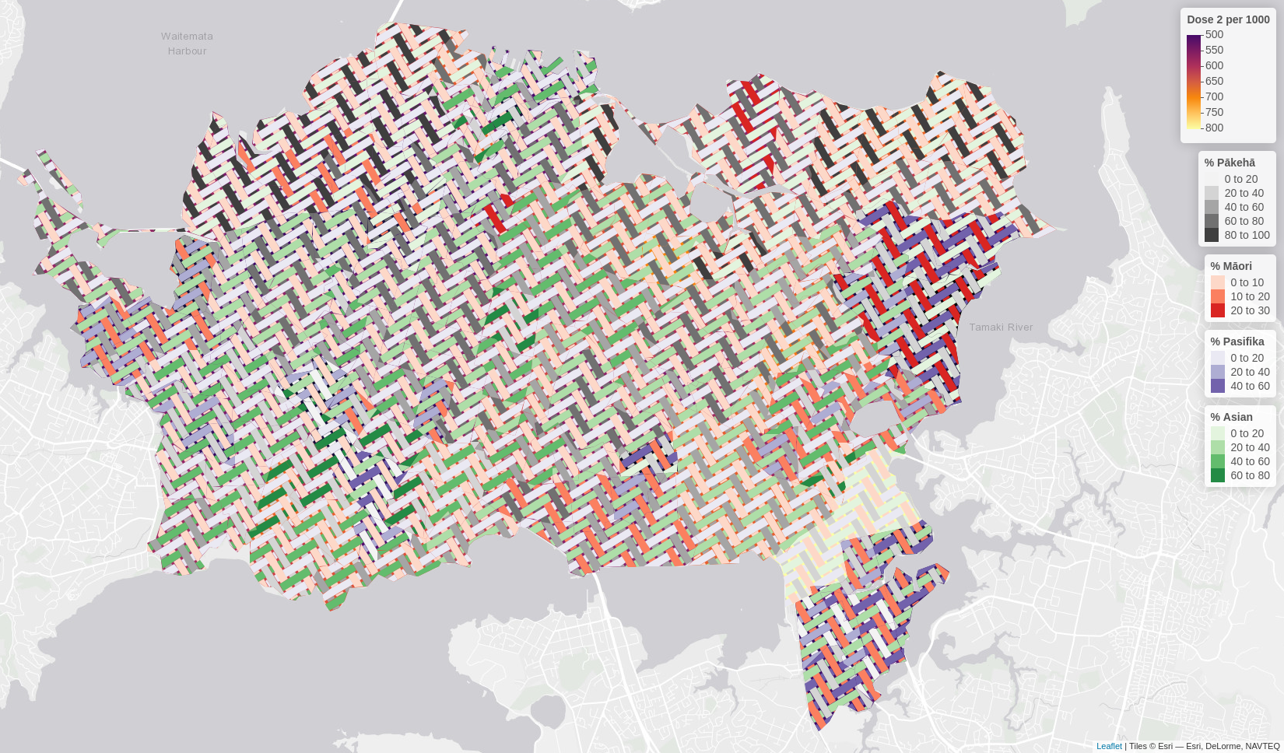Figure 1 Example woven map

The idea behind the approach is that large enough elements (segments of the weave strands) are present to properly ‘carry’ the colour information that conveys attribute values, but at the same time combinations of attribute values are ‘blended’ by the weave pattern to convey an overall impression of those different attribute combinations. At the same time, the oriented nature of the strands serves (literally, visually, and metaphorically) to draw connections among places based on similarities in their attribute values. We hope that this example shows the potential of the method.

An example woven map has appeared in a recently published article (Chaves et al. 2021) where two categorical choropleths are combined in a plain weave pattern, and this was the original work which the present research is developing further.

# Mapping multivariate data

Mapping multivariate data is not a new problem. Among many others the following give an idea of the variety of approaches that have been adopted:

* The most obvious approach is *small multiples* where many small maps are arrayed (usually) in a grid. This approach has been strongly recommended by Tufte (1990) and is also a common default in statistical mapping packages (for example it is the default output from the plot() function in the *R* simple features package sf [Pebesma 2018]). The reader has to scan across multiple maps and multiple legends to develop a sense of the relations within and between different attributes across the mapped area. This approach is demanding of relatively large areas on the page or on a screen.
* *Bivariate* or even *trivariate choropleth* maps mix two or three colour ramps to represent two or three numeric attributes in a single map view (Olson 1975). A related technique is value-by-alpha mapping (Roth et al. 2010). A serious problem with such approaches is that colour mixes can quickly become ‘muddy’ so that very careful selection of the colour palettes to be mixed is essential.
* *Geographically arranged statistical graphics* can be an effective way to present complex mult-attribute data. Bar charts, box plots, histograms, time series, pie charts and so on can be arranged at or near the centroid of map areas to convey complicated multi-attribute data. A particularly ambitious example of this was Dorling’s Chernoff face cartograms of UK socieconomic and electoral data from the 1980s (Dorling 2012, originally from his PhD dissertation in 1991).
* *Categorical dot maps* symbolise count data for multiple categories. Each dot represent one or more instances of a particular category with different coloured dots used for each category. A well publicised recent example is the Cooper Center’s *Racial Dot Map* of US Census data (see <https://racialdotmap.demographics.coopercenter.org/>). The overall effect of such maps is that detailed information can be gleaned ‘close up’ while ‘zoomed out’ colours blend to give an overall impression of the distribution.

We consider the last method described a ‘multi-element pattern’ approach and it shares features with our woven maps particularly the ability to carry detailed information on close inspection and convey and overall impression when viewed at a distance. Because our pattern elements are spatially more extended than dots they can potentially carry richer information (such as position along a numerical range via a colour ramp).

# **Making woven maps**

Our overall approach is simple and schematically illustrated in Figure 2. A tileable ‘weave unit’ (see next section) is repeated at intervals across the map area. Once the tiling is complete, the different spatial elements (i.e., strands) in the woven pattern ‘pick up’ the attributes from the map areas underneath (by a GIS intersection operation), and can be symbolised in any way applicable to conventional choropleth mapping.

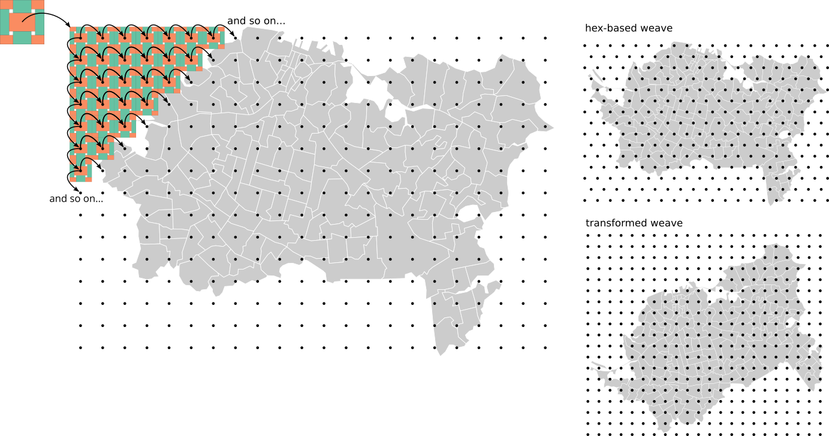Figure 2 Schematic illustration of the method. A tileable ‘weave unit’ is repeated on a grid across the map area. Grids may be rectangular or hexagonal depending on the requirements of the weave unit. A transformed weave (rotated, stretched, etc.) can also be produced by (inverse) transforming the region to be tiled, applying the desired weave unit tile, then transforming the woven map back to the original map view.

The woven map layer is a conventional geospatial data layer and can be exported to a spatial data format for use in any mapping tool. This makes the approach portable, and there is no requirement for prospective users to learn how to make maps in the *R*-spatial platform we have used to develop the code to produce woven maps.

## Weave units

Our approach is based on producing tileable ‘fundamental blocks’ (this term is from the mathematical theory of tessellations, see Grünbaum and Shephard 1987), although we prefer to use our own term ‘weave units’ in this context, because we do not guarantee producing the smallest tileable unit required in all cases.

An underlying matrix mathematics for working with conventional (biaxial) weaving is presented by Andrew Glassner (2002, see also Albaugh 2018). We have extended this approach to represent triaxial weaves as three intersecting biaxial weaves. Perhaps surprisingly, it appears that triaxial weaves offer fewer options for variation than conventional weaving (see Mooney 1984), although they are visually distinctive enough to be preferable in some applications. To date it has proven more difficult to determine the minimum repeating unit (the fundamental block) of triaxial weaves than in the biaxial case.

The flexibility of the approach is shown by the examples in Figure 3, which include biaxial (a-e) and triaxial (f-h) examples, and also cases where the weave itself is a feature (b and c) and missing (e, f, h) or sliced strands (e) are used.

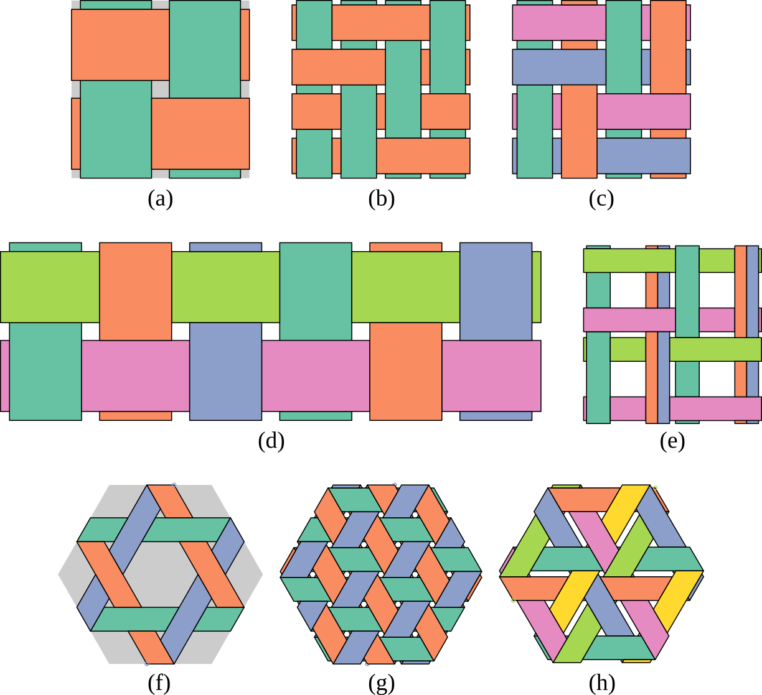*Figure 3* Example weave units: (a) a simple plain weave, (b) a two by two twill weave, (c) a two by two basket weave with two distinct strands in each direction, (d) a plain weave where up to three attributes can be symbolised by vertical strands, and two more by horizontal strands, (e) a biaxial weave with some strands missing or ‘skipped’ to create ‘holes’ through which another map layer might be viewed, and some strands ‘sliced’ to carry more than one data attribute, (f) an open hexagon triaxial weave, (g) the ‘mad weave’ (see Gailiunas 2017) or cube weave, and (h) a cube weave with some strands skipped. The colours in the units denote distinct strands usable to carry different attribute data, not actual colours to be used in mapping. The background grey shading in (a) and (f) shows the extent of the weave unit ‘tile’.

## Making a woven map

To clarify the simplicity of the approach, the code used to produce the woven layer of the map in Figure 1 is shown below.

weave_unit <- get_weave_unit(spacing = 200, type = "twill", n = 3,  
 aspect = 0.6, strands = "ab|cd",   
 crs = st_crs(region))

fabric <- weave_layer(weave_unit, region, angle = 30)

The first line of code makes a three by three twill unit, with two distinct strands in each direction (the “ab|cd” specification), spacing of 200 metres, and an aspect (strand width relative to the spacing) of 0.6. The second line of code tiles the generated unit across the map region.

The result is a spatial data layer of appropriately arranged strands intersected with the areas in the regional data, carrying both those data and a strand identifier (“a”, “b”, “c” or “d” in this case). The strand identifier allows strands to be selected for separate symbolisation.

# **Further work**

This work is at a preliminary stage. Code for making woven maps as described is available at <https://github.com/DOSull/weaving-space> although it remains under development and is subject to rapid change. Many questions remain around the design of such maps, among them

* How does colour work in this setting? What kinds of colour combinations are usable, and how does what is usable or not depend on data distributions and relations among attributes?
* What symbolisation schemes work? Are continuous colour ramps, classified colour ramps workable, or is the approach most suitable for categorical data? (as originally applied in Chaves et al. 2021)
* We consider the oriented nature of weave strands to be an important visual feature of the maps we have made so far, but a better understanding of how ‘orientation’ works as a visual variable is yet to be developed.
* Gaps or missing strands in a weave pattern open up holes in the weave layer that allow other data to show through. How useful is this approach?

Ultimately our woven maps are an exploration of the application of pattern and texture as visual variables . Weaves are a special case of the broader category of tessellations (see Grünbaum and Shephard 1988) of which weaves are a special case more generally

# References

Albaugh, L. 2018. “It’s just matrix multiplication!” Notation for weaving. Presented at Strange Loop Conference, St Louis, 27-28 September. Video available at [youtube.com/watch?v=oMOSiag3dxg](https://www.youtube.com/watch?v=oMOSiag3dxg)

Bertin, J. 1983. Semiology of Graphics. Madison, WI: University of Wisconsin Press.

Dorling, D. 2012. *The Visualization of Spatial Social Structure*. Chichester, England: John Wiley & Sons.

Gailiunas, P. 2017, Mad weave. *Journal of Mathematics and the Arts* **11**(1):40–58.   
doi: [10.1080/17513472.2016.1273037](https://dx.doi.org/10.1080/17513472.2016.1273037)

Glassner, A. 2002. Digital weaving. 1. *IEEE Computer Graphics and Applications* **22** (6):108–118. doi: [10.1109/MCG.2002.1046635](https://dx.doi.org/10.1109/MCG.2002.1046635)

Grünbaum, B., and G. C. Shephard. 1987. *Tilings and Patterns*. New York: W. H. Freeman and Company.

Grünbaum, B., and G. C. Shephard. 1988. Isonemal Fabrics. *The American Mathematical Monthly* **95** (1):5–30. doi: [10.1080/00029890.1988.11971960](https://dx.doi.org/10.1080/00029890.1988.11971960)

Mooney, D. R. 1984. Triaxial Weaves and Weaving: An Exploration for Hand Weavers. *Ars Textrina* **2**:9–68.

Olson, J. M. 1975. The organization of color on two-variable maps. In *Proceedings of the International Symposium on Computer-Assisted Cartography (Auto-Carto II)*, 289–94.

Pebesma, E. 2018. Simple Features for R: Standardized Support for Spatial Vector Data. *The R Journal* **10** (1):439. doi: [10.32614/RJ-2018-009](https://dx/doi/org/10.32614/RJ-2018-009)

Roth, R. E., A. W. Woodruff, and Z. F. Johnson. 2010. Value-by-alpha Maps: An Alternative Technique to the Cartogram. *The Cartographic Journal* **47** (2):130–140. doi: [10.1179/000870409X12488753453372](https://dx.doi.org/10.1179/000870409X12488753453372)

Tufte, E. R. 1990. *Envisioning Information*. Cheshire, CT: Graphics Press.