Build the simplest (almost) C++ Program

Welcome to the “Hello World” assignment. This is typically the first program that a computer scientist will create when learning a new language. The assignment will walk you through the steps of building this simple application in C++.

To begin start up Visual Studio 2015 and select, **File -> New -> Project.**

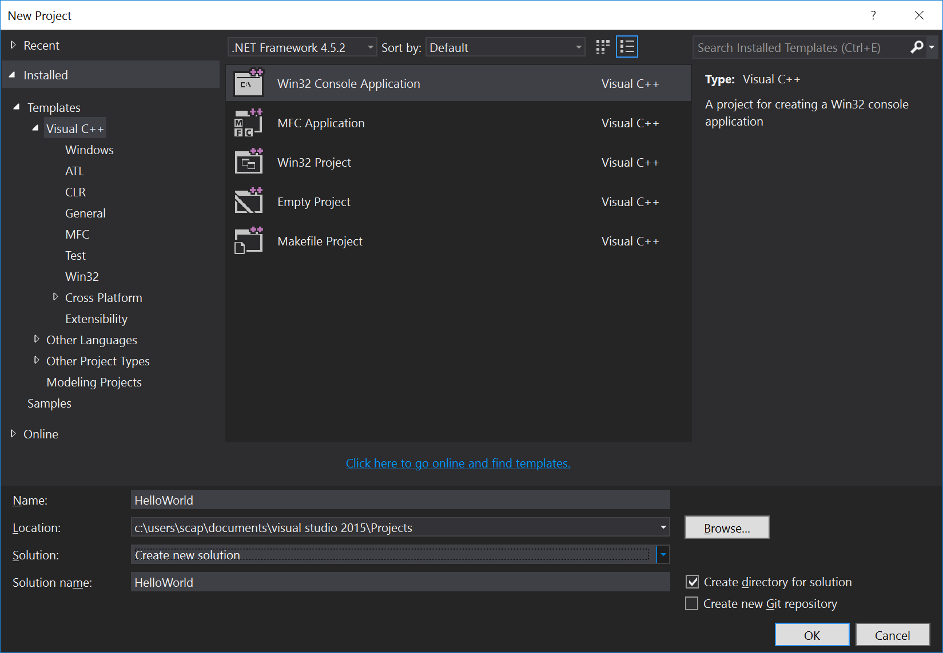

You should be presented with the “New Project” dialog.

1. Select Win32 Console Application.
2. Give the project a name
3. Browse to the location that you would like to store your file. It is important that you know where this is so that you can find your files later.
4. Click OK



Click next.



Select empty project and hit finish.

Now you are ready to create your first C++ program. To start add a cpp file to your project by going to **Project->Add new item**

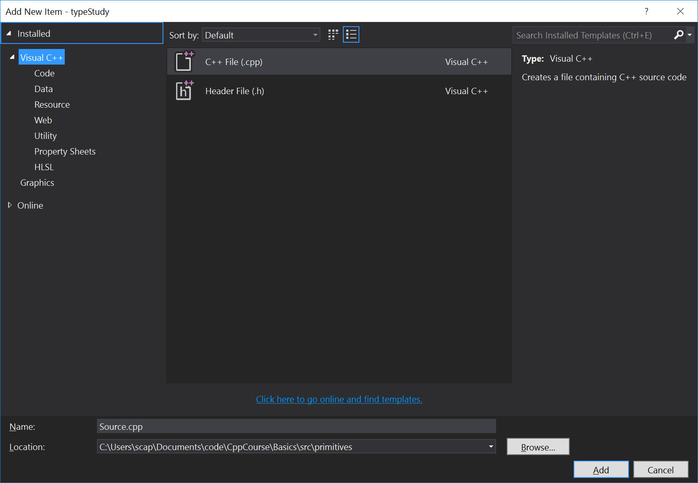

Give the file a name and ensure it is in a good location (under your project directory somewhere).

Enter the following program into the source editor:

#include <iostream>

using namespace std;

int main()

{

cout << “Hello World” << std::endl;

return 0;

}

To compile your program, **Build->Compile.**

If there are no compilation errors, congratulations you have just created your first C++ program.

To run the program select **Debug->Start Debugging or Start without Debugging.**

# While you wait for others:

Can you print out all arguments passed to your program? You may want to open a console to call your program. An additional hint is given below.

int main(int argc, char* argv[])

Can you figure out the difference between:

cout << "Hello World once!\n";

//and

cout << "Hello World twice!" << std::endl;

What happens if you remove the “using namespace std;” line? Unlike in C, C++ has namespaces which can hold variable names, functions, and types. If I want to access a variable “foo” that is in namespace “bar” I would write bar::foo. Can you fix the code so that it works without the “using namespace std;” line?