# java.lang.NoClassDefFoundError: org/apache/commons/collections/FastHashMap

at org.apache.commons.beanutils.PropertyUtilsBean.getPropertyDescriptor(PropertyUtilsBean.java:963)

at org.apache.commons.beanutils.PropertyUtils.getPropertyDescriptor(PropertyUtils.java:498)

at org.apache.shiro.config.ReflectionBuilder.isTypedProperty(ReflectionBuilder.java:251)

at org.apache.shiro.config.ReflectionBuilder.applyProperty(ReflectionBuilder.java:544)

at org.apache.shiro.config.ReflectionBuilder.applySingleProperty(ReflectionBuilder.java:206)

at org.apache.shiro.config.ReflectionBuilder.applyProperty(ReflectionBuilder.java:167)

at org.apache.shiro.config.ReflectionBuilder.buildObjects(ReflectionBuilder.java:124)

at org.apache.shiro.config.IniSecurityManagerFactory.buildInstances(IniSecurityManagerFactory.java:161)

at org.apache.shiro.config.IniSecurityManagerFactory.createSecurityManager(IniSecurityManagerFactory.java:124)

at org.apache.shiro.config.IniSecurityManagerFactory.createSecurityManager(IniSecurityManagerFactory.java:102)

at org.apache.shiro.config.IniSecurityManagerFactory.createInstance(IniSecurityManagerFactory.java:88)

at org.apache.shiro.config.IniSecurityManagerFactory.createInstance(IniSecurityManagerFactory.java:46)

at org.apache.shiro.config.IniFactorySupport.createInstance(IniFactorySupport.java:123)

at org.apache.shiro.util.AbstractFactory.getInstance(AbstractFactory.java:47)

at org.apache.shiro.web.env.IniWebEnvironment.createWebSecurityManager(IniWebEnvironment.java:203)

at org.apache.shiro.web.env.IniWebEnvironment.configure(IniWebEnvironment.java:99)

at org.apache.shiro.web.env.IniWebEnvironment.init(IniWebEnvironment.java:92)

at org.apache.shiro.util.LifecycleUtils.init(LifecycleUtils.java:45)

at org.apache.shiro.util.LifecycleUtils.init(LifecycleUtils.java:40)

at org.apache.shiro.web.env.EnvironmentLoader.createEnvironment(EnvironmentLoader.java:221)

at org.apache.shiro.web.env.EnvironmentLoader.initEnvironment(EnvironmentLoader.java:133)

at org.apache.shiro.web.env.EnvironmentLoaderListener.contextInitialized(EnvironmentLoaderListener.java:58)

at org.apache.catalina.core.StandardContext.listenerStart(StandardContext.java:4842)

at org.apache.catalina.core.StandardContext.startInternal(StandardContext.java:5303)

at org.apache.catalina.util.LifecycleBase.start(LifecycleBase.java:147)

at org.apache.catalina.core.ContainerBase$StartChild.call(ContainerBase.java:1407)

at org.apache.catalina.core.ContainerBase$StartChild.call(ContainerBase.java:1397)

at java.util.concurrent.FutureTask.run(FutureTask.java:266)

at java.util.concurrent.ThreadPoolExecutor.runWorker(ThreadPoolExecutor.java:1149)

at java.util.concurrent.ThreadPoolExecutor$Worker.run(ThreadPoolExecutor.java:624)

at java.lang.Thread.run(Thread.java:748)

Caused by: java.lang.ClassNotFoundException: org.apache.commons.collections.FastHashMap

at org.apache.catalina.loader.WebappClassLoaderBase.loadClass(WebappClassLoaderBase.java:1332)

at org.apache.catalina.loader.WebappClassLoaderBase.loadClass(WebappClassLoaderBase.java:1166)

... 31 more

缺少对应的jar包,应该导入commons-collections-3.2.1.jar就可以了,或者是降低commons-beanutils-1.9.3.jar的版本

# java.lang.NoClassDefFoundError: org/apache/commons/pool2/impl/GenericObjectPoolConfig

at com.xiaomuedu.common.config.MainConfig.configPlugin(MainConfig.java:71)

at com.jfinal.core.Config.configJFinal(Config.java:49)

at com.jfinal.core.JFinal.init(JFinal.java:62)

at com.jfinal.core.JFinalFilter.init(JFinalFilter.java:49)

at org.apache.catalina.core.ApplicationFilterConfig.initFilter(ApplicationFilterConfig.java:279)

at org.apache.catalina.core.ApplicationFilterConfig.getFilter(ApplicationFilterConfig.java:260)

at org.apache.catalina.core.ApplicationFilterConfig.<init>(ApplicationFilterConfig.java:105)

at org.apache.catalina.core.StandardContext.filterStart(StandardContext.java:4689)

at org.apache.catalina.core.StandardContext.startInternal(StandardContext.java:5329)

at org.apache.catalina.util.LifecycleBase.start(LifecycleBase.java:147)

at org.apache.catalina.core.ContainerBase$StartChild.call(ContainerBase.java:1407)

at org.apache.catalina.core.ContainerBase$StartChild.call(ContainerBase.java:1397)

at java.util.concurrent.FutureTask.run(FutureTask.java:266)

at java.util.concurrent.ThreadPoolExecutor.runWorker(ThreadPoolExecutor.java:1149)

at java.util.concurrent.ThreadPoolExecutor$Worker.run(ThreadPoolExecutor.java:624)

at java.lang.Thread.run(Thread.java:748)

Caused by: java.lang.ClassNotFoundException: org.apache.commons.pool2.impl.GenericObjectPoolConfig

at org.apache.catalina.loader.WebappClassLoaderBase.loadClass(WebappClassLoaderBase.java:1332)

at org.apache.catalina.loader.WebappClassLoaderBase.loadClass(WebappClassLoaderBase.java:1166)

... 16 more

缺少commons-pool.jar包

# invalid LOC header (bad signature)

如果使用maven下载下来的包无法使用的时候,前往自己在setting.xml配置的仓库中寻找该jar 存放的位置

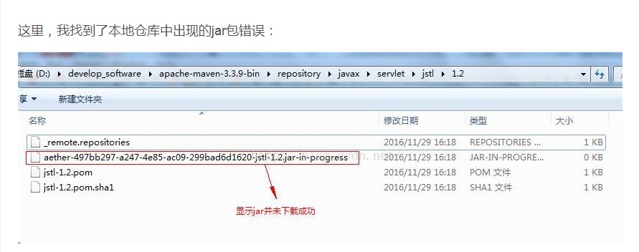

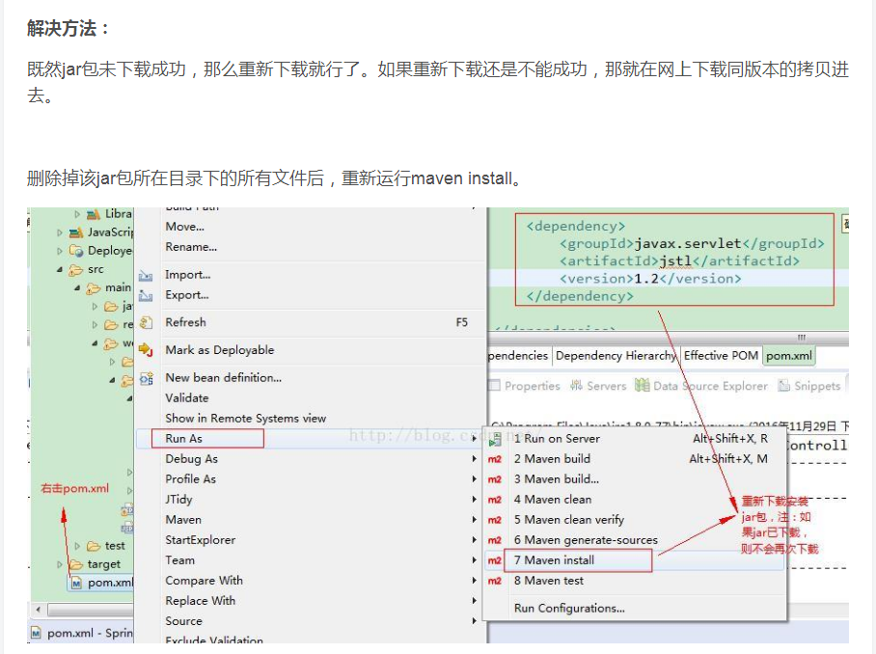

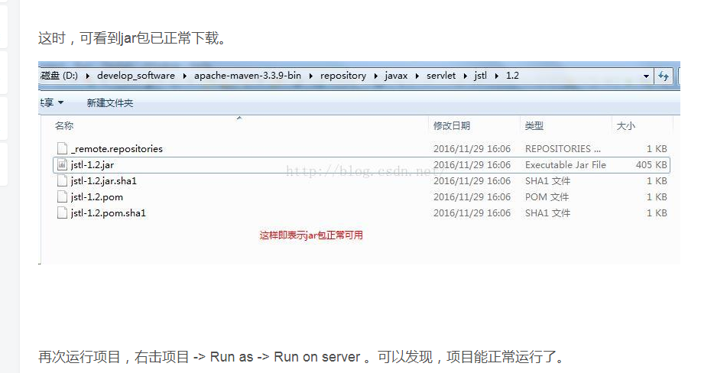

# 关于maven导入的包是存在的,tomcat启动的时候出现错误缺少jar包

右键项目--🡪Properties

