 | Progress and Gantt Chart  Presentation Slides  Project I  The first semester of academic year 2026 | 

Project Title : Development of a Web-Based Application for Partial Discharge Source
Classification and Severity Assessment in Cable Terminations
Authors : | Mr. Tanaphat Boonsong | Student ID 6401012622030
 | [ชื่อสมาชิกคนที่ 2] | Student ID [รหัสนักศึกษา]
Advisor : Assoc. Prof. Cattareeya Suwannasri
หมายเหตุ: กรุณากรอกชื่อ-รหัสนักศึกษาสมาชิกคนที่ 2 ให้ครบก่อนส่งเอกสารจริง
FACULTY OF ENGINEERING KMUTNB

Main Topic
- Abstract / Introduction
- Principles / Theory / Related Work
- Project Plan (Gantt Chart)
- Technologies Used
- Results of Operations
- Problems / Obstacles Encountered
- Plans for Next Steps

Abstract / Introduction
Partial Discharge (PD) is a localized electrical discharge that only partially bridges the insulation between conductors. It commonly occurs in cable terminations, joints, and gas-insulated equipment, and if left undetected, it gradually degrades the insulation and can eventually lead to catastrophic failure of the power system.
Diagnosing PD currently relies on experts manually reading Phase-Resolved Partial Discharge (PRPD) patterns and cross-referencing gap-time measurements. This process is time-consuming, depends heavily on the reviewer's experience, and is difficult to scale across large volumes of measurement data.
This project proposes PD Insight, a web-based diagnostic application that assists engineers in classifying the PD source (Corona, Surface, or Internal discharge) from PRPD images and assessing defect severity, combining deep learning-based image classification with rule-based gap-time analysis to support faster and more consistent diagnostic decisions.

Principles / Theory / Related Work (1)
Partial Discharge (PD)
A localized dielectric breakdown that does not completely bridge the insulation between two conductors. Repeated PD activity progressively erodes insulating material.
Phase-Resolved Partial Discharge (PRPD) Pattern
A PRPD pattern plots discharge magnitude against the AC voltage phase angle over many cycles. Different PD sources produce visually distinct clustering patterns on this plot, which is the basis for source classification.
PD Source Categories Studied
- Corona - discharge in air around a sharp conductor edge
- Surface - discharge tracking along an insulation surface
- Internal - discharge inside a void or cavity within the insulation
Gap-Time Analysis
The time interval between the positive-half and negative-half discharge clusters on the PRPD pattern, converted from electrical phase angle to milliseconds. Combined with the PD source category, the gap-time value is used to assess the severity of the defect (Initial / Moderate / High).

Principles / Theory / Related Work (2)
Convolutional Neural Network (CNN) - Transfer Learning
MobileNetV2, pre-trained on ImageNet, is used as a frozen feature extractor for PRPD images. Its output is passed through Global Average Pooling, a Dense(256) + BatchNorm + Dropout(0.5) layer, then Dense(128) + Dropout(0.3), and finally a Dense(3) layer with independent sigmoid activations - one confidence score per PD source class (Corona / Surface / Internal) rather than a single softmax choice.
RESTful API Design
FastAPI together with SQLAlchemy ORM is used to structure the diagnosis workflow - image upload, inference, calibration, and case data - as versioned REST endpoints.
Relational Database Design
A PostgreSQL schema stores case records, calibration presets, and edit history, modeled to keep each account's data strictly isolated.

ขั้นตอนและวิธีดำเนินการทำปริญญานิพนธ์โดยสังเขป
ขั้นตอน  ที่ | รายละเอียดขั้นตอนการดำเนินงาน  เริ่มทำปริญญานิพนธ์เมื่อ 9 เดือน มิถุนายน พ.ศ. 2569 | เดือนที่
ขั้นตอน  ที่ |  | 1 | 2 | 3 | 4 | 5 | 6 | 7 | 8 | 9 | 10 | 11 | 12
1 | รวบรวม System Requirements ออกแบบ User Workflow และ Wireframe บน Figma | ✓ | ✓ | ✓
2 | พัฒนาสถาปัตยกรรมโมเดล AI (CNN Engine) ด้วย Python สำหรับประมวลผลรูปภาพ PRPD |  |  |  | ✓ | ✓ | ✓
3 | พัฒนาระบบหลังบ้านด้วย FastAPI ร่วมกับ PostgreSQL เพื่อสร้าง RESTful API และระบบคำนวณ |  |  |  | ✓ | ✓ | ✓ | ✓ | ✓ | ✓
4 | พัฒนาระบบหน้าบ้านด้วย Next.js (TypeScript + Tailwind) สร้างระบบ Dashboard และเชื่อมต่อ API |  |  |  |  |  |  | ✓ | ✓ | ✓ | ✓ | ✓ | ✓
5 | ทดสอบระบบรวม (Integration Testing), ปรับแต่ง Web Performance และจัดทำเล่มรายงาน |  |  |  |  |  |  |  |  |  | ✓ | ✓ | ✓
6
7
8

Technologies Used
Design (Step 1 - completed)
- Figma - UI/UX wireframes and user workflow design
AI Engine (Step 2 - in progress)
- Python
- TensorFlow - MobileNetV2 transfer learning
- OpenCV - PRPD image preprocessing
Backend (Step 3 - in progress)
- FastAPI
- SQLAlchemy ORM
- PostgreSQL
Planned for later phases (per Gantt Chart, not yet started)
- Next.js / TypeScript / Tailwind CSS - frontend dashboard
- Docker - deployment

Results of Operations - UI/UX Design
Step 1 (System Requirements, User Workflow, and Wireframe on Figma) is complete.
- Collected system requirements for the PD diagnostic workflow
- Designed the user workflow covering sign-in / sign-up, the dashboard overview, and the case review process
- Produced high-fidelity wireframes in Figma for the main screens
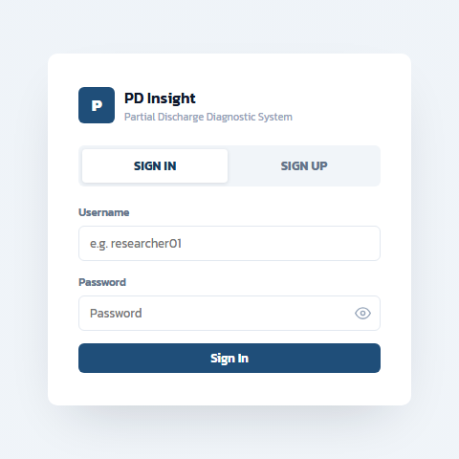
Figure 1: Sign-in screen wireframe
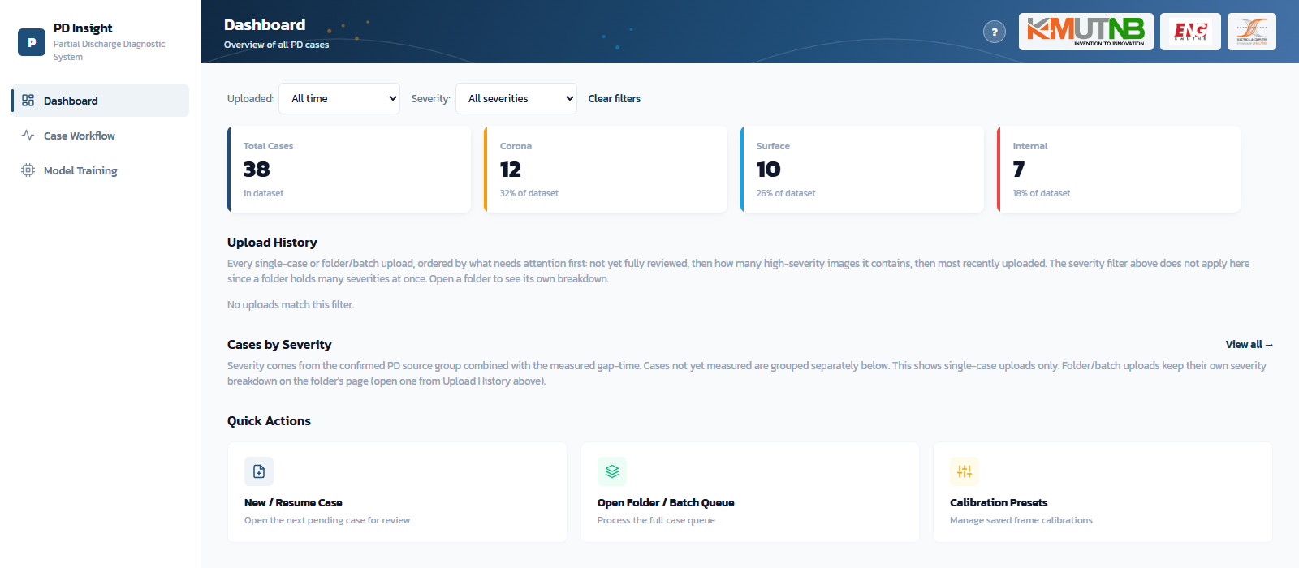
Figure 2: Dashboard overview wireframe (mock data)
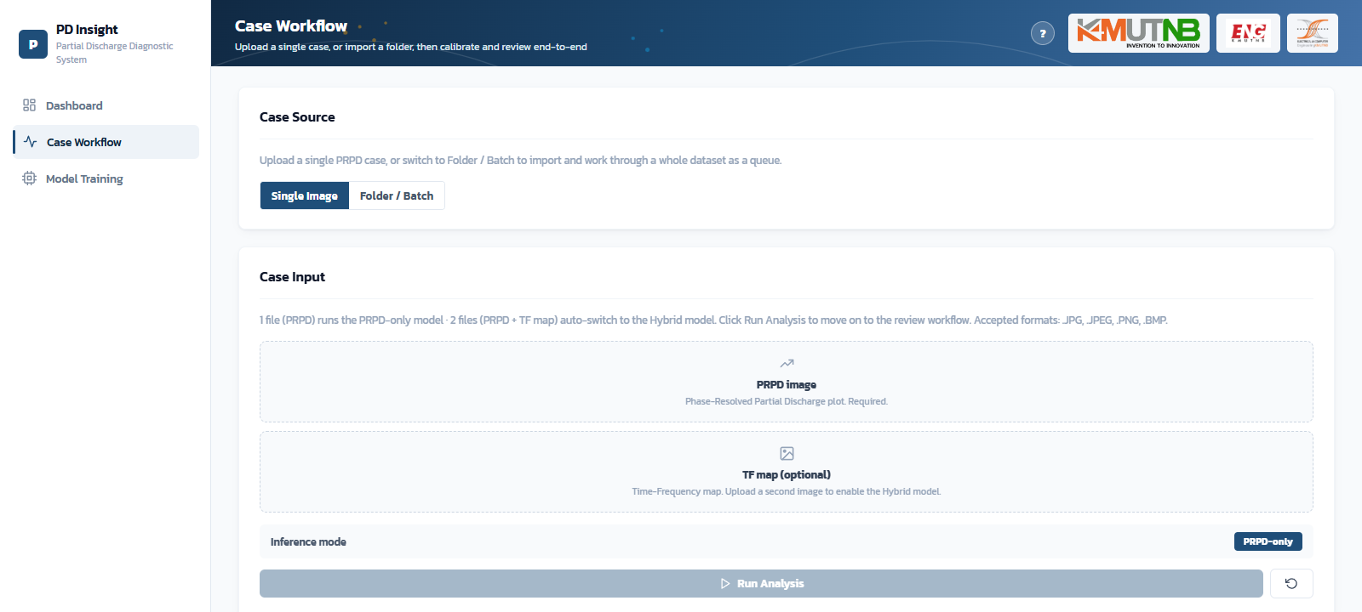
Figure 3: Case Workflow (upload) screen wireframe

Results of Operations - AI Model & Backend
Steps 2 and 3 are in progress, building on the Step 1 design.
AI Model (CNN Engine) - in progress
- Selected a MobileNetV2 transfer-learning architecture for 3-class PD source classification (Corona / Surface / Internal)
- Preparing and cleaning the PRPD image dataset for training
- Implementing the model pipeline in Python
Backend (FastAPI + PostgreSQL) - in progress
- Scaffolded the initial FastAPI project structure
- Designing the PostgreSQL schema for case records and diagnostic results
- Drafting the first REST endpoints for image upload and case retrieval

Problems / Obstacles Encountered
- PRPD images from different users can vary in resolution and format, requiring extra preprocessing before they can be used
- Distinguishing "Internal" PD from visually similar patterns needs careful threshold tuning to avoid misclassification
- Keeping the data schema consistent between the AI engine and the backend API while both are still under active development
- Limited team experience with deploying a combined deep-learning and web-service pipeline

Plans for Next Steps
- Complete training and validation of the AI PD-source classification model
- Finish the backend RESTful API and PostgreSQL integration
- Begin frontend development (Next.js dashboard) per the project Gantt chart
- Proceed to Integration Testing and report preparation in the final phase

