Case geotechnical cross sections

Introduction
The Geotechnics division and DOV are interested in the development of a tool to create geotechnical cross sections and layer descriptions. One of the possibilities is to develop this using pydov.
We would like to know how other parties create their geotechnical cross sections and layer descriptions by means of pydov. Therefore we would like to launch a case ‘Geotechnical cross section - Royer lock’. For this case a lot of geotechnical input data is available which can be used to create a geotechnical cross section with layer description. We are looking forward not only to your cross sections and layer descriptions, but we are also interested in the way this result was obtained, which steps were automated in scripts, and where engineering judgement came in.
The case is split up in a low level case on the one hand -which requires relatively little work- and a more extended, high level case on the other hand.

The low level case

Input

Location
The location chosen is the area between the river Scheldt and The Royer lock in Antwerp, as indicated on the map in Figure 1. The data can be found directly in DOV, using this link:
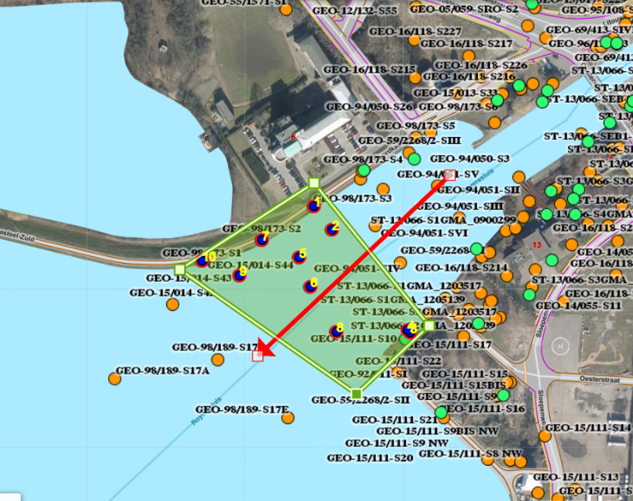
Figure 1: Area between river Scheldt and Royer lock with available CPT and borehole data. The red arrow is a suggestion of the projection line for the geotechnical cross section.
The area can be chosen a little wider, in order to obtain more borehole data and additional CPT data, in case you would like to.

CPT and boreholes in dov:

Table 1: Overview of CPT’s and boreholes in the area of interest. A slightly more extended area has been considered for the boreholes compared to the CPT’s (to get more borehole data).
CPT’s | Boreholes
GEO-15/014-S43  GEO-15/014-S44  GEO-15/014-S45  GEO-59/2268/2-SII  GEO-92/011-SI  GEO-98/173-S1  GEO-98/173-S2  GEO-98/173-S3  GEO-98/189-S17C  GEO-98/189-S17F | GEO-59/2268/1-A  GEO-59/2268/1-B  GEO-59/2268/2-C  GEO-98/180-B1  GEO-98/180-B4  GEO-15/013-B32  GEO-15/013-B33  GEO-17/047-B211

What would we like to obtain as output?

Graphical soil layer cross section

We would like to get a graphical cross section where several soil layers are indicated as well as the geotechnical characteristics of the soil layers.
Interpolating lines between CPT’s and borehole locations can be used, as shown in Figure 2a. However, horizontal lines on CPT diagrams are OK as well, see Figure 2b.

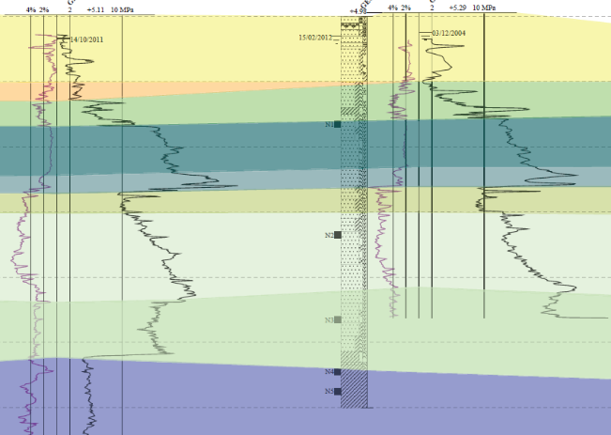 | 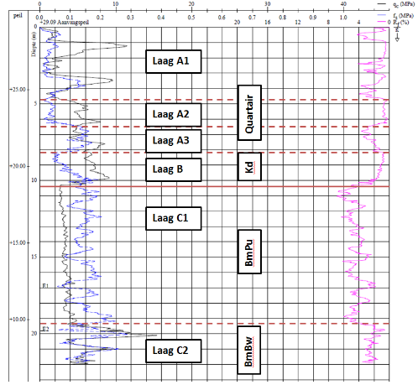
Figure 2a: example of a soil layer cross section with interpolation between CPT’s / borehole locations. | Figure 2b: example of a soil layer section with horizontal indication of layers on a CPT- diagram.

Table with geotechnical characteristics

Table 2 is an example of a table where the geotechnical characteristics can be listed in, see also excel file. We would like to receive your estimation of these geotechnical characteristics, where possible.

Table 2: Geotechnical characteristics low level case
 |  |  |  |  |  | Modulus of subgrade reaction
Description | γ_{d} | γ_{n} | c' | ϕ' | Quarternary/  Tertiary (Paleogene/  Neogene) | k₁ | k₂ | k₃
[-] | [kN/m³] | [kN/m³] | [kN/m²] | [°] |  | [kN/m³] | [kN/m³] | [kN/m³]
eg. clay, moderately stiff
eg. Medium dense clayey sand
eg. peat

The high level case

Input

Location
The location is the same as for the low level case.

CPT’s and borehole locations
See low level case.

Lab tests
In DOV 2 map layers are available with laboratory test results performed on soil samples in the previously indicated area.
- The results of the soil classification tests and the determination of the volume mass and water content are stored in publicly available map layers. They can be found using the following tabs (in Dutch): ‘Grondonderzoek’ → ‘Grondmonsters’.
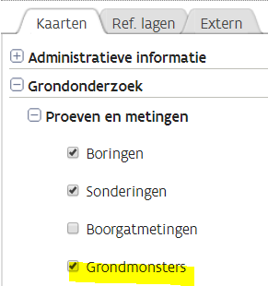

- In a separate map layer, specific for the region of this case, the following additional lab data can be found:
- Oedometer tests
- Triaxial tests
- Hydraulic conductivity tests

This map layer can be found through the following link: https://www.dov.vlaanderen.be/geoserver/gmk/wms?
When this wms link is added in DOV explorer (‘DOV verkenner’) -through tab ‘extern’, see screenshot- or in your own GIS application, you can click on the map layer ‘Monsters perceel3a’ at the bottom of the drop down list and add it to your map view.
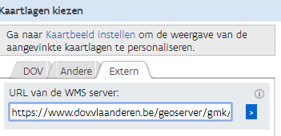 → 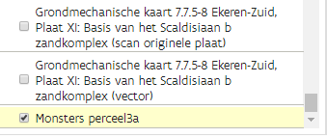
For oedometer tests, results are reported from 1998 onwards (files GEO-98/180 and more recent). For triaxial tests and hydraulic conductivity tests, results are reported from 2004 onwards (files GEO-04/169 and more recent).
It needs to be mentioned that all data in this map layer has been made available in a purely informative way. Only the geotechnical test reports (GEO reports) have gone through a complete quality control and contain all correct data.
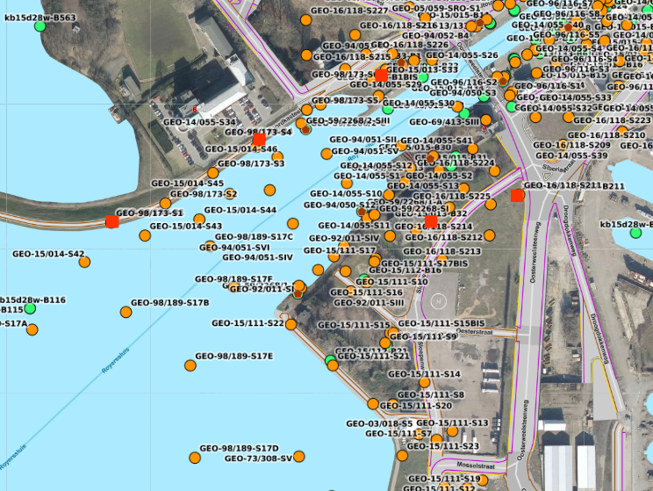
Figure 3: Area between river Scheldt and Royer lock with indication of lab data.
The small, brown hexagons contain information of boreholes with soil classification tests from the map layer: ‘grondmonsters’ (soil samples). The red squares contain the extended laboratory information from the external wms link to be added to the viewer or directly obtained in DOV with this link:
For boreholes of which the data of mechanical tests are not available within this map layer, the info can be delivered in pdf, with an exception of the older boreholes from file GEO-59/2268.

What would we like to get as output?

Graphical soil layer cross section
See low level case

Table with geotechnical characteristics

Table 3 is an example of an extended table with geotechnical characteristics, see also excel file.
If possibly, we would like to obtain your estimation for these geotechnical characteristics based on the available data. Of course, one can choose how far one wants to go in depth in the data analysis. It would be extra useful for us if you could mention which lab data have been used and how the parameters were determined. A distinction can be made between the parameters derived from the test results and the parameters which you suggest to be used for calculation purposes.
The additional parameters in this table are the angle of dilatancy ψ, the wall friction angle δ and the stiffness parameters (Young’s modulus of elasticity (E₅₀), the oedometermodulus (E_{oed}), the modulus of elasticity at unloading-reloading, E_{ur}, and power m, defined by the relationship:
$$E_{50}=E_{50,ref}∙{\left(\frac{a+{σ'}_{3}}{a+p_{ref}}\right)}^{m}$$
A reference pressure p_{ref} = 100 kPa can be considered to determine these values.
Table 3: Geotechnical characteristics high level case
 |  |  |  |  | Quarter-nary/ |  | Modulus of subgrade reaction
Description | γ_{d} | γ_{n} | c' | ϕ' | Tertiary (Paleo-gene/  Neogene) | δ'_{curved} | k₁ | k₂ | k₃ | ψ | E₅₀ | E_{oed} | E_{ur} | m
[-] | [kN/m³] | [kN/m³] | [kN/m²] | [°] |  | [°] | [kN/m³] | [kN/m³] | [kN/m³] | [°] | [kN/m²] | [kN/m²] | [kN/m²] | [-]
eg. clay, stiff
eg. Medium dense silty sand
eg. peat

