Hangar Complex Electrical Distribution Upgrade
5-Point Justification | Quality tier: Exemplary
Field | Value
Business group | Facilities / Corporate Real Estate
Location | Hub Station 1 - Maintenance Hangar Complex
Request | Capital - Phase II construction
Total request | $31.0M (Phase I & II)
Training label | Gold standard: quantified, illustrated, fully appendixed

1. Current Situation
The hangar complex electrical distribution infrastructure must be updated to reliably support current and future power demand. The upgrade protects aircraft maintenance operations, building infrastructure and, most importantly, the safety of team members. The age of each building’s main switchgear and distribution panels is shown below.
Building | Year built | Age of main switchgear / panels
Hangar 1 | 1973 | 53 years
Hangar 1 Central Utility Plant* | 1973 / 2018 | 53 years / 5 years
Old Stores | 1973 | 53 years
New Stores | 1987 | 39 years
Hangar 2 | 1987 | 39 years
Hangar 3 | 1991 | 35 years
Hangar 4 | 1992 | 34 years
*Central Utility Plant distribution panels were replaced in 2018 due to repeated failures.
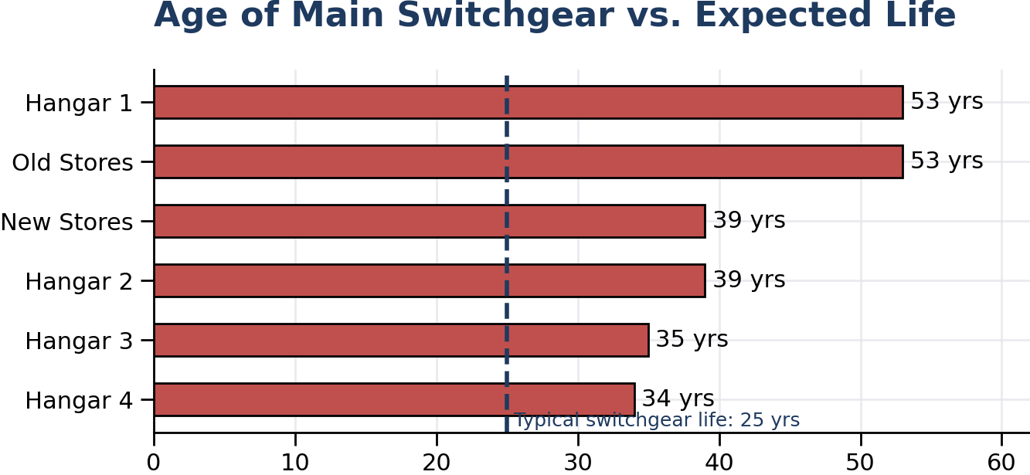
Every building exceeds the typical 25-year switchgear life | Chart recreated from anonymized data

Aging and obsolete equipment
- A well-maintained main switchgear lasts about 25 years and a motor control center about 20 years. Most of the complex is well past both, and replacement parts are increasingly obsolete and hard to source.
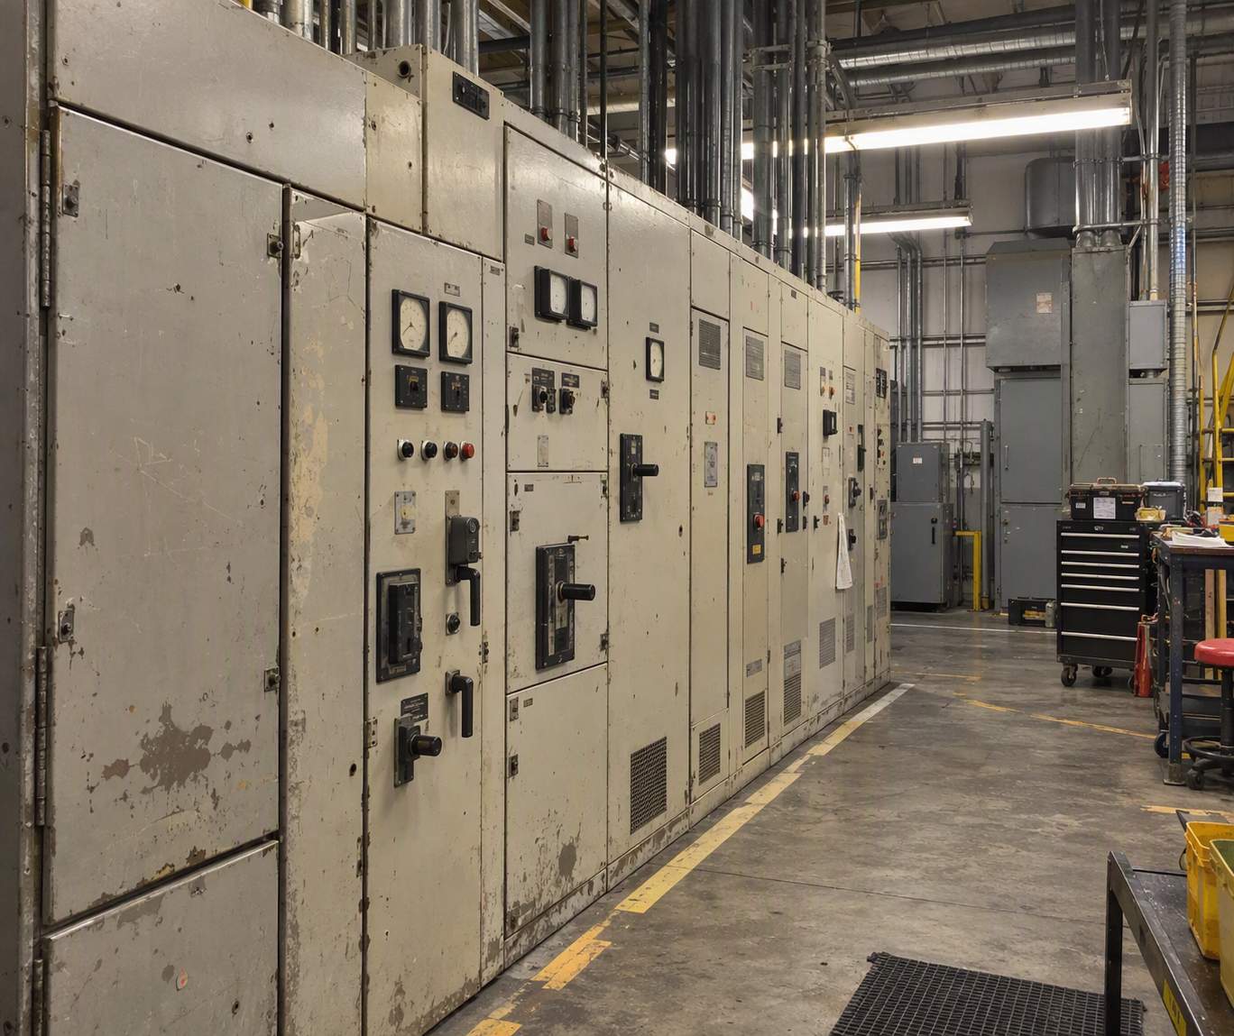
Representative aging main switchgear line-up | Synthetic photo - generated with Microsoft Copilot

Power reliability risk
- Three electrical shorts in the last five years. No injuries occurred, but each panel had to be replaced and repairs were delayed by parts availability. In the most recent event, replacement components took about four months to arrive and the damaged panel position was abandoned.
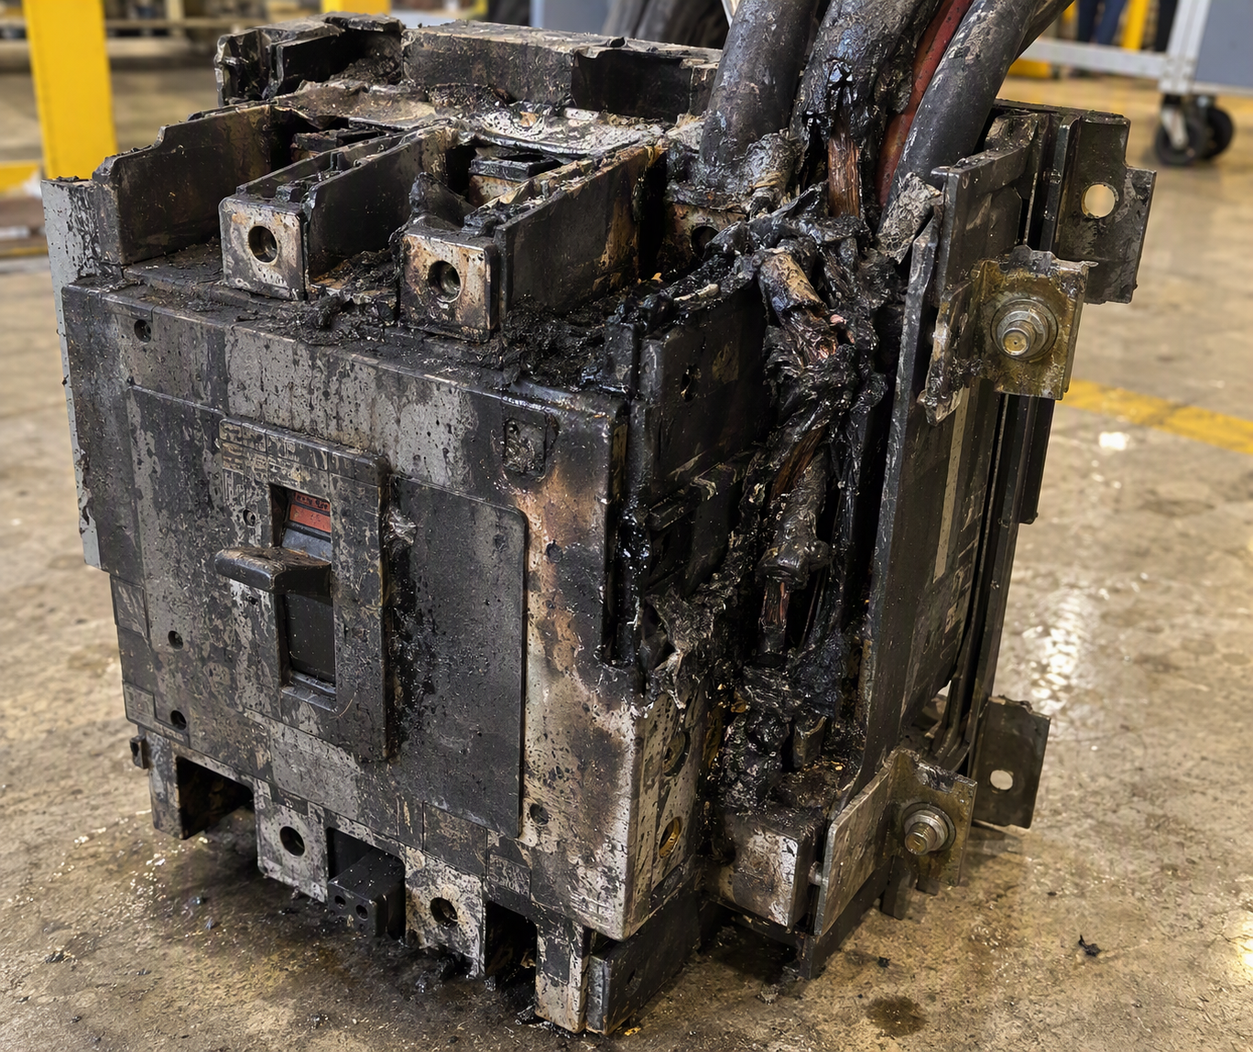
Breaker assembly damaged in an electrical short (representative) | Synthetic photo - generated with Microsoft Copilot
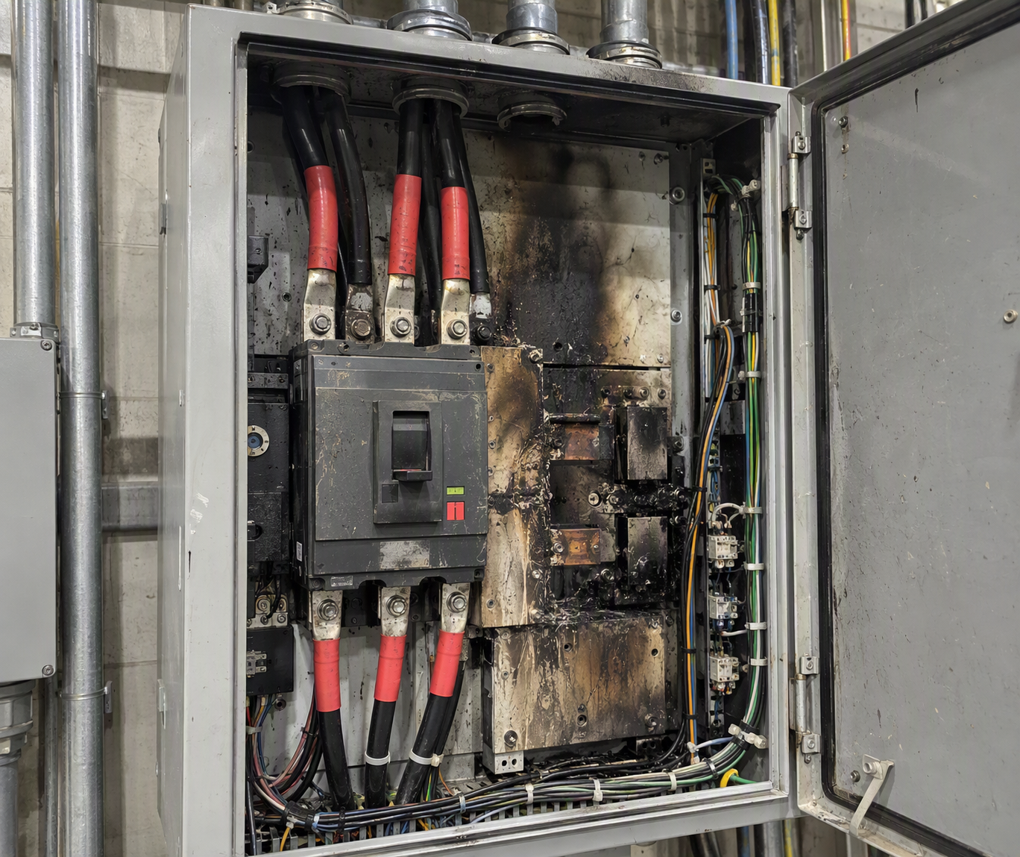
Distribution panel after a short - damaged section abandoned and re-fed | Synthetic photo - generated with Microsoft Copilot

Distribution does not match today’s fleet
- Six widebody bay positions across Hangars 2, 3 and 4 were designed for legacy widebody aircraft. The current next-generation widebody fleet requires three power connections; these bays provide two.
- Teams work around the gap with portable ground power units, which can only be positioned at four of the six affected bays.
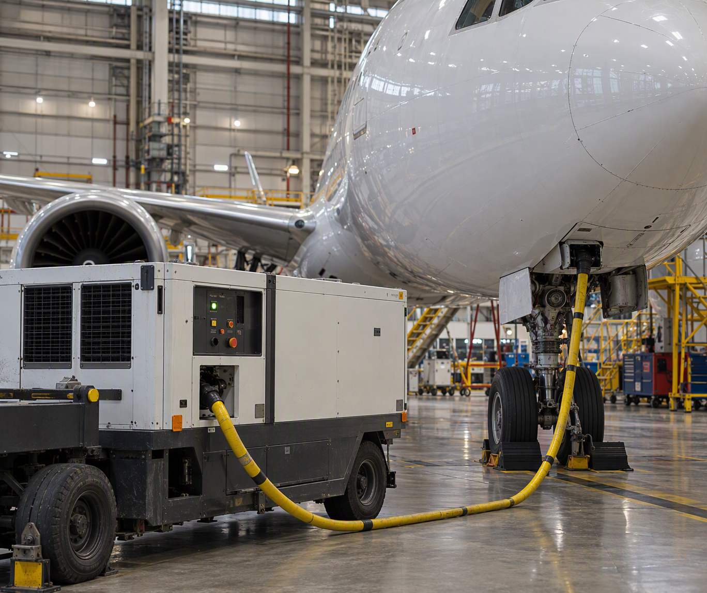
Portable GPU workaround supplying the third power source | Synthetic photo - generated with Microsoft Copilot

Single points of failure
- Manual transfer switches: Hangars 1 and 2 rely on manual transfer to backup power; Hangars 3 and 4 already use automatic transfer switches (ATS). The project standardizes ATS across the complex.
- Single utility feed: Hangars 2 and 4 rely on a single feed. The project adds dual-feed service so power transfers automatically if the primary feed is lost.

2. Proposal
Engage Contractor C to perform the work under the management of Engineering Firm R, which developed the equipment specification and scope of work and will provide design and construction-management services. The upgrade meets current power demand, secures all hangar electrical utilities, and establishes a single electrical standard across the complex.
Foundation for future projects: The new distribution backbone is a prerequisite for planned pre-conditioned air, ground power and air-start upgrades. Upgrading it first avoids temporary solutions and costly redesign later.

3. Cost
Description | Cost ($) | Comment
Demolition | 840,294
Asbestos allowance | 600,000 | Possible asbestos in walls, equipment, conduit insulation
Tax @ 8.25% + 5% contingency | 144,805
Subtotal OpEx (Phase II) | 1,585,099
Electrical replacement - Hangars 1-4 | 24,817,511 | Labor $5.1M (~72,300 hrs); materials $19.7M
Soft cost | 1,119,492 | Insurance, bond, permits
Additional A&E (arc flash study) | 576,600 | Safety certification / fault analysis
Tax @ 8.25% + 5% contingency | 2,421,227
Subtotal CapEx (Phase II) | 28,934,830
Previously approved A&E (Phase I) | 483,000 | Approved as CapEx in prior year
Grand total (Phase I & II) | 31,002,929
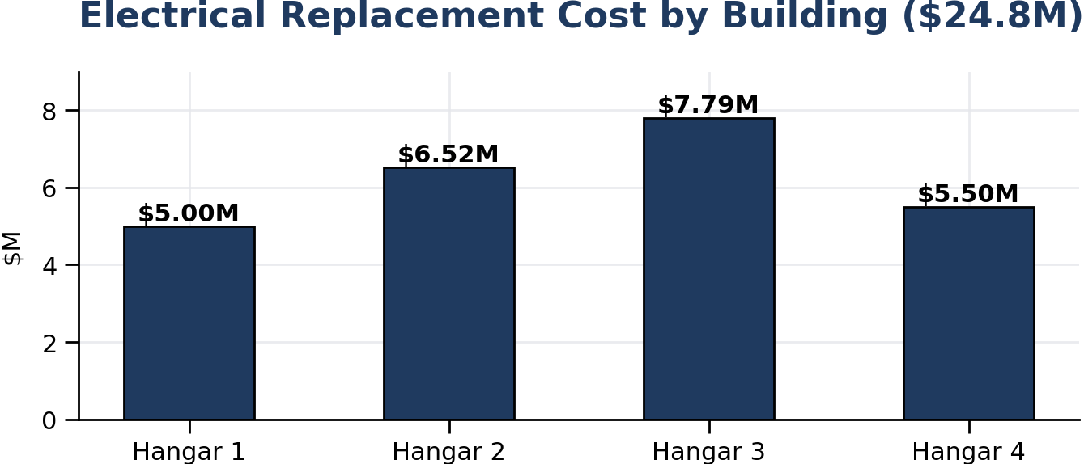
Electrical replacement cost by building | Chart recreated from anonymized data
Why the estimate grew from $10.5M to $30.5M: (1) Electrical equipment prices rose sharply on data-center construction demand, and (2) design found upstream transformers and switchgear were also deteriorating, so they were added to scope.

4. Justification
The upgrade maximizes the safety of anyone operating the electrical system and provides the infrastructure every building system depends on. The goal is to minimize the cost of operational interruption and the risk of injury caused by system age. Weather and ground conditions around the 50-year-old structures have accelerated decay - visible where conduit is pulling away from panels as the floor slab settles.
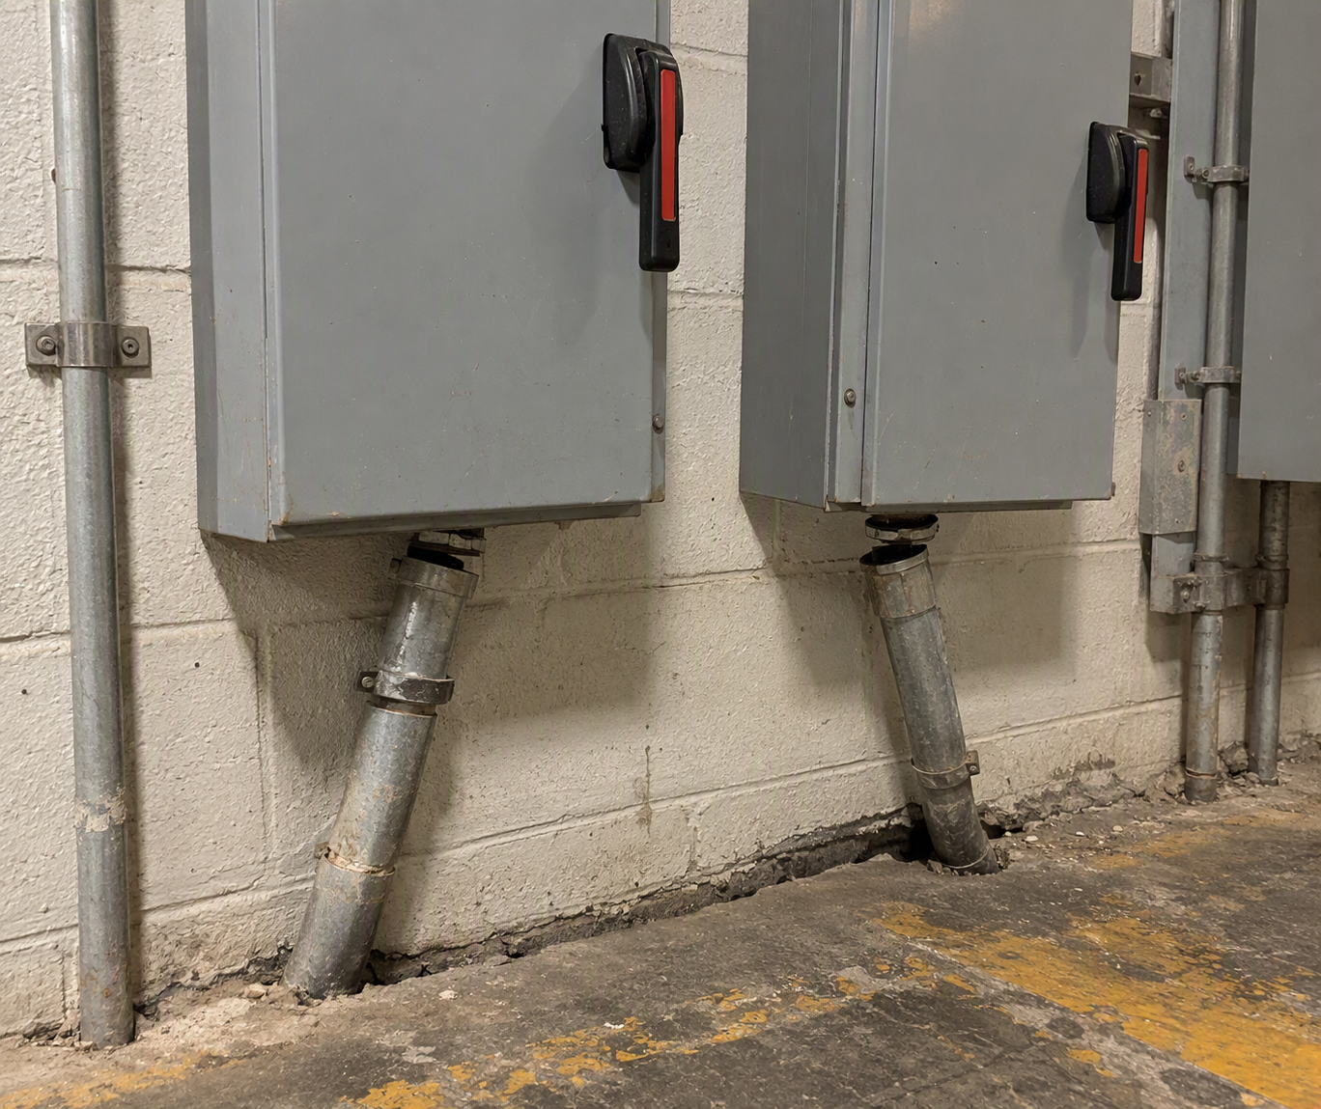
Slab settlement pulling conduit away from wall-mounted disconnects | Synthetic photo - generated with Microsoft Copilot

5. Alternatives
- Run to failure: replace panels as issues arise. If a panel failed tomorrow, parts would come from the secondary market, full replacement, or custom fabrication - each causing significant downtime.
- Phased delivery: each phase takes 12-18 months, and deferred work is expected to escalate at least 8% per year.

Appendix A - Hangar Bay Context
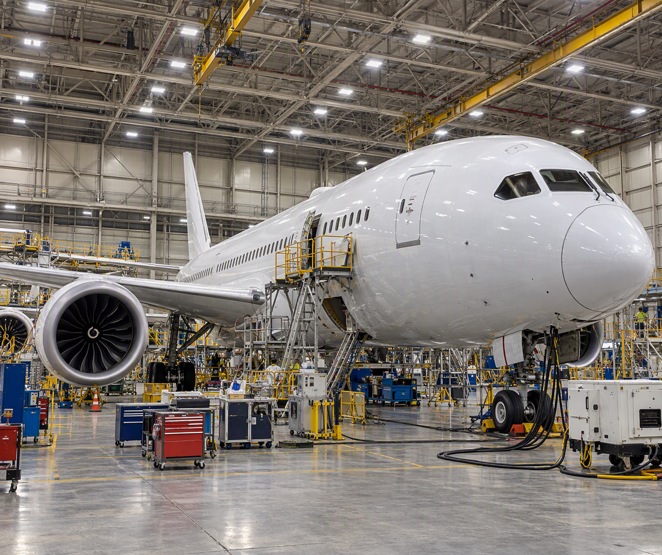
Widebody aircraft in a maintenance bay that relies on supplemental ground power | Synthetic photo - generated with Microsoft Copilot

Appendix B - Project Timeline
Date | Milestone
Year 1 Q4 | A&E approval
Year 2 Q3 | A&E completion
Year 2 Q4 | Initial construction estimate ($23.2M)
Year 3 Q2 | Updated construction bid ($25.5M)
Year 4 Q2 | Pricing elements found incomplete; re-quote required
Year 4 Q3 | Updated bid ($29.3M); 5-point complete; finance approval begins

Appendix C - Bid Summary
Contractor | Base + alternates | 5% contingency | Total
Contractor A* | $14.72M | $0.74M | $15.46M
Contractor B | $30.83M | $1.54M | $32.37M
Contractor C (selected) | $27.89M | $1.39M | $29.28M
*Rejected - did not bid the full scope. Totals exclude arc-flash study ($0.58M) and asbestos allowance ($0.6M).

