Widebody Engine Transport Stands
5-Point Justification | Quality tier: Refined (minor edits needed)
Field | Value
Business group | Technical Operations - Powerplant
Locations | Line Maintenance Base (Site A) and Overhaul Base (Site B)
Request | Purchase two engine transport stands
Total request | $800,536.80 (offset with OEM service credits)
Training label | Strong structure and NPV; a few gaps to tighten

Background / Current Situation
- There are 18 transport stands for Engine Type X across Sites A and B: 7 hold spare engines, 8 are at the OEM supporting overhaul, and 3 are empty to support removals and production. Stand availability tightens whenever engines are in transit or awaiting production.
- Engines are removed mainly at Site A, shipped to Site B for disassembly, then sent to the OEM for overhaul. Every shipment consumes a stand, so once an engine leaves Site A no stand remains for the next removal.
- When an overhauled engine returns to Site B for assembly, limited stand availability delays production (Appendix B).
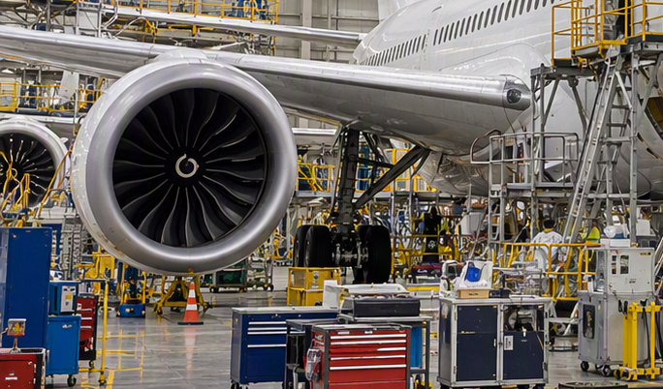
Widebody turbofan of the type supported by these stands | Synthetic photo - generated with Microsoft Copilot

Proposal
- Purchase two engine stands, one for Site A and one for Site B, offset with OEM service credits. Credits are contractually limited to LRU and overhaul expenses, but the OEM has agreed to a one-time exception for select items including stands, inspection tools and a fuel-nozzle repair reconciliation (Appendix A).

Costs
Description | Qty | Cost ($)
Pneumatic power-option engine transport stand | 2 | 762,416.00
5% contingency |  | 38,120.80
Total |  | 800,536.80
Because the purchase is funded from OEM service credits, stands must be procured from the OEM’s approved stand supplier.

Alternatives
- Option 1: Lease two stands at $1,250/day until 2028 | NPV @ 6.1%: $2.88M
- Option 2: Purchase with service credits | NPV @ 6.1%: $2.59M (recommended)
- Option 3: Purchase with cash, preserving credits | NPV @ 6.1%: $2.93M
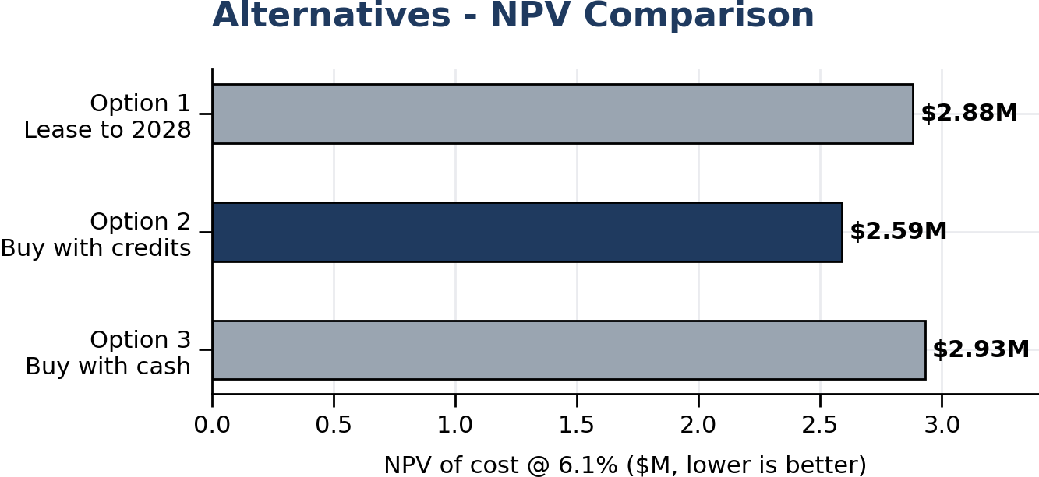
Option 2 has the lowest cost on an NPV basis | Chart recreated from anonymized data
Reviewer note (training): A Justification section summarizing delay cost avoided and risk reduction would make this approval-ready.

Appendix A - OEM Side Letter (summary)
Item approved for service-credit use | Amount ($)
Two pneumatic power-option engine stands | 762,416.00
Fuel-nozzle repair reconciliation invoice | 849,361.08
Seven rigidizable borescope guide-tube tools | 70,000.00
OEM overseas repair invoices aged > 90 days | 62,406.00

Appendix B - Production Delays
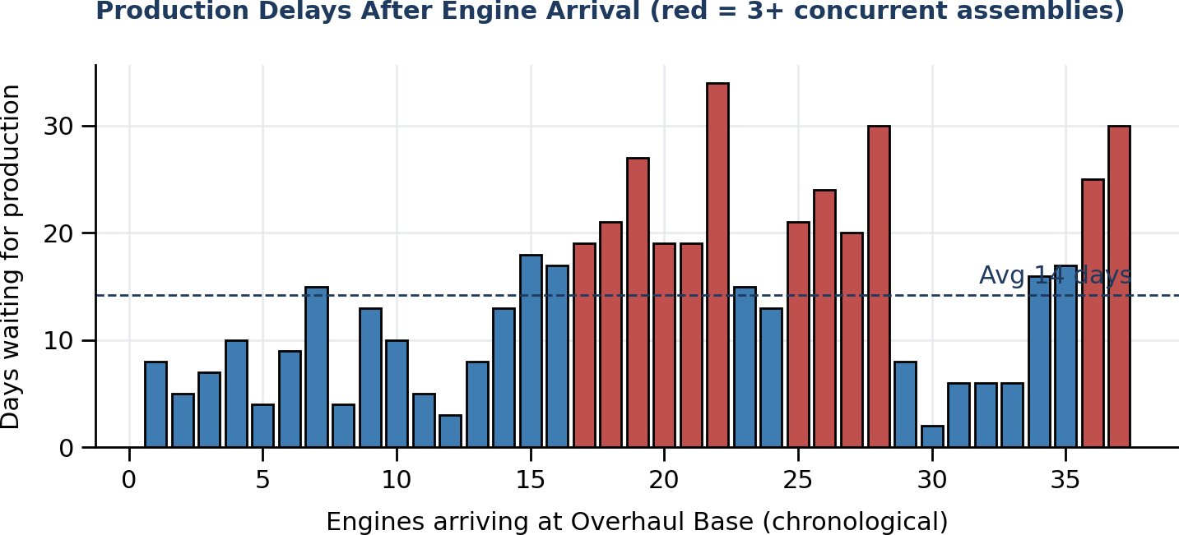
Delays spike when three or more engines compete for assembly | Chart recreated from anonymized data

Appendix C - Overhaul Volume
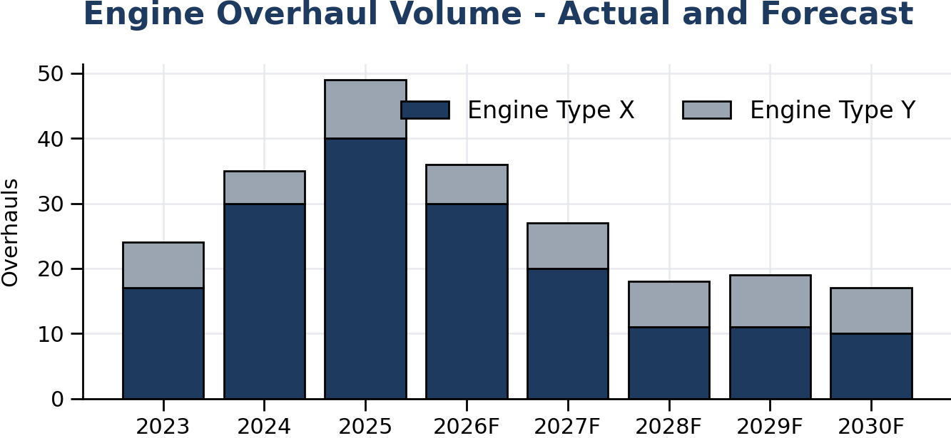
Overhaul demand stays elevated through 2027 | Chart recreated from anonymized data

Appendix D - Stand Inventory and Workflow
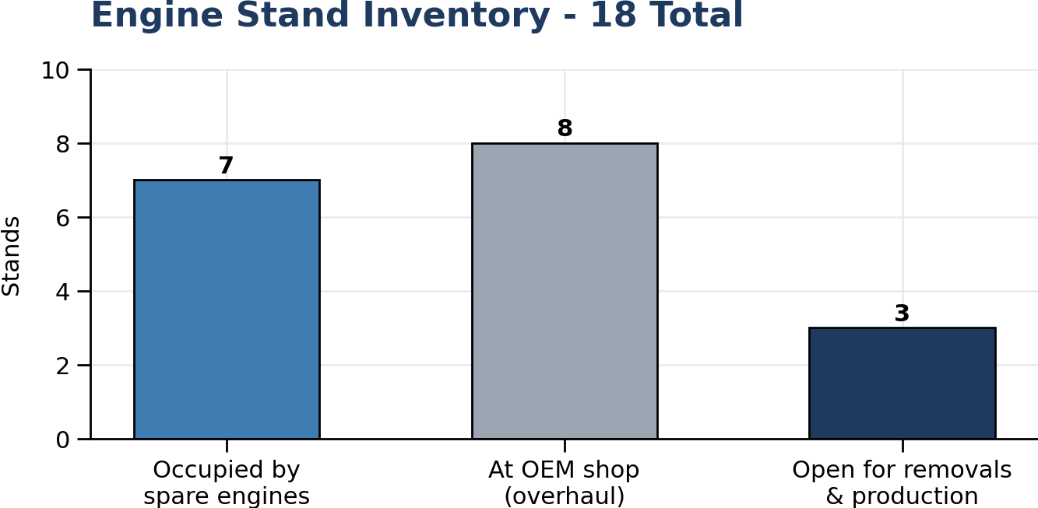
Only 3 of 18 stands are free for removals and production | Chart recreated from anonymized data
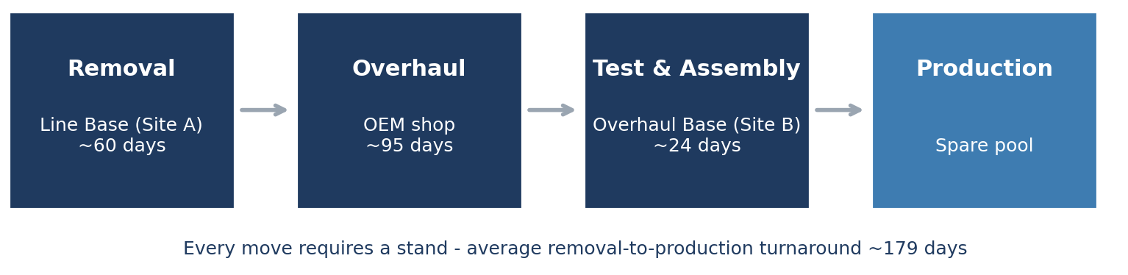
Engine transportation workflow | Chart recreated from anonymized data

