Needs analysis

Bureau of Standards of Jamaica

Carmen Gagnon

January 2020

Content

Client Servicing WBS (Work Breakdown Structure) 2

Client 3

BSJ staff 4

Phase 5

Phase 1 5

Client 5

Coordinator and Consultant 5

Information required 5

Phase 2 7

Phase 3 7

Phase 4 7

Status 8

Security level 8

Consultant 8

Coordinator 8

Client 8

Database 9

Work to do 10

# Client Servicing WBS (Work Breakdown Structure)

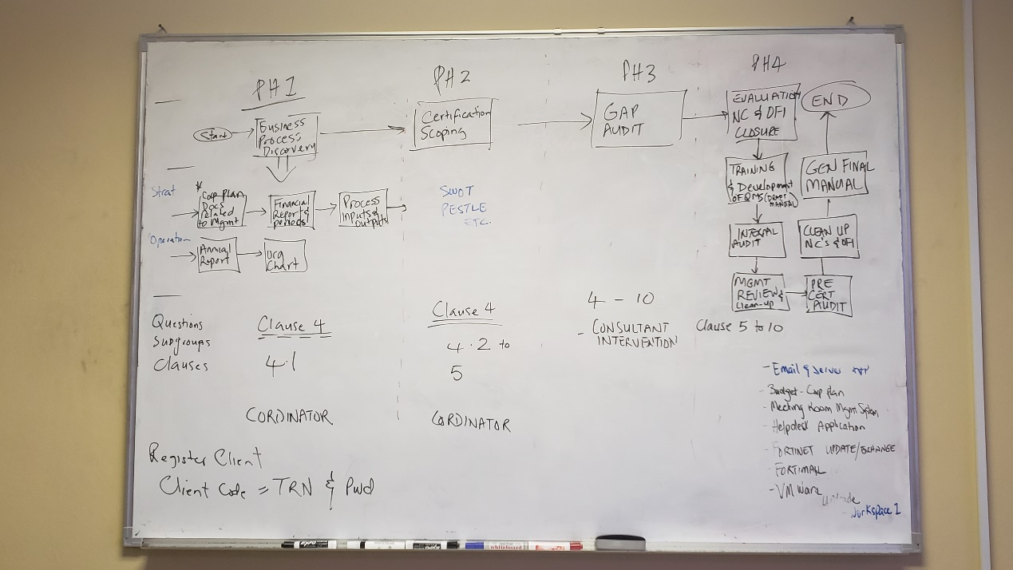

* Consultant will be introduced in phase 3. Only the coordinator can change the phase.
* It’s not all the clients that can go to Phase 2
* Client will update the questions in Phase 1, Phase 2 and 4, after the coordinator will give access to each phase.
* The coordinator can check the client to update or not the question. A limit of date will make it possible to extend the limits.
* First the client enter in BSJ website to ask for registration. It will be short answer question and will be sent to the coordinator. The coordinator will decide if the client will be answered and he will send him the code (TRN of the client) and the password. The password will have to be modify on the first entry in the system. This is partially done. The coordinator can create the user directly in the consultation page. We need to develop the mail to be sent to the user…
* Do we need to keep a trace of clients before the Selection? I need the part of Nicholas to be completed first.
* All the information filled by the client should be protected. Only the client can modify the information and the questions answered in Phase 1-2 and 4.
* Nothing happens in the system in Phase 3.
* Any communication with the clients (email and phone) should be listed in the intervention… I began to work on the email facilities of CodeIgniter to create and send email directly in the system. Not working right now but it will come…

# Client

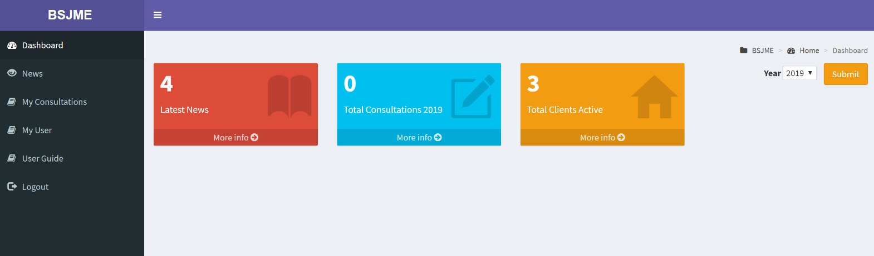

The client will see:

* Dashboard
* News that concern the clients in general
* My consultations: might be more than one for a client
* My User: to update their user information (password phone etc..)
* User guide: For the client interface

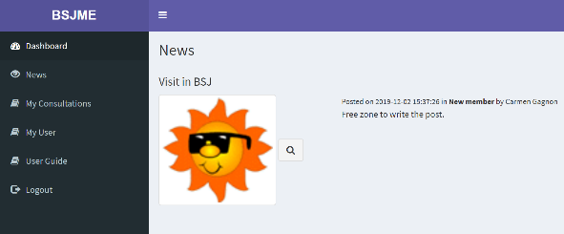 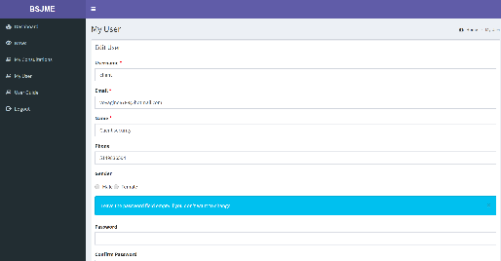

My consultation is to be developed…. But should include basic client information update, consultation update, questions (phase 1-2-4) and documents.

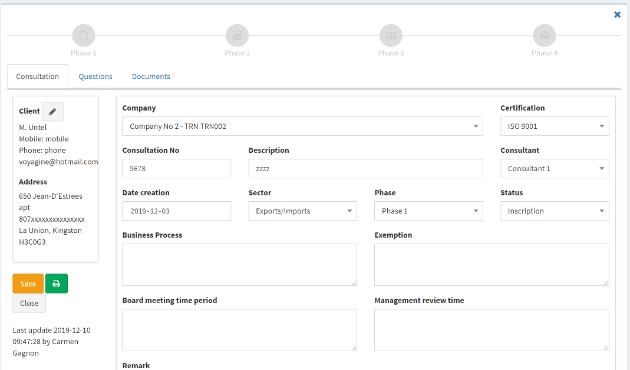

# BSJ staff

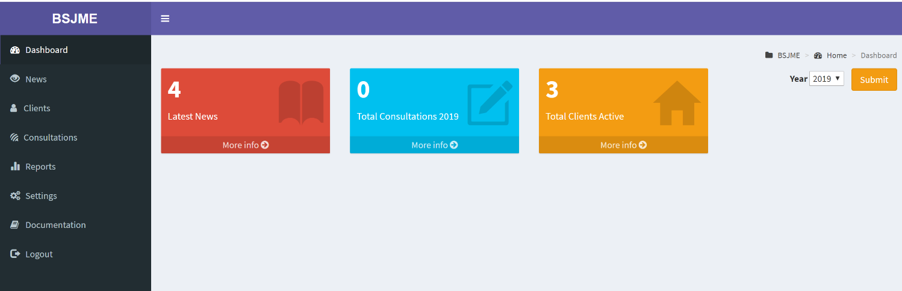

The coordinator will get the whole system, with all the clients and consultations. The consultant will have access only to the clients and consultations he has been assigned.

* Dashboard: to be developed
* News: All the news (news can be categorized depending on the needs)
* Clients: The clients (selected or not ?).
* Consultations: All the consultations
* Reports: Reports on clients and consultations
* Settings: Update of all the settings that compose the system
* User guide: Documentation of the system

Security is done for 4 different profiles protected in the system.

* Coordinator (profile.id = 2)
* Consultant (profile.id = 3)
* Client (profile.id = 4)
* Admin (profile.id = 5)

# Phase

## Phase 1

## 

### Client

The client has been pre-selected and has received their code and password. He now has access to the system to fill the information required for Phase 1. Some informations will be encoded, other will be documents uploaded or questions of clauses depending on the certification asked.

Some of the information that have been captured on the pre-selection will be already filled in the system.

### Coordinator and Consultant

There should be a period of time to answer Phase 1. If the client didn’t answer yet to the phase 1 questions, there should be a different color in the client list meaning that the coordinator need to get in touch with the client.

### Information required

General information of the client to be completed:

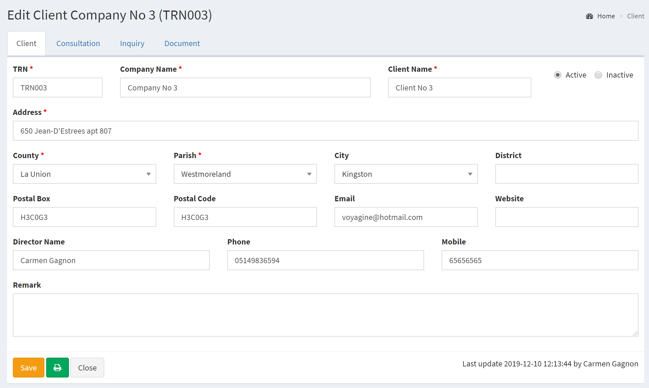

History tab will be added. I don’t know yet what will be included in the history but it will be around dates of the different changes of phase and status….

Consultation information (information related to the consultation) Clause is now available. The client can ask for a standard and a specific clause.

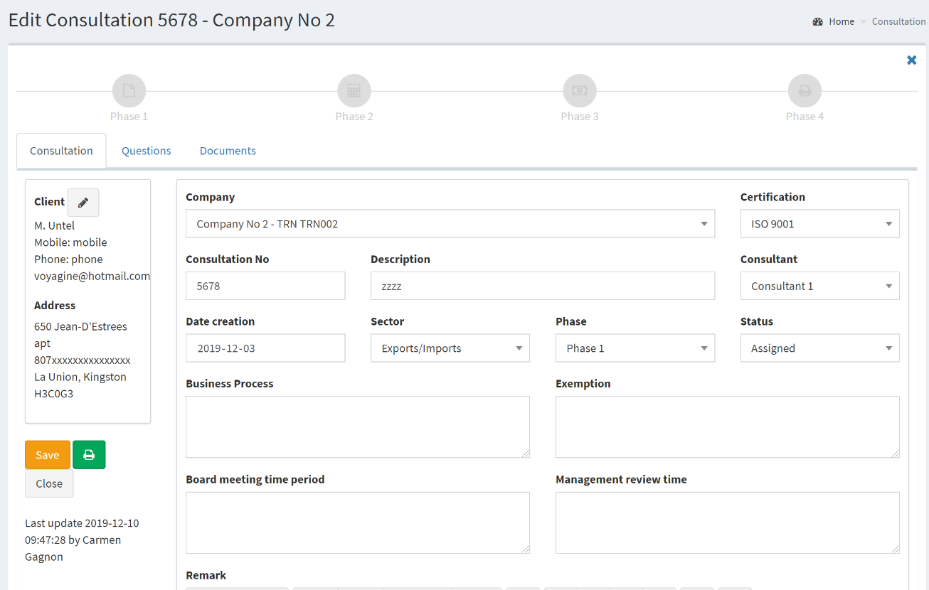

Questions to come, it will be in view mode ….

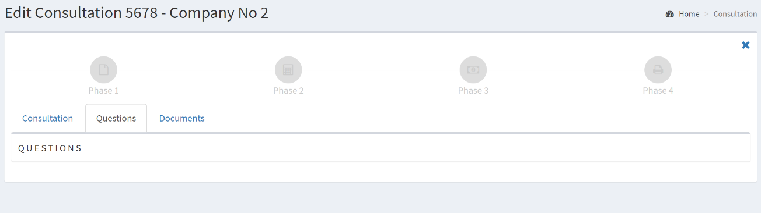

The phases are visible on the time line. More to be developed.

Documents

Can the document be deleted by the coordinator? Can the coordinator or the consultant can upload documents at any phase? The security have been developed to give the permission or not to a specific profile.

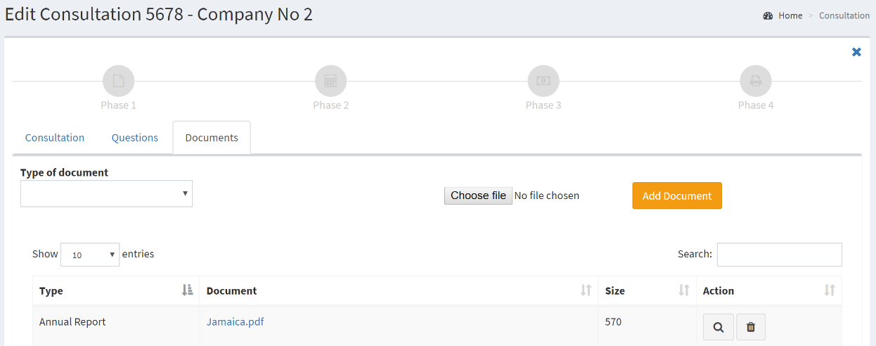

## Phase 2

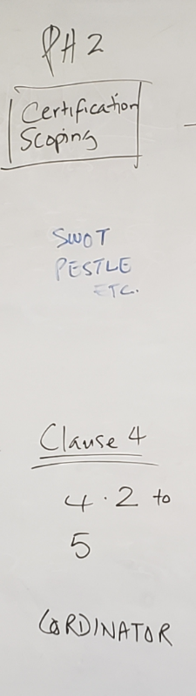The client answer the second part of clauses required. It will be questions and can also be documents uploaded.



At the end of this phase, the coordinator will assign a consultant and pass to Phase 3.

## Phase 3

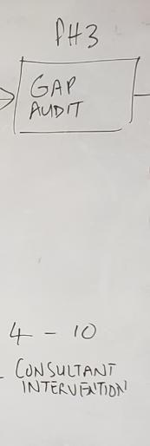Consultant have the control over the information submitted.

Should be identified what the consultant can modify in the system, when in phase 3?

What if the client must give more information?

Can the consultant check the UPDATE permission to client or pass by the coordinator?

## Phase 4

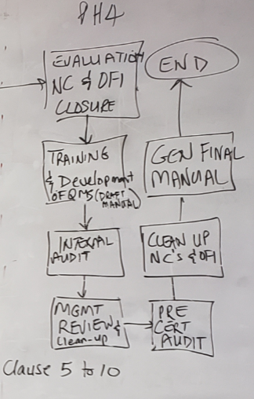After the assessment of the consultant what’s happening?

Who is in charge of Phase 4?

Who will generate the Final Manual?

Is there any more questions (clause 5 to 10) to answer from the client? If so, who will open the updating part of the client?

# Status

1. Assigned
2. Engaged
3. Update request for customer
4. Awaiting feedback from consultant
5. Feedback submitted
6. Changes implemented/Completed

Phase 1 to 3 get the same status.

Phase 4:

1. Evaluation
2. Training & Development
3. Internal Audit
4. Management review
5. Pre certification
6. Clean up NC
7. Generate Manual

# Security level

Security is ready for 4 different profiles.

## Consultant

* only interventions assigned are visible
* Can update only in Phase 3 and 4? What can he update?

## Coordinator

* Sees all the interventions
* Manages cost ???
* Set time for each phase?
* Change phase and status

## Client

* Ask for an entry in the system
* The ID will be the TRN (Taxpayer Registration Number) and a password will be given bsj+trn
* The user should change his password on the first entry
* The information required will be updated by the client until a certain phase (1 or 2?). The coordinator have the possibility to open the clauses for a range of time to continue the evaluation.

# Database

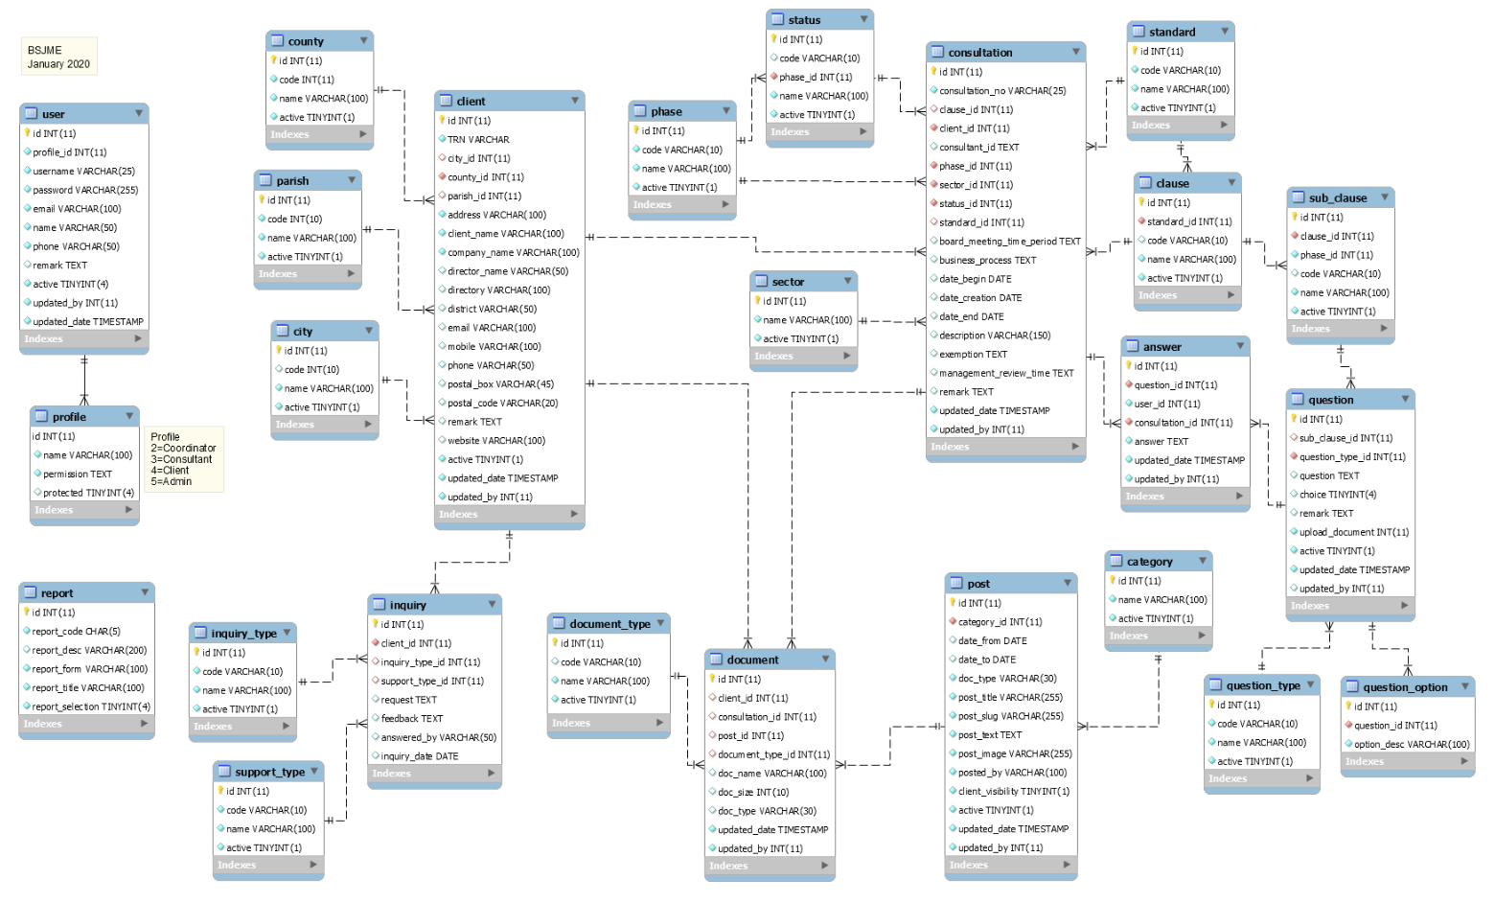

# Work to do

| Section | Work to do | Who | Estimate |
| --- | --- | --- | --- |
| **Client** |  |  |  |
| Registration | The client requests help from the website BSJ (BSJ360?). Interface to qualify the client to be developed | Nicholas | Weeks |
| BSJME for client  Questions and answers  (clauses update) | Interventions of the client and the information required are all to be developed. This is the question and answer (clauses) part. | Orville, Nicholas and Carmen | Month |
| Security | A client can see all the information about their consultation but only in Phase 1 and 2, info can be updated. After only view will be possible. What about clause 5 to 10 in Phase 4? | Orville, Nicholas and Carmen | Week |
| ~~Search by consultant~~ | ~~If the consultant table is removed, the search should be modified~~ | ~~Carmen~~ | ~~Hours~~ |
| List and Search | Should be optimized to give the coordinator and consultant to identify the work to do for each clients …  Should we include the pre-selection clients? | Orville, Nicholas and Carmen | Day |
| Communication with the client | Should it be by email directly? Or should we use the News (Posts) possibilities to communicate with the client? | Orville and Carmen | Hours or Days |
|  |  |  |  |
| TOTAL |  |  |  |
| **Consultation** |  |  |  |
| Clarify Phase  1 to 4 | I need to clarify the treatment of each phase. (see the section on phase in this document) | Orville and Carmen |  |
| ~~Consultant~~ | ~~More than one consultant is possible,~~ a lead consultant must be identified. Can a consultant be lead on one consultation but not lead on another one?  What are the privileges of being a lead consultant? | ~~Orville and Carmen~~ | ~~Hours~~ |
| History | History tab to be added. I don’t know yet what will be included in the history but it will be around dates of the different changes of phase and status…. | Nicholas and Carmen | Day |
| Questions and answers (view Clauses) | Should be visible in the question tab of the consultation. | Nicholas and Carmen | Days |
| Security | From Phase 1 to phase 4, what is available to client, consultant and coordinator? The security will depends on what is available or not to each profile …. | Orville | Week |
|  |  |  |  |
| TOTAL |  |  |  |
| **Settings** |  |  |  |
| ~~Status~~ | ~~Status are different depending on the phase. It should be possible to identify the phase in this table. A code will be added because the description is too long for the reports.~~ | ~~Carmen~~ | ~~Hour~~ |
| ~~Remove the table Consultant~~ | ~~The list of consultants should be taken from the user table. If the profile is consultant, I will generate the list. It will not be necessary to create the consultant as a user and after in the table consultant.~~ | ~~Carmen~~ | ~~Hours~~ |
| ~~List of Questions~~ | ~~Update of questions still need to work on the process of changing data table values based on selected value from dropdown.~~  ~~1) Choose Certification (brings the table Clause for the certification chosen). Table clause is empty unless a certification is selected.~~  ~~2) Choose Clause (brings the table sub-clauses for the clause chosen). Table sub-clause is empty unless a certification is selected.~~  ~~3) Table sub-clause list only the sub-clause of certification and clause~~  ~~The upload is not a selection in the question_type, it’s Yes or No. To adjust~~ | ~~Carmen and Orville~~ | ~~Hours~~ |
| TOTAL |  |  |  |
| **Reports** |  |  |  |
| List of reports | All reports needed to be identified | Orville | Weeks |
| Manual | Should be developed. Solution to explore on Word/PHP tool or pure PHP solution? There should be more than one manual, so template can be different. | Carmen | Weeks |
|  |  |  |  |
| TOTAL |  |  |  |
| **General** |  |  |  |
| Dashboard | What is needed in the Dashboard ? Any statistics useful? | Orville |  |
| News | Can the news be directed to a specific client? In this case, we should have a comment box. | Orville | Day |
| Logo and Name | What will be the name of BSJME? | Orville |  |
| Cell phone optimization | The framework codeigniter can be programmed easily for use in cell phone but some adjustments must be done in the programming. | Nicholas | Week |
|  |  |  |  |
| TOTAL |  |  |  |
| **Security** |  |  |  |
| ~~Consultant~~ | ~~There must be 2 different consultant profiles (lead and normal). It might be better to use the profile to get the list of consultant.~~ | ~~Carmen~~ | ~~Hours~~ |
| ~~Restriction on some profile~~ | ~~Some profile will be protected in the system. Client – Coordinator – Consultant Leader – Consultant – Admin – SuperAdmin it won’t be possible to delete, only to modify the rights.~~  ~~The superadmin will be the only person able to check the Restricted profile in the system. While restricted is checked, it’s not possible to delete.~~  ~~Other profile can be created like Reader~~ | ~~Carmen~~ | ~~Day~~ |
|  |  |  |  |
| TOTAL |  |  |  |
| **System** |  |  |  |
| Database | Optimization of the database (create more indexes or some Views) | Carmen and Nicholas | Hours |
|  |  |  |  |
| TOTAL |  |  |  |
| **Conversion** |  |  |  |
| Questions and clauses | Maybe a tool for conversion of excel sheet directly in the system can be developed … but lots of programming hours to automate the process… | Nicholas | Week |
| Conversion | Need to remake the conversion of question because a sub-clause can be part of more than one phase.???? | Carmen | Hour |
|  |  |  |  |
|  |  |  |  |
| TOTAL |  |  |  |
|  |  |  |  |

The work will be shared with Orville and Nicholas.