

BSJME

Bureau of Standards Jamaica

Monitoring & Evaluation

User Guide CLIENT

Version 1.0

October 2019

Content

Introduction 3

BSJME features 3

Concept of operation 4

Getting around 4

Getting started 5

Implementation Action Plan 5

A. Pre-installation activities 5

B. Installation activities System only 5

C. Database build-up activities 5

D. Advocacy – information dissemination 5

E. Re-echo of user's training activities 5

F. System Implementation 6

G. System monitoring 6

Login 6

BSJME Dashboard 7

News 8

Clients 9

Print Client 9

Edit Client 10

Interventions 11

Performance 11

Inquiries 12

Document 12

Interventions 13

Print Intervention 13

Edit Intervention 14

Document 14

Map 15

How to embed a map in google Map 15

Map in Intervention 16

Reports 17

Report01 – List of Clients 17

Report02 – List of Interventions 18

Report 03 – Performance 18

Report 04 – Inquiries 18

Report 05 – List of Interventions by County 18

Settings 19

Location 20

Client 20

Intervention 20

User 20

Profile 21

My Profile 21

My User 22

News 23

Category 23

Post 23

Reportico 25

Documentation 25

# Introduction

## BSJME features

BSJME is a web application that enables the Bureau of Standards Jamaica to identify, monitor and evaluate the MSMEs that could benefit from the various interventions of the Bureau. The system groups the information and interventions made by the consultants of BSJ. The various actors can more easily follow all clients as well as their needs. They find in the same place all documents and information.

**Report Flexibility**

BSJME supports the generation of reports and responses to queries. Among the reports and responses it can provide users are: List of clients (with interventions, performance, inquiry and documents) and other reports required.

**Deployment Versatility**

BSJME is practical and usable by any users. It can run in stand-alone mode, in a local area network (LAN) environment or directly on the Web. It can also be hosted on the BSJ own network and shielded with a firewall and other security measures, or on a dedicated server of an outside party.

**Multi-Module System**

The BSJME opens up and expands BSJ's capability in the administration of interventions in different key areas:

*Client*

* All the information about the client is at the same place
* Consultants can view and add all the information about interventions and performance of their clients.
* Client search is possible on different criteria
* Many reports can be asked
* Consultants can give different rating to a client
* All documents related to the client can be uploaded and downloaded

*Interventions*

* Searching a specific intervention is easy
* An intervention have a specific type, status and phase which makes it easier to group the information
* Can follow-up the interventions that will end for a specific range of dates
* Documents on the intervention, association, clients’ activities and environment can be attached to the intervention and are also available on the client form.

**User Friendliness**

Although user friendliness is very subjective, the system is designed to minimize user intervention, meaning, it takes less time to accomplish a particular task. Fields are appropriately labeled which make the screens intuitive and easy to learn. The system is available in English or French.

**Integrity of the database**

Required fields are indicated by a red asterisk. Error messages and confirmations are presented properly and are easy to understand. Inputs are validated prior to being passed to the next step, which prevents incorrect processing of data. To ensure the integrity of the database, some data from the setting tables can be active or inactive.

## Concept of operation

To ensure the smooth operation of the system, it is best that a system administrator (SA) be designated first to oversee the overall implementation and operation of the system. Once this person has been assigned, the application may be installed. After installing the system, the next step is the creation of user accounts by the SA. As part of system security, only authorized users are given access to the system. As such, before any other user can enter the system, the administrator must first create an account, specifying the username, password, email, phone, gender, and language preference and access rights. Access rights refer to permissions given to a particular type of user that said user can have access to.

Once the user accounts have been created by the SA, authorized users may now start using the system. However, in order for the system to operate properly, the different system settings have to be set first. Follow the sequence described in this manual since there is a hierarchy in the setup of system settings. After these have been defined properly, clients and interventions can be created.

### Getting around

Back to Home

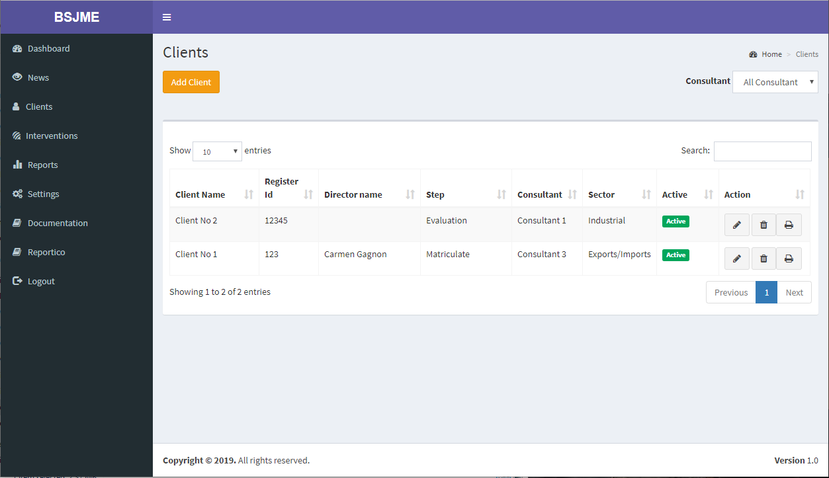

BSJME version

Entries to show

Sorting column

Specific Search

Actions

Display area

Main Menu

**Main Menu** – Serves as the main access point for the system’s main modules.

**Display area** – Pages of modules accessed through the Main Menu are displayed in this area.

**BSJME version** – Is the current version of the software.

**Entries to show** – The number of entries to display before changing pages.

**Specific Search** – Search on the data’s showed on the page

**Column sorting** - Each column can be sorted in ascending and descending order.

**Actions** – Used for quick access to a process for the line:  View  Edit  Delete  Print

# Getting started

## Implementation Action Plan

### A. Pre-installation activities

1. Verify availability of server: if local approach is the target you need a server, if web option you need a hosting service.
2. Verify availability of workstations for the users
3. Verify availability of Local area networking if it’s the avenue chosen
4. Draft the Memo for the BSJME Task Force Unit. Define members, duties and responsibilities
5. Putting it all together, schedule the following :
   * Orientation of Task Force Unit;
   * Installation;
   * Re-echo training for BSJME users
   * period of build-up.
   * acquisition of ICT resources;
6. With the Task Force Unit define the following :
   * Decide if each user of the system will have only one username or if each users can have multiple usernames depending on the various functions of the user.
   * Determine who will draft the lists of the settings needed in the system (Parish, Phase, Types etc…)
   * Group the different excel sheet that might be used for a conversion in the new system
   * Prepare test data to be used for testing your installed system.

### B. Installation activities System only

1. Backup any database you have in the server
2. Store backup files in an external storage/device
3. Install BSJME database and system on the host server
4. Configuration of BSJME system settings
5. Run the browser from the workstations and access BSJME.

### C. Database build-up activities

1. Build-up of System tables for Location (County – Parish – City)
2. Build-up of System tables for Client (Step, Sector, Consultant, Inquiry type, Support Type)
3. Build-up of System tables for Intervention (Target, Status, Phase)
4. Build-up of Clients and documents related to the client
5. Build-up of Interventions and documents on sector, environment, activities etc..
6. Use sample data to test and verify if system data are configured correctly as a result of the print-out documents from your system.

### D. Advocacy – information dissemination

1. Provide information to the personnel regarding the implications of the computerization of the client and interventions.
2. Provide information to public regarding possible implications of your computerization of the client and interventions.

### E. Re-echo of user's training activities

1. Prepare training resources (sample data, servers, and computers)
2. Conduct training
3. Test and evaluate trainees

### F. System Implementation

From your observations and experiences with testing and using sample data, improve and perfect the system data vs Reference-General Settings. These should be configured correctly as shown by the print-outs from your system.

### G. System monitoring

1. Monitor and Report system usage
2. Monitor and Report problems encountered

# Login

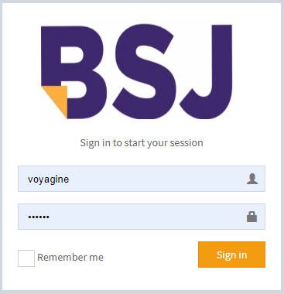To access BSJME, you need to identify yourself. The IT administrator will give you the username and password needed for your access.

At the opening of BSJME you will have access to the modules allowed. You will also be informed about the current version of BSJME.

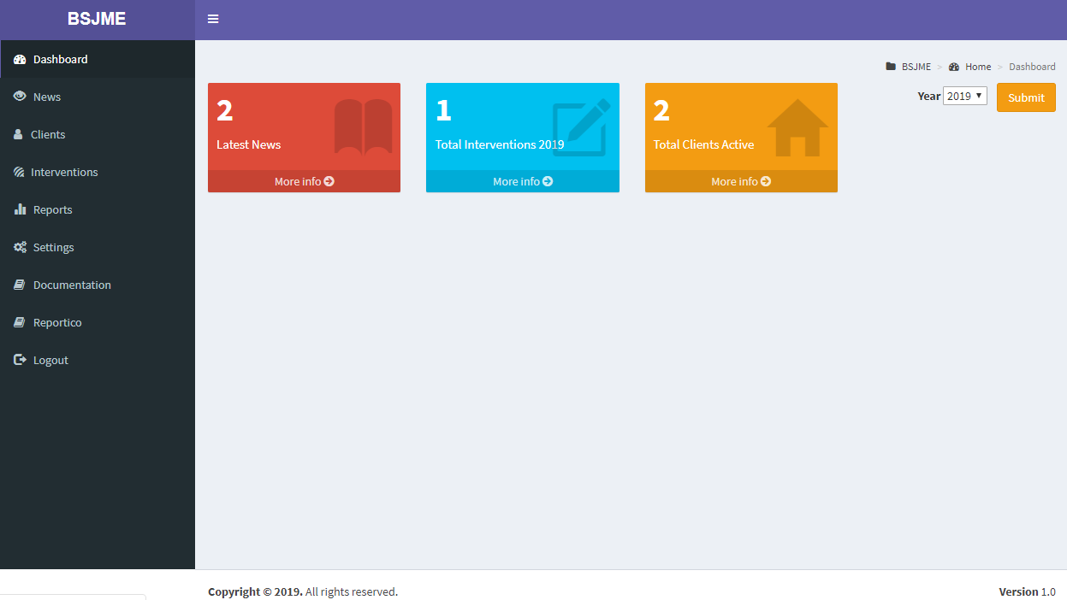

# BSJME Dashboard

By opening the BSJME dashboard, you will have an overview of the progress of monitoring for the current year. You will also see if some news have been posted on the system. More facilities might be developed in the future in the Dashboard.



From the **News** menu, you will read the latest news posted by the users of the system. From the **Clients** menu on the left, you will get the list of clients. From **Interventions**, you will have the list of interventions. In the **Reports** section, you will have all the reports on clients and interventions. In **Settings**, you will find all the tables that feed the system. And finally, the system **documentation** with the user guide. **Reportico** is a flexible web reporting tool that can report on data from a variety of tables.

Depending on your security level, some menus may not appear on the screen.

# News

News is the list of the posts written by the BSJME users.

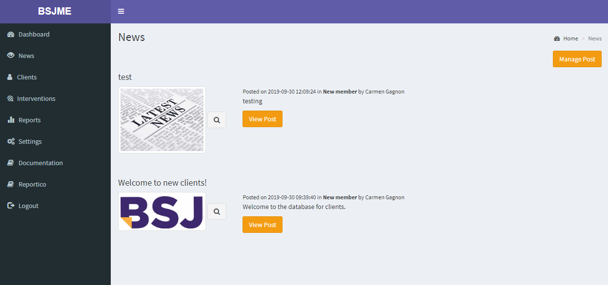

When you press View Post, you will have access to the documents that might be attached to the post.

If you have the permission, you will be able to **Manage Post** from this screen. The settings of the News, like category, are available in the Settings page.

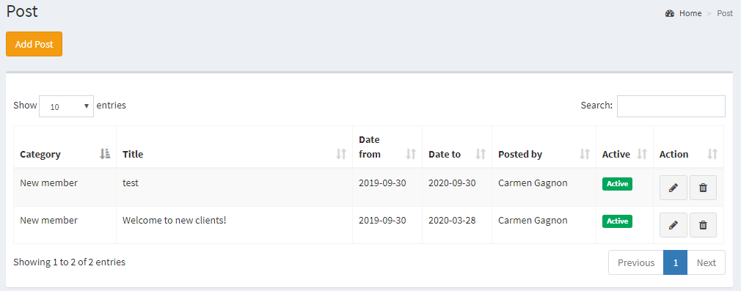

# Clients

When you click on Clients menu, you get the list of clients. If you want to create a new client, click on **Add Client**. In the Action of the list, you will be able to **Edit** or **Delete** a client. You can also **print** the content of the client with all the information related. The search will allow you to find the clients according to the information displayed in the list. You can also get the list for a specific consultant.

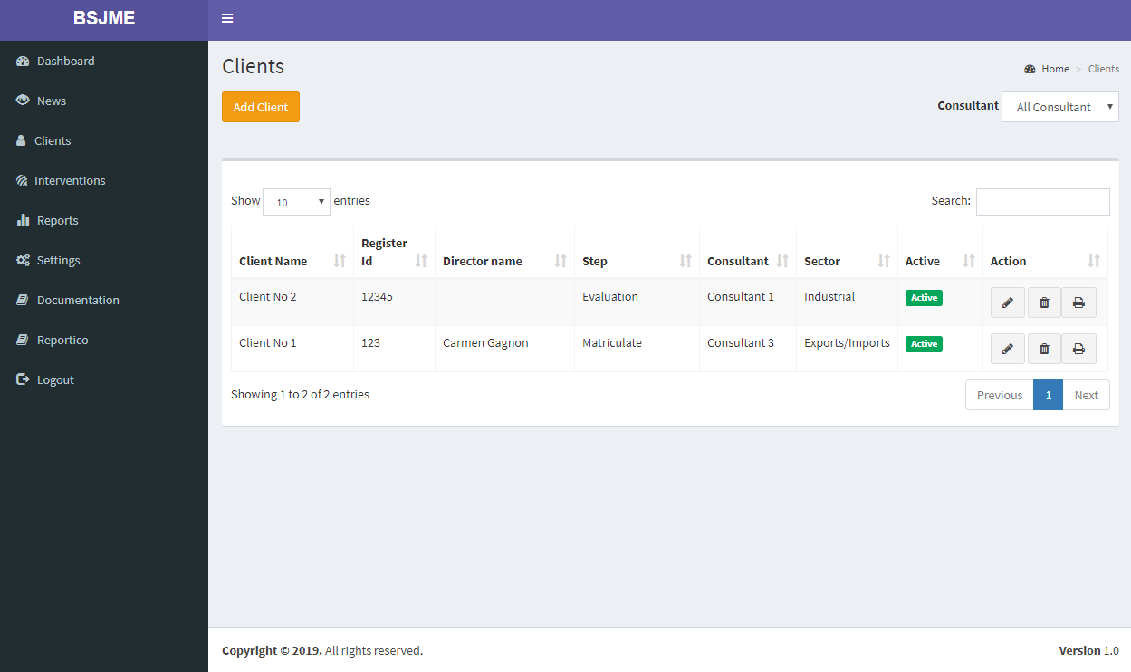

## Print Client

The print of a client will be presented on a PDF file that you can print or save.

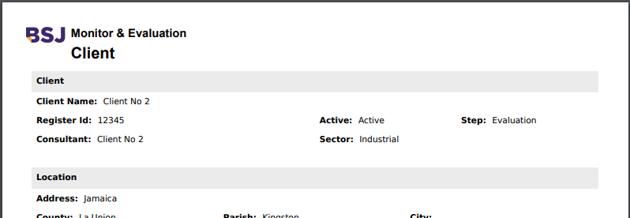

## Edit Client

To edit a client, you have to click on the  in the list. All the required fields are indicated by a red asterisk.

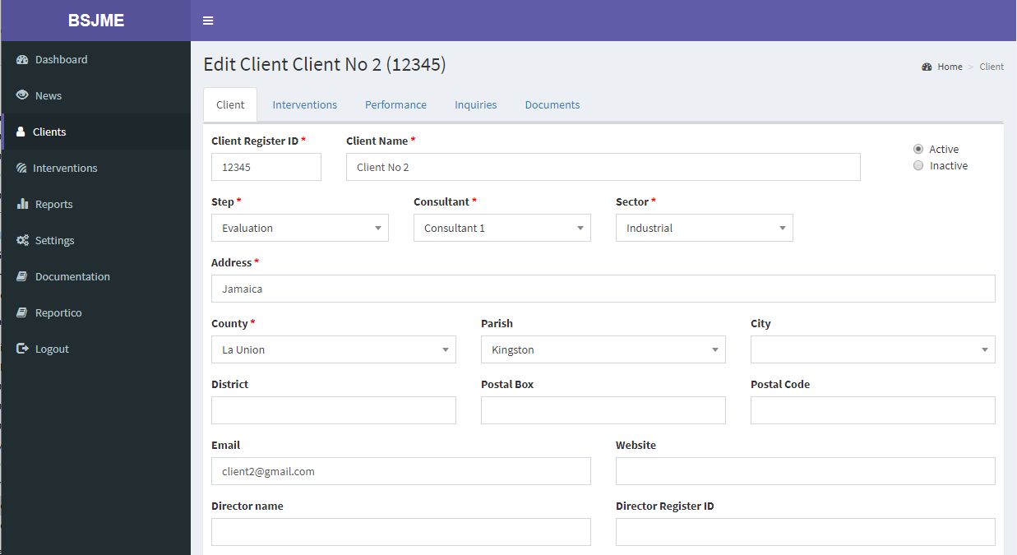

When all the data are completed, you can save. You have the possibility to print the content of the client with all the information related by using the command print at the bottom of the page.

All information related to the client can be found in the tabs:

* Interventions
* Performance
* Inquiries
* Documents

## Interventions

The intervention tab is the list of the interventions associated to the client. You can print the details of the intervention using the printer. If you want to have details on the intervention, you can press the edit button. You will then be redirected to Intervention.

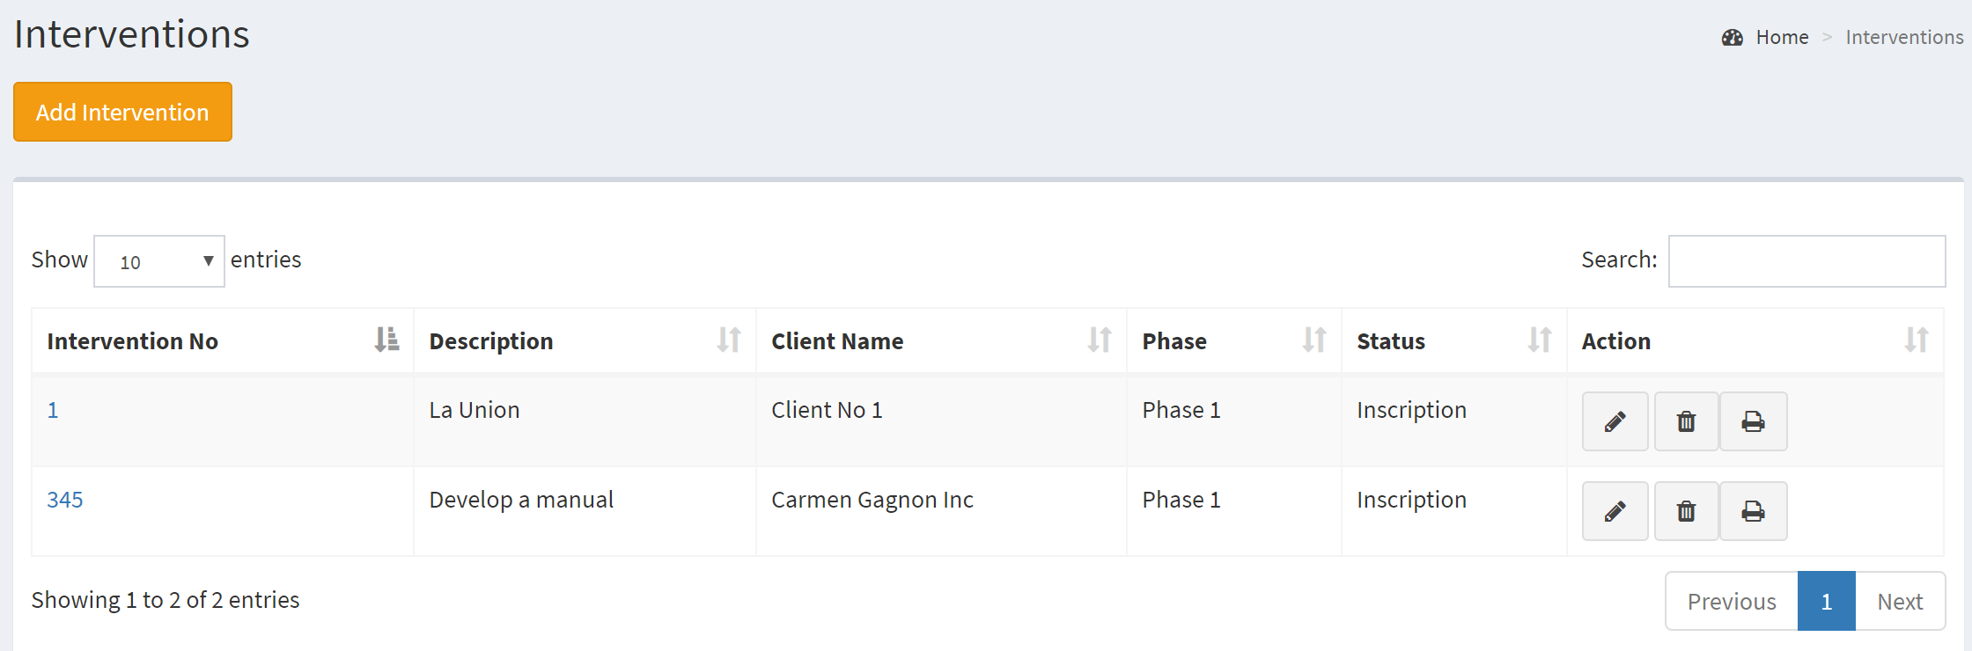

From the intervention module, you will find the button  near the client to bring you back to the client.

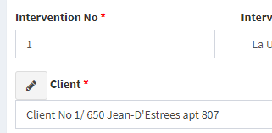

## Performance

Performance is a list of the performance data send by the client.

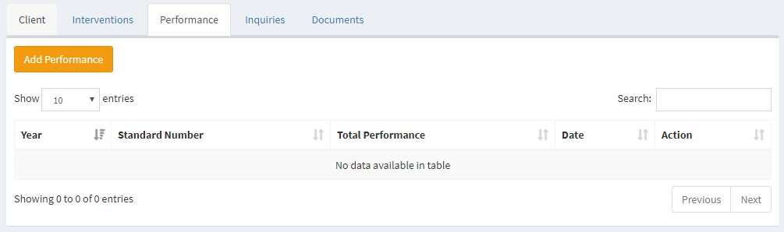

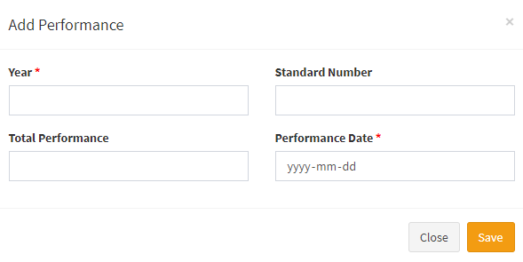To add a new Performance line, press the **Add Performance** button. For editing a Performance, select the line you wish to **edit**. Fill in the required data and press the **save** command. You will get a confirmation. If the data is not consistent, the system will generate error messages. To delete a performance, select the entry in the row and press the **Delete** command.

## Inquiries

Inquiry is the list of all inquiries coming from the client. This will serve as a knowledge basis.

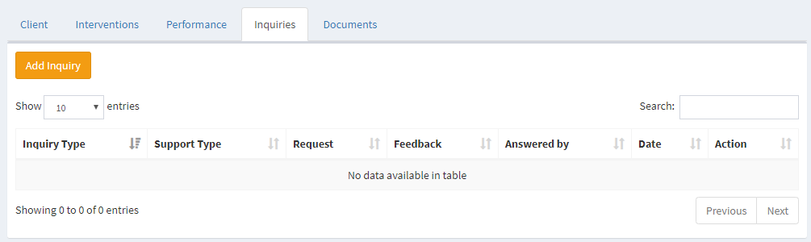

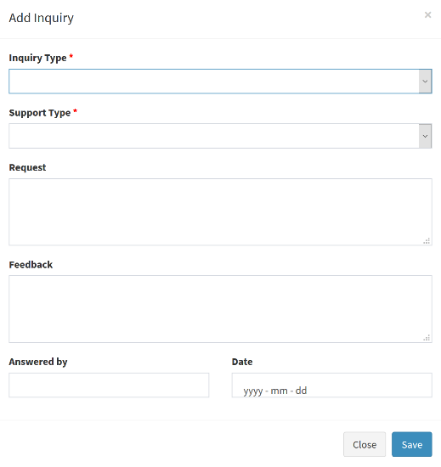To add a new inquiry line, press the **Add Inquiry** button. For editing a inquiry, select the line you wish to **edit**. Fill in the required data and press the **save** command. You will get a confirmation. If the data is not consistent, the system will generate error messages. To delete an inquiry, select the entry in the row and press the **Delete** command

## Document

In the document tab, you will find all the documents related to the client and attached to a specific intervention. In the client document tab, you will be able to upload only the document to be attached to the client. All the documents in relation with an intervention, should be uploaded in the intervention module.

To upload a document, you must first choose the file and then press the Add Document button. To view the document, you press the button  Depending on the format of the document, your browser will open different windows. If the format is JPG or PDF, another tab will be opened in your browser and you will see the document immediately. If it’s a Word, Excel or PowerPoint, it will be uploaded to be opened with Office.

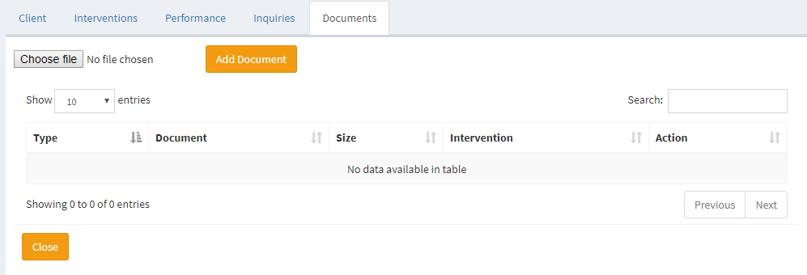

# Interventions

When you click on Interventions menu, you get the list of interventions. If you want to create a new intervention, click on **Add Intervention**. In the Action of the list, you will be able to **Edit** or **Delete** an intervention. You can also **print** the content of the intervention with all the information related. The search will allow you to find the interventions according to the information displayed in the list.

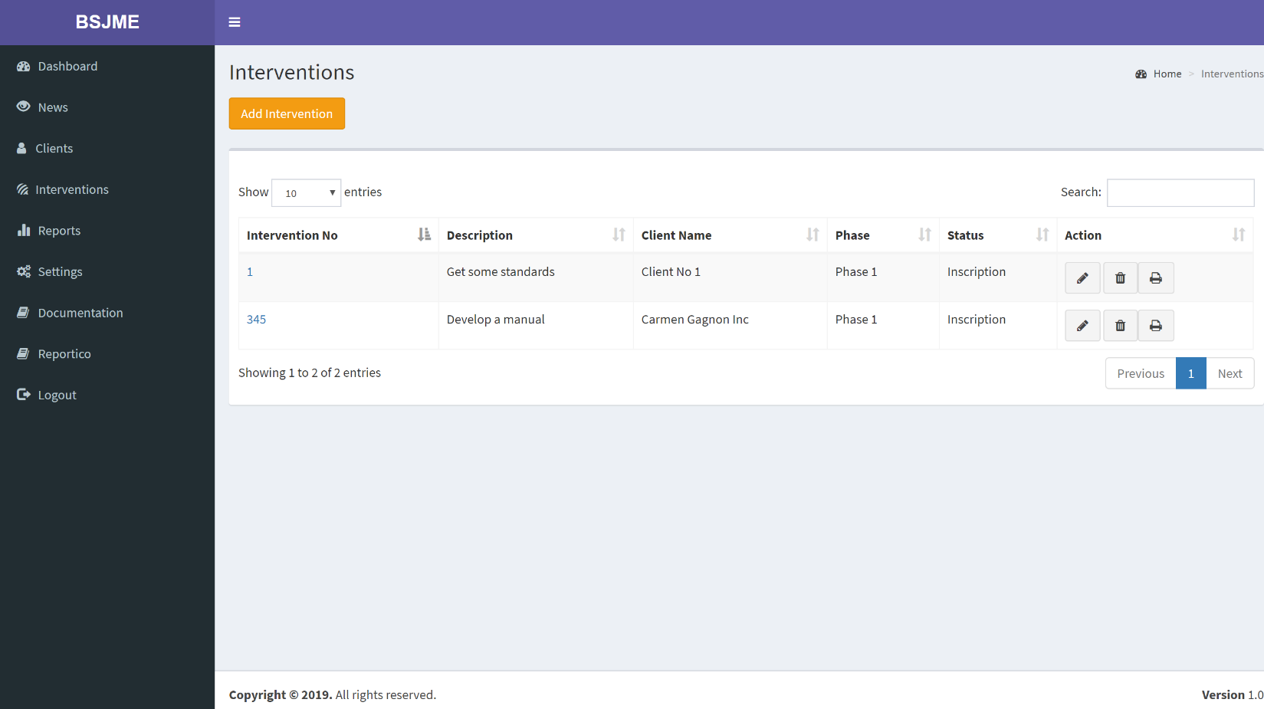

## Print Intervention

The print of an intervention will be presented on a PDF file that you can print or save.

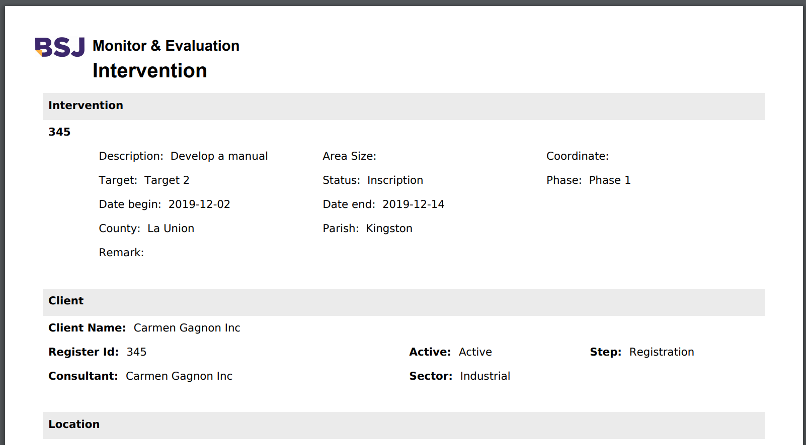

## Edit Intervention

To edit an intervention, you have to click on the  in the list. All the required fields are indicated by a red asterisk.

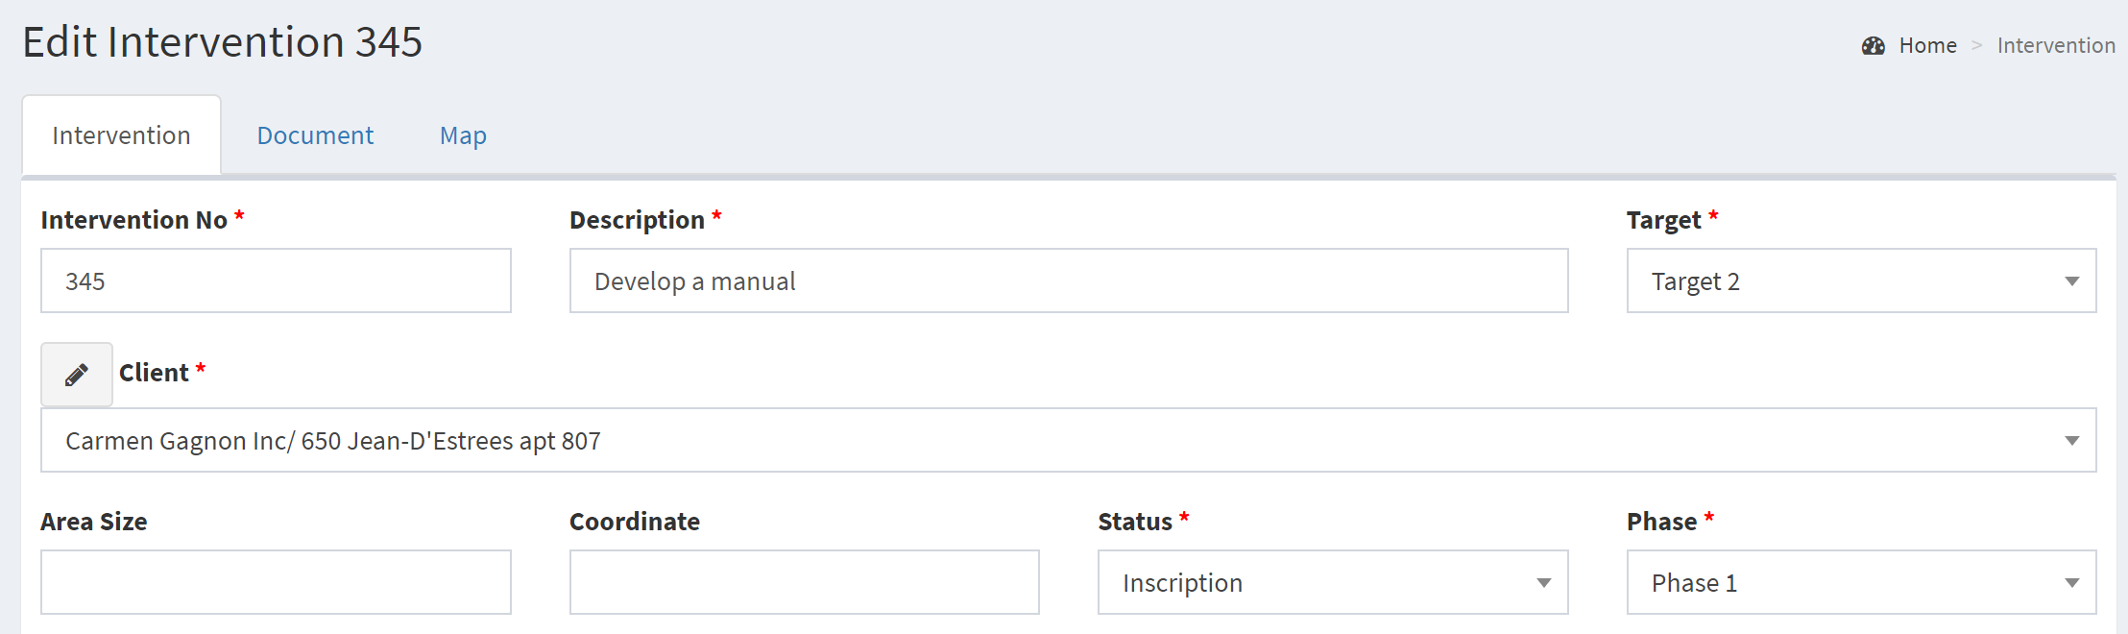

You can also go directly to the Client if you need more details about the whole content of the client by pressing the button  that appear in front the client name.

## Document

In the document tab, you will find all the documents related to the intervention. To upload a document, you must first choose the file and then press the **Add Document** button. The type of documents must be indicated, unless all will be associated to the intervention in general. You can indicate if the document is part of the Association, or concern the Activities or Environment.

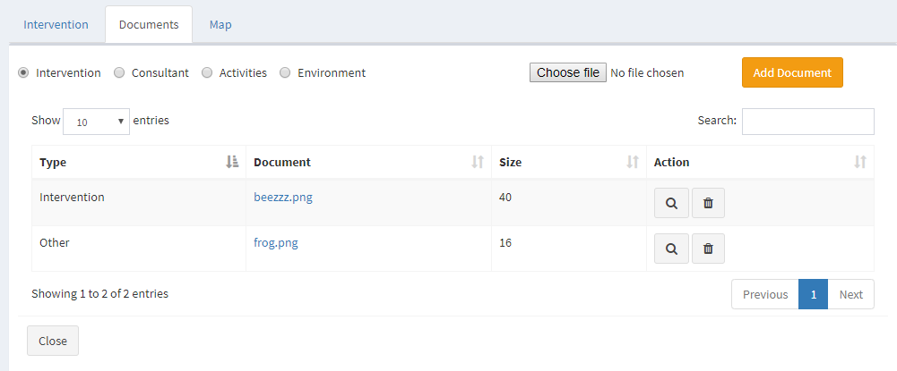

To view the document, you press the button  Depending on the format of the document, your browser will open different windows. If the format is JPG or PDF, another tab will be opened in your browser. If it’s a Word, Excel or PowerPoint, it will be uploaded to be open with Office.

## Map

It will be possible to locate the exact location of the intervention.

### How to embed a map in google Map

To get a free access to a google map you can embed a map in your site. The method is very simple. Go to Google map and find the site you wish to show in a map.

Press share and choose **embed a map.**

Copy the **html** part in the map field of the intervention and save.

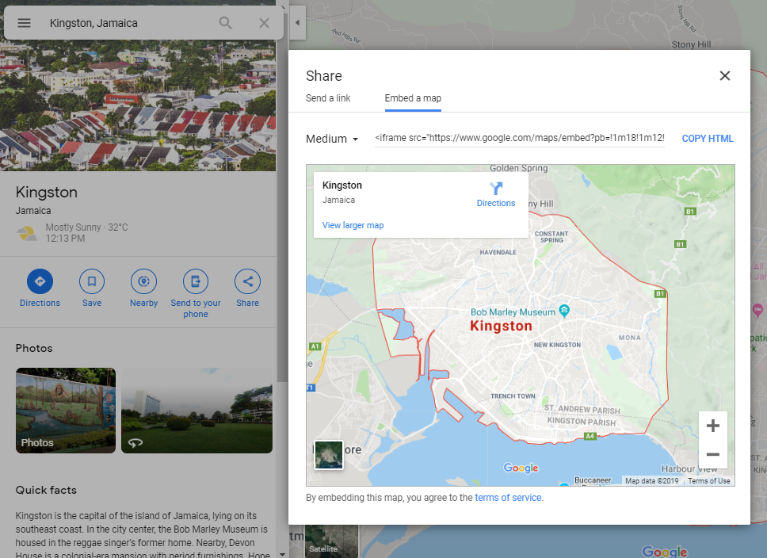

### Map in Intervention

In Intervention part, the tab MAP will present the view of the google map of the site.

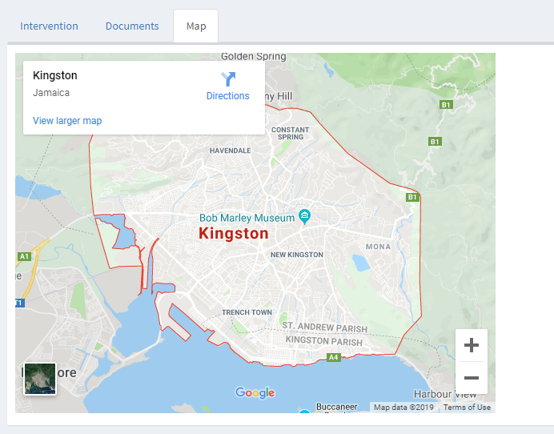

# Reports

BSJME can generate reports. It is highly recommended that the machine or workstation on which BSJME is running should have a pre-installed Acrobat Reader. From the PDF viewer, users can print the report to any printer that has been pre-configured/installed in the workstation/machine.

All reports require parameters to be inputted or selected before the report can be generated. The system will tell you if the parameters is required. These parameters will be different from one report to another.

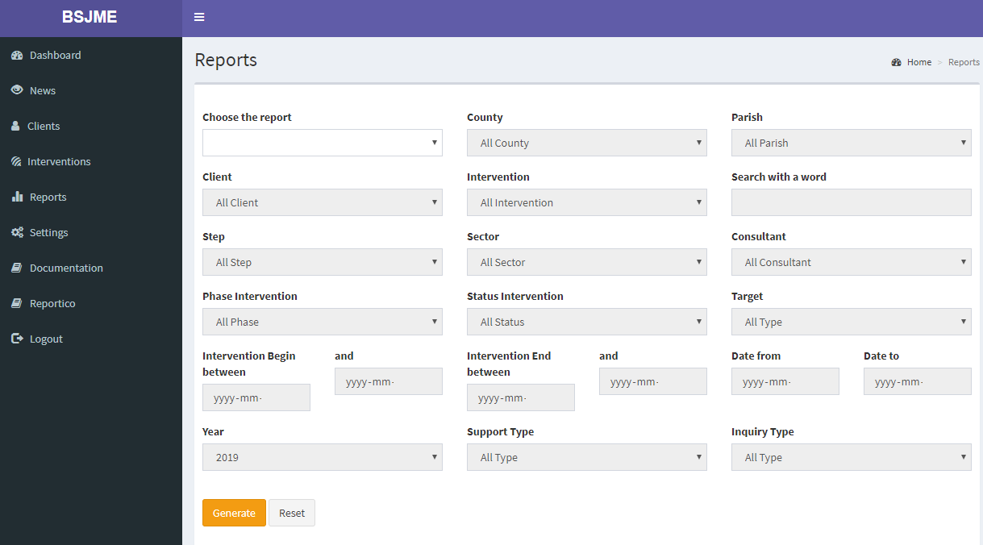

## Report01 – List of Clients

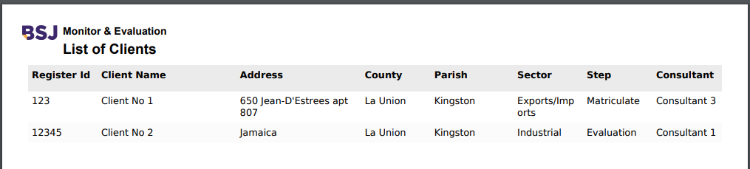

## Report02 – List of Interventions

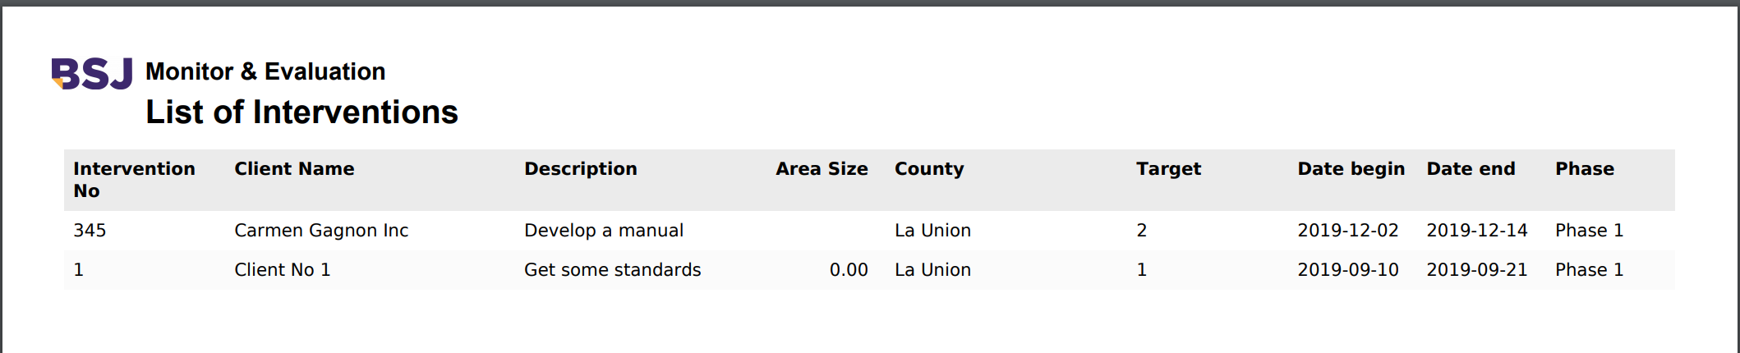

## Report 03 – Performance

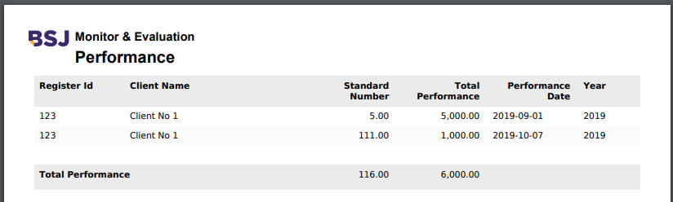

## Report 04 – Inquiries

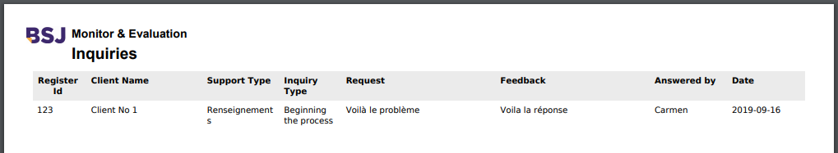

## Report 05 – List of Interventions by County

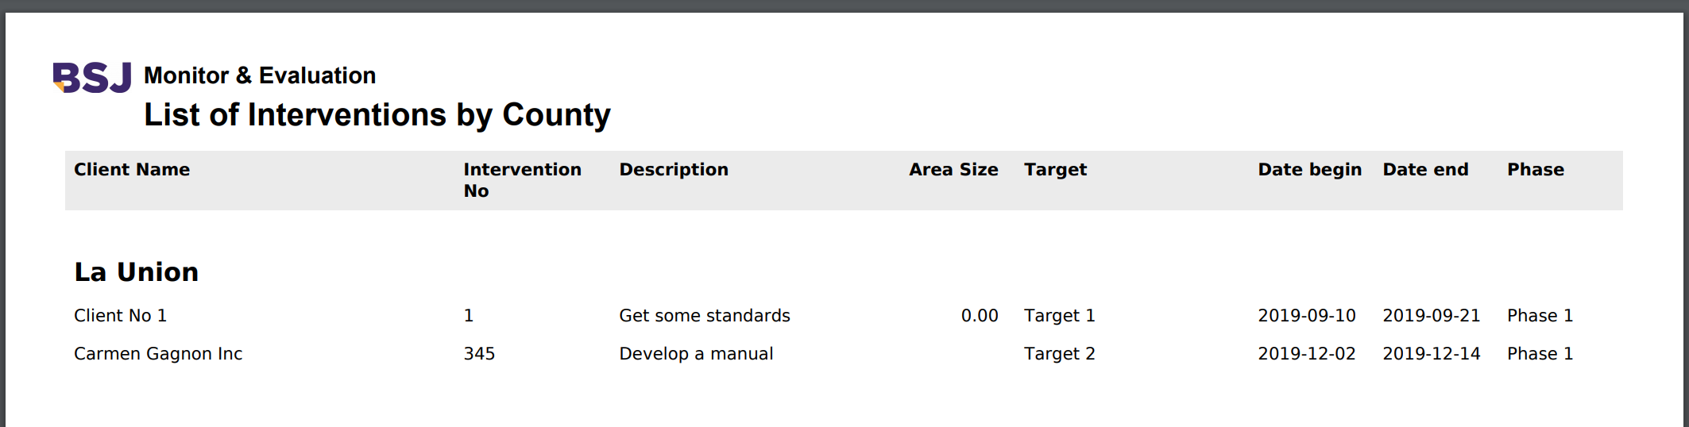

# Settings

The Settings module is where basic information and necessary data are defined. The overall behavior of BSJME in the processing of **Clients** and **Interventions** printout depends on how these settings are setup. Build-up of Location, Client and Interventions for the system is defined here as well. The **System Administrator** is the one in-charge of setting up these settings.

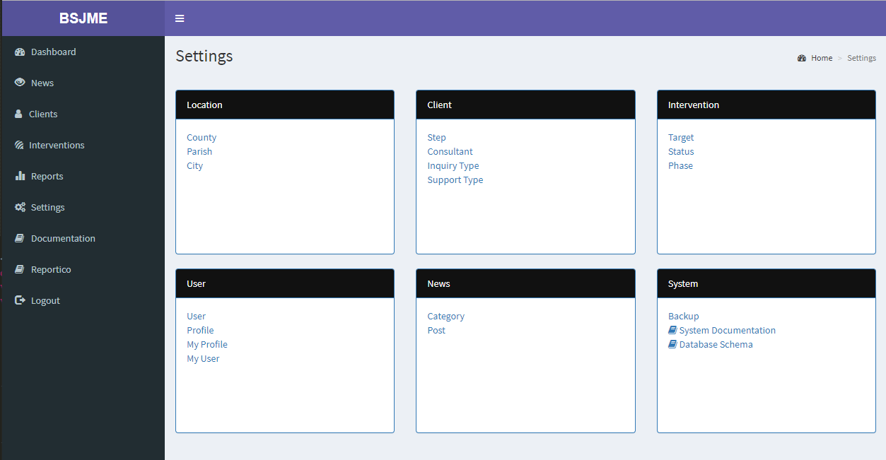

All the settings are using the same method. First you get the list of the settings where you can **Add**, **Edit** or **Delete**.

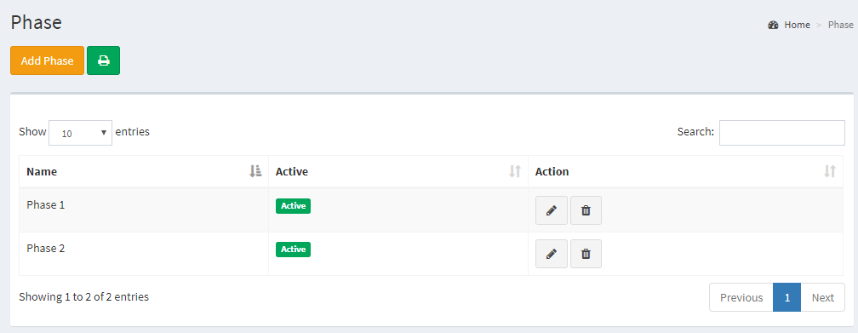

To add a new setting, press the **Add** button. For editing the data, select the line you wish to **edit**. Fill in the required data and press the **save** command. You will get a confirmation. If the data is not consistent, the system will generate error messages. 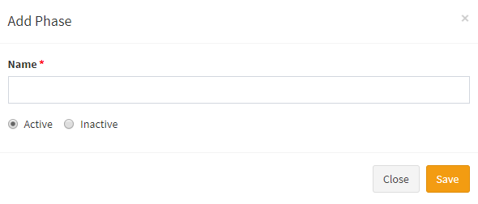To delete an entry, select in the row and press the **Delete** command. It will not be possible to delete an entry if it is related to other data in the system.

You can print the list of the settings by using the printer.

## Location

The settings for administration of the location include:

* **County**
* **Parish**
* **City**

## Client

The settings for administration of the clients include:

* **Step**: is the step where the client is in the process
* **Consultant**: Is the consultant in charge of the client
* **Type of support**: Support given after an inquiry
* **Type of inquiry**: Kind of inquiry. This will serve to build a knowledge basis.

## Intervention

The settings for administration of the interventions include:

* **Target** : Is the target of the intervention
* **Status**: In which status is the intervention
* **Phase**: At what phase is the intervention

## User

When you click User, you get the list of users.

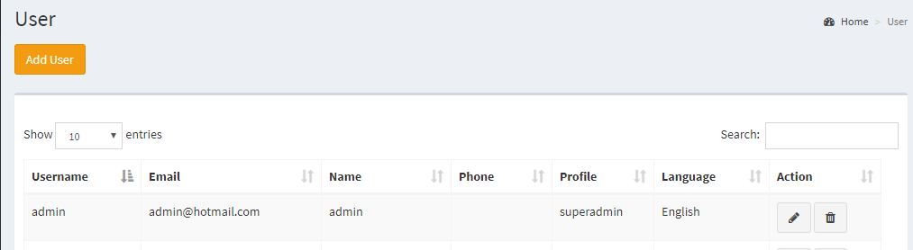

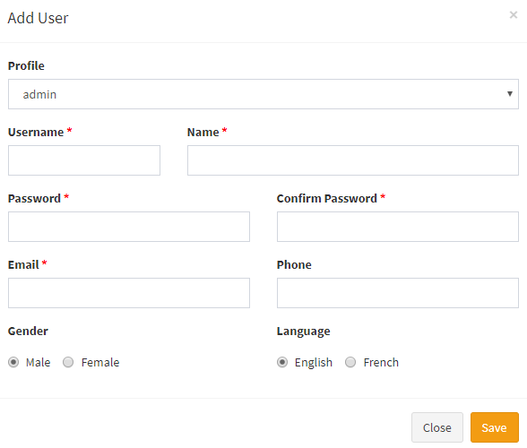

To add a new User, press the **Add User** button. For editing a User, select the line you wish to **edit**.

A user will be given a Profile. It’s the profile that will give the access granted to each user. The language preference should be indicated. The system will open in the language given to the user.

Fill in the required data and press the **save** command. You will get a confirmation. If the data is not consistent, the system will generate error messages. To delete a User, select the entry in the row and press the **Delete** command.

### Profile

The profile will give the access to different parts of the system. You can create as much profile needed to ensure that the system is safely used.

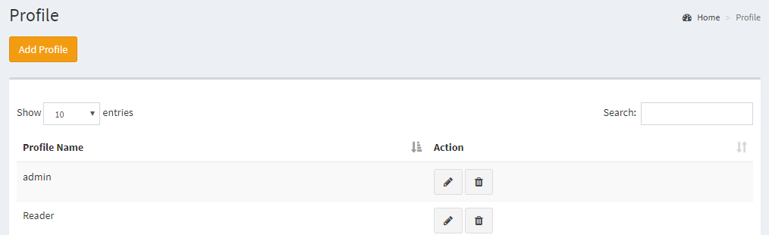

To add a new Profile, press the **Add Profile** button. For editing a Profile, select the line you wish to **edit**. Fill in the required data and press the **save** command. You will get a confirmation. If the data is not consistent, the system will generate error messages. To delete a Profile, select the entry in the row and press the **Delete** command. It will not be possible to delete a Profile if it is related to other data in the system.

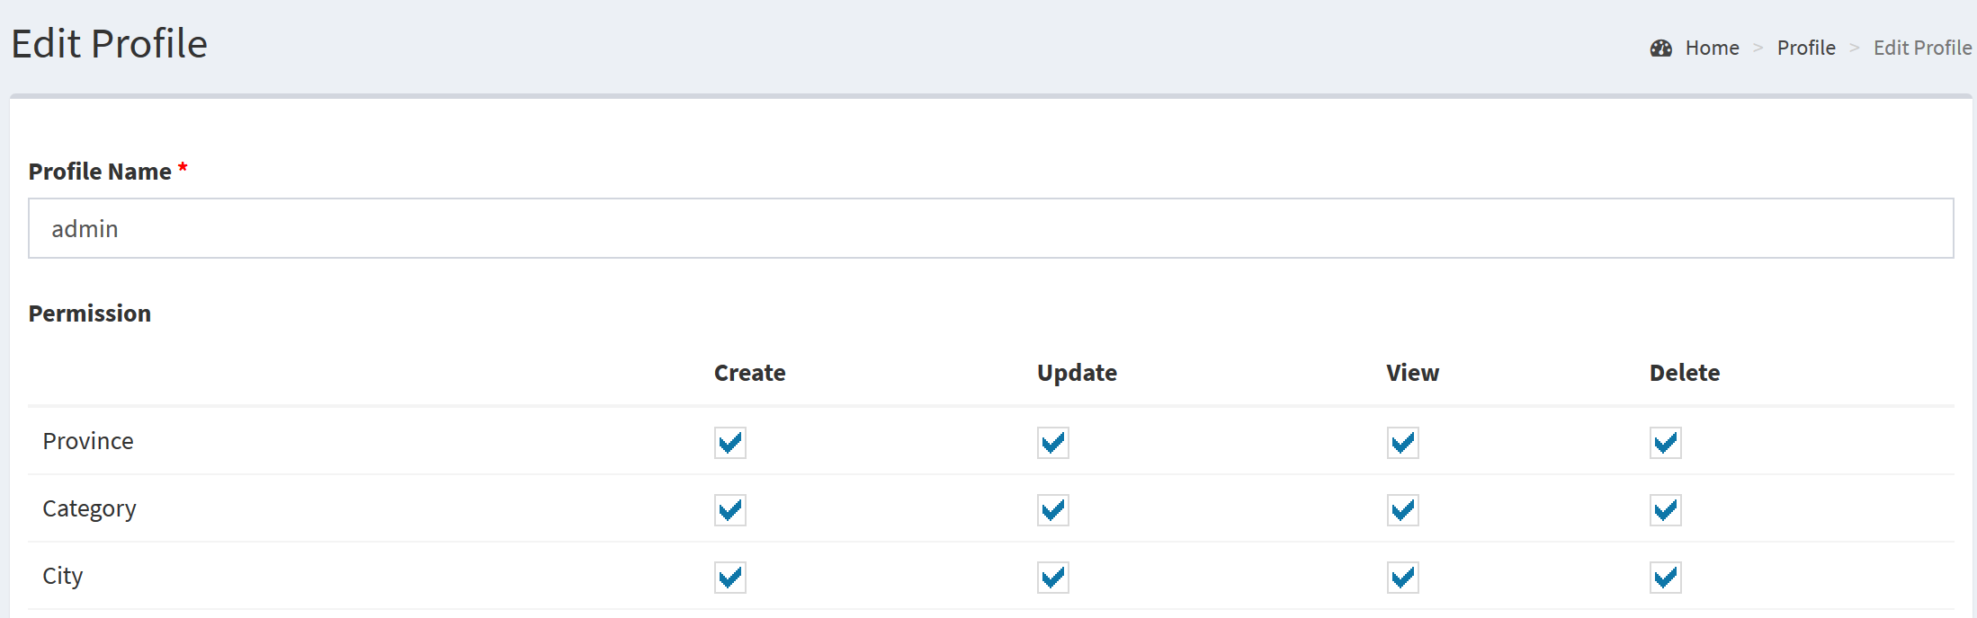

If the option is checked, the user having this profile will get access. If no access is given, the information won’t appear in the menu of the user.

### My Profile

My profile will allowed the user to see his own profile.

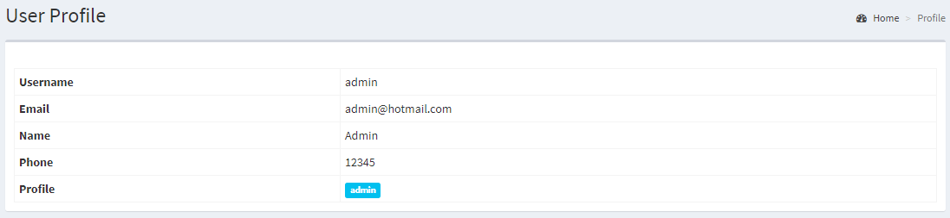

### My User

The user will be able to update his own information in My User.

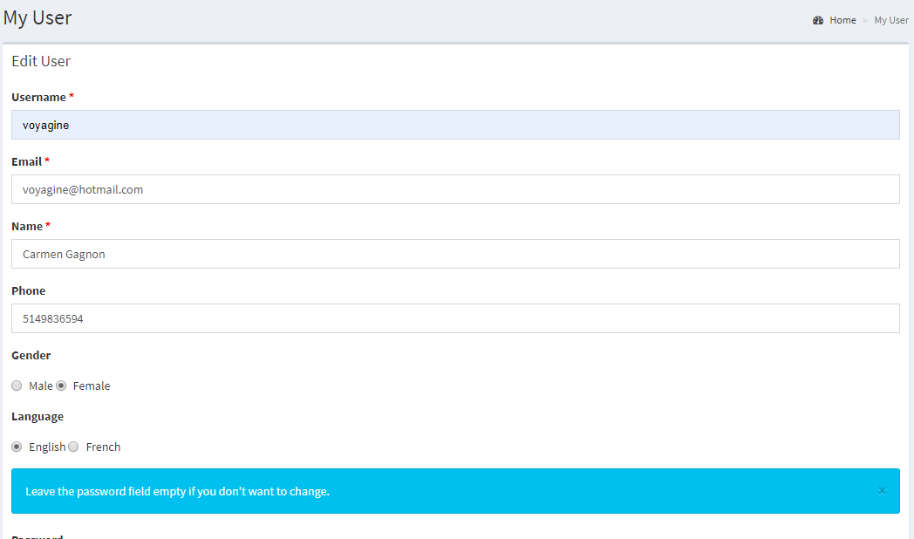

## News

In the News settings, you will be able to create new post category and manage the posts.

### Category

When you click Category, you get the list of categories.

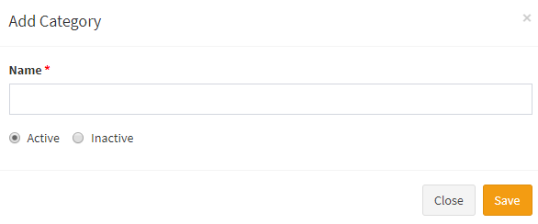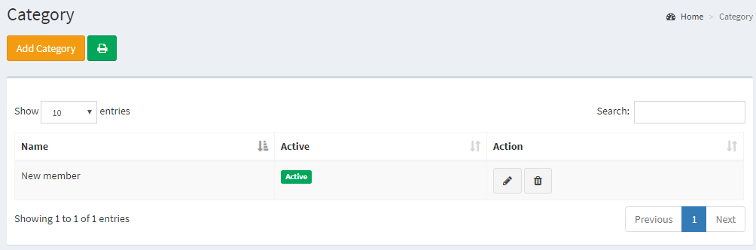

To add a new Category, press the **Add Category** button. For editing a Category, select the line you wish to **edit**. Fill in the required data and press the **save** command. You will get a confirmation. If the data is not consistent, the system will generate error messages. To delete a Category, select the entry in the row and press the **Delete** command. It will not be possible to delete a category if it is related to other data in the system.

### Post

Management of the post is done in this part. You will also get this access from the News page, on the right corner you will find the command Manage Post.

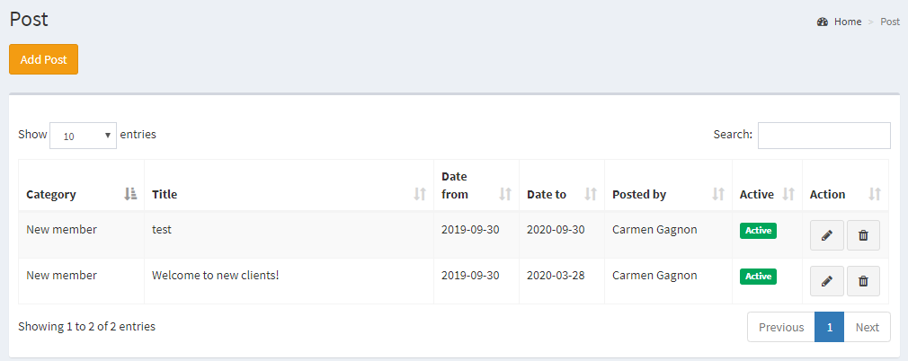

To add a new Post, press the **Add Post** button. For editing a Post, select the line you wish to **edit**. Fill in the required data and press the **save** command. You will get a confirmation. If the data is not consistent, the system will generate error messages. To delete a Post, select the entry in the row and press the **Delete** command.

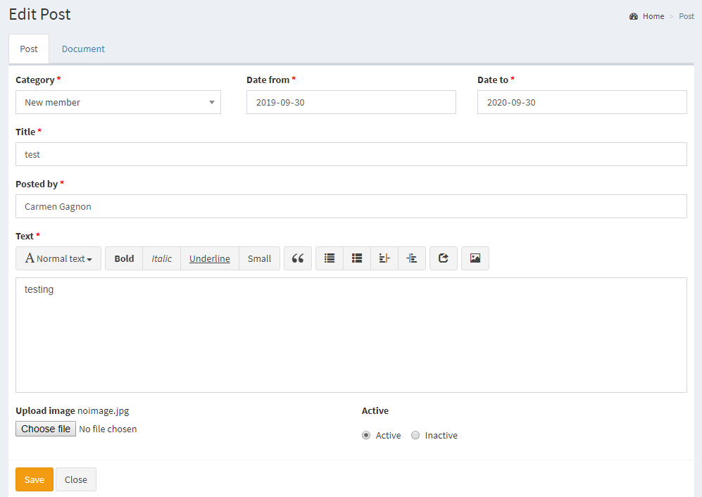

**Date From and Date To** will determine if the post will be presented or not in the News page.

**Active** or Inactive will get the same reaction.

Finally, in the **Document** tab you will be able to upload differents documents for the post.

# Reportico

Reportico is a flexible web reporting tool that can report on data from a variety of tables. A browser-driven front end allows the creation, maintenance and execution of reports. This software is complex and will be a future training for the county. The advantages is that users can developed their own reports without the help of programmers.

Some knowledge on the definition of the database should be acquired first. The user of Reportico must also know how to generate query with MySQL. You can have more details on [www.reportico.org](http://www.reportico.org)

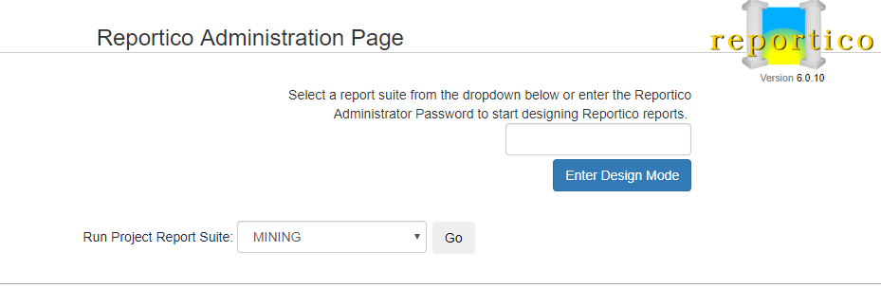

# Documentation

In the documentation menu, you will get documentation on the system. You can download or print the user guide.

