Sports identification and timing program

1. Heading and information for the participants

The people which are a part of this project are:

Dimitar Dyakov,9V class, e-mail: DPDyakov18@codingburgas.bg;    
Ema Mateva, 9B class, e-mail: EMMateva@codingburgas.bg;   
Petаr Stoev, 9A class, e-mail: PKStoev18@codingburgas.bg;   
Stoyan Ponchev,9A class, e-mail: SMPonchev18@codingburgas.bg;

Mentor: Mariana Encheva, e-mail: [mencheva@codingburgas.bg](mailto:PGeorgiev@codingburgas.bg)

2. Content

The program is made for any types of sport centers. The main idea is easily to calculate and add customers to database or cycle of information. The menu has the following functions: 1. Add a new customer; 2. Finish a customer; 3. Show all customers; 4. Calculate money; 5. Refer a friend; 6. Show most popular sport; 7. Exit. After you choose one of the following functions the program shows you the next part of the menu. But if you choose number out of the range of 1 to 7 the program will show you "Incorrect input!" And "Please fill in again.", which gives you another chance to choose one of the options. The third option is to Show all customers which have already been added in this program. The fourth option is like calculator for the money which the customer has to pay. When you choose the Refer a friend function, you add the names of the friend which invited you and he collects points. When he collects enough points, he gets a discount. The sixth function is showing the sport which is the most selected from the customers.

2.1 Short description of the project and objectives

The project is about making yourself an id in a sports center. With this id you can check who are the customers, who are with you on the sports center, it can calculate your account according to the time spent at the sports site, it shows the most popular sport and it can edit the list of people, give discounts and many more. The program can help to easily manage your big customers data of information. That way you can easily add customers, remove them and all of the functions which are added in the menu.

2.2 Diagram describing menus

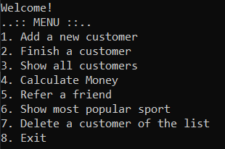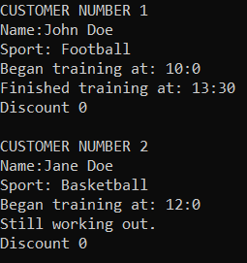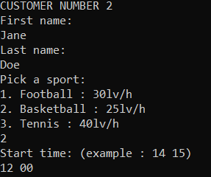

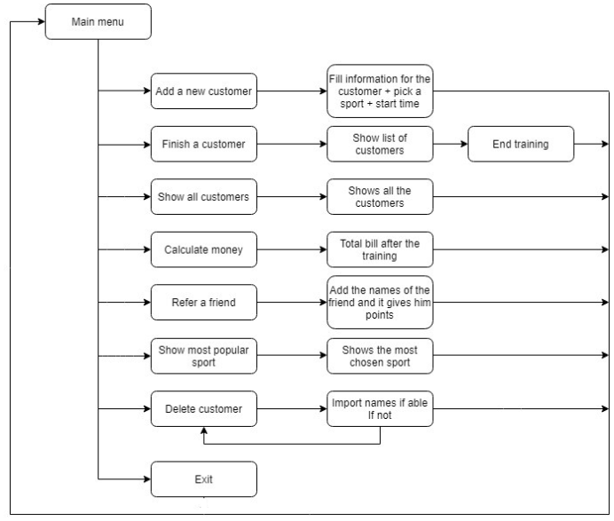

2.3 Description of the functions used

Add a new customer: The main idea is by five parameters in which four are pseudonyms. The other part is array of structure. In this function you input the data, that is used later in the program.   
Finish a customer: In this function we are adding the end time of the training of any customer. There are used three parameters in which two are pseudonyms and an array of structures.   
Show all customers: In this function the system is showing all the added customers.

Calculate money: In this function the system is calculating the money for the training and if there are any discount points, the price changes. The price is calculating by the type of the sport and at the end is showing the total amount.

Refer a friend: In this function you can add the name of the customer that has invited you. In this case the said customer receives points that transfer to different discounts.

Delete a customer: In this function you can manually delete a selected customer.

2.3.1 Purpose

Each function has its own purpose. They use the same inputted data with aliases. There are functions for inputting and outputting data, calculating, sorting and deleting.

2.3.2 Arguments

* int& NumberOfCustomers: integer for counting the number of all inputted and deleted customers
* PersonalInfo PI []: array for the structure
* int& popularityFootball, int& popularityBasketball, in t& popularityTennis : integer for counting the times each sport is being played
* int& countRemain: integer for counting the number of customers that haven’t been updated yet.

2.3.3 Return Value

The type of “return” we use mostly is “return 0”. We use it to stop the chosen function when the wanted data is displayed. To output the data, we use “cout”.