**AGREEMENT**

07/09/23

This agreement is made between Henry Agcaoili and Ms. Rosemarie Balidoy. Henry aims to accomplish his goal of losing weight and bulking his body to reach a goal weight of 68 kilograms between July and the end of November. Failure to accomplish this task will result in Henry providing Ms. Balidoy with a four-month supply to satisfy her food cravings. If he accomplishes his goal within the given time, no money will be exchanged between the parties.

Both parties agree to keep this agreement confidential and not disclose its contents to the public.

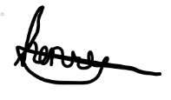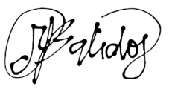

__________________ ___________________

**HENRY AGCAOILI ROSEMARIE BALIDOY**