Enhancement One: Software Design and Engineering
Artifact: CS-360 Warehouse Inventory App
CS – 499 Capstone
Dylan Harmon
July 26, 2026

Artifact Description:
This artifact comes from my final project in CS-360: Mobile Architecture and Programming. It is a Warehouse Inventory App built in Android Studios. The app lets warehouse employees create and account and log in, then add, update, and delete items in a local database, and the app sends an SMS alert for low inventory (when an item hits 0). It is written in Java on the standard Android stack: a SQLite database accessed through Room, a repository and a ViewModel following the MVVM pattern, and RecyclerView driven screens for the login flow and the inventory list. I created the original artifact in April 2026.
Justification for Inclusion:
I selected this artifact because I only had two to choose from. I have my full stack project and my mobile app that can be used to satisfy a “Software Design Artifact”. I had different plans for the full stack app and thought maybe this artifact would be the best one for a security enhancement. It was already a complete layered application that included user authentication, a permission gate SMS feature, and user input flowed to the Room database. It made for a perfect opportunity to take existing code and improve it, and show my ability to refactor code for a different authentication design.
The original app stored passwords as a basic SHA-256 hash. I replaced that with a salted, iterated PBKDF2-HMAC-SHA256 hashing. Each password now gets a unique random salt, the derived has is stored in a self-describing record - Stored format: pbkdf2sha256$<iterations>$<base64 salt>$<base64 hash> - so the parameters can evolve without a database migration. Verification uses a constant time comparison to avoid leaking information through timing. I also added a backward compatible path so accounts created under the old scheme still authenticate and are transparently upgraded to the stronger scheme on their next login.
Why add authentication for legacy users, and why re-hash behind the scenes?
I chose to go this route for a few different reasons. I wanted to display my adaptability. Rather than just changing the password hash to something stronger, I wanted to showcase a more realistic scenario. My current assumption is that in the near future I will be working on existing code; upgrading security or adding features means making the new work with the old. A common approach used in software applications is Lazy Migration. Lazy migration is a data and business logic technique that happens while the application performs it’s usual operations. “It is a data migration because it moves data from A to B. It is also a business migration because while moving A to B it will perform a series of operations to comply with the new or updated business rules” (Davis, 2018). In this enhancement I am applying a new security policy. My approach to converting old password security to new security is when that user logs in, their password hash is checked, if it was the previous unsalted version (which lacks the current format), or if it is ran on less iterations, the password gets re-hashed to fit the current security policy.
Constant Time Comparison?
I wanted to make sure I implemented Constant Time Comparison. It was something I stumbled upon in my readings when studying cryptography and hashing. I never really understood it when I first read about it over a year ago, however I came across it again while taking CS-360, and again with my full stack course when learning about PBKDF2. “ A constant-time implementation is a programming technique used in cryptography to prevent timing attacks by ensuring that a program’s execution time does not depend on secret data” (), the goal is to remove nay measurable timing differences that could allow an attacker to infer secret information. For example, while authenticating a user, check the user’s password hash and verify it meets the current security policy.
I also wanted to continue with this idea of “if I was working on legacy code and updating security, and utilizing a lazy migration technique, how else can I verify my implementation is done following modern secure coding standards”.
The next component implemented in the enhancement is improving the permission handling. I modified the manifest to fit the principle of least privilege by removing a notifications permission the app never used, improved the runtime SMS request from Android’s callback API to the current ActivityResultLauncher, and added handling for the “don’t ask again” case so that a user who has permanently blocked the permission is guided to settings instead of hitting a dead end.
The final component was Input Validation with the inclusion of a Validators class that enforces rules on usernames, passwords, item names, and quantitates before that input reaches the database. This also fixed a crash where non-numeric quantity input threw and unhandled exception and has a focus on protecting against injection style attacks.
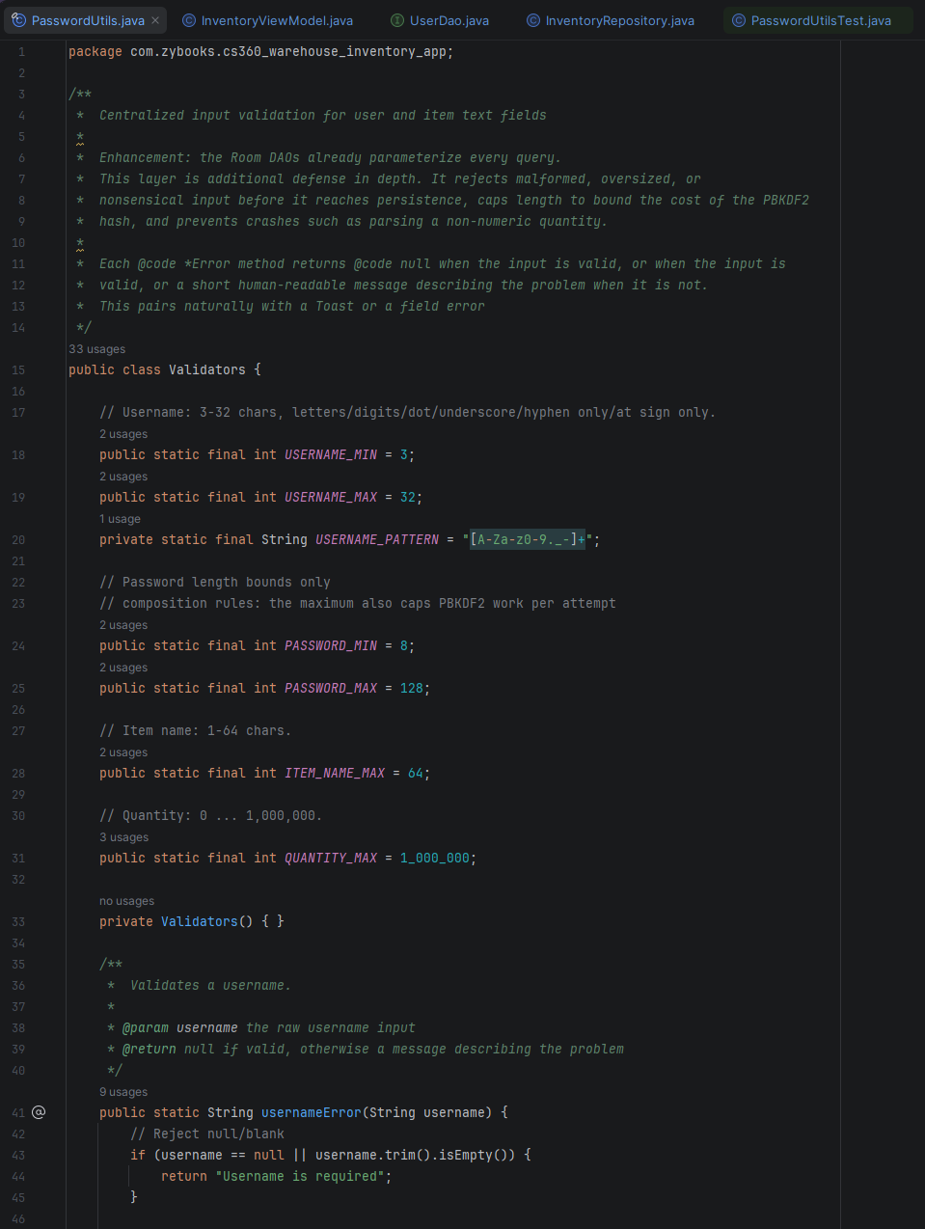
Together the artifact improved from a functional but weak (security wise) prototype into an application that stores credentials the way modern standards recommend, requests only the permissions it needs, refuses malformed input safely. The layered MVVM structure is what allowed these changes to be made in an efficient manner, because persistence, business logic, and UI were already separated, I could strengthen security logic in one place and let the rest of the app inherit it.

One final note, in a fully secure coding mindset, and thankfully I had previously implemented JUnit testing, I provided full testing on the implementation for the input validation and the security enhancement. Show in the following images:

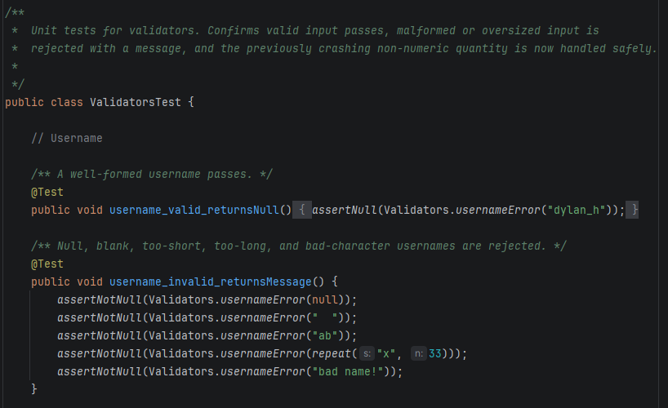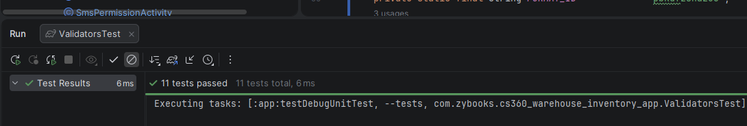
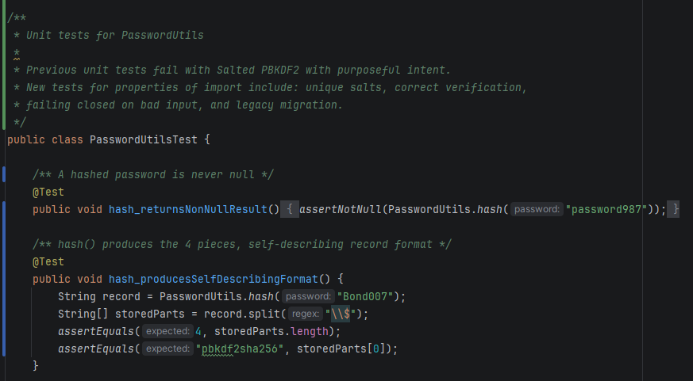
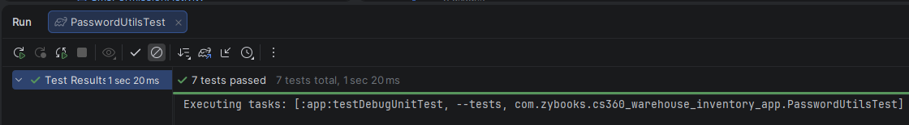

Course Outcomes
In module one I planned for this enhancement to meet three outcomes, and I believe I met all three.
For the security-mindset outcome:
Develop a security mindset that anticipates adversarial exploits in software architecture and designs to expose potential vulnerabilities, mitigate design flaws, and ensure privacy and enhanced security of data and resources
the entire enhancement is evidence. I approached the app by asking how an adversary would attack it. Offline brute force, timing side channels, injection style input, and denial of service through an oversized password. I believe I mitigated each. Strengthening password storage, restricting and validating input and enforcing least privilege are all expressions of anticipating exploitation and protecting user data.
For Outcome Three:
Design and evaluate computing solutions that solve a given problem using algorithmic principles and computer science practices and standards appropriate to its solution, while managing the trade-offs involved in design choices (data structures and algorithms)
the clearest example is the PBKDF2 work factor (iteration count). Current OWASP guidance recommends a very high iteration count, but that guidance targets server side hashing. OWASP also recommends (OWASP, 2021, sec. Password Storage) “When you choose a work factor, strike a balance between security and performance … There is no golden ruled for the ideal work factor – it will depend on the performance of the server and the number of users on the application”. With this mobile app, verifying a login is done on the device, and an iteration count that high adds seconds of latency. I made the iteration count a single named constant and chose a value that balances resistance to brute force against a responsive login, with commenting that documents the reasoning so that decisions can be revisited and altered without much headache.
For Outcome Four:
Demonstrate an ability to use well-founded and innovative techniques, skills, and tools in computing practices for the purpose of implementing computer solutions that deliver value and accomplish industry-specific goals (software engineering/design/database)
I used well founded industry standard mechanisms rather than inventing my own. First with PBKDF2 through Java’s SecretKeyFactory. Secondly the implementation of a lazy migration and secure coding practices such as constant time implementation for cryptography to further secure the lazy migration. I also displayed the ability to utilize modern Android permission API and further utilized JUnit tests to verify the implementation of changes made during this enhancement.
I have one slight adjustment from the initial enhancement plan to mention and it relates to input validation. I believe I mentioned adding parameterized queries to the data layer to prevent injection. Room already parameterizes every query and validates it at compile time, so that was not an area that needed modification. Instead I put my time towards an input-validation layer as a defense in depth technique. The outcomes I targeted did not change, however I did want to clarify the change and the reason for the addition of the Validators java class and unit test.
Reflection
The main thing I learned is that I enjoy working with security. The non deterministic design feature implemented by a salted hash exemplifies the difference in security strength when compared the original artifacts unsalted SHA-256 hash. That may be read in a different tone, but that one I am using in my head as I write this is shock and awe. I remember first learning about cryptographic hashing a year ago and thinking about how interesting and amazing the SHA-256 algorithm is. It is amazing, cryptography is a fascinating and important area of any application especially when there is a focus on protecting user data. When I first touched PBKDF2 with my full stack course it was like a happy nod to something more advance, however with this enhancement I got to fully immerse myself in a security first mindset and I really enjoyed the different pieces that apply to this enhancement. I had to adapt my previous code to include the new salted hash, verify a unique salt was applied every time, that the model pulls the stored salt back out and is able to deconstruct its format to verify and check the hash fits the current security policy and re-derives with the stored salt. I also got to not only learn or write a report about potential risks but show an ability to write code that is proactive in its defense. Designing the legacy path and learning about lazy migration made understanding clear in practice; that you cannot just change an algorithm and lock out every user who registered an account previously. That shift from does it work to how does it fail, and for who will it fail is what I took away most from this enhancement.

Sources
Android. (2024). ActivityResultLauncher | android developers. In Android Developers. https://developer.android.com/reference/androidx/activity/result/ActivityResultLauncher
Davis, E. G. (2018). Lazy migration applied to software applications. In Medium. https://medium.com/@eduardogulias/lazy-migration-applied-to-software-applications-27939ba8f375
Hashing and Validation Across Programming Languages. (2025). Pbkdf2 in Java | hashing and validation across programming languages. Hashing and Validation across Programming Languages. https://mojoauth.com/hashing/pbkdf2-in-java#introduction-to-pbkdf2
Kumar, S. (2025, November 4). Constant time implementation for cryptography. Medium. https://medium.com/@chmodshubham/constant-time-implementation-for-cryptography-68d42e3dcd23
Oleksandr Stefanovskyi. (2019, June 19). How to keep passwords safe using pbkdf2 hashing algorithm in Java. Medium. https://medium.com/@stefanovskyi/how-to-keep-passwords-safe-using-pbkdf2-f23700710ec3
OWASP. (2021). Password storage - owasp cheat sheet series. In cheatsheetseries.owasp.org. https://cheatsheetseries.owasp.org/cheatsheets/Password_Storage_Cheat_Sheet.html

