Enhancement Two: Algorithms and Data Structures
CS – 499 Capstone: Milestone Two
Artifact: CS-300: Data Structures and Algorithms: Analysis and Design
July 23, 2026
Dylan Harmon

- Briefly describe the artifact. What is it? When was it created?
Artifact Once comes from Project Two (the final project) in my CS-300 DSA: Analysis and Design course. I created this artifact in August 2025. It is a console based C++ program that reads a CSV of academic courses and their prerequisites, stores them in a binary search tree, and provides a menu-driven interface for the user to load the file, print every course in alphanumeric order, or look up a single course with its prerequisites. Prerequisite validation in the original artifact is handled by parsing through the CSV two separate times, copying the course IDs into an array, running a QuickSort, and then binary searching for each prerequisite reference. This poor algorithmic implementation is the primary reason I chose this artifact for enhancement.
- Justify the inclusion of the artifact in your ePortfolio.
There are two primary key reasons for my inclusion of this artifact. Firstly I greatly enjoyed learning DSA (data structures and algorithms). I want to show I can take a poor algorithmic structure and make it better (faster/efficient). Secondly I want to show that I have paid attention in the year since working on this project. In the code review, I struggled with this artifact because of the code is located in a single file. This makes hunting down a certain piece of logic more time consuming and it does not follow any separation of concerns principles [Ref1]. The original artifact has no self-balancing logic, which can slow down search speeds depending on the CSV file and how the courses are listed within, and the QuickSort used to display the courses in an alphanumeric lists is not required with a self-balancing search tree. This proposes the area for improvement. The project lacking structure offers the opportunity to re-write the program (since it is a small program) to represent Software Engineering practices and Architectural Patterns I have learned over the course of the previous year.
The Components that best showcase my growth are:
- The AVL Tree (AVLTree.h / AVLTree.cpp): Please refer to [Ref2] and [Ref3] for sources I used to adapt the original BST to include self-balancing logic. The self-balancing AVL Tree (named after Georgy Adelson-Velsky and Evgenii Landis) guarantees O(log n) insert and search regardless of input order. I implemented the height field, the balance-factor check, and the four rebalancing cases (Left-Left, Right-Right, Left-Right, Right-Left), as well as the two rotation primitives. The node type, height tracking, and rotation logic are private, so callers only interact with Insert, Find, and ForEachInOrder – encapsulation is deliberate and enforced by the class boundary.
- All in single pass (CourseLoader.h / CourseLoader.cpp): This replaces the two – pass quick sort and binary – search with one file pass into memory, supported with a hash set of course IDs for O(1) prerequisite lookup. It also collects improper formatted rows and unresolved prerequisites not a LoadResult for the application layer to display, so that the loader has no dependencies on iostream.
- The layered architecture: I addressed separation of concerns issues by implementing a layered architecture, adding proper encapsulation, eliminating the global states, which improves testability. The program can easily be adapted for different csv formats by addressing a single file. UI elements can be added to the program without modification of data logic. The original single file in now five files organized by responsibility – Domain model, Data Structure Layer, Data Access Layer, application/UI layer, and a main.cpp which only builds and runs the app.
CoursePlanner/
├── main.cpp → entry point only
├── Course.h → domain model
├── AVLTree.h / AVLTree.cpp → data structure layer
├── CourseLoader.h / .cpp → data access layer (CSV parsing + validation)
└── CoursePlannerApp.h / .cpp → application layer (menu, user interaction)
- Defensive input handling in the menu loop:
In my code review I addressed a lack of checks. A specific issue I addressed was the if the course list is empty or if file not loaded completely, the user would get no explanation. The enhanced version guards both operations with a clear message directing the user back to the load option, and it recovers from non-numeric menu input instead of falling into an infinite loop.
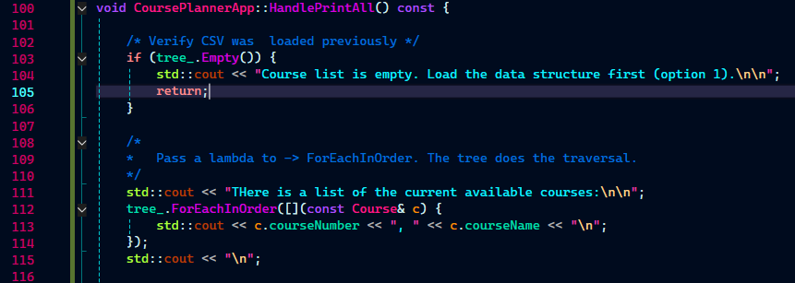
(line 103-105 in CoursePlannerApp)
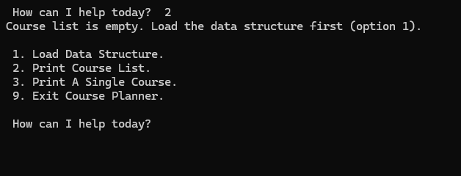
(App addresses lack of data)
- Did you meet the course outcomes you planned to meet with this enhancement in Module One?
In module one I targeted Outcome 3 – design and evaluate computing solutions using algorithmic principles and managing trade-offs – and Outcome 2 – Design, develop and deliver professional written communication that are coherent, technically sound and appropriately adapted to specific audiences and contexts – with this artifact enhancement. I believe I have met Outcome 3, the AVL and hash-set choices are both grounded in Big-O analysis of the original’s inefficiencies, and I can articulate the trade-offs.
The trade-offs being that the AVL adds a height field and rotation cost per insert to eliminate a worst case scenario (Big-O worst case scenario), the Hash set adds memory overhead to eliminate the QuickSort step.
Outcome 2 will be represented in the Technical Design Document I will be submitting alongside this.
I do have an update to my outcome-coverage plan. In the original enhancement plan I submitted in Module One, I did not address or plan for the layered architecture as part of this enhancement. This is because it only became an obvious enhancement to me after doing the code review in Module 2. However, this created an opportunity to demonstrate Outcome 4 – Demonstrate an ability to use well-founded and innovative techniques, skills and tools in computing practices for the purpose of implementing computer solutions that deliver value and accomplish industry-specific goals (software engineering/design/database). Separation of concerns, encapsulation, elimination of global state are standard practices that I used to enhance the original artifact from initial single-file program.

- Reflection
What really stood out to me is the importance of structure in a program, even a smaller program like this, but especially in large programs that I will most likely be working with in my future. Debugging is so much easier with the implementation of standard design principles. After finishing the code and rewriting the tree with self-balancing logic I had an infinite loop. The program would crash, but the visual studio call stack showed AVLTree::InsertNode being repeatedly called hundreds of times. This pointed me directly to the rotation logic, where I noticed I had made an error in the RotateLeft method and under that I had pointed to the wrong node in the RR rebalance check (node → left instead of node → right). Instead of having to scroll the file, try to find the correct area of error and try to read through the code to try to find these two tiny errors, I was directed to a single file. It took me maybe 3 minutes to find and fix the error and then the program was working as intended.

Source:
[Ref1] - GeeksforGeeks. (2024). Separation of Concerns (SoC). In GeeksforGeeks. https://www.geeksforgeeks.org/software-engineering/separation-of-concerns-soc/
[Ref2] - Obregon, A. (2023). AVL trees: In-Depth guide & java code | medium. In Medium. https://medium.com/@AlexanderObregon/avl-trees-an-in-depth-look-9a0e0481487a
[Ref3] - GeeksforGeeks. (2023). AVL tree data structure. In GeeksforGeeks. https://www.geeksforgeeks.org/dsa/introduction-to-avl-tree/

