Asset Management and Repair Ticketing System (AMS)

Technical Architecture and Functional Specification

1. Introduction
The Asset Management and Repair Ticketing System (AMS) is a centralized, LAN-hosted enterprise application designed to manage the complete lifecycle of IT and non-IT physical assets within the organization. The system delivers robust operational control over the acquisition, tagging, allocation, reallocation, repair, and condemnation of assets, while maintaining full traceability through persistent audit and lifecycle history.
This platform ensures that every procured asset is uniquely identifiable, properly documented, and efficiently allocated to employees or business units. In addition to asset management, the system embeds a structured issue/ticketing workflow, enabling employees to report asset-related problems, technicians to process and update repair progress, and administrators to finalize the post-repair disposition of assets.
AMS seamlessly integrates with internal employee identity sources and enforces strong session governance using JWT-backed authentication, DB session validation, and role-based access control. The solution is engineered with a modular Node.js + Express architecture, MariaDB persistence, and EJS-based server-rendered interfaces optimized for secure, offline, internal network environments.

Core Objectives
The AMS is engineered to:
- Establish a single definitive registry for all IT assets.
- Maintain continuous, traceable tagging of assets derived from procurement line items.
- Provide controlled and validated allocation and reallocation of assets to employees.
- Offer a structured asset health and repair life cycle using ticket-based workflows.
- Ensure audit-grade logging of every asset event, compliant with organizational governance.
- Deliver role-specific operational dashboards for Administrators, Issue Desk users, and Technicians.
- Operate securely and efficiently without internet dependency, suitable for sensitive environments.

Primary System Roles
Role | Capabilities
Admin / Asset Manager | Full asset registry control, allocation management, issue finalization, reporting dashboards
Technician | Receives assigned tickets, updates repair actions, resolves asset issues
Employee / End User | Raises asset-related issues and follows ticket progress
System Auditor (optional) | Queries life cycle history and compliance logs

Key Functional Domains
- Procurement & Acquisition Management – Ingest and structure Purchase Orders and line item details.
- Asset Tag Generation & Registry – Produce immutable asset tags and maintain asset metadata.
- Allocation and Reallocation – Manage ownership and assignment life cycle across departments.
- Maintenance & Repair Workflow – Issue creation, assignment, repair, waiting parts state, resolution, and final administrative action.
- Asset Condemnation – Govern permanent retirement of unusable assets.
- Audit & Compliance Logging – Persist chronological, tamper-evident activity logs.

1. System Overview

1.1 Purpose
This AMS is a LAN-hosted internal system for:
- Tracking procurement of IT assets (via Acquisition + Line Items)
- Creating tagged assets
- Allocating / reallocating assets to employees
- Handling repairs via an issue/ticket system
- Letting technicians work from their own dashboard
- Giving admins a consolidated dashboard (status + utilization + tickets)

1.2 Major Modules
- Acquisition & Tagging
  - Acquisition, Acqisition_Line_Items, Assets
  - Handles PO-based procurement and asset creation/tagging.
- Asset Registry & Allocation
  - Assets, Allocation, Asset_Log
  - assetAllocationService.js
  - UI: /ams/asset-management
- Issue / Ticketing
  - AssetIssue, asset_log
  - issueService (not shown but inferred)
  - Admin Issue Desk UI
  - Technician Dashboard UI
- Dashboards
  - Admin Asset Dashboard: /ams/asset/dashboard
  - Issue Desk view
  - Technician Dashboard: /ams/tech/dashboard (implied)
- Core / Security
  - JWT + cookie-based session (jwtToSession)
  - DB session validation (JwtSessionStore)
  - Path-based + menu-based authorization middleware (authenticate)

2. High-Level Architecture

2.1 Logical Architecture

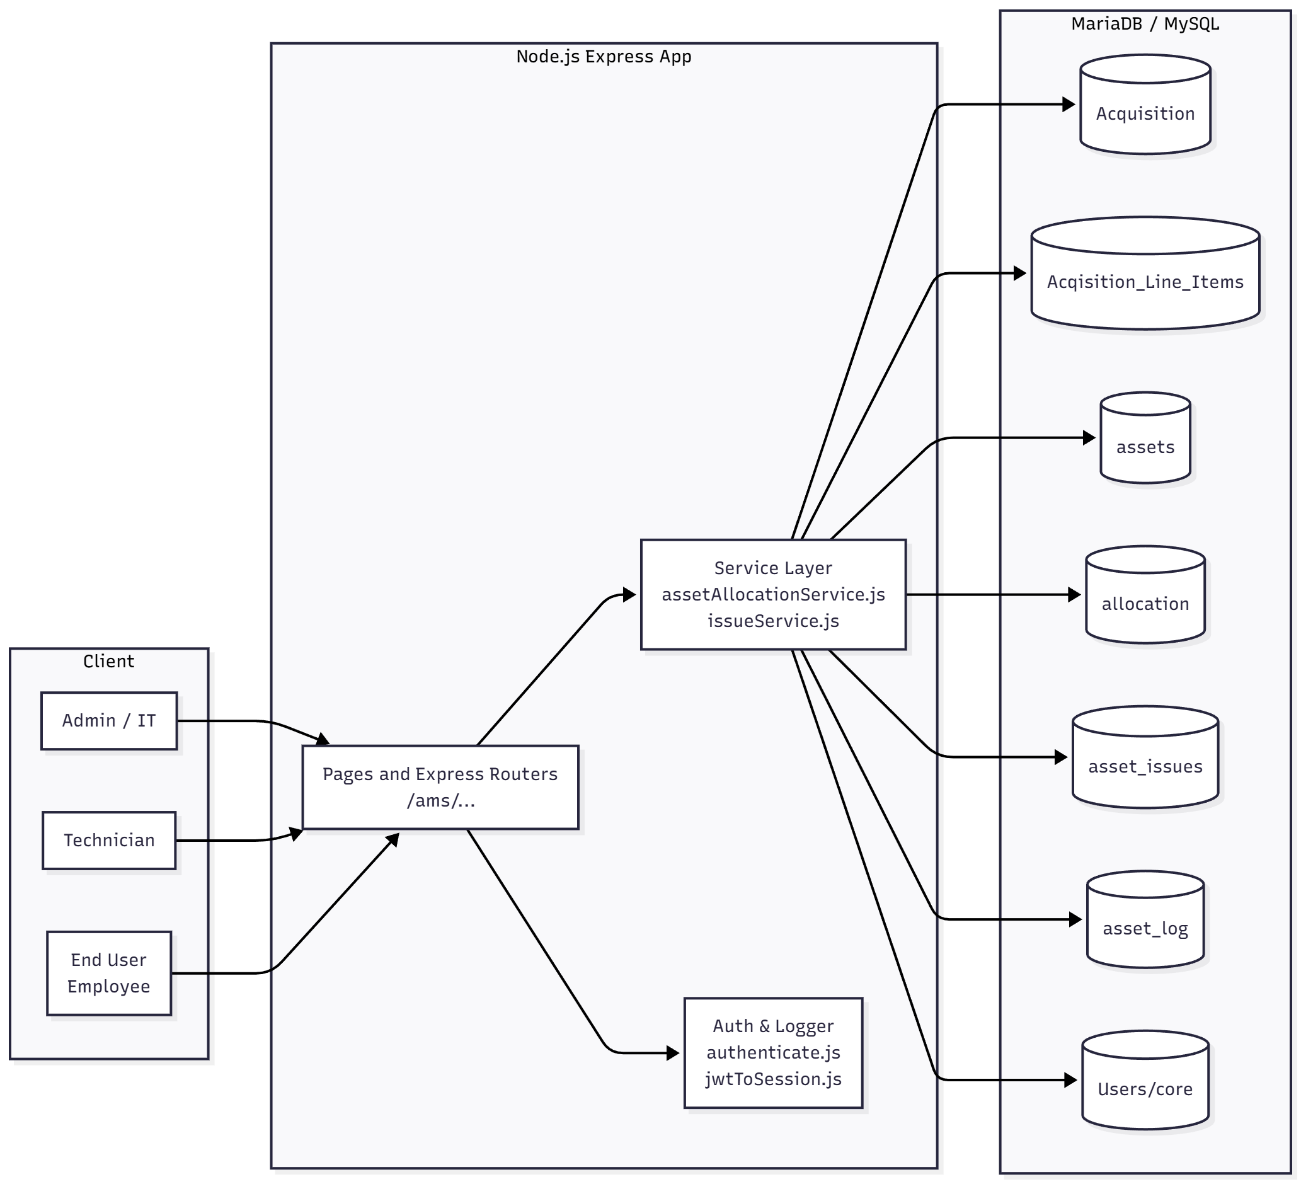

3. Data Model & Relationships

3.1 Entity Overview
Acquisition (Acquisition)
- Header for a PO.
- One Acquisition → many Acqisition_Line_Items.
AcqisitionLineItems (Acqisition_Line_Items)
- Items under a PO (type, material, qty, value…).
- Drives asset creation + available quantity.
Assets (assets)
- Physical asset registry.
- One asset has many allocation logs and many issues.
Allocation (allocation)
- Logical allocation record per tag.
- You reuse last allocation row instead of creating a new one per cycle.
AssetLog (asset_log)
- General audit log for asset lifecycle events.
AssetIssue (asset_issues)
- Ticket raised against a tag.
- Tied to repair workflow and technician dashboard.
User (User / core Users)
- Core user identity, mapped into session via JWT.

3.2 ERD
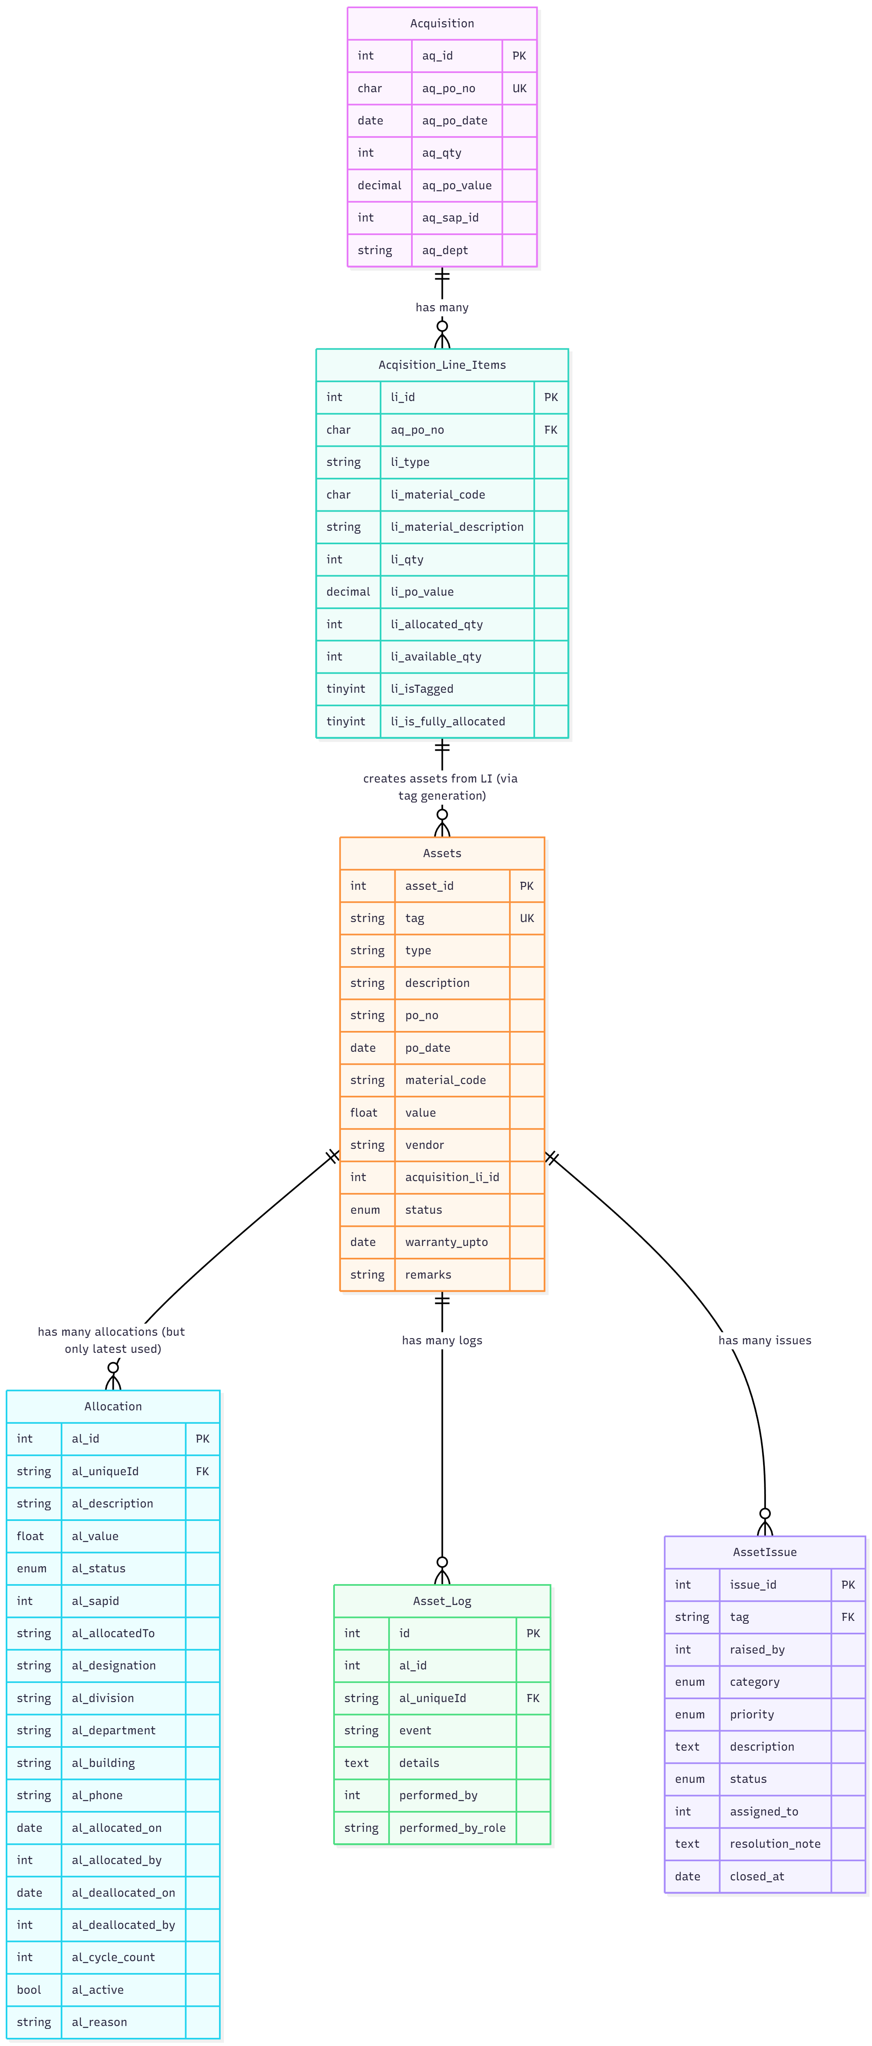

4. Business Flows

4.1 Asset Lifecycle
- Procurement
  - Acquisition created from PO header.
  - Acqisition_Line_Items created for each material.
- Tag Creation (From Line Item)
  - Admin decides to tag/allocate a unit from line.
  - assetAllocationService.allocateFromLineItem():
    - Ensures li_available_qty > 0.
    - Generates continuous tag: po_no/YYYY-MM/sequence.
    - Creates Assets row.
    - Creates Allocation row with status Alloted.
    - Updates li_allocated_qty++, li_available_qty--.
    - Logs Allocated in asset_log.
- Direct Asset Allocation (Existing Tag)
  - From /ams/asset-management.
  - assetAllocationService.allocateAsset():
    - Validates asset exists, not Condemned / Repair.
    - If no Allocation row → creates one with Alloted.
    - If last allocation row al_status = 'Free' → reuse row, update to Reallocated, increment al_cycle_count.
    - If last allocation row not free → error “Asset is already allocated. Deallocate first.”
    - Updates Assets.status accordingly.
    - Logs event in Asset_Log.
- Deallocation
  - From asset management UI, Deallocate modal.
  - assetAllocationService.deallocateAsset():
    - Locks asset & latest allocation.
    - If already Free, error.
    - Sets al_status = 'Free', al_deallocated_on, al_reason.
    - Updates Assets.status = 'Free'.
    - Logs Deallocated.
- Repair & Condemnation
  - Goes through Issue workflow (below).
  - Finalization step calls:
    - action = 'free' → mark asset free.
    - action = 'reallocate' → create/update allocation and keep asset in use.
    - action = 'condemn' → mark asset as Condemned in both Assets and Allocation, and log.

4.2 Issue Life cycle
High-level state machine:

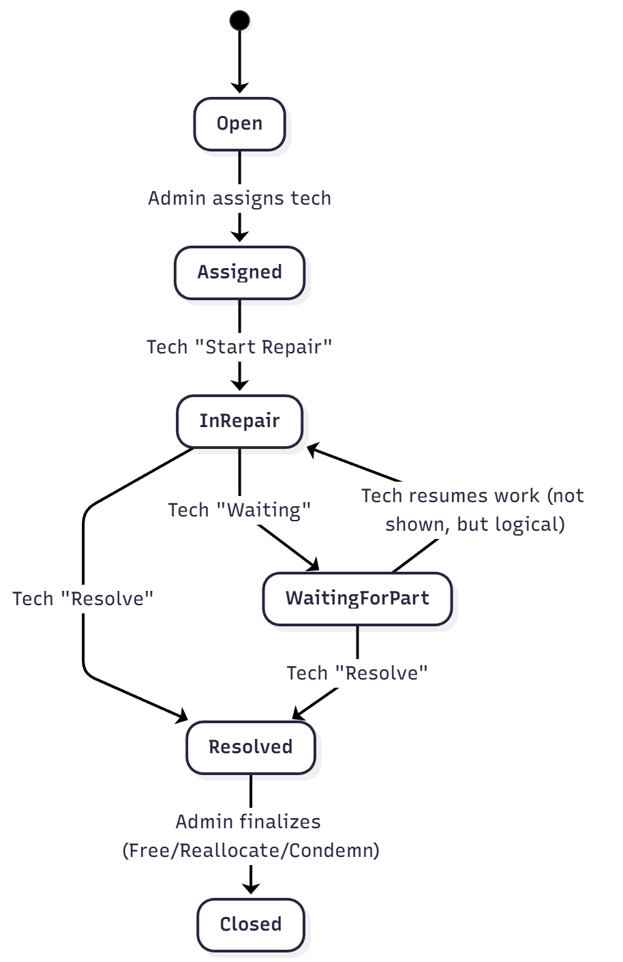

Key Roles:
- User (Employee) – raises issue against a tag.
- Admin – sees Issue Desk, assigns technicians, performs final asset state after resolution.
- Technician – works from Technician Dashboard and updates status.

5. Service Layer

5.1 assetAllocationService.js

5.1.1 generateContinuousTag(po_no, po_date, tx)
- Input: po_no, po_date, transaction tx
- Logic:
  - Reads last Assets row ordered by asset_id DESC under SELECT ... FOR UPDATE.
  - Computes next = last.asset_id + 1 (or 100001 if none).
  - Formats po_date as YYYY-MM.
  - Returns string:
"<po_no>/<YYYY-MM>/<next>".
- Notes: This is not per-PO sequence, it’s global incremental based on asset_id.

5.1.2 createAssetsFromLineItem({ li_id, quantity, tx, adminId })
- Purpose: Pre-create N Assets from a line item (without allocating).
- Flow:
  - Lock Acqisition_Line_Items row for li_id.
  - Fetch matching Acquisition to get aq_po_no, aq_po_date.
  - For quantity times:
    - Generate tag using generateContinuousTag.
    - Insert into Assets:
      - description = li_material_description
      - po_no, po_date from Acquisition
      - value = li_po_value / li_qty
      - status = 'Free'
      - remarks = "Created from LI li_id"
    - Increment li.li_created_assets.
- Transaction: Must be called inside a transaction passed via tx.back-end implementation is done needs to be triggered from front-end – pending front-end implementation.

5.1.3 allocateAsset({ tag, emp, adminId })
- Input:
  - tag – asset tag (required).
  - emp – { name, sapid, designation, division, department, phone, building, role? }.
  - adminId – acting admin (fallback to DEFAULT_ADMIN_ID).
- Behavior:
  - Opens transaction.
  - Locks Assets row where tag.
  - Rejects if asset status is Condemned or Repair.
  - Fetches last Allocation row for al_uniqueId = tag, locked.
  - Case 1 – no allocation:
    - Creates new Allocation with al_status = 'Alloted'.
    - Sets Assets.status = 'Alloted'.
    - Logs Allocated.
  - Case 2 – last allocation status Free:
    - Reuses row; updates fields with emp values.
    - Increments al_cycle_count.
    - Sets al_status = 'Alloted'.
    - Sets Assets.status = 'Alloted'.
    - Logs Reallocated.
  - Case 3 – allocation exists but not free:
    - Rolls back and throws “Asset is already allocated. Deallocate first.”
- Invariants:
  - Exactly one “current” allocation row per tag (latest by al_id).
  - Assets.status mirrors the high-level status visible in UI.

5.1.4 deallocateAsset({ tag, reason, adminId })
- Purpose: Mark latest allocation row as free and asset as free.
- Flow:
  - Open transaction.
  - Lock Assets row (by tag).
  - Lock latest Allocation row (by al_uniqueId).
  - If al_status = 'Free', error.
  - Update allocation:
    - al_status = 'Free'
    - al_deallocated_on = now()
    - al_deallocated_by = adminId
    - al_reason = reason
  - Update Assets.status = 'Free'.
  - Insert Asset_Log event Deallocated.

5.1.5 allocateFromLineItem({ li_id, emp, adminId })
- Purpose: One-shot creation + allocation from acquisition line item (used by legacy list-acquisition UI).
- Flow:
  - Lock line item row.
  - Ensure li.li_available_qty > 0.
  - Fetch corresponding Acquisition.
  - Generate new tag.
  - Insert Assets with:
    - type = li.li_type
    - status = 'Alloted'
    - remarks = 'Created and allocated from LI li_id'
  - Create Allocation row set to Alloted.
  - Log Allocated.
  - Update li_allocated_qty++, li_available_qty--.

5.2 issue Service

5.2.1 raiseIssue({ tag, raised_by, category, description })
- Creates an AssetIssue with:
  - status = 'Open'
  - priority default Medium
- Adds log: "Issue raised by user <id>".

5.2.2 assignTechnician({ issue_id, technicianId, adminId })
- Valid only if current status is Open.
- Updates:
  - status = 'Assigned'
  - assigned_to = technicianId
- Adds log: "Assigned to technician <id> by admin <adminId>".

5.2.3 updateTechnicianStatus({ issue_id, technicianId, action, note })
- Maps to status transitions for technician dashboard:
  - action = 'start-repair' → InRepair
  - action = 'waiting' → WaitingForPart
- Writes an asset_issues update and an asset_log entry containing the note.

5.2.4 completeRepair({ issue_id, technicianId, resolution })
- Valid only for InRepair or WaitingForPart.
- Updates issue:
  - status = 'Resolved'
  - resolution_note = resolution
  - closed_at = now()
- Logs "Resolved by technician <id>: <resolution>".

5.2.5 adminFinalizeRepair({ issue_id, adminId, action, emp? })
Backed by /ams/admin/api/issues/finalize:
- Uses issue_id to get AssetIssue, tag, and latest Allocation.
- Branches:
  - action = 'free'
    - Calls deallocateAsset({ tag }).
    - Sets issue status = 'Closed'.
    - Logs "Finalized as free.".
  - action = 'reallocate'
    - Calls allocateAsset({ tag, emp }) with new employee details.
    - Sets issue status = 'Closed'.
    - Logs "Finalized by reallocating to <emp>.".
  - action = 'condemn'
    - Sets Assets.status = 'Condemned'.
    - Last Allocation status = Condemned.
    - Issue status = 'Closed'.
    - Logs "Asset condemned.".

6. API Documentation

6.1 Asset Management APIs

6.1.1 GET /ams/asset-management
- Auth: isAuthenticated
- Description: Renders Asset Management page with Tabulator grid.
- Response: HTML (EJS template ams/assetManagement/list-assets).

6.1.2 GET /ams/api/assets
- Auth: isAuthenticated
- Query Params:
  - filter: all|free|alloted|reallocated|repair|condemned (case-insensitive).
  - q: optional string; searches al_uniqueId, al_description, al_allocatedTo, al_sapid.
- Behavior:
  - Builds where based on filter + search.
  - Returns all Allocation rows matching, ordered by al_id DESC.
- Response (200):
{
"success": true,
"data": [
{
"al_id": 1,
"al_uniqueId": "PO123/2025-01/100001",
"al_description": "Laptop Dell...",
"al_status": "Alloted",
"al_allocatedTo": "EMP NAME",
"al_sapid": 12345,
"al_department": "IT",
"al_cycle_count": 0,
...
}
]
}
Note: Your frontend expects json.counts for badges, but current route returns only data. Either update route to compute counts or adjust frontend to compute them client-side.

6.1.3 POST /ams/api/asset/allocate
- Auth: isAuthenticated
- Body (JSON):
{
"al_uniqueId": "TAG-123",
"empname": "John Doe",
"sapid": 12345,
"designation": "Engineer",
"division": "IT",
"department": "IT",
"phone": "9876543210",
"building": "Main Block"
}
- Behavior:
  - Builds emp object from body; passes to assetService.allocateAsset.
  - Conflict if already allocated.
- Responses:
  - 200:
{
"success": true,
"action": "Allocated",
"allocation": { ...latest allocation row... }
}
- 409: asset already allocated.
- 400: missing required fields.

6.1.4 POST /ams/api/asset/deallocate
- Auth: isAuthenticated
- Body:
{
"al_uniqueId": "TAG-123",
"reason": "User resigned"
}
- Behavior:
  - Calls deallocateAsset.
- Response:
{
"success": true,
"action": "Deallocated",
"allocation": { ... }
}

6.1.5 GET /ams/api/asset/history/:tag
- Auth: isAuthenticated
- Path Params:
  - tag – asset tag
- Behavior:
  - Fetches AssetLog where al_uniqueId = tag ordered by id ASC.
- Response:
{
"success": true,
"data": [
{
"id": 1,
"al_uniqueId": "TAG-123",
"event": "Allocated",
"details": "Allocated to John Doe (12345)",
"performed_by": 999999,
"performed_by_role": "Admin",
"createdAt": "2025-11-14T10:00:00.000Z"
}
]
}

6.2 Issue / Ticket APIs (Admin + User)

6.2.1 POST /ams/api/issues/raise
- Auth: isAuthenticated (user)
- Body:
{
"tag": "TAG-123",
"category": "Hardware",
"description": "System not booting"
}
- Behavior:
  - raised_by = req.session.user.id
  - Delegates to issueService.raiseIssue.
- Response:
{
"success": true,
"issue": {
"issue_id": 45,
"tag": "TAG-123",
"status": "Open",
"category": "Hardware",
"description": "System not booting",
"raised_by": 10001,
...
}
}

6.2.2 POST /ams/api/issues/assign (Admin assigns technician)
- Auth: isAuthenticated (admin)
- Body:
{
"issue_id": 45,
"assigned_to": 201
}
- Behavior:
  - issueService.assignTechnician({ issue_id, technicianId, adminId }).
- Response:
{
"success": true,
"issue": { ...updated issue... }
}

6.2.3 POST /ams/api/issues/resolve (Tech resolves)
- Auth: isAuthenticated (technician)
- Body:
{
"issue_id": 45,
"resolution": "Replaced SMPS and tested OK"
}
- Behavior:
  - issueService.completeRepair(...).
- Response:
{ "success": true, "issue": { ...status: "Resolved"... } }

6.2.4 POST /ams/api/issues/tech-update
- Auth: isAuthenticated (technician)
- Body:
{
"issue_id": 45,
"action": "InRepair" | "WaitingForPart",
"note": "Part ordered from store"
}
- Behavior:
  - Maps technician actions from dashboard to status changes.
- Response:
{ "success": true, "issue": { ...updated... } }

6.2.5 POST /ams/admin/api/issues/finalize
- Auth: isAuthenticated (admin)
- Body:
{
"issue_id": 45,
"action": "free" | "reallocate" | "condemn",
"emp": {
"name": "New User",
"sapid": 5555,
"designation": "...",
"division": "...",
"department": "...",
"phone": "...",
"building": "..."
}
}
- emp is mandatory only for reallocate.
- Response:
{
"success": true,
"result": {
"issue": { "status": "Closed", ... },
"asset": { ... },
"allocation": { ... }
}
}

6.3 Technician APIs
Your technician dashboard JS currently uses:
- GET /ams/api/tech/issues – returns all issues assigned to the logged-in technician.
- POST /ams/api/tech/issues/update – updates status (Assigned → InRepair / WaitingForPart).
- POST /ams/api/tech/issues/resolve – resolves the ticket.
In your latest routes/ams/issues.js, you’ve named them:
- /ams/api/issues/resolve
- /ams/api/issues/tech-update

6.4 Utility AJAX APIs
From your older route chunk:
- GET /ams/asset/fetch-fill-data?s_id=...
  - Hits remote CORE API over HTTPS with client cert.
  - Returns employee data for auto-fill.
- GET /ams/asset/fetch-tagSuggestion?value=..&type=empname|sapid|phone|building|designation|dept
  - Various suggestions and auto-fill from Employee and Asset tables.
- GET /ams/asset/fetch-assetStatus?type=...
  - Reads from constants table for asset status transitions.
- PUT /ams/asset/condemn_asset
  - Older condemn flow that touches Tag, Asset, Issue, AssetLog.
  - Newer design pushes condemnation via adminFinalizeRepair.

7. Dashboards

7.1 Admin Asset Dashboard (/ams/asset/dashboard)
- Data Sources:
  - Acquisition for total asset count & total value per department.
  - assets.type for pie distribution.
  - Latest allocation subquery for status counts.
  - allocation + asset_issues for utilization and ticket counts.
- Key Metrics:
  - finalTotal: sum of aq_qty for admin’s department.
  - totalValue: sum of aq_po_value.
  - Status counts: allocated, free, repair, condemned.
  - utilization = (allocated / totalAssets) * 100.
  - deptDist: department-wise ownership counts.
  - Monthly trends for Allocated, Condemned, Repair.
  - Ticket stats: total, pending (Open|Assigned|InRepair|WaitingForPart), closed (Resolved|Closed).

7.2 Issue Desk (Admin)
- Tabulator-based list of active tickets (primarily Open/Assigned/InRepair/Resolved).
- Actions:
  - Assign technician.
  - View details.
  - Finalize resolved tickets as Free/Reallocate/Condemn.
- Uses:
  - /ams/api/issues/assign
  - /ams/admin/api/issues/finalize
  - /ams/admin/issues/get-last-allocation/:tag (needs matching backend)
  - /ams/admin/issues/:id for full details.

7.3 Technician Dashboard
- Stats: Assigned, In Repair, Waiting for Part, Resolved (for this technician).
- Filter tabs by status.
- Ticket cards show:
  - Tag, category, description.
  - Current status badge.
- Actions:
  - Start Repair → InRepair.
  - Waiting for Part → WaitingForPart.
  - Resolve → opens resolution modal.

8. Security & Auth

8.1 JWT + Session Flow
- Login happens via core app; successful login issues:
  - token – user JWT with id, name, unit, grade, theme, department, session_id.
  - permToken – JWT containing compressed menus.
- jwtToSession middleware:
  - Decrypts & verifies both tokens using JWT_SECRET.
  - Inflates menu JSON via zlib.
  - Writes:
req.session.user = {
id,
name,
unit,
grade,
theme,
department,
currentPath,
menus,
session_id
};
req.user = decoded; // for quick access

8.2 Authorization Middleware
- Validates:
  - Domain (req.hostname vs SESSION_DOMAIN).
  - If path is allowed (APP_ALLOWED_PATHS env).
  - If AJAX/fetch request → still validates DB session but can bypass menu checks.
  - inDBSession() ensures JwtSessionStore has most recent session_unique matching current session_id.
  - isPageInMenus() matches requested path (with numbers and :id stripped) against user’s menus.
- If mismatch:
  - Redirects to login with appropriate error message.

9. Deployment

9.1 Runtime & Dependencies
- Node.js: >= 20 recommended.
- Database: MariaDB/MySQL.
- Web Server: Nginx reverse proxy (HTTPS, port 443) → Node app (port 3003 or similar).
- Process Manager: PM2.

9.2 Environment Variables
Core ones inferred from code:
- JWT_SECRET – JWT signing/verification.
- SESSION_DOMAIN – domain validation for requests.
- APP_ALLOWED_PATHS – comma-separated list of public endpoints.
- DEV_SSL_CERT_PATH, DEV_SSL_KEY_PATH, DEV_SSL_PASS_PHRASE – for axios HTTPS to core API.
- DB connection vars (host, user, password, DB name) inside config/database.js.

9.3 Suggested Directory Layout
Project-root || ams/
config/
database.js
coredb.js
middlewares/
authenticate.js
authS.js
logger.js
noCache.js
models/
Acquisition.js
AcqisitionLineItems.js
Assets.js
Allocation.js
AssetLog.js
AssetIssues.js
core/
Users.js
JwtSessionStore.js
Constants.js
routes/
ams/
dashboardRoutes.js
assetManagementRoutes.js
issues.js
...
services/
assetAllocationService.js
issueService.js
views/
ams/
dashboard.ejs
assetManagement/
issues/
tech/
partials/
header.ejs
footer.ejs
public/
css/
js/
logs/
server.js / app.js

