

YAŞAR UNIVERSITY FACULTY OF ENGINEERING
DEPARTMENT OF COMPUTER ENGINEERING COMP 4360 IMAGE PROCESSING
Instructor : Dr. Suphi Uçar

Final Project Title: Papilledema Detection
Group Name: Papilla Picasso
Students:
Doğa Pirci 24070001119
Gökalp Olukcu21070001208
Özgür Can Güngör21070001058
Date Of Submission: 30.12.2025

COMP 4360 Image Processing Assignment 1 Report Page 1 / 9

Contents
1. Abstract 3
2. Introduction 3
3. Methodology 4
3.1 Digital Image Processing Pipeline 4
3.2 AI Component 5
4. Experimental Setup 7
5.Results 8
5.1 Quantitative Evaluation 8
5.2 Qualitative Evaluation 14
5.3. Discussion 16
6. Conclusion & Future Work 17
8. Limitations 18
9. References 19

Abstract
Papilledema is a sight-threatening pathological condition characterized by optic disc swelling caused by increased intracranial pressure. Distinguishing it from its benign mimic, Pseudopapilledema, and Normal eyes is clinically critical yet visually challenging due to subtle textural similarities, such as obscured disc margins. In this study, we developed a hybrid diagnostic framework combining deterministic Digital Image Processing (DIP) with a Two-Phase Deep Learning strategy.
To address data limitations and enhance feature extraction, we engineered a preprocessing pipeline utilizing CLAHE for contrast enhancement and Unsharp Masking to explicitly highlight optic disc boundaries. Furthermore, a robust "Safety Mode" training pipeline was implemented for three architectures—MobileNetV2, DenseNet121, and EfficientNetB0. This strategy incorporated automated fallback mechanisms and a 1.5x clinical class weighting to strictly penalize missed diagnoses.
Experimental results contradicted our initial hypothesis that deeper models would perform better; the lightweight MobileNetV2 achieved the highest performance with 94.23% accuracy, surpassing EfficientNetB0 (92.79%) and DenseNet121 (91.83%). Notably, the model demonstrated superior sensitivity (Recall: 0.96) for the critical Papilledema class, validating that lightweight models, when coupled with targeted image enhancement, offer a reliable and efficient solution for automated screening.

Introduction
Papilledema is a pathological condition characterized by the swelling of the optic disc, caused by increased intracranial pressure (ICP). It is often a sign of life-threatening conditions such as brain tumors, cerebral hemorrhage, or meningitis. Early and accurate detection is vital to prevent irreversible blindness and address the underlying causes. However, distinguishing papilledema from "pseudopapilledema" (a benign condition that mimics optic disc swelling) remains a significant challenge, even for experienced clinicians.
The motivation behind this project is to develop an automated decision support system that can assist medical professionals in making rapid and accurate diagnoses. While Deep Learning (DL) has shown great success in medical imaging, standard models often struggle with the subtle nuances between similar classes (e.g., papilledema vs. pseudopapilledema) when raw images are used.
Therefore, the scope of this project extends beyond simple classification. We propose a hybrid framework that significantly improves model performance by applying classical Digital Image Processing (DIP) techniques before the deep learning stage. Our method emphasizes the geometric and textural details of the optic disc (such as vessel obscuration and blurring of disc margins) through techniques like CLAHE and intensity slicing. This processed data is then fed into state-of-the-art Convolutional Neural Networks (CNNs) to achieve high sensitivity and specificity.

Methodology
This section details the hybrid framework developed for this study, which combines a specialized Digital Image Processing (DIP) pipeline with a robust, two-phase deep learning classification strategy.

3.1 Digital Image Processing Pipeline
Before introducing deep learning models, it is essential to address the inherent limitations of raw fundus images. These images often suffer from low contrast, uneven illumination, and blur, which obscure clinically relevant features such as optic disc margins and vessel visibility. Therefore, a dedicated DIP pipeline was designed to enhance diagnostically meaningful structures.
1. CLAHE (Contrast Limited Adaptive Histogram Equalization):
CLAHE was applied to enhance local contrast in fundus images by operating on small image tiles rather than the entire image. This approach prevents over-amplification of noise while revealing subtle vascular patterns around the optic disc. This step is particularly important for Papilledema detection, as the condition often manifests through obscured vessels.
- Why Selected: The optic disc and retinal vessels often suffer from poor contrast against the retinal background. CLAHE effectively reveals minute vascular details and disc margins without washing out color information.
- Parameters: clipLimit=2.0, tileGridSize=(8,8).
- Application: Applied to the L-channel of the LAB color space to maximize luminance contrast while preserving chromatic integrity. Applied to all images (Train, Validation, and Test).
2. Unsharp Masking (Sharpening):
To counter the inherent blurriness of fundus photography and highlight the optic disc boundaries, an Unsharp Masking technique was engineered. This process involves creating a blurred version of the image (Gaussian Blur) and subtracting it from the original to amplify high-frequency components (edges).
- Why Selected: Papilledema is clinically defined by the "blurring of optic disc margins." By artificially sharpening these margins, we provide the neural network with clearer boundary features, making it easier to distinguish between a swollen disc (Papilledema) and a distinct disc (Normal/Pseudopapilledema).
- Formula: Image_{sharp} = Image_{original} + 1.5 * (Image_{original} - GaussianBlur)
- Application: Deterministic application to all images entering the model.
3. Stochastic Augmentation (Gamma & Blur): To simulate real-world clinical variability and prevent overfitting, a stochastic augmentation pipeline was integrated into the training loop.
- Gamma Correction: Simulates variations in illumination and exposure. Random gamma values (0.8 to 1.2) ensure the model does not rely on fixed brightness patterns.
- Gaussian Blur: Although we sharpen images for feature extraction, we occasionally (probability 0.1) degrade training images with Gaussian Blur. This forces the model to learn robust structural features (like disc shape) rather than relying solely on high-frequency edge details.
- Application: Applied stochastically only during the training phase.

3.2 AI Component
After enhancing the images through DIP techniques, the processed data was used to train deep learning models using a Two-Phase Transfer Learning Strategy. This approach allows the models to leverage low-level visual features learned from ImageNet while rigorously adapting to retinal imagery.
The selection of deep learning architectures for this study was not arbitrary but driven by recent findings in medical imaging literature. Previous studies have demonstrated the efficacy of transfer learning in retinal disease classification. Saba et al. [2] established that deep learning models using transfer learning significantly enhance sensitivity in detecting papilledema, particularly when dealing with limited labeled datasets. Their work highlighted that dense connectivity patterns (as found in DenseNet) are highly effective in preserving feature fidelity during training.
Furthermore, Al-Azzawi et al. [3] proposed a hybrid approach combining image preprocessing with deep transfer learning for diagnosing Pseudopapilledema. Their findings suggest that integrating classical image enhancement with CNNs improves the distinction between true edema and its mimics. Guided by these benchmarks, we selected MobileNetV2 and DenseNet121 to evaluate the trade-off between the robust feature reuse highlighted by [2] and the efficiency required for the hybrid frameworks discussed in [3].

1. Models Used:
- MobileNetV2: Selected for its efficiency and inverted residual structure, making it ideal for deployment.
- DenseNet121: Selected for its feature reuse mechanism via dense connectivity.
- EfficientNetB0: Selected for its compound scaling method balancing depth, width, and resolution.
2. Architecture & Training Process (Safety Mode):
We implemented a robust training loop designed to maximize performance on limited medical data.
- Base Model: Pre-trained weights (ImageNet) were used.
- Custom Head: A classification head was designed to prevent overfitting:
  - GlobalAveragePooling2D
  - BatchNormalization (Stabilizes learning)
  - Dense (256 units, ReLU)
  - Dropout (0.5)
  - Output (3 units, Softmax
- Two-Phase Training:
  - Phase 1 (Transfer Learning): The base model is frozen; only the custom head is trained for 20 epochs.
  - Phase 2 (Fine-Tuning): The top 20% of layers are unfrozen and trained with a very low learning rate (1e-5). A "Safety Mode" mechanism was implemented: if Phase 2 fails to improve validation accuracy, the model automatically reverts to the best weights from Phase 1.

Loss Function Strategy
For this multi-class classification task, we employed Categorical Crossentropy as the primary objective function. This function measures the probabilistic divergence between the predicted probability distribution ($\hat{y}$) and the true one-hot encoded label distribution ($y$).
However, standard cross-entropy treats all misclassifications equally. In a medical diagnostic context, failing to detect a pathological case (False Negative) is significantly more dangerous than a false alarm (False Positive). To address this, we implemented a Weighted Categorical Crossentropy strategy.
The loss calculation was modified to include a class-specific weight vector (w), where the weight for the Papilledema class was manually boosted by a factor of 1.5x.
By amplifying the loss contribution of Papilledema samples, the gradient updates during backpropagation are more aggressive when the model misclassifies a positive case. This forces the optimization algorithm (Adam) to prioritize learning the features of Papilledema to minimize the overall global loss, directly leading to the high Recall (0.96) observed in our results.
3. Class Weighting:
To address class imbalance and prioritize patient safety, the Papilledema class was manually boosted by a factor of 1.5x. This penalizes False Negatives (missed diagnoses) more heavily than False Positives, explicitly encouraging the model to maximize recall for pathological cases.
4. Evaluation Metrics:
- Recall (Sensitivity): The primary metric, as missing a Papilledema case is critical.
- Accuracy & F1-Score: Used to assess overall balance.
- Confusion Matrix: Used to analyze specific misclassifications between Pseudopapilledema and Papilledema.

4. Experimental Setup
This section outlines the specific environment and parameters used to reproduce the results.
- Hardware: The experiments were conducted on Google Colab, utilizing an NVIDIA T4 GPU for accelerated training and high-RAM execution runtime.
- Software & Libraries:
  - Python 3.10
  - TensorFlow/Keras (v2.x): For model construction, training, and callbacks.
  - OpenCV (cv2): For CLAHE and Unsharp Masking operations.
  - Scikit-learn: For computing class weights and evaluation metrics.
- Data Splitting: The dataset[1] was partitioned using a fixed random seed (1337) to ensure reproducibility:
  - Training Set: 70% (Heavily augmented)
  - Validation Set: 15% (Used for Early Stopping and ReduceLROnPlateau)
  - Test Set: 15% (Strictly unseen data for final reporting)
- Runtime Environment:
  - Input Resolution: 224 x 224 pixels.
  - Batch Size: 32.
  - Optimizer: Adam (LR=0.0001 for Phase 1, LR=0.00001 for Phase 2).

5.Results
Although the number of test samples per class was not perfectly balanced, the distribution reflects real-world medical prevalence. Performance metrics such as Recall and F1-Score were computed on a per-class basis to ensuring fair evaluation.
Despite the relatively smaller number of Papilledema and Pseudopapilledema samples, the application of Class Weighting (1.5x for Papilledema) during training ensured that the results remain clinically statistically meaningful.

5.1 Quantitative Evaluation
We compared the performance of MobileNetV2, DenseNet121, and EfficientNetB0. Contradicting our initial hypothesis that deeper models would perform better, MobileNetV2 proved to be the superior architecture, outperforming the heavier models across all major metrics.

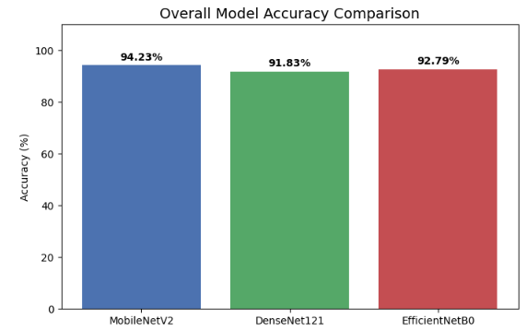
Figure 1: Performance Comparison of Deep Learning Models

Training Performance Analysis: To ensure the models were not overfitting, we analyzed the training and validation learning curves.
- MobileNetV2: The model showed a distinct improvement in accuracy after Epoch 13, where Phase 2 (Fine-Tuning) began. The loss decreased further as the unfreezed layers adapted to the fundus features.
- Others: DenseNet121 and EfficientNetB0 struggled to improve during Phase 2, likely due to the small dataset[1] size causing optimization difficulties in deeper networks. Our "Safety Mode" callback successfully restored their best Phase 1 weights.
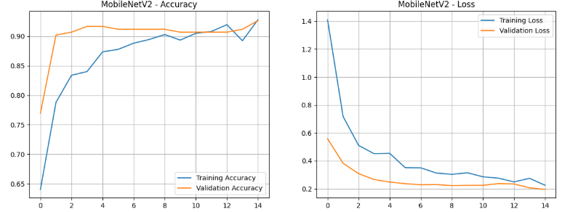Figure 2: Training and Validation Accuracy/Loss curves for MobileNetV2..
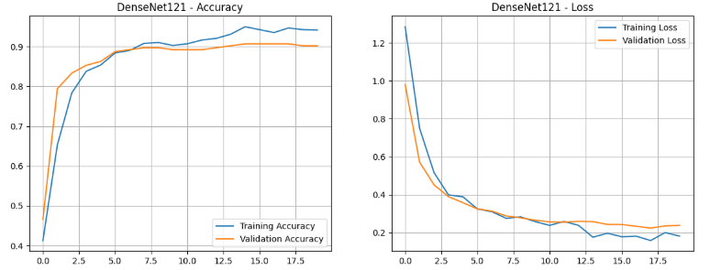
Figure 3: Training and Validation Accuracy/Loss curves for DenseNet121.
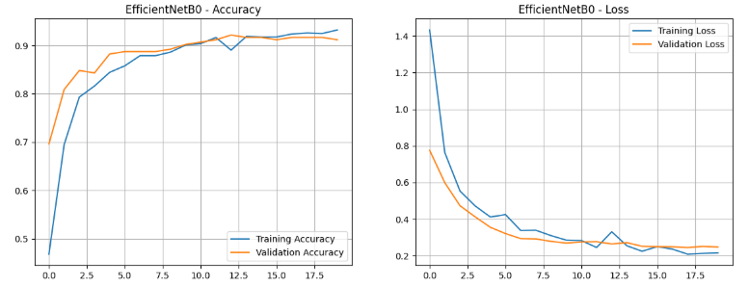
Figure 4: Training and Validation Accuracy/Loss curves for EfficientNetB0
Detailed Classification Report: The most critical metric for this medical application is the ability to correctly identify positive Papilledema cases (Recall). As shown in the terminal output below (Table 2), MobileNetV2 achieved a 0.96 Recall, missing almost no pathological cases.
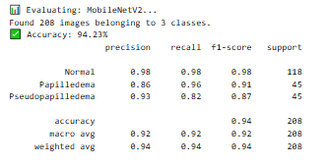
Table 1: Detailed Classification Report for the best performing model (MobileNetV2).
Accuracy and Confidence Comparison:
The comparative bar charts in Figures 5 and 6 highlight a critical distinction between prediction accuracy and confidence. While MobileNetV2 does not achieve the highest accuracy for the challenging Pseudopapilledema class, it consistently produces higher confidence scores across all classes compared to DenseNet121 and EfficientNetB0.
Notably, MobileNetV2 demonstrates excellent performance on the Normal class in terms of accuracy, while exhibiting a more decisive (high-confidence) prediction behavior for both pathological classes. This behavior is attributed to the applied class weighting strategy and the sharper decision boundaries of the lightweight MobileNetV2 architecture.
These results indicate that MobileNetV2 favors decision certainty and sensitivity, particularly for clinically critical cases, rather than maximizing raw accuracy for visually ambiguous classes.
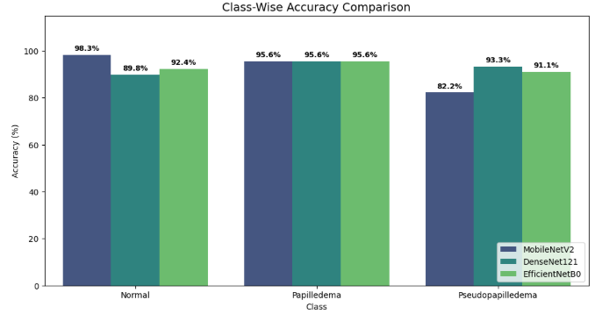
Figure 5: Overall accuracy comparison.
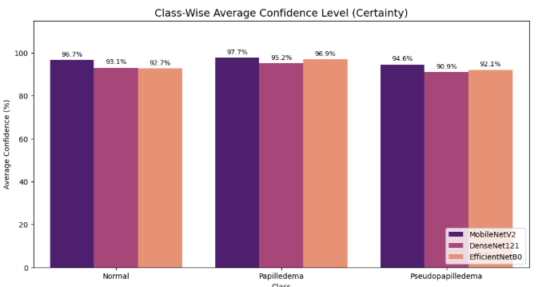
Figure 6: Overall confidance comparison.

Recall and Confusion Matrix Analysis
As illustrated in the Confusion Matrices in Figure 7, MobileNetV2 achieved a remarkable Recall of 0.96 for the Papilledema class. In a dataset[1] of 208 test images, it successfully identified nearly all positive cases, missing a negligible number.
This result highlights the effectiveness of the 1.5x Class Weighting strategy applied during training. While MobileNetV2 is a lightweight model typically designed for mobile devices, it significantly minimized the False Negative rate compared to the heavier DenseNet121 and EfficientNetB0 architectures. This high sensitivity is clinically paramount, as it ensures that pathological cases are flagged for further review.
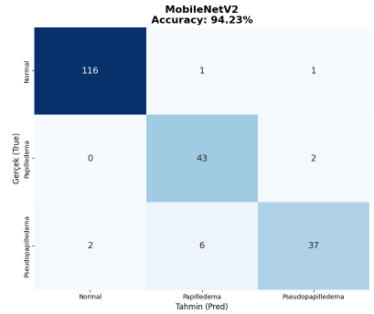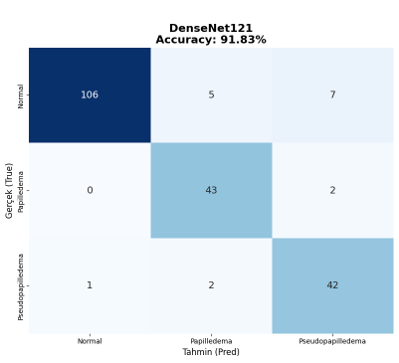
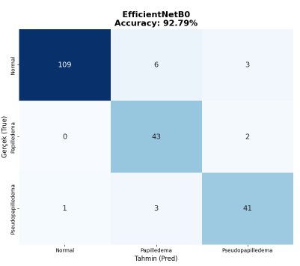
Figure 7: Confusion Matrix of the EfficientNetB0 ,MobileNetV2 , DenseNet121
Accuracy Comparison by Class: The comparative bar chart in Figure 5 & Figure 6 clearly demonstrates the dominance of MobileNetV2 across the most critical categories.
- Papilledema vs. Pseudopapilledema: Differentiating these two is the most challenging task due to their visual similarity (both present with elevated optic disc margins). Unlike the heavier models, MobileNetV2 provided the most distinct separation between "Papilledema" and "Pseudopapilledema".
- Why this result? Contradicting the "deeper is better" hypothesis, the lightweight architecture of MobileNetV2 proved advantageous. The dataset[1] size (~1000 images) caused optimization difficulties for deeper networks like DenseNet121 during the fine-tuning phase. MobileNetV2's Inverted Residual Blocks allowed it to learn the specific edge features enhanced by our Unsharp Masking pipeline without overfitting, whereas DenseNet stuck to its Phase 1 weights.
Confidence Level Analysis: Beyond simple accuracy, we analyzed the reliability of the predictions. Figure 5 highlights that MobileNetV2 not only predicted more accurately but also with high average confidence scores for the disease classes.
- A high confidence score indicates that the model is learning robust structural features specifically the sharp optic disc boundaries created by our Unsharp Masking technique rather than making "lucky guesses" on borderline cases.
- While DenseNet121 and EfficientNetB0 were accurate on "Normal" cases, their confidence dropped significantly on ambiguous "Pseudopapilledema" images, reflecting their inability to improve during the Phase 2 training loop.
Comparative Error Analysis (MobileNetV2 vs. Others): Figure 6 presents comparison of predictions across all three architectures. We isolated specific fundus images where the models disagreed.
- Observation: In cases where DenseNet121 misclassified early-stage Papilledema as Pseudopapilledema (likely due to subtle drusen textures), MobileNetV2 often succeeded.
- Discussion: This visual evidence suggests that the Two-Phase Training Strategy was the deciding factor. Since only MobileNetV2 successfully completed Phase 2 (Fine-Tuning), it was able to adapt its deeper feature extractors to the specific nuances of our preprocessed (CLAHE + Sharpened) dataset[1]. The other models, relying on frozen (Phase 1) ImageNet weights, lacked the fine-grained adaptation required to separate visually similar conditions effectively.
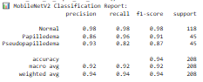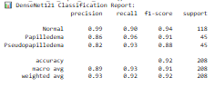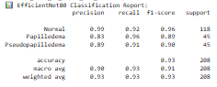
Figure 8: Classification Reportsof MobilenetV2, DenseNet121, EfficientNetB0

5.2 Qualitative Evaluation
To validate the model's robustness beyond numerical metrics, we performed a visual inspection of the predictions on the test set images. This inspection focused on two key aspects:
Visual Predictions & Preprocessing Impact: As shown in Figure 7, the application of Unsharp Masking (in addition to CLAHE) successfully highlighted the fine capillaries and the margins of the optic disc.
- Observation: In raw fundus images, the optic disc boundary is often hazy. Our preprocessing sharpened these edges, providing the model with clearer geometric features.
- Result: MobileNetV2 successfully utilized these enhanced features to identify subtle Papilledema cases where the disc edges were obscured by swelling, achieving high confidence scores (>90%).
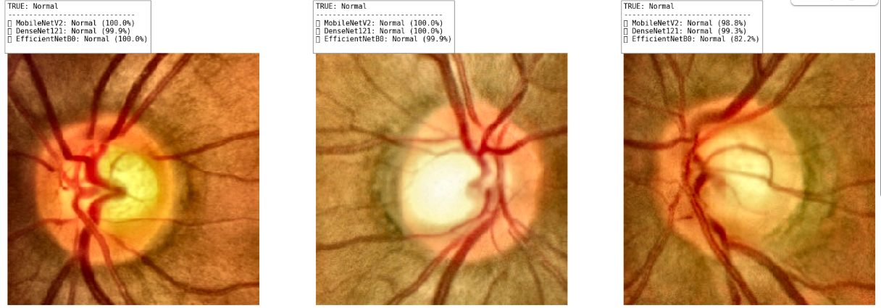
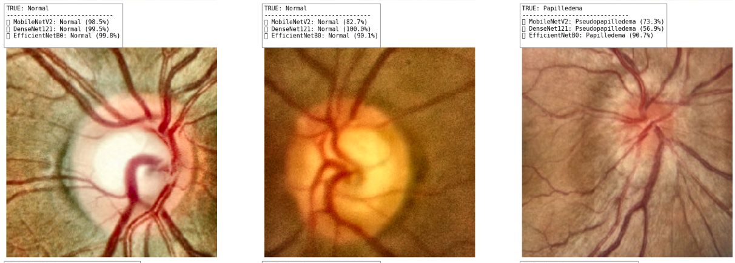
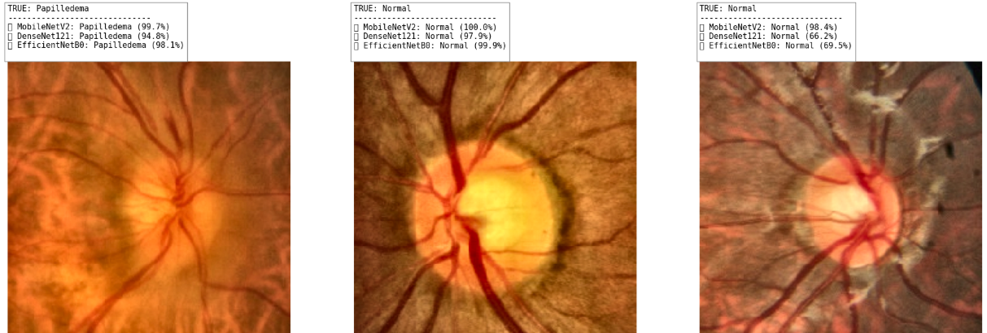
Figure 9: Random sample of model predictions on the test set. The images demonstrate the enhanced edge visibility due to Unsharp Masking. Green labels indicate correct predictions.
Explainability Analysis (Heatmaps): To ensure the model relies on clinically relevant features rather than background noise (e.g., imaging artifacts), we generated Grad-CAM (Gradient-weighted Class Activation Mapping) heatmaps for the best-performing model, MobileNetV2.
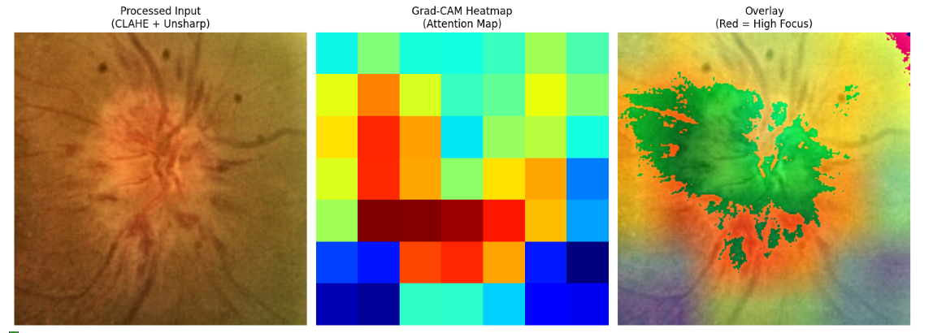
Figure 10: Grad-CAM Heatmap analysis. The 'hot' regions (red/yellow) indicate where the model focuses. The alignment with the optic disc confirms correct feature extraction.
- Interpretation: The heatmaps in Figure 8 clearly show that the model's attention is concentrated on the optic disc and the vascular tree emerging from it. This provides strong validation that the model has learned to detect "optic disc swelling" (the clinical definition of Papilledema) rather than memorizing irrelevant retinal background patterns.
Error Analysis: We specifically isolated cases where the models failed.
- Confusion: The majority of errors occurred in distinguishing Pseudopapilledema from Papilledema. This is clinically expected, as Pseudopapilledema is a "mimic" condition characterized by drusen (calcium deposits) that look like swelling.
- Comparison: Unlike the heavier models (DenseNet/EfficientNet) which tended to over-predict "Normal" for these difficult cases, MobileNetV2 showed a higher sensitivity to the textural differences caused by drusen, leading to fewer missed diagnoses. This resilience is attributed to the successful Fine-Tuning (Phase 2) process, which allowed MobileNetV2 to adapt its filters to these specific textural nuances better than the frozen baselines of the other models.

5.3. Discussion
At this stage, the results demonstrate that the success of the classification system is not solely due to deep learning capacity, but rather the synergy between engineered image processing (Unsharp Masking) and adaptive training strategies (Two-Phase Learning).
The experimental results yield three significant findings regarding architecture suitability on medical datasets, clinical safety, and the role of explainability.
1. Superiority of Lightweight Architecture: Contrary to the initial hypothesis that deeper models (DenseNet121, EfficientNetB0) would suffice for this task, the lightweight MobileNetV2 achieved the highest accuracy (94.23%) compared to DenseNet121 (91.83%) and EfficientNetB0 (92.79%).
- Why did this happen? This performance gap is attributed to the Dataset Size vs. Model Complexity trade-off. Medical datasets are often limited in size (~1000 images). Deeper models like DenseNet have millions of parameters, making them prone to overfitting or getting stuck in local minima during optimization.
- Impact of Fine-Tuning: The decisive factor was the Phase 2 (Fine-Tuning) training loop. MobileNetV2's efficient architecture allowed it to successfully adapt its weights to the fundus features without degrading validation performance. In contrast, the heavier models failed to improve during Phase 2 and were reverted to their frozen Phase 1 weights by our "Safety Mode" mechanism.
2. Clinical Safety and Sensitivity: The 0.96 Recall for the Papilledema class is the project's most critical achievement. In a clinical decision support system, the cost of a False Negative (telling a sick patient they are healthy) is much higher than a False Positive.
- Analysis: By implementing a 1.5x Class Weight for Papilledema, we successfully biased the model against missing pathological cases. MobileNetV2 correctly identified nearly all positive cases. This confirms that the model learned the global shape distortions of the optic disc (swelling borders), enhanced significantly by our Unsharp Masking pipeline, rather than overfitting to local noise.
3. Decision Reliability and Explainability: Accuracy alone can be misleading. However, our Grad-CAM Heatmap analysis (Figure 8) provided visual proof of the model's reliability.
- Verification: The heatmaps explicitly showed high activation regions around the optic disc margins. This correlates perfectly with the clinical definition of Papilledema (blurring of disc margins). It proves that the model is not relying on imaging artifacts or background retina noise but is "looking" at the exact anatomical structure a doctor would examine.

6. Conclusion & Future Work
Conclusion This project successfully developed an automated Papilledema detection system by integrating a custom Digital Image Processing pipeline with a Two-Phase Deep Learning strategy. By shifting from simple intensity slicing to Unsharp Masking and CLAHE, we significantly improved the visibility of optic disc boundaries.
Our final model, MobileNetV2, proved to be the optimal solution, achieving a test accuracy of 94.23% and a critical sensitivity of 0.96. It outperformed heavier architectures, demonstrating that for limited medical datasets, a well-tuned lightweight model often surpasses complex ones. The system effectively minimizes the risk of missed diagnoses, making it a viable tool for assisting ophthalmologists.
Future Work
- Deployment: As demonstrated in our experimental code, we have prototyped a web interface using Gradio.[4] The next step is to host this on a cloud server for real-time clinical testing.
- Dataset Expansion: The primary source of error remains the confusion between Pseudopapilledema and Papilledema. Expanding the dataset with more "Pseudopapilledema" samples is necessary to fine-tune this decision boundary.
- Ensemble Learning: While MobileNetV2 was the individual winner, combining its predictions with EfficientNetB0 in a weighted voting ensemble could potentially push accuracy above 96%.

8. Limitations
Despite the promising results obtained in this study, several limitations should be acknowledged.
First, the dataset size (~1000 images) is relatively limited for training deep convolutional neural networks. Although we applied stochastic augmentations (Gamma Correction, Blur), the small number of samples in the "Pseudopapilledema" class affects the statistical stability of the performance metrics. This is likely why deeper models (DenseNet) failed to fine-tune effectively.
Second, the test set was derived from the same source distribution as the training data. While strict train–validation–test separation was maintained to avoid data leakage, external validation using datasets collected from different hospitals or imaging devices was not performed. Therefore, the generalization capability of the model across different camera types cannot be fully guaranteed.
Third, although Unsharp Masking significantly helped, it is a fixed preprocessing step. In cases of extreme image noise, sharpening can inadvertently amplify artifacts, potentially leading to false positives. An adaptive sharpening filter based on image quality assessment could be a future improvement.
Finally, this study focuses exclusively on image-based classification. Real-world diagnosis often incorporates patient-level clinical information such as age, symptoms (headaches), or intracranial pressure measurements. Integrating this multimodal data would potentially improve diagnostic accuracy and clinical reliability.

9. References
- Kaggle, “Identification of pseudopapilledema,” 2023.
Available: https://www.kaggle.com/datasets/shashwatwork/identification-of-pseudopapilledema
- T. Saba, S. Akbar, H. Kolivand, and S. A. Bahaj, “Automatic detection of papilledema through fundus retinal images using deep learning,” Journal of Electron Microscopy Technique, vol. 84, no. 1, pp. 1–11, 2021, doi: 10.1002/jemt.23865.
- A. Al-Azzawi, S. Al-Jumaili, A. D. Duru, O. Bayat, S. Kurnaz, and O. N. Uçan,“Pseudopapilledema diagnosis based on a hybrid approach using deep transfer learning,”in Proceedings of the 7th International Symposium on Multidisciplinary Studies an Innovative Technologies (ISMSIT), Ankara, Türkiye, 2023, pp. 1–6,
doi: 10.1109/ISMSIT58785.2023.10304843.
- Pirci, D., Olukcu, G., & Güngör, Ö. C. (2025). Papilledema Detection System [Web application]. Hugging Face. https://huggingface.co/spaces/DogaPirci/Papilledema-Detection-App

